Supplementary data

Structure elucidation and anti-Klebsiella activity with in silico ADME prediction and molecular docking of the bioactive metabolite from Aspergillus sp. 3MAG.

CONTENTS OF SUPPLEMENTARY DATA
No. of figure | Name of figure | Page no.
Figure S1 | VITEK 2 GN-ID card | 3
Figure S2 | Antibiotic sensitivity of Klebsiella pneumoniae strain 3MAG | 4
Figure S3 | Yellowish-gray marine soft coral | 5
Figure S4 | Small scale fermentation Flasks | 6
Figure S5 | Pre-Screening of the fungal extracts | 7
Figure S6 | Aspergillus isolate under microscope | 8
Figure S7 | UV- spectroscopy of the pure compound | 9
Figure S8 | LC-MS Positive & Negative of the pure compound | 10
Figure S9 | ¹³C-NMR of the pure compound | 11
Figure S10 | ¹H-NMR of the pure compound | 12

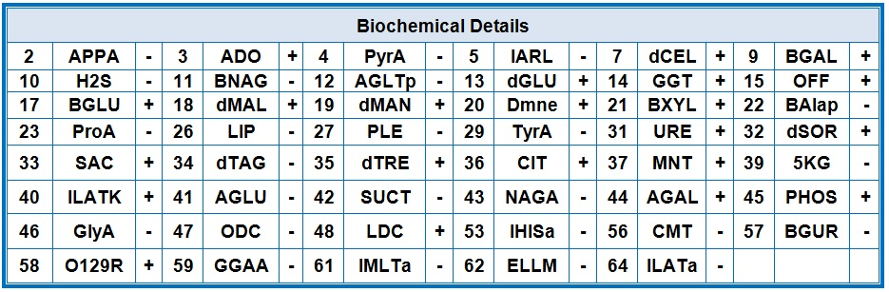

Figure S1: VITEK 2 GN-ID CARD.

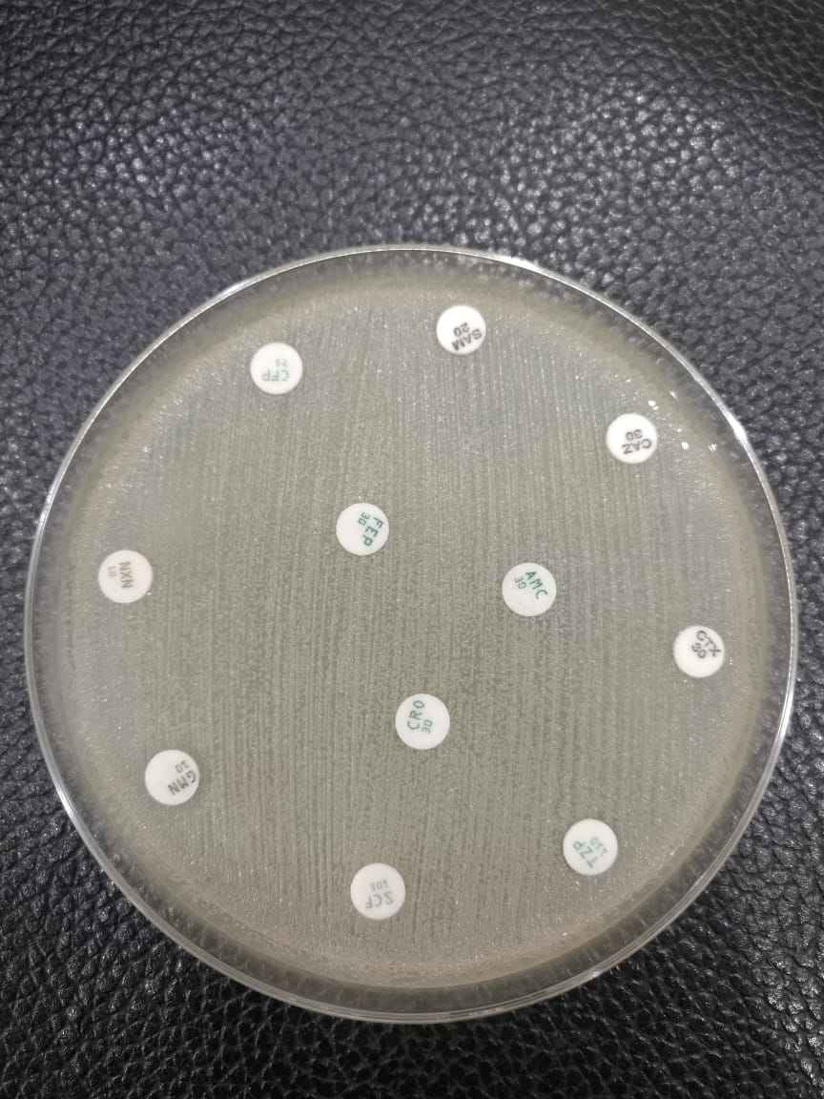
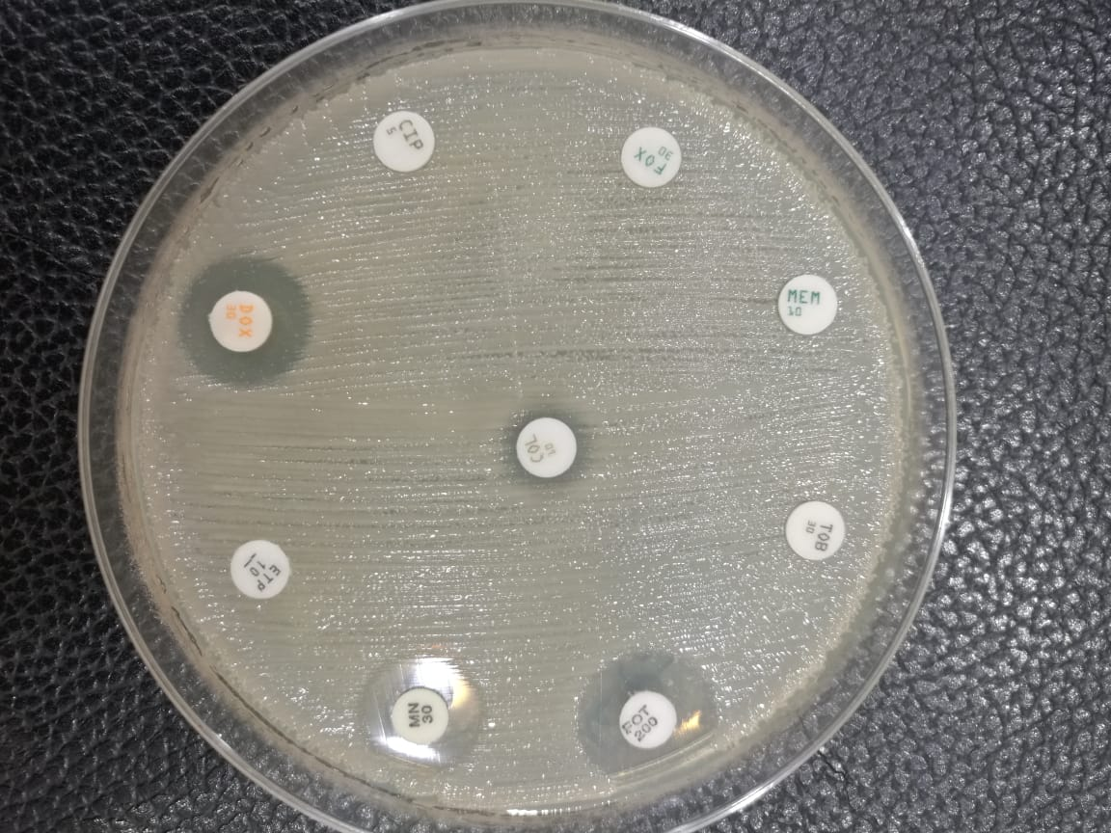
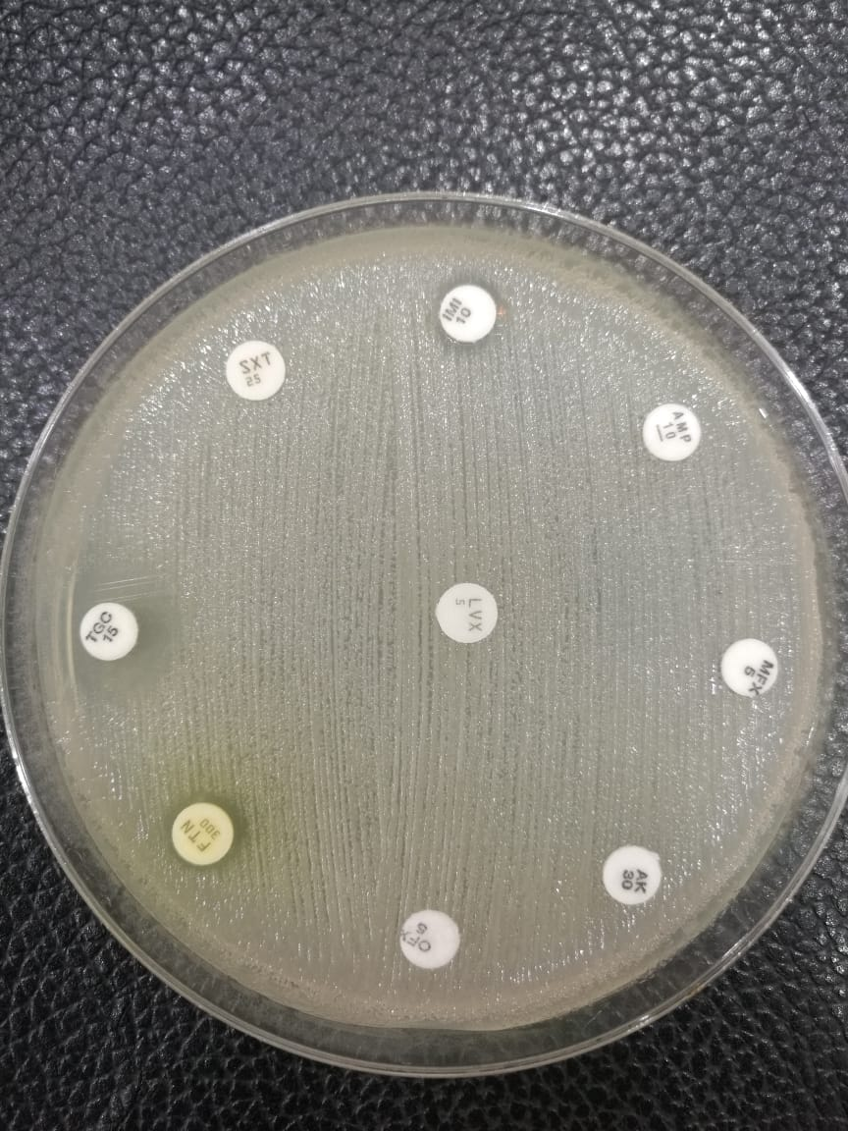

Figure S2: Antibiotic sensitivity disk for Klebsiella pneumoniae strain 3MAG
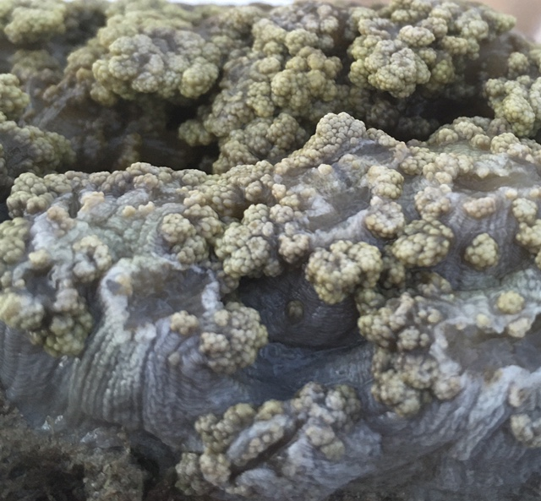

Figure S3: Yellowish-gray Soft coral marine

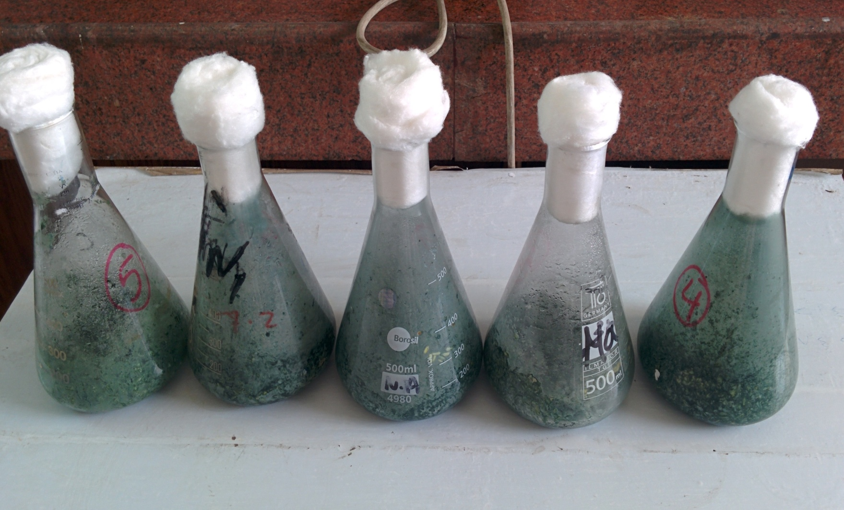

Figure S4: Small scale fermentation Flasks

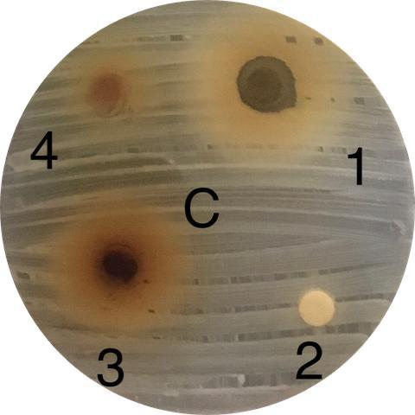
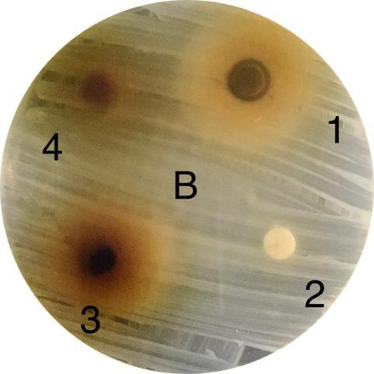
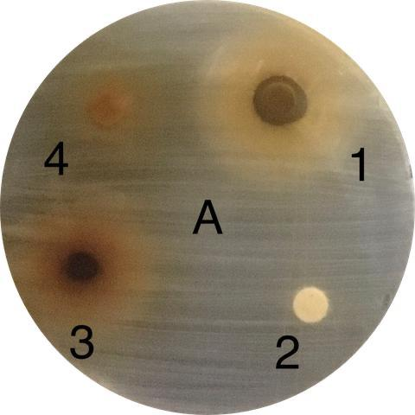

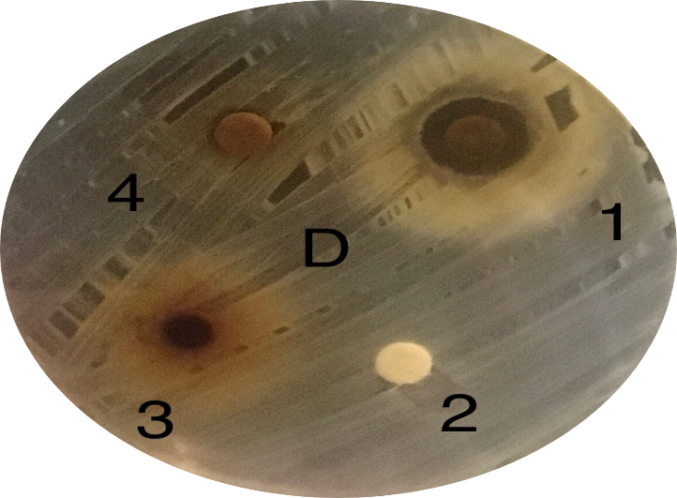
Figure S5: Pre-Screening of the fungal extracts

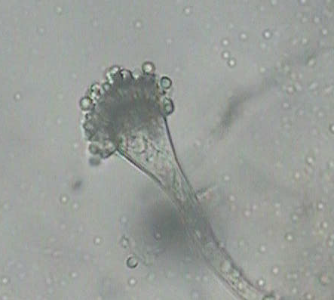

Figure S6: Aspergillus isolate under microscope.

.

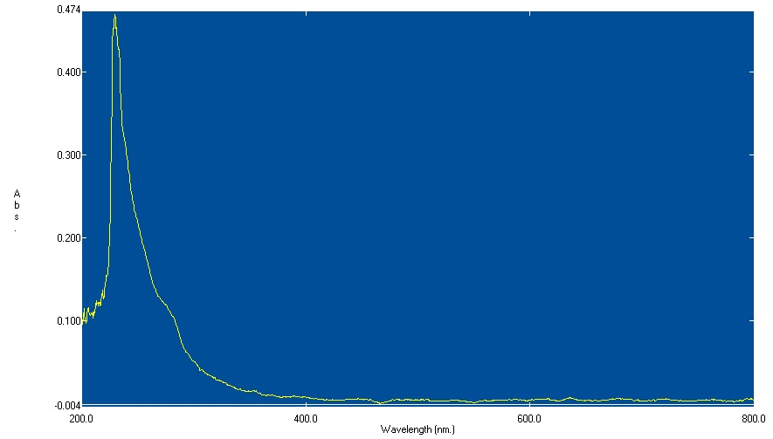

Figure S7: UV- spectroscopy of the pure compound

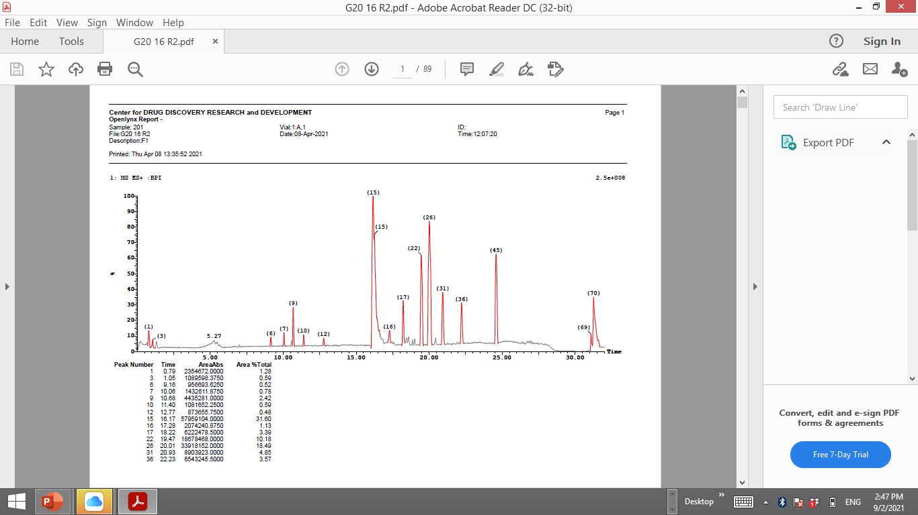

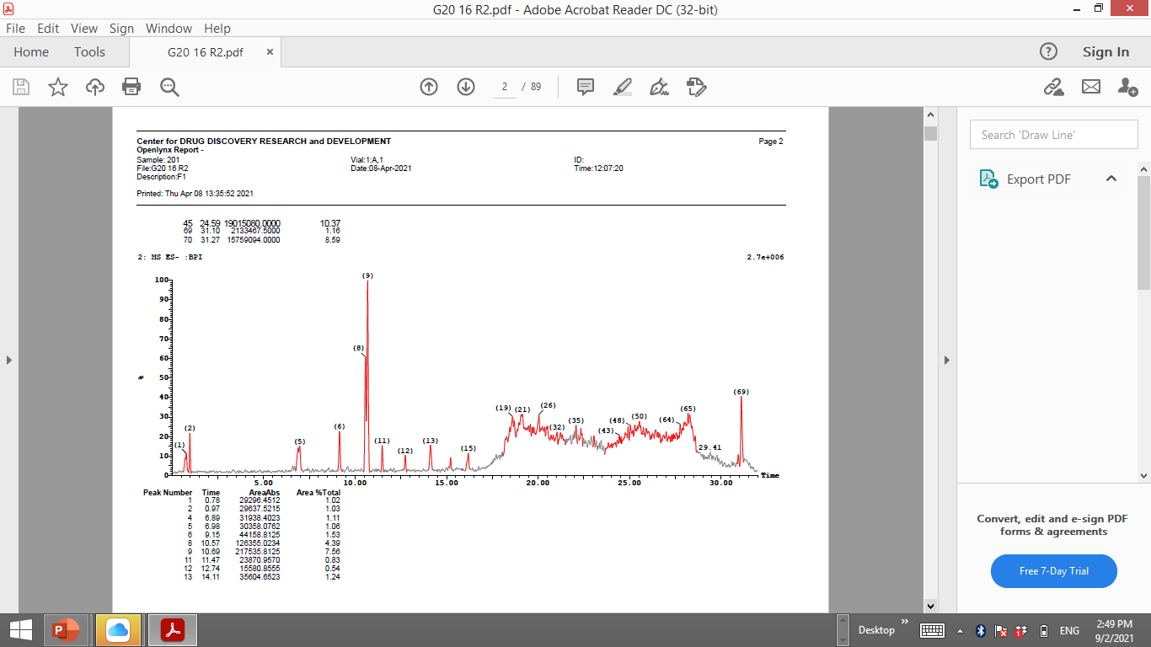

Figure S8: LC-MS Positive & Negative of the pure compound

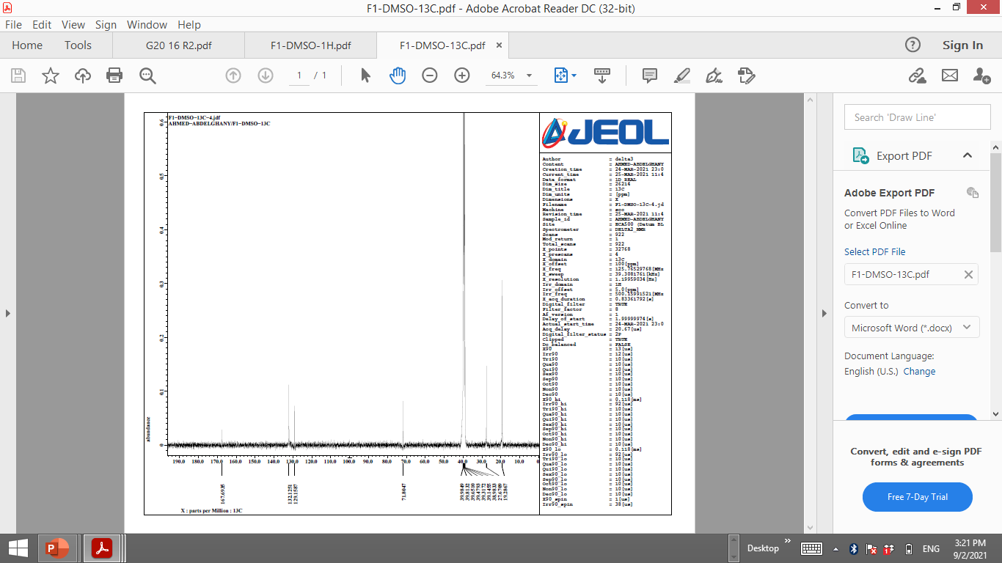

Figure S9: ¹³C-NMR of the pure compound

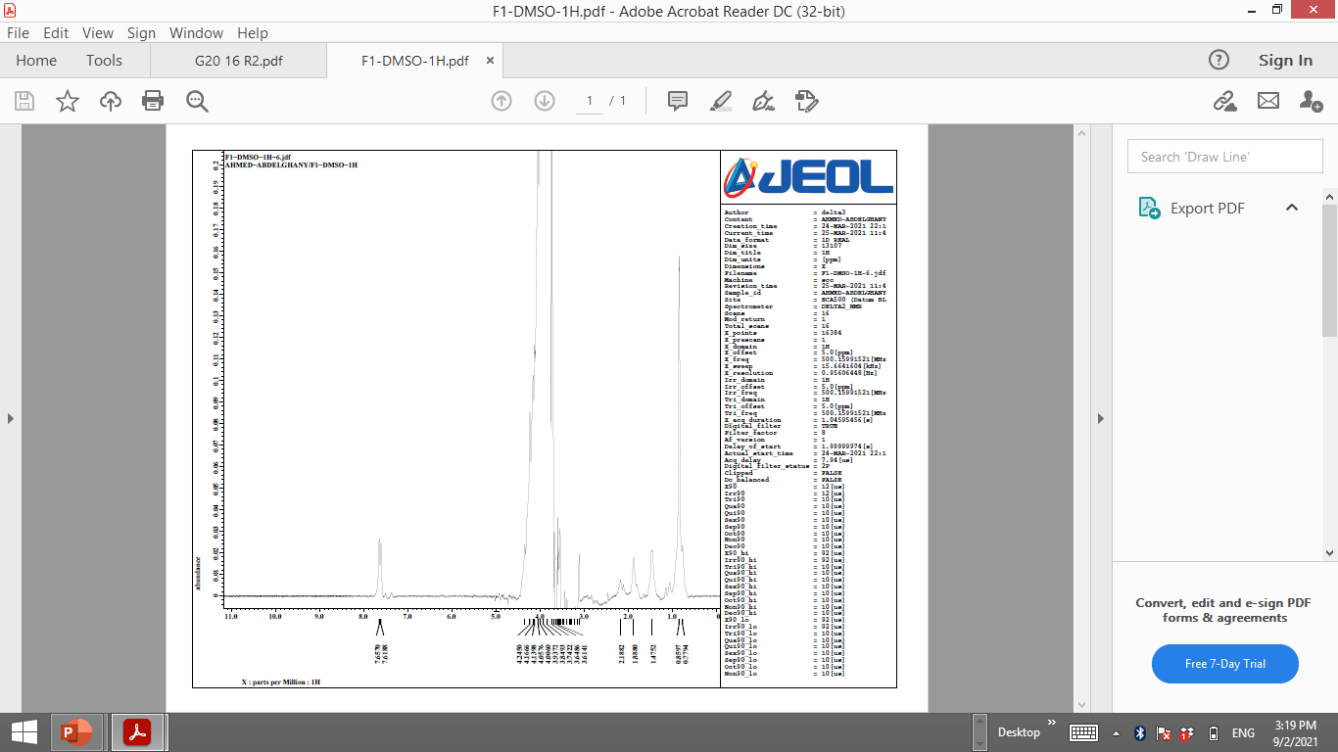

Figure S10: ¹H-NMR of the pure compound

