Supplementary Information
Self-powered non-reciprocal phononic logic gates
Zhang et al.

Supplementary Figure 1 to 4
Supplementary Note 1
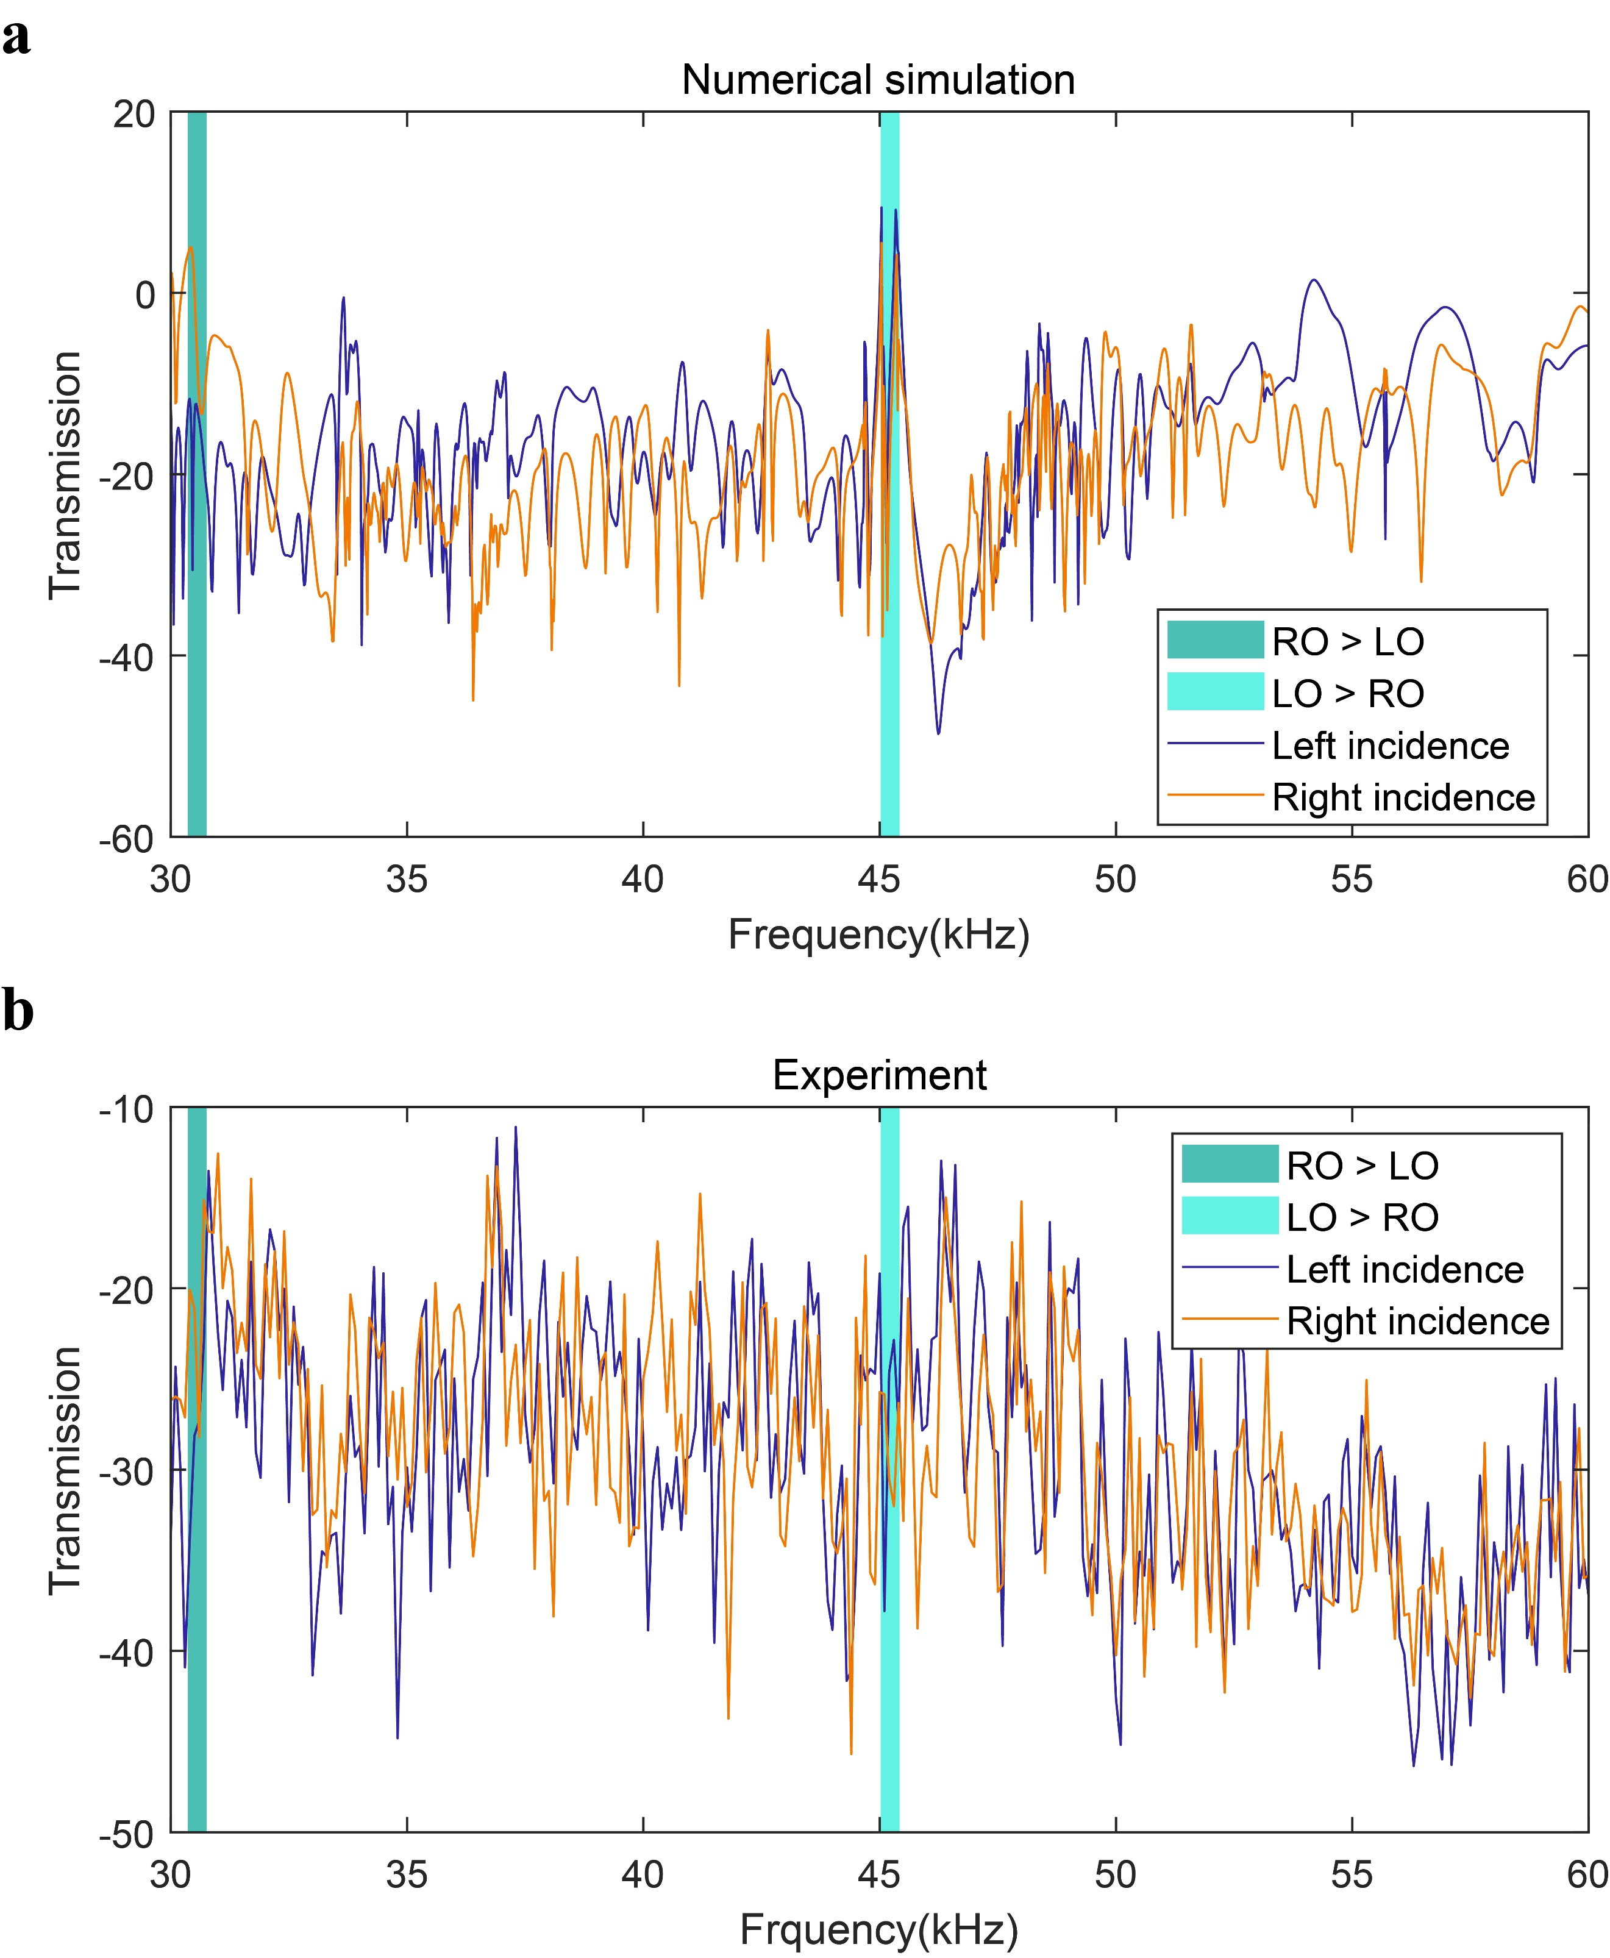
Supplementary Figure 1. Numerical and experimental transmission curves at the left or right incidence. (a) The numerical transmission curves within 30000 ~ 60000 Hz under the incidence on the left or right side, the excitation amplitude is 5 μm, the displacement response represents the center point of the upper surface, and the transmission spectrum is calculated according to the transmission spectrum formula. It can be seen that there is an apparent difference between the left and right incidences, which is caused by the non-reciprocal transmission characteristics of elastic waves. The representative frequency bands of LO > RO and RO > LO are marked in the figure. (b) In the experiment, the voltages applied to the piezoelectric patch at the right and left input ends are the same. The RMS voltage value of the piezoelectric patch at the output end under each frequency excitation is measured at an interval of 100Hz within the range of 30,000 ~ 60,000 Hz, and the transmission curve is then determined by the voltage of input end and output end. The models of the input and output piezoelectric patch can be considered as the same since they are from the same batch. It can be seen that the transmission curves under the left or right excitation are quite different, which verifies the non-reciprocal property of the proposed phononic structure in the experiment. Similarly, the representative frequency bands of LO > RO and RO > LO are marked in the figure.

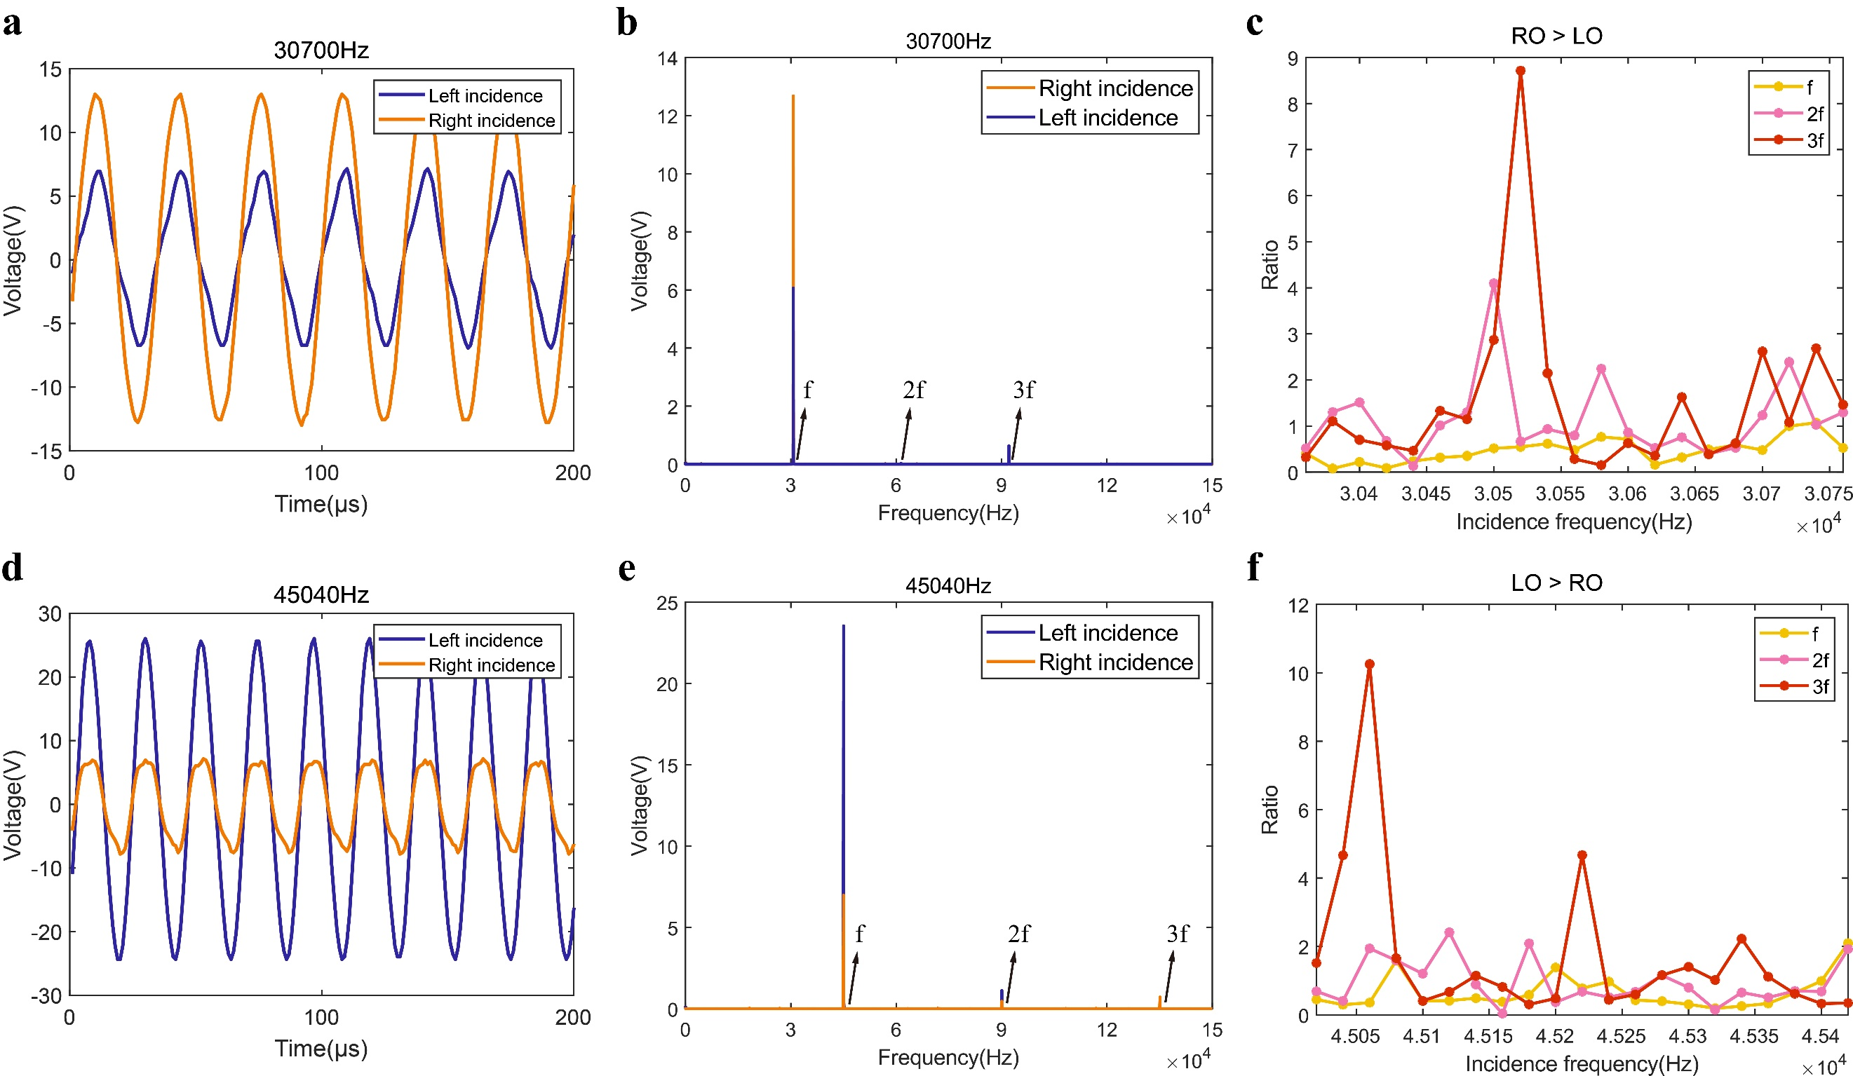
Supplementary Figure 2. Exposition of nonlinear phenomena in experiments. (a) 200-μs steady state time history curve of output voltage at the excitation frequency of 30700 Hz. (b) The spectrum diagram of output signal at the excitation frequency of 30700 Hz. (c) The ratio of the f, 2f and 3f voltage components between the right-incidence and left-incidence spectrums in the RO > LO frequency band. (d) 200-μs steady time history curve of the output voltage at the excitation frequency of 45040Hz. (e) The spectrum diagram of output signal at the excitation frequency of 45040 Hz. (f) The ratio of the f, 2f and 3f voltage components between the left-incidence and right-incidence spectrums in the LO > RO frequency band.

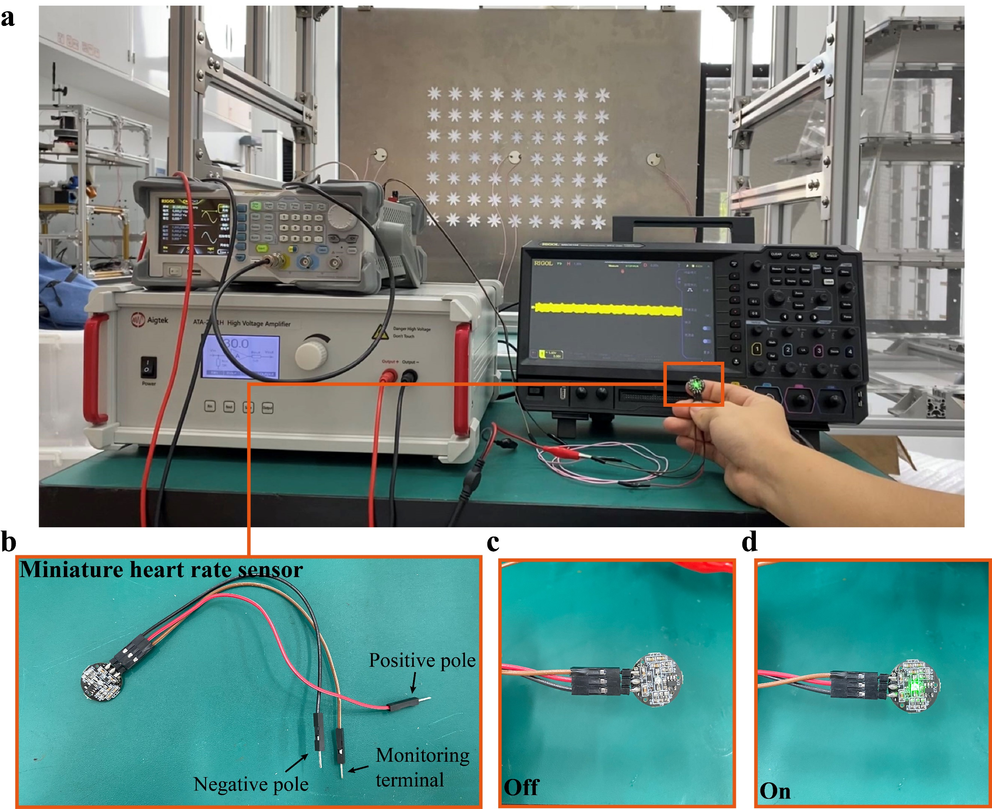
Supplementary Figure 3. The connection diagram of each experimental device in the heart rate monitoring experiment and the detailed diagram of the miniature heart rate sensor. (a) Experimental device connection diagram in the heart rate monitoring experiment. In this experiment, we set the excitation frequency as 45040Hz, and select the left piezoelectric patch for excitation since the left piezoelectric patch produces a larger output power at this frequency. The output piezoelectric patch is first connected with the AC-to-DC circuit board and then with the miniature heart rate sensor, and the monitoring end of the miniature heart rate sensor is connected with the oscilloscope. (b) Schematic diagram of the miniature heart rate sensor. The sensor has the positive pole, negative pole and monitoring terminal. The positive and negative poles are connected with those of the AC-to-DC circuit board. The monitoring terminal is connected with the oscilloscope. (c) Schematic diagram when the miniature heart rate sensor is in the Off state. (d) Schematic diagram when the miniature heart rate sensor is in the On state.

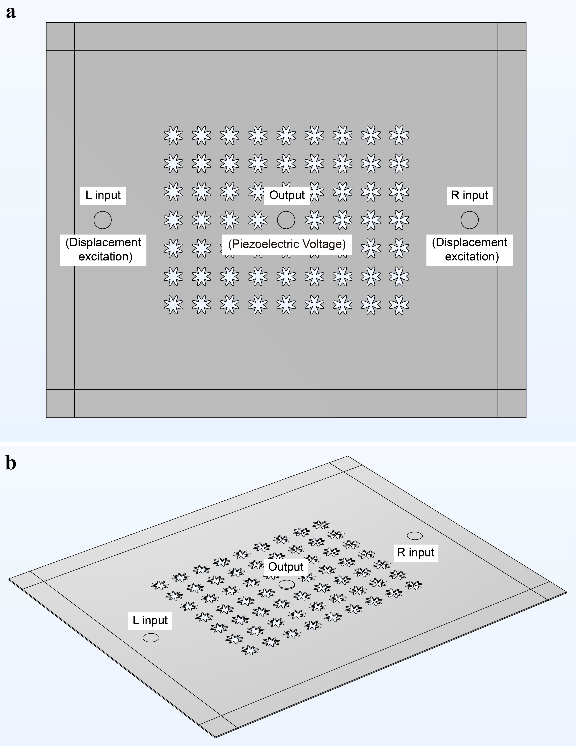
Supplementary Figure 4. The numerical simulation diagram of the mechanical computing part. (a) Plane diagram of the numerical simulation model. In this model, surface displacement excitation is introduced at the input end and PML is applied around the model. One piezoelectric patch is set at the output end, and the output signal is voltage signal. The whole calculation is carried out using electro-mechanical coupling model. The steady-state voltage-time curve at the output end is obtained with COMSOL's FFT algorithm from frequency domain to time domain. (b) 3D diagram of the numerical simulation model. In the diagram, the existence of the piezoelectric patch at the output end can be clearly noticed, and the input ends are two same diameter circles as the piezoelectric patch for applying displacement excitation.

Supplementary Note 1. Analysis of nonlinear effect in the experiment.
Since the fourth or above harmonic components are relatively weak, we only focus on the second and third harmonic components in nonlinear analysis. To further investigate the nonlinear characteristics in non-reciprocal transmission, we conduct fixed-frequency experiments at 20-Hz intervals in the RO > LO band (30360~30760Hz) and the LO > RO band (45020~45420Hz), and analyze the spectrum at each excitation frequency. In the RO > LO frequency band, the excitation frequency of 30700Hz is representatively selected to analyze the nonlinear effect, the steady voltage-time history and spectrum are as shown in Supplementary Figure.2a and 2b. At the excitation frequency of 30700 Hz, the f and 3f components are more obvious under both left and right incidence, while the 2f component is weaker. Among them, the fundamental frequency component dominates and is significantly larger for the right incidence than for the left incidence. The voltage value of the fundamental frequency component is 6.06 V for the left incidence, while it is 12.68 V for the right incidence, which is 109.24% higher compared to its left incidence counterpart. However, the voltage value of the 3f component at the right incidence (0.24V) is smaller than that at the left incidence (0.63V), which is opposite to the non-reciprocity of the fundamental frequency, suggesting that the non-reciprocity generated by the second or third harmonic components may be opposite to the non-reciprocity of the fundamental frequency. To verify this conjecture, we divide the left incident f, 2f and 3f components by the right incident f, 2f and 3f components respectively, for 21 frequencies of excitation in the range of 30360~30760 Hz to obtain Supplementary Figure.2c. In the range of 30360~30760 Hz, the ratios of f components are mostly less than 1. However, the ratios of 2f are often greater than 1, and the maximum value can reach about 5. Similarly, the ratios of 3f tend to be greater than 1, and the maximum reaches about 9. Similarly, in the LO > RO frequency band, we representatively selected the excitation frequency of 45040Hz for the nonlinear analysis, the steady voltage-time history and spectrum are as shown in Supplementary Figure.2d and 2e. At the excitation frequency of 45040Hz, the components of f, 2f and 3f are more obvious under both left and right incidence, in which the fundamental frequency component also plays a dominant role. The fundamental frequency component of the left incidence is significantly larger than that of the right incidence. The voltage value of the fundamental frequency component is 6.98V in the right incidence, while that is 23.53V in the left incidence, which is 237.11% higher compared to its right incidence counterpart. However, the difference between the 2f component at left incidence (1.12V) and the 2f component at right incidence (0.46V) is then significantly smaller. The 3f component at left incidence (0.15V) is smaller than that at right incidence (0.72V), which once again indicates that the non-reciprocity generated by the higher harmonics may be the opposite of the non-reciprocity at fundamental frequency. To further verify this, we divided the f, 2f and 3f components of the right incident by the f, 2f and 3f components of the left incident at 21 frequencies of excitation in the range of 45020 to 45420 Hz to obtain Supplementary Figure.2f. In the range of 45020 to 45420 Hz, the ratios of the f component are almost all less than 1, the ratios of the 2f component are all greater than 1, and the maximum value is about 3, while the ratios of 3f component are overall greater than the ratios of 2f component, and the maximum value is about 10. Therefore, the overall non-reciprocity of this structure is dominated by the fundamental frequency component, whether in the LO > RO band or the RO > LO band, while the non-reciprocity of the second and third harmonic components is likely to be the opposite of the non-reciprocity of the fundamental frequency component. This effect may further increase the richness and possibility of wave manipulation methods.

