Supplementary Figures
Supplementary Figure 1: The stain free gel of GFE and PFE sperm proteins.
Supplementary Figure 2: The first and second repeats of PRDX6 WB image of GFE and PFE sperm.
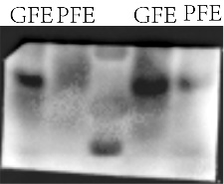
Supplementary Figure 3: The third repeat of PRDX6 WB image of GFE and PFE sperm.
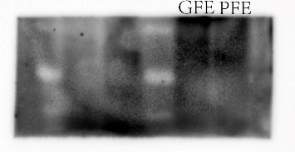
Supplementary Figure 4: The first and second repeats of Tublin WB image of GFE and PFE sperm.
Supplementary Figure 5: The third repeats of Tublin WB image of GFE and PFE sperm.

