Supporting Information for
Functionalization of melamine sponge for the efficient recovery of Pt(IV) from acid leachates
Zhaojiang Wu ª, Zheng Lin ª, Shengye Wang ª, Bo Yang ª, Ke Xiao ª∗
ª College of Chemistry and Environmental Engineering, Shenzhen University, Shenzhen 518060, China

2. Methods
2.1. Materials
Hydrochloric acid and sulfuric acid were acquired from Energy Chemical Co., Ltd (China). Potassium hexachloroplatinate(IV), cupric sulfate, aluminum chloride, iron chloride hexahydrate, sodium chloride, and sodium sulfate anhydrous were acquired from West Long Chemical Co., Ltd. (China) and used as a simulated Pt(IV)-containing acid leachates (Table S1).
Table S1 Simulated Pt(IV)-containing acid leachates.
Parameter | Pt | Cu | Zn | Ni | Na
Unit（mg/L） | 17.2 | 0.3 | 4.4 | 0.6 | 2100

2.4. ML and ML/ACPG sponges stabilization and adsorption experiments
2.4.1. Adsorption isotherm
150 mg of ML/ACPG sponges were added to Pt(IV) solution containing 100 mL and pH = 1, and the initial concentrations of Pt(IV) in the solutions were 10, 20, 30, 50, 75, 100, 150, and 200 mg/L at room temperature (25 ± 2 °C), respectively. After shaking at 200 rpm for 48 h, the samples were taken before and after the reaction. After the samples were filtered through 0.22 μm filter membrane, the concentration of Pt(IV) ions in the filtrate was detected by ICP.
Adsorption isotherms of Pt(IV) by sponges were described by the Freundlich and Langmuir models.
Langmuir model： (S1)
Freundlich model： ${q_{e}=KC}_{e}^{1/n}$ (S2)
where $q_{e}$ is the equilibrium adsorption capacity (mg/g); $C_{e}$ is the equilibrium Pt(IV) concentration (mg/L); $q_{m}$ is the saturated adsorption capacity (mg/g) ; $b$ is Langmuir constant; $K$ is Freundlich constant; and $n$ is Freundlich index, which indicates the strength of adsorption.
2.4.2. Absorption kinetic curve
ML/ACPG sponges (150 mg) were added into 1L solution containing Pt(IV)( 25 mg/L) at pH 0.5, 1, 2 and 3, respectively, and the reaction was oscillated at room temperature (25 ± 2℃) and 200 rpm for 48 h. Samples were taken at intervals from 0 h to 48 h. The Pt(IV) concentration was measured by ICP, and the pseudo-first-order kinetic model and pseudo-second-order kinetic model were used for fitting the experimental data.
Adsorption kinetics could be used to study the adsorption process and mechanism, and it is an important parameter for reactor design and parameter adjustment. In this study, pseudo-first order rate equation (PFORE, Eq. [6]) was mainly used to study the adsorption process controlled by physical action. Pseudo-second order rate equation (PSORE, Eq. [7]) was mainly used to study the adsorption process controlled by chemical adsorption. The resistance to the intraparticle diffusion equation (IPD, Eq. [8]) was mainly used to study the boundary layer adsorption process.
${ q}_{\text{t }}\text{= }q_{e}(1\text{ - }{\text{e}}^{-k_{1}t})$ (S3)
(S4)
(S5)
where $k_{1}$ is PFORE constant (min⁻¹), $k_{2}$is PSORE constant (g/mg·min),$k_{int}$ is IPD constant (min⁻¹), $q_{e}$ is the equilibrium adsorption capacity (mg/g), $q_{t}$ is the adsorption capacity at time t, $C$ is the constant related to the boundary layer.
2.4.3. Sequential batch adsorption and continuous adsorption
(1) Sequential batch adsorption at different vibration velocities: Three parts of ML/ACPG sponges (150 mg) were weighed and subjected to oscillatory reaction at 100, 200, and 250 rpm for 48 h under the same solution properties (pH of 1 and Pt(IV) concentration of 25 mg/L). Samples were taken at intervals of 0–48 h. The concentration of Pt(IV) in the sample was detected by ICP after the sample was filtered through 0.22 μm membrane.
(2) Continuous adsorption at different flow rates: Three parts of ML/ACPG sponges (150 mg) were weighed and adsorbed at flow rates of 2, 10, and 20 mL/min under the same solution properties (pH of 1 and Pt(IV) concentration of 25 mg/L). The Pt(IV) concentration was detected by ICP after the sample was filtered through 0.22μm membrane.
2.5. Desorption experiments of ML/ACPG sponges
(1) The effect of different desorption reagents: After adsorption, the Pt(IV)-loaded ML/ACPG sponge was placed into a beaker containing 250 mL of different desorption agents, and the shaking speed was 200 rpm for 2 h at room temperature (25 ± 2 °C). The desorption solution was diluted with deionized water, then the concentration of Pt(IV) was detected by ICP.
(2) The effect of volumes of desorption solution (sequential batch): After adsorption, the Pt(IV)-loaded ML/ACPG sponge was placed into a beaker containing 100, 250, and 500 mL of three different volumes of desorption agents, and the shaking speed was 200 rpm for 2 h at room temperature (25 ± 2 °C). The desorption solution was diluted with deionized water, and then the concentration of Pt(IV) was detected by ICP.
(3) Desorption effect at different flow rates (continuous): The balanced adsorbent was desorbed with 120 mL of desorption agent at the flow rate of 1, 2 and 10 mL/min, respectively. The desorption solution was diluted with deionized water, then the concentration of Pt(IV) was detected by ICP.
- Results and discussion
  - Adsorption performance of Pt(IV)
3.2.5 Effect of sequential batch and continuous adsorption on Pt(IV)
Table S2 Kinetic model parameters of Pt adsorption at different vibration speeds.
Model | Unit | 100 rpm | 200 rpm | 250 rpm
PFORE | q_{e}（mgPt/g） | 96.50143 | 92.96282 | 92.13283
PFORE | K₁×10³ | 0.28999 | 0.52863 | 0.74446
PFORE | R² | 0.88084 | 0.91764 | 0.913283
PSORE | q_{e}（mgPt/g） | 106.45809 | 104.32006 | 102.51734
PSORE | K₁×10³ | 0.00397 | 0.00678 | 0.00962
PSORE | R² | 0.94586 | 0.9765 | 0.97761
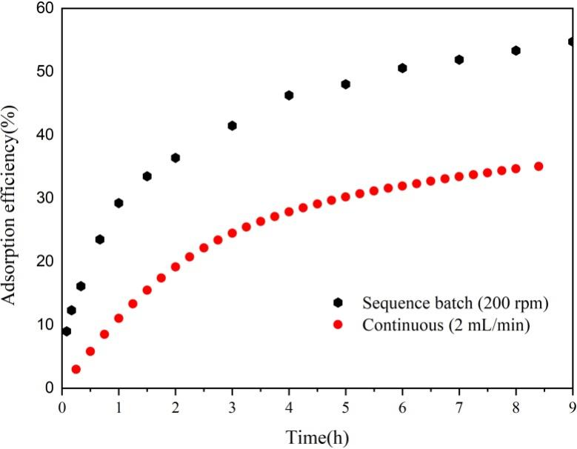
Fig.S1. Comparison of sequencing batch adsorption and continuous Pt(IV) adsorption efficiency.
  - Stability and reusability of functionalized ML/ACPG sponge
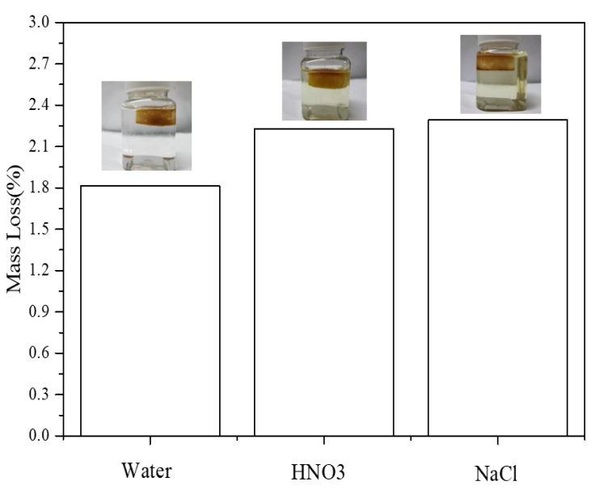
Fig.S2. Stability of ML/ACPG shaking in different solutions for 72 h.
3.5. Adsorption mechanism of Pt(IV) by ML/ACPG sponge
Table S3 Kinetic model parameters of Pt(IV) adsorption at different pH.
Model | Unit | pH=3 | pH=2 | pH=1 | pH=0.5
PFORE | q_{e}（mgPt/g） | 66.22616 | 75.4951 | 108.79923 | 110.1976
PFORE | K₁×10³ | 0.16854 | 0.20967 | 0.21949 | 0.19269
PFORE | R² | 0.93264 | 0.8113 | 0.80756 | 0.87091
PSORE | q_{e}（mgPt/g） | 67.21472 | 72.58563 | 104.31973 | 105.35987
PSORE | K₁×10³ | 0.00429 | 0.00909 | 0.00678 | 0.00396
PSORE | R² | 0.98367 | 0.97467 | 0.9765 | 0.96474

Table S4 Adsorption isotherm model parameters.
Model | Unit | pH=1
Langmuir | q | 117.2
Langmuir | R_{L} | 0.06527
Langmuir | R² | 0.9383
Freundlich | k | 33.83718
Freundlich | 1/n | 0.22919
Freundlich | R² | 0.85299

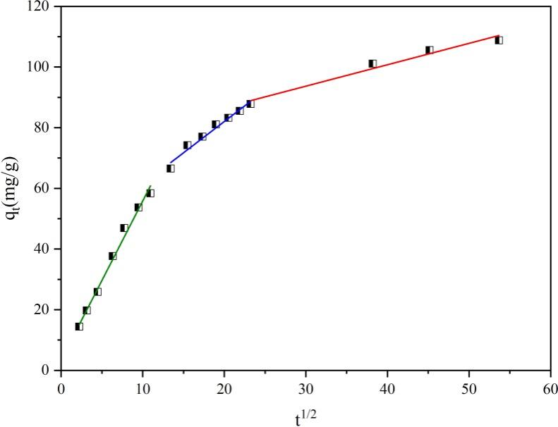
Fig.S3. Intra-particle diffusion model fitting of Pt(IV) adsorption process.
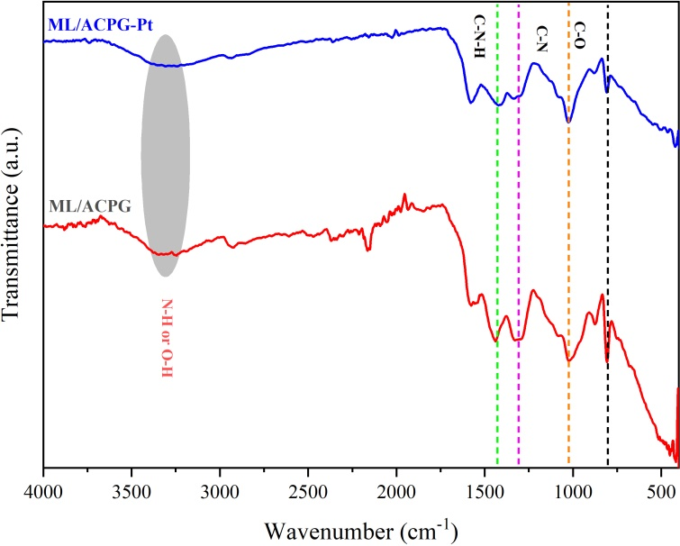
Fig.S4. FTIR of ML/ACPG sponge and Pt(IV)-loaded ML/ACPG sponge.

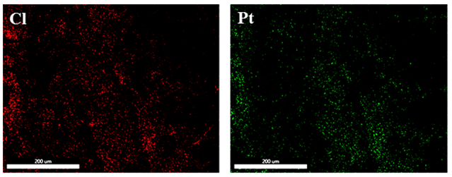
Fig.S5. Distribution of Cl and Pt of the Pt(IV)-loaded ML/ACPG sponge.

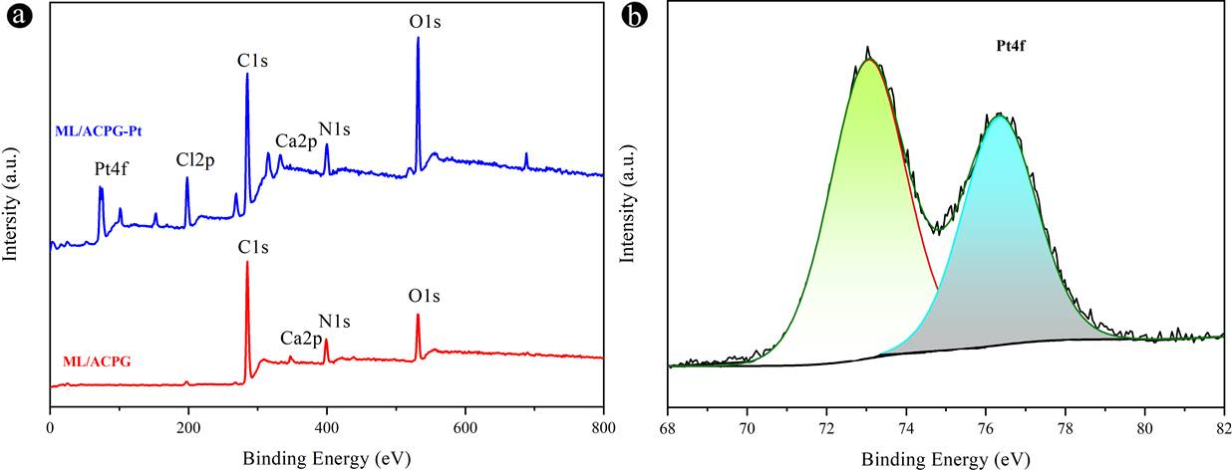
Fig.S6. (a) XPS spectrum of ML/ACPG sponge and Pt(IV)-loaded ML/ACPG sponge. (b) Pt 4f spectrum of Pt(IV)-loaded ML/ACPG sponge.
3.6 Application to the treatment of acid leachates
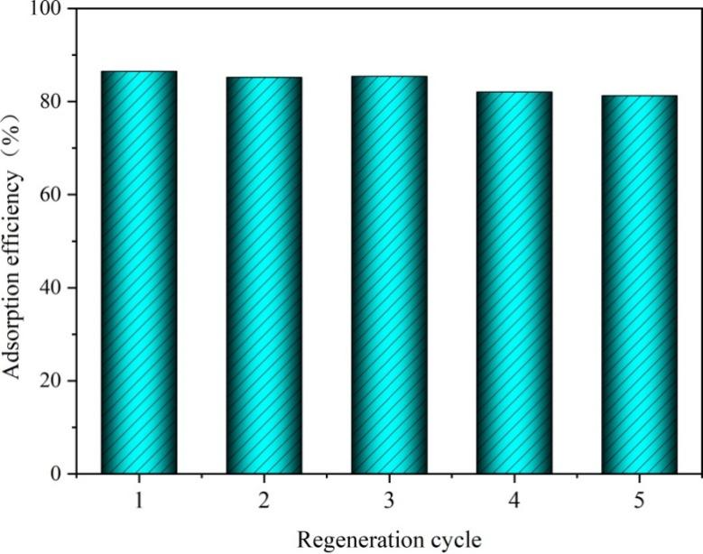
Fig.S7 Adsorption efficiency of Pt(IV) with different regeneration cycles.

∗ Corresponding author. Tel.: +86 755 26732904; fax: +86 755 26536141. E-mail address: xiaoke@szu.edu.cn (K. Xiao).

