Supplementary Information for
Managing ammonia emission for multi-benefits in China

This PDF file includes:
Supplementary Methods
Supplementary Discussion
Supplementary Figures S1 to S13
Supplementary Tables S1 to S4
Supplementary References (1-30)

Supplementary Methods

Estimation of Livestock NH₃
Data sources. The animal NH₃ EFs in 2017 are estimated based on the China’s second national census of agricultural pollution source and the related parameters derived from the recommended values from the Ministry of Agriculture and Rural Affairs of China. The animal NH₃ emission factors are changed with the management practices and manure treatment methods from the national census, as shown in the following equation (1)

${EF}_{i,j,k} ={NE}_{i,j}×C_{i,j}×\left(1-η_{U}\right)×V_{i,j,k}+ {NE}_{i,j}×\left(1-C_{i,j}\right)×V_{i,j, na}$ (1)

NE_{i,j} (kg/head) is the N excretion rate in feeding and housing stage; $C_{ij}$ (%) is the manure collection ratio; $η_{U}$ (%) is the reuse ratio of excretion; $V_{i,j,k}$ (kg N /head) is the quantity of NH₃ volatilization with the manure treatment measure k; $V_{i, j,na}$ is the quantity of NH₃ volatilization from the uncollected manure.

Parameters used in equations (1) are derived from the farm surveys of China’s second nation census of livestock pollution source in 2017, which were processed following the detail steps and methods described in the Zhu et al¹. In total, approximately 380,000 large-scale farms and 11,919 smallholder farms were surveyed in 2017, respectively. The geographical coordinates of each large-scale farm were recorded in the censuses and used to generate high resolution distribution maps of large-scale farms. For small-scale farms, statistical surveys were conducted at a county scale to record the total number of each animal type. The threshold numbers defining the category of “large-scale” farms are larger than 50, 100, 500, 500, 10,000, and 2,000 for beef cattle (slaughtered), dairy cattle (stock), pig (slaughtered), sheep/goat (slaughtered), broiler (slaughtered) and laying hen (stock).

Sampling sites and NH₃ collections
The research was conducted in Luancheng District (37°41′34″~38°01′07″N, 114°28′35″~114°47′35″E), located in the north China plain. Three sampling sites (farmland, livestock and rural) were selected for this study. The farmland sampling site (37°53′24″N, 114°41′46″E) was located in Luancheng Agro-Eco-Experimental Station of Center for Agricultural Resources Research, Institute of Genetics and Developmental Biology, Chinese Academy of Sciences. The livestock sampling site (37°53′2″N, 114°42′0″E) was located in a pig farm, which is 3 km away from the west side of the farmland sampling site. The rural sampling site (37°52′52″N, 114°44′31″E) was 10 km away from the farmland sampling site, where belong to the typical suburban area.

The collection of NH₃-N can be found in Ti et al.². Briefly, ambient NH₃ concentrations were captured by acid solution every 10 days at each site using integrated air samplers (ZC-Q0102, Zhejiang Hengda Instrument Company, China), which were operated for 24 h and sampled ambient air at a height of 2 m above ground level. The NH₄⁺-N concentrations in the absorption solution were then determined using a continuous-flow analyser (Skalar San++ System, Breda, the Netherlands), with the detection limit of concentration determination of 0.046 mg N L⁻¹. The isotopic N concentration of the absorbent solutions at natural abundance was analyzed using the method of Liu et al³. (2014).

Supplementary Discussion

Emissions from different sources
We have calculated the NH₃ emission of N fertilizer from 14 crops in each county according to the previously developed empirical model (Extended Data Fig. 2). Maize is mainly because its high N fertilization rate and the high environmental temperature during growth period in summer in the North China Plain (NCP) region. Followed by rice and vegetables (18%), which are planted in the southern region with a high emission factor. In the course of our estimation, the emissions of wheat are smaller (8%) even with a large planted area, which is not identified in previous studies. This is mainly because wheat has a low EF and is usually only applied as a base fertilizer in autumn. Fruits, often using manure as a base fertilizer, have a continuous volatilization of NH₃ throughout the year and, like vegetables, have no significant seasonality, with emissions concentrated in special provinces (e.g., Guangzhou, Guangxi and Shaanxi). The emissions from other crops with small acreage, including legumes, sugar and cotton, were all relatively low.

The NH₃ emissions from livestock in 2017 were estimated based on the intensive production of pollution census data from farms and the statistical data of free-range breeding (Fig. S10). The hogs, sheep and cattle contributed 70% of the total emissions, with the highest from the spreading on cropland (2.3 Tg, 46%), followed by housing (31%), storage (13%) and outdoors (10%) in four stages volatilizing a large amount of NH₃ in the open air (Extended Data Fig. 3). The emissions at the fourth stage are the highest, especially from free-range farming (1.7 Tg), where manure is produced at home and applied directly to cropland without professional treatment or simple fermentation (Extended Data Fig. 6). The overall emissions from large-scale farming are lower than those from free-range farming because we consider the emissions from different barn management in large-scale farming, such as mechanical manure removal, such better management methods to reduce NH₃ emissions at the housing and storage stages, and manure is returned to the cropland after treated⁴ (Extended Data Fig. 3). Therefore, more large-scale livestock farms should be used to improve the current farming situation, increase the rate of return to the field and use more efficient manure treatment methods.

Our results show that non-agricultural sources account for a larger proportion of emissions (30%), and previous studies also have also stressed that emissions have been increasing and are underestimated (Fig. 1). In addition to enhanced automobile exhaust emissions in urban areas, large emissions from cement production and coal-fired power plants in the past two decades, primarily due to the NH₃ scape caused by the large-scale application of the denitration process (e.g., non-selective catalytic reduction (SNCR) and selective catalytic reduction (SCR) technologies)⁵⁻⁸, which could cause “slip out” of NH₃. Other emission sources, such as grassland and aquaculture, were easily to be ignored in previous studies. This is also an important emission source that deserves attention due to the increase of urban greening and the serious atmospheric nitrogen deposition in recent years^{9, 10}. Our efforts, together with a recently implemented, stress the importance and potential risks towards those fast-increasing emissions and call for more restricted and comprehensive policies.

High temporal-spatial resolution
For cropland, we used secondary pollution census data to obtain the frequency of fertilizer application at ten-day intervals throughout the year, which is the latest and most accurate fertilization time for different crops. The annual emission change of livestock is mainly affected by environmental factors. For example, when the temperature in Northeast China is low in winter with lower emissions, while the emissions in the south are still high. From the perspective of different region across China, the emission of temporal variation in each city are different, due to the temperature discrepancy of the year¹¹. We use county-level environmental data to correct the impact, which could better identify the spatial differences. For livestock, we achieved the spatial distribution of large-scale farms in the way of latitude and longitude positioning for the first time, with NH₃ emissions from each farm on a 1 km spatial grid, so the spatial uncertainty was substantially decreased compared with the previous studies. The emission intensity is still the highest in South China, followed by YRD. For non-agricultural sources, emissions are usually concentrated in urban areas and it is easier to form a complex of atmospheric pollution together with other pollutants (e.g., O₃, NOx) (Fig. 1h, i). Thus, there is a greater impact on human health risks and should further stressed. Our efforts could advance these understandings through the development of an unprecedented high temporal-spatial resolution data set of China’s NH₃ emissions with county-level and survey point-level data.

Comparison with previous studies
The lapsed inventories that are no longer to reflect the current situation due to the fertilization and livestock farming in China have undergone great changes. The previous study mainly has the following deficiencies based on the above research: (1) Since the current fertilization and livestock farming in China have undergone great changes^{1, 12}, the lapsed inventories that are no longer to reflect the current situation without timeliness. (2) Inventories are mostly compiled using provincial or municipal scale statistics, and then downscale emissions to a smaller spatial resolution simply in ArcGIS, and it is difficult to capture the precise NH₃ emission hotspot^{13, 14}. (3) Most of the estimation calculated by foreign emission factors, and there is no localized emission database. (4) The temporal resolution is mostly annual, quarterly and monthly, which can only reflect the rough temporal distribution characteristics of emissions and cannot be simulated carefully^{13, 15, 16}; These all limit the implementation of NH₃ emission reduction measures. Therefore, accurate NH₃ emissions inventory is important to identifying high-resolution spatial and temporal characteristics and provide references for fine agricultural management in different regions, as well as for air pollution control. The specific classification and estimation methods of each study are list in the Extended Data Table S1. Improved inventory has been developed in recent years, as well as scenario analyses to explore the possible emission reduction potential^{4, 17, 18}. Satellite and ground-based concentration data can well find emission hot spots and identify the monthly variation. From the perspective of the overall interannual change trend, our research is within a reasonable range (Fig. 3f).

We listed the references about NH₃ emission in the Extended Data Table S1.
EDGARv5.0¹⁹
Huang et al. (2012)¹³
Paulot et al. (2014)²⁰
Kang et al. (2016)¹⁶
Zhang et al. (2018)²¹
Kong et al. (2019)¹⁸
Fu et al. (2020)²²
Kurokawa et al. (2020)²³
Ma et al. (2020)²⁴
Li et al. (2021)¹⁷
Xu et al. (2015)¹⁵

Limitations and uncertainty
China feeds 30% of the world's population on 11% of the world's arable land, and agriculture is fundamental to our development, inevitably resulting in a large magnitude of NH₃ emissions, so abatement control is also encountering difficulties. Although China is booming in science and technology, the level of agricultural technology has not kept pace with development. The main reason is that there are too many small-scale farms in China, which are managed by some elderly people, who cannot apply the more advanced management practices proposed in this study above, so promote the reform of China’s land tenure system to facilitate large-scale farming is also a great challenge^{12, 25, 26}. In addition, the large number of small-scale livestock farms makes it difficult for the state to manage them, and strict policies and rational planning at the national level in terms of the layout of cropland and livestock are needed¹.

This study demonstrates the spatial distribution of the environmental impact of NH₃ emissions, but as more accurate county-level environmental data are limited, this study uses county-level data weights for correction, which can be explored in future studies. As the process of soil acidification is complex, this study does not precisely explore the mechanistic changes involved²⁷. Atmospheric nitrogen deposition also has a neutralizing effect on acid rain, which can be combined with its specific chemical reactions to quantify soil acidification and biodiversity loss²⁸. In addition, it is more difficult to compile and integrate county-level data, and this study can present a high-resolution spatial distribution using 2017-based data. This distribution may not have changed much in recent years, so it has strong reference significance, but it also needs to be updated continuously, for example at a time point of five years, to follow up on its spatial changes. At the same time, our other findings in CHANS are sufficient to see how the temporal trend changes in order to make a basis for future policy prediction.

In order to analyses the uncertainty in our inventory, we used qualitative and semiquantitative approaches that classify all the NH₃-related parameters, coefficients, and activity data into several confidence levels. The uncertainty of NH₃ emissions was calculated using the Monte Carlo method, which has been widely used in previous studies. Based on existing statistical or experimental data and expert judgement, NH₃ emission related parameters (Coefficients of variation (CVs)) were derived or assumed for this study. Detailed methods and related parameters are described and consistent with our our previous studies^{9, 11, 29, 30}. Uncertainty range of the NH3 emissions by sector in 2017 are list in Table S4, which effectively improves inventory accuracy and applicability. For different sources, cropland and livestock are the two dominant sources of the total uncertainty. Although our study has significant improvement in spatial-temporal resolution compared to previous studies, there are still some problems in the assessment process. On the one hand, the time lag of the activity data due to the long period of the survey process, and the omission of some newly established farms may lead to errors in the data. On the other hand, some provincial level parameters are still used for county level calculation such as animal nitrogen excretion coefficients due to data limitation, therefore, there is still some bias and uncertainty in the research.

Figure S1 Illustration of cropland NH₃ estimation.

Figure S2 Illustration of livestock NH₃ estimation.

Fig. S3 Spatial distribution of cropland survey points.

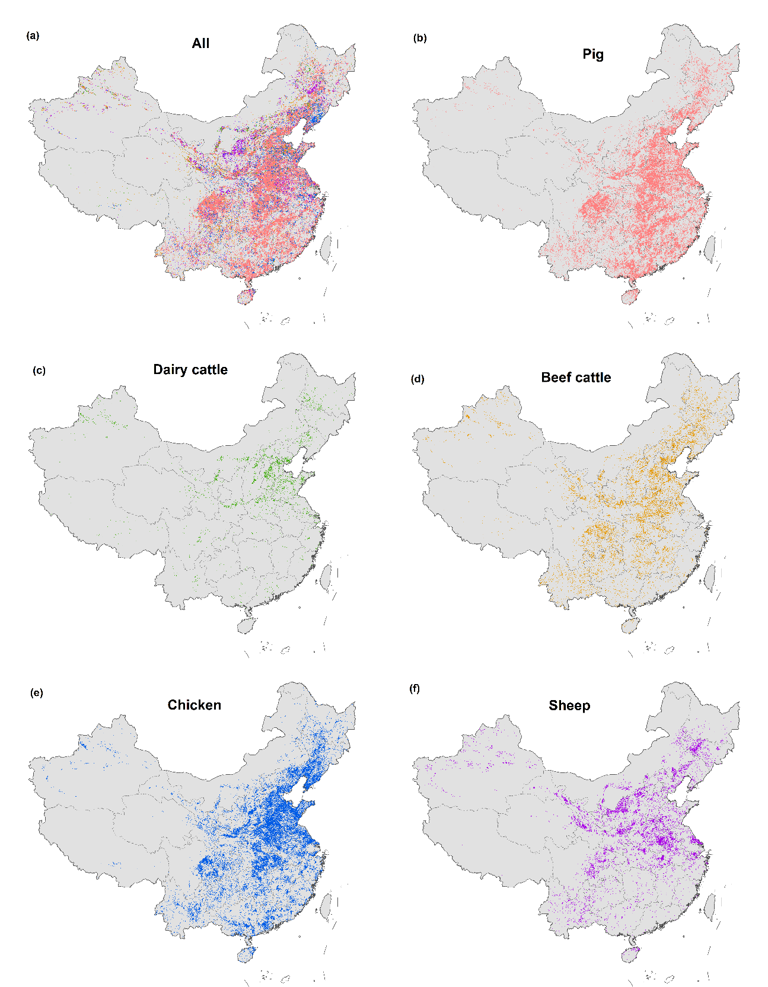
Fig. S4 Spatial location of animal farms in 2017 based on the second agricultural pollution source censuses. (a) All animals; (b) Pig; (c) Dairy cattle; (d) Beef cattle; (e) Chicken; (f) Sheep/goat.

Fig. S5 Ammonia emissions by cropping system in 2017.

Fig. S6 Proportion of manure treatment methods of different animals in intensive in China.
Fig. S7 The time series and spatial distribution of PM_{2.5} concentrations in January and July in North China Plain and observed by the model.

Fig. S8 Verification of emission inventory by isotopic traceability. (a) agricultural sources; (b) Industrial sources; (c) Other sources

Fig.S9 Comparison of the process model simulation and emission inventory method at city level. Red bar graphs indicate lower than the process model simulation, on the contrary blue is indicating higher. Acronyms for 31 provinces, autonomous regions, and municipalities directly under the Central Government are listed in Table S1.

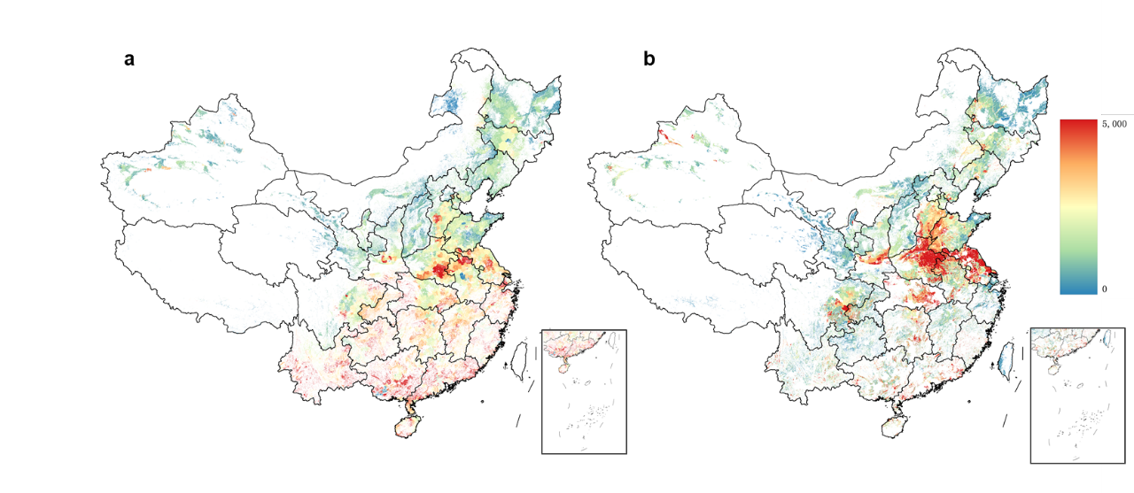
Fig.S10 Compare the spatial distribution of the process model simulation and emission inventory method in 1km. (a) The spatial distribution of emission inventory method; (b) The spatial distribution of process model simulation.

Fig. S11 Soil acidification due to TNHx deposition in forests and croplands 2017.

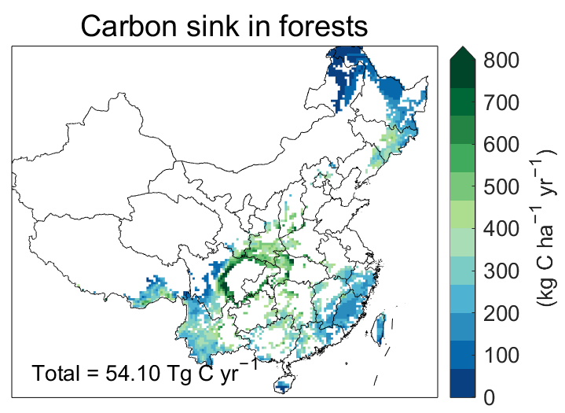
Fig. S12 Carbon sink due to TNHx deposition in forests 2017.
Fig. S13 Total ammonium deposition from WRF-Chem in forest, grassland and cropland ecosystems.
Table S1 The abbreviation of agricultural region and 31 provinces, autonomous regions, and municipalities directly under the Central Government.
Agricultural region | Abbreviation | Province | Abbreviation
Huang-Huai-Hai Region | HHH | Beijing | BEJ
Huang-Huai-Hai Region | HHH | Tianjin | TAJ
Huang-Huai-Hai Region | HHH | Hebei | HEB
Huang-Huai-Hai Region | HHH | Henan | HEN
Huang-Huai-Hai Region | HHH | Shandong | SHD
Middle and Lower Yangtze River Region | MLYR | Shanghai | SHH
Middle and Lower Yangtze River Region | MLYR | Jiangsu | JSU
Middle and Lower Yangtze River Region | MLYR | Zhejiang | ZHJ
Middle and Lower Yangtze River Region | MLYR | Anhui | ANH
Middle and Lower Yangtze River Region | MLYR | Jiangxi | JXI
Middle and Lower Yangtze River Region | MLYR | Hubei | HUB
Middle and Lower Yangtze River Region | MLYR | Hunan | HUN
Northwest Region | NW | Shanxi | SHX
Northwest Region | NW | Inner Mongolia | NEG
Northwest Region | NW | Shanxi | SHA
Northwest Region | NW | Gansu | GAS
Northwest Region | NW | Qinghai | QIH
Northwest Region | NW | Ningxia | NXA
Northwest Region | NW | Xinjiang | XIN
Northeast Region | NE | Liaoning | LIA
Northeast Region | NE | Jilin | JIL
Northeast Region | NE | Heilongjiang | HLJ
Southwest Region | SW | Chongqing | CHO
Southwest Region | SW | Sichuan | SCH
Southwest Region | SW | Guizhou | GUI
Southwest Region | SW | Yunnan | YUN
Southwest Region | SW | Xizang | TIB
Southern China Region | SC | Fujian | FUJ
Southern China Region | SC | Guangdong | GUD
Southern China Region | SC | Guangxi | GXI
Southern China Region | SC | Hainan | HAN

Table S2 NH₃ emissions (Gg) from various sources in the different provinces in China in 2017.
 | Livestock | Fertilizer | Human | Biomass burning | Vehicle | Chemical industry | Fossil combustion | Waste treatment |  | Aquaculture |  | Grassland |  | Others |  | Total
BEJ | 11.2 | 2.6 | 0.5 | 0.2 | 12.2 | 0.0 | 12.0 | 3.8 | 0.4 |  | 0.0 |  | 0.2 |  | 43.1
TAJ | 22.9 | 9.8 | 0.6 | 0.8 | 6.2 | 0.8 | 10.8 | 1.6 | 2.8 |  | 0.2 |  | 0.9 |  | 57.4
HEB | 264.7 | 168.0 | 13.3 | 13.8 | 30.1 | 9.1 | 49.7 | 4.0 | 7.4 |  | 9.2 |  | 17.9 |  | 587.1
SHX | 127.7 | 44.4 | 8.8 | 4.9 | 13.0 | 19.5 | 46.0 | 2.7 | 0.5 |  | 16.7 |  | 7.5 |  | 291.6
NEG | 329.6 | 98.1 | 3.3 | 19.9 | 10.4 | 21.8 | 39.9 | 2.3 | 1.4 |  | 156.7 |  | 19.3 |  | 702.6
LIA | 208.7 | 82.5 | 4.7 | 8.7 | 15.8 | 2.5 | 35.8 | 5.3 | 28.8 |  | 21.5 |  | 9.2 |  | 423.5
JIL | 96.7 | 136.0 | 3.4 | 15.4 | 8.4 | 0.9 | 16.4 | 1.9 | 2.0 |  | 14.0 |  | 14.0 |  | 309.1
HLJ | 145.5 | 154.4 | 6.3 | 35.2 | 9.5 | 2.0 | 23.8 | 2.8 | 5.3 |  | 17.4 |  | 35.0 |  | 437.1
SHH | 6.7 | 12.5 | 0.5 | 0.3 | 8.2 | 0.1 | 21.8 | 3.8 | 2.2 |  | 0.0 |  | 0.6 |  | 56.6
JSU | 172.6 | 196.4 | 2.3 | 13.0 | 35.5 | 9.1 | 52.4 | 7.4 | 40.6 |  | 0.8 |  | 16.3 |  | 546.6
ZHJ | 57.8 | 82.6 | 1.5 | 2.7 | 29.9 | 2.2 | 34.6 | 7.1 | 42.5 |  | 0.0 |  | 4.1 |  | 265.0
ANH | 153.6 | 234.8 | 11.2 | 15.5 | 15.4 | 7.3 | 32.9 | 3.3 | 19.8 |  | 3.3 |  | 19.3 |  | 516.3
FUJ | 113.1 | 59.0 | 1.7 | 2.2 | 11.9 | 2.8 | 21.1 | 3.5 | 47.9 |  | 1.4 |  | 3.2 |  | 267.7
JXI | 135.7 | 147.7 | 2.6 | 9.3 | 9.9 | 0.2 | 20.6 | 3.1 | 22.7 |  | 7.6 |  | 11.8 |  | 371.1
SHD | 431.4 | 171.4 | 6.0 | 19.4 | 41.9 | 20.2 | 88.3 | 7.9 | 53.7 |  | 6.8 |  | 24.5 |  | 871.5
HEN | 321.0 | 327.7 | 17.5 | 23.9 | 27.7 | 19.5 | 48.4 | 6.8 | 8.6 |  | 3.7 |  | 32.7 |  | 837.5
HUB | 200.7 | 196.4 | 6.4 | 13.2 | 14.7 | 13.0 | 31.8 | 4.7 | 42.2 |  | 8.5 |  | 16.7 |  | 548.4
HUN | 220.7 | 192.7 | 8.5 | 13.8 | 14.8 | 2.3 | 32.3 | 5.2 | 21.9 |  | 9.8 |  | 17.2 |  | 539.1
GUD | 212.3 | 217.5 | 4.3 | 5.0 | 40.7 | 0.0 | 57.5 | 14.7 | 60.6 |  | 1.7 |  | 8.7 |  | 623.0
GXI | 190.7 | 209.2 | 3.7 | 5.7 | 10.8 | 1.0 | 21.7 | 2.9 | 21.7 |  | 4.4 |  | 11.9 |  | 483.9
HAN | 35.8 | 41.5 | 0.9 | 0.5 | 2.4 | 3.4 | 4.7 | 0.9 | 13.1 |  | 0.5 |  | 1.4 |  | 105.2
CHO | 90.2 | 73.2 | 5.5 | 5.2 | 8.1 | 5.5 | 15.7 | 3.1 | 4.7 |  | 3.3 |  | 6.9 |  | 221.4
SCH | 353.7 | 157.8 | 10.5 | 17.9 | 21.5 | 12.6 | 37.1 | 5.1 | 13.7 |  | 122.3 |  | 20.2 |  | 772.3
GUI | 121.4 | 103.1 | 9.7 | 6.1 | 8.8 | 8.4 | 22.6 | 1.9 | 2.3 |  | 12.9 |  | 11.3 |  | 308.5
YUN | 263.3 | 206.6 | 9.8 | 9.4 | 13.2 | 4.6 | 21.9 | 2.1 | 5.7 |  | 61.4 |  | 13.8 |  | 611.9
TIB | 72.3 | 1.0 | 1.5 | 0.2 | 0.9 | 0.0 | 0.8 | 0.3 | 0.0 |  | 9.2 |  | 0.5 |  | 86.5
SHA | 132.6 | 109.4 | 12.2 | 4.9 | 0.0 | 5.8 | 27.9 | 2.8 | 1.5 |  | 37.9 |  | 8.3 |  | 343.2
GAS | 172.7 | 42.2 | 4.7 | 4.7 | 0.0 | 1.1 | 13.5 | 1.3 | 0.1 |  | 108.9 |  | 7.5 |  | 356.9
QIH | 73.5 | 3.6 | 0.6 | 0.3 | 0.0 | 0.8 | 1.9 | 0.2 | 0.1 |  | 60.6 |  | 0.4 |  | 142.2
NXA | 46.7 | 14.5 | 1.1 | 1.3 | 0.0 | 1.8 | 11.1 | 0.6 | 1.6 |  | 30.6 |  | 2.1 |  | 111.4
XIN | 223.6 | 75.8 | 6.6 | 16.9 | 0.0 | 10.9 | 26.2 | 2.2 | 1.5 |  | 78.5 |  | 12.1 |  | 454.3
CHA | 5009.0 | 3572.2 | 170.1 | 290.2 | 421.7 | 189.0 | 881.4 | 115.2 | 477.6 |  | 809.8 |  | 355.5 |  | 12291.7
Note: Others: Soil, BNF and crop residues compost; BNF: Biological nitrogen fixation.

Table S4 Uncertainty range of the NH₃ emissions by sector in 2017
 | Emission | Mean | Uncertainty range
 | (Gg yr⁻¹) | (Gg yr⁻¹) | Uncertainty range
Livestock | 5009.1 | 4962.3 | (-29%,33%)
Fertilizer | 3572.2 | 3599.6 | (-26%, 29%)
Human | 170.1 | 176.3 | (-19%, 23%)
Biomass | 290.2 | 270.6 | (-28%, 33%)
Vehicle | 421.7 | 418.6 | (-21%,23%)
Chemical | 189.0 | 188.6 | (-18%,16%)
Fossil | 881.4 | 883.8 | (-20%, 23%)
Waste | 115.2 | 113.6 | (-32%, 28%)
Aquaculture | 477.6 | 480.5 | (-20%, 23%)
Grassland | 809.8 | 808.3 | (-19%, 22%)
Others | 355.5 | 354.2 | (-16%, 17%)
Note: The uncertainty ranges are at a 95% confidence interval. Others: Soil, BNF and crop residues compost. (1Gg = 10⁹g)

Table S5 Summary of N-induced Carbon sink C gain per unit N deposited (kg C kg⁻¹ N) in forests, grassland and cropland by various studies.
Study | Ecosystem | C gain per unit N deposited
This studyª | Forest | 20.3
Geshere et al. | Forest | 29
De Vries et al. | Forest | 23
Du and de Vries | Forest | 12
Wang et al. | Forest | 25
Schulte-Uebbing and De Vries | Forest | 10
Fleischer et al. | Forest | 23
Deng et al. | Grassland | 15.55
Deng et al. | Cropland | 4.61
Note: a: Values in this study are weighted averages of other studies.

References:
1. Zhu, Z., et al. Integrated livestock sector nitrogen pollution abatement measures could generate net benefits for human and ecosystem health in China. Nat Food 3, 161-168 (2022).
2. Ti, C., et al. Isotopic characterization of NHx-N in deposition and major emission sources. Biogeochemistry 138, 85-102 (2018).
3. Liu, D., Fang, Y., Tu, Y. & Pan, Y. Chemical Method for Nitrogen Isotopic Analysis of Ammonium at Natural Abundance. Anal Chem 86, 3787-3792 (2014).
4. Zhang, X., et al. Societal benefits of halving agricultural ammonia emissions in China far exceed the abatement costs. Nat Commun 11 (2020).
5. Chen, Y., et al. Rapid Increase in China’s Industrial Ammonia Emissions: Evidence from Unit-Based Mapping. Environ Sci Technol (2022).
6. Li, S., et al. Trends in ammonia emissions from light-duty gasoline vehicles in China, 1999–2017. Sci Total Environ 700, 134359 (2020).
7. Farren, N.J., Davison, J., Rose, R.A., Wagner, R.L. & Carslaw, D.C. Underestimated Ammonia Emissions from Road Vehicles. Environ Sci Technol 54, 15689-15697 (2020).
8. Sun, K., et al. Vehicle Emissions as an Important Urban Ammonia Source in the United States and China. Environ Sci Technol 51, 2472-2481 (2017).
9. Zhang, X., et al. Ammonia Emissions May Be Substantially Underestimated in China. Environ Sci Technol 51, 12089-12096 (2017).
10. Xu, W., Zhang, L. & Liu, X. A database of atmospheric nitrogen concentration and deposition from the nationwide monitoring network in China. Sci Data 6, 51-56 (2019).
11. Wang, C., et al. An empirical model to estimate ammonia emission from cropland fertilization in China. Environ Pollut 288, 117982 (2021).
12. Wang, C., et al. Ammonia Emissions from Croplands Decrease with Farm Size in China. Environ Sci Technol (2022).
13. Huang, X., et al. A high-resolution ammonia emission inventory in China. Global Biogeochem Cycles 26, n/a-n/a (2012).
14. Zhang, L., et al. Agricultural ammonia emissions in China: reconciling bottom-up and top-down estimates. Atmos Chem Phys 18, 339-355 (2018).
15. Xu, P., et al. An inventory of the emission of ammonia from agricultural fertilizer application in China for 2010 and its high-resolution spatial distribution. Atmos Environ (1994) 115, 141-148 (2015).
16. Kang, Y., et al. High-resolution ammonia emissions inventories in China from 1980 to 2012. Atmos Chem Phys 16, 2043 (2016).
17. Li, B., et al. Improved gridded ammonia emission inventory in China. Atmos Chem Phys 21, 15883-15900 (2021).
18. Kong, L., et al. Improved Inversion of Monthly Ammonia Emissions in China Based on the Chinese Ammonia Monitoring Network and Ensemble Kalman Filter. Environ Sci Technol 53, 12529-12538 (2019).
19. Crippa, M., et al. High resolution temporal profiles in the Emissions Database for Global Atmospheric Research. Sci Data 7 (2020).
20. Paulot, F., et al. Ammonia emissions in the United States, European Union, and China derived by high‐resolution inversion of ammonium wet deposition data: Interpretation with a new agricultural emissions inventory (MASAGE_NH3). Journal of Geophysical Research: Atmospheres 119, 4343-4364 (2014).
21. Zhang, L., et al. Agricultural ammonia emissions in China: reconciling bottom-up and top-down estimates. Atmos Chem Phys 18, 339-355 (2018).
22. Fu, H., Luo, Z. & Hu, S. A temporal-spatial analysis and future trends of ammonia emissions in China. Sci Total Environ 731, 138897 (2020).
23. Kurokawa, J. & Ohara, T. Long-term historical trends in air pollutant emissions in Asia: Regional Emission inventory in ASia (REAS) version 3. Atmos Chem Phys 20, 12761-12793 (2020).
24. Ma, S. High-resolution assessment of ammonia emissions in China: Inventories, driving forces and mitigation. Atmos Environ (1994) 229, 117458 (2020).
25. Ren, C., et al. Fertilizer overuse in Chinese smallholders due to lack of fixed inputs. J Environ Manage 293, 112913 (2021).
26. Gu, B., Song, Y., Yu, C. & Ju, X. Overcoming socioeconomic barriers to reduce agricultural ammonia emission in China. Environ Sci Pollut Res Int 27, 25813-25817 (2020).
27. Zeng, M., et al. Model-Based Analysis of the Long-Term Effects of Fertilization Management on Cropland Soil Acidification. Environ Sci Technol 51, 3843-3851 (2017).
28. Liu, X.J., et al. Environmental impacts of nitrogen emissions in China and the role of policies in emission reduction. Philos Trans A Math Phys Eng Sci 378, 20190324 (2020).
29. Zhang, X., Ren, C., Gu, B. & Chen, D. Uncertainty of nitrogen budget in China. Environ Pollut 286, 117216 (2021).
30. Zhou, F., et al. Re-estimating NH3 Emissions from Chinese Cropland by a New Nonlinear Model. Environ Sci Technol 50, 564-572 (2015).

