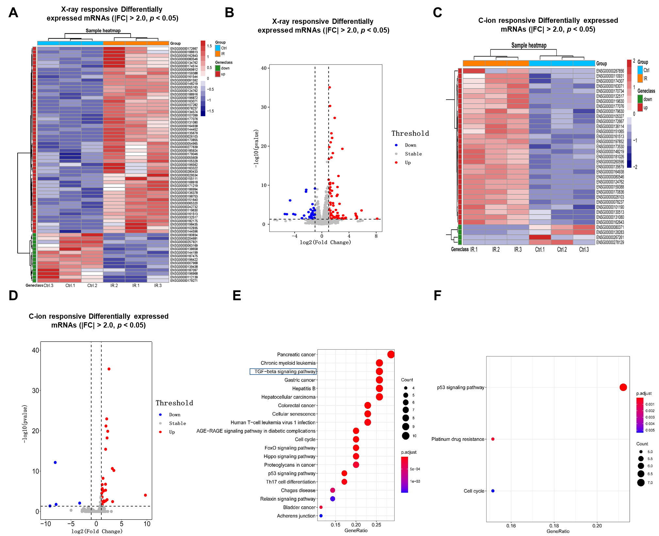
Fig. S1: Irradiation-induced differentially expressed mRNAs in NSCLC cells. A&C, the heat map shows the differentially expressed mRNAs of X-ray (A) or C-ion irradiated (C) NSCLC tumor cell samples (p < 0.05, FC > 2.0). B&D, Volcano plot displays the significantly up-regulated and down-regulated that as described in (A and C) after irradiation. Blue and red dots indicated genes that were significantly changed (p < 0.05, FC > 2.0). E&F, KEGG analysis of the differentially expressed mRNAs in X-ray (E) or C-ion (F) irradiated cells.

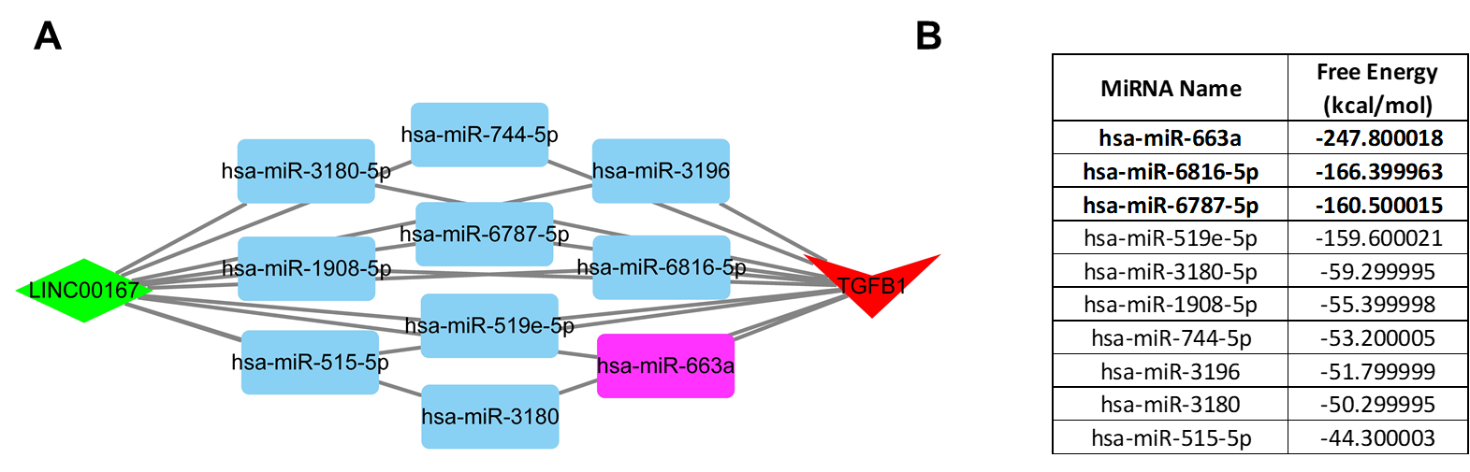
Fig. S2: The predicated ceRNA network between LINC00167 and TGF-β1. A, The ceRNA network between LINC00167 and TGF-β1 was predicated with ENCORI and drawn by Cytoscape. B, The minimal binding free energy between LINC00167 and the predicated miRNAs was calculated with RNAhybrid.

