Supplementary Figure 1. Trends in the discrimination performance according to the age and standardised upper lobe-volume
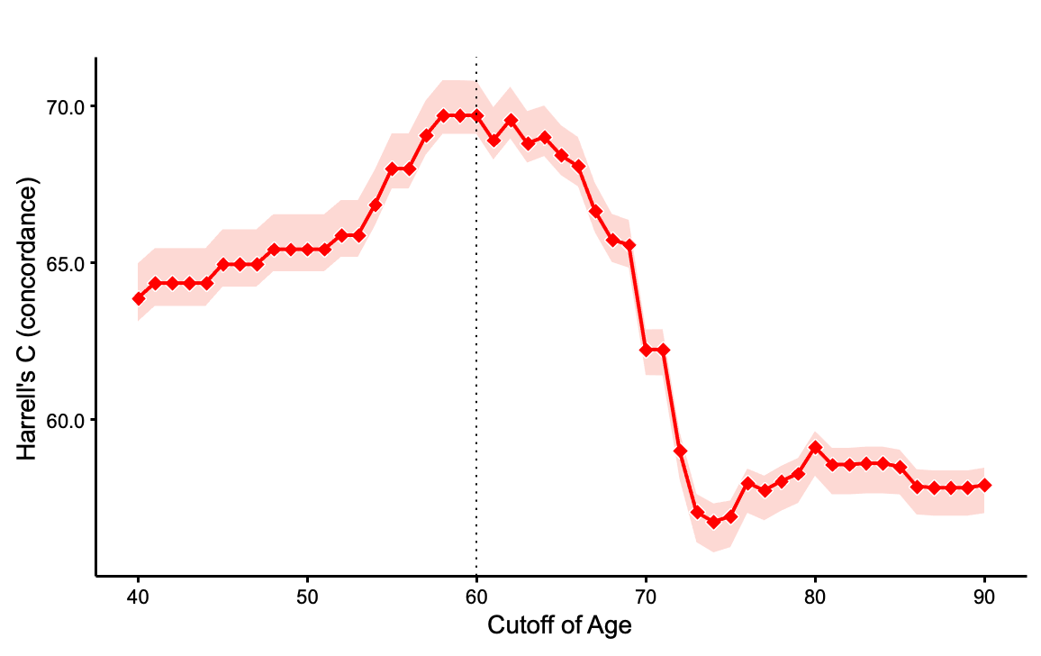
Trends in the discrimination performance (C-index) by age, sex and standardised upper lobe-volume for mortality. The C-index values at each age is shown. The box plots indicate the distributions of the C-index acquired using leave-one-out analysis, and the dotted line represent the maximum and minimum values at each point.

