Breaking the voltage hysteresis of conversion electrodes for high energy batteries

Haosheng Li^{1,#}, Yufan Xia^{1,#}, Xuan Zhang^{1,#}, Keshuang Cao¹, Wenping Sun¹, Zhu Liu¹, Yue Lin³, Zhiyu Lu⁴, Jie Ma⁵, Chin-Wei Wang^{6,7}, Hongge Pan^{1,2,}* Ben Bin Xu⁸, Mi Yan^{1,}*, Yinzhu Jiang^{1,}*

¹ School of Materials Science and Engineering, ZJU-Hangzhou Global Scientific and Technological Innovation Center, Zhejiang University, Hangzhou 310027, China
² Institute of Science and Technology for New Energy, Xi'an Technological University, Xi'an 710021, China
³ Hefei National Research Center for Physical Sciences at the Microscale, University of Science and Technology of China, Hefei 230026, China
⁴ School of Chemistry and Materials Science, University of Science and Technology of China
⁵ Key Laboratory of Artificial Structures and Quantum Control, School of Physics and Astronomy, Shanghai Jiao Tong University, Shanghai 200240, China
⁶ Neutron Group, National Synchrotron Radiation Research Center, Hsinchu 30076, Taiwan
⁷ Australian Nuclear Science and Technology Organization, Lucas Heights, NSW 2232, Australia
⁸ Department of Mechanical and Construction Engineering, Faculty of Engineering and Environment, Northumbria University, Newcastle upon Tyne NE1 8ST, UK

*Corresponding authors: yzjiang@zju.edu.cn (Y. Jiang)
honggepan@zju.edu.cn (H. Pan)
mse_yanmi@zju.edu.cn (M. Yan)

Methods
Preparation of cathode
Iron fluoride (FeF₃, Aladdin, 97%), Copper fluoride (CuF₂, Aladdin, 99.5%), Poly (vinylidene fluoride-co-hexafluoropropylene) (PVDF-HFP, Macklin, melt index:9-15 g/10 min), Polyethylene oxide (PEO, Aladdin, average Mv ~600,000), Polyethylenimine (PEI, Macklin) and bis(trifluoromethylsulfonyl)imide (LiTFSI, Macklin, 99.9%) were purchased as raw materials. The active powder CuF₂@C was obtained by ball milling the raw material CuF₂ and super P in a mass ratio of 8:2 at 400 r/min for 12 h. The active powder FeF₃@C was obtained by ball milling the raw material FeF₃ and super P in a mass ratio of 8:2 at 400 r/min for 12 h. All cathodes were made by a traditional slurry-coating way where active powder, super P, and poly-(vinylidene fluoride) (PVDF) binder were ground at a mass ratio of 70:20:10 and then homogenized in n-methyl-2-pyrrolidone (NMP) at a speed of 4000 rpm in a micro homogenizer (MSK-SFM-12M) for 10 minutes. The slurry was then bladed on Al foil to render uniform coating, which was further dried in a vacuum oven at 100 °C for at least 24 h and the cathode mass loading was around 0.5-1 mg cm⁻².
Sintering of solid electrolyte pellet
Sodium carbonate (Na₂CO₃, 99%), zirconia (ZrO₂, 99.99%), silicon dioxide (SiO₂, 99.5%), Ammonium dihydrogen phosphate (NH₄H₂PO₄, 99%) were purchased from Macklin. Firstly, the stoichiometric Na₂CO₃, ZrO₂, SiO₂, and NH₄H₂PO₄ were mixed in the zirconia jars. Secondly, all powders were ball milled in the ethanol with zirconia balls for 12 h, rotary speed of 400 rpm. These mixtures were dried at 80 °C in a vacuum oven for 12 h. Finally, the powders were calcined at 1000 °C for 6 h with a heating rate of 5 °C/min to form precursors.
The milled powder was pressed for disk-shaped pellets (16 mm in diameter and 1.2 mm in thickness) at around 150 MPa for 5 min. The green pellets were calcined at 1240 °C for 6 h with a heating rate of 5 °C/min to form Na₃Zr₂Si₂PO₁₂ (NZSP) pellet.
Li_{1.5}Al_{0.5}Ge_{1.5}(PO₄)₃ (LAGP) powder was bought from Hubei Solid New Energy Technology Co., Ltd and pressed as a pellet, then the green pellet was calcinated at 900 °C for 10 h with a heating rate of 5 °C/min to form LAGP pellet.
Assembly of semi-solid-state batteries
Preparation of polymer interface layers (PILs) was conducted in an argon-filled glovebox. The different PILs were composed of different polymers and LiTFSI salts.
Among them, PIL-PVDF-HFP was prepared by dissolving PVDF-HFP and LiTFSI in N,N-dimethylformamide (DMF) solvent at a mass ratio of 2:1 to make a solution (the concentration of LiTFSI is about 7.0 *10⁻² mol/L), and then coating ~30 μL solution on the positive electrode side by drop coating and heating at 80 °C for 5 h to remove DMF to get PIL.
PIL-PEI was prepared by dissolving PEI and LiTFSI in DMF solvent at a mass ratio of 2:1 to make a solution, and then coating the solution on the positive electrode side by drop coating.
When PILs were used in sodium semi-solid battery systems, only LiTFSI was replaced with NaClO₄, and the rest of the preparation process was the same.
The semi-solid-state batteries were assembled in an argon-filled glovebox. The sodium semi-solid-state batteries (SSSBs) were made with a Na-metal anode, NZSP electrolyte, and a CuF₂ cathode with PIL coated. The liquid electrolyte was composed of 0.8 M NaClO₄ in the mixture solution of ethylene carbonate, diethyl carbonate, and propylene carbonate with a volume ratio of 4:4:2. ~5 μl of above electrolyte with the addition of 5 wt% fluoroethylene carbonate is used to wet the positive side interface. The lithium semi-solid-state batteries (LSSBs) were made with a Li-metal anode, LAGP electrolyte, and a CuF₂ cathode with PIL coated. The liquid electrolyte was composed of 1 M LiTFSI or 0.8 M LiClO₄ in the mixture solution of ethylene carbonate, diethyl carbonate, and propylene carbonate with a volume ratio of 4:4:2. ~5 μl of above electrolyte with the addition of 5 wt% fluoroethylene carbonate is used to wet the positive side interface ⁽¹⁾.
Electrochemical tests
The battery test system (Neware BTS-5) was used to conduct galvanostatic measurements of the batteries. All batteries testing was performed using CR-2032 coin-type batteries in a voltage window of 2-4.1 V for LSSB at 35 ºC (308.15K)/60 ºC (333.15K) and 1.7-4 V for SSSB at 30 ºC and 35 ºC. The cyclic voltammetry (CV) curve and electrochemical impedance spectroscopy were obtained by employing a CHI660C electrochemical workstation.
The current density of the galvanostatic intermittent titration technique (GITT) tests was 42 mA g⁻¹, the duration time of each current pulse was 30 minutes, and the resting time was 10 h for CuF₂.
Characterization
Phase structures of the as-prepared materials were investigated by X-ray diffraction (XRD) on a Bruker D8 diffractometer (equipped with Cu-Kα radiation) with a scan range of 10-80°.
In situ XRD data in Figure S10b were collected using a homemade in situ XRD cell, which is a button battery with a hole in the positive electrode and sealed with Kapton tape. The structure of it is shown in Figure S10a.
In situ XRD data in Figure S30 were collected using an in-situ cell (further information about the cell design can be obtained at http://www.bjscistar.com) with an X-ray transparent beryllium window.
Neutron Powder Diffraction: The measurements were performed on the High Resolution Powder Diffractometer(λ=2.4395(2) Å)⁽²⁾, ECHIDNA at the Australian Nuclear Science and Technology Organisation (ANSTO). The neutron powder diffraction (NPD) patterns were collected at the temperature of ~300 K. All diffraction patterns were refined using the FullProf program.
Scanning electron microscopy (SEM, Hitachi S-4800) and Transmission electron microscopy (TEM, FEI Tecnai G2 F20) measurements were employed to characterize the morphology and microstructure of samples. Low-magnification HAADF-STEM images were collected from spherically corrected transmission electron microscope (FEI Titan G² 80-200 ChemiSTEM). High-resolution transmission electron microscopy (HRTEM) images were collected from Talos F200S. Atomic resolution HAADF-STEM images and electron energy loss spectroscopy (EELS) mapping spectra were obtained from probe aberration-corrected JEM ARM200F (S) TEM and aberration-corrected *JSM-IT500HR/*JSM-IT500HR TEM operated at 200 kV.
Energy dispersive spectroscopy (EDS) mappings were carried out on FEI Talos F200X and Talos F200X S/TEM. Molybdenum grid was used to replace Cu support film when samples containing Cu elements for element analysis.
X-ray photoelectron spectroscopy (XPS) was recorded on Escalab250Xi and Thermo ESCALAB 250XI X-ray photoelectron spectrometer.
The solid-state Nuclear Magnetic Resonance (ss-NMR) one-dimensional (1D) ¹⁹F direct polarization (DP) experiments were measured with Bruker AVANCE NEO 500WB spectrometer with a 1.3 mm HXY magic-angle spinning (MAS) probe in double-resonance mode tuned to ¹⁹F frequencies. All ¹⁹F spectra were carried out at 298 K and processed in Bruker TopSpin software. ¹⁹F Larmor frequency of 470 MHz, with a spinning frequency of 20, 40, and 60 kHz, respectively. Spectra were referenced to the external standard LiF at −204 ppm.
Electron Paramagnetic Resonance (EPR) spectra were recorded at room temperature, in continuous-wave mode, EPR200M (CIQTEK, China), at mw power of ~0.1 mW. The field was modulated at 100 kHz with an amplitude of 2 G. The micro frequency was typically 9.57 GHz and a Bruker strong pitch (g = 2.0028) reference was used as a calibrator.
The Raman analysis was performed with a Raman spectrometer (LabRaAM HR Evolution) with an excitation wavelength of 532 nm.
Synchrotron X-ray absorption spectroscopy (XAS): For the sample during the discharge process, Cu K-edge XAS measurements were performed at the 4B9A beamline⁽³⁾ of BSRF under ring conditions of 2.2 GeV and about 80-mA. A Si (111) double-crystal monochromator was used for energy selection, and the sample data was collected in fluorescence mode. While data on the standard (i.e., Cu foil) was collected in transmission mode. The spectrometer energy resolution was approximately 1.4 eV, which gives an overall energy resolution of about 1.5 eV at the Cu K-edge, including core-hole effects. Energy calibration was performed by simultaneous measurement of the absorption edge of a Cu foil, i.e., referencing to energy shift between the maximum of the first peak in the derivative spectrum of a pure Cu foil and the Cu K-edge reference energy (8979 eV).
For the samples during the charge process. All XAS measurements were performed in transmission mode. The measurements performed at the Institute of Science and Technology for New Energy, Xi’an Technological University used a laboratory-based X-ray absorption spectrometer. The measurements performed at easyXAFS used a similar instrument easyXAFS300 employing an Ag anode and operated at ≈1200 W power (40 kV and 30 mA). All EXAFS measurements were performed at easyXAFS.
Each XAFS scan spanned the energy range from 100 eV below the Cu K-edge to 150 eV above edge for XANES and up to k = 12 from edge for the EXAFS analysis. All measurements were calibrated using the first derivative of a Cu foil reference. Data processing was carried out using the Athena and Artemis software.
Wavelet transform (WT) analysis of the experimental EXAFS spectra:
Wavelet transform of a given signal χ(k) is defined as⁽⁴⁾:
${\text{W}}_{\text{f}}^{\text{Ψ}}\left(\text{a,}{\text{k}}^{\text{'}}\right)\text{=}\frac{\text{1}}{\sqrt{\text{a}}}\int_{\text{-∞}}^{\text{+∞}}{\text{χ}\left(\text{k}\right)\text{Ψ}\left(\frac{\text{k-k'}}{\text{a}}\right)}\text{dk}$ (1)
where the scalar product of the EXAFS signal, and the complex conjugate of the wavelet ψ(k) is calculated as a function of a and k'; a is the parameter connected with R and k' conform to localization of wavelet function in k space. In this work we use the WT based on the Morlet wavelet functions:
$\text{Ψ}\left(\text{k}\right)\text{=}\frac{\text{1}}{\sqrt{\text{2π}}\text{σ}}{\text{e}}^{\text{iηk}}{\text{e}}^{\text{-}{\text{k}}^{\text{2}}\text{/2}{\text{σ}}^{\text{2}}}$ (2)
These parameters should be adjusted to get appropriate resolution in k- an R-space. For providing better quality WT images, we used modified WT functions, where parameters σ and η correspond to width and frequency of the wavelet function, respectively. Here, to better observe the atomic information of the second shell, σ=10 and η=1.
First-principle calculations
The Vienna Ab-initio Simulation Package (VASP)^{(5, 6)}, which implements density functional theory (DFT) with a GGA-PBE functional⁽⁷⁾, was used for first-principle calculations. The projector-augmented-wave (PAW) method was used to describe core electrons⁽⁸⁾. The valence electrons of Cu, Fe, F, O, N, and C atoms were Cu: 3d¹⁰4s¹, Fe: 3d⁶4s², F: 2s²2p⁵, O: 2s²2p⁴, N: 2s²2p³, C:2s²2p². The plane waves of kinetic energy were set to 400 eV. In this study, bulk Cu, CuF, and CuF₂ crystal structures were simulated within space groups Fm$\overline{\text{3}}$m (Face-Centered Cubic), F$\overline{\text{4}}$3m (Face-Centered Cubic), and P2₁/c (Monoclinic), respectively. For surface configurations, the slabs of Cu (011), CuF (011), CuF₂ (011), Fe (110), FeF₂ (110), and FeF₃ (012) were considered in adsorption calculations. Polymer adsorbates (PVDF-HFP and PEI) are generally made of rather long polymer chains, while, in our adsorption models, we only consider the 1,1-difluoroethylene + hexafluoropropylene and ethyleneimine as repeating units of PVDF-HFP and PEI, respectively. For the protonation behavior of PEI, the secondary amine is protonated by adding an extra H⁺ to the ethyleneimine in our calculations. The DFT+U method was employed to treat localized Cu 3d and Fe 3d orbits. The effective single parameters U−J of 4.0 and 5.2 eV were set for Cu and Fe in fluoride based on previous DFT studies. ^{(9, 10)} Spin-polarized total energy calculations and structure relaxations were performed. For surface geometry optimization, the first Brillouin zone was sampled using a grid of 2 × 2 × 1 Γ-centered mesh k-point because of the supercell. Dispersion interactions were taken into account using Grimme’s method (DFT-D3)⁽¹¹⁾ to consider the interactions between slab atoms and the adsorbed molecules. CuF_{x} (x = 0-2) and FeF₂ surface slabs are made of eight atomic layers, with the bottom four layers fixed to describe the bulk properties, and there are six layers of atoms on the surface of Fe and FeF₃, the slabs of Fe and FeF₃ are fixed with three and four atomic layers respectively. Then, 15 Å vacuum layers were chosen to simulate all adsorption models. The atoms were relaxed until the energy converged smaller than 10⁻⁶ eV. Meanwhile, all atomic coordinates and lattice parameters are fully relaxed until the force convergence of 0.02 eV/Å.
Correspondingly, phonon dispersion curves were calculated with the PHONOPY code⁽¹²⁾ using the finite displacement method. VESTA⁽¹³⁾ and VMD⁽¹⁴⁾ were employed to display all crystal structures and the post-processing VASPKIT code⁽¹⁵⁾ was used to deal with the VASP-calculated data.
The adsorption energy (${\text{E}}_{\text{ads.}}$) between the slab and various adsorbed molecules was calculated using the following equation:
${\text{E}}_{\text{ads.}}\text{=}{\text{E}}_{\text{(slab+molecules)}}\text{-}{\text{E}}_{\text{slab}}\text{-}{\text{E}}_{\text{molecules}}$ (3)
where ${\text{E}}_{\text{(slab+molecules)}}$ was the total energy of the adsorption structures. ${\text{E}}_{\text{slab}}$ and ${\text{E}}_{\text{molecules}}$ were the energy of the surface and the adsorbate configurations, respectively. Noticeably, negative adsorption energy indicates a spontaneous exothermic process.
In Bader charge analysis, we counted all Bader charge changes of Cu atoms on the surfaces of Cu, CuF, and CuF₂ respectively according to the following equation:
$$\text{△}\text{Q=}{\text{Q}}_{\text{ads.}}\text{-}{\text{Q}}_{\text{surface}}$$
where $Q_{ads.}$ was the surface Cu atoms Bader charge of the adsorption structures with adsorbates. $Q_{surface}$ was the pristine surface Cu atoms charge of the surface structures without polymer adsorbates. Considering that the PILs have an influence on the Cu-F coordination in the upper four layers of the fluoride, we counted the Bader charges of the Cu atoms in the top four layers for CuF (011) and CuF₂ (011) slabs, and the Bader charges of the Cu atoms in the top layer for Cu (011) slab, respectively.

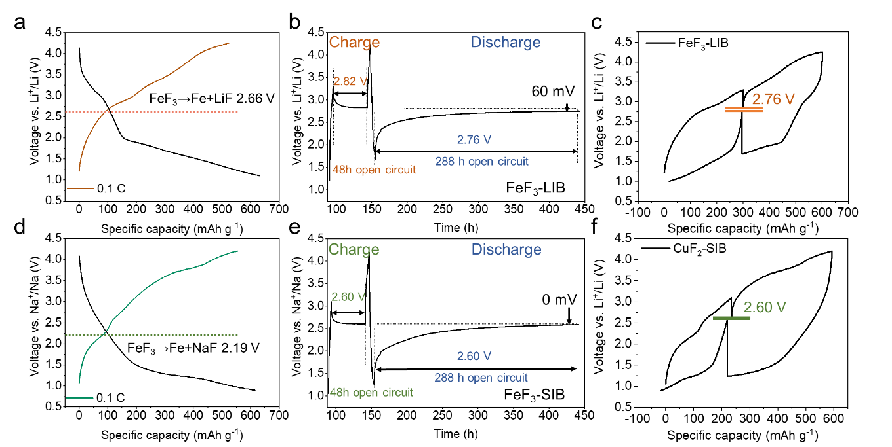
Figure S1. Relaxation experiment studies on several conversion electrode materials. Galvanostatic charge-discharge (GCD) profiles and relaxation experiment analysis of (a-c) FeF₃ lithium-ion battery (LIB) and (d-f) FeF₃ sodium-ion battery (SIB). For FeF₃ LIB, the electrode was relaxed for 48 h in the charged state (~Li 1.2) and relaxed for 288 h in the discharged state (~Li 1.2). For FeF₃ SIB, the electrode was relaxed for 48 h in the charged state (~Na 1.0) and relaxed for 288 h in the discharged state (~Na 1.0). All results indicate that voltage hysteresis can be significantly eliminated after a sufficiently long relaxation time.

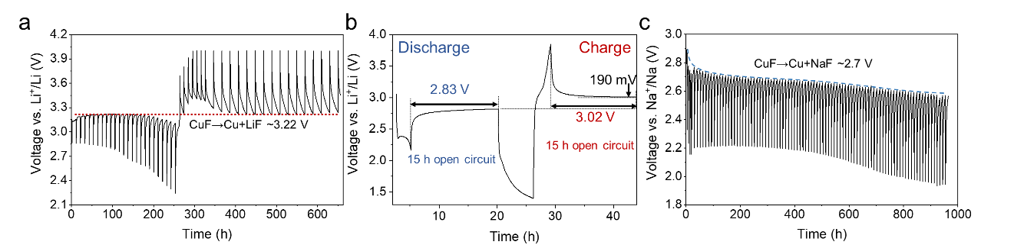
Figure S2. GITT curves of CuF₂ for (a) LIB and (b,c) SIB with liquid electrolyte. After relaxation, both CuF₂ SIB and LIB with liquid electrolyte exhibited a trend of approaching the equilibrium voltage of CuF.
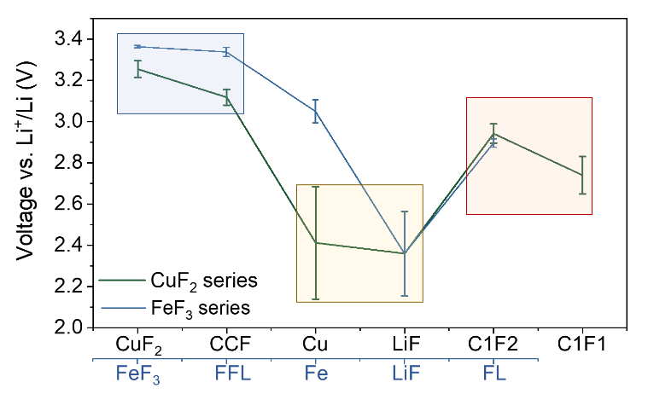
Figure S3. Open-circuit voltage statistics for different product ratios of several transition metal compounds (CCF means the molar ratio of CuF₂: Cu: LiF = 1: 1: 2; FFL means the molar ratio of FeF₃: Fe: LiF = 1: 1: 3; C1F2 means the molar ratio of Cu: LiF = 1: 2; C1F1 means the molar ratio of Cu: LiF =1: 1; FL means the molar ratio of Fe: LiF = 1: 1).
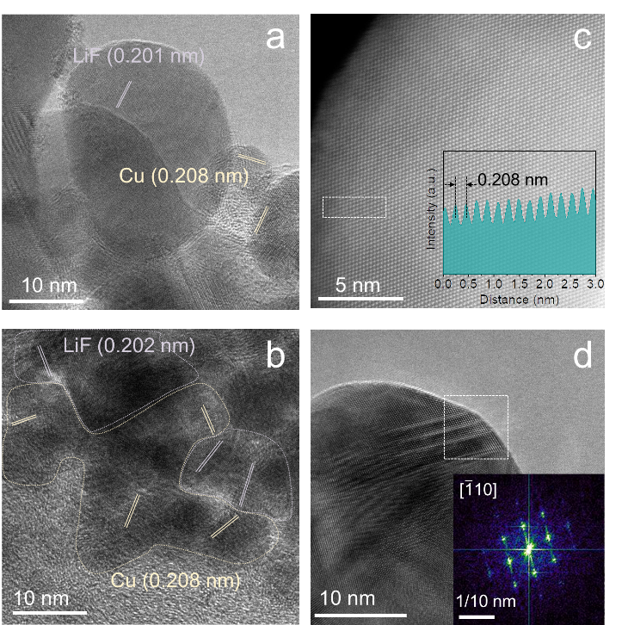
Figure S4. (a, b) HRTEM images of the intermediates at the surface of the CuF₂ electrode in the discharged state (~Li 1.0). (c) HAADF-STEM image of spherical Cu nanoparticles at the surface of the CuF₂ electrode in the discharged state (~Li 1.0). (d) HRTEM image of the spherical Cu nanoparticles.
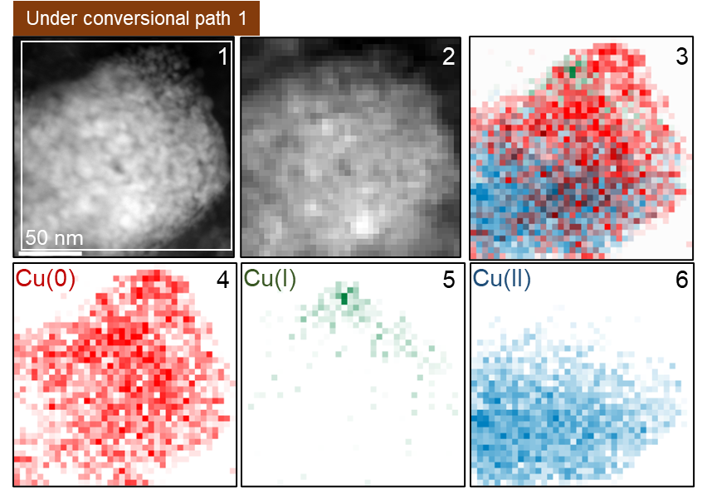
Figure S5. Spatial distribution of Cu element with different valence states under the conversional path 1. EELS mappings of Cu value state of the active particle of CuF₂ electrode without PIL-PVDF-HFP in the discharged state (~Li-1.0). Among them, Cu(I) is mainly distributed in the outer layer of the particles.

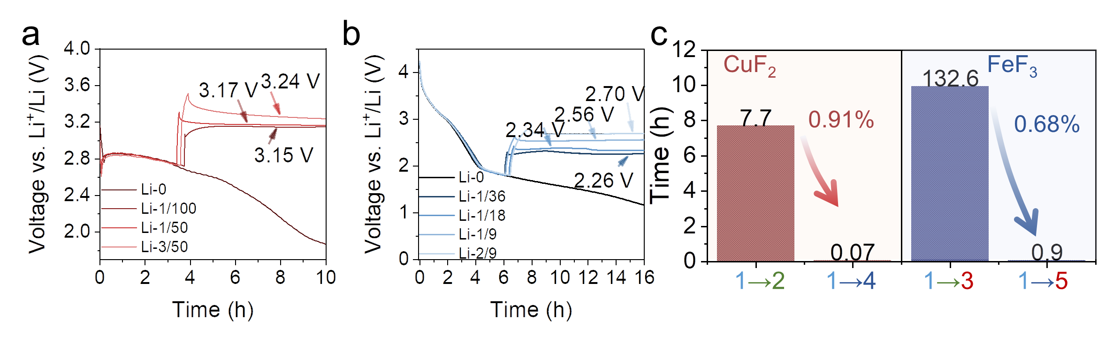
Figure S6. Relaxation and reverse charging experiments. (a) Voltage-time curve of CuF₂ LIB after reverse charging for different times when discharging to 2.7 V. (b) Voltage-time curve of FeF₃ LIB after reverse charging for different times when discharging to 1.8 V (the reverse charging process is a constant current charging process, which can be understood as delithiation. The legend marked (Li-x) is the degree of delithiation of charge, x is the degree of lithiation (theoretical capacity is Li-2.0 for CuF₂ and Li-3.0 for FeF₃), and (c) the corresponding statistical results. (1→2 means relaxation of CuF₂; 1→4 means reverse charging of CuF₂;1→3 means relaxation of FeF₃; 1→5 means reverse charging of FeF₃).
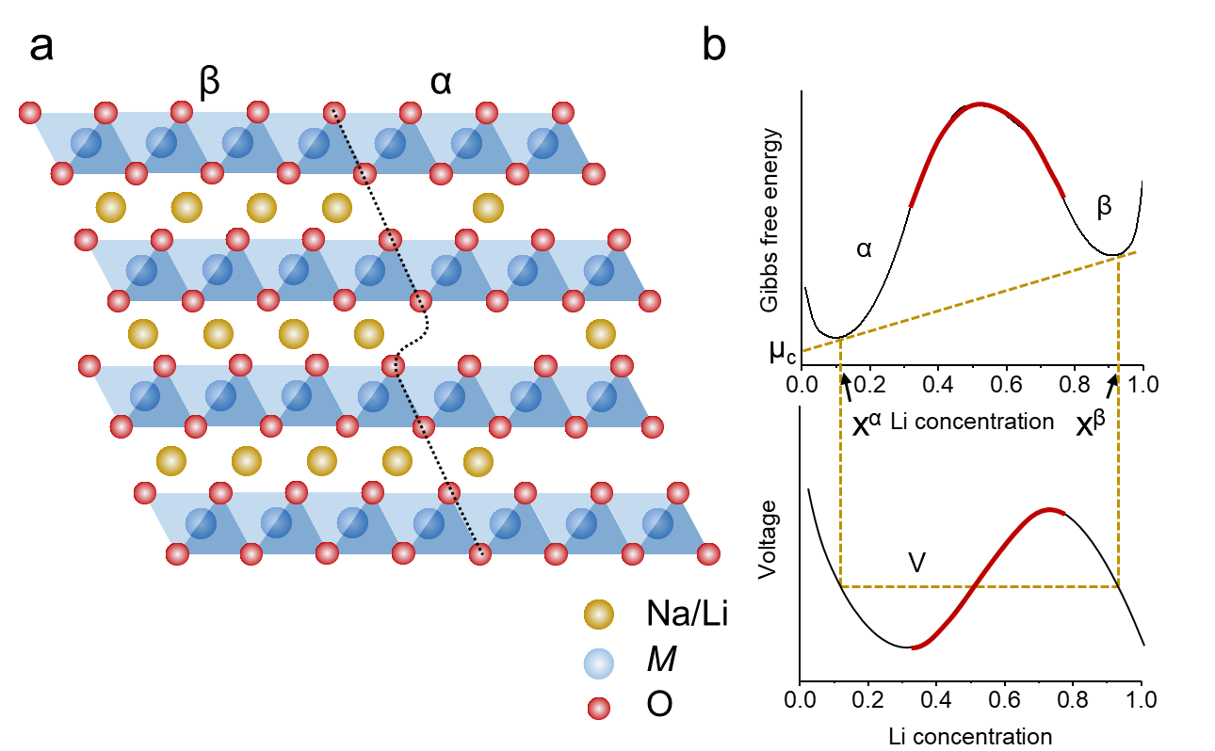
Figure S7. (a) Schematic diagram of the intercalation-type cathode phase transition, consisting of the conversion between the lithium-rich phase β and the lithium-poor phase α and (b) the corresponding simplest free energy and voltage curve schematic diagram.

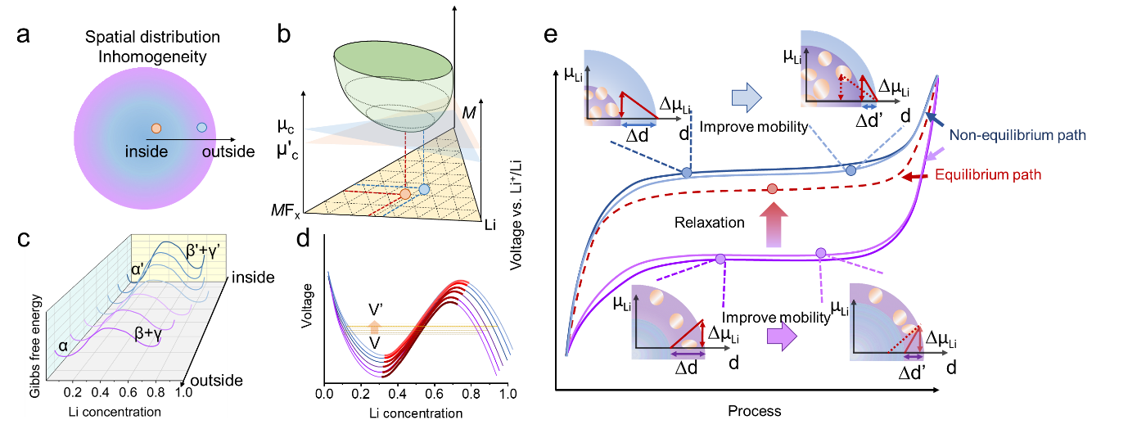
Figure S8. Schematic diagram of the conversion-type electrode phase transition. (a) Schematic diagram of the spatial distribution of the phase composition during the discharge process. (b) The corresponding lithium chemical potential in different regions of the ternary phase diagram. Schematic diagram of simplified (c) free energy curve and (d) voltage curve of electrode active particles from the outside in. (e) Schematic diagram of the origin of voltage hysteresis of the conversion reaction, which indicates that voltage hysteresis is due to the difference in equilibrium half-reaction caused by the uneven spatial distribution of reaction products. This provided a plausible picture of the ineffectiveness of traditional kinetic optimization strategies: that is, the improvements in kinetics accelerate the diffusion of Li, Cu, and F, but the driving force for Li, Cu, and F diffusion requires differences in chemical potential⁽¹⁶⁾ caused by the inhomogeneity, which means that the inhomogeneity elimination by the diffusion of Li, Cu and F always lags behind the new inhomogeneity generated by the reaction.
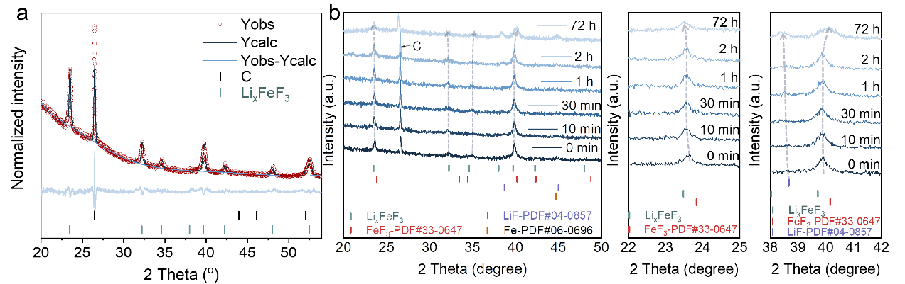
Figure S9. (a) Rietveld refinement of XRD pattern of FeF₃ electrode in the discharged state of ~Li-1.0; (b) In-situ XRD patterns of FeF₃ electrode in the discharged state of ~Li-1.0 during the relaxation process and its magnification patterns. The FeF₃ electrode in the discharged state exhibits the previously reported Li_{x}FeF₃ phase⁽¹⁷⁾. After different relaxation times, the structural transition during the relaxation process can be observed. In detail, with the progress of the relaxation process, the intermediate products Li_{x}FeF₃ phase and the final products of the conversion reaction, LiF and Fe, are gradually produced, and the carbon peak shifts to a low angle, indicating that the crystal plane spacing and degree of graphitization slightly increase⁽¹⁸⁾.

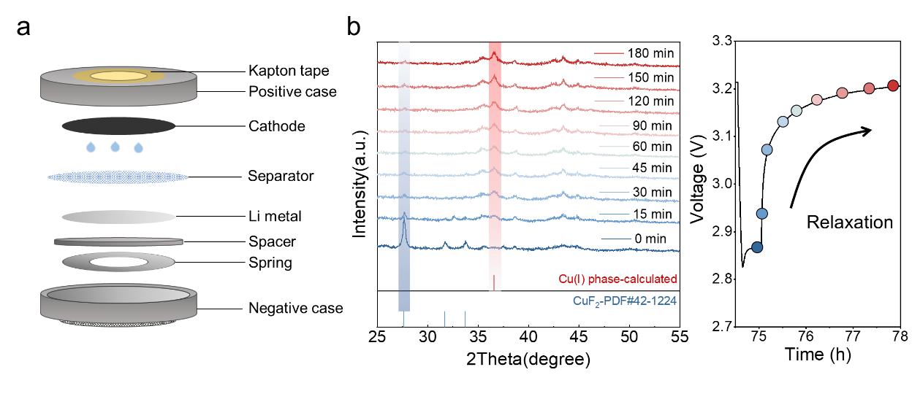
Figure S10. (a) Schematic diagram of a homemade in situ XRD cell. (b) In situ XRD pattern of the relaxation process of CuF₂ LIB in discharge state (~0.5 Li), the phase structure changed from Cu(II) phase to Cu(I) phase-calculated (Cu(I)F and Li₃Cu(I)F₄ phases can be obtained from Figure S11 d,e).
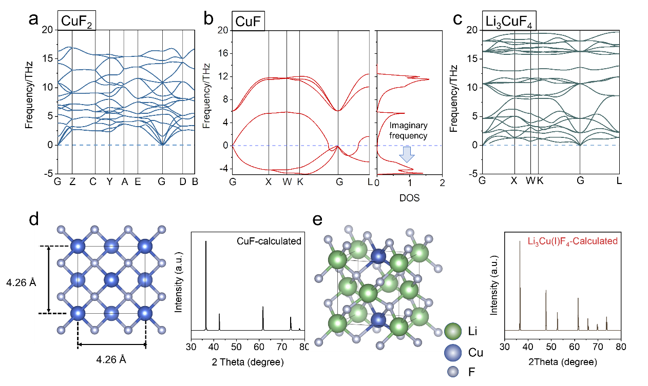
Figure S11. Phonon spectra of (a) Cu(II)F₂, (b) Cu(I)F and (c) Li₃Cu(I)F₄ based on finite displacement method from DFT calculations. Obvious imaginary frequencies from Cu(I)F phonon spectrum could be observed, indicating that its crystal was thermodynamically metastable. (d,e) The structure of CuF phase and Li₃Cu(I)F₄ phase and their corresponding XRD results.

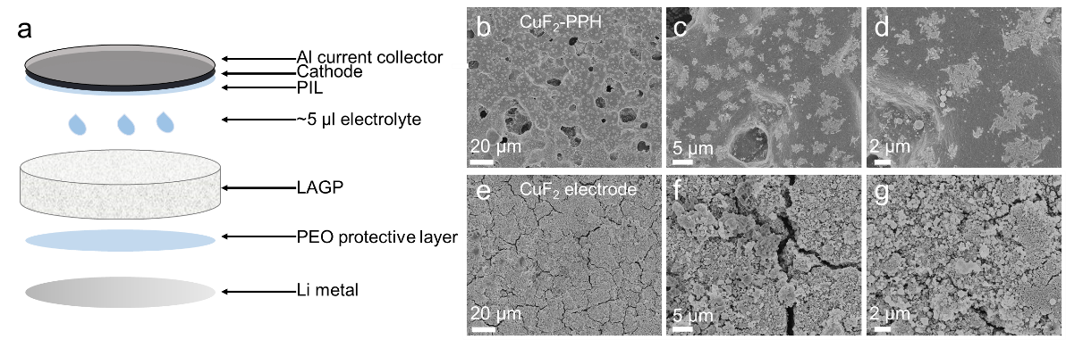
Figure S12. (a) Schematic diagram of the cell’s internal structure. SEM images of (b-d) CuF₂ with PIL-PVDF-HFP (CuF₂-PPH) cathode and (e-g) CuF₂ cathode. A large number of cracks could be seen in the electrode, but after being coated with PIL-PVDF-HFP, the surface became flat and dense.

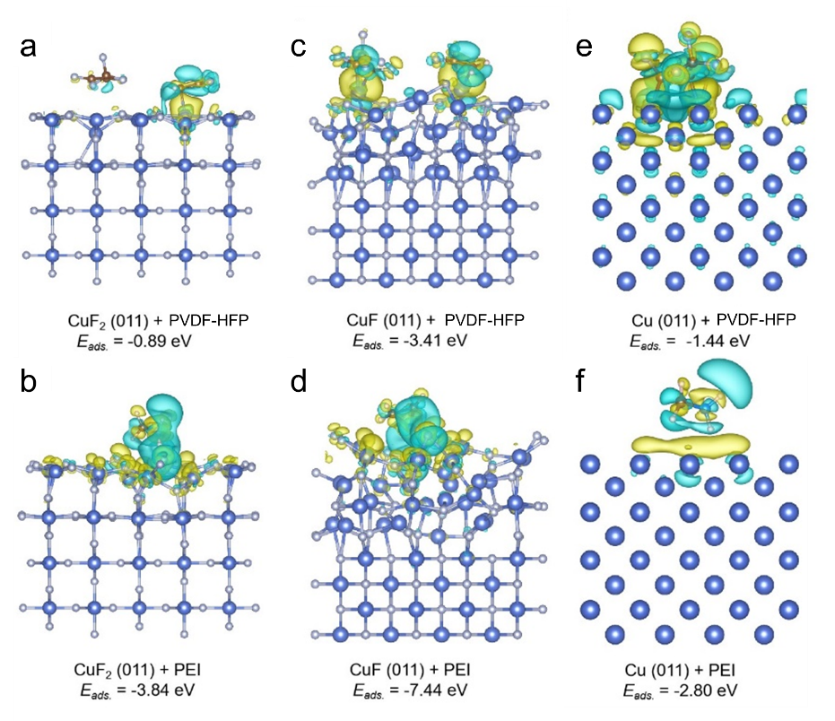
Figure S13. (a,b) The charge density difference plots of CuF₂ (011) surface with PVDF-HFP and PEI. (c,d) The charge density difference plots of CuF (011) surface with PVDF-HFP and PEI. (e,f) The charge density difference plots of Cu (011) surface with PVDF-HFP and PEI. (isovalue=1×10⁻³ e Bohr⁻³, yellow and cyanine semi-transparent clusters represent increase and decrease of electron density, respectively.)

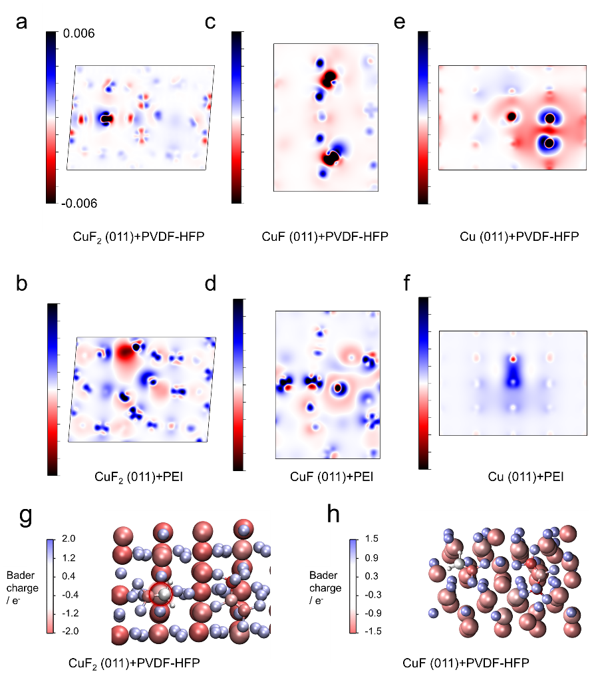
Figure S14. Top view of the images of the 2D surface slice charge difference density. (a,b) The 2D surface slice charge difference density mappings of CuF₂ (011) surface with PVDF-HFP and PEI, (c,d) The 2D surface slice charge difference density mappings of CuF (011) surface with PVDF-HFP and PEI, (e,f) The 2D surface slice charge difference density mappings of Cu (011) surface with PVDF-HFP and PEI. (blue and red represent the increase and decrease of electron density, respectively). Bader charges analysis mappings of PVDF-HFP with (g) CuF₂ (011) and (h) CuF (011) from DFT calculations (wathet blue and red represent gain and loss charge, respectively. Among them, the charge of surface Cu atoms increase on the surface of CuF₂ (011) marked by the red circle).
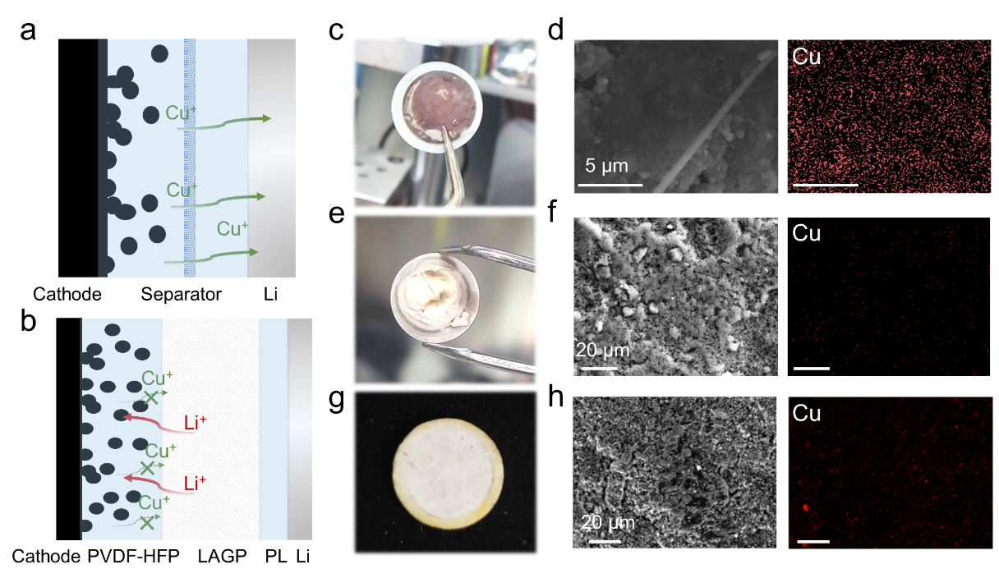
Figure S15. Schematic diagram of structure comparison between (a) CuF₂ LIB with liquid electrolyte and (b) CuF₂-PPH LSSB (PL means protective layer) after 5 cycles. (c) Optical photo and (d) EDS mapping of the negative side of the CuF₂ LIB with liquid electrolyte; (e) optical photo and (f) EDS mapping of the negative side of CuF₂-PPH LSSB; (g) optical photo and (h) EDS mapping of the solid electrolyte pellet corresponding to the positive side. The introduction of PVDF-HFP and semi-solid-state design can significantly inhibit the dissolution of copper and diffuse to the lithium metal anode.
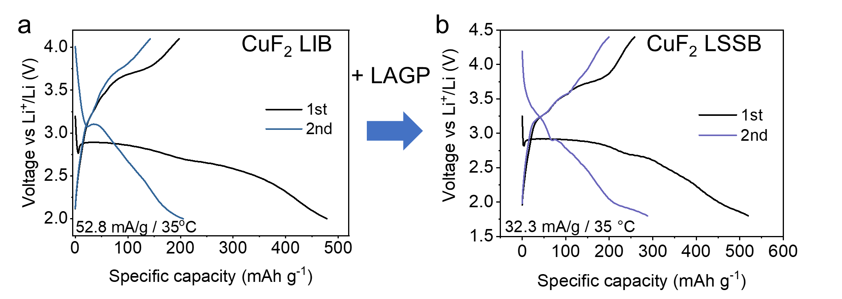
Figure S16. GCD profiles of (a) CuF₂ LIB without PIL and (b) CuF₂ LSSB without PILs.

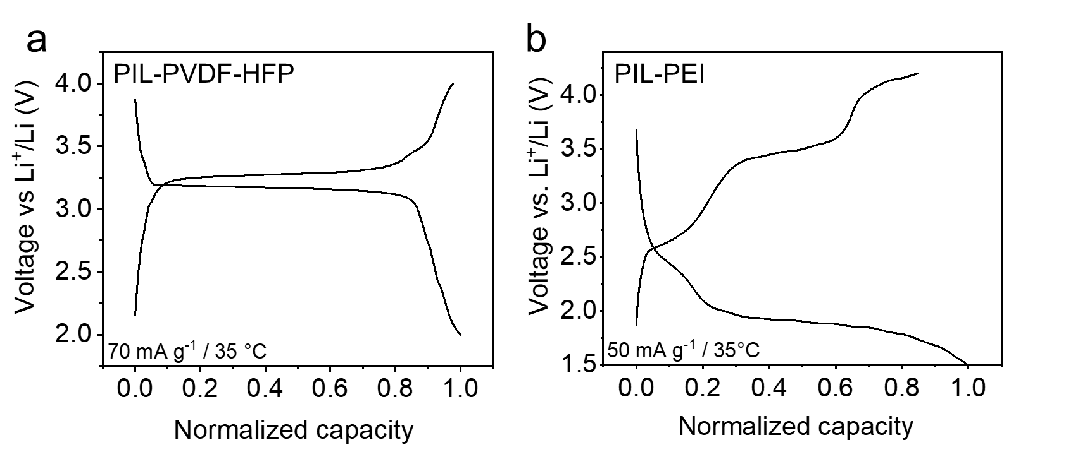
Figure S17. (a-c) GCD profiles of (a) CuF₂-PPH LSSB and (b) CuF₂ LSSB with PIL-PEI. Among them, CuF₂-PPH LSSB exhibited small voltage hysteresis, while CuF₂ LSSB with PIL-PEI exhibited huge voltage hysteresis.
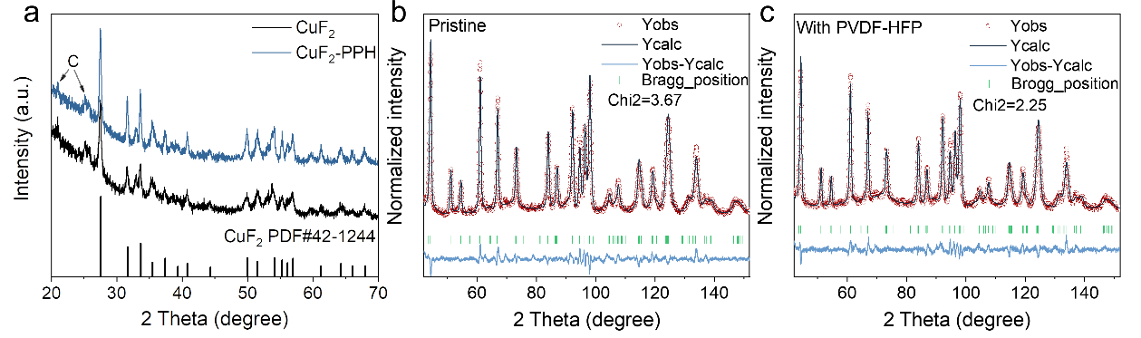
Figure S18. (a) XRD patterns of pure CuF₂ powder and CuF₂-PPH; the neutron powder diffraction (ND) patterns of (b) pristine CuF₂ powder and (c) CuF₂-PPH, showed that the crystal structure of CuF₂ remained unchanged after composited with PVDF-HFP.

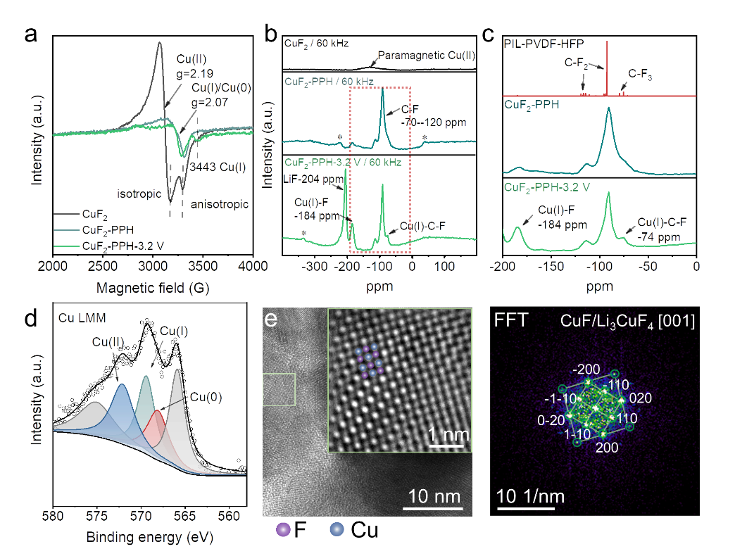
Figure S19. (a) EPR spectra of CuF₂, CuF₂-PPH and CuF₂-PPH in the half-discharged state (~3.2 V) (CuF₂-PPH-3.2 V). (b) NMR spectra of CuF₂, CuF₂-PPH and CuF₂-PPH-3.2 V (sidebands are marked with asterisks), and (c) its partial magnification (x-axis range: -200--100), in which the PIL-PVDF-HFP spectrum indicates that the peaks in the range -70--120 ppm come from C-Fx; (d) XPS Augar spectra of CuF₂-PPH LSSB in the discharged state (~3.2 V). (e) HRTEM image of Cu(I)F phase and its FFT result.

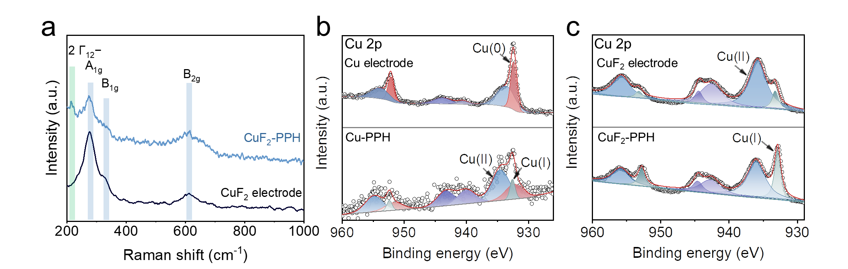
Figure S20. (a) Raman spectra of CuF₂ electrode and CuF₂-PPH. XPS spectra of (b) Cu electrode and Cu-PPH; (c) XPS spectra of CuF₂ electrode and CuF₂-PPH.

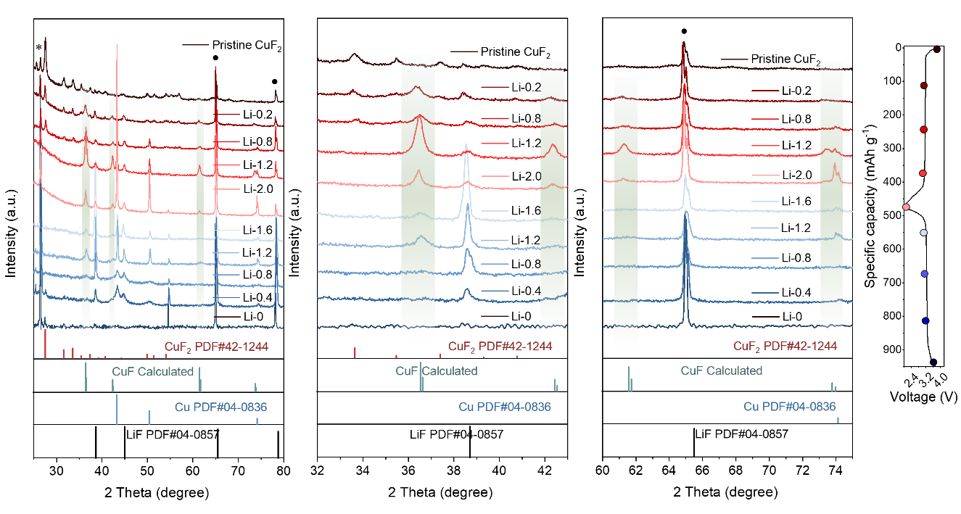
Figure S21. Ex situ XRD patterns of CuF₂-PPH LSSB in the new path during charge-discharge process and its magnification patterns (carbon is marked with an asterisk and aluminium is marked with black dot. The different charge/discharged states are represented by Li-x (x=0-2.0), where Li-2.0 represents a fully-discharged state in which the discharge capacity of the electrode reaches ~90% of the theoretical capacity).
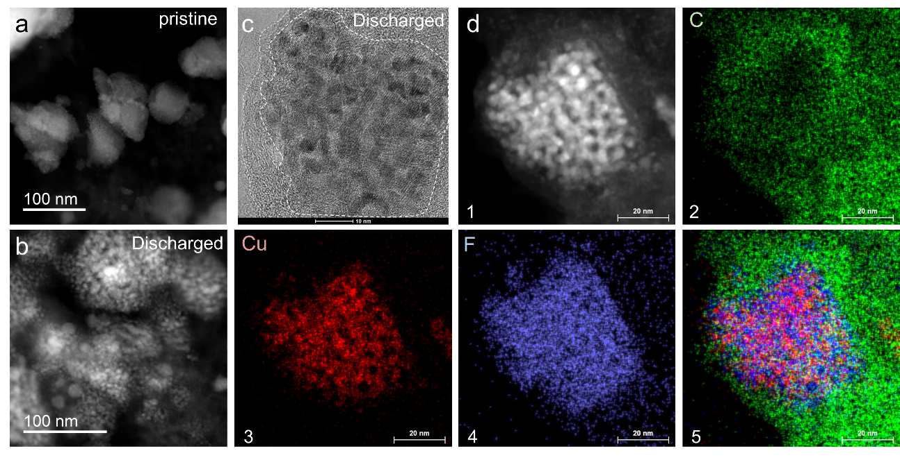
Figure S22. HAADF images of CuF₂ (a) in the pristine state and (b) the fully-discharged state. (c) TEM image of CuF₂ in the fully-discharged state. (d) HAADF images and EDS mappings of CuF₂ in the half-discharged state.

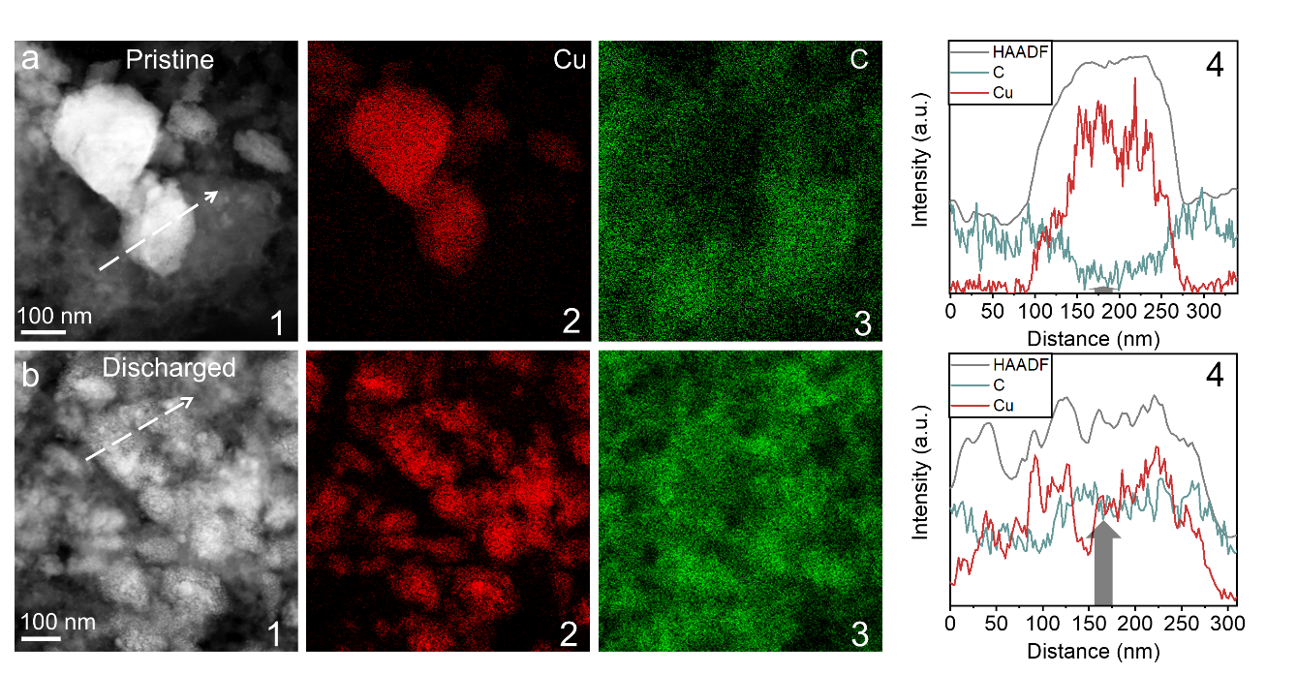
Figure S23. HAADF images and EDS mappings of CuF₂-PPH LSSB in the (a) pristine state and (b) fully-discharged state.
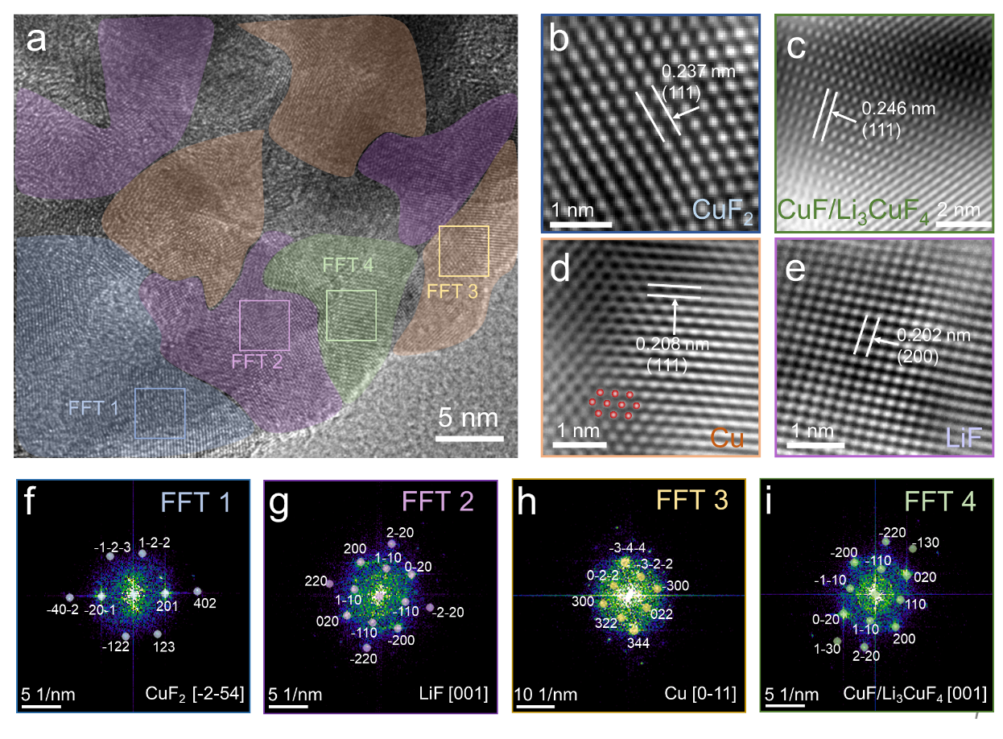
Figure S24. (a) HRTEM images of the new path of CuF₂-PPH LSSB in the discharged state (~Li 1.0). The distribution of the intermediate products was indicated by different color regions. There were mainly four kinds of products coexisting, i.e. (b) CuF₂ (blue region), (c) Cu(I) phase (CuF/Li₃CuF₄, green region), (d) Cu (orange region), and (e) LiF (purple region). (f-i) FFT results of the four intermediate products. Except for CuF₂, the other three phases are cubic, which also provides a structural basis for the conversion reaction.

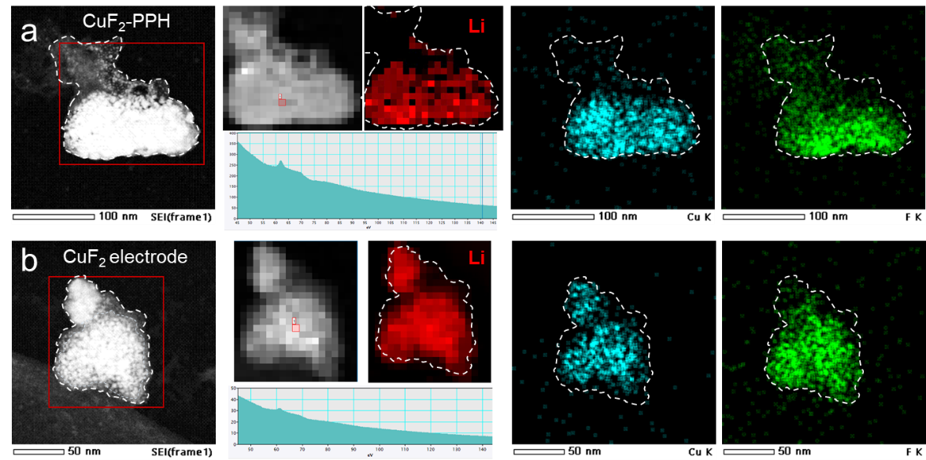
Figure S25. HAADF-EDS mappings and EELS mappings of (a) CuF₂-PPH LSSB and (b) CuF₂ LSSB in the discharged state (~Li 1.0). The shallow contrast was LiF-rich nanoparticles produced by the conversion reaction during the discharge process. In the absence of PIL-PVDF-HFP, the outside of the particles was LiF-rich phase, while more Cu was located inside the particles. On the contrary, the distribution of each element was relatively more uniform with PIL-PVDF-HFP.
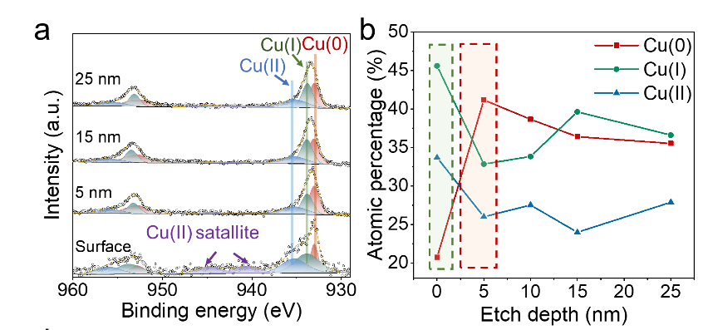
Figure S26. (a-b) XPS spectra of different etching depths of CuF₂-PPH LSSB electrodes in the discharged state (~Li 1.0).
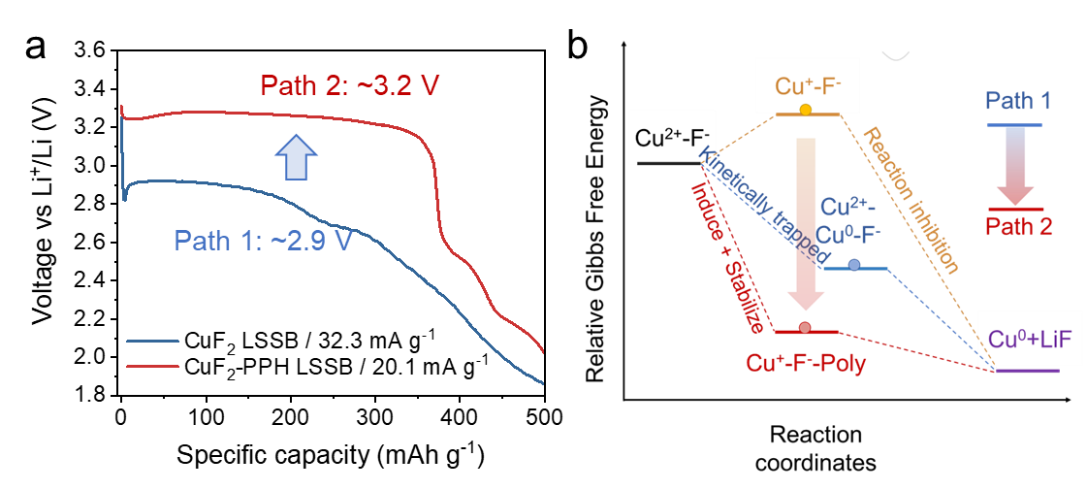
Figure S27. (a) First discharge curves of CuF₂ LSSB at 32.3 mA g⁻¹ and CuF₂-PPH LSSB at 20.1 mA g⁻¹. (b) Schematic illustration of path switching. The surface energy of the Cu(I) intermediate was reduced through interfacial absorption, which greatly promoted the reaction to a new pathway.

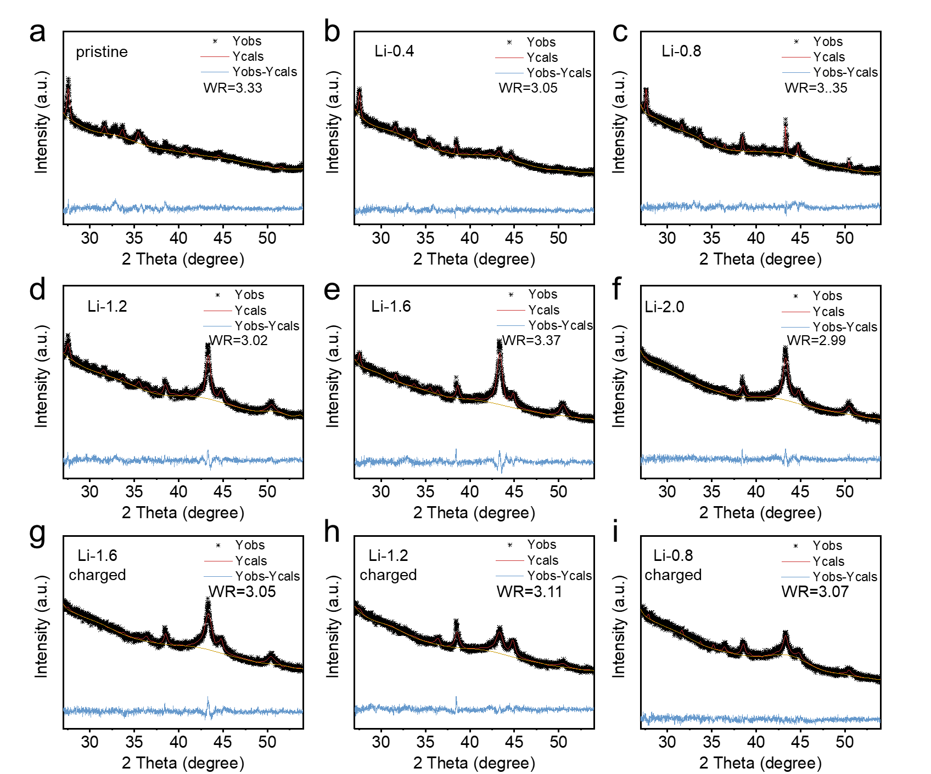
Figure S28. (a-i) Traditional reaction path: Rietveld refinement of XRD pattern of CuF₂ LSSB in the different states of charge.

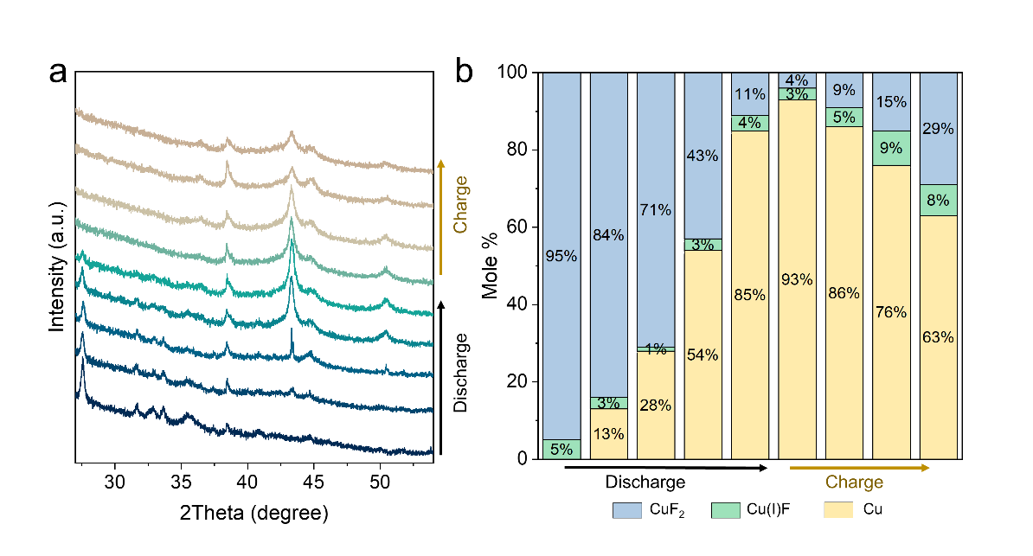
Figure S29. Study of the composition of the conventional reaction route process of CuF₂ electrode without PIL. (a) Ex-situ XRD patterns of the conventional reaction route process of CuF₂ LSSB without PIL and (b) molar ratio statistics for each component (the Cu(I) phase is obtained from Figure S11d,e).

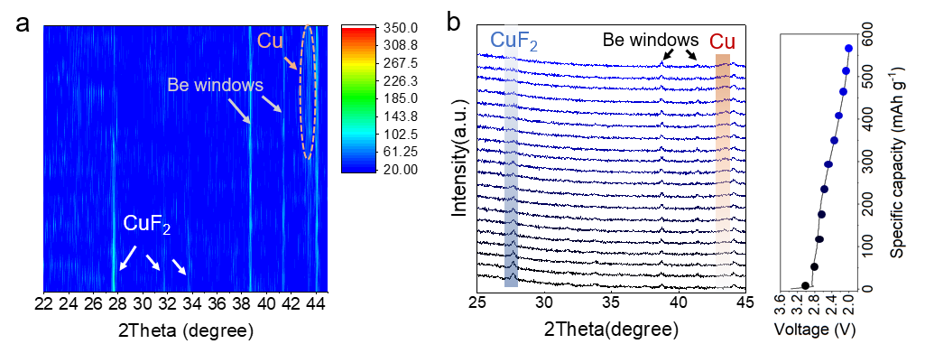
Figure S30. Structural evolution of CuF₂ LIB with liquid electrolyte. (a,b) The in situ XRD pattern of CuF₂ LIB with liquid electrolyte indicated that the Cu(I) phase did not appear in the conversion reaction process under the conventional path 1.

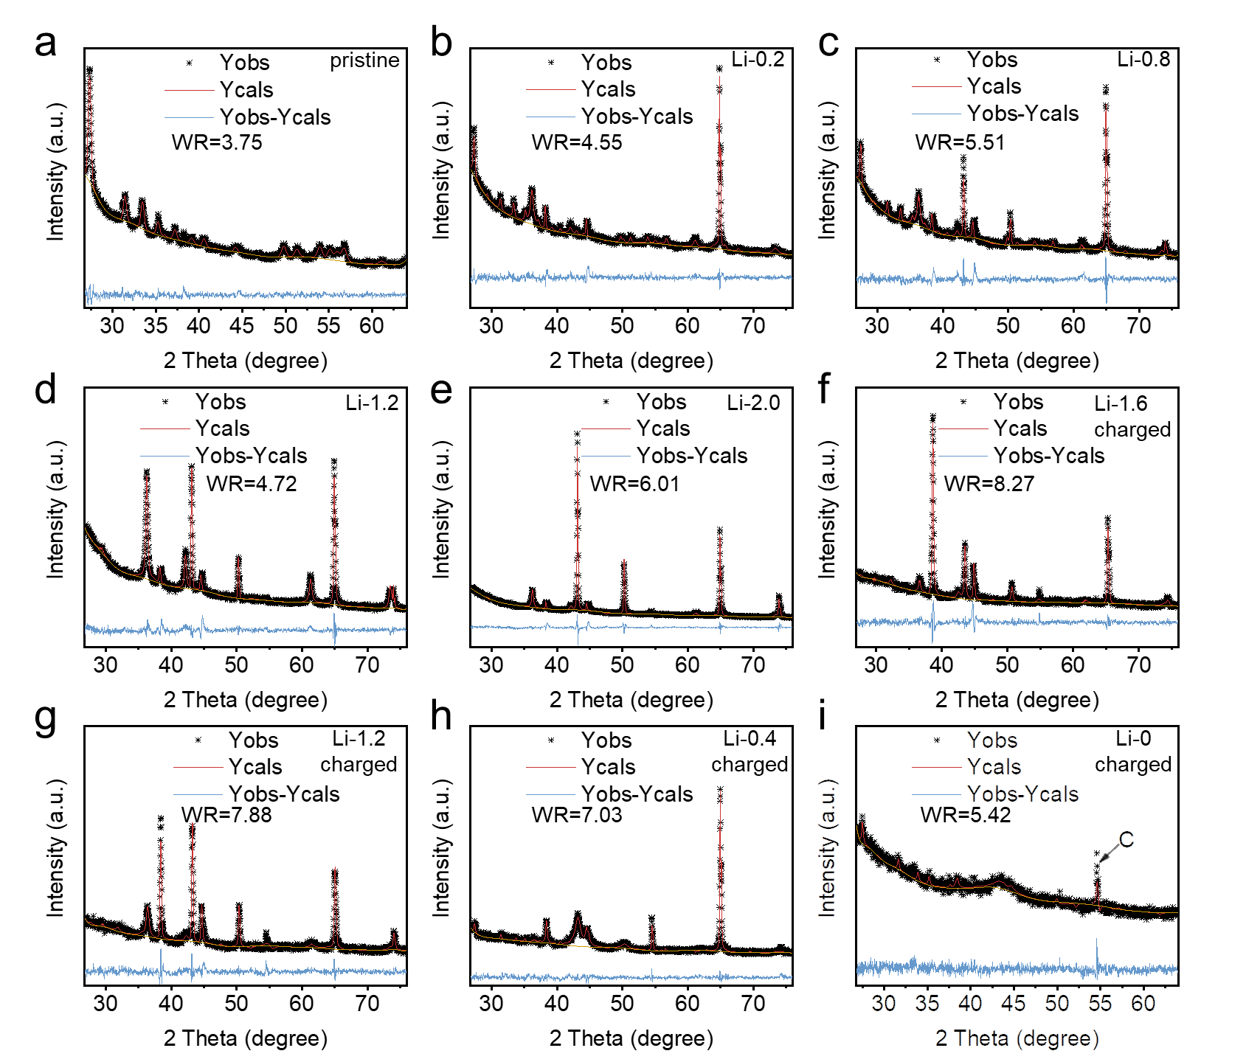
Figure S31. (a-i) Rietveld refinement of XRD pattern of CuF₂-PPH electrode in the different states of charge.

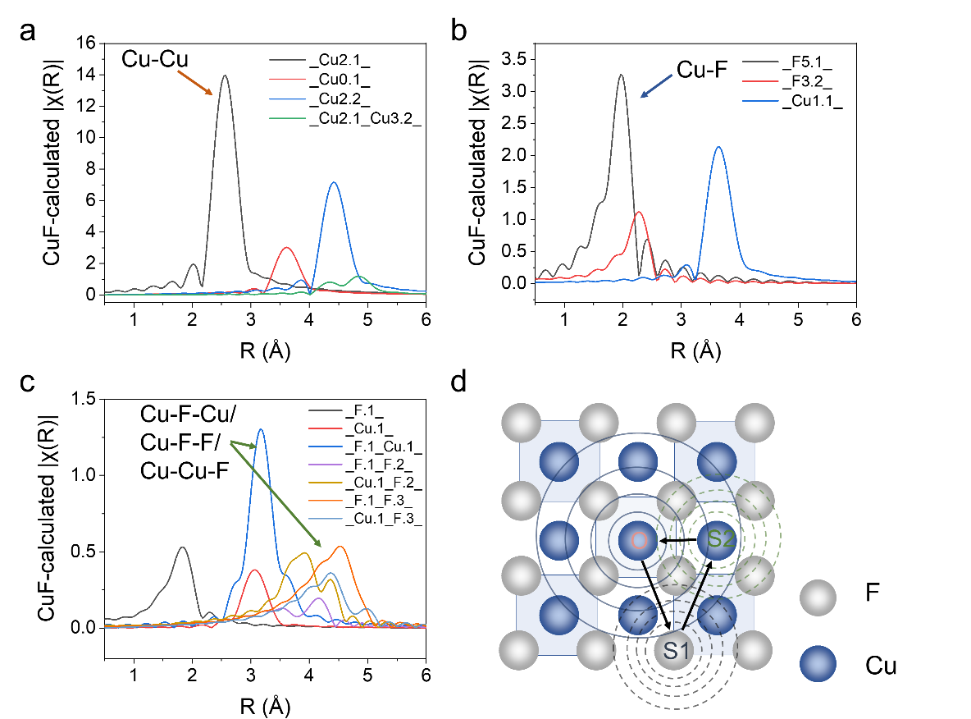
Figure S32. Theoretical coordination calculation results of (a) Cu, (b) CuF₂, and (c) CuF. CuF exhibited a large amount of Cu-F/Cu-F-F/Cu-Cu-F coordination information in the R range of 3-5 Å, which demonstrated a large number of polyatomic scattering phenomena corresponding to high k values in CuF⁽¹⁹⁾. (d) Schematic diagram of the mechanism of synchrotron X-ray absorption spectroscopy. The excited central atom was scattered by the energy of surrounding atoms to obtain information, and the coordination environment and bulk structure characteristics of the central atom could be further analyzed⁽²⁰⁾.

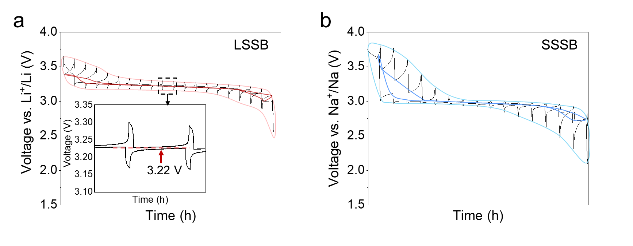
Figure S33. GITT curves of (a)CuF₂-PPH LSSB and (b) CuF₂-PPH SSSB. “Voltage hysteresis free” of the conversion reaction is achieved under the new path.

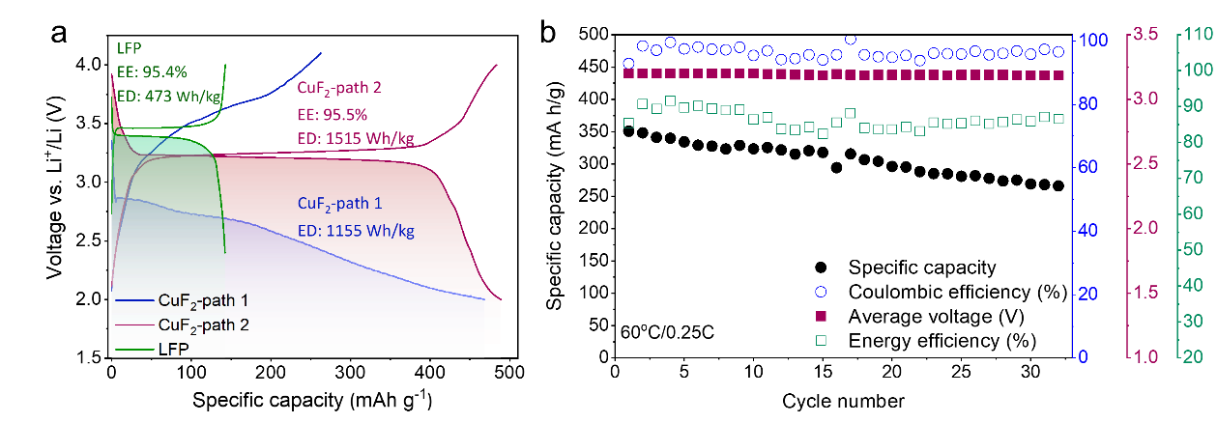
Figure S34. (a) GCD profiles of LiFePO₄ (LFP) LSSB, CuF₂ LIB (path 1), and CuF₂-PPH LSSB (path 2) at 60 °C (EE means energy efficiency, ED means energy density); (b) Cycle performance of CuF₂-PPH LSSB with PIL at 60 °C. The current density is 0.1 C (1 C=500 mAh g⁻¹). The charge-discharge behavior under the new path 2 of CuF₂ took into account the high specific capacity of the multi-electron transfer reaction of the conversion reaction and the high energy efficiency close to the intercalation cathode.

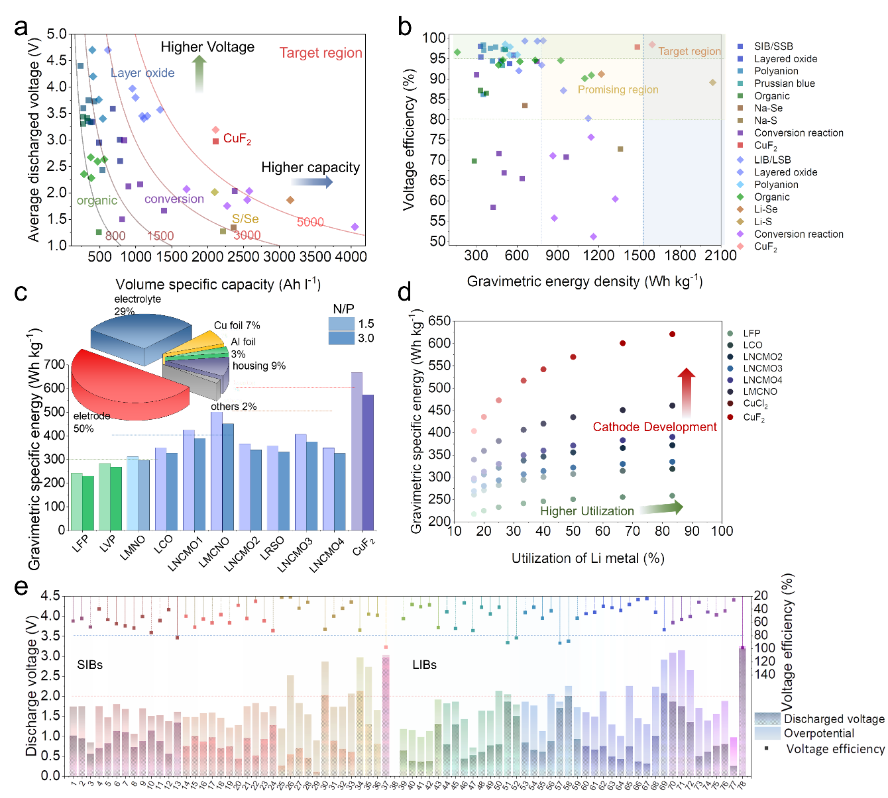
Figure S35. Summary graph of electrochemical performance. (a) Discharge voltage-volume energy density plot, showing the potential application of various cathode systems in terms of voltage and volume energy density. (b) Voltage efficiency-gravimetric energy density graph, showing the comprehensive performance potential of various secondary battery cathode systems considering both high energy efficiency and energy density. (c) Combined with the mass ratio of each component of the solid-state battery, the mass energy density of the full battery under different cathode material systems (LFP means LiFePO₄; LVP means Li₃V₂(PO₄)₃; LMNO means LiMn_{2-x}Ni_{x}O₄; LCO means LiCoO₂; LNCMO1 means Li_{1.17}Ni_{0.2}Co_{0.05}Mn_{0.58}O₂; LMCNO means Li_{1.2}Mn_{0.54}Co_{0.13}Ni_{0.13}O₂; LNCMO2 means LiNi_{0.6}Co_{0.2}Mn_{0.2}O₂; LRSO means Li₂Ru_{1−y}Sn_{y}O₃; LNCMO3 means LiNi_{0.9}Co_{0.05}Mn_{0.05}O₂; LNCMO4 means LiNi_{0.8}Co_{0.1}Mn_{0.1}O₂), (d) The effect of the utilization ratio of Li metal and cathodes on the mass energy density of all-solid-state batteries (the mass ratio of cathode is set to 45 wt%). (e) Statistical results of voltage and polarization of various conversion-type electrodes showed that most of the current conversion-type electrodes could not meet the basic requirements of energy efficiency (>80%) due to serious voltage hysteresis problems. However, CuF₂-PPH in our work exhibited both high discharge voltage and high energy efficiency. The reference mainly studies and displays various types of polyanionic type, Prussian blue, layered oxide, organic cathode cathodes ⁽²¹⁻⁴²⁾, and some conversion-type cathodes (Table S5).
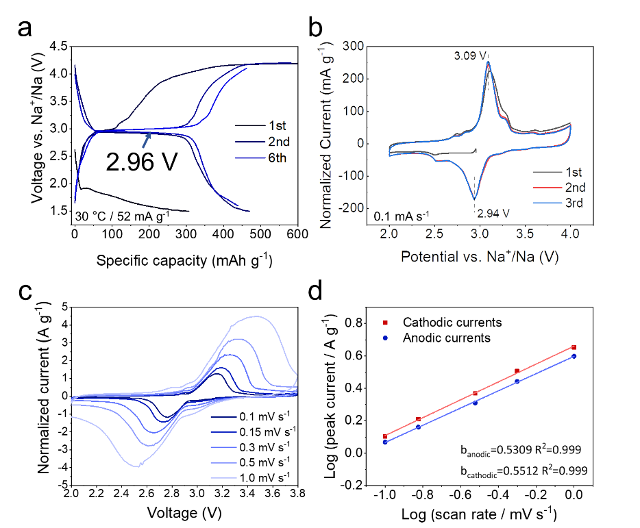
Figure S36. Electrochemical performance of CuF₂-PPH sodium batteries configuration. (a) GCD profiles of CuF₂-PPH SSSB and (b) its CV curve; (c) CV curves of CuF₂-PPH SSSB at different scan rates and (d) the corresponding fitting results.

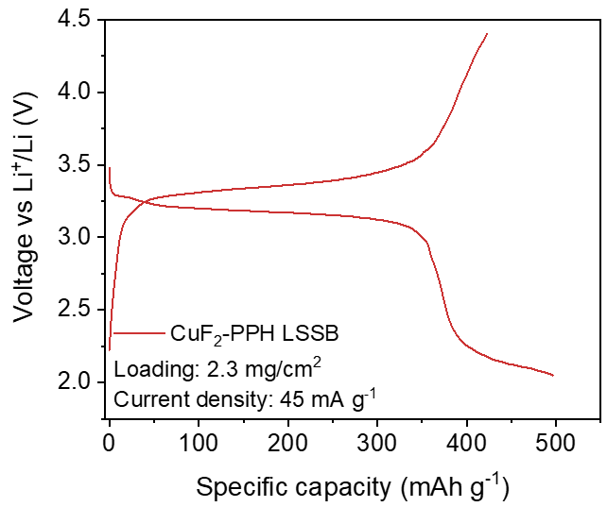
Figure S37. GCD profiles of CuF₂-PPH LSSB at 45 mA g⁻¹ under a high loading of ~2.3 mg cm⁻² and a low interfacial electrolyte of 6 μl cm⁻². The PIL layer is prepared from a solution of about 20 μl cm⁻² (PVDF-HFP: LiTFSI = 0.2 g: 0.1g in 3 ml DMF). Here, CuF₂ LSSB delivers a discharge capacity of 500 mAh g⁻¹. Considering the mass of the introduced PIL leads to a decrease in the proportion of active material to 57 wt%, so it is actually possible to achieve a total specific capacity of 285 mAh g⁻¹.

Tablet S1 Adsorption energy of Cu (011), CuF (011), and CuF₂ (011) surfaces with polymer adsorbates from DFT calculations.
Adsorption structures | Adsorption energy/eV
CuF₂ (011) + PVDF-HFP | -0.89013232
CuF₂ (011) + PEI | -3.83540454
CuF (011) + PVDF-HFP | -3.41241039
CuF (011) + PEI | -7.43768445
Cu (011) + PVDF-HFP | -1.43991977
Cu (011) + PEI | -2.8033432

Tablet S2 Number of Cu-F bonds of CuF (011) surface and CuF (011) surface with polymer adsorbates from DFT calculations. The statistical results show that the adsorption of PVDF-HFP on CuF (011) surface has little effect on the coordination of Cu-F bonds.
Number of Cu-F bonds | CuF | CuF (011) +PVDF-HFP | CuF (011) + PEI
First layer of the surface | 24 | 24 |  | 24
Second layer of the surface | 32 | 30 |  | 20
Third layer of the surface | 32 | 32 |  | 30
Fourth layer of the surface | 32 | 31 |  | 29
Total number | 120 | 117 |  | 103

Tablet S3 Surface Cu atoms Bader charge analysis and charge transfer between CuF₂, CuF, and Cu surfaces and different polymer adsorbates from DFT calculations. The positive and negative values represent the Bader charge gained or lost by the surface Cu atoms after the adsorption of PILs, respectively.
CuF₂ (011) | ΔQ/e⁻ | CuF (011) | ΔQ/e⁻ | Cu (011) | ΔQ/e⁻
CuF₂+PVDF-HFP | 0.1044 | CuF+ PVDF-HFP | 0.076309 | Cu+ PVDF-HFP | -0.919078
CuF₂+PEI | 0.787233 | CuF+PEI | 1.325601 | Cu+PEI | 0.542586

Table S4. Statistical table of Rietveld refinement results of XRD of CuF₂ electrode without PIL-PVDF-HFP in the different charge of states.

 | phase | Unit cell | Size(μ) | microstrain | Ratio(%)
Pristine  WR=3.33 | CuF₂ | a=4.60929;  b=4.55034;  c=3.29578. | 1 | 1000 | 95
 | CuF | a=4.28133. | 1 | 1000 | 5
Li-0.2  WR=3.05 | CuF₂ | a=4.61055;  b=4.5549;  c=3.29936. | 1 | 1000 | 84
 | CuF | a=4.2709 | 1 | 1000 | 3
 | Cu | a=3.61358 | 0.105 | 1000 | 13
Li-0.8  WR=3.55 | CuF₂ | a=4.63257;  b=4.53155;  c=3.29977. | 1.5308 | 5981.3 | 71
Li-0.8  WR=3.55 | CuF | a=4.26957 | 1 | 1000 | 1
 | Cu | a=3.61386 | 1.1423 | 503.7 | 28
Li-1.2  WR=3.02 | CuF₂ | a=4.62475;  b=4.53827;  c=3.29971. | 1 | 1000 | 43
Li-1.2  WR=3.02 | CuF | a=4.26943 | 1 | 1000 | 3
 | Cu | a=3.61447 | 0.1564 | 5779.3 | 54
Li-1.6  WR=3.37 | Cu | a=3.6147 | 0.0251 | 10533.7 | 85
Li-1.6  WR=3.37 | CuF₂ | a=4.62644;  b=4.56021;  c=3.29478 | 1 | 10733.3 | 11
Li-1.6  WR=3.37 | CuF | a=4.27595 | 0.475 | 4457.5 | 4
Li-2.0  WR=2.99 | CuF₂ | a=4.61255;  b=4.54382;  c=3.33022. | 1 | 15909.6 | 4
 | CuF | a=4.28221 | 0.0838 | 17804.4 | 3
 | Cu | a=3.61728 | 0.0274 | 16084.5 | 93
Li-1.2(Charge)  WR=3.05 | CuF₂ | a=4.61627;  b=4.56285;  c=3.27425. | 0.0347 | 5377.2 | 9
Li-1.2(Charge)  WR=3.05 | CuF | a=4.27914 | 0.0659 | 16437.9 | 5
Li-1.2(Charge)  WR=3.05 | Cu | a=3.61642 | 0.0188 | 20798.9 | 86
Li-0.4(Charge)  WR=3.11 | CuF₂ | a=4.61482;  b=4.55014;  c=3.28503. | 0.0385 | 12114.0 | 15
Li-0.4(Charge)  WR=3.11 | CuF | a=4.26183 | 0.0701 | 6993.2 | 9
Li-0.4(Charge)  WR=3.11 | Cu | a=3.60921 | 0.0164 | 12533.1 | 76
Li-0(Charge)  WR=3.07 | CuF₂ | a=4.62506;  b=4.4912;  c=3.32907. | 1 | 4581.9 | 29
Li-0(Charge)  WR=3.07 | CuF | a=4.28281 | 0.0709 | 6814.9 | 8
Li-0(Charge)  WR=3.07 | Cu | a=3.62742 | 0.019 | 5611.8 | 63

Table S5. Statistical table of Rietveld refinement results of XRD of CuF₂ electrode with PIL-PVDF-HFP in the different charge of states.

 | phase | Unit cell | Size(μ) | microstrain | Ratio(%)
Pristine  WR=3.757 | CuF₂ | a=4.61051;  b=4.55332;  c=3.294. | 1 | 1000 | 99.4
 | CuF | a=4.28133. | 1 | 1000 | 0.6
Li-0.2  WR=4.555 | CuF₂ | a=4.61055;  b=4.5549;  c=3.29936. | 0.0524 | 1691.7 | 64.7%
 | CuF | a=4.26749. | 0.0305 | 8540.3 | 20.9%
 | Li₃CuF₄ | a=4.26064;  b=4.26064;  c=4.26064. | 1 | 5653.5 | 11.2%
 | Cu | a=3.61796 | 1.0331 | 5879.5 | 3.2%
Li-0.8  WR=5.51 | CuF₂ | a=4.60987;  b=4.55705;  c=3.29593. | 1.9768 | 3756.4 | 12.
Li-0.8  WR=5.51 | CuF | a=4.26957 | 0.0345 | 2329.5 | 15.1%
Li-0.8  WR=5.51 | Li₃CuF₄ | a=4.26064;  b=4.26064;  c=4.26064. | 1 | 8105.1 | 11.3%
 | Cu | a=3.61386 | 10 | 946.7 | 27.4%
Li-1.2  WR=4.72 | CuF₂ | a=4.61328;  b=4.53827;  c=3.29971. | 0.6 | 25337.9 | 0.6%
Li-1.2  WR=4.72 | CuF | a=4.25989 | 0.1017 | 4960.6 | 51.1%
 | Li₃CuF₄ | a=4.26064;  b=4.26064;  c=4.26064. | 0.6066 | 28103.7 | 19.5%
 | Cu | a=3.61089 | 1 | 125 | 28.8%
Li-2.0  WR=6.01 | CuF | a=4.26785 | 0.0463 | 1000 | 13.7%
Li-2.0  WR=6.01 | Li₃CuF₄ | a=4.26064;  b=4.26064;  c=4.26064. | 1 | 19442.4 | 3.4%
Li-2.0  WR=6.01 | Cu | a=3.61503 | 1.4554 | 1583.8 | 82.9%
Li-1.6  WR=8.27 | CuF₂ | a=4.58893;  b=4.5507;  c=3.29903. | 0.0619 | 15243.6 | 6.1%
 | CuF | a=4.25815 | 0.18 | 18670.8 | 15.9%
 | Li₃CuF₄ | a=4.26064;  b=4.26064;  c=4.26064. | 1 | 12994.4 | 4.9%
 | Cu | a=3.60834 | 0.3016 | 7093.8 | 73.1%
Li-1.2(Charge)  WR=7.88 | CuF₂ | a=4.61601;  b=4.4795;  c=3.26664. | 1 | 32060.2 | 12.2%
Li-1.2(Charge)  WR=7.88 | CuF | a=4.26328 | 0.1627 | 10378.7 | 20.9%
Li-1.2(Charge)  WR=7.88 | Li₃CuF₄ | a=4.26064;  b=4.26064;  c=4.26064. | 1 | 9702.6 | 17.1%
Li-1.2(Charge)  WR=7.88 | Cu | a=3.61418 | 1 | 412.5 | 49.8%
Li-0.4(Charge)  WR=7.03 | CuF₂ | a=4.7067;  b=4.5123;  c=3.30579. | 1 | 1000 | 25.6%
Li-0.4(Charge)  WR=7.03 | CuF | a=4.25676 | 0.1857 | 7078.0 | 9.9%
Li-0.4(Charge)  WR=7.03 | Li₃CuF₄ | a=4.26064;  b=4.26064;  c=4.26064. | 1 | 50922.9 | 15.7%
Li-0.4(Charge)  WR=7.03 | Cu | a=3.62337 | 0.0658 | 30091.8 | 48.8%
Li-0(Charge)  WR=5.42 | CuF₂ | a=4.65184;  b=4.45216;  c=3.26037. | 1 | 1291.0 | 80.8%
Li-0(Charge)  WR=5.42 | Li₃CuF₄ | a=4.26064;  b=4.26064;  c=4.26064. | 1 | 3181.6 | 4.2%
Li-0(Charge)  WR=5.42 | Cu | a=3.59154 | 0.0871 | 61830.4 | 15%

Tablet S6⁽⁴³⁻¹⁰⁹⁾ Statistics on the voltages and overpotentials of various conversion-type electrodes in LIB and SIB.
Number | Compound | Battery | Overpotential  (V) | Discharge voltage (V) | Voltage efficiency (%) | Reference
1 | FeP | SIB | 0.73 | 1.01 | 58.2 | 43
2 | CoP | SIB | 0.80 | 0.95 | 54.1 | 44
3 | CuP₂ | SIB | 0.27 | 0.56 | 67.2 | 45
4 | FeSe₂ | SIB | 1.05 | 0.70 | 39.9 | 46
5 | FeSe | SIB | 0.64 | 0.82 | 56.1 | 47
6 | CoSe | SIB | 0.68 | 1.12 | 62.2 | 48
7 | NiSe | SIB | 0.58 | 1.10 | 65.3 | 49
8 | SnSe | SIB | 0.33 | 0.72 | 68.4 | 50
9 | MnSe | SIB | 0.83 | 0.87 | 51.2 | 51
10 | VSe₂ | SIB | 0.37 | 1.14 | 75.6 | 52
11 | MoSe₂ | SIB | 0.65 | 0.87 | 57.4 | 53
12 | CuSe | SIB | 0.81 | 0.56 | 40.9 | 54
13 | Na-Se | SIB | 0.27 | 1.3 | 83.4 | 55
14 | FeS₂ | SIB | 0.73 | 0.75 | 50.8 | 56
15 | FeS | SIB | 0.48 | 1 | 67.6 | 57
16 | CoS | SIB | 0.70 | 0.86 | 55.1 | 58
17 | NiS | SIB | 0.62 | 0.97 | 61.1 | 59
18 | SnS₂ | SIB | 0.76 | 0.70 | 48.2 | 60
19 | SnS | SIB | 0.47 | 0.74 | 61.1 | 61
20 | MnS | SIB | 0.84 | 0.44 | 34.3 | 62
21 | VS₂ | SIB | 0.80 | 0.95 | 54.2 | 63
22 | MoS₂ | SIB | 1.31 | 0.51 | 28.1 | 64
23 | CuS | SIB | 0.67 | 0.92 | 57.8 | 65
24 | Na-S | SIB | 0.48 | 1.27 | 72.7 | 66
25 | Fe₂O₃ | SIB | 0.93 | 0.26 | 21.9 | 67
26 | CoO | SIB | 1.99 | 0.54 | 21.4 | 68
27 | NiO | SIB | 1.13 | 0.7 | 38.3 | 69
28 | SnO₂ | SIB | 1.10 | 0.45 | 29.3 | 70
29 | SnO | SIB | 0.79 | 0.1 | 11.2 | 71
30 | MnO₂ | SIB | 0.84 | 2.03 | 70.7 | 72
31 | VO₂ | SIB | 0.85 | 0.88 | 50.7 | 73
32 | MoO₂ | SIB | 1.07 | 0.68 | 38.8 | 74
33 | CuO | SIB | 1.46 | 0.6 | 29.1 | 75
34 | FeF₂ | SIB | 0.84 | 2.13 | 71.7 | 76
35 | FeF₃ | SIB | 1.43 | 1.30 | 47.5 | 77
36 | MnF₂ | SIB | 0.84 | 0.82 | 49.3 | 78
37 | CuF₂ | SSSB | 0.06 | 2.97 | 97.8 | our work
38 | FeP | LIB | 0.54 | 0.60 | 52.7 | 79
39 | CoP | LIB | 0.54 | 0.64 | 54.4 | 44
40 | CuP₂ | LIB | 0.77 | 0.38 | 33.0 | 80
41 | V₄P₇ | LIB | 0.62 | 0.35 | 36.3 | 81
42 | TiP₂ | LIB | 0.75 | 0.38 | 33.4 | 82
43 | FeSe | LIB | 0.61 | 1.30 | 67.9 | 83
44 | CoSe | LIB | 1.02 | 0.80 | 43.9 | 84
45 | NiSe | LIB | 0.57 | 1.29 | 69.4 | 49
46 | MnSe | LIB | 0.99 | 0.43 | 30.4 | 85
47 | SnSe | LIB | 0.20 | 0.52 | 72.5 | 50
48 | VSe₂ | LIB | 1.03 | 0.60 | 37.0 | 86
49 | MoSe₂ | LIB | 0.86 | 0.77 | 47.2 | 53
50 | CuSe | LIB | 1.34 | 0.79 | 37.1 | 87
51 | Li-Se | LIB | 0.18 | 1.86 | 91.1 | 88
52 | FeS | LIB | 0.29 | 1.5 | 83.8 | 57
53 | NiS | LIB | 1.02 | 0.84 | 45.2 | 89
54 | CoS | LIB | 1.11 | 0.66 | 37.2 | 58
55 | SnS₂ | LIB | 0.52 | 0.61 | 53.7 | 90
56 | MoS₂ | LIB | 1.18 | 0.87 | 42.5 | 91
57 | CuS | LIB | 0.16 | 1.71 | 91.6 | 92
58 | Li-S | LIB | 0.25 | 2.0 | 88.9 | 93
59 | FeO | LIB | 0.80 | 0.92 | 53.6 | 94
60 | Fe₂O₃ | LIB | 0.85 | 0.75 | 47.0 | 67
61 | CoO | LIB | 0.82 | 0.66 | 44.6 | 68
62 | NiO | LIB | 1.37 | 0.75 | 35.4 | 69
63 | MnO | LIB | 0.80 | 0.49 | 37.9 | 96
64 | SnO₂ | LIB | 0.58 | 0.42 | 42.0 | 95
65 | VO₂ | LIB | 1.51 | 0.74 | 32.9 | 97
66 | MoO₂ | LIB | 1.08 | 0.37 | 25.4 | 98
67 | Cr₂O₃ | LIB | 0.99 | 0.31 | 23.8 | 99
68 | CuO | LIB | 1.24 | 1.00 | 44.7 | 100
69 | FeF₂ | LIB | 0.84 | 2.07 | 71.1 | 101,102
70 | FeF₃ | LIB | 1.22 | 1.86 | 60.4 | 103
71 | CoF₂ | LIB | 1.39 | 1.75 | 55.7 | 104
72 | NiF₂ | LIB | 1.29 | 1.35 | 51.2 | 105
73 | MnF₂ | LIB | 1.2 | 0.5 | 29.4 | 78
74 | FeCl₂ | LIB | 0.77 | 0.61 | 44.3 | 106
75 | FeCl₃ | LIB | 0.79 | 0.76 | 48.9 | 107
76 | CoCl₂ | LIB | 1.08 | 0.8 | 42.6 | 108
77 | SnCl₂ | LIB | 0.72 | 0.25 | 25.9 | 109
78 | CuF₂ | LSSB | 0.05 | 3.19 | 98.4 | Our work

Tablet S6 Adsorption energy of Fe (110), FeF₂ (110), and FeF₃ (012) surfaces with different polymer adsorbates from DFT calculations.
Adsorption structures | Adsorption energy/eV
Fe (110) + PVDF-HFP | -22.9334313
Fe (110) + PEO | -19.46937206
FeF₂ (110) + PVDF-HFP | -9.31059368
FeF₂ (110) + PEO | -6.65929626
FeF₃ (012) + PVDF-HFP | -0.79220663
FeF₃ (012) + PEO | -1.00252759

Supplementary references
1. J.-S. Kim et al., Surface engineering of inorganic solid-state electrolytes via interlayers strategy for developing long-cycling quasi-all-solid-state lithium batteries. Nature Communications 14, 782 (2023).
2. M. Avdeev, J. R. Hester, ECHIDNA: a decade of high-resolution neutron powder diffraction at OPAL. Journal of Applied Crystallography 51, 1597-1604 (2018).
3. S. W. W. U. Z. Liu Yunpeng, Synchrotron Radiation and Its Applications Progress in Inorganic Materials. Journal of Inorganic Materials 36, 901-918 (2021).
4. J. Timoshenko, A. Kuzmin, Wavelet data analysis of EXAFS spectra. Computer Physics Communications 180, 920-925 (2009).
5. G. Kresse, J. Furthmüller, Efficient iterative schemes for ab initio total-energy calculations using a plane-wave basis set. Physical Review B 54, 11169-11186 (1996).
6. G. Kresse, J. Furthmüller, Efficiency of ab-initio total energy calculations for metals and semiconductors using a plane-wave basis set. Computational Materials Science 6, 15-50 (1996).
7. J. P. Perdew, K. Burke, M. Ernzerhof, Generalized Gradient Approximation Made Simple. Physical Review Letters 77, 3865-3868 (1996).
8. P. E. Blöchl, Projector augmented-wave method. Physical Review B 50, 17953-17979 (1994).
9. F. Wang et al., Ternary metal fluorides as high-energy cathodes with low cycling hysteresis. Nature Communications 6, 6668 (2015).
10. J. K. Seo et al., Revisiting the conversion reaction voltage and the reversibility of the CuF2 electrode in Li-ion batteries. Nano Research 10, 4232-4244 (2017).
11. S. Grimme, J. Antony, S. Ehrlich, H. Krieg, A consistent and accurate ab initio parametrization of density functional dispersion correction (DFT-D) for the 94 elements H-Pu. The Journal of Chemical Physics 132, 154104 (2010).
12. A. Togo, I. Tanaka, First principles phonon calculations in materials science. Scripta Materialia 108, 1-5 (2015).
13. K. Momma, F. Izumi, VESTA 3 for three-dimensional visualization of crystal, volumetric and morphology data. Journal of Applied Crystallography 44, 1272-1276 (2011).
14. W. Humphrey, A. Dalke, K. Schulten, VMD: Visual molecular dynamics. Journal of Molecular Graphics 14, 33-38 (1996).
15. V. Wang, N. Xu, J.-C. Liu, G. Tang, W.-T. Geng, VASPKIT: A user-friendly interface facilitating high-throughput computing and analysis using VASP code. Computer Physics Communications 267, 108033 (2021).
16. H. C. Yu et al., Designing the next generation high capacity battery electrodes. Energy & Environmental Science 7, 1760-1768 (2014).
17. X. Hua et al., Revisiting metal fluorides as lithium-ion battery cathodes. Nature Materials 20, 841-850 (2021).
18. A. Lazzarini et al., Graphitization of Activated Carbons: A Molecular-level Investigation by INS, DRIFT, XRD and Raman Techniques. Physics Procedia 85, 20-26 (2016).
19. Z. Xia, H. Zhang, K. Shen, Y. Qu, Z. Jiang, Wavelet analysis of extended X-ray absorption fine structure data: Theory, application. Physica B: Condensed Matter 542, 12-19 (2018).
20. A. G. McKale, B. W. Veal, A. P. Paulikas, S. K. Chan, G. S. Knapp, Improved ab initio calculations of amplitude and phase functions for extended x-ray absorption fine structure spectroscopy. Journal of the American Chemical Society 110, 3763-3768 (1988).
21. F. Ding et al., A Novel Ni-rich O3-Na[Ni0.60Fe0.25Mn0.15]O2 Cathode for Na-ion Batteries. Energy Storage Materials 30, 420-430 (2020).
22. T. Jin et al., Realizing Complete Solid-Solution Reaction in High Sodium Content P2-Type Cathode for High-Performance Sodium-Ion Batteries. Angewandte Chemie International Edition 59, 14511-14516 (2020).
23. H. Kim et al., Anomalous Jahn–Teller behavior in a manganese-based mixed-phosphate cathode for sodium ion batteries. Energy & Environmental Science 8, 3325-3335 (2015).
24. M. Kim, S. Lee, B. Kang, Fast-Rate Capable Electrode Material with Higher Energy Density than LiFePO4: 4.2V LiVPO4F Synthesized by Scalable Single-Step Solid-State Reaction. Advanced Science 3, 1500366 (2016).
25. M. Kunduraci, G. G. Amatucci, Effect of oxygen non-stoichiometry and temperature on cation ordering in LiMn2−xNixO4 (0.50≥x≥0.36) spinels. Journal of Power Sources 165, 359-367 (2007).
26. M. Law, P. Balaya, NaVPO4F with high cycling stability as a promising cathode for sodium-ion battery. Energy Storage Materials 10, 102-113 (2018).
27. J. Lee et al., A new class of high capacity cation-disordered oxides for rechargeable lithium batteries: Li–Ni–Ti–Mo oxides. Energy & Environmental Science 8, 3255-3265 (2015).
28. Y. Liang, Y. Yao, Positioning Organic Electrode Materials in the Battery Landscape. Joule 2, 1690-1706 (2018).
29. X. Liu, L. Tang, Q. Xu, H. Liu, Y. Wang, Ultrafast and ultrastable high voltage cathode of Na2+2xFe2-x(SO4)3 microsphere scaffolded by graphene for sodium ion batteries. Electrochimica Acta 296, 345-354 (2019).
30. C. Luo et al., Graphene oxide wrapped croconic acid disodium salt for sodium ion battery electrodes. Journal of Power Sources 250, 372-378 (2014).
31. E. McCalla et al., Visualization of O-O peroxo-like dimers in high-capacity layered oxides for Li-ion batteries. Science 350, 1516-1521 (2015).
32. L. Mu et al., Prototype Sodium-Ion Batteries Using an Air-Stable and Co/Ni-Free O3-Layered Metal Oxide Cathode. Advanced Materials 27, 6928-6933 (2015).
33. M. Nose et al., Na4Co2.4Mn0.3Ni0.3(PO4)2P2O7: High potential and high capacity electrode material for sodium-ion batteries. Electrochemistry Communications 34, 266-269 (2013).
34. K. Saravanan, C. W. Mason, A. Rudola, K. H. Wong, P. Balaya, The First Report on Excellent Cycling Stability and Superior Rate Capability of Na3V2(PO4)3 for Sodium Ion Batteries. Advanced Energy Materials 3, 444-450 (2013).
35. M. Sathiya et al., Reversible anionic redox chemistry in high-capacity layered-oxide electrodes. Nature Materials 12, 827-835 (2013).
36. J. Song et al., Removal of Interstitial H2O in Hexacyanometallates for a Superior Cathode of a Sodium-Ion Battery. Journal of the American Chemical Society 137, 2658-2664 (2015).
37. Z. Song, Y. Qian, T. Zhang, M. Otani, H. Zhou, Poly(benzoquinonyl sulfide) as a High-Energy Organic Cathode for Rechargeable Li and Na Batteries. Advanced Science 2, 1500124 (2015).
38. Z. Song, H. Zhan, Y. Zhou, Polyimides: Promising Energy-Storage Materials. Angewandte Chemie International Edition 49, 8444-8448 (2010).
39. R. Usiskin et al., Fundamentals, status and promise of sodium-based batteries. Nature Reviews Materials 6, 1020-1035 (2021).
40. T. Wang et al., Electrode Materials for Sodium-Ion Batteries: Considerations on Crystal Structures and Sodium Storage Mechanisms. Electrochemical Energy Reviews 1, 200-237 (2018).
41. N. Yabuuchi, K. Kubota, M. Dahbi, S. Komaba, Research Development on Sodium-Ion Batteries. Chemical Reviews 114, 11636-11682 (2014).
42. X. Yin et al., Recent Progress in Advanced Organic Electrode Materials for Sodium-Ion Batteries: Synthesis, Mechanisms, Challenges and Perspectives. Advanced Functional Materials 30, 1908445 (2020).
43. S. Shi et al., Electrospun free-standing FeP@NPC film for flexible sodium ion batteries with remarkable cycling stability. Energy Storage Materials 29, 78-83 (2020).
44. A. S. Murali, D. Susan Baji, S. Nair, D. Santhanagopalan, Vapour phase conversion of metal oxalates to metal phosphide nanostructures and their use as anode in rechargeable Li, Na and K-ion batteries. Electrochimica Acta 388, 138643 (2021).
45. J. Duan et al., Chitosan Derived Carbon Matrix Encapsulated CuP2 Nanoparticles for Sodium-Ion Storage. ACS Applied Materials & Interfaces 11, 12415-12420 (2019).
46. Y. Zhang et al., Highly Efficient Sodium-Ion Storage Enabled by an rGO-Wrapped FeSe2 Composite. ChemSusChem 14, 1336-1343 (2021).
47. K. Wu et al., In situ TEM and half cell investigation of sodium storage in hexagonal FeSe nanoparticles. Chemical Communications 55, 5611-5614 (2019).
48. X. Li et al., Ultrafine CoSe nano-crystallites confined in leaf-like N-doped carbon for long-cyclic and fast sodium ion storage. Electrochimica Acta 294, 173-182 (2019).
49. Z. Zhang, X. Shi, X. Yang, Synthesis of core-shell NiSe/C nanospheres as anodes for lithium and sodium storage. Electrochimica Acta 208, 238-243 (2016).
50. J. Xia et al., Electrospun SnSe/C nanofibers as binder-free anode for lithium–ion and sodium-ion batteries. Journal of Power Sources 449, 227559 (2020).
51. L. Hu, L. He, X. Wang, C. Shang, G. Zhou, MnSe embedded in carbon nanofibers as advanced anode material for sodium ion batteries. Nanotechnology 31, 335402 (2020).
52. Y. Wu et al., Flexible electrode constructed by encapsulating ultrafine VSe2 in carbon fiber for quasi-solid-state sodium ion batteries. Journal of Power Sources 470, 228438 (2020).
53. X. Yang, Z. Zhang, Y. Fu, Q. Li, Porous hollow carbon spheres decorated with molybdenum diselenide nanosheets as anodes for highly reversible lithium and sodium storage. Nanoscale 7, 10198-10203 (2015).
54. H. Lin et al., Nanosheets-Assembled CuSe Crystal Pillar as a Stable and High-Power Anode for Sodium-Ion and Potassium-Ion Batteries. Advanced Energy Materials 9, 1900323 (2019).
55. B. Yuan, X. Sun, L. Zeng, Y. Yu, Q. Wang, A Freestanding and Long-Life Sodium–Selenium Cathode by Encapsulation of Selenium into Microporous Multichannel Carbon Nanofibers. Small 14, 1703252 (2018).
56. Y. Shao, J. Yue, S. Sun, H. Xia, Facile Synthesis of FeS2 Quantum-Dots/Functionalized Graphene-Sheet Composites as Advanced Anode Material for Sodium-ion Batteries. Chinese Journal of Chemistry 35, 73-78 (2017).
57. X. Wei, W. Li, J.-a. Shi, L. Gu, Y. Yu, FeS@C on Carbon Cloth as Flexible Electrode for Both Lithium and Sodium Storage. ACS Applied Materials & Interfaces 7, 27804-27809 (2015).
58. F. Han et al., Dual-carbon phase-protective cobalt sulfide nanoparticles with cable-type and mesoporous nanostructure for enhanced cycling stability in sodium and lithium ion batteries. Carbon 118, 731-742 (2017).
59. J. Wang, D. Cao, G. Yang, Y. Yang, H. Wang, Synthesis of NiS/carbon composites as anodes for high-performance sodium-ion batteries. Journal of Solid State Electrochemistry 21, 3047-3055 (2017).
60. X. Xie et al., SnS2 Nanoplatelet@Graphene Nanocomposites as High-Capacity Anode Materials for Sodium-Ion Batteries. Chemistry – An Asian Journal 9, 1611-1617 (2014).
61. P. He, Y. Fang, X.-Y. Yu, X. W. Lou, Hierarchical Nanotubes Constructed by Carbon-Coated Ultrathin SnS Nanosheets for Fast Capacitive Sodium Storage. Angewandte Chemie International Edition 56, 12202-12205 (2017).
62. S. Gao et al., Flexible MnS–Carbon Fiber Hybrids for Lithium-Ion and Sodium-Ion Energy Storage. Chemistry – A European Journal 24, 13535-13539 (2018).
63. D. Yu et al., Hierarchical flower-like VS2 nanosheets – A high rate-capacity and stable anode material for sodium-ion battery. Energy Storage Materials 11, 1-7 (2018).
64. D. Su, S. Dou, G. Wang, Ultrathin MoS2 Nanosheets as Anode Materials for Sodium-Ion Batteries with Superior Performance. Advanced Energy Materials 5, 1401205 (2015).
65. Z.-G. Yang et al., Hydrangea-Like CuS with Irreversible Amorphization Transition for High-Performance Sodium-Ion Storage. Advanced Science 7, 1903279 (2020).
66. S. Xin, Y.-X. Yin, Y.-G. Guo, L.-J. Wan, A High-Energy Room-Temperature Sodium-Sulfur Battery. Advanced Materials 26, 1261-1265 (2014).
67. Z.-g. Wu et al., Subunits controlled synthesis of α-Fe2O3 multi-shelled core–shell microspheres and their effects on lithium/sodium ion battery performances. Journal of Materials Chemistry A 3, 10092-10099 (2015).
68. J. Jiang et al., A novel CoO hierarchical morphologies on carbon nanofiber for improved reversibility as binder-free anodes in lithium/sodium ion batteries. Journal of Alloys and Compounds 794, 385-395 (2019).
69. A. Iturrondobeitia, A. Goñi, I. Gil de Muro, L. Lezama, T. Rojo, Physico-Chemical and Electrochemical Properties of Nanoparticulate NiO/C Composites for High Performance Lithium and Sodium Ion Battery Anodes. Nanomaterials 7, 423 (2017).
70. Y. Wang, D. Su, C. Wang, G. Wang, SnO2@MWCNT nanocomposite as a high capacity anode material for sodium-ion batteries. Electrochemistry Communications 29, 8-11 (2013).
71. F. Zhang, J. Zhu, D. Zhang, U. Schwingenschlögl, H. N. Alshareef, Two-Dimensional SnO Anodes with a Tunable Number of Atomic Layers for Sodium Ion Batteries. Nano Letters 17, 1302-1311 (2017).
72. D. Su, H.-J. Ahn, G. Wang, β-MnO2 nanorods with exposed tunnel structures as high-performance cathode materials for sodium-ion batteries. NPG Asia Materials 5, e70-e70 (2013).
73. F. Wu et al., A 3D flower-like VO2/MXene hybrid architecture with superior anode performance for sodium ion batteries. Journal of Materials Chemistry A 7, 1315-1322 (2019).
74. H. He, Y. Man, J. Yang, J. Xie, M. Xu, MoO2 nanosheets embedded in amorphous carbon matrix for sodium-ion batteries. Royal Society Open Science 4, 170892.
75. X. Wang, Y. Liu, Y. Wang, L. Jiao, CuO Quantum Dots Embedded in Carbon Nanofibers as Binder-Free Anode for Sodium Ion Batteries with Enhanced Properties. Small 12, 4865-4872 (2016).
76. D. Ni et al., FeF2@MHCS Cathodes with High Capacity and Fast Sodium Storage Based on Nanostructure Construction. ACS Applied Energy Materials 3, 10340-10348 (2020).
77. Y. Shen et al., Sheet-like structure FeF3/graphene composite as novel cathode material for Na ion batteries. RSC Advances 5, 38277-38282 (2015).
78. Y. Wei et al., Solvothermal Synthesis of Porous MnF2 Hollow Spheroids as Anode Materials for Sodium-/Lithium-Ion Batteries. ChemElectroChem 6, 2726-2732 (2019).
79. X. Wang, K. Chen, G. Wang, X. Liu, H. Wang, Rational Design of Three-Dimensional Graphene Encapsulated with Hollow FeP@Carbon Nanocomposite as Outstanding Anode Material for Lithium Ion and Sodium Ion Batteries. ACS Nano 11, 11602-11616 (2017).
80. S.-O. Kim, A. Manthiram, Phosphorus-Rich CuP2 Embedded in Carbon Matrix as a High-Performance Anode for Lithium-Ion Batteries. ACS Applied Materials & Interfaces 9, 16221-16227 (2017).
81. K.-H. Kim, C.-H. Jung, W.-S. Kim, S.-H. Hong, V4P7@C nanocomposite as a high performance anode material for lithium-ion batteries. Journal of Power Sources 400, 204-211 (2018).
82. S.-O. Kim, A. Manthiram, High-Performance Red P-Based P–TiP2–C Nanocomposite Anode for Lithium-Ion and Sodium-Ion Storage. Chemistry of Materials 28, 5935-5942 (2016).
83. D. Zhong et al., The yolk-shell FeSe@C nanobox with novel synthesis and its high performance for the anode of lithium-ion batteries. Materials Research Express 6, 085058 (2019).
84. J. Li, D. Yan, T. Lu, Y. Yao, L. Pan, An advanced CoSe embedded within porous carbon polyhedra hybrid for high performance lithium-ion and sodium-ion batteries. Chemical Engineering Journal 325, 14-24 (2017).
85. J. Feng et al., Hexagonal prism structured MnSe stabilized by nitrogen-doped carbon for high performance lithium ion batteries. Journal of Alloys and Compounds 789, 451-459 (2019).
86. Q. Jiang et al., Selenium vacancy-rich and carbon-free VSe2 nanosheets for high-performance lithium storage. Nanoscale 12, 8858-8866 (2020).
87. Z. Zhou, W. Zhang, W. Zhao, Z. Yang, C. Zeng, A Replacement Etching Route to CuSe with a Hierarchical Hollow Structure for Enhanced Performance in Lithium Ion Batteries. Journal of Electronic Materials 43, 359-368 (2014).
88. J. Xu, J. Ma, Q. Fan, S. Guo, S. Dou, Recent Progress in the Design of Advanced Cathode Materials and Battery Models for High-Performance Lithium-X (X = O2, S, Se, Te, I2, Br2) Batteries. Advanced Materials 29, 1606454 (2017).
89. D. Han, N. Xiao, B. Liu, G. Song, J. Ding, One-pot synthesis of core/shell-structured NiS@onion-like carbon nanocapsule as a high-performance anode material for Lithium-ion batteries. Materials Letters 196, 119-122 (2017).
90. S. Tao et al., A versatile strategy for ultrathin SnS2 nanosheets confined in a N-doped graphene sheet composite for high performance lithium and sodium-ion batteries. Chemical Communications 54, 8379-8382 (2018).
91. L. Zhang, X. W. Lou, Hierarchical MoS2 Shells Supported on Carbon Spheres for Highly Reversible Lithium Storage. Chemistry – A European Journal 20, 5219-5223 (2014).
92. H. Li, Y. Wang, J. Huang, Y. Zhang, J. Zhao, Microwave-assisted Synthesis of CuS/Graphene Composite for Enhanced Lithium Storage Properties. Electrochimica Acta 225, 443-451 (2017).
93. J. Lei et al., Single-dispersed polyoxometalate clusters embedded on multilayer graphene as a bifunctional electrocatalyst for efficient Li-S batteries. Nature Communications 13, 202 (2022).
94. M. Gao et al., FeO/C anode materials of high capacity and cycle stability for lithium-ion batteries synthesized by carbothermal reduction. Journal of Alloys and Compounds 565, 97-103 (2013).
95. S. Ding, J. S. Chen, X. W. Lou, CNTs@SnO2@Carbon Coaxial Nanocables with High Mass Fraction of SnO2 for Improved Lithium Storage. Chemistry – An Asian Journal 6, 2278-2281 (2011).
96. X. Zhou et al., N-doped carbon encapsulated MnO nanoparticles for enhanced lithium storage. Materials Letters 234, 335-338 (2019).
97. G. He, L. Li, A. Manthiram, VO2/rGO nanorods as a potential anode for sodium- and lithium-ion batteries. Journal of Materials Chemistry A 3, 14750-14758 (2015).
98. C. Lingfei, Y. Liu, G. Zhang, R. Zhang, Mesoporous MoO2-carbon nanocomposites synthesized by triconstituent co-assembly approach for high performance lithium-ion batteries. Microporous and Mesoporous Materials 327, 111427 (2021).
99. Z. Cao et al., Facile route for synthesis of mesoporous Cr2O3 sheet as anode materials for Li-ion batteries. Electrochimica Acta 139, 76-81 (2014).
100. Q. Wang et al., CuO nanorods/graphene nanocomposites for high-performance lithium-ion battery anodes. Journal of Alloys and Compounds 590, 424-427 (2014).
101. J. Li et al., The fluorination-assisted dealloying synthesis of porous reduced graphene oxide-FeF2@carbon for high-performance lithium-ion battery and the exploration of its electrochemical mechanism. Inorganic Chemistry Frontiers 8, 3273-3283 (2021).
102. A. W. Xiao et al., Understanding the conversion mechanism and performance of monodisperse FeF2 nanocrystal cathodes. Nature Materials 19, 644-654 (2020).
103. W. Fu et al., Iron Fluoride–Carbon Nanocomposite Nanofibers as Free-Standing Cathodes for High-Energy Lithium Batteries. Advanced Functional Materials 28, 1801711 (2018).
104. F. Wu et al., Metal–Organic Framework-Derived Nanoconfinements of CoF2 and Mixed-Conducting Wiring for High-Performance Metal Fluoride-Lithium Battery. ACS Nano 15, 1509-1518 (2021).
105. Q. Huang et al., Fading Mechanisms and Voltage Hysteresis in FeF2–NiF2 Solid Solution Cathodes for Lithium and Lithium-Ion Batteries. Small 15, 1804670 (2019).
106. L. Wang et al., A FeCl2-graphite sandwich composite with Cl doping in graphite layers: a new anode material for high-performance Li-ion batteries. Nanoscale 6, 14174-14179 (2014).
107. X. Qi et al., FeCl3 intercalated few-layer graphene for high lithium-ion storage performance. Journal of Materials Chemistry A 3, 15498-15504 (2015).
108. J.-l. Liu, W.-j. Cui, C.-x. Wang, Y.-y. Xia, Electrochemical reaction of lithium with CoCl2 in nonaqueous electrolyte. Electrochemistry Communications 13, 269-271 (2011).
109. X. He et al., Synthesis of PAN/SnCl2 composite as Li-ion battery anode material. Ionics 12, 323-326 (2006).

