Supplementary materials for
Polar Solomon Rings in Ferroelectric Nanocrystals
Jing Wang^{1,2} †, Deshan Liang¹ †, Jing Ma² †, Yuanyuan Fan¹, Ji Ma^{2,3}, Hasnain Mehdi Jafri¹, Huayu Yang¹, Qinghua Zhang⁴, Yue Wang², Changqing Guo¹, Shouzhe Dong¹, Di Liu¹, Xueyun Wang⁵, Jiawang Hong⁵, Nan Zhang⁶, Lin Gu^{2,4}, Di Yi², Jinxing Zhang⁷, Yuanhua Lin², Long-Qing Chen⁸, Houbing Huang¹*, Ce-Wen Nan²*
†These authors contributed equally to this work.
*E-mail: hbhuang@bit.edu.cn, cwnan@tsinghua.edu.cn.

This PDF file includes:
Supplementary Text
Supplementary Figures 1 to 15
Supplementary Table 1
Captions for Supplementary Movies 1 to 3
Other Supplementary Materials for this manuscript include the following:
Supplementary Movies 1 to 3

Supplementary text
The transformation between the 3D domain in a BiFeO₃ nanocrystal and the polar Solomon rings across a donut.
To have a deep understanding of how the domains in BiFeO₃ nanocrystals can be extracted to polar Solomon rings, we render $R_{4}^{-}[\overline{1}1\overline{1}]$, $R_{3}^{+}[\overline{1}\overline{1}1]$, $R_{2}^{-}[1\overline{1}\overline{1}]$,$R_{1}^{+}[111]$ polarization variants in red, and $R_{4}^{+}[1\overline{1}1]$, $R_{3}^{-}[11\overline{1}]$, $R_{2}^{+}[\overline{1}11]$, $R_{1}^{-}[\overline{1}\overline{1}\overline{1}]$ polarization variants in blue as shown in Supplementary Fig. 5a. When we gradually shrink the domain structure of the blue region and that of the red region into a tube shape, distorted Solomon rings are extracted, as shown in Supplementary Fig. 5b and 5c. Finally, standard Solomon rings are extracted in Supplementary Fig. 5d, where the two rings are interwoven across a donut. The reversible expanding and shrinking of the Solomon rings can be seen in Supplementary Movie 1.
The definition of linking number (LN) for polar Solomon rings.
Solomon rings are composed of two intertwined rings with four crossing points (Fig. 1a). Commonly, there are two overlapping possibilities for the intertwined rings at each crossing point, i.e., either the red ring is on top of the blue ring, or the blue ring is on top of the red ring. However, if the polar vector is further taken into consideration, there should be four possibilities at each crossing point (Supplementary Fig. 6a). The corresponding linking number for the crossing point is defined as n₁=+1, n₂=+1, n₃=-1, and n₄=-1, respectively. Thus, if the polar vector in both red ring and blue ring rotates counter-clockwise (Supplementary Fig. 6b and 6c) or clockwise (see Supplementary Fig. 6b and 6c from the backside of the paper), two kinds of polar Solomon rings with the respective linking number of +2 and -2 can be identified. Simultaneously, if the polar vector in the red ring rotates counter-clockwise whereas the polar vector in the blue ring rotates clockwise (Supplementary Fig. 6d and 6e) or vice versa (see Supplementary Fig. 6d and 6e from the backside of the paper), the corresponding linking number of the polar Solomon rings are -2 and +2, respectively. Thus, we conclude there are only two types of polar Solomon rings, e.g., with the linking number of +2 or -2.
Supplementary Figures
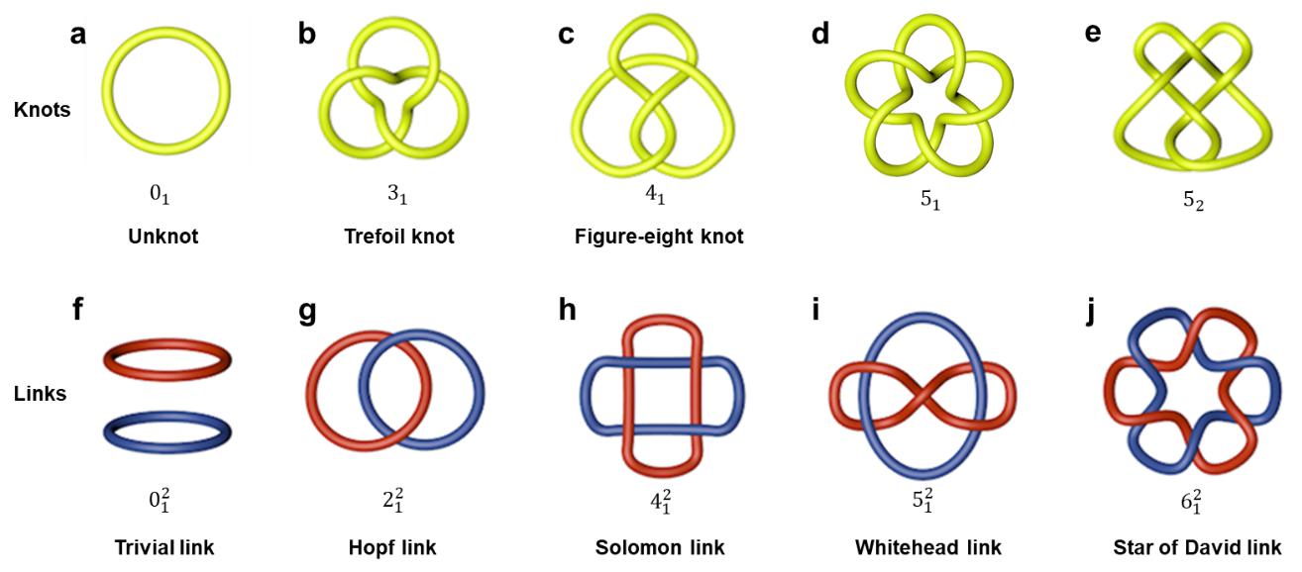
Fig. S1.
Stereoscopic representations of multiple knots and links. a, Unknot, $0_{1}$. b, Trefoil knot, $3_{1}$. c, Figure-eight knot, $4_{1}$. d, $5_{1}$ e, $5_{2}$. f, Two-component trivial link, $0_{1}^{2}$. g, Hopf link, $2_{1}^{2}$. h, Solomon link, $4_{1}^{2}$. i, Whitehead link, $5_{1}^{2}$ j, Star of David link, $6_{1}^{2}$.

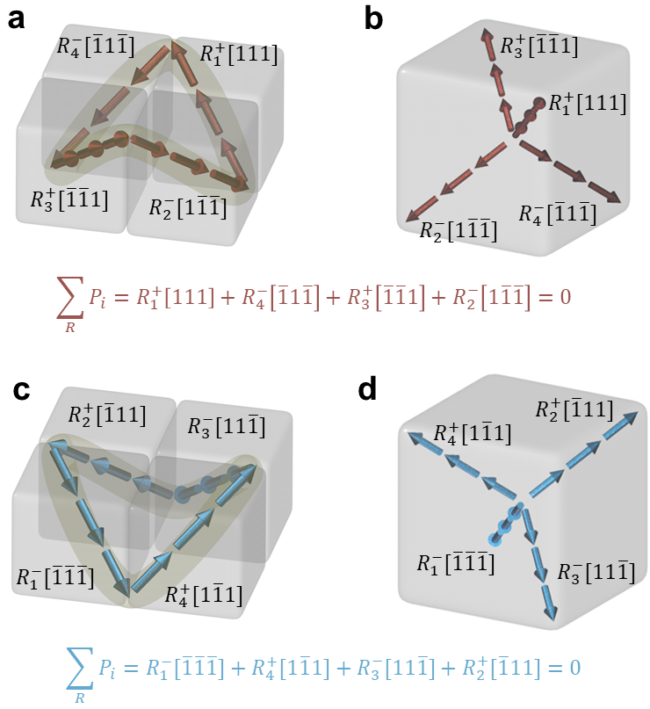
Fig. S2.
Decoupled Solomon rings composed of 3D vortex with rhombohedral ferroelectric polarization variants. a, A 3D polar vortex composed of $R_{4}^{-}[\overline{1}1\overline{1}]$, $R_{3}^{+}[\overline{1}\overline{1}1]$, $R_{2}^{-}[1\overline{1}\overline{1}]$,$R_{1}^{+}[111]$ polarization variants in rhombohedral phase BiFeO₃. b, Rearrangement of the corresponding polarization variants in A from one original point. c, A 3D polar vortex composed of $R_{4}^{+}[1\overline{1}1]$, $R_{3}^{-}[11\overline{1}]$, $R_{2}^{+}[\overline{1}11]$, $R_{1}^{-}[\overline{1}\overline{1}\overline{1}]$ polarization variants in rhombohedral phase BiFeO₃. d, Rearrangement of the corresponding polarization variants in C from one original point. The selected polarization variants for one 3D vortex follow the polarization conservation law.

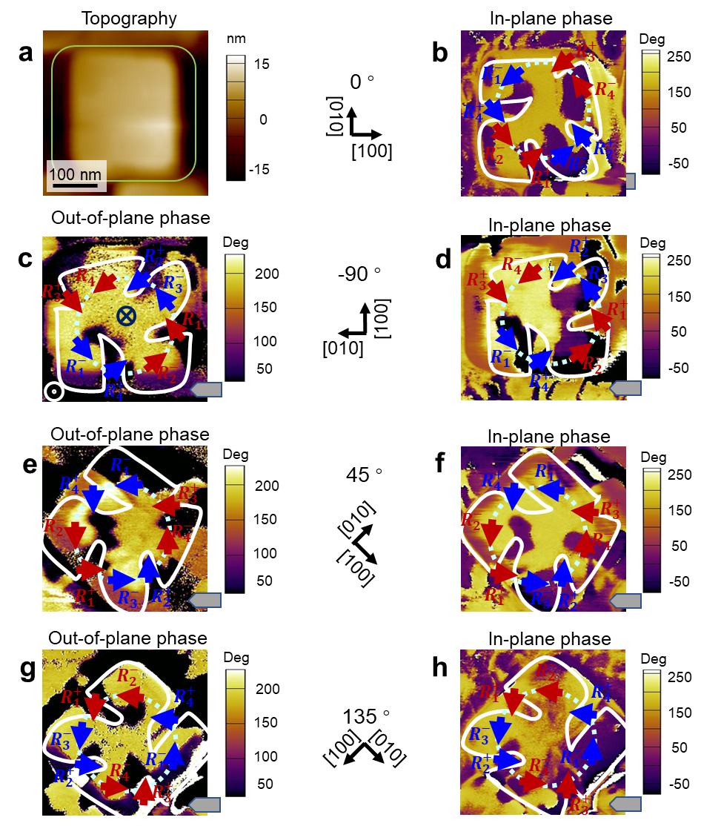
Fig. S3.
PFM characterization of the OOP and IP polarization projection for polar Solomon rings with LK of 2. a,b, Morphology and IP PFM phase image for the BiFeO₃ nanocrystal at the initial state. c-h, OOP (c, e, g) and IP (d, f, h) PFM phase images for the BiFeO₃ nanocrystal when the specimen is rotated by -90° (c, d), 45° (e, f), and 135° (g, h) with respect to the cantilever. This BiFeO₃ nanocrystal is the same as presented one in Fig. 1D in the main text.

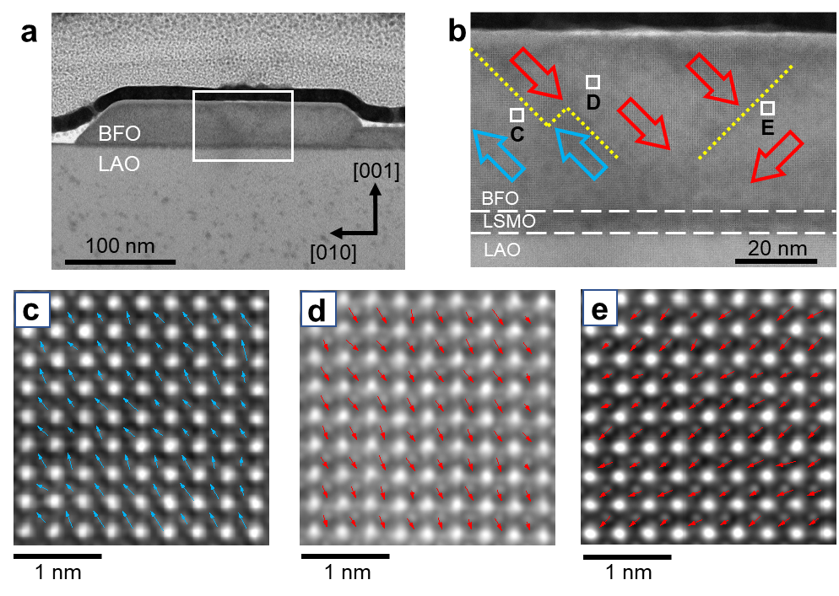
Fig. S4.
Cross-sectional polarization distribution of BiFeO₃ nanocrystal. a, Cross-sectional topography for an entire nanocrystal. b, Polarization projections in (010)-plane for the magnified region enlaced by white box in (a). c-e, Atomic polar mapping for three different domain regions highlighted by white boxes in (b), respectively.

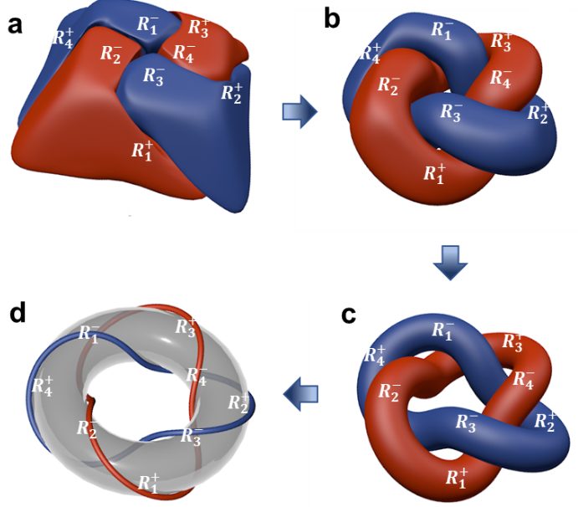
Fig. S5.
The transformation from a 3D domain to polar Solomon rings. a-c, Evolution of the 3D domain pattern in BiFeO₃ nanocrystals by gradually shrinking each domain. d, Extracted polar Solomon rings across a donut.

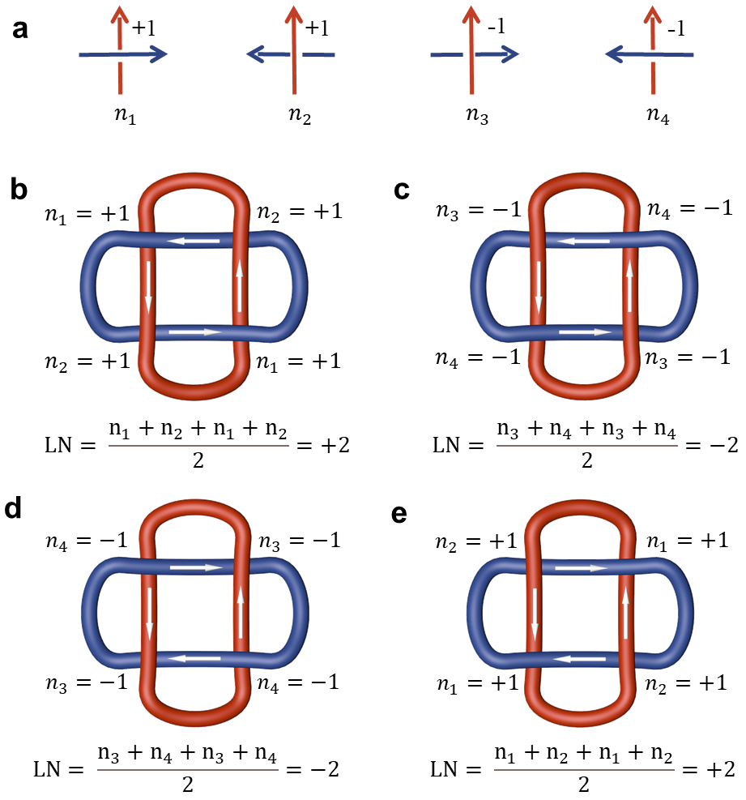
Fig. S6.
Mathematical definition of polar Solomon rings. a, The illustration of each intersecting knot for n₁, n₂, n₃, and n₄. b, c, Polar Solomon rings with calculated LN of +2 and -2, where the polarization in both red ring and blue ring rotates counterclockwise. d, e, Polar Solomon rings with calculated LN of -2 and +2, where the polarization in the red ring rotates counterclockwise and the polarization in the blue ring rotates clockwise.

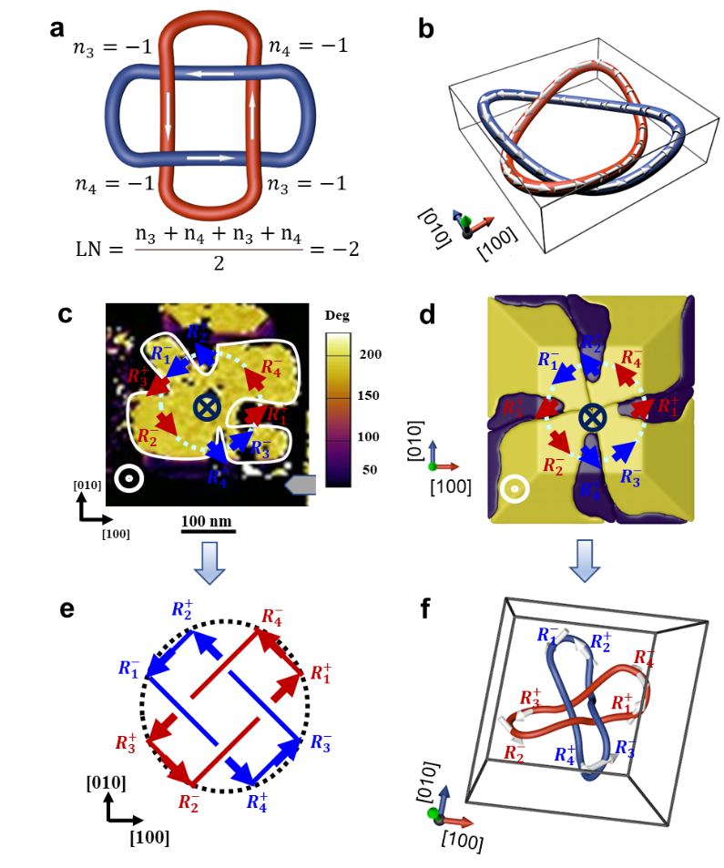
Fig. S7.
Observation of polar Solomon rings with LK of -2 in BiFeO₃ nanocrystal. a, The definition of polar Solomon rings with LK of -2. b, The distorted 3D polar Solomon rings with LK of -2. c, The construction of OOP and IP polarization projection for a BiFeO₃ nanocrystal by PFM measurement. d, Phase-field simulations of the 3D domain pattern for BiFeO₃ nanocrystal. e, The extracted two intersecting polar vortices projected in (001)-plane. f, The extracted polar Solomon rings from (d).

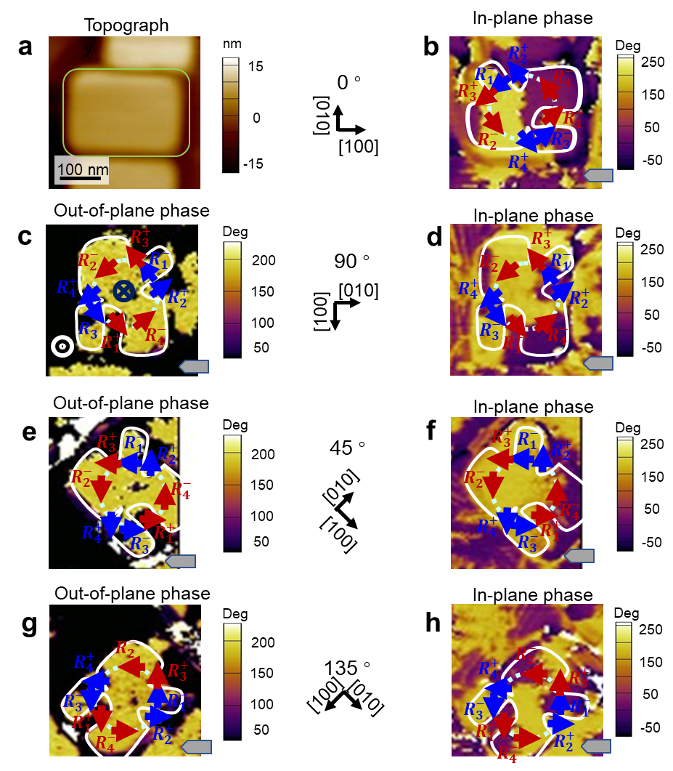
Fig. S8.
PFM characterization of the OOP and IP polarization projection for polar Solomon rings with LK of -2. This BiFeO₃ nanocrystal is the same as the presented one in Fig. S8. a, b, Morphology and IP PFM phase image for the BiFeO₃ nanocrystal at the initial state. c-f, OOP (c, e, g) and IP (d, f, h) PFM phase images for the BiFeO₃ nanocrystal when the specimen is rotated by 90° (c, d), 45° (e, f), and 135° (g, h) with respect to the cantilever.
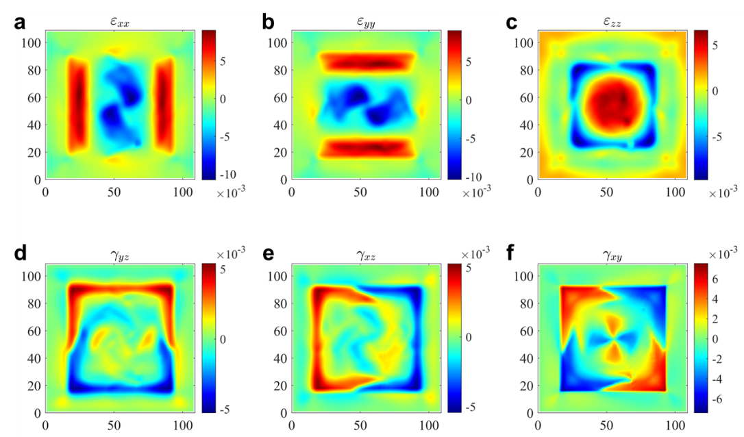
Fig. S9.
Strain distribution in BiFeO₃ nanocrystal with polar Solomon rings. a, $ε_{xx}$. b, $ε_{yy}$. c, $ε_{zz}$. d, $γ_{yz}$. e, $γ_{xz}$. f, $γ_{xy}$.

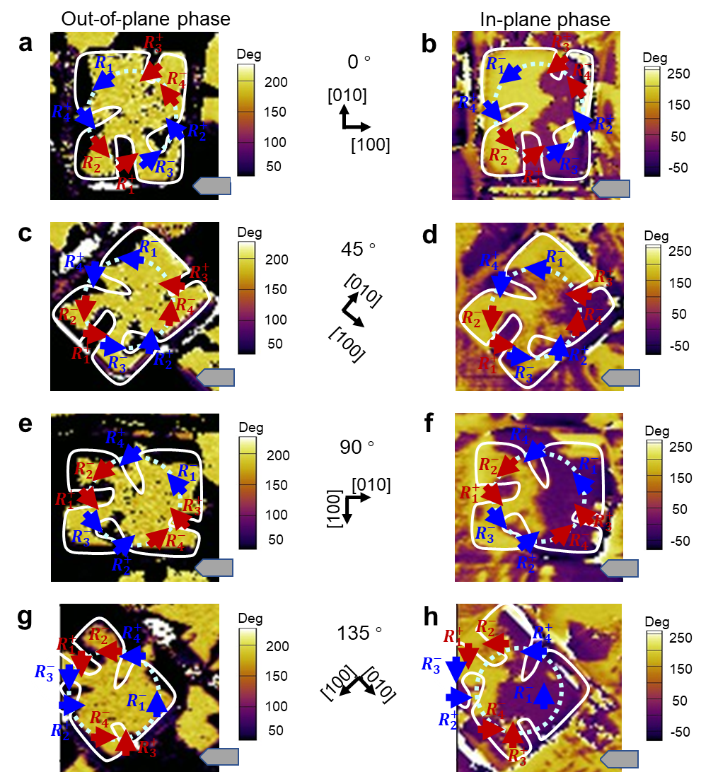
Fig. S10.
PFM characterization of the OOP and IP polarization projection for polar Solomon rings with LK of +2 in BiFeO₃ nanocrystal. a, b, OOP (a) and IP (b) PFM phase images for the BiFeO₃ nanocrystal at the initial state. c, d, OOP (c) and IP (d) PFM phase images for the BiFeO₃ nanocrystal when the specimen is rotated by 45° with respect to the cantilever. e, f, OOP (e) and IP (f) PFM phase images for the BiFeO₃ nanocrystal when the specimen is rotated by 90° with respect to the cantilever. g, h, OOP (g) and IP (h) PFM phase images for the BiFeO₃ nanocrystal when the specimen is rotated by 135° with respect to the cantilever.
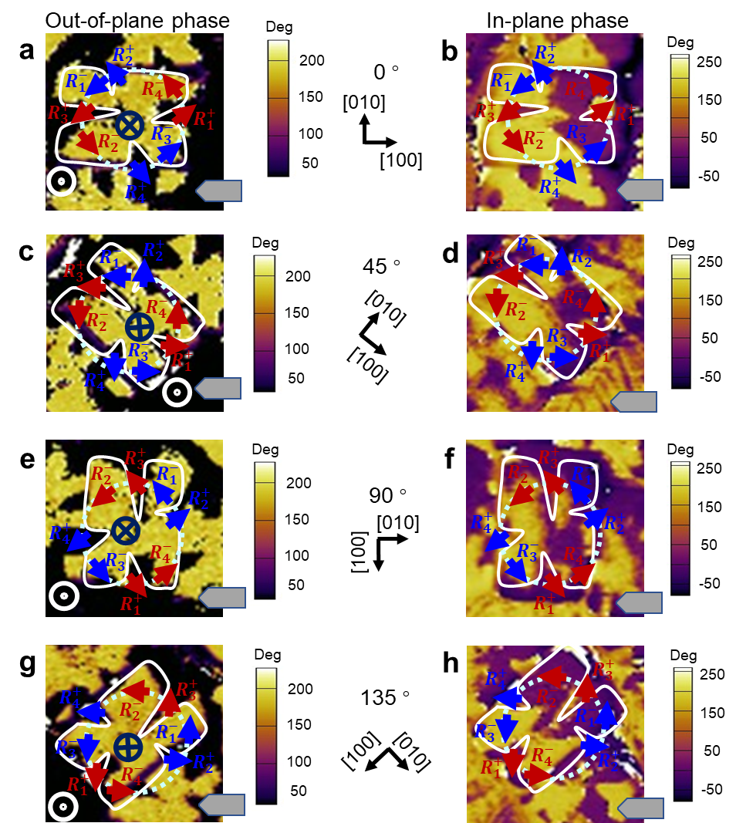
Fig. S11.
PFM characterization of the OOP and IP polarization projection for Solomon rings with LK of -2. a, b, OOP (a) and IP (b) PFM phase images for the BiFeO₃ nanocrystal at the initial state. c, d, OOP (c) and IP (d) PFM phase images for the BiFeO₃ nanocrystal when the specimen is rotated by 45° with respect to the cantilever. e, f, OOP (e) and IP (f) PFM phase images for the BiFeO₃ nanocrystal when the specimen is rotated by 90° with respect to the cantilever. g, h, OOP (g) and IP (h) PFM phase images for the BiFeO₃ nanocrystal when the specimen is rotated by 135° with respect to the cantilever.

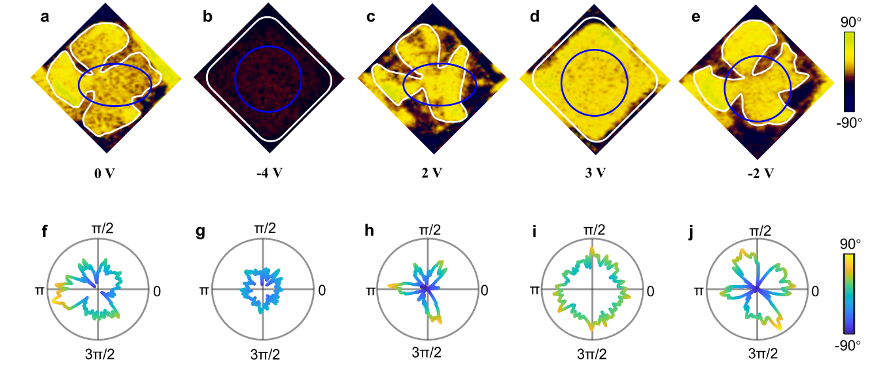
Fig. S12.
Electric-field control of the polar Solomon rings in BiFeO₃ nanocrystal. a-e, OOP PFM phase image when the nanocrystal is composed to 0V, -2V, -4V, 2V and 3V probe voltage, respectively. f-j The corresponding line profile of the OOP phase along the blue circle in (a-e), respectively.

Fig. S13.
FT-IR spectrum for rhombohedral BiFeO₃ continuous thin film.

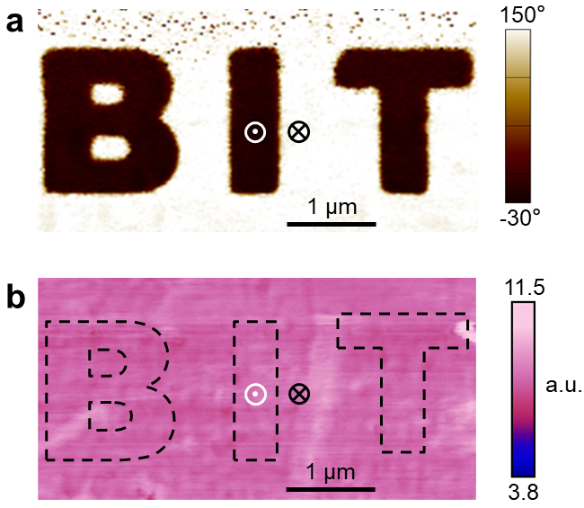
Fig. S14.
Similar IR absorption for upward and downward domains in BiFeO₃ continuous thin film. a, OOP phase image for the written ‘BIT’ characteristics. b, The corresponding IR absorption for the same location. The result indicates the similar IR absorption intensity for the upward and downward domain in the continuous BiFeO₃ thin film.

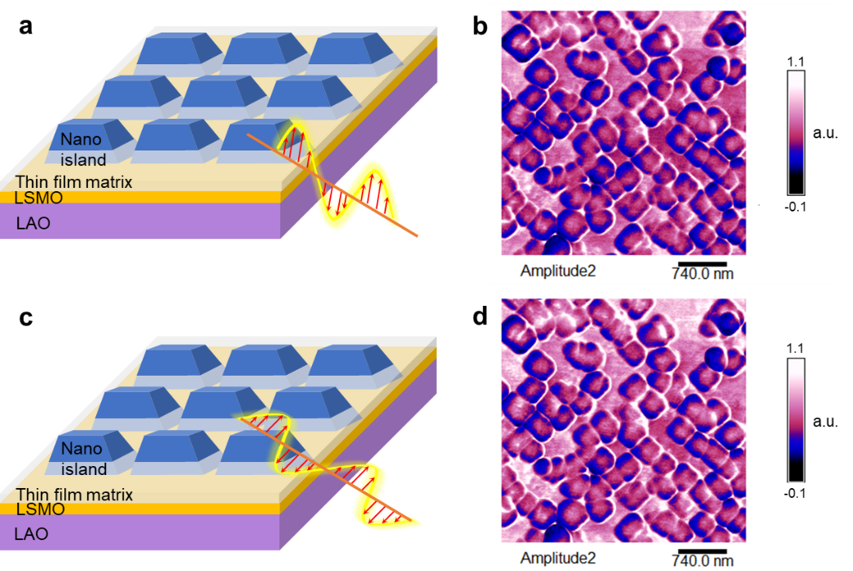
Fig. S15.
AFM IR absorption for Solomon rings with OOP and IP electric field vector. a,c, Schematic for the experimental setup with OOP (a) and IP (c) electric field vector. b, d, The corresponding IR absorption image when the electric field is OOP (b) and IP (d).

Supplementary Table 1.
List of coefficients used in the present work.
Coefficients | Values
$$α_{1}$$ | 4.64385×(T-1103)×10⁵ C⁻²m²N
$$α_{11}$$ | 2.29047×10⁸ C⁻⁴m⁶N
$$α_{12}$$ | 3.06361×10⁸ C⁻⁴m⁶N
$$α_{111}$$ | 5.99186×10⁹ C⁻⁶m¹⁰N
$$α_{112}$$ | -3.33980×10⁸ C⁻⁶m¹⁰N
$$α_{123}$$ | -1.77754×10⁹ C⁻⁶m¹⁰N
$$Q_{11}$$ | 3.2×10⁻² C⁻²m⁴
$$Q_{12}$$ | -1.6×10⁻²C⁻²m⁴
$$Q_{44}$$ | 2.0×10⁻² C⁻²m⁴
$$C_{11}$$ | 302 GPa
$$C_{12}$$ | 162 GPa
$$C_{44}$$ | 68 GPa

Supplementary Movie 1.
The transformation process between the 3D domain and the polar Solomon rings.
Supplementary Movie 2.
The dynamic domain evolution from polar Solomon rings to upward quad-domain.
Supplementary Movie 3.
The dynamic domain evolution from polar Solomon rings to downward quad-domain.

