Association of Polycyclic Aromatic Hydrocarbon Metabolite Concentration in Urine and Occupational Stress in Underground Coal Miners, China
Hongmei Zhang¹, Jingjing Cao¹, Aixiang Liu¹, Qian Gao², Jisheng Nie³, Xiaoling Zhou¹, Jianjun Huang⁴, Chenming Sun⁵, Tong Wang²*

¹Department of Environmental Health, School of Public Health, Shanxi Medical University, 56 Xinjian South Road, Taiyuan, Shanxi, 030001, People’s Republic of China.²Department of Health Statistics, School of Public Health, Shanxi Medical University, 56Xinjian South Road, Taiyuan, Shanxi, 030001, People’s Republic of China.³Department of Occupational Health, School of Public Health, Shanxi Medical University, 56 Xinjian South Road, Taiyuan, Shanxi, 030001, People’s Republic of China.⁴Department of Neurosurgery, General Hospital of Datong Coal Mining Group, Datong, 7 Xinpingwangwei 1 Ave, Datong, Shanxi, 037003, People’s Republic of China.⁵Department of Urology, General Hospital of Datong Coal Mining Group, 7 Xinpingwangwei 1 Ave, Datong, Shanxi, 037003, People’s Republic of China.

Corresponding to: Tong Wang, Department of Health Statistics, Shanxi Medical University, 56 Xinjian South Road, Taiyuan 030001, China, E-mail: tongwang@sxmu.edu.cn, Tel: 86 351-4935397.

Type of contribution: Originals
Running title: Urinary Polycyclic Aromatic Hydrocarbon Metabolite Concentration and Occupational Stress in Underground Coal Miners.
Funds: This work received the financial support from the National Natural Science Foundation of China (NSFC81001258, 81973093), Research Project Supported by Shanxi Scholarship Council of China (2017-059), Personnel Training Project of Shanxi Graduate Joint Training Base (2017JD24),Scientific and Technological Innovation Programs of Higher Education Institutions in Shanxi (STIP201802061).
Conflict of interest
No relevant financial or non-financial interests to disclose.

Supplemental Materials
Table and Figure legends
Table legends:
Table S1 Interpretation of the higher scores of ORQ, PSQ, and PRQ
Table S2 The spectrometry measurement parameters of 10 OH-PAHs and 2 internal standards
Table S3 Spearman correlation coefficient (β) between OH-PAHs congeners in urine
Table S4 Variations of urinary LMW OH-PAHs concentrations with the socio-demographic characteristics in coal miners [M(P25,P75)]
Table S5 Variations of urinary HMW OH-PAHs concentrations with the socio-demographic characteristics in coal miners [M (P25,P75)]
Table S6 Spearman correlation coefficient (β) between OH-PAHs concentrations in urine and the scores of OQR, PSQ and PRQ in coal miners
Figure legends:
Figure S1 The odd ratios (OR) changes of ORQ with OH-PAHs concentrations in urine

Table S1 Interpretation of the higher scores of ORQ, PSQ, and PRQ
Scale | Subscale | Interpretation
ORQ | Role Overload | A high score indicates an increased, unreasonable and unsupported work load.
ORQ | Role Insufficiency | A high score indicates a poor fit between the subject’s skills and the job they are performing.
ORQ | Role Ambiguity | A high score indicates that the subject has an unclear sense of what they are expected to do on their job.
ORQ | Role Boundary | A high score indicates that the subject feels caught between conflicting supervisory demands and factions.
ORQ | Responsibility | A high score suggests high levels of responsibility for activities and work performance.
ORQ | Physical Environment | A high score indicates high levels of noise, moisture, dust, heat, cold, light, poisonous substance or unpleasant odours, having an erratic work schedule or feeling personally isolated.
PSQ | Vocational Strain | A high score indicates that the subject has a poor attitude towards their work.
PSQ | Psychological Strain | A high score indicates that the subject feels depressed, anxious, unhappy or irritable.
PSQ | Interpersonal Srain | A high score indicates frequent quarrels or excessive dependency on family members or friends.
PSQ | Physical Strain | A high score indicates that the subject worries frequently about their health as well as a number of physical symptoms.
PRQ | Recreation | A high score indicates that the subject takes advantage of their recreational time and engages in a variety of activities.
PRQ | Self-Care | A high score indicates that the subject takes exercise regularly, sleeps 8 h/day, cares about their diet, practices relaxation techniques and avoids harmful substance.
PRQ | Social Support | A high score indicates that the subject has at least one person to rely on.
PRQ | Rational Coping | A high score for rational coping indicates that the subject has a systematic approach to problem solving and think through the consequences of their choices.

Table S2 The spectrometry measurement parameters of 10 OH-PAHs and 2 internal standards
Analyte | Retention time (min) | Parent ion (m/z) | Daughter ion (m/z) | Collision voltage (eV)
2-OH-Nap | 11.337 | 143 | 115 | 30
1-OH-Nap | 12.118 | 143 | 115 | 30
3-OH-Fluo | 15.134 | 181 | 180 | 30
2-OH-Fluo | 15.560 | 181 | 180 | 30
2-OH-Phen | 16.544 | 193 | 165 | 30
3-OH-Phen-¹³C₆ | 16.544 | 199 | 165 | 30
1-OH-Phen | 17.596 | 193 | 171 | 30
1-OH-Py | 20.878 | 217 | 189 | 35
3-OH-Chry | 22.531 | 243 | 215 | 35
6-OH-Chry | 22.912 | 243 | 215 | 35
6-OH-Chry-¹³C₆ | 22.912 | 249 | 221 | 35
9-OH-BaP | 26.373 | 267 | 239 | 40

Table S3 Spearman correlation coefficient (β) between OH-PAHs congeners in urine
OH-PAHs | LMW OH-PAHs | 2-OH-Nap | 1-OH-Nap | 3-OH-Fluo | 2-OH-Fluo | 2-OH-Phen | 1-OH-Phen | HMW OH-PAHs | 1-OH-Py | 3-OH-Chry | 6-OH-Chry | 9-OH-BaP
LMW OH-PAHs | 1.00 | 0.79**
2-OH-Nap | 0.79** | 1.00
1-OH-Nap | 0.52** | 0.67** | 1.00
3-OH-Fluo | 0.88** | 0.60** | 0.40** | 1.00
2-OH-Fluo | 0.96** | 0.66** | 0.39** | 0.90** | 1.00
2-OH-Phen | 0.91** | 0.63** | 0.35** | 0.84** | 0.90** | 1.00
1-OH-Phen | 0.73** | 0.65** | 0.49** | 0.63** | 0.69** | 0.73** | 1.00
HMW OH-PAHs | 0.50** | 0.47** | 0.54** | 0.44** | 0.43** | 0.49** | 0.66** | 1.00
1-OH-Py | 0.54** | 0.53** | 0.54** | 0.47** | 0.49** | 0.53** | 0.73** | 0.89** | 1.00
3-OH-Chry | 0.49** | 0.43** | 0.28** | 0.41** | 0.43** | 0.47** | 0.37** | 0.42** | 0.27** | 1.00
6-OH-Chry | 0.31** | 0.35** | 0.32** | 0.22** | 0.22** | 0.29** | 0.29** | 0.46** | 0.28** | 0.63 | 1.00
9-OH-BaP | -0.044 | -0.06 | 0.11** | -0.01 | -0.09* | -0.03 | -0.11** | 0.26** | -0.01 | 0.24** | 0.44** | 1.00

Table S4 Variations of urinary LMW OH-PAHs concentrations with the socio-demographic characteristics in coal miners [M(P25,P75)]
Demographic characteristics | n | LMW OH-PAHs | χ² | P value
Age（years）
<35 | 164 | 9.57 (2.27,22.99) | 0.406 | 0.816
35-45 | 242 | 8.49 (2.97,20.96)
>=45 | 185 | 10.28 (3.47,21.46)
Marital status
Married | 560 | 9.44 (3.15,22.18) | 5.544 | 0.019
Single | 31 | 6.28 (0.12,14.45)
Educational level
Bachelor’s | 43 | 8.76 (2.59,14.14) | 14.861 | 0.001
College | 373 | 8.09 (2.70,18.68)
Higher school and below | 174 | 13.71 (3.70,28.11)
Length of employment
4-10 y | 92 | 9.59 (1.87,18.99) | 2.010 | 0.570
11-15 y | 107 | 9.29 (3.62,25.91)
16-21 y | 139 | 8.25 (3.15,18.48)
>=21 y | 263 | 10.12 (3.47,21.46)
Work type
Front-line | 224 | 9.21 (3.17,19.20) | 0.005 | 0.945
Auxiliary work | 367 | 9.28 (2.85,23.58)
Job category
Heavy physical labor | 247 | 9.30 (3.05,19.05) | 2.369 | 0.306
Light physical labor | 284 | 9.98 (2.90,23.62)
Mental labor | 60 | 6.99 (2.84,15.73)
Tobacco smoking
Yes | 192 | 7.78 (2.56,19.13) | 3.043 | 0.081
No | 399 | 9.67 (3.47,23.58)
Alcohol drinking
Yes | 322 | 9.68 (2.85,21.26) | 0.026 | 0.871
No | 269 | 8.71 (3.15,22.48)
Sleeping status
Good | 310 | 8.66 (3.03,20.70) | 1.235 | 0.539
Moderate | 211 | 9.89 (2.68,21.54)
Bad | 30 | 12.53 (6.99,24.54)
Use of sleeping pills
Often | 1 | 0.07 (0.07,0.07) | 5.795 | 0.552
Occasionally | 2 | 36.81 (35.49,38.14)
Never | 576 | 9.08 (2.95,21.35)
Accidents and injury occurrence
Yes | 558 | 9.27 (3.00,21.46) | 0.151 | 0.698
No | 33 | 10.91 (2.87,21.55)

Table S5 Variations of urinary HMW OH-PAHs concentrations with the socio-demographic characteristics in coal miners [M (P25,P75)]
Demographic characteristics | n | HMW OH-PAHs | χ² | P value
Age (years)
<35 | 164 | 0.26 (0.11,1.01) | 0.198 | 0.906
35-45 | 242 | 0.31 (0.12,0.98)
>=45 | 185 | 0.31 (0.11,0.81)
Marital status
Married | 560 | 0.29 (0.11,0.95) | 1.335 | 0.248
Single | 31 | 0.31 (0.11,0.59)
Educational level
Bachelor’s | 43 | 0.17 (0.07,0.49) | 6.903 | 0.032
College | 373 | 0.29 (0.12,0.86)
Higher school and below | 174 | 0.35 (0.11,1.11)
Length of employment
4-10 y | 92 | 0.38 (0.15,1.09) | 3.451 | 0.327
11-15 y | 107 | 0.24 (0.11,1.01)
16-21 y | 139 | 0.24 (0.10,0.75)
>=21 y | 263 | 0.35 (0.11,0.95)
Underground working type
Front-line | 224 | 0.31 (0.13,1.03) | 1.447 | 0.229
Auxiliary work | 367 | 0.28 (0.11,0.84)
Job category
Heavy physical labor | 247 | 0.32 (0.15,1.01) | 6.515 | 0.039
Light physical labor | 284 | 0.30 (0.11,0.81)
Mental labor | 60 | 0.18 (0.09,0.93)
Tobacco smoking
Yes | 192 | 0.27 (0.11,0.77) | 0.824 | 0.360
No | 399 | 0.31 (0.11,0.97)
Alcohol drinking
Yes | 322 | 0.33 (0.11,0.89) | 0.043 | 0.840
No | 269 | 0.27 (0.11,0.92)
Sleeping status
Good | 310 | 0.31 (0.12,1.03) | 5.371 | 0.068
Average | 211 | 0.26 (0.10,0.69)
Poor | 30 | 0.60 (0.22,1.16)
Use of sleeping pills
Often | 1 | 0.51 (0.51,0.51) | 0.785 | 0.675
Occasionally | 2 | 1.45 (0.22,2.69)
Never | 576 | 0.29 (0.11,0.89)
Accidents and injury occurrence
Yes | 558 | 0.30 (0.11,0.90) | 0.738 | 0.390
No | 33 | 0.26 (0.07,0.77)

Table S6 Spearman correlation coefficient (β) between OH-PAHs concentrations in urine and the scores of OQR, PSQ and PRQ in coal miners
OH-PAHs | OQR | PSQ | PRQ
LMW OH-PAHs | 0.081*  (P=0.045) | -0.010  (P=0.803) | 0.015  (P=0.712)
2-OH-Nap | 0.089*  (P=0.029) | -0.002  (P=0.955) | 0.014  (P=0.732)
1-OH-Nap | -0.003  (P=0.939) | -0.009  (P=0.813) | -0.022  (P=0.591)
3-OH-Fluo | 0.103*  (P=0.011) | -0.017  (P=0.675) | -0.035  (P=0.395)
2-OH-Fluo | 0.088*  (P=0.030) | -0.008  (P=0.845) | 0.006  (P=0.887)
2-OH-Phen | 0.058  (P=0.152) | -0.034  (P=0.411) | 0.002  (P=0.954)
1-OH-Phen | 0.004  (P=0.913) | 0.007  (P=0.862) | 0.020  (P=0.632)
HMW OH-PAHs | 0.289  (P=0.477) | -0.019  (P=0.643) | -0.037  (P=0.356)
1-OH-Py | 0.073#  (P=0.074) | 0.006  (P=0.892) | -0.126  (P=0.518)
3-OH-Chry | 0.012  (P=0.768) | 0.009  (P=0.833) | -0.064  (P=0.114)
6-OH-Chry | 0.055  (P=0.179) | -0.034*  (P=0.040) | 0.069#  (P=0.088)
9-OH-B[a]P | 0.048  (P=0.231) | 0.024  (P=0.559) | 0.006  (P=0.987)

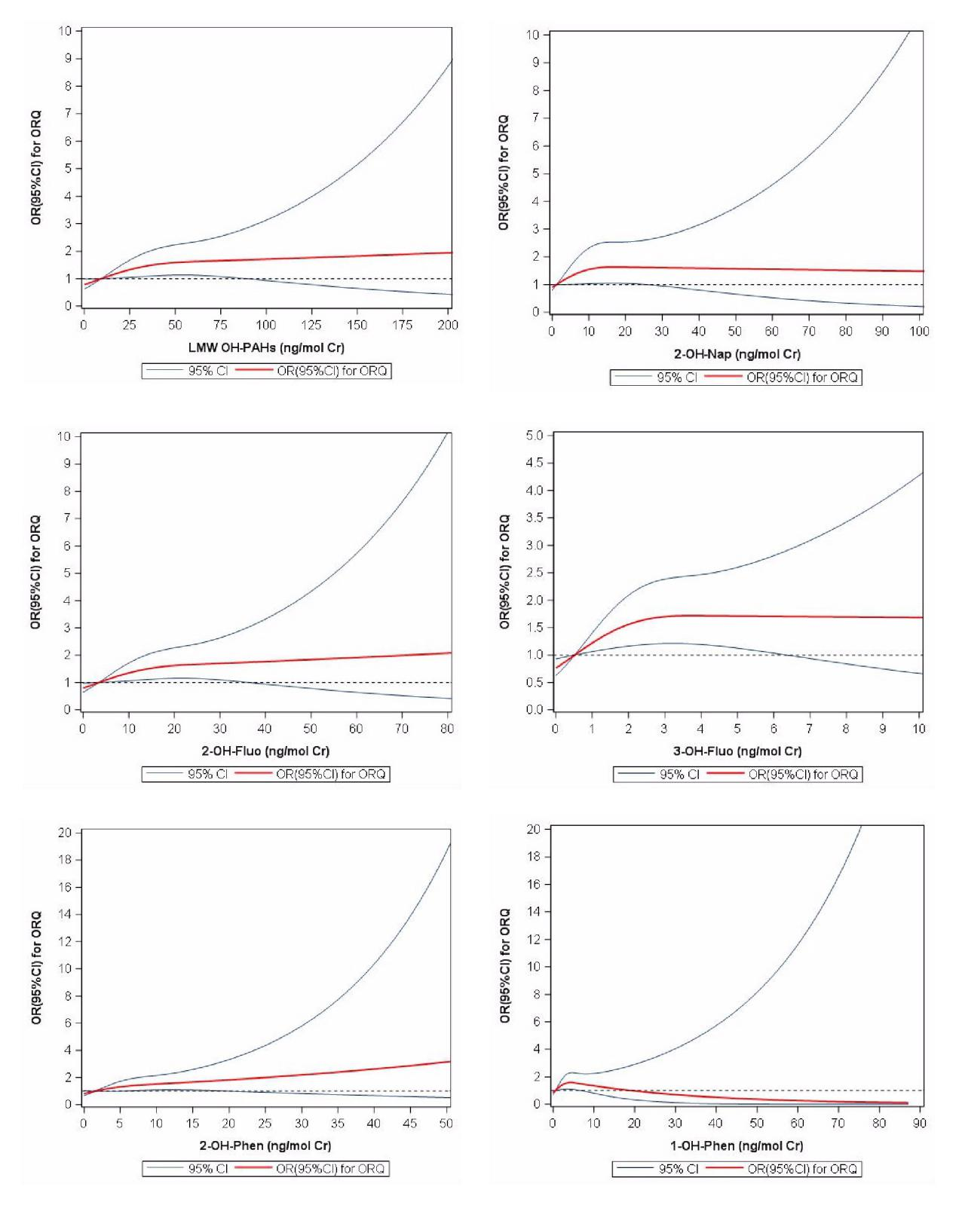
Figure S1 The odd ratios (OR) changes of ORQ with OH-PAHs concentrations in urine

