Supplementary Information for Assembling the puzzle for conducting research through the lens of diversity and cohesion: The SALURBAL experience

Sofía Baquero^{a*}, Felipe Montesª, Ivana Stankov^{b,c}, Olga L. Sarmiento^{d}, Pablo Medina^{e}, S. Claire Slesinski^{f}, Francisco Diez-Canseco^{g}, Maria F. Kroker-Lobos^{h}, Waleska Teixeira^{i}, Alejandra Vives^{j}, Marcio Alazraqui^{k}, Tonatiuh Barrientos-Gutiérrez ^{l} and Ana V. Diez Roux^{b}

*Sofía Baquero, Address: Crr 1 Este No.19A - 40 Piso 8, Bogotá, Colombia, Phone: +57 3167525836
Email: sdc.baquero10@uniandes.edu.co

Supplementary Information

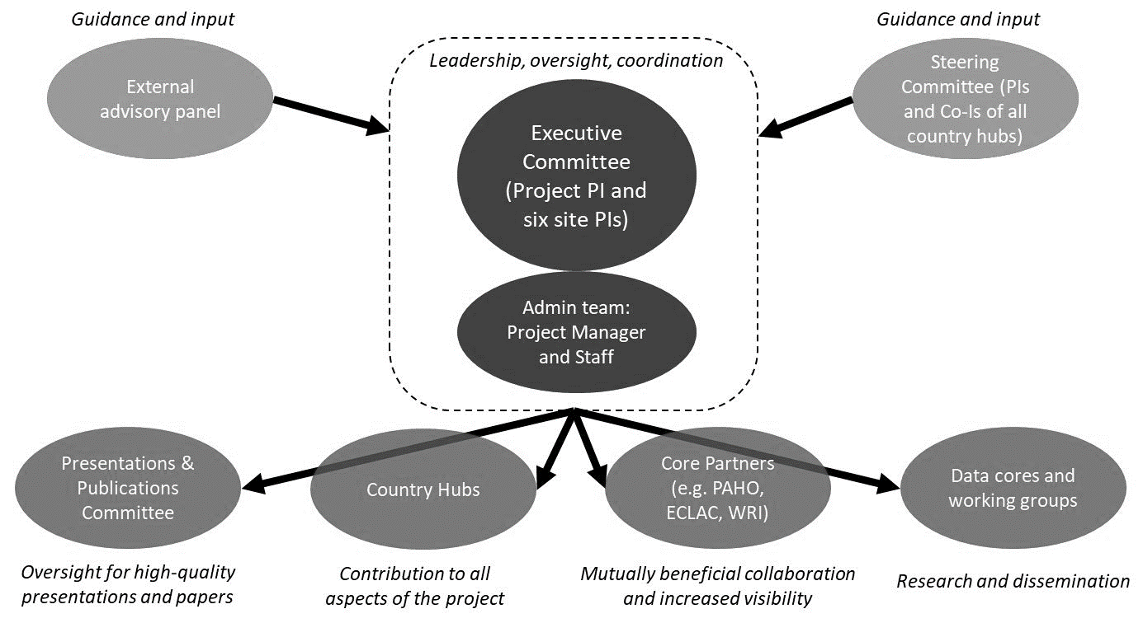

Fig. S1. SALURBAL’s Governance and Administrative Structure¹.

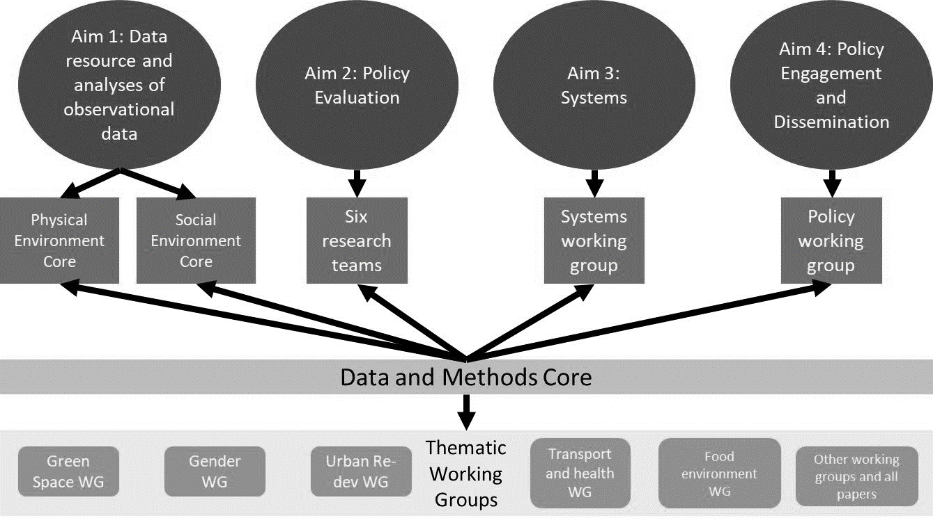

Fig. S2. SALURBAL’s Cores and Working Groups by Study Aims ¹.

Table S1. SALURBAL project activities.
Activity | Description | Goals | Frequency
Proposals | Manuscript proposals for peer review papers. The Publications and Presentations Committee (P&P) reviews proposals for publications and presentations. |  | Monthly
Academic training workshops | Multilevel analysis training workshops and Introduction to Directed Acyclic Graphs (DAGs) for Causal Inference workshop mainly for young investigators. | Capacity building for analyzing SALURBAL data. | Three: Belo Horizonte 2018, Lima 2019, and virtual 2020
Meetings | Virtual full team meetings. Young and senior investigators are invited to present updates on the research. | Team meetings which to give presentations on their work at SALURBAL’s to receive input and support from the project’s senior research leadership and for the SALURBAL team to learn from each other. | Monthly
Meetings | In-person team meetings in SALURBAL’s country hubs. During the two-day event. | These team meetings include updates on project policies and events but focus mostly on the presentation of “works-in-progress”, updates on and discussions of SALURBAL analyses and papers. SALURBAL team members facilitated a set of activities focused on dialogue and group reflection. | Biannual before COVID-19 pandemic
Meetings | Virtual core and working group meetings (n:13). | Cores and working groups to move forward with tasks related to data compilation, analysis, creation of indicators, and interest groups. | Bimonthly to monthly
Group Model Building | Three in-person regional workshops (Lima, Guatemala y Brazil) with a diverse set of stakeholders (government, nonprofits, community members, international organizations, academics) that were very carefully designed to maximize diversity across geography, gender, discipline, | Workshop goals include: (1) to engage diverse stakeholders in the SALURBAL project and vision; (2) to provide stakeholders with experience in the application of systems approaches to urban health problems, and (3) to obtain stakeholder input that will help identify and prioritize research questions to be pursued by the SALURBAL Project using systems modeling in the future. | Three: Lima 2017, Sao Paulo 2018, Antigua 2018
Papers | Approved papers by Publications and Presentations Committee (P&P) or peer review published papers. | To disseminate SALURBAL research. | 2019 (n=28) to July 2020 (n=20)
Forums and symposiums | Knowledge to Policy Forum. Forum participants represented an interdisciplinary and diverse group of organizations with an interest in urban health, equity, and sustainability. Attendees included representatives from municipal governments, health secretariats, non-governmental organizations, and community-based organizations. | First, introduced the project to key regional stakeholders, built connections with them, and increased the project’s overall visibility. Second, the project solicited and received feedback from these stakeholders on the project’s research questions, policy engagement activities, and dissemination products to inform SALURBAL’s ongoing activities. Finally, provided a space for these stakeholders to discuss regional challenges to the translation of knowledge to policy and developed a set of potential solutions and approaches for overcoming those challenges. | Mexico City 2018
Forums and symposiums | Local Policy Symposiums after biannual research team meetings held by countries hubs. Attendees included representatives from municipal governments, health secretariats, non-governmental organizations, and community-based organizations. | To discuss SALURBAL results in the context of local policies. | Bogotá 2017, Lima 2017, Antigua 2018 and Belo Horizonte 2019

Table S2. SALURBAL participants attributes.
Country | City | Discipline* | Research topic | Sector | Career stage | Gender
Argentina | Ames | Administration | Administrative Support | Academia | Senior | Women
Australia | Ann Arbor | Anthropology | Aging | Intersectoral | Junior | Men
Bolivia | Austin | Architecture | Air Pollution | Private Sector
Brazil | Barcelona | Communications | Biostatistics | Public and Government
Canada | Barranquilla | Complex Systems | Built Environment
Chile | Beijing | Computer Science | Data Analysis
China | Belo Horizonte | Data Management | Data Science
Colombia | Berkeley | Demography | Data Visualization
Costa Rica | Bethesda | Economics | Demographic Transition
Ecuador | Bogotá | Engineering | Dissemination
El Salvador | Boston | Environmental Health | Econometrics
France | Braga | Environmental Sciences / Environmental Studies | Employment
Guatemala | Brasilia | Epidemiology | Financial Management
Honduras | Buenos Aires | Geography | Gender Disparities
Indonesia | Cali | Geophysics | Gender Statistics
Mexico | Cambridge | Management | GIS
Panama | Caracas | Public Health | Health Behaviors
Peru | Centre County | Public Policy | Health Communication
Portugal | Chapel Hill | Physics | Health Disparities
Saudi Arabia | Chicago | Social System | Health Economics
Singapore | Ciudad de Guatemala | Sociology | Health Management
Spain | Ciudad de Mexico | Statistics | Language Interpretation
Switzerland | Ciudad de Panamá | Systems Thinking | Maternal & Child Health
United Kingdom | Cochabomba |  | Mobility
USA | Córdoba |  | Mortality
Venezuela | Cuernavaca |  | Network Analysis
 | Cuiabá |  | Non-Communicable Diseases
 | Diamantina |  | Nutrition
 | Durham |  | Obesity
 | Feira de Santana |  | Operations Research
 | Gainesville |  | Peri-Urban Studies
 | Geneva |  | Physical Activity
 | Goiania |  | Policy evaluation
 | Governador Valadares |  | Policymaker Engagement
 | Ibagué |  | Project Administration
 | Jeddah |  | Public Management
 | Lanús |  | Qualitative Research
 | Lima |  | Remote Sensing
 | London |  | Road safety
 | Los Angeles |  | Segregation
 | Madison |  | Simulation-based Methods
 | Makassar |  | Social Determinants of Health
 | Medellín |  | Social Dynamics
 | Melbourne |  | Social Environment
 | Mexico City |  | Social Epidemiology
 | Minneapolis |  | Social Work
 | Montpellier |  | Spatial Analysis
 | Natal |  | Statistical Analysis
 | New Haven |  | Transport
 | New York |  | Urban Health
 | Ottawa |  | Urban Planning
 | Ouro Preto |  | Violence
 | Philadelphia
 | Porto
 | Quito
 | Raleigh
 | Rio de Janeiro
 | Salvador da Bahia
 | San José
 | San Salvador
 | Santiago de Chile
 | Santo Andre
 | São Paulo
 | Seattle
 | Singapore
 | St. Louis
 | Stanford
 | Tandil
 | Tegucigalpa
 | Valencia
 | Vancouver
 | Villa Nueva
 | Washington D.C.

* To be considered a discipline, it must fulfill the following characteristics: have a particular object of research, have a body of accumulated specialist knowledge, have theories and concepts; use specific terminologies; have developed specific research methods; must have some institutional manifestation in the form of subjects taught and professional associations connected to it ².

SI References

1. Slesinski, C., Roux, A. D. & SALURBAL team. SALURBAL Mid-Project report 2019. (2019).
2. Krishnan, A. What are academic disciplines? Natl. Cent. Res. Methods 57 (2009).

