Supplementary figures
Fig. A.1 Diversity of Simpson (A), Chao1 (B) and ACE’s index (C) of soil prokaryotic communities under different soil water content conditions in the south shore grassland ecosystem of Hulun Lake. HW: high water content; MW: medium water content; LW: low water content. Boxplots with different letters above the box indicate significantly different means (P < 0.05).

Fig. A.2 Direct and indirect effects of biotic and abiotic factors on the diversity of microbial communities. Line thickness is related to the relative strength of the relationships between variables. Solid lines indicate positive relationships; dashed lines indicate negative relationships. Biotic factors: aboveground biomass (AGB); abiotic factors: soil water content (SWC), pH, texture (sand/clay/silt), nutrient (SOC/TN). The SEM plot corresponds to a histogram of stacking effects, where the direct and indirect effects are represented by orange and green, respectively.

Fig. A.3 Spearman correlations between dominant phyla and biotic and abiotic factors. The horizontal axis is the biotic and abiotic factors and the vertical axis is the dominant microbial phylum. The colors from blue to red represent the negative to positive correlation between the two.
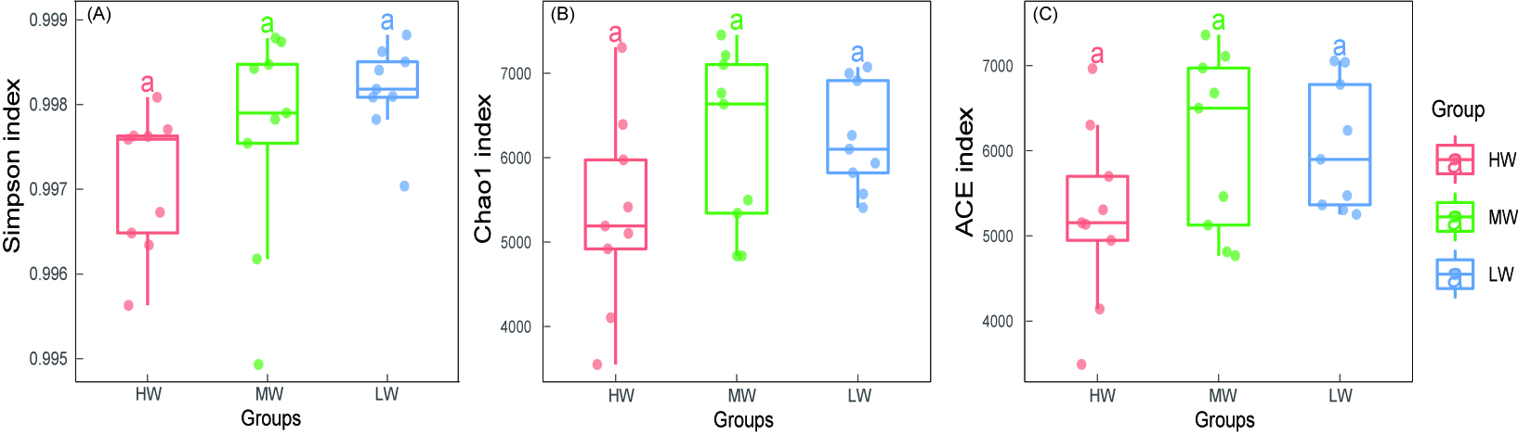

Fig. A.1 Diversity of Simpson (A), Chao1 (B) and ACE’s index (C) of soil prokaryotic communities under different soil water content conditions in the south shore grassland ecosystem of Hulun Lake. HW: high water content; MW: medium water content; LW: low water content. Boxplots with different letters above the box indicate significantly different means (P < 0.05).

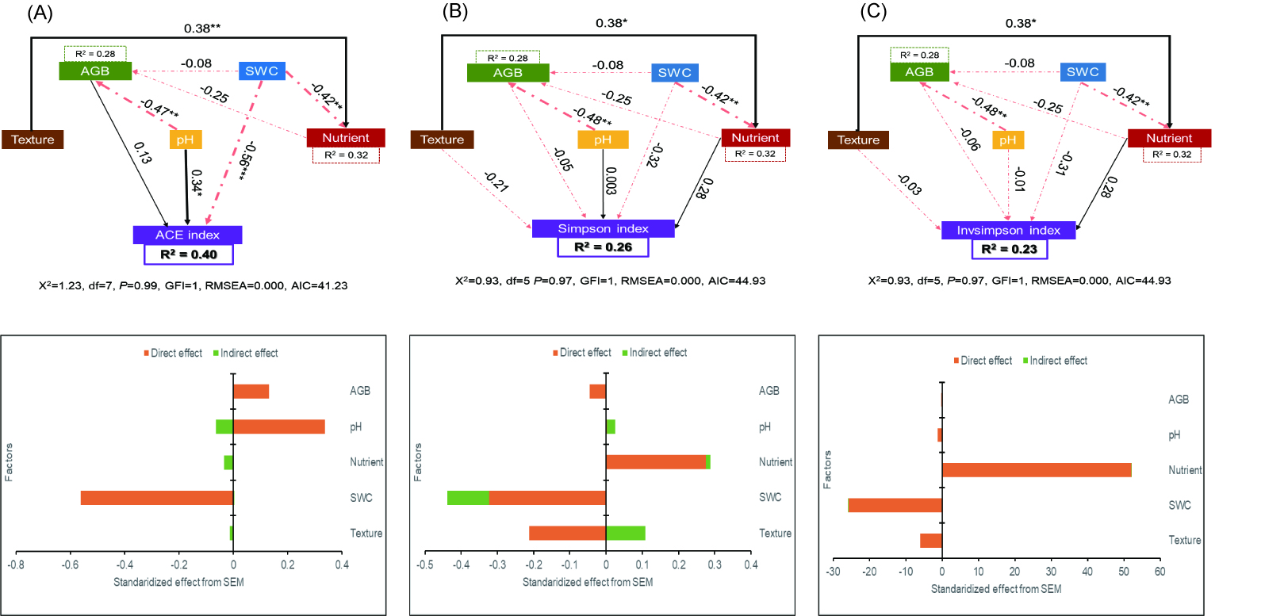

Fig. A.2 Direct and indirect effects of biotic and abiotic factors on the diversity of microbial communities. Line thickness is related to the relative strength of the relationships between variables. Solid lines indicate positive relationships; dashed lines indicate negative relationships. Biotic factors: aboveground biomass (AGB); abiotic factors: soil water content (SWC), pH, texture (sand/clay/silt), nutrient (SOC/TN). The SEM plot corresponds to a histogram of stacking effects, where the direct and indirect effects are represented by orange and green, respectively.

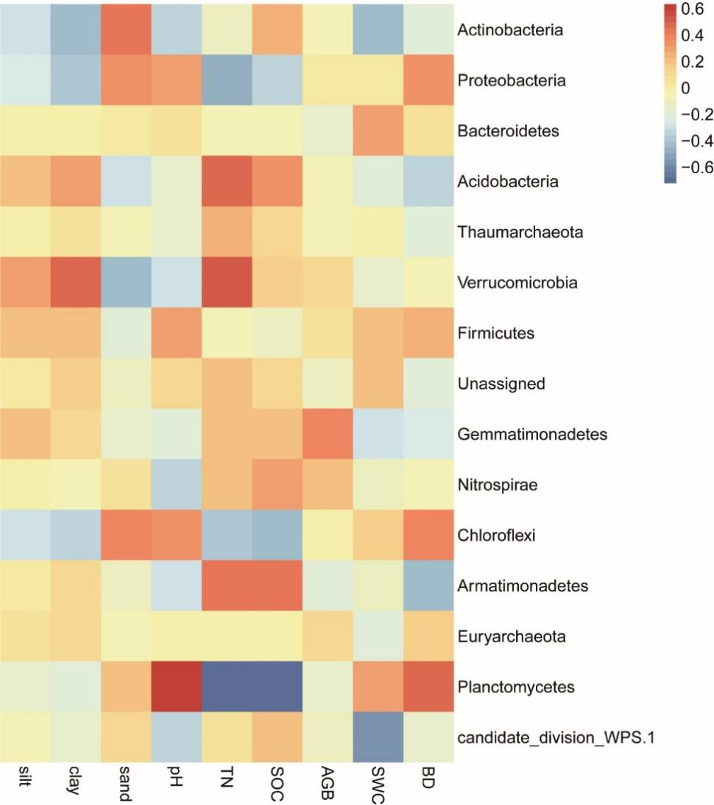

Fig. A.3 Spearman correlations between dominant phyla and biotic and abiotic factors. The horizontal axis is the biotic and abiotic factors and the vertical axis is the dominant microbial phylum. The colors from blue to red represent the negative to positive correlation between the two.

