Expanded Sediment Core Descriptions
Table S1: Thickness of deposits related to the Hunga Volcano eruption sampled at the different multicore sites, including identification of deposits attributable to the pyroclastic density currents and to ashfall. Thickness annotated as >X cm indicate that the core did not recover the base of the deposits and that the true thickness is greater than that presented. Station numbers are given in Figure S6.
Core Site  (Station # / Site #) | Total thickness of HTHH deposits sampled [cm] | PDC deposit thickness [cm] | Ashfall deposit thickness [cm]
090/23 | 30.5 | 23 | 7.5
096/31 | 48.5 | 47 | 1.5
022/16 | 42.5 | 42 | 0.5
087/21A | >18.5 | >12.7 | 5.8
087/21B | >19.0 | >15.9 | 3.1
083/4 | >22.0 | >19.0 | 3.0
065/30 | >32.2 | >27.7 | 4.5
095/24 | 6.5 | 4.5 | 2.0
070/17 | >11.2 | >11.2 | Absent
031/20 | >33.8 | >32.8 | 1.0
036/22 | 38.0 | 34.0 | 4.0
076/18 | 2.45 | 2.45 | Absent

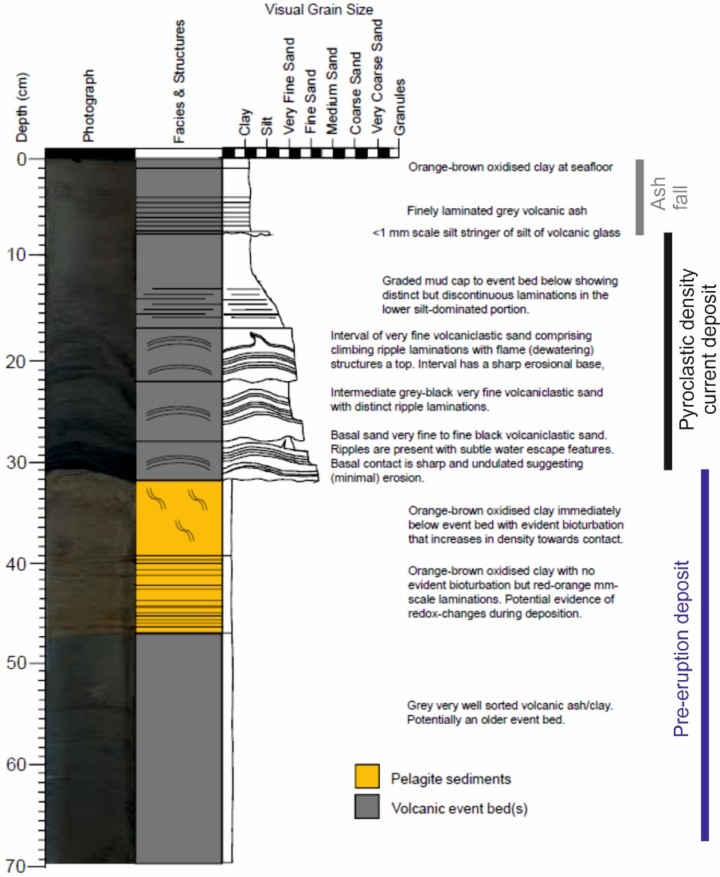
Figure S1: Representative visual core log from multicore location 90/23, illustrating pre-eruption, pyroclastic density current and ash fall deposits.

Expanded Geochemical Results (See Supplemental Data 1 for complete data)
Effect of washing submarine ash on major element composition.
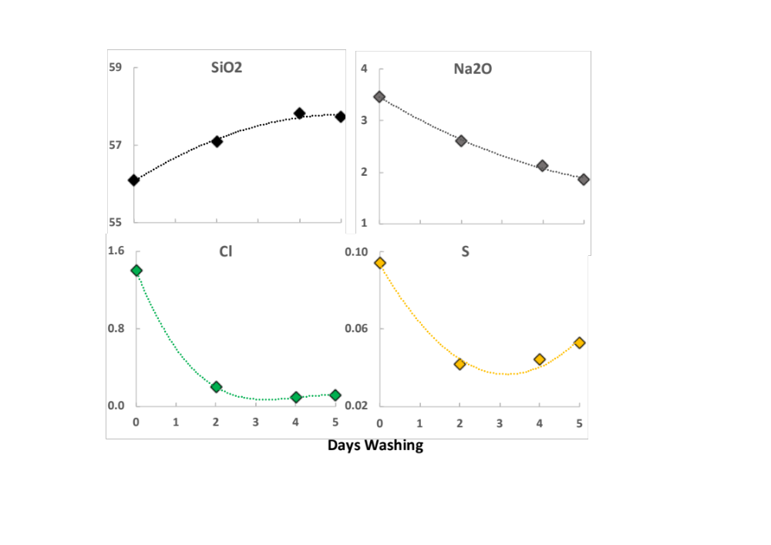
The major element composition of sample 90-1 varied depending on the extent of washing the sample had undergone (Figure S2, Supplementary Data 1). After five days of washing Na₂O contents had almost halved, going from 3.47 wt % in the unwashed sample to 1.86 wt. %. Similarly, Cl and S were excessively high in the unwashed sample (1.4 wt. % and >900 ppm, respectively) although equilibrium was reached after 2 days of washing (~ 0.1 wt. % and ~500 ppm). Due to the high contents of these elements in unwashed samples (and samples only washed for a day) other elements had correspondingly lower totals. The most pronounced effect was on SiO₂, which was ~1.6 wt. % in the fully washed sample compared to the unwashed sample.
Figure S2: The effect of washing ash samples in distilled water on the chemical composition. Initial Na₂O, Cl and S values were high in unwashed samples but plateaued after 5 days washing. Conversely SiO₂ significantly increased.

These results, for fine ash samples, are consistent with a previous study on whole rock samples undertaken by Tani et al. (2003) and highlight the importance of adequately washing submarine samples to remove seawater contaminants.

The source of ash in TAN2206 cores.
All core samples analysed are andesitic in composition. Glass shards from ash collected from Tongatapu and those found in CTD casts, overlap in composition with core samples, but range to dacitic in composition. This may be due to higher degrees of fractionation of the glasses, or an artefact of the semi-quantitative nature of the EDS analyses. Nevertheless, all samples have compositions similar to samples from HT-HH reported by Brenna et al. (2022) and are distinct from samples analysed from other nearby volcanoes. This is consistent with the TAN2206 samples originating from the 2022 HT-HH eruption, as indicated by seafloor bathymetry and images.

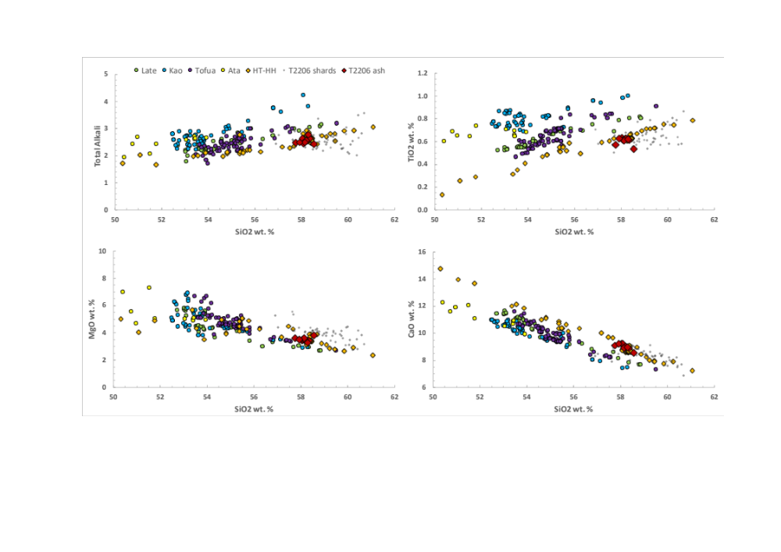
Figure S3: Major element compositions of core material (T2206 ash) and glass shards from TAN2206 and ash from Tongatapu (T2206 shards) compared to previously published data from HT-HH (Brenna et al., 2022) and surrounding volcanoes: (north to south) Late, Kao, Tofua and Ata (Beier et al., 2017).
Core samples have a more restricted compositional range than samples from HT-HH analysed by Brenna et al. (2022), which can be explained by their petrological composition. The Brenna et al. (2022) samples are whole rock compositions that show extensive fractionation, whereas TAN2206 samples are mostly fine ash, so are more representative of glass compositions than a mixture of glass and minerals. The exception are the two sandy samples (31-III and 70-Ash), which have a high proportion of felsic material (plagioclase), resulting in higher Al₂O₃ and lower Fe2O₃ and TiO₂ contents.
Samples from core 90, representing different depositional phases of the eruptive deposits, have similar compositions, suggesting little chemical variation between the depositional phases. Significantly, the old seafloor sample (90 base) is indistinct from other samples, indicating that previous eruptions from HT-HH also deposited material in this locality.

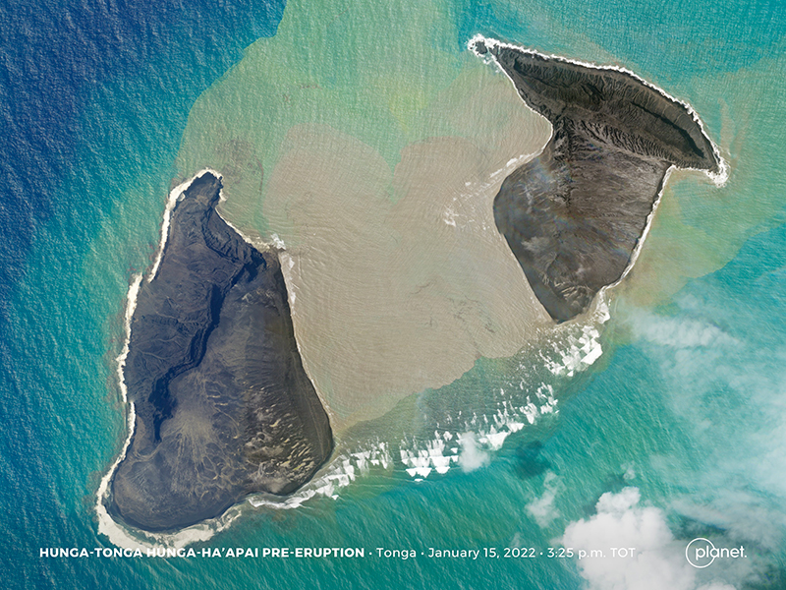Figure S4: Satellite image of Hunga Tonga Hunga Ha’apai on 15 January before the largest eruptive event on the evening of 15 January, showing the impact of the 14 January eruption and the centre portion of the island/caldera. Image courtesy of Tanya Harrison, Planet Labs.

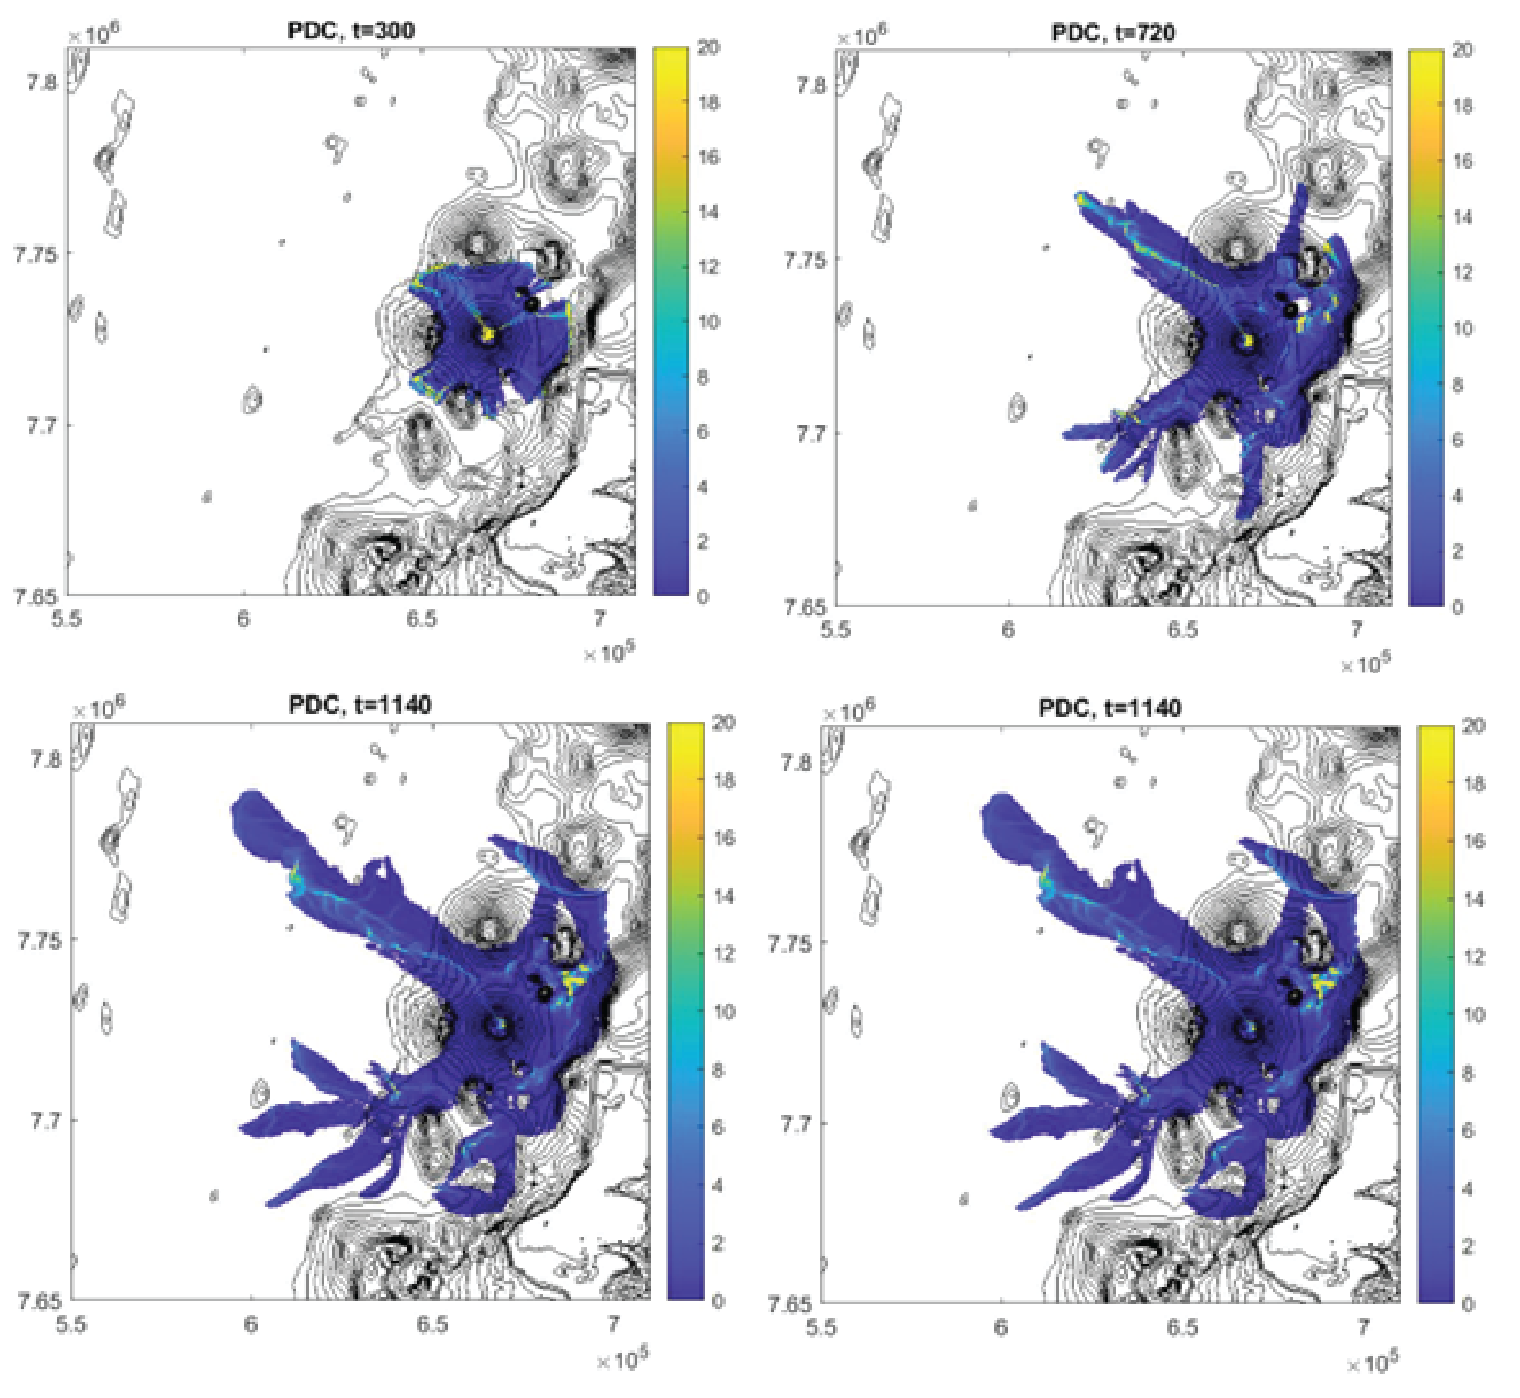
Figure S5: Select images of the Pyroclastic Density Current (PDC) model intreprated in Figures 2 and 3, and given in Supplemental Video 1. (t=time in model run)
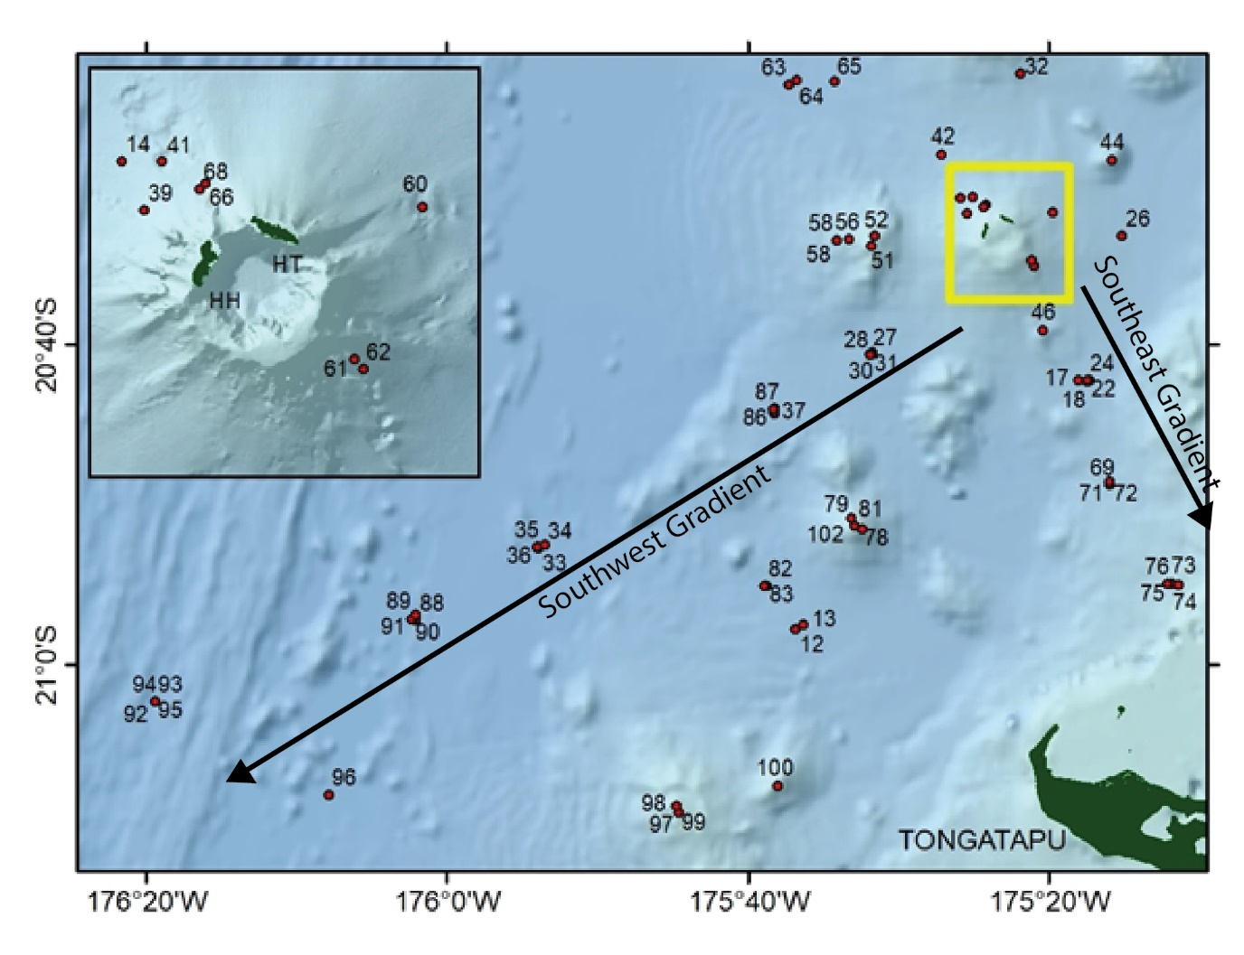
Figure S6: Map of study region with station numbers indicated, which correlate to the station numbers given in the included tables and figures below, as well as additional supplementary tables.

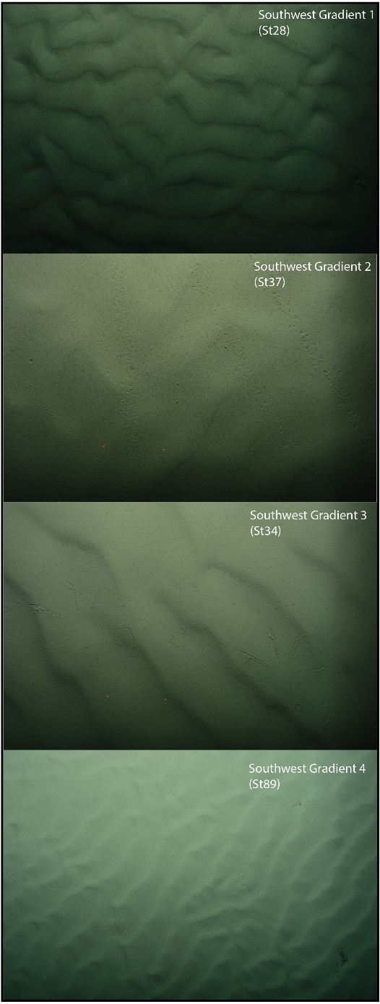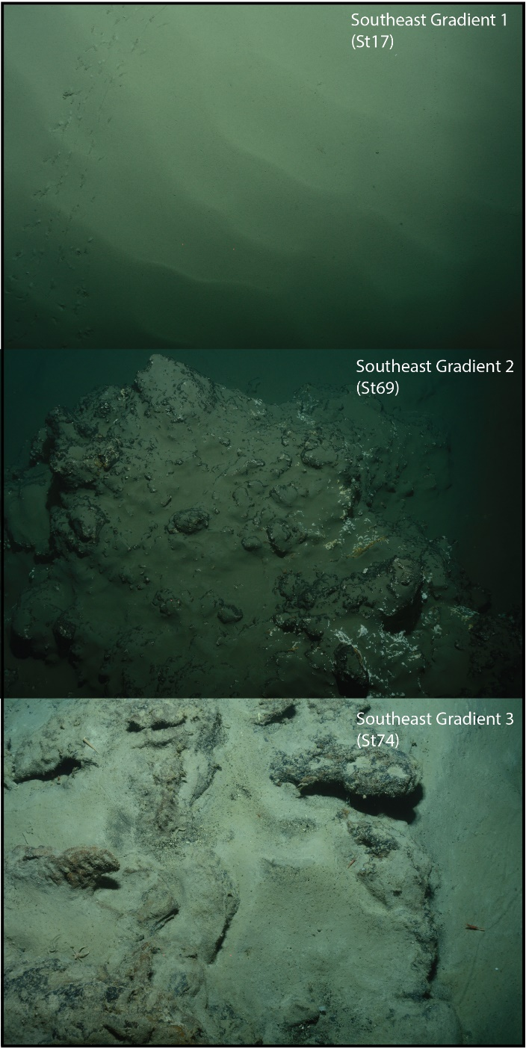
Figure S7: Images from the DTIS along the Southwest and Southeast gradient sites, with Station numbers correlated to Figure S6 indicated. These regions are interpreted as being regions of PDC deposition. Seafloor ripples were obvious extending across both gradient sites, with fine ashfall over rocky terrain also seen.
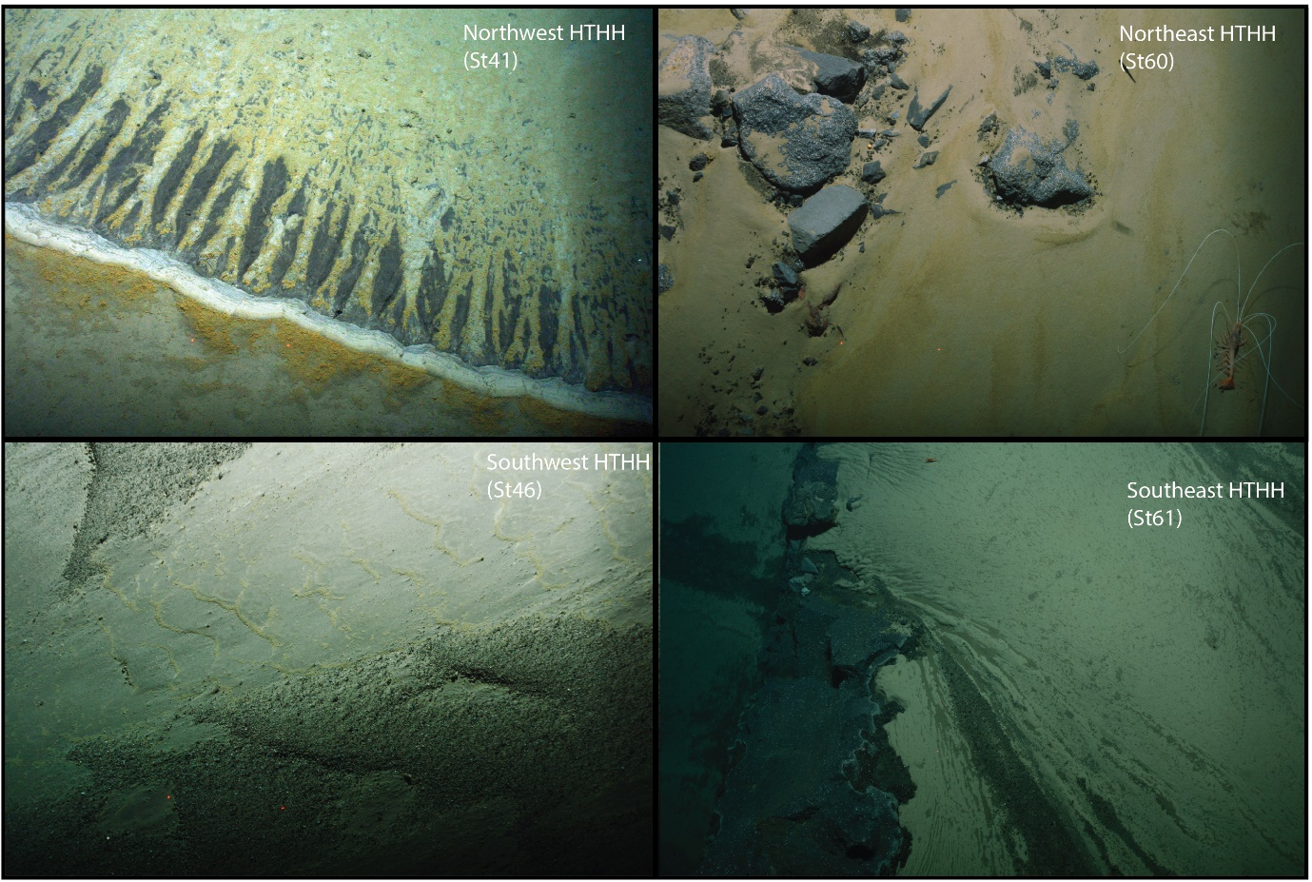
Figure S8: Images from the DTIS along the flanks of Hunga Volcano, with station numbers correlating to Figure S6 indicated.

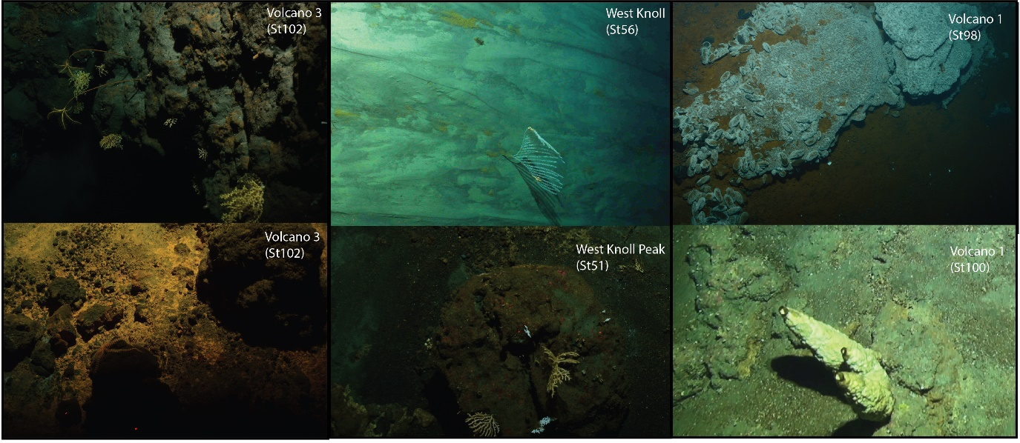
Figure S9: Seafloor images from DTIS from three seamounts in the region. Station numbers correlate to those indicated in Figure S6. Deep sea corals and other invertebrates can be seen, as well as microbial mats, the mussel bed found by Falkor in 2017, and a chimney structure.
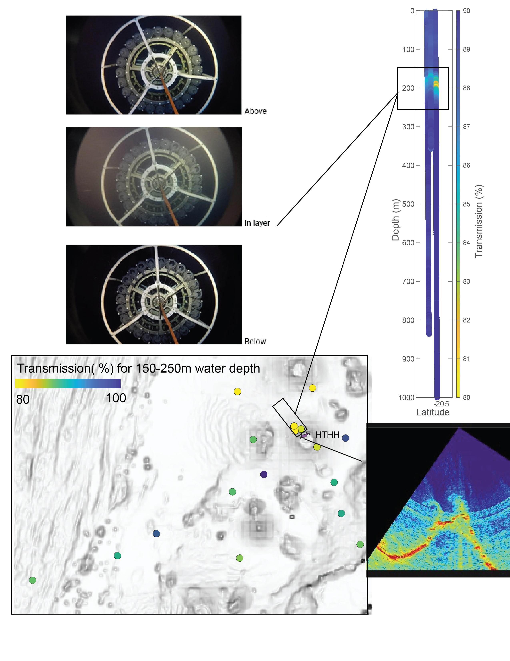Figure S10: Top left: images of the CTD in the water column, above, within, and below the midwater ash layer. Top right: The corresponding high turbidity layer is shown with a vertical cross section of the water column, a lower % beam transmission corresponds to more particles in the water column. Bottom left: a map of the region with dots colored by the intensity of the beam transmission of the CTD. Bottom right: water column acoustics indicating a gas or particle plume on the caldera rim, with the location indicated.

References
Beier C., Turner, S.P., Haase, K.M., Pearce, J.A., Munker C., Regelous, M., 2017. Trace element and isotope geochemistry of the northern and central Tongan Islands with an emphasis on the genesis of high Nb/Ta signatures at the northern volcanoes of Tafahi and Niuatoputapu. Journal of Petrology 58, 1073-1106. doi: 10.1093/petrology/egx047
Brenna, M., Cronin, S.J., Smith, I.E.M., Pontesilli, A., Tost, M., Barker, S., Tonga’onevai, S., Kula, T., Vaimounga, R., 2022. Post-caldera volcanism reveals shallow priming of an intra-ocean arc andesitic caldera: Hunga volcano, Tonga, SW Pacific. Lithos 412-413 (106614). doi: 10.1016/j.lithos.2022.106614
Tani, K., Kawabata, H., Chang, Q., Sato, K. & Tatsumi, Y., 2003. Quantitative analyses of silicate rock major and trace elements by X-ray fluorescence spectrometer: Evaluation of analytical precision and sample preparation. Frontier Research on Earth Evolution 2, Article 2-16, 8 pp.

