SUPPLEMENTARY TABLE
Soil Sample | R | Y | R+Y | C | R+C | A | R+A | F | R+F | D | R+D
N (mg kg⁻¹) | 70.0±3.61ª | 36.0±2.00^{d} | 58.6±2.52^{bc} | 6.33±1.15^{g} | 29.6±2.08^{e*} | 16.3±1.53^{f} | 62.0±2.00^{b} | 5.67±1.15^{g} | 53.0±2.00^{c*} | 9.67±0.58^{g} | 59.3±1.15^{b}
P (mg kg⁻¹) | 2±0.08^{f} | 179±6.56^{a*} | 37±0.21^{c} | 17±0.58^{d} | 2±0.09^{f} | 43±0.58^{b} | 2±0.08^{f} | 4 ±0.22^{f} | 2±0.08^{f} | 10±0.00e | 2±0.09^{f}
K (mg kg⁻¹) | 131±2.26^{c} | 108±2.26de | 122±2.26^{c} | 200±4.51^{b} | 123±2.26^{c} | 260±4.51ª | 74.3±2.26^{f*} | 109±6.77^{d} | 99.1±2.26^{e*} | 100±2.26de | 122±2.26^{c}
pH (H₂O) | 5.31±0.00^{g} | 4.36±0.02^{h} | 5.31±0.02^{g} | 7.31±0.03^{b} | 5.51±0.02^{e*} | 6.12±0.03^{d} | 5.43±0.01^{f*} | 8.29±0.02ª | 5.39±0.01^{f*} | 7.15±0.04^{c} | 5.42±0.01^{f*}
Organic matter (%) | 13.2±0.21^{d} | 22.3±0.58ª | 16.8±0.31^{b*} | 1.70±0.10e | 12.8±0.25^{d} | 1.20±0.06e | 12.9±0.25^{d} | 1.08±0.03e | 12.6±0.25^{d} | 1.12±0.03e | 14.6±0.67^{c}
K (cmol⁺ kg⁻¹) | 0.34±0.01^{c} | 0.28±0.01de | 0.31±0.01^{c} | 0.51±0.01^{b} | 0.32±0.01^{c} | 0.67±0.01ª | 0.19±0.01^{f*} | 0.28±0.02^{d} | 0.25±0.01^{e*} | 0.26±0.01de | 0.31±0.01^{c}
Na (cmol⁺ kg⁻¹) | 0.17±0.01e | 0.45±0.01^{cd} | 0.23±0.01^{e*} | 1.15± 0.07^{b} | 0.42±0.01^{cd*} | 1.65±0.03ª | 0.48±0.00^{c*} | 0.42±0.01^{cd} | 0.23±0.00^{e*} | 0.38±0.02^{d} | 0.23±0.00^{e*}
Ca (cmol⁺ kg⁻¹) | 3.04±0.02^{f} | 1.67±0.10^{g} | 3.44±0.02^{e*} | 10.3±0.09^{c} | 3.83±0.03^{d*} | 11.5±0.08^{b} | 3.27±0.01^{e*} | 12.5±0.15ª | 3.97±0.01^{d*} | 1.25±0.04^{h} | 3.33±0.01^{e*}
Mg (cmol⁺ kg⁻¹) | 0.97±0.00^{h} | 1.07±0.02f^{g} | 1.02±0.01^{gh*} | 14.6±0.09ª | 3.11±0.05^{c*} | 5.90±0.02^{b} | 1.45±0.01^{e*} | 1.76±0.02^{d} | 1.13±0.01^{f*} | 1.05±0.01^{fgh} | 1.04±0.01^{fgh*}
Al (cmol⁺ kg⁻¹) | 0.05±0.00^{cd} | 2.46±0.06ª | 0.09±0.00^{c*} | 0.02±0.00^{d} | 0.02±0.01^{d*} | 0.76±0.01^{b} | 0.03±0.00^{d*} | 0.01±0.00^{d} | 0.04±0.00^{d*} | 0.02±0.00^{d} | 0.03±0.00^{d*}
Al Saturation (%) | 1.10±0.00^{d} | 41.5±0.72ª | 1.77±0.01^{c*} | 0.08±0.00^{ef} | 0.30±0.07^{ef*} | 3.70±0.04^{b} | 0.55±0.00^{def*} | 0.07±0.00^{f} | 0.71±0.00^{de*} | 0.68±0.01^{def} | 0.61±0.00^{def*}
ECEC (cmol⁺ kg⁻¹) | 4.56±0.01^{h} | 5.93±0.14e | 5.09±0.02^{g*} | 26.6±0.20ª | 7.70±0.03^{d*} | 20.4±0.11^{b} | 5.43±0.01^{f*} | 14.9±0.12^{c} | 5.62±0.01^{f*} | 2.96±0.05^{i} | 4.94±0.01^{g*}
SB (cmol⁺ kg⁻¹) | 4.51±0.01^{g} | 3.47±0.11^{h} | 5.00±0.02^{f*} | 26.56±0.20ª | 7.68±0.03^{d*} | 19.7±0.11^{b} | 5.40±0.01^{e*} | 14.9±0.12^{c} | 5.58±0.01^{e*} | 2.94±0.05^{i} | 4.91±0.01^{f*}
WHC (%) | 66.1±2.40^{d} | ND | 77.2±0.20^{b*} | ND | 73.2±0.80^{c} | ND | 76.5±1.60^{bc*} | ND | 81.4±0.20^{a*} | ND | 82.1±0.40^{a*}
Supplementary table 1. Chemical properties of Andisol soil (Receptor soil; R), Antarctic donor soils (Y, C, A, F and D) and soils mixtures (R+Y, R+C, R+A, R+F and R+D) in G0. Values having a common letter are not significantly different (P ≤0.05) according to One-way ANOVA (Tukey test; n=3). ˚ = Plant–available (Olsen) soil P. ND, not determined. * = The means between Andisol soil and mixed soil are statistically different at the P ≤0.05 probability level according to the student’s t test.

Supplementary table 2. Statistical determination of community differences (beta diversity) between treatments were evaluated using permutational multivariate analysis of variance (PERMANOVA).

 |  | Df | Sums_Of_Seqs | MeanSqs | F.Model | R2 | Pr(>F)
Generation 2 | Soil | 5 | 59458 | 11891.5 | 1.9012 | 0.21764 | 0.001 ***
Generation 2 | Treatment | 1 | 17218 | 17217.8 | 2.7528 | 0.06303 | 0.001 ***
Generation 2 | Soil:Treatment | 5 | 46400 | 9280.1 | 1.4837 | 0.16985 | 0.001 ***
Generation 2 | Residual | 24 | 150112 | 6254.7 |  | 0.54948
Generation 2 | Total | 35 | 273188 |  |  | 1.00000
Generation 5 | Soil | 5 | 45574 | 9114.8 | 1.6243 | 0.19428 | 0.001 ***
Generation 5 | Treatment | 1 | 16008 | 16008.4 | 2.8528 | 0.06824 | 0.001 ***
Generation 5 | Soil:Treatment | 5 | 38324 | 7664.8 | 1.3659 | 0.16337 | 0.001 ***
Generation 5 | Residual | 24 | 134673 | 5611.4 |  | 0.57410
Generation 5 | Total | 35 | 234580 |  |  | 1.00000
Generation 10 | Soil | 5 | 60800 | 12160 | 2.0165 | 0.20450 | 0.001 ***
Generation 10 | Treatment | 1 | 34459 | 34459 | 5.7143 | 0.11590 | 0.001 ***
Generation 10 | Soil:Treatment | 5 | 57323 | 11465 | 1.9011 | 0.19280 | 0.001 ***
Generation 10 | Residual | 24 | 144728 | 6030 |  | 0.48679
Generation 10 | Total | 35 | 297309 |  |  | 1.00000

SUPPLEMENTARY FIGURES
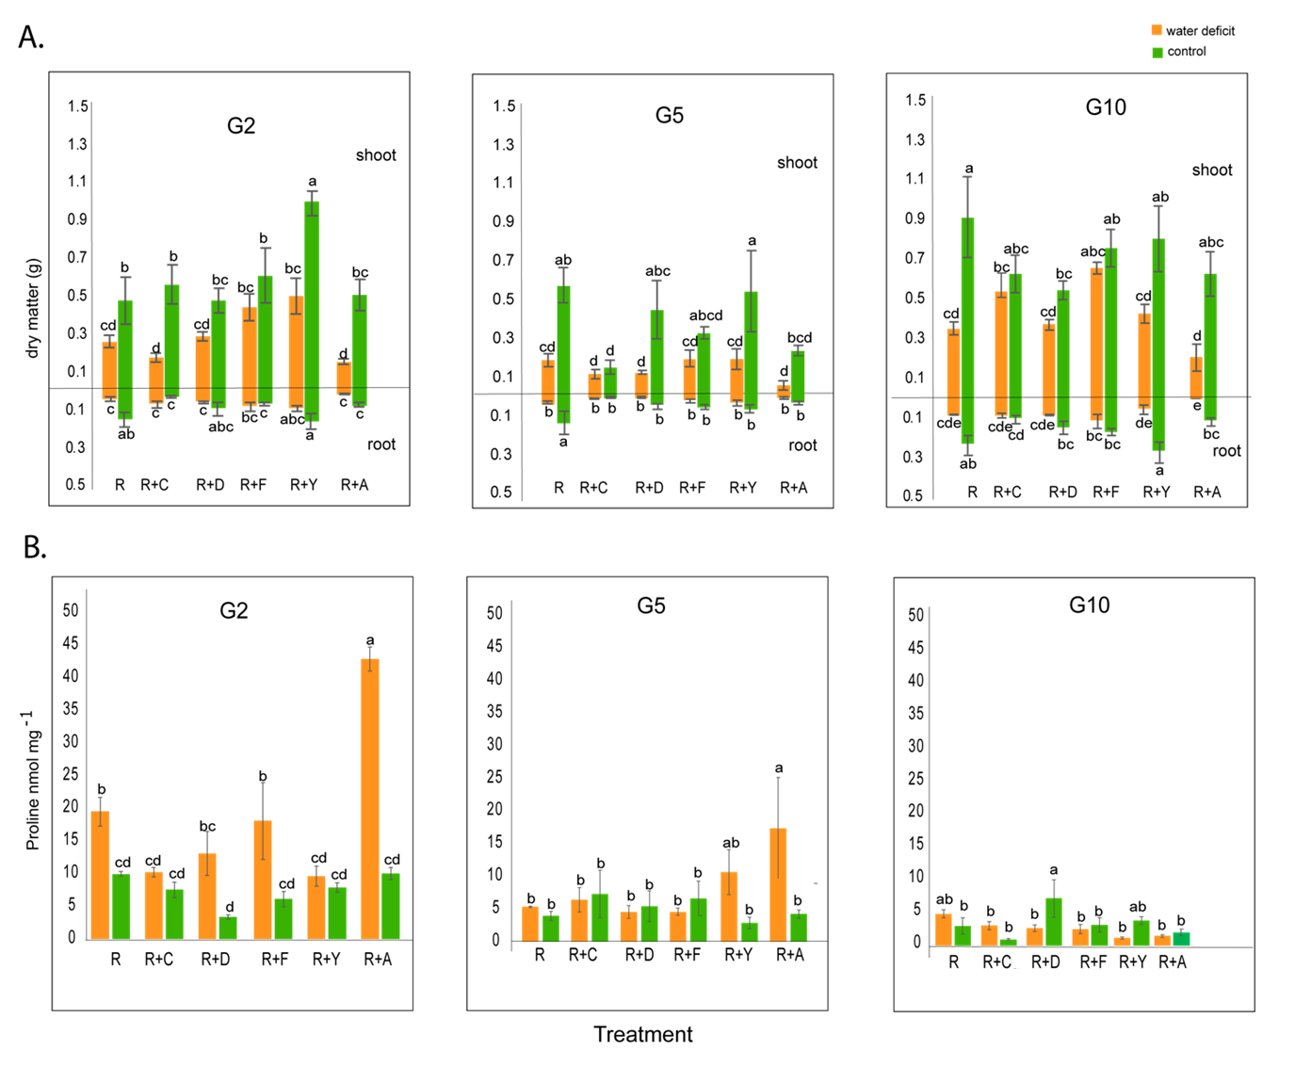

Figure Supplementary 1. A. Dry matter of shoot and root of tomato plants and B. Proline content in shoot of tomato plants. G= generation, R= Receptor soil, R+C (receptor mixed with Coppermine Antarctic soil); R+D (receptor mixed with Deception Antarctic soil); R+F (receptor mixed with Fildes Antarctic soil); R+Y (receptor mixed with Yelcho Antarctic soil); R+A (receptor mixed with Arctowsky Antarctic soil).

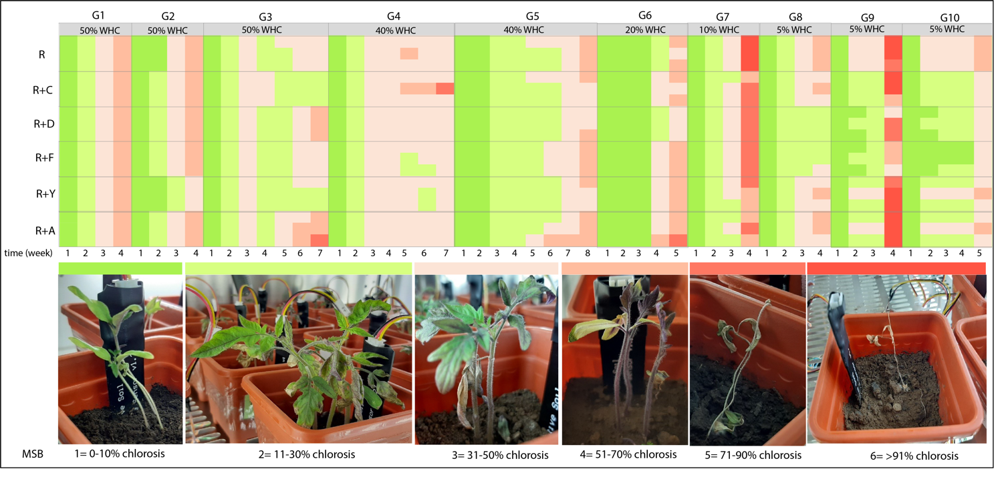
Supplementary Figure 2. Matrix based scale of tomato plants exposed to water deficit stress based to Water-Holding Capacity (WHC) and visualized according to chlorosis scale. G=Generation.

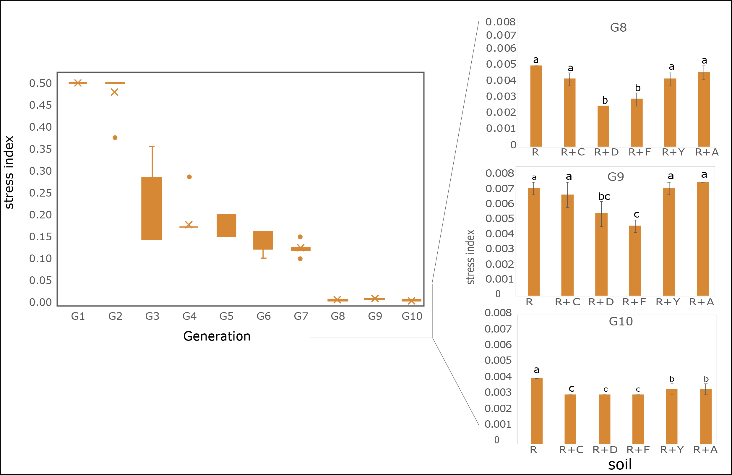
Supplementary Figure 3. Stress index obtained from the MSB taking account the equation 1.

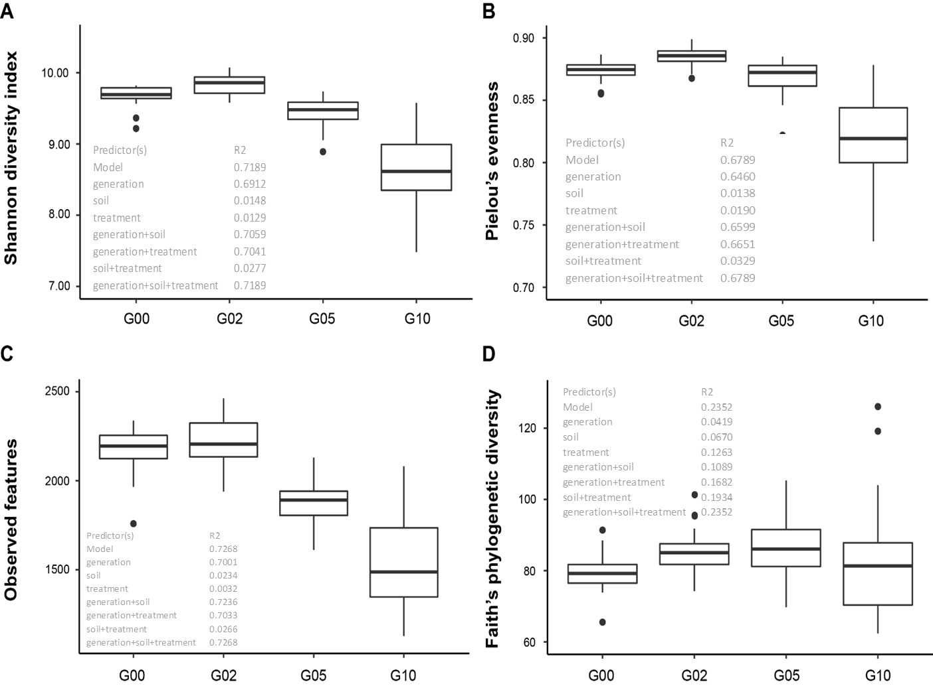

Supplementary Figure 4. Alpha diversity of all soil samples. (A) Shannon's diversity index, (B) Pielou´s evenness, (C) Features (richness) and (D) Faith's Phylogenetic Diversity of all data and all generations.

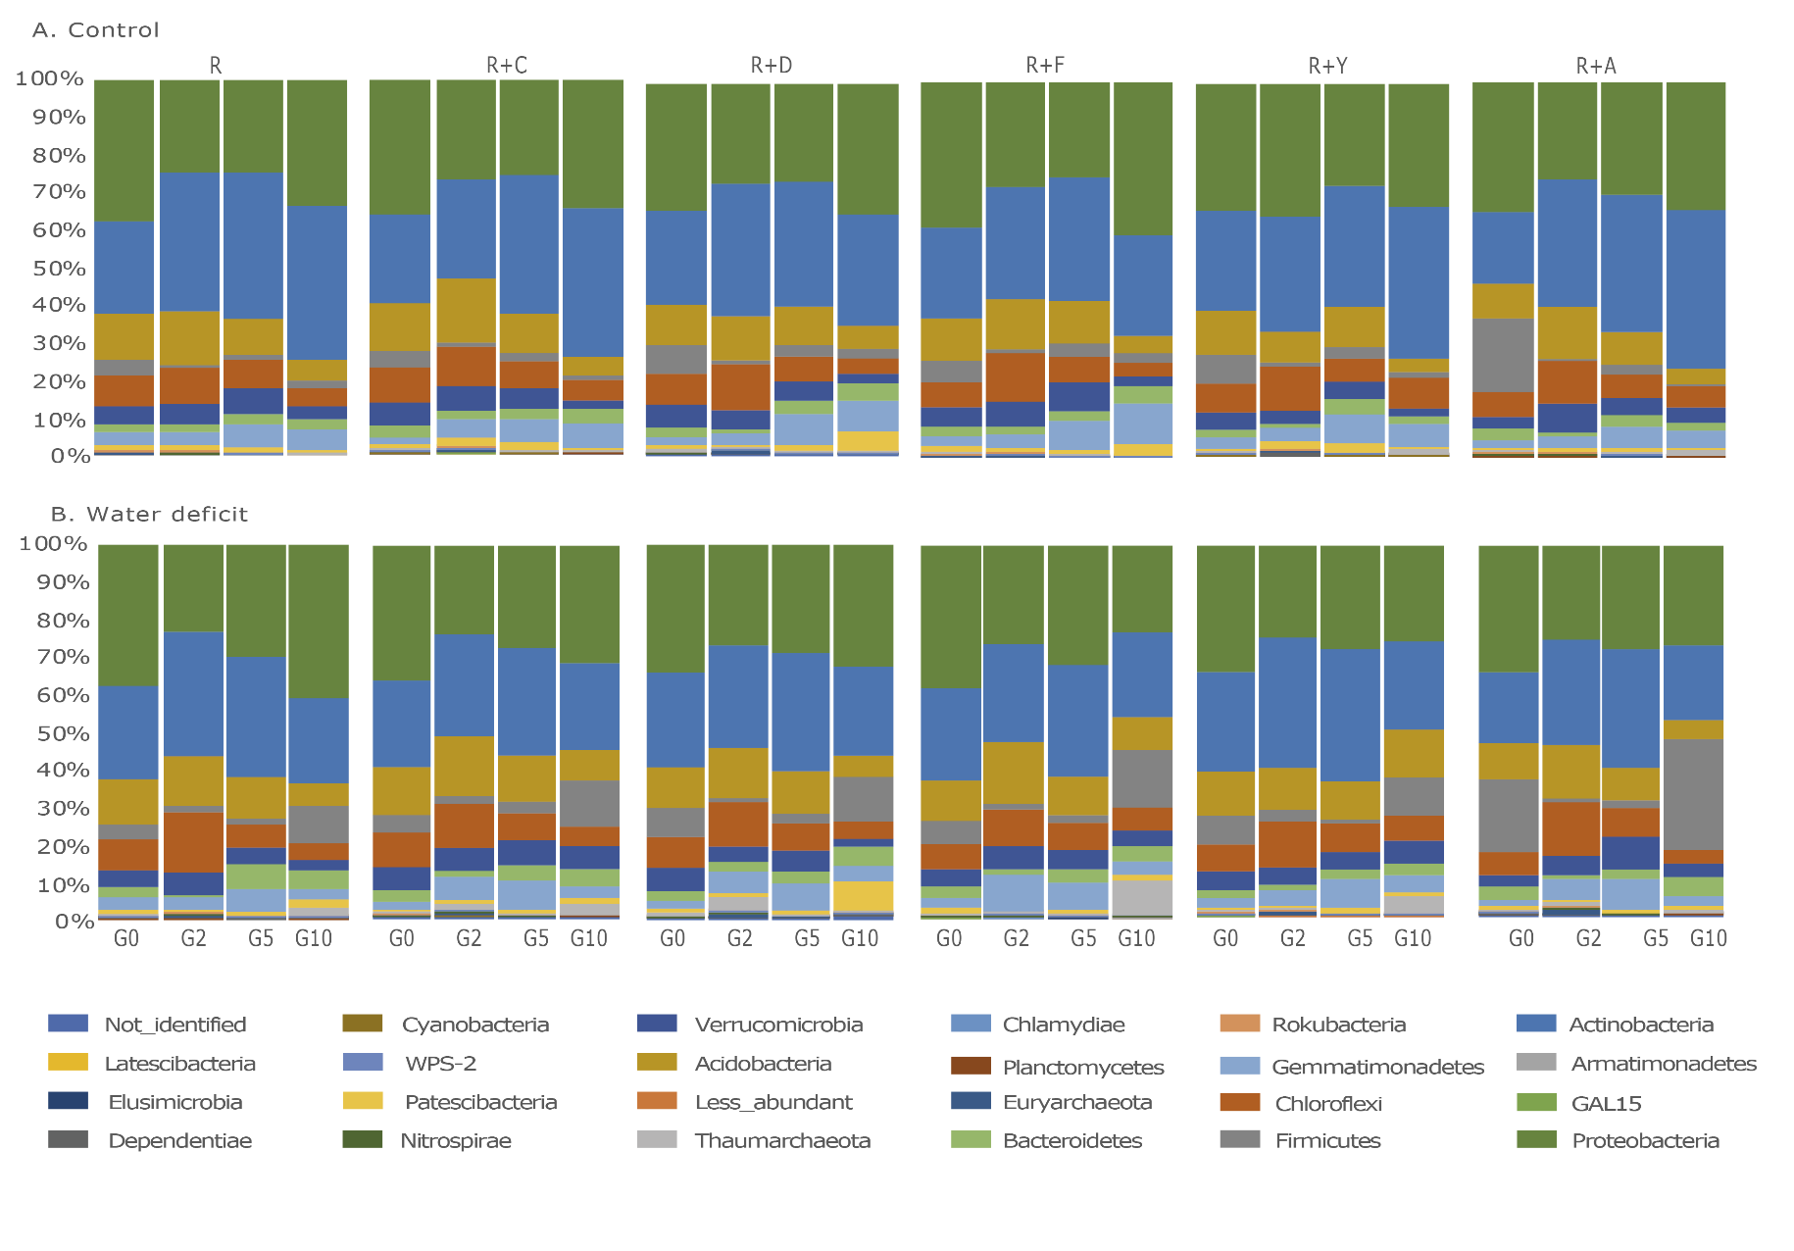
Supplementary figure 5. Relative abundance of each taxa at the phylum level in the total rhizobacterial community associated with G2, G5 and G10 in (A) control treatments and (B) water deficit. G=generation.

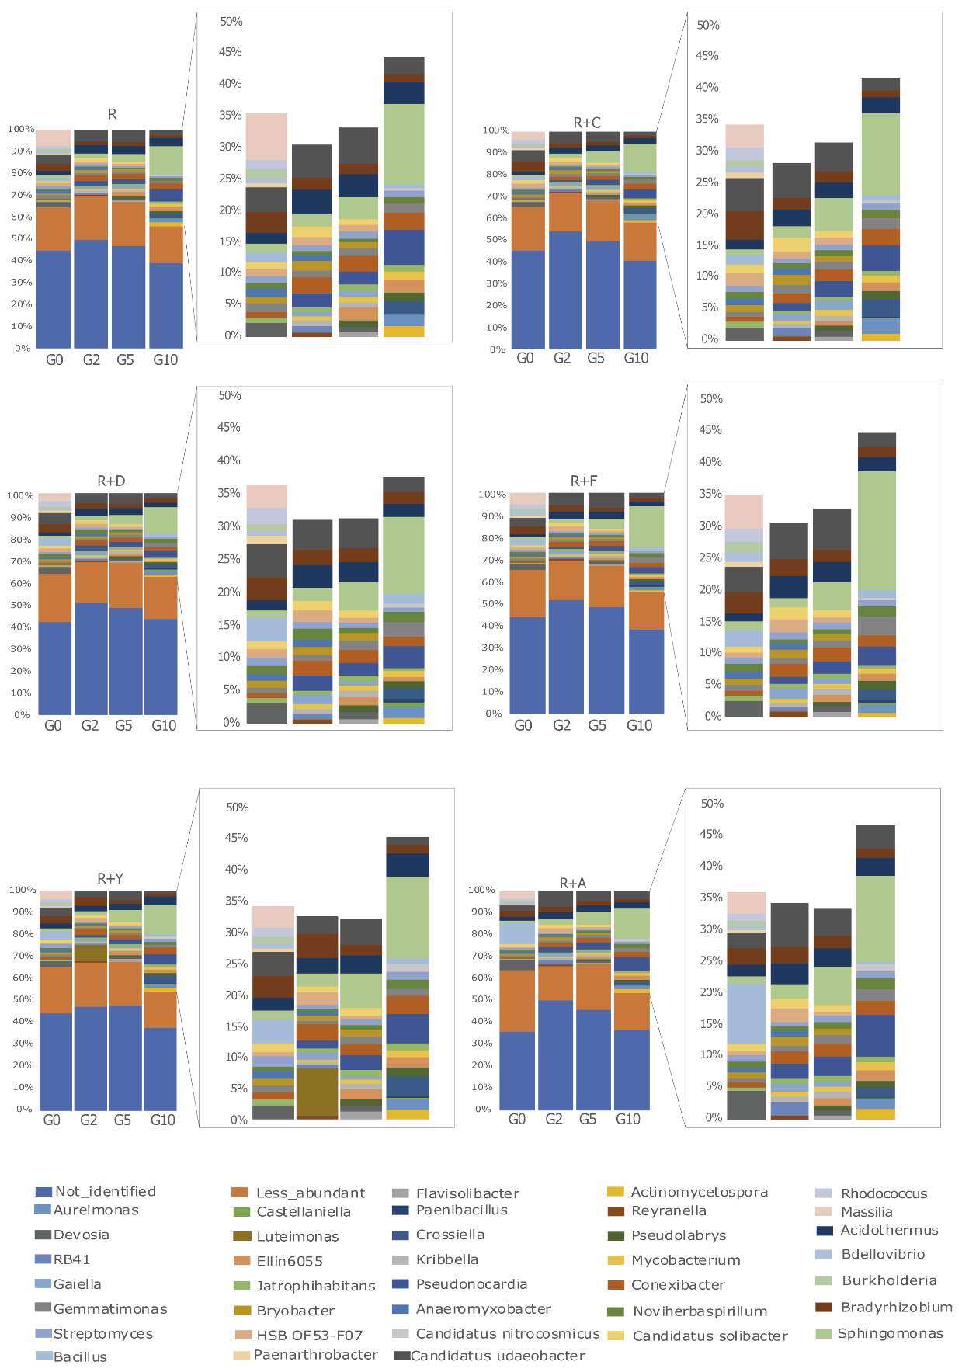

Supplementary Figure 6. Relative abundance of each taxa at the genus level in the total rhizobacterial community associated with G2, G5 and G10 in control treatments. G=generation.
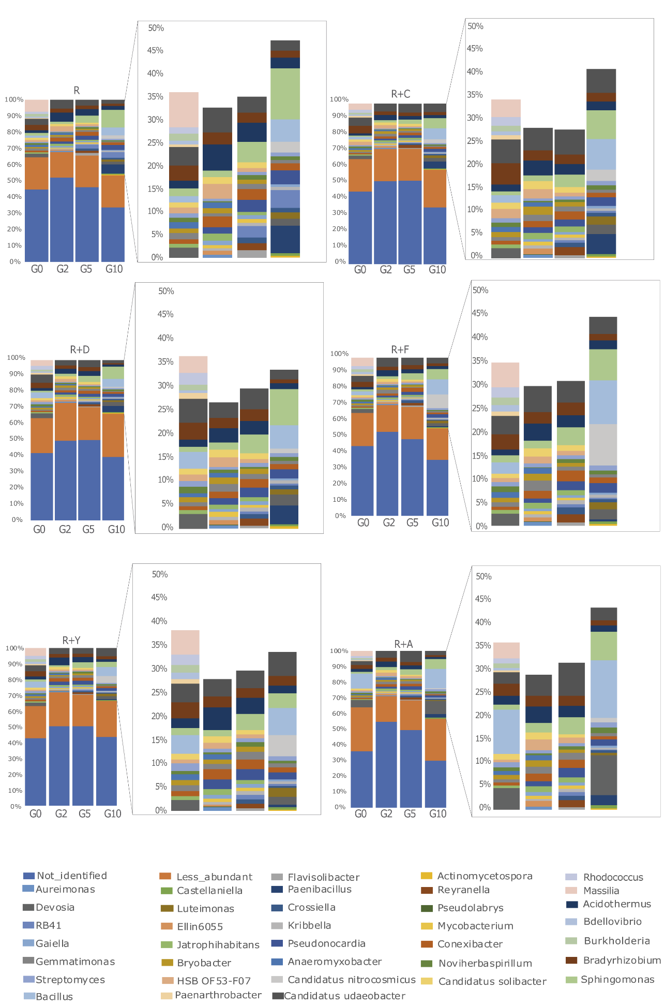
Supplementary Figure 7. Relative abundance of each taxa at the genus level in the total rhizobacterial community associated with G2, G5 and G10 in water deficit treatments. G= generation
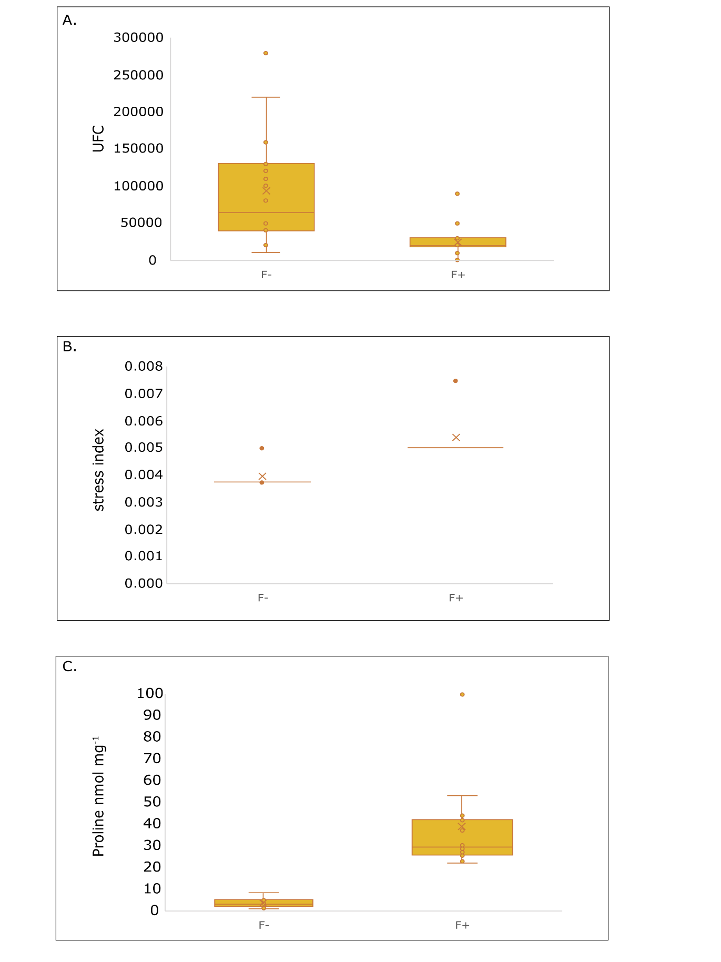

Supplementary Figure 8. Unit formed of colony (A), stress index obtained from the MSB taking account the equation 1, G= generation (B) and Proline content on fumigated (F+) and not fumigated (F-) treatments with chloroform.
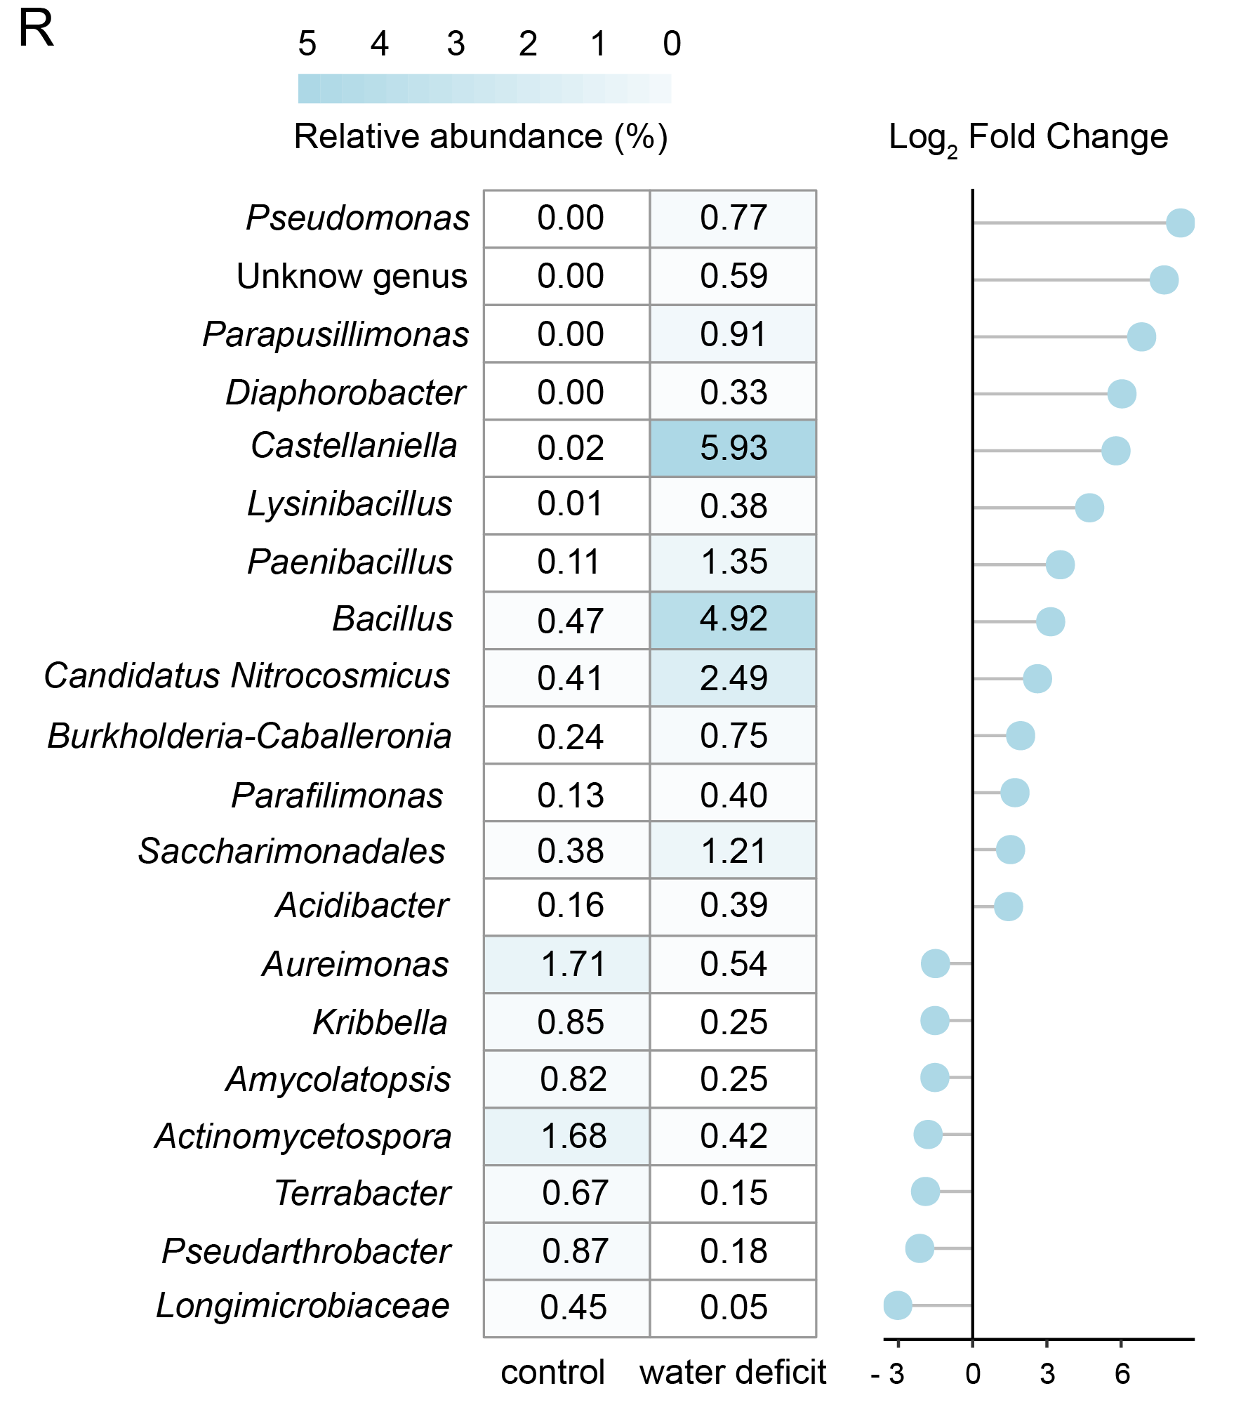
Supplementary Figure 9. Differential abundance by ZIGMM using metabarcoding data in G10 of R treatment. Negative values in Log₂ Fold change represent a loss in the relative abundance of the species and positive values in Log₂ Fold Change represent gains in relative abundance for each taxonomic group.
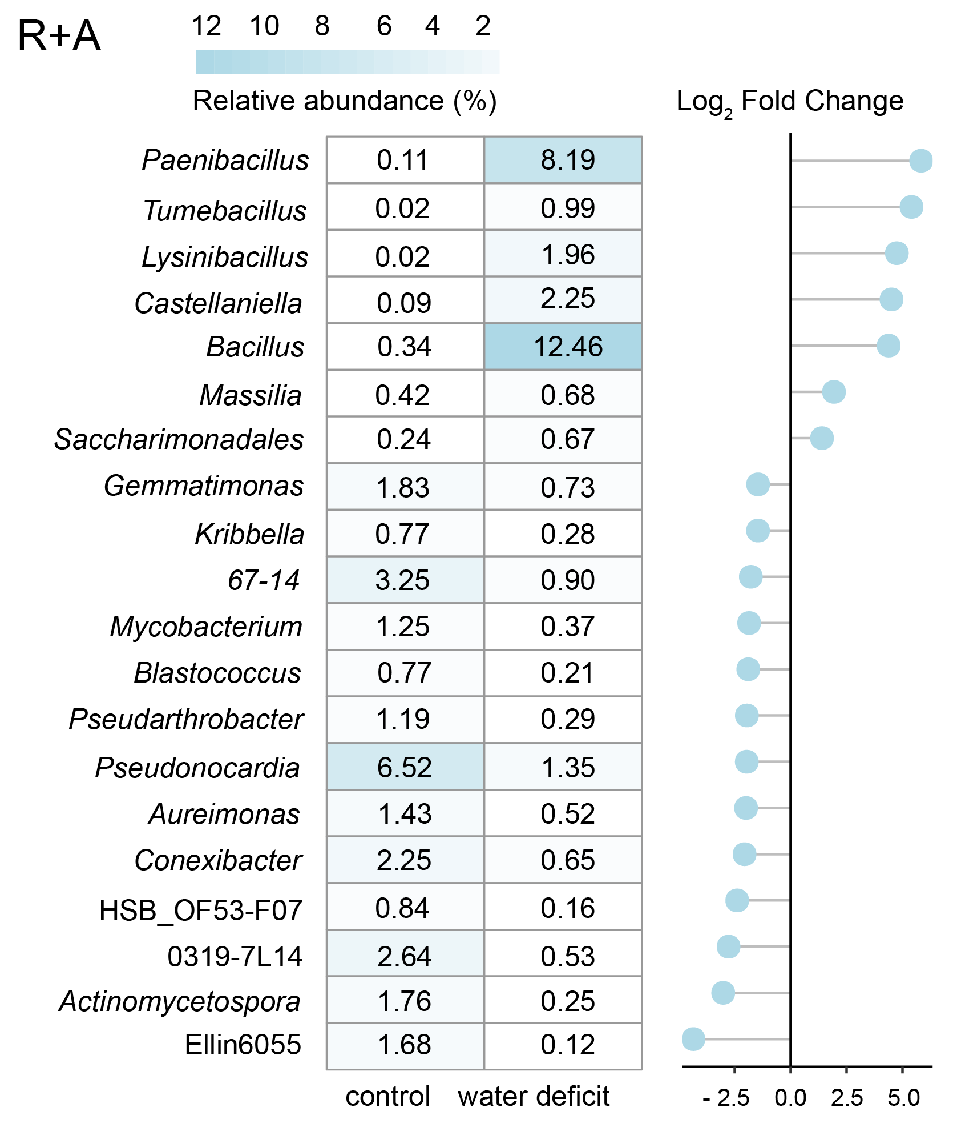
Supplementary Figure 10. Differential abundance by ZIGMM using metabarcoding data in G10 of R+A treatment. Negative values in Log₂ Fold change represent a loss in the relative abundance of the species and positive values in Log₂ Fold Change represent gains in relative abundance for each taxonomic group.

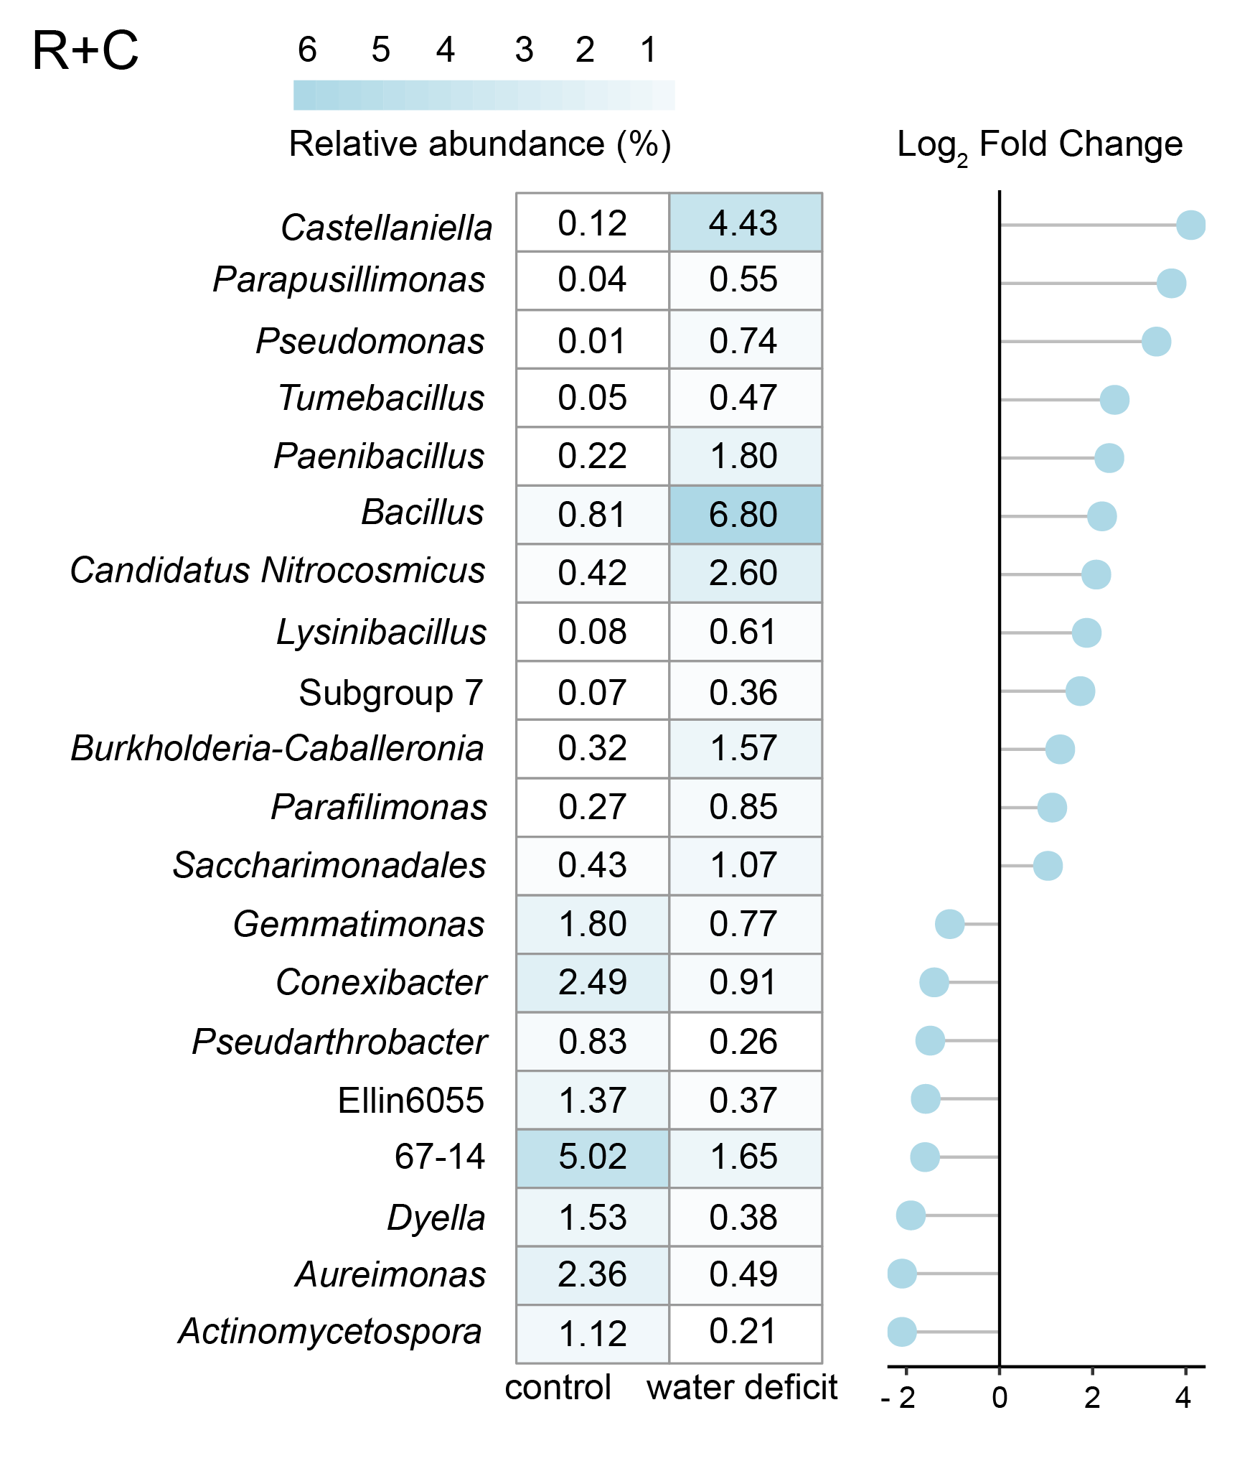
Supplementary Figure 11. Differential abundance by ZIGMM using metabarcoding data in G10 of R+C treatment. Negative values in Log₂ Fold change represent a loss in the relative abundance of the species and positive values in Log₂ Fold Change represent gains in relative abundance for each taxonomic group.

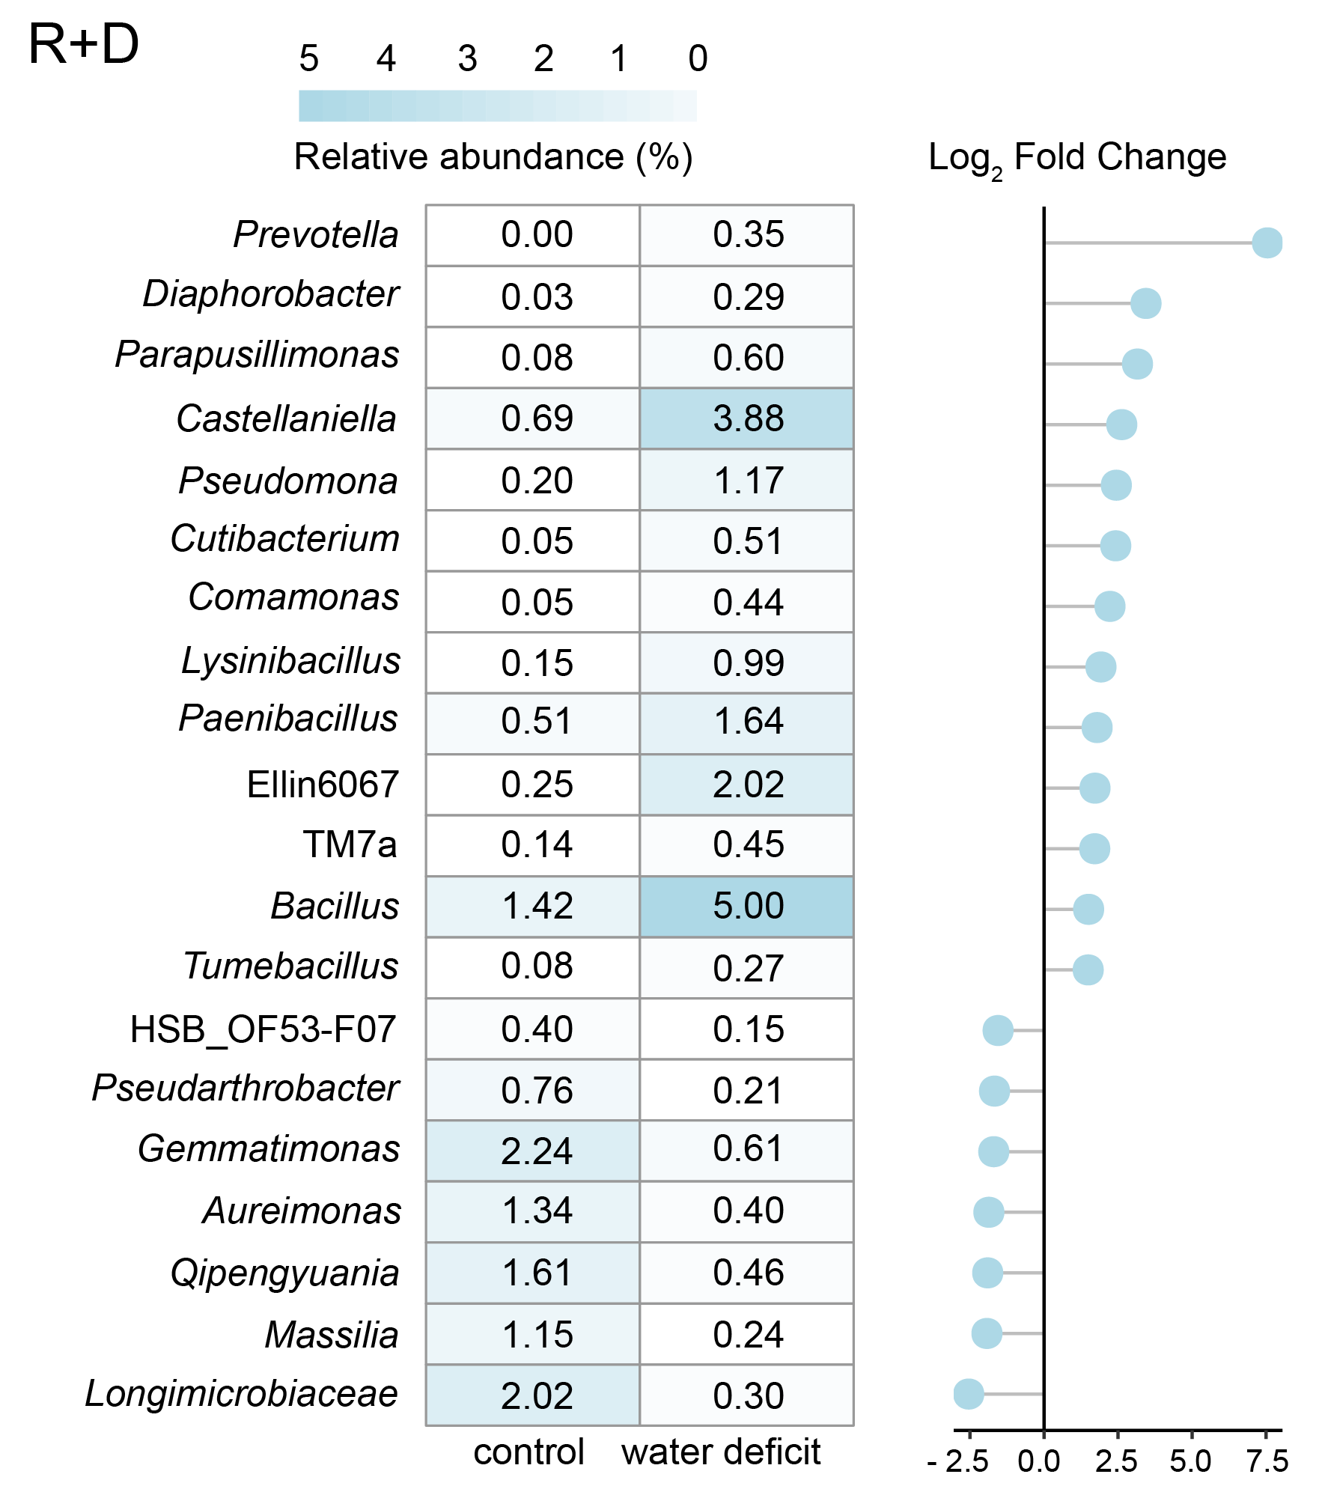
Supplementary Figure 12. Differential abundance by ZIGMM using metabarcoding data in G10 of R+D treatment. Negative values in Log₂ Fold change represent a loss in the relative abundance of the species and positive values in Log₂ Fold Change represent gains in relative abundance for each taxonomic group.

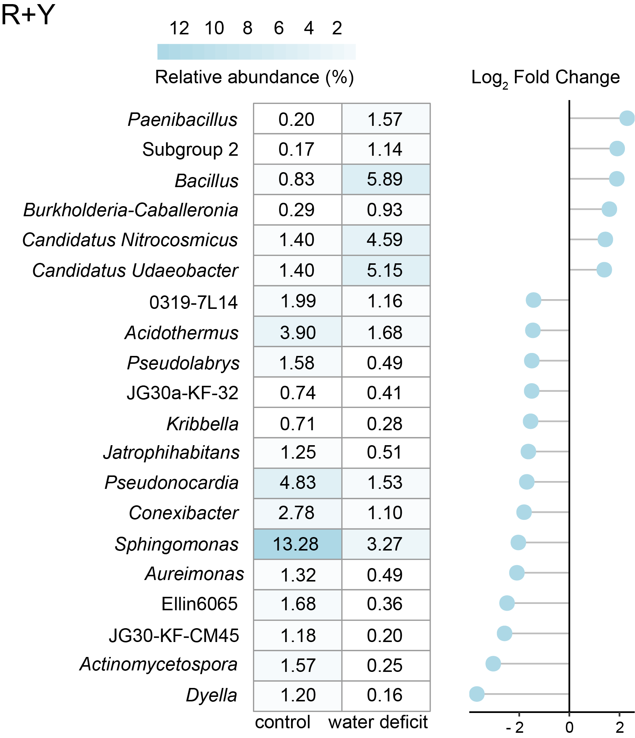
Supplementary Figure 13. Differential abundance by ZIGMM using metabarcoding data in G10 of R+Y treatment. Negative values in Log₂ Fold change represent a loss in the relative abundance of the species and positive values in Log₂ Fold Change represent gains in relative abundance for each taxonomic group.

