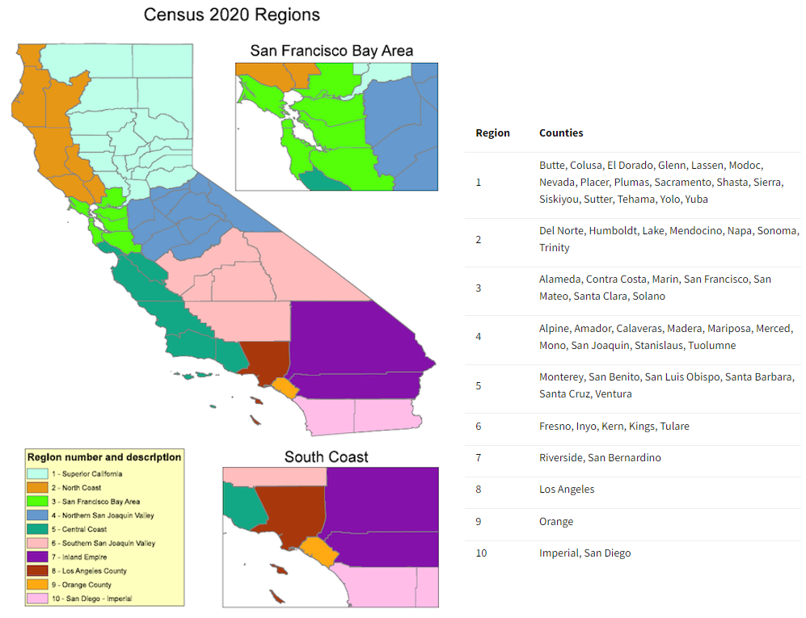 Supplemental Figure 1. Map of California census regions. Source: https://census.ca.gov/regions/

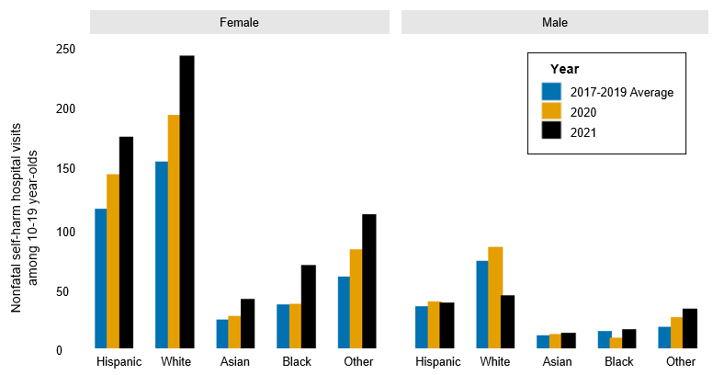
Supplemental Figure 2. Counts of nonfatal intentional self-harm visits to UC hospitals among 10-19 year-olds from 2017-2021, by gender and race/ethnicity. Note: all race/ethnicity categories, aside from Hispanic, are non-Hispanic.

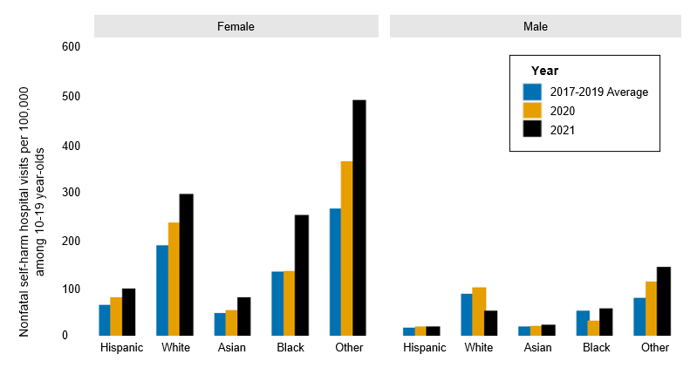
Supplemental Figure 3. Rates of nonfatal intentional self-harm visits to UC hospitals among 10-19 year-olds from 2017-2021, by gender and race/ethnicity. Note: all race/ethnicity categories, aside from Hispanic, are non-Hispanic.

Supplemental Table 1. Counts of suicide and firearm suicide in California from 2017-2021, by sociodemographic characteristics
 |  | All methods |  |  |  |  |  |  |  | Firearm
 | Number of suicides |  |  |  | Count change  (% Change¹) |  |  | Number of suicides |  |  |  |  | Count change  (% Change¹)
 | 2017-19 Average |  | 2020 | 2021 | 2017-19 average  to 2020 | 2017-19 average  to 2021 |  | 2017-19 Average |  |  | 2020 | 2021 | 2017-19 average  to 2020 | 2017-19 average  to 2021
STATE-WIDE | 4484 |  | 4123 | 4104 | -361  (-8.1%) | -380  (-8.5%) |  | 1618 |  |  | 1550 | 1564 | -68  (-4.2%) | -54  (-3.3%)
SEX
Female | 983 |  | 908 | 866 | -75  (-7.6%) | -117  (-11.9%) |  | 160 |  |  | 174 | 155 | +14  (8.8%) | -5  (-3.1%)
Male | 3500 |  | 3215 | 3237 | -285  (-8.1%) | -263  (-7.5%) |  | 1458 |  |  | 1376 | 1409 | -82  (-5.6%) | -49  (-3.4%)
AGE GROUP
10 to 19 | 204 |  | 225 | 212 | +21  (10.3%) | +8  (3.9%) |  | 59 |  |  | 58 | 60 | -1  (-1.7%) | +1  (1.7%)
20 to 29 | 734 |  | 674 | 691 | -60  (-8.2%) | -43  (-5.9%) |  | 201 |  |  | 198 | 229 | -3  (-1.5%) | +28  (13.9%)
30 to 44 | 1028 |  | 1023 | 1085 | -5  (-0.5%) | +57  (5.5%) |  | 289 |  |  | 302 | 321 | +13  (4.5%) | +32  (11.1%)
45 to 64 | 1568 |  | 1270 | 1202 | -298  (-19.0%) | -366  (-23.3%) |  | 531 |  |  | 441 | 423 | -90  (-17.0%) | -108  (-20.3%)
65+ | 945 |  | 921 | 906 | -24  (-2.5%) | -39  (-4.1%) |  | 539 |  |  | 554 | 527 | +15  (2.8%) | -12  (-2.2%)
RACE/ETHNICITY
Hispanic | 957 |  | 940 | 1002 | -17  (-1.8%) | +45  (4.7%) |  | 257 |  |  | 242 | 301 | -15  (-5.8%) | +44  (17.1%)
NH² White | 2794 |  | 2446 | 2349 | -348  (-12.5%) | -445  (-15.9%) |  | 1180 |  |  | 1098 | 1066 | -82  (-7.0%) | -114  (-9.7%)
NH Asian | 387 |  | 388 | 380 | +1  (0.3%) | -7  (-1.8%) |  | 74 |  |  | 87 | 74 | +13  (17.6%) | 0  (0.0%)
NH Black | 187 |  | 210 | 210 | +23  (12.3%) | +23  (12.3%) |  | 61 |  |  | 78 | 82 | +17  (27.9%) | +21  (34.4%)
NH AI/AN³ | 24 |  | 15 | 30 | -9  (-37.5%) | +6  (25.0%) |  | 7 |  |  | 6 | 6 | -1  (-14.3%) | -1  (-14.3%)
NH NH/PI⁴ | 17 |  | 15 | 13 | -2  (-11.8%) | -4  (-23.5%) |  | 6 |  |  | 6 | 6 | 0  (0.0%) | 0  (0.0%)
Other | 117 |  | 109 | 120 | -8  (-6.8%) | +3  (2.6%) |  | 35 |  |  | 34 | 28 | -1  (-2.9%) | -7  (-20.0%)
HIGHEST LEVEL OF EDUCATION
Less than a Bachelor’s degree | 3322 |  | 3018 | 3025 | -304  (-9.2%) | -297  (-8.9%) |  | 1207 |  |  | 1134 | 1183 | -73  (-6.1%) | -24  (-2.0%)
Bachelor's Degree or higher | 1044 |  | 979 | 954 | -65  (-6.2%) | -90  (-8.6%) |  | 378 |  |  | 378 | 343 | 0  (0.0%) | -35  (-9.3%)
¹Percent Change = (2020 (or 2021) N – 17-19 Average N)/ 17-19 Average N*100
²NH = Non-Hispanic
³AI/AN = American Indian (Native American)/Alaskan Native
⁴NH/PI = Native Hawaiian/Pacific Islander

Supplemental Table 2. Rates of suicide and firearm suicide in California from 2017-2021, by sociodemographic characteristics
 |  |  |  | All methods |  |  |  |  |  |  |  | Firearm
 |  |  | Suicides per 100,000 |  |  |  | Rate change  (% Change¹) |  |  | Suicides per 100,000 |  |  |  |  | Rate change  (% Change¹)
 |  |  | 2017-19 Average |  | 2020 | 2021 | 2017-19 average  to 2020 | 2017-19 average  to 2021 |  | 2017-19 Average |  |  | 2020 | 2021 | 2017-19 average  to 2020 | 2017-19 average  to 2021
STATE-WIDE |  |  | 11.4 |  | 10.5 | 10.4 | -0.9  (-7.9%) | -1.0  (-8.8%) |  | 4.1 |  |  | 3.9 | 4.0 | -0.2  (-4.9%) | -0.1  (-2.4%)
SEX
Female |  |  | 5.0 |  | 4.6 | 4.4 | -0.4  (-8.0%) | -0.6  (-12.0%) |  | 0.8 |  |  | 0.9 | 0.8 | +0.1  (12.5%) | 0  (0.0%)
Male |  |  | 17.9 |  | 16.4 | 16.5 | -1.5  (-8.4%) | -1.4  (-7.8%) |  | 7.5 |  |  | 7.0 | 7.2 | -0.5  (-6.7%) | -0.3  (-4.0%)
AGE GROUP
10 to 19 |  |  | 4.0 |  | 4.4 | 4.1 | +0.4  (10.0%) | +0.1  (2.5%) |  | 1.1 |  |  | 1.1 | 1.2 | 0  (0.0%) | +0.1  (9.1%)
20 to 29 |  |  | 12.7 |  | 11.7 | 12.0 | -0.9  (-7.1%) | -0.6  (-4.8%) |  | 3.5 |  |  | 3.4 | 4.0 | -0.1  (-2.9%) | +0.5  (14.3%)
30 to 44 |  |  | 12.6 |  | 12.5 | 13.3 | -0.1  (-0.8%) | +0.7  (5.6%) |  | 3.5 |  |  | 3.7 | 3.9 | +0.2  (5.7%) | +0.4  (11.4%)
45 to 64 |  |  | 16.0 |  | 13.0 | 12.3 | -3.0  (-18.8%) | -3.7  (-23.1%) |  | 5.4 |  |  | 4.5 | 4.3 | -0.9  (-16.7%) | -1.1  (-20.4%)
65+ |  |  | 16.7 |  | 16.3 | 16.1 | -0.4  (-2.4%) | -0.6  (-3.6%) |  | 9.5 |  |  | 9.8 | 9.3 | +0.3  (3.2%) | -0.2  (-2.1%)
RACE/ETHNICITY
Hispanic |  |  | 6.2 |  | 6.1 | 6.5 | -0.1  (-1.6%) | +0.3  (4.8%) |  | 1.7 |  |  | 1.6 | 2.0 | -0.1  (-5.9%) | +0.3  (17.7%)
NH² White |  |  | 19.4 |  | 17.0 | 16.4 | -2.4  (-12.4%) | -3.0  (-15.5%) |  | 8.2 |  |  | 7.6 | 7.4 | -0.6  (-7.3%) | -0.8  (-9.8%)
NH Asian |  |  | 6.7 |  | 6.8 | 6.6 | +0.1  (+1.5%) | -0.1  (-1.5%) |  | 1.3 |  |  | 1.5 | 1.3 | +0.2  (15.4%) | 0  (0.0%)
NH Black |  |  | 8.7 |  | 9.8 | 9.8 | +1.1  (12.6%) | +1.1  (12.6%) |  | 2.8 |  |  | 3.6 | 3.8 | +0.8  (28.6%) | +1.0  (35.7%)
NH AI/AN³ |  |  | 18.2* |  | 11.4* | 22.8* | -6.8  (-37.4%) | +4.6 (25.3%) |  | 5.3* |  |  | 4.6* | 4.6* | -0.7  (-13.2%) | -0.7  (-13.2%)
NH NH/PI⁴ |  |  | 12.5* |  | 11.1* | 9.6* | -1.4  (-11.2%) | -2.9  (-23.2%) |  | 4.4* |  |  | 4.4* | 4.4* | 0  (0.0%) | 0  (0.0%)
Other |  |  | 8.1 |  | 7.5 | 8.3 | -0.6  (-7.4%) | +0.2  (2.5%) |  | 2.4 |  |  | 2.4 | 1.9* | 0  (0.0%) | -0.5  (-20.8%)
HIGHEST LEVEL OF EDUCATION
Less than a Bachelor’s degree |  |  | 19.1 |  | 17.4 | 17.4 | -1.8  (-9.4%) | -1.7  (-8.9%) |  | 6.9 |  |  | 6.5 | 6.8 | -0.4  (-5.8%) | -0.1  (-1.5%)
Bachelor's Degree or higher |  |  | 11.3 |  | 10.3 | 10.3 | -0.7  (-6.2%) | -1.0  (-8.9%) |  | 4.1 |  |  | 4.1 | 3.7 | 0  (0.0%) | -0.4  (-9.8%)
¹Percent Change = (2020 (or 2021) Rate – 17-19 Average Rate)/ 17-19 Average Rate*100
²NH = Non-Hispanic
³AI/AN = American Indian (Native American)/Alaskan Native
⁴NH/PI = Native Hawaiian/Pacific Islander
*Rate is based on counts of 30 or less.

Supplemental Table 3. Proportion of deaths by suicide that involved a firearm in California from 2017-2021, by sociodemographic characteristics
 | Proportion of deaths by suicide that involved a firearm |  |  | Proportion Change¹
 | 2017-19 Average | 2020 | 2021 | 2017-19 average to 2020 | 2017-19 average to 2021
State-wide | 36.1% | 37.6% | 38.1% | 1.5% | 2.0%
Sex
Female | 16.3% | 19.2% | 17.9% | 2.9% | 1.6%
Male | 41.7% | 42.8% | 43.5% | 1.1% | 1.8%
Age group
10 to 19 | 28.9% | 25.8% | 28.3% | -3.1% | -0.6%
20 to 29 | 27.4% | 29.4% | 33.1% | 2.0% | 5.7%
30 to 44 | 28.1% | 29.5% | 29.6% | 1.4% | 1.5%
45 to 64 | 33.9% | 34.7% | 35.2% | 0.8% | 1.3%
65+ | 57.0% | 60.2% | 58.2% | 3.2% | 1.2%
Race/ethnicity
Hispanic | 26.9% | 25.7% | 30.0% | -1.2% | 3.1%
NH² White | 42.2% | 44.9% | 45.4% | 2.7% | 3.2%
NH Asian | 19.1% | 22.4% | 19.5% | 3.3% | 0.4%
NH Black | 32.6% | 37.1% | 39.0% | 4.5% | 6.4%
NH AI/AN³* | 29.2% | 40.0% | 20.0% | 10.8% | -9.2%
NH NH/PI⁴* | 35.3% | 40.0% | 46.2% | 4.7% | 10.9%
Other | 29.9% | 31.2% | 23.3%* | 1.3% | -6.6%
Highest level of education
Less than a  Bachelor’s degree | 36.3% | 37.6% | 39.1% | 1.3% | 2.8%
Bachelor's Degree or higher | 36.2% | 38.6% | 36.0% | 2.4% | -0.2%
CA Census region
Superior California | 38.6% | 41.6% | 37.3% | 3.0% | -1.3%
North Coast | 38.0% | 37.6% | 38.1% | -0.4% | 0.1%
San Francisco Bay Area | 27.7% | 29.3% | 29.5% | 1.6% | 1.8%
Northern San Joaquin Valley | 34.7% | 39.6% | 38.8% | 4.9% | 4.1%
Central Coast | 40.7% | 33.3% | 41.2% | -7.4% | 0.5%
Southern San Joaquin Valley | 37.7% | 39.2% | 47.6% | 1.5% | 9.9%
Inland Empire | 40.6% | 44.0% | 44.0% | 3.4% | 3.4%
Los Angeles County | 31.2% | 31.9% | 32.8% | 0.7% | 1.6%
Orange County | 30.1% | 34.2% | 28.9% | 4.1% | -1.2%
San Diego - Imperial | 36.4% | 35.2% | 35.2% | -1.2% | -1.2%
¹Proportion Change = (2020 (or 2021) proportion – 17-19 proportion)
²NH=Non-Hispanic
³AI/AN=American Indian
(Native American)/Alaskan Native
⁴NH/PI = Native Hawaiian/Pacific Islander
*Proportion is based on counts of 30 or less.

Supplemental Table 4. Counts and rates of suicide and firearm suicide, by CA census region 2017-2021.
 | Number of suicides  (Rate per 100,000) |  |  | Count Change  (% Change¹) |  | Rate Change  (% Change²)
 | 2017-19 Average | 2020 | 2021 | 2017-19 average to 2020 | 2017-19 average to 2021 | 2017-19 average to 2020 | 2017-19 average to 2021
ALL METHODS
Superior California | 513  (15.8) | 468  (14.2) | 480  (14.5) | -45  (-8.8%) | -33  (-6.5%) | -1.6  (-10.1%) | -1.3  (-8.2%)
North Coast | 165  (17.1) | 161  (16.7) | 147  (15.2) | -4  (-2.4%) | -18  (-10.9%) | -0.4  (-2.3%) | -1.9  (-11.1%)
San Francisco Bay Area | 695  (9.8) | 646  (9.1) | 639  (9.0) | -49  (-7.1%) | -56  (-8.1%) | -0.7  (-7.1%) | -0.8  (-8.2%)
Northern San Joaquin Valley | 228  (12.0) | 229  (11.8) | 228  (11.7) | +1  (0.1%) | 0  (-0.1%) | -0.2  (-1.7%) | -0.3  (-2.5%)
Central Coast | 298  (12.7) | 261  (11.1) | 274  (11.7) | -37  (-12.4%) | -24  (-8.1%) | -1.6  (-12.6%) | -1.0  (-7.9%)
Southern San Joaquin Valley | 291  (11.6) | 286  (11.2) | 254  (9.9) | -5  (-1.7%) | -37  (-12.7%) | -0.4  (-3.5%) | -1.7  (-14.7%)
Inland Empire | 533  (11.6) | 482  (10.5) | 523  (11.4) | -51  (-9.5%) | -10  (-1.8%) | -1.1  (-9.5%) | -0.2  (-1.7%)
Los Angeles County | 921  (9.2) | 852  (8.5) | 817  (8.2) | -69  (-7.5%) | -104  (-11.3%) | -0.7  (-7.6%) | -1.0  (-10.9%)
Orange County | 342  (10.8) | 281  (8.8) | 332  (10.4) | -61  (-17.9%) | -10  (-3.0%) | -2.0  (-18.5%) | -0.4  (-3.7%)
San Diego - Imperial | 470  (13.4) | 432  (12.4) | 384  (11.0) | -38  (-8.1%) | -86  (-18.3%) | -1.0  (-7.5%) | -2.4  (-17.9%)
FIREARM
Superior California | 198  (6.1) | 195  (5.9) | 179  (5.4) | -3  (-1.6%) | -19  (-9.4%) | -0.2  (-3.3%) | -0.7  (-11.5%)
North Coast | 63  (6.5) | 61  (6.3) | 56  (5.8) | -2  (-3.5%) | -7  (-10.6%) | -0.2  (-3.1%) | -0.7  (-10.8%)
San Francisco Bay Area | 193  (2.7) | 190  (2.7) | 189  (2.6) | -3  (-1.6%) | -4  (-2.2%) | 0.0  (0.0%) | -0.1  (-3.7%)
Northern San Joaquin Valley | 79  (4.2) | 91  (4.7) | 89  (4.6) | +11  (14.1%) | +9  (11.6%) | +0.5  (11.9%) | +0.4  (9.5%)
Central Coast | 121  (5.2) | 87  (3.7) | 113  (4.8) | -34  (-28.3%) | -8  (-6.9%) | -1.5  (-28.9%) | -0.4  (-7.7%)
Southern San Joaquin Valley | 110  (4.4) | 112  (4.4) | 121  (4.7) | +2  (2.1%) | +11  (10.3%) | 0.0  (0.0%) | +0.3  (6.8%)
Inland Empire | 216  (4.7) | 212  (4.6) | 230  (5.0) | -4  (-2.0%) | +14  (6.3%) | -0.1  (-2.1%) | +0.3  (6.4%)
Los Angeles County | 287  (2.9) | 272  (2.7) | 268  (2.7) | -15  (-5.2%) | -19  (-6.6%) | -0.2  (-6.9%) | -0.2  (-6.9%)
Orange County | 103  (3.2) | 96  (3.0) | 96  (3.0) | -7  (-6.8%) | -7  (-6.8%) | -0.2  (-6.3%) | -0.2  (-6.3%)
San Diego - Imperial | 171  (4.9) | 152  (4.4) | 135  (3.9) | -19  (-11.1%) | -36  (-21.1%) | -0.5  (-10.2%) | -1.0  (-20.4%)
¹Percent Change = (2020 (or 2021) N – 17-19 N)/ 17-19 N*100
²Percent Change = (2020 (or 2021) Rate – 17-19 Rate)/ 17-19 Rate*100

Supplemental Table 5. Counts and rates of nonfatal intentional self-harm visits in UC hospitals from 2017-2021, by sociodemographic characteristics
 | Number of nonfatal self-harm visits  (Rate per 100,000) |  |  | Count change  (% Change¹) |  | Rate change  (% Change²)
 | 2017-19 Average | 2020 | 2021 | 2017-19 average  to 2020 | 2017-19 average  to 2021 | 2017-19 average  to 2020 | 2017-19 average  to 2021
STATE-WIDE | 2083  (29.6) | 2160  (30.7) | 2175  (30.9) | +77  (3.7%) | +92  (4.4%) | +1.1  (3.7%) | +1.3  (4.4%)
SEX
Female | 1094  (31.0) | 1113  (31.5) | 1224  (34.7) | +19  (1.7%) | +130  (11.8%) | +0.5  (1.6%) | +3.7  (11.9%)
Male | 989  (28.2) | 1047  (29.8) | 951  (27.1) | +58  (5.9%) | -38  (-3.8%) | +1.6  (5.7%) | -1.1  (-3.9%)
AGE GROUP
10 to 19 | 553  (70.5) | 663  (84.5) | 792  (100.9) | +110  (20.0%) | +239  (43.3%) | +14.0  (19.9%) | +30.4  (43.1%)
20 to 39 | 912  (38.1) | 896  (37.4) | 821  (34.3) | -16  (-1.8%) | -91  (-10.0%) | -0.7  (-1.8%) | -3.8  (-10.0%)
40 to 59 | 444  (24.9) | 423  (23.7) | 370  (20.8) | -21  (-4.7%) | -74  (-16.7%) | -1.2  (-4.8%) | -4.1  (-16.5%)
60+ | 175  (13.4) | 179  (13.8) | 192  (14.8) | +4  (2.3%) | +18  (10.0%) | +0.4  (3.0%) | +1.4  (10.5%)
RACE/ETHNICITY
Hispanic | 447  (16.9) | 534  (20.2) | 561  (21.3) | +88  (19.6%) | +115  (25.6%) | +3.3  (19.5%) | +4.4  (26.0%)
NH³ White | 1021  (43.5) | 1007  (42.9) | 900  (38.4) | -14  (-1.3%) | -121  (-11.8%) | -0.6  (-1.4%) | -5.1  (-11.7%)
NH Asian | 131  (10.8) | 124  (10.2) | 139  (11.5) | -7  (-5.5%) | +8  (6.0%) | -0.6  (-5.6%) | +0.7  (6.5%)
NH Black | 215  (40.8) | 184  (34.9) | 231  (43.8) | -31  (-14.5%) | +16  (7.4%) | -5.9  (-14.5%) | +3.0  (7.4%)
Other | 270  (85.6) | 312  (98.9) | 344  (109.1) | +42  (15.4%) | +74  (27.4%) | +13.3  (15.5%) | +23.5  (27.5%)
¹Percent Change = (2020 (or 2021) N – 17-19 Average N)/ 17-19 Average N*100
²Percent Change = (2020 (or 2021) Rate – 17-19 Average Rate)/ 17-19 Average Rate*100
³NH=Non-Hispanic

Supplemental Table 6. Among 10-19 year-olds, counts and rates of nonfatal intentional self-harm visits in UC hospitals from 2017-2021, by sociodemographic characteristics
 | Number of nonfatal self-harm visits among 10-19 year-olds  (Rate per 100,000) |  |  | Count change  (% Change¹) |  | Rate change  (% Change²)
 | 2017-19 Average | 2020 | 2021 | 2017-19 average  to 2020 | 2017-19 average  to 2021 | 2017-19 average  to 2020 | 2017-19 average  to 2021
STATE-WIDE | 552  (79.4) | 663  (95.4) | 792  (114.0) | +110  (20.0%) | +239  (43.3%) | +16.0  (20.2%) | +34.6  (43.6%)
SEX
Female | 396  (115.8) | 488  (142.8) | 643  (188.1) | +92  (23.3%) | +247  (62.5%) | +27.0  (23.3%) | +72.3  (62.4%)
Male | 157  (44.5) | 175  (49.6) | 149  (42.2) | +18  (11.5%) | -8  (-5.1%) | +5.1  (11.5%) | -2.3  (-5.2%)
RACE/ETHNICITY
Hispanic | 153  (42.7) | 185  (51.6) | 215  (60.0) | +32  (20.9%) | +62  (40.5%) | +8.9  (20.9%) | +17.3  (40.5%)
NH³ White | 229  (138.3) | 279  (168.4) | 288  (173.9) | +50  (21.7%) | +59  (25.6%) | +30.1  (21.8%) | +35.6  (25.7%)
NH Asian | 37  (34.6) | 41  (38.4) | 56  (52.4) | +4  (9.8%) | +19  (50.0%) | +3.8  (11.0%) | +17.8  (51.5%)
NH Black | 53  (93.1) | 48  (84.3) | 87  (152.9) | -5  (-10.0%) | +34  (63.1%) | -8.8  (-9.5%) | +59.8  (64.2%)
Other | 80  (172.0) | 110  (236.5) | 146  (313.9) | +30  (38.1%) | +66  (83.3%) | +64.5  (37.5%) | +141.9  (82.5%)
¹Percent Change = (2020 (or 2021) N – 17-19 Average N)/ 17-19 Average N*100
²Percent Change = (2020 (or 2021) Rate – 17-19 Average Rate)/ 17-19 Average Rate*100
³NH=Non-Hispanic

