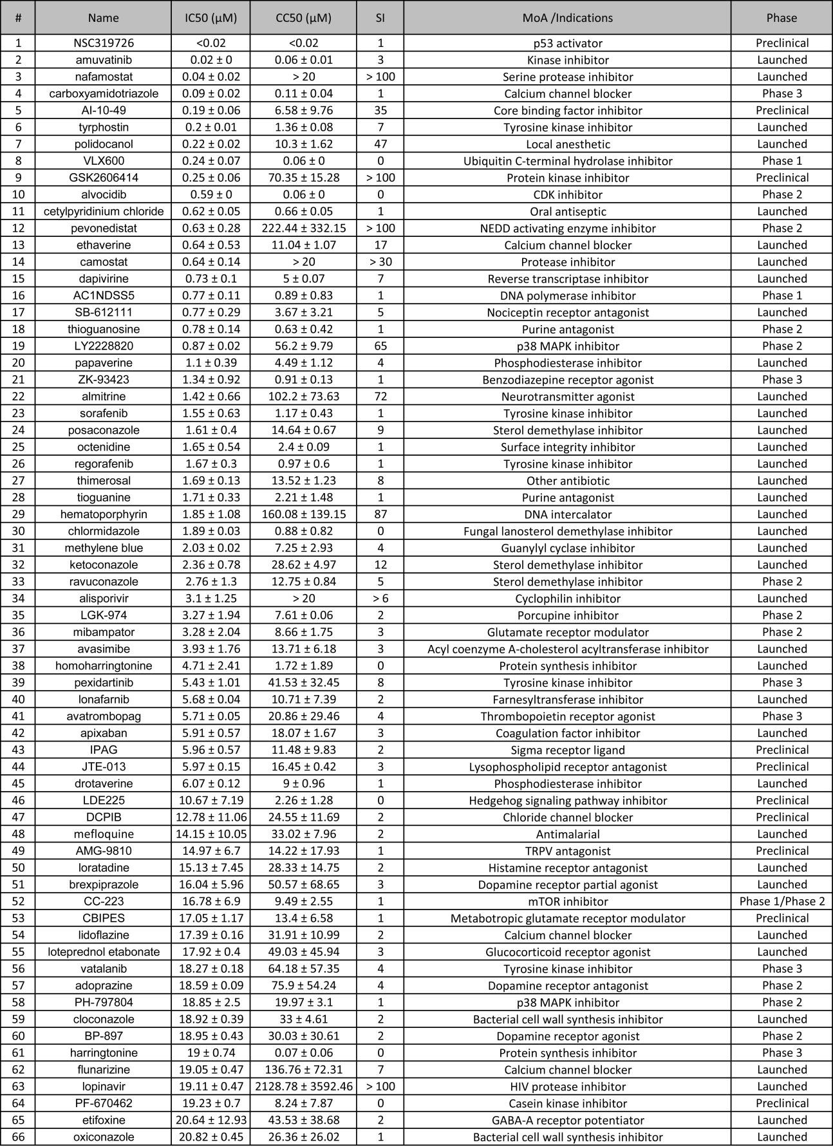

Table 1: Compounds identified in the primary screen with IC50 <20 µM (plus alisporivir). The IC50 and CC50 calculated from 3 independent measurements. Cytotoxicity index (CI) = (IC50 / CC50). Corresponding dose response curves are shown in Figure S4. Target and Clinical Phase annotation from https://clue.io/repurposing(4). ‡ Reported in clinicaltrial.gov or suggested in Li et al.(2)

