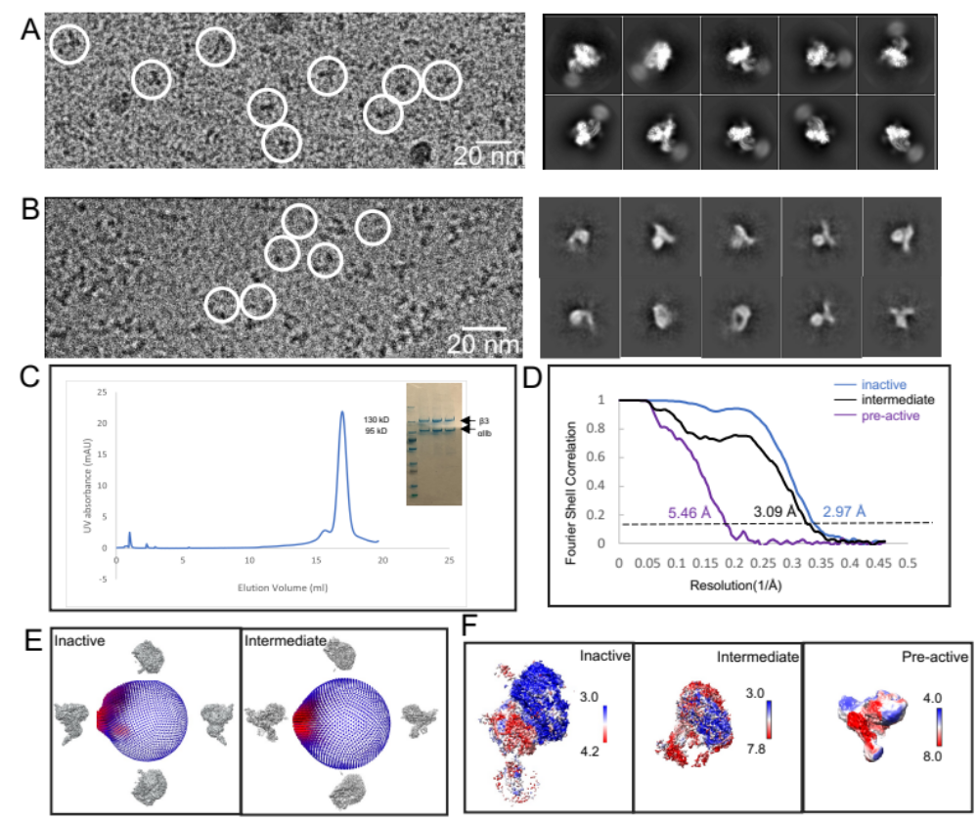
Supplemental Figure 1. The sample and SPA of integrin in the inactive state and intermediate state. A) Representative micrograph and 2d classification of integrin in inactive state. B) Representative micrograph and 2d classification of integrin in intermediate state. C) SEC-FPLC profile D) The fourier shell correlation (FSC) curves of the three reconstructions using the gold-standard criteria (FSC=0.143). E) The angular distribution plot for two maps. F) The local resolution variations in the three cryo-EM maps.
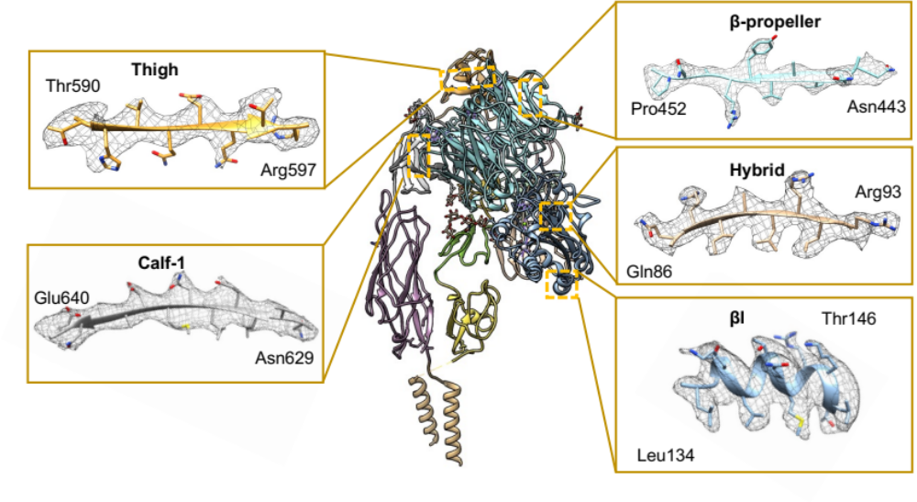
Supplemental Figure 2. Representative sample of the 2.9 Å inactive cryo-EM map of αIIβ3 integrin showing side-chain densities along with the modeled structure.

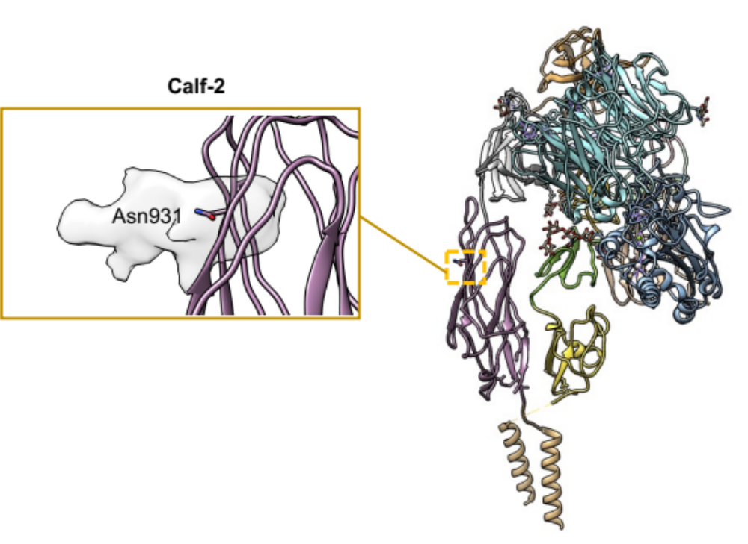
Supplemental Figure 3. Extra density of the glycosylation for Asn931 is showed in the low-pass filter map (resolution ≈ 7.5 Å).
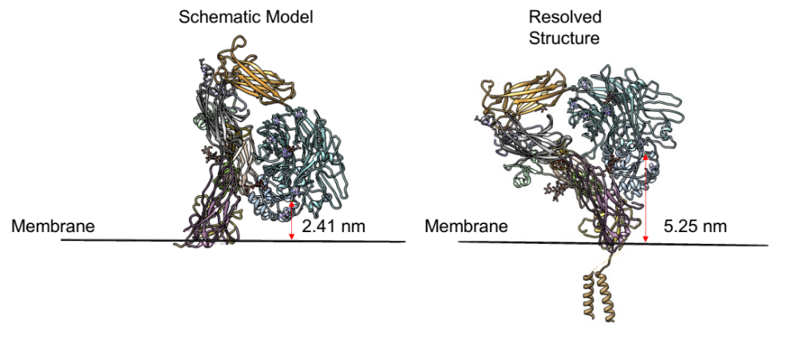
Supplemental Figure 4. Distance between MIDAS (use the coordinate of Mg²⁺ ) and cell membrane. In the previous schematic model, cell membrane plane is perpendicular to “leg” region. The distance is 2.41 nm. (left) In our model, cell membrane plane is perpendicular to TM region and extracellular domain is tilted compared to previous model. The distance is 5.25 nm. (right)
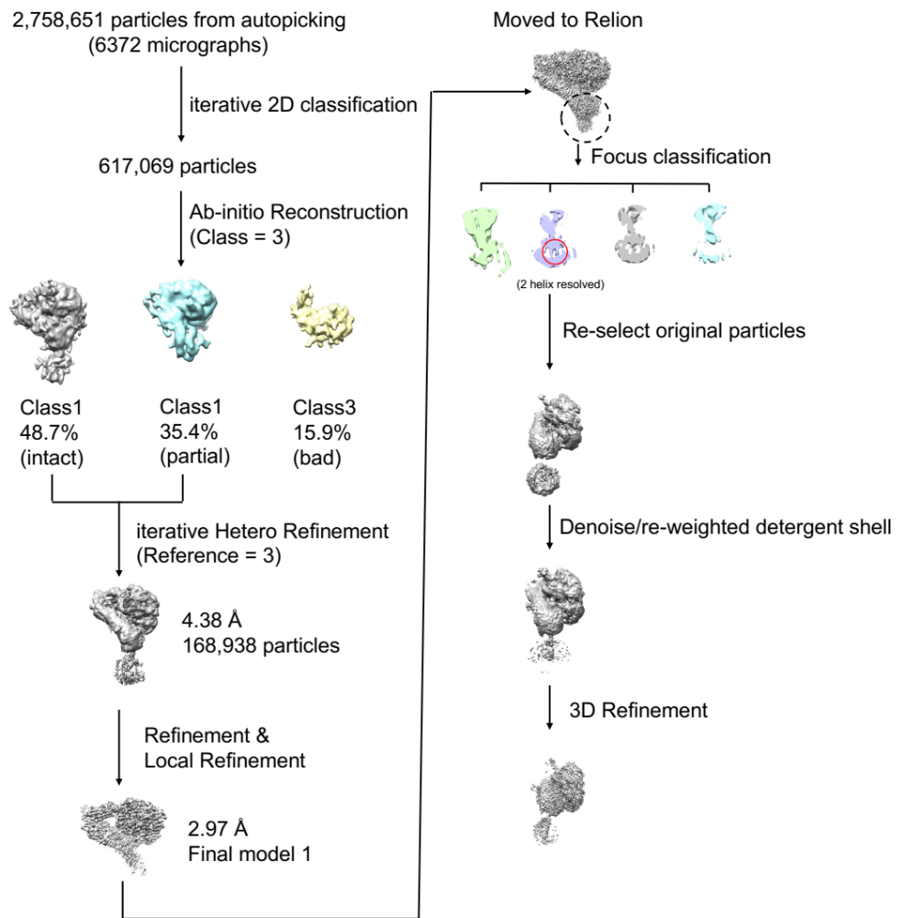
Supplemental Figure 5. CryoEM data processing for αIIβ3 in Ca²⁺ and Mg²⁺ condition.
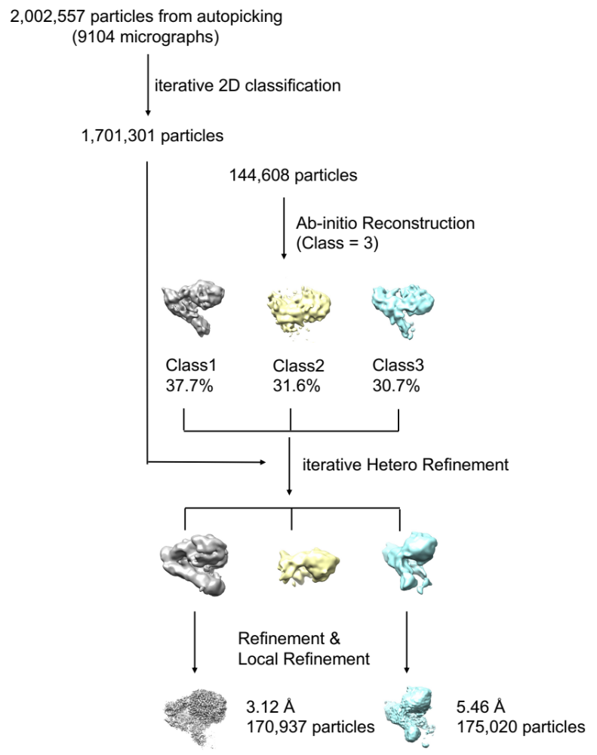
Supplemental Figure 6. CryoEM data processing for αIIβ3 in Ca²⁺ and Mn²⁺ condition.

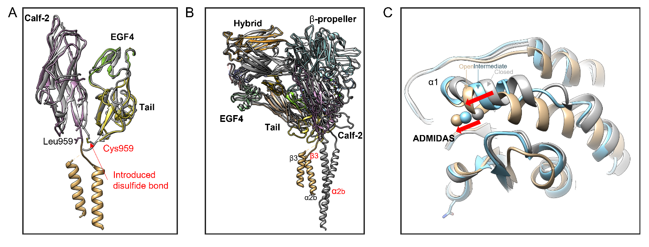
Supplemental Figure 7. Structural comparison with previous models. A) Superimposed α-Calf2 and β-tail domains of the structures in this study (colored) and 3FCS (gray) (RMSD=5.74 Å) . Leu959 (black) is mutated to Cys959 (red) in 3FCS and disulfide bond is introduced. B) Superimposed overall structure in this study (colored) and previous study (gray). C) α1 helix movement during activation indicated by comparison with previous reported closed state (gray, PDB:3T3P) and open state (gold, PDB:2VDR)) and intermediate state in this study (cyan).

Supplemental Movie 1. Shown are the cryoEM density maps and structure for the inactive state of αIIβ3 in Ca²⁺ and Mg²⁺.
Supplemental Movie 2. Shown are the cryoEM density maps and structure for the intermediate state of αIIβ3 in Ca²⁺ and Mn²⁺.
Supplemental Movie 3. Transition morph movie from inactive state to intermediate state and pre-active state of αIIβ3.
Supplemental Table1 Cryo-EM data collection, refinement and validation statistics
 | Inactive αIIbβ3  (EMDB-XXXX)  (PDB-XXXX) | Intermediate αIIbβ3  (EMDB-XXXX)  (PDB-XXXX) | (EMDB-XXXX)
Data collection and processing
Instrument | Krios (FEI) | Krios (FEI) | Krios (FEI)
Director | K2 | K2 | K2
Magnification | 130K | 130K | 130K
Voltage (kV) | 300 | 300 | 300
Electron dose (e-/Å²) | 1.43 | 1.43 | 1.43
Defocus range (μm) | −1.0 to −2.6 | −1.0 to −2.6 | −1.0 to −2.6
Pixel size (Å) | 1.07 | 1.07 | 1.07
Symmetry imposed | C1 | C1 | C1
Micrograph collected (N) | 6372 | 9104 | 9104
Initial particle images(N) | 2,758,651 | 2,002,557 | 2,002,557
Final particle images(N) | 168,938 | 170,937 | 175,020
Map resolution (Å) | 2.97 | 3.12 | 5.46
FSC threshold | 0.143 | 0.143 | 0.143
Refinement
Initial model used(PDBs) | 3FCS | 3FCS
Model resolution(Å) | 3.49 | 3.90
FSC threshold | 0.5 | 0.5
Validation
B factors(Å²)(mean) | 61.79 | 49.91
R.m.s. deviations
Bond lengths (Å) | 0.007 | 0.005
Bond angles (°) | 1.412 | 0.777
MolProbity score | 1.96 | 2.27
Clash score | 10.66 | 18.00
Poor rotamers (%) | 0.53 | 0.37
Ramachandran plot
Favoured (%) | 93.74 | 91.06
Allowed (%) | 6.11 | 8.75
Disallowed (%) | 0.15 | 0.19

