Fig S1. Illustration of different delineations of spinal cord. Although the two radii may differ by 5 pixels, they are both clinically acceptable.

Fig S2. Illustration of the non-pixel-level lung contour delineated by human. Yellow line denotes the deviation of the manual lung contour from the true lung edge.

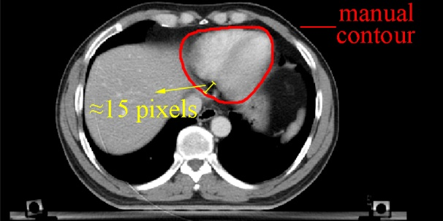
Fig S3. Illustration of the non-pixel-level heart contour delineated by human. Yellow line denotes the deviation of the manual heart contour from the true heart edge.

