Supplementary Tables
Table S1. Leaf- and plant-level trait and other variables (left) and corresponding ecosystem analogues in our study (centre), with abbreviations (right).
Plant trait | Analogous Ecosystem Property | Abbreviation
Photosynthetic capacity (Amass) | Photosynthetic capacity at light saturation | GPPsat
Dark respiration rate (Rmass) | Maximum ecosystem respiration | RECOmax
Leaf longevity (LL) | Community-weighted mean leaf longevity | wLL
Nitrogen content per unit leaf mass (Nmass) (or N concentration) | Community-weighted mean nitrogen per unit leaf mass (or N concentration) | wNmass
Leaf area (LA) | Maximum leaf area index | LAImax
Plant height (H) | Maximum canopy height | Hc
Stem specific density (SSD) | Community-weighted mean stem specific density | wSSD
Stomatal conductance (gs) | Maximum surface conductance | Gsmax
Photosynthetic nitrogen use-efficiency (PNUE) | Photosynthetic nitrogen use-efficiency | PNUE
Water use-efficiency (WUE) | Water use-efficiency based on transpiration | WUEt
Air Temperature (Ta) | Air Temperature | Ta

Table S2. Principal Component Analysis (PCA) information for the leaf economics spectrum analogue at the ecosystem scale, for all sites (left) and forest sites only (right); value refers to the analysis of the data used, std to the bootstrap standard error (standard deviation); retention is the percentage of bootstrap iterations in which each principal component was retained as significant according to the Dray method¹.
Table S3. Principal Component Analysis (PCA) information for the global spectrum of plant form and function at the ecosystem scale; value refers to the analysis of the actual data, mean refers to the average over bootstrapped values, std to the bootstrap standard error (standard deviation); retention is the percentage of bootstrap iteration that each principal component was selected to be retained as significant according to the Dray method¹.
Table S4. Principal Component Analysis (PCA) information for the least-cost hypothesis at the ecosystem scale for all sites (top left), forest sites (top right), with water use efficiency (WUE) based on evapotranspiration (WUEet, centre left), underlying WUE (uWUE, centre right), photosynthetic Nitrogen use efficiency (PNUE) without leaf area index (LAI) normalization (bottom left), and Absorbed Photosynthetically Active Radiation (APAR) divided by community weighted mean nitrogen concentration (wNmass) (APAR_N, bottom right); value refers to the analysis of the actual data, std to the bootstrap standard error (standard deviation); retention is the percentage of bootstrap iterations in which each principal component was retained as significant according to the Dray method¹.
Table S5. List of eddy covariance sites used in the analysis, including references.
See separate excel file.

Table S6. Percentage of sites for each vegetation type for each section of the analysis. Abbreviations: IGBP: International Geosphere-Biosphere Programme vegetation type; CSH: closed shrubland; DBF: deciduous broadleaf forest; EBF: evergreen broadleaf forest; ENF: evergreen needleleaf forest; GRA: grassland; MF: mixed forest; OSH: open shrubland; SAV: savannah; WET: wetland; WSA: woody savannah.
IGBP | Leaf economics spectrum | Global spectrum of plant form and function | Least cost hypothesis
CSH | 3.3 | 3.4 | 4.9
DBF | 14.4 | 14.6 | 13.4
EBF | 6.7 | 7.9 | 4.9
ENF | 50.0 | 51.7 | 50.0
GRA | 8.9 | 5.6 | 7.3
MF | 5.6 | 5.6 | 4.9
OSH | 2.2 | 2.2 | 3.7
SAV | 2.2 | 3.4 | 3.7
WET | 4.4 | 3.4 | 4.9
WSA | 2.2 | 2.2 | 2.4

Table S7. List of TRY datasets used in the analysis, including references.
See separate excel file.

Table S8. List of original FLUXNET variables used in the analysis.
Variable | Original variable name in FLUXNET 2015 dataset | Units | Variable name
GPP | GPP_NT_VUT_USTAR50 | µmol CO₂ m⁻² s⁻¹ | Gross primary productivity from night-time partitioning
H | H_F_MDS | W m⁻² | Sensible heat flux
LE | LE_F_MDS | W m⁻² | Latent heat flux
NEE | NEE_NT_VUT_USTAR50 | µmol CO₂ m⁻² s⁻¹ | Net ecosystem exchange
P | P | mm | Precipitation
RECO | RECO_NT_VUT_USTAR50 | µmol CO₂ m⁻² s⁻¹ | Ecosystem respiration from night-time partitioning
SW_IN | SW_IN_F_MDS | W m⁻² | Shortwave radiation, incoming, gap-filled,
TA | TA_F_MDS | ° C | Air temperature
VPD | VPD_F_MDS | hPa | Vapour pressure deficit
USTAR | USTAR | m s⁻¹ | Friction velocity
WS | WS | m s⁻¹ | Wind speed

Supplementary Figures
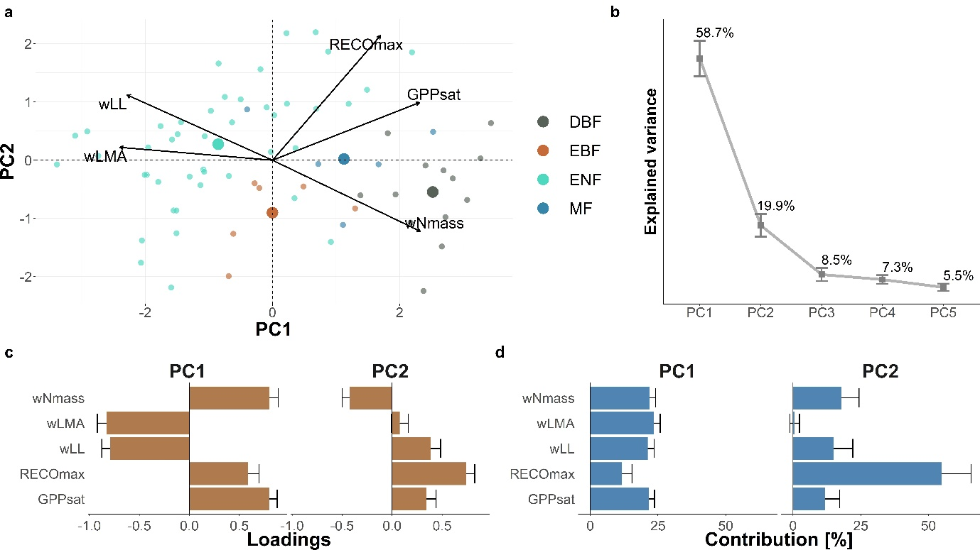
Figure S1. Principal Component Analysis (PCA) on variables representing the Leaf Economics Spectrum on forest sites at the ecosystem scale (69 sites). a) Biplot resulting from PCA; point colours represent plant functional types following the IGBP classification: CSH (Closed Shrubland), DBF (Deciduous Broadleaf Forest), EBF (Evergreen Broadleaf Forest), ENF (Evergreen Needleleaf Forest), GRA (Grassland), MF (Mixed Forest), OSH (Open Shrubland), SAV (Savannah), WET (Wetland), WSA (Woody Savannah). Bigger points represent the centroid of the distribution for each habitat type. b) Explained variance for the retained Principal Components (PCs). c) Barplot for the loadings, and d) contributions for each variable on the retained PCs. Error bars represent the standard error estimated with bootstrap procedure (n = 499). Variable acronyms: photosynthetic capacity at light saturation (GPPsat), maximum ecosystem respiration (RECOmax), community-weighted mean leaf longevity (wLL), community-weighted mean leaf mass per area (wLMA), community-weighted mean nitrogen per leaf mass (wNmass).
Figure S2. Relative importance² of the predictors of maximum Gross Primary Productivity at light saturation (GPPsat) - the ecosystem scale photosynthetic capacity, based on multimodel inference analysis³ (n = 87). In panel a) the analysis includes community-weighted mean N concentration (wNmass), community-weighted mean leaf mass per area (wLMA), community-weighted mean leaf longevity (wLL), and maximum leaf area index (LAImax) (62 % explained variance). b) Same as in panel a) but with area-based nitrogen estimates, which is wNmass divided by wLMA. Results show that LAImax followed by N content and average leaf longevity are the three most important predictors of the GPPsat (53 % explained variance). Variable acronyms: community-weighted mean leaf longevity (wLL), community-weighted mean leaf mass per area (wLMA), community-weighted mean nitrogen per leaf area (wNarea), community-weighted mean nitrogen per leaf mass (wNmass), maximum leaf area index (LAImax).
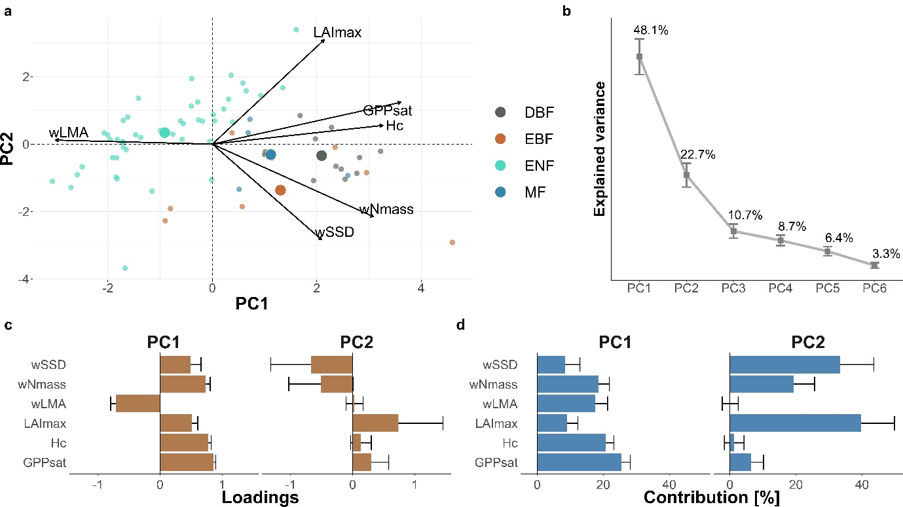
Figure S3. Principal Component Analysis on the global spectrum of plant form and function on forest sites at the ecosystem scale (71 sites). a) Biplot resulting from PCA; point colours represent plant functional types following the IGBP classification: DBF (Deciduous Broadleaf Forest), EBF (Evergreen Broadleaf Forest), ENF (Evergreen Needleleaf Forest), MF (Mixed Forest). Bigger points represent the centroid of the distribution for each habitat type. b) Explained variance for the retained Principal Components (PCs). c) Barplot for the loadings, and d) contributions for each variable on the retained PCs. Error bars represent the standard error estimated with bootstrap procedure (n = 499). Variable acronyms: gross primary productivity at light saturation (GPPsat), canopy height (Hc), maximum leaf area index (LAImax), community-weighted mean leaf mass per area (wLMA), community-weighted mean nitrogen per leaf mass (wNmass), community-weighted mean stem specific density (wSSD).
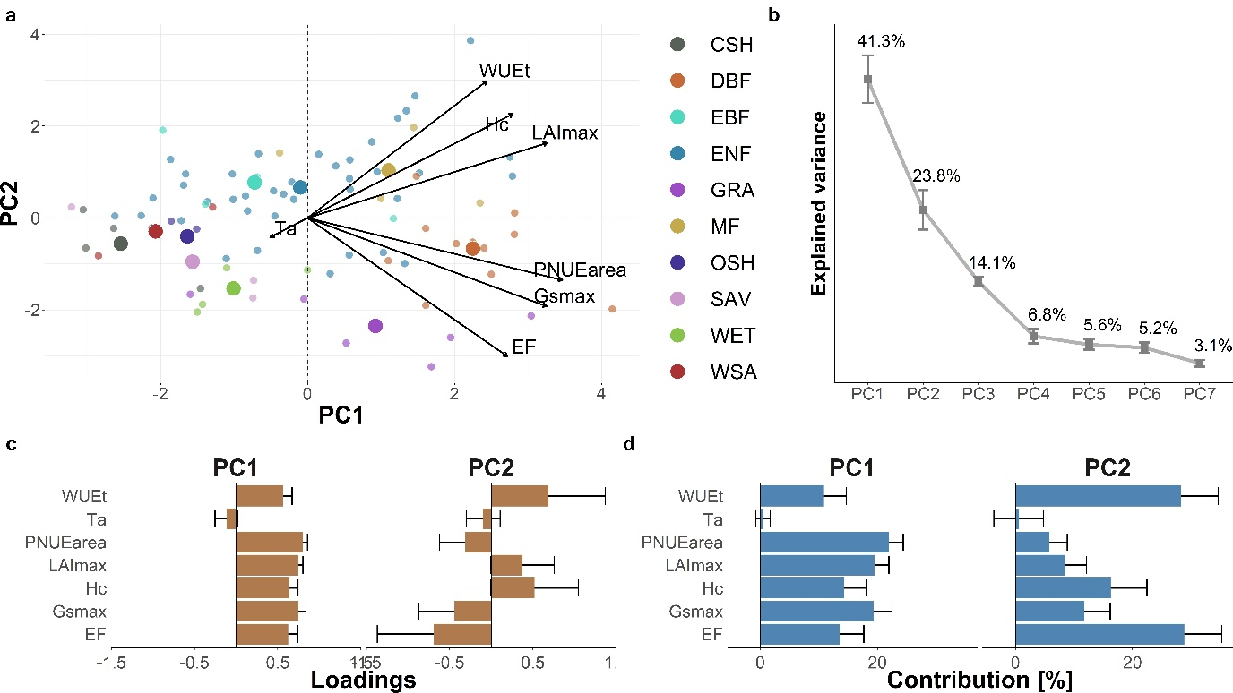Figure S4. Principal Component Analysis (PCA) on least-cost hypothesis analogue with PNUEarea and LAImax at the ecosystem scale (82 sites). a) Biplot resulting from PCA; point colours represent plant functional types following the IGBP classification: CSH (Closed Shrubland), DBF (Deciduous Broadleaf Forest), EBF (Evergreen Broadleaf Forest), ENF (Evergreen Needleleaf Forest), GRA (Grassland), MF (Mixed Forest), OSH (Open Shrubland), SAV (Savannah), WET (Wetland), WSA (Woody Savannah). Bigger points represent the centroid of the distribution for each vegetation type. b) Explained variance for the retained Principal Components (PCs). c) Barplot for the loadings, and d) contributions for each variable on the retained PCs. Error bars represent the standard error estimated with bootstrap procedure (n = 499). Variable acronyms: evaporative fraction (EF), maximum surface conductance (Gsmax), canopy height (Hc), maximum leaf area index (LAImax), photosynthetic nitrogen use efficiency without LAImax normalization (PNUEarea), air temperature (Ta), water use efficiency based on transpiration (WUEt). We calculated PNUEarea based on Narea, without normalizing by LAImax (PNUEarea = GPPsat / wNarea).
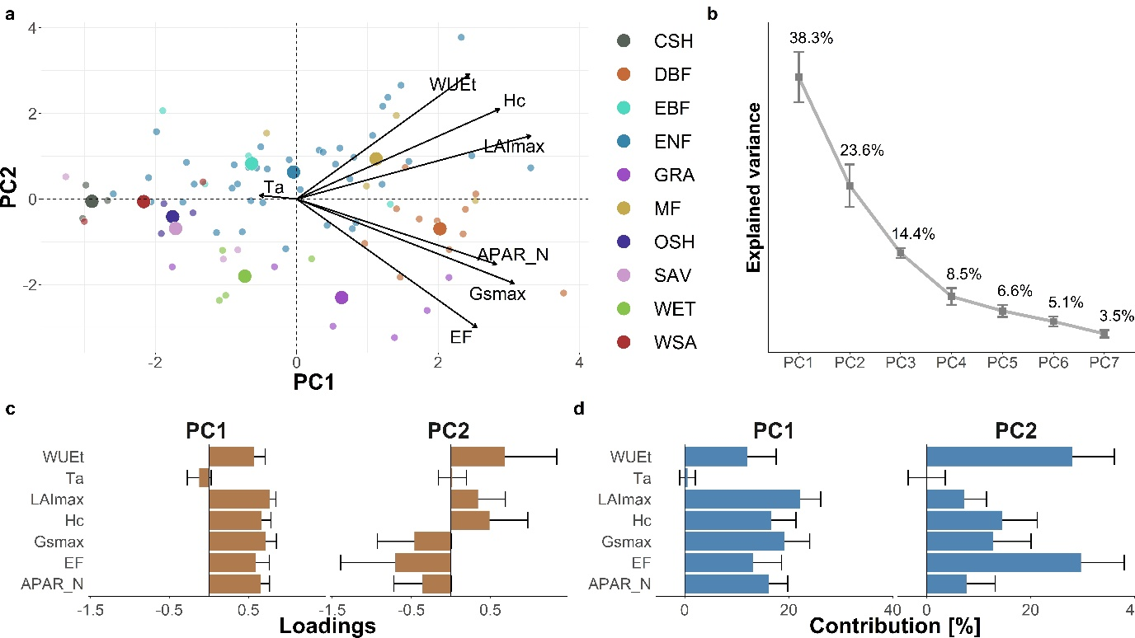Figure S5. Principal Component Analysis (PCA) on least-cost hypothesis analogue with APAR_N and LAImax at the ecosystem scale (80 sites). a) Biplot resulting from PCA; point colours represent plant functional types following the IGBP classification: CSH (Closed Shrubland), DBF (Deciduous Broadleaf Forest), EBF (Evergreen Broadleaf Forest), ENF (Evergreen Needleleaf Forest), GRA (Grassland), MF (Mixed Forest), OSH (Open Shrubland), SAV (Savannah), WET (Wetland), WSA (Woody Savannah). Bigger points represent the centroid of the distribution for each vegetation type. b) Explained variance for the retained Principal Components (PCs). c) Barplot for the loadings, and d) contributions for each variable on the retained PCs. Error bars represent the standard error estimated with bootstrap procedure (n = 499). Variable acronyms: ratio between maximum absorbed photosynthetically active radiation and community-weighted mean of nitrogen per leaf mass (APAR_N), evaporative fraction (EF), maximum surface conductance (Gsmax), canopy height (Hc), maximum leaf area index (LAImax), air temperature (Ta), water use efficiency based on transpiration (WUEt). To avoid a spurious relationship between PNUE and WUE, we developed the alternative metric of APAR_N, related to PNUE, and based on absorbed photosynthetically active radiation (APAR), since APAR correlates with GPPsat (cor = 0.55, p < 0.001 for 167 sites in our dataset). We computed APAR as the product between fPAR, and the photosynthetic photon flux density (PPFD, μmol m-2 s-1) of photosynthetically active radiation. We first extracted data for the fraction of photosynthetically active radiation (fPAR, -) from the MCD15A3H MODIS product. For each flux tower location, we averaged the fPAR information from an area of 3 x 3 500 m² pixels. We used the fPAR-LAI quality information provided in the MCD15A3H product flags to focus on data points retrieved from the main algorithm under the following criteria: good retrieval quality, with and without saturation, limited dead detector problems, and clear sky conditions. For a more detailed filtering, we removed ocean or shore pixels, snow or ice, as well as clouds, cloud shadows and cirrus. After aggregating SW_IN to 4 days to match the temporal aggregation of the extracted fPAR, we multiplied SW_IN by 2.11 for the conversion to PPFD. We calculated the yearly APAR as the 90th percentile of 4-days aggregates of the product between fPAR and PPFD, and averaged yearly APAR values to site means. APAR was then computed as the mean yearly maximum at each site (APARmax, correlation to GPPsat: cor = 0.64, p < 0.001 for 167 sites). We computed APAR_N = APARmax / wNarea as an independent proxy of “potential” PNUE.
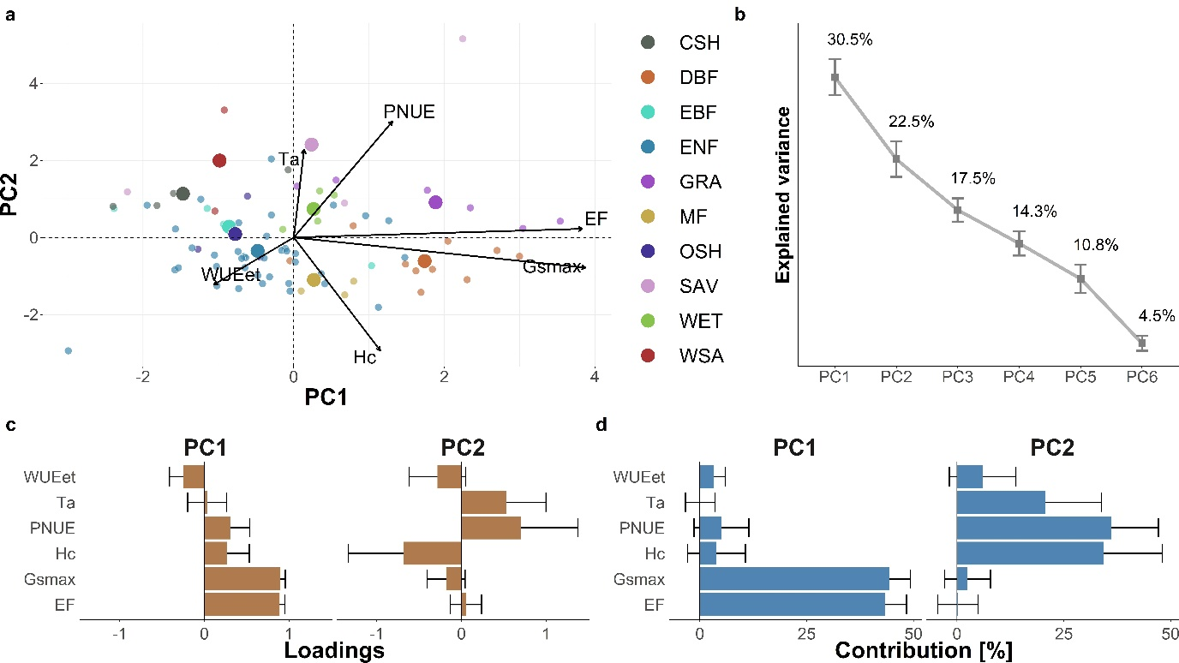Figure S6. Principal Component Analysis (PCA) on least-cost hypothesis analogue with WUE based on evapotranspiration (WUEet) at the ecosystem scale (82 sites). a) Biplot resulting from PCA; point colours represent plant functional types following the IGBP classification: CSH (Closed Shrubland), DBF (Deciduous Broadleaf Forest), EBF (Evergreen Broadleaf Forest), ENF (Evergreen Needleleaf Forest), GRA (Grassland), MF (Mixed Forest), OSH (Open Shrubland), SAV (Savannah), WET (Wetland), WSA (Woody Savannah). Bigger points represent the centroid of the distribution for each vegetation type. b) Explained variance for the retained Principal Components (PCs). c) Barplot for the loadings, and d) contributions for each variable on the retained PCs. Error bars represent the standard error estimated with bootstrap procedure (n = 499). Variable acronyms: evaporative fraction (EF), maximum surface conductance (Gsmax), canopy height (Hc), photosynthetic nitrogen use efficiency (PNUE), air temperature (Ta), water use efficiency based on evapotranspiration (WUEet).
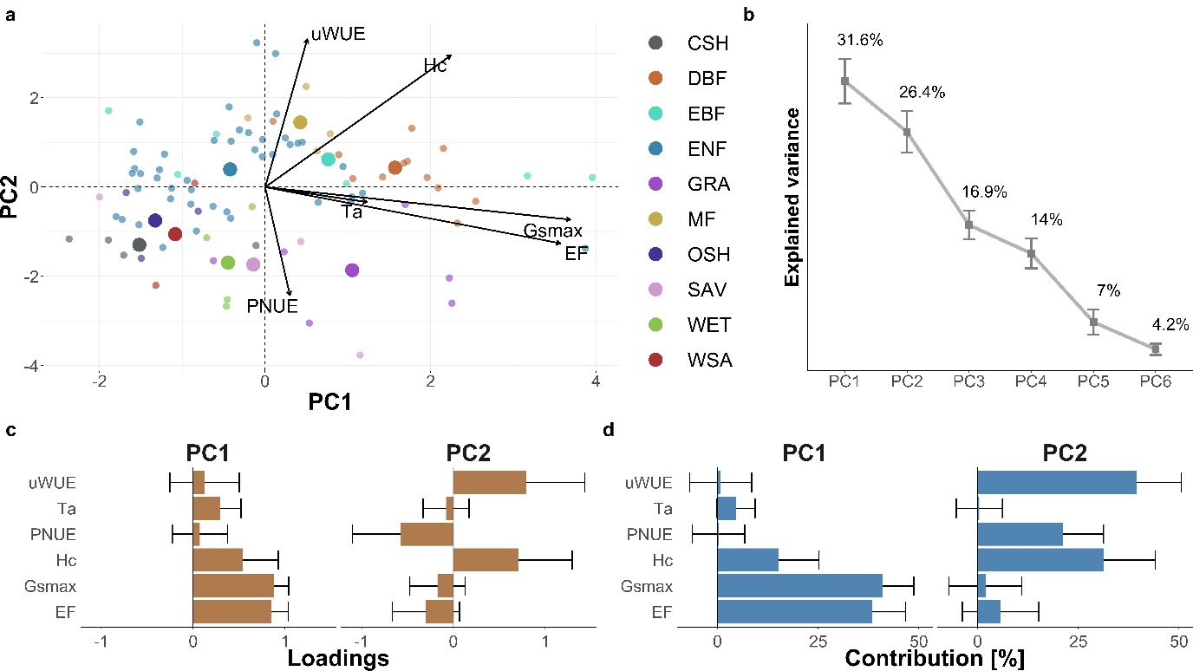Figure S7. Principal Component Analysis (PCA) on least-cost hypothesis analogue with the underlying water use-efficiency (uWUE)⁴ at the ecosystem scale (89 sites). a) Biplot resulting from PCA; point colours represent plant functional types following the IGBP classification: CSH (Closed Shrubland), DBF (Deciduous Broadleaf Forest), EBF (Evergreen Broadleaf Forest), ENF (Evergreen Needleleaf Forest), GRA (Grassland), MF (Mixed Forest), OSH (Open Shrubland), SAV (Savannah), WET (Wetland), WSA (Woody Savannah). Bigger points represent the centroid of the distribution for each vegetation type. b) Explained variance for the retained Principal Components (PCs). c) Barplot for the loadings, and d) contributions for each variable on the retained PCs. Error bars represent the standard error estimated with bootstrap procedure (n = 499). Variable acronyms: evaporative fraction (EF), maximum surface conductance (Gsmax), canopy height (Hc), photosynthetic nitrogen use efficiency (PNUE), air temperature (Ta), underlying water use efficiency (uWUE).
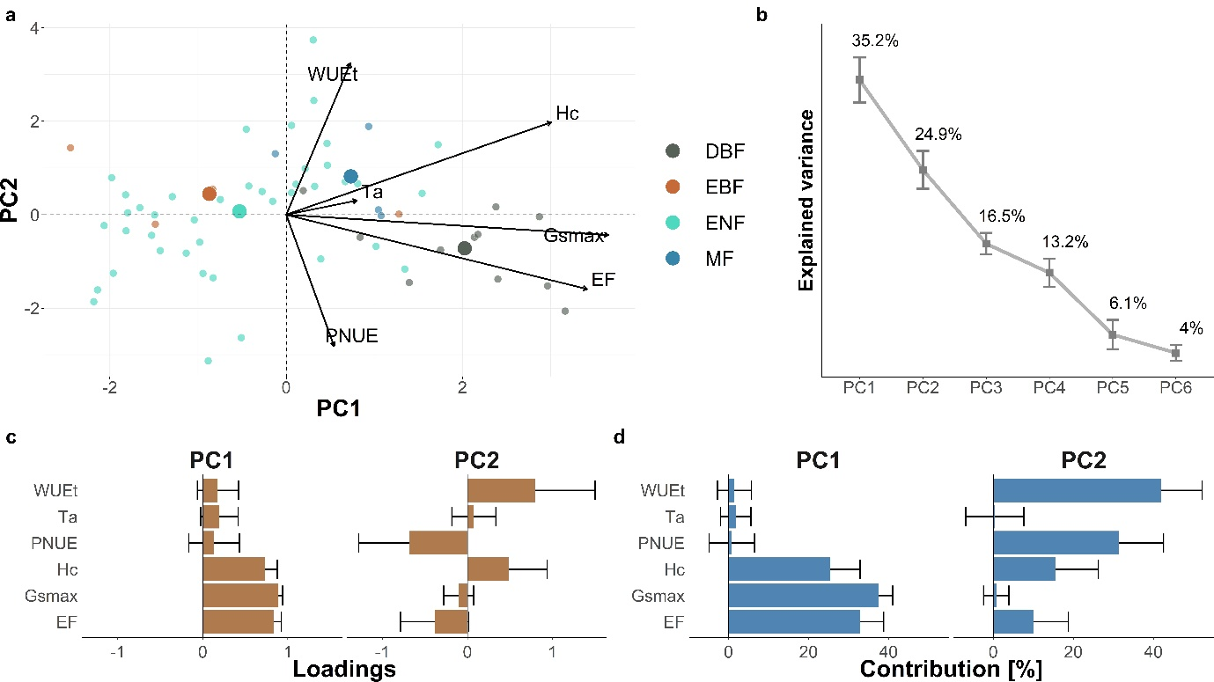Figure S8. Principal Component Analysis (PCA) on least-cost hypothesis analogue on forest sites at the ecosystem scale (60 sites). a) Biplot resulting from PCA; point colours represent plant functional types following the IGBP classification: CSH (Closed Shrubland), DBF (Deciduous Broadleaf Forest), EBF (Evergreen Broadleaf Forest), ENF (Evergreen Needleleaf Forest), GRA (Grassland), MF (Mixed Forest), OSH (Open Shrubland), SAV (Savannah), WET (Wetland), WSA (Woody Savannah). Bigger points represent the centroid of the distribution for each vegetation type. b) Explained variance for the retained Principal Components (PCs). c) Barplot for the loadings, and d) contributions for each variable on the retained PCs. Error bars represent the standard error estimated with bootstrap procedure (n = 499). Variable acronyms: evaporative fraction (EF), maximum surface conductance (Gsmax), canopy height (Hc), photosynthetic nitrogen use efficiency (PNUE), air temperature (Ta), water use efficiency based on transpiration (WUEt).

References
1. Dray, S. On the number of principal components: A test of dimensionality based on measurements of similarity between matrices. (2008) doi:10.1016/j.csda.2007.07.015.
2. Grömping, U. Relative Importance for Linear Regression in R: The Package relaimpo. Journal of Statistical Software 17, 1–27 (2006).
3. Bartoń, K. MuMIn: Multi-modal inference. Model selection and model averaging based on information criteria (AICc and alike). http://cran.r-project.org/web/packages/MuMIn/index.html (2013).
4. Zhou, S., Yu, B., Huang, Y. & Wang, G. The effect of vapor pressure deficit on water use efficiency at the subdaily time scale. Geophysical Research Letters 41, 5005–5013 (2014).

