Supplementary Information

Metal-to-metal charge transfer driven by the electropositive species for stable anionic redox chemistry

Min-Ho Kim^{1,3}, Haeseong Jang^{1,2,3}, Eunryeol Lee^{1,3}, Jaehyun Park¹, Taewon Kim¹, Jeongwoo Seo¹, Young Hwa Jung², Seok Ju Kang¹, Jaephil Cho¹, Min Gyu Kim^{2,*}, Dong-Hwa Seo^{1,*}, Hyun-Wook Lee^{1,*}

Table of contents
Part I: Supplementary Notes
Supplementary Note 1. | Methods for computational modeling
Supplementary Note 2. | The reason why Ni is not oxidized up to 4+, in contrast to conventional wisdom.

Part II: Supplementary Figures 1-26
Synchrotron XRD investigation: Suppl. Fig. 1, 2, 24
Electrochemical evaluation: Suppl. Fig. 3, 4, 5, 23
Operando XANES analysis: Suppl. Fig. 6, 7, 8, 9, 10, 11, 12
Operando EXAFS analysis: Suppl. Fig. 13, 14, 15, 16, 17, 18, 19, 20
TEM analysis: Suppl. Fig. 21
EELS analysis: Suppl. Fig. 22
DEMS analysis: Suppl. Fig. 25
Raman analysis: Suppl. Fig. 26

Part Ⅲ: Supplementary Tables
Table S1. | The newly proposed concepts of the anionic redox mechanisms
Table S2. | A brief introduction to the terminologies we designate in this paper

Supplementary Note 1 | Method for computational modeling
To compare the computational results between Li₂RuO₃ and Li_{1.22}Ni_{0.17}Ru_{0.61}O₂, we designed its structural modeling as follows. A cell size is minimized to evaluate a cost-expensive electronic structure. The size of supercell is 2 x 2 x 2, consisting of 8 Li, 4 Ru and 12 O atoms for LRO and 2 x 4 x 3, consisting of 15 Li, 2 Ni, 7 Ru and 24 O atoms for LNRO, respectively. Reciprocal-space k-point meshes were 5 x 2 x 4 for LRO and 5 x 5 x 2 for LNRO. We employed the HSE06 hybrid functional with a general hybrid mixing parameter (HFSCREEN=0.2) to evaluate an accurate electronic structure for LRO and LNRO in various a state of charge (SOC). A proper Li configuration in charged state is determined, based on the obtained results with GGA+U calculation for thirty stable orderings evaluated by Ewald-summation methods. Bader charge analysis are adopted to relatively compare a charge density of Ru atom with and without neighboring Ni atoms. Note that the bader charge only enables to expect a relative distribution of charge around Ru atom depending on a neighboring environment, not a formal oxidation state. Local Orbital Basis Suite Towards Electronic-Structure Reconstruction (LOBSTER) program is performed to analyze a chemical bonding based on plane-wave and paw output. The electronic results obtained by HSE06 calculation in VASP are used as an input file for LOBSTER program. Meanwhile, we evaluate an extent of a covalency in a chemical bond with Integrated Crystal Orbital Overlap Population (Integrated COOP) which is one of output files calculated by LOBSTER program. The isosurface level is commonly fixed at 0.10 for an accurate comparison in LRO and LNRO modeled structures.

Supplementary Note 2 | The reason why Ni is not oxidized up to 4+, in contrast to the conventional wisdom.
As shown in Ni K-edge XANES spectra in Fig. 3f, Ni in LNRO is not oxidized up to oxidation state of +4. It is closely related to inductive effect. As Ni is more electropositive than Ru, the electron is polarized toward Ru-O σ-bonds away from Ni-O σ-bonds. It makes Ru-O bonds more covalent and Ni-O bonds less covalent. Reduced covalency between Ni and O drives reduced orbital splitting between e_{g} and t_{2g}, with increased thermodynamic redox potential. Thus, more electronegative Ru with respect to general 3d TMs, such as Co and Mn, would cause significant potential shift, so Ni cannot be oxidized to oxidation state of +4, at least, at upper cut-off voltage of 4.6 V.

Supplementary Fig. 1 | Synchrotron XRD pattern and Le bail fitting of Li_{2-x}RuO₃ (a) and Li_{1.22-x}Ni_{0.17}Ru_{0.61}O₂ (b). Almost all XRD pattern of both samples are refined with C_{2/c} space group.

Supplementary Fig. 2 | The comparison of synchrotron XRD patterns before and after cycling. a, the comparison of XRD patterns for pristine, 1st charged, 1st discharged and 50th cycled sample. The green shaded regions represent the superstructure peaks of Li_{1/3}TM_{2/3} honeycomb-phase, demonstrating that corresponding peaks of LNRO is well-maintained even at charge state and after 50th cycle, compared to LRO. b, XRD patterns of LRO and LNRO with normalized intensity by (002) area before and after formation process. The insets manifest the degree of dissipation of honeycomb phase during the formation process, which corresponds to decreasing ratio of summed area of superstructure peaks within the 16°–38° range during 1st cycle.

Supplementary Fig. 3 | Voltage profiles of LRO (a) and LNRO (b) over extended cycling (1st, 2nd 10^{th,} 50th and 100th).

Supplementary Fig. 4 | Electrochemical evaluation of LRO (a) and LNRO (b) during 50 cycles at 25 ℃. Both samples are tested within 4.6-2.0 V.

Supplementary Fig. 5 | Electrochemical evaluation of LRO (a) and LNRO (b) during 50 cycles at 60 ℃. Both samples are tested within 4.6-2.0 V.

Supplementary Fig. 6 | Basic principles of X-ray absorption fine spectroscopy (XAFS). As a core electron absorbs an X-ray, which have sufficient energy to eject an electron from an atom, the intensity ratio of the incoming and outgoing X-ray is proportional to the exponential of the absorption coefficient and thickness of the samples. X-ray absorption near-edge structure (XANES) is correlated with not only oxidation state of the chemical species, but also site symmetry and covalent bond strength; Although pre-edge features is dipole-forbidden, it has been used to obtain the information of local structure around the central atom, where the peak intensity is affected by 3d and 4p orbital mixing by perturbation of site symmetry of transition metal. And extended X-ray absorption fine structure (EXAFS) is useful to check quantitative local structural information including interatomic distance, coordination number, and Debye-Waller factor.

Supplementary Fig. 7 | Operando Ru K-edge XANES 2D contour plot of Li_{2-x}RuO₃ during the 1st cycle (a) and 50th cycle (b).

Supplementary Fig. 8 | Operando Ru K-edge XANES 2D contour plot of Li_{1.22-x}Ni_{0.17}Ru_{0.62}O₂ during the 1st cycle (a) and 50th cycle (b).

Supplementary Fig. 9 | Operando Ni K-edge XANES 2D contour plot of Li_{1.22-x}Ni_{0.17}Ru_{0.62}O₂ during the 1st cycle (a) and 50th cycle (b).

Supplementary Fig. 10 | Evolution of Ru whiteline (WL) energy and intensity on Li_{2-x}RuO₃ during 1st charging. a, Voltage profile of Li_{2-x}RuO₃. b, Operando Ru K-edge XANES spectra during 1st charging. c, Ru WL energy and intensity evolution during 1st charging, which represents monotonic change in energy and intensity during stable cationic redox but different tendency during high-voltage redox. d, Change in Ru WL energy depending on the charged states, showing energy relaxation owing to ligand-to-metal charge transfer (LMCT) at the end of charging. It confirms that Ru is oxidized to >5.5+, returning back to 5.0+.

Supplementary Fig. 11 | Evolution of Ru whiteline (WL) energy and intensity on Li_{1.22-x}Ni_{0.17}Ru_{0.62}O₂ during 1st charging. a, Voltage profile of Li_{1.22-x}Ni_{0.17}Ru_{0.62}O₂. b, Operando Ru K-edge XANES spectra during 1st charging. c, Ru WL energy and intensity evolution during 1st charging, which represents monotonic change in energy and intensity during stable cationic redox but different tendency during high-voltage redox. d, Change in Ru WL energy depending on the charged states, showing energy relaxation due to pi back-bonding of oxygen ligands at the end of charging. It confirms that Ru is oxidized from 3.5+ to 4.9+.

Supplementary Fig. 12 | Operando Ni K-edge XANES variation of Li_{1.22-x}Ni_{0.17}Ru_{0.61}O₂ during the 1st cycle. a, Ni K-edge spectra of LNRO show consecutive energy shift during the whole charge and discharge process. Insets indicate pre-edge peak evolution (black dotted box). However, as considering the energy of reference data, Ni is seemingly oxidized from approximately 2+ to approximately 3+, not to 4+. b, the change in oxidation number of Ni on delithiated LNRO is also confirmed for whiteline, half-maximum intensity, and edge peak at absorption coefficient of 0.5, with respect to the reference.
Supplementary Fig. 13 | Schematic diagram of scattering paths in the TM atomic arrangements.

Supplementary Fig. 14 | Operando Ru K-edge EXAFS of Li_{2-x}RuO₃ during the 1st cycle.

Supplementary Fig. 15 | Operando Ru K-edge EXAFS of Li_{2-x}RuO₃ during the 50th cycle.

Supplementary Fig. 16 | Operando Ru K-edge EXAFS of Li_{1.22-x}Ni_{0.17}Ru_{0.61}O₂ during the 1st cycle.

Supplementary Fig. 17 | Operando Ru K-edge EXAFS of Li_{1.22-x}Ni_{0.17}Ru_{0.61}O₂ during the 50th cycle.

Supplementary Fig. 18 | Operando Ni K-edge EXAFS of Li_{1.22-x}Ni_{0.17}Ru_{0.61}O₂ during the 1st cycle.

Supplementary Fig. 19 | Operando Ni K-edge EXAFS of Li_{1.22-x}Ni_{0.17}Ru_{0.61}O₂ during the 50th cycle.

Supplementary Fig. 20 | Change in coordination number and Debye-Waller factor of Ni on Li_{1.22-x}Ni_{0.17}Ru_{0.61}O₂ during 1st cycle and 50th cycle. It represents that Ni tends to migrate from original octahedral sites on TM layer to octahedral sites on Li layer via neighboring tetrahedral sites during 1st cycle. However, after 50 cycles, its migration is quite suppressed to octahedral sites on Li layer.

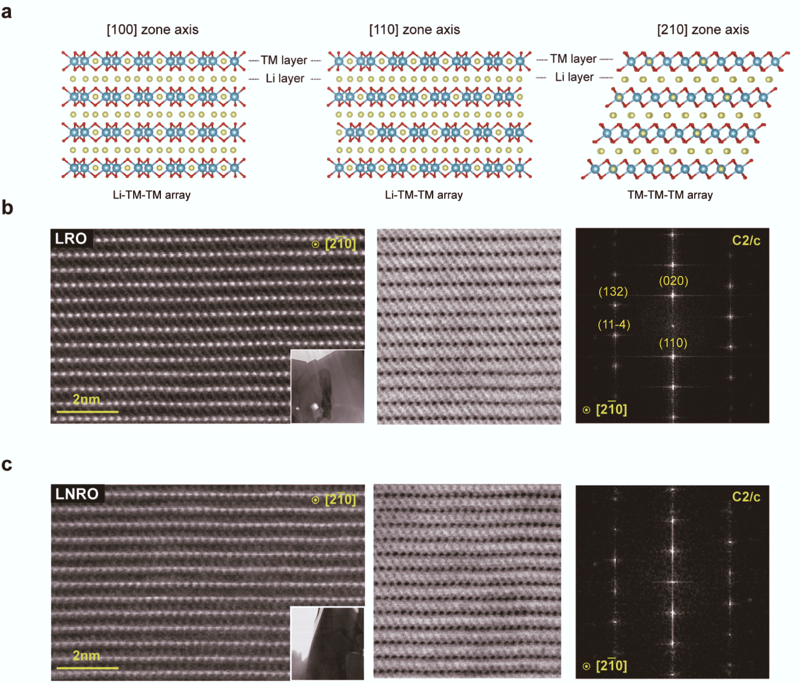
Supplementary Fig. 21 | Structure analysis of Li₂RuO₃ and Li_{1.22-x}Ni_{0.17}Ru_{0.61}O₂ with FFT patterns. a, Illustration of atomic arrangements of c_{2/c} structure depending on the zone axis. HAADF/ABF-STEM images of Li₂RuO₃ (b) and Li_{1.22-x}Ni_{0.17}Ru_{0.61}O₂ (c) with corresponding FFT image.

Supplementary Fig. 22 | Electron energy loss spectroscopy (EELS) analysis, which shows Ni-L edge spectra in Li_{1.22-x}Ni_{0.17}Ru_{0.61}O₂. It represents that Ni exhibits oxidation states of 2+ on particle surface but, it shows 3+ on the bulk.

Supplementary Fig. 23 | Voltage profiles of various TM_{3d}-substituted samples on 1st cycle and corresponding dQ/dV plots.

Supplementary Fig. 24 | The comparison of synchrotron XRD patterns of various TM_{3d}-substituted samples before and after cycling.

Supplementary Fig. 25 | Differential electrochemical mass spectroscopy (DEMS) of various TM_{3d}-substituted samples during 1st cycle. It represents that oxygen evolution is significantly suppressed whichever TM_{3d} is substituted on lithium ruthenate.

Supplementary Fig. 26 | The Raman spectra of pristine and charged states of Li₂RuO₃ (a) and Li_{1.22}Ni_{0.17}Ru_{0.61}O₂ (b). It represents that Li₂RuO₃ exhibits 848.6 cm⁻¹ peak evolution during charging, corresponding to peroxo stretch (O₂)^{n-}, but Li_{1.22}Ni_{0.17}Ru_{0.61}O₂ does not, indicating oxygen dimerization is successfully suppressed by Ni substitution.

Table S1. The newly proposed concepts of the anionic redox mechanisms

No. | Redox mechanisms | Explanation | The form of oxidized O
[1] | Non-bonding  O redox | The oxygen directly participates in charge compensation. The electrons extracted during oxygen redox originate from non-bonding O p states, leaving the holes nearby oxygen. | O²⁻ to O^{n-} (n<2)
[2] | Reductive coupling mechanism | Deeply charged TM and oxidized oxygen can easily drive structural distortion with O-O bond shortening via ligand-to-metal charge transfer (LMCT). The reversibility of such anionic redox can be governed by the number of holes per oxygen, hº. | Peroxo-like O₂^{n-}
[3] | Coupling between O redox and TM migration | Anionic redox is achieved by reversible out-of-plane metal migration, inducing band reshuffling owing to the drastic change in the local oxygen coordination environments associated with the metal migration. This redox process leads to the oxidized oxygen via ligand-to-metal charge transfer. | Migrated TM-coordinated oxidized O^{n-}
[4] | Molecular  O redox | Oxygen dimers are de-coordinated from the crystal network, but it remains trapped within the bulk. On discharge, the dimers reversibly recover back into the crystal network. | Molecular O₂
[5] | Delocalized TM-O π redox | Non-bonding TM d orbitals and non-bonding O p orbitals form π states. The electrons extracted on anionic redox are delocalized in TM-O π redox center. The more significant oxygen contribution to the redox center is, the worse the reversibility of the anionic redox is. | The hole in TM-O π bonds
 | This work | The metal-to-metal charge transfer from electropositive 3d TM to electronegative 4d Ru via π interaction between TMs and O expands the reversible extent of Ru π redox, lowering valence of Ru π states. | N/A

Table S2. A brief introduction to the terminologies we designate in this paper

No. | Redox mechanisms | Explanation
[1] | Cationic redox  (TM redox) | Conventional charge compensation system, based on TM-dominant energy states in traditional layered cathodes (for examples, Co^{3+/4+} in Li_{1-x}CoO₂, Ni^{2+/4+} in Li_{1-x}[Ni,Co,Mn]O₂, Ru^{4+/5+} in Li_{2-x}RuO₃, etc.).
[2] | Anionic redox | The origin of abnormal delivery capacity in Li-rich layered oxides (LLOs) or disordered rock-salt cathodes (DRXs), based on oxygen non-bonding states (e.g., 3d-based LLOs) or O-dominant energy states (e.g., 4d and 5d-based LLOs).
[3] | (Pure) Oxygen redox  (Non-bonding O redox) | The oxygen directly participates in charge compensation. The electrons extracted during oxygen redox originate from non-bonding O p states, leaving the holes nearby oxygen (O²⁻/O^{n-}). These O_{NB} states align with Li-O-Li configurations
[4] | Oxygen-related redox | The concept related to charge compensation systems based on O-dominant redox states, except for O_{NB} redox. This concept includes coupling between O redox and TM migration, delocalized TM-O π redox, reductive coupling mechanism, and molecular O₂ formation. Also, these mechanisms can induce, or be induced by O_{NB} redox.
[5] | Anionic TM-O π redox  (Delocalized π redox) | Redox system extracting electrons from hybridized b₁* states between TM t_{2g} and O_{NB} states. These hybridized states are equally contributed by t_{2g} state and O_{NB} states, or dominantly by O_{NB} state, perhaps leading to chemical and structural instability during oxidation.
[6] | Cationic π redox  (Localized π redox) | Redox system extracting electrons from M-dominant hybridized b₁* states, which is quite reversible like TM redox. Ru^{4+/5+} redox also corresponds to this system but, here, we use this notation for deeply charged but, still Ru-dominant redox states.

