Table 1: List of Ligands downloaded from Zinc Database and saved in SDF format
Name | Zinc DB ID | Structure | Molecular Weight | H-bond Acceptors | H-Bond Donors | High Lipophilicity Log P
Gingerol | 1531846 | 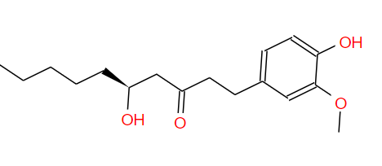 | 294.391 | 4 | 2 | 3.234
6-Gingerol | 3872686 | 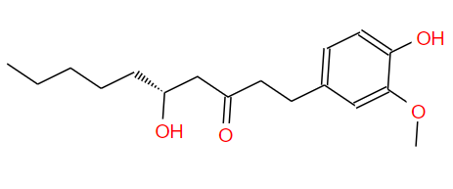 | 294.391 | 4 | 2 | 3.234
Shogaol | 1531865 | 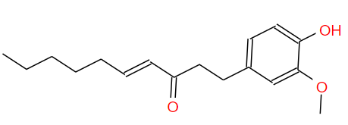 | 276.376 | 3 | 1 | 4.039
6-Paradol | 1531857 | 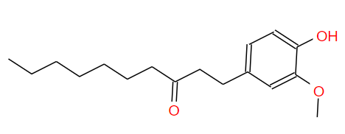 | 278.392 | 3 | 1 | 4.263
Meletin | 3869685 | 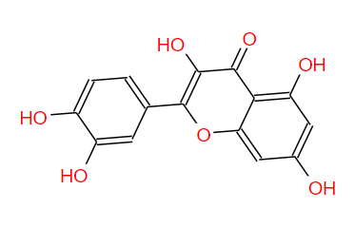 | 302.238 | 7 | 3 | 1.988
Isorhamnetin | 517261 | 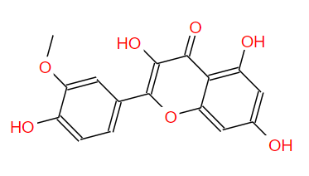 | 316.265 | 7 | 3 | 2.291
Zingerone Glucoside | 13339791 | 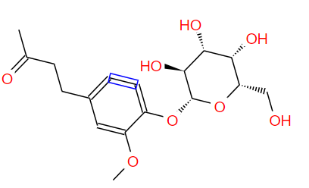 | 356.371 | 0 | 0 | -0.605
Jyperin | 3973253 | 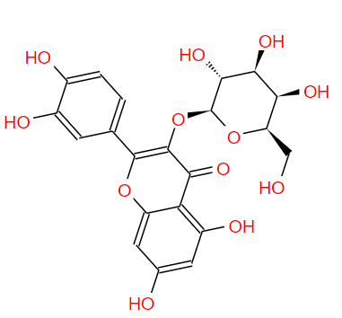 | 464.379 | 0 | 0 | -0.539
Gingerenone A | 1531844 | 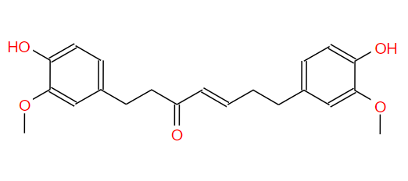 | 356.418 | 5 | 2 | 3.806
Gingerenone B | 13377938 | 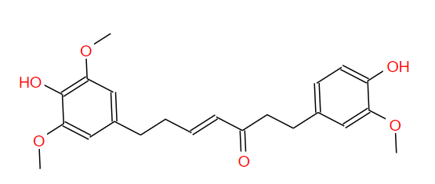 | 386.444 | 6 | 2 | 3.814

