Supporting Information: Single-material MoS₂ thermoelectric junction enabled by substrate engineering
Mohammadali Razeghi¹, Jean Spiece³, Oğuzhan Oğuz¹, Doruk Pehlivanoğlu², Yubin Huang³, Ali Sheraz², Phillip S. Dobson⁴, Jonathan M. R. Weaver⁴, Pascal Gehring³, T. Serkan Kasırga^{1,2*}
¹ Bilkent University UNAM – Institute of Materials Science and Nanotehcnology, Bilkent 06800 Ankara, Turkey
² Department of Physics, Bilkent University, Bilkent 06800 Ankara, Turkey
³ IMCN/NAPS, Université Catholique de Louvain (UCLouvain), 1348 Louvain-la-Neuve, Belgium
⁴ James Watt School of Engineering, University of Glasgow, Glasgow G12 8LT, U.K
*Corresponding Author: kasirga@unam.bilkent.edu.tr

- Theoretical prediction of the substrate-effect induced Seebeck coefficient difference in MoS₂
As discussed in the main text, we assume that the Seebeck coefficient S in thermal equilibrium is composed of contributions from the energy-dependent diffusion ($S_{N}$), scattering ($S_{τ}$) and the phonon-drag ($S_{pd}$), so that $S=S_{N}+S_{τ}+S_{pd}$. Here, $S_{N}$ and $S_{τ}$ terms can be written from the Mott relation assuming that MoS₂ is in the highly conductive state and electrons are the majority carriers:
$S_{τ}=-\frac{π^{2}k_{B}^{2}T}{3e}{\left.\frac{∂lnτ}{∂E}\right| }_{E=E_{F}}$and $S_{N}= ±\frac{k_{B}}{e}\left[\frac{E_{F}-E_{C}}{k_{B}T}-\frac{\left(r+2\right)F_{r+1}\left(η\right)}{\left(r+1\right)F_{r}\left(η\right)}\right]$
As mentioned in the main text, $S_{τ}$ is zero as $τ$ is energy independent in the 2d limit. $S_{N}$ term is composed of constants related to material properties, scattering parameter $r$ and the Fermi integral of the $r$-th order: $F_{r}=\int_{0}^{∞}{ [\frac{x^{m}}{e^{x-η}}+1]dx}$. The scattering parameters of 2d materials are listed in Table 1.^{1,2} Here, as discussed in detail in Ref. ¹, $r=0$ adequately accounts for the acoustic phonon scattering and small deviations of experimental data from the calculated values is due to the other scattering mechanisms. As a result, at the room temperature $S_{N}$ for suspended MoS₂ (10¹² cm⁻²) is about -400 µV/K and for SiO₂ supported MoS₂ (10¹³ cm⁻²) is about -200 µV/K.
Table 1. Scattering parameters $r$ of 2d materials.
Scattering mechanism | $$r$$
Charged Impurity Scattering | 3/2
Acoustic Phonon Scattering | 0
Intervalley Scattering | 0
Strongly Screened Coulomb Scattering | -1/2

$S_{pd}$ term can be estimated from the theory of phonon-drag in semiconductors in the first order as $S_{pd}=-\frac{βv_{p}l_{p}}{μT}$ where, $v_{p}$ and $l_{p}$ are the group velocity and the mean free path of a phonon, $β$ is a parameter to modify the electron-phonon interaction strength and ranges from 0 to 1, and $μ$ is the electron mobility, respectively. As the dominant charge carriers are electrons, $S_{pd}$ term has a negative sign. We use the parameters given in Table 2. Based on the values given in the table we obtain $S_{pd}^{SiO_{2}}= -230$ µV/K and $S_{pd}^{Sus}= -100$ µV/K.
The total $S=S_{N}+S_{pd}$ for suspended and SiO₂ supported parts can be calculated by adding both contributions. $S^{Sus}=-$500 µV/K and $S^{SiO_{2}}=-430$ µV/K. Of course, we consider this to be a rough estimate as we ignore charged impurity scattering and strongly screeded Coulomb scattering. Also there are certain errors associated with the measurement of the parameters used for the calculation of the Seebeck coefficients. However, overall, this calculation shows that the substrate induced effect must be present under right experimental conditions.
Table 2. Parameters used for $S_{pd}$ calculation
Parameter | On SiO₂ (Ref. ³) | Suspended (Ref. ³)
$$v_{p}$$ | 7 10⁵ cm/s | 7 10⁵ cm/s
$$l_{p}$$ | 5 nm | 20 nm
$$μ$$ | 5 cm²/V.s | 50 cm²/V.s

- SPCM map on a gold electrode substrate engineered MoS₂ device
Throughout the study we used indium contacted devices thanks to their rapid fabrication. To compare our indium device results, we fabricated gold contacted devices. Figure S1 shows the optical microscope images and corresponding SPCM reflection and photocurrent maps. There is no qualitative difference between the indium contacted devices and gold contacted device in the substrate-engineered photocurrent. Despite IV measurement is collected from 0.25 to -0.25 V its rectifying behaviour can be observed. Power dependence of the photocurrent from the substrate engineered junction is also comparable to the one reported in indium contacted devices.
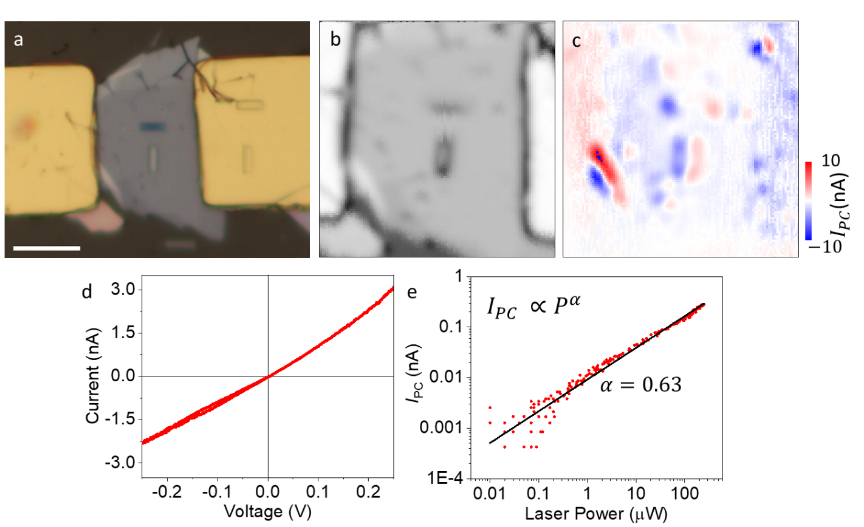
Figure S1 a. Optical microscope micrograph of a gold contacted substrate engineered MoS₂ device is shown. Scale bar is 10 µm. b. SPCM reflection map and c. photocurrent map. d. IV curve shows signs of rectifying nature of the contacts. e. Power dependence of the photocurrent at one of the side of the junction is plotted in a log-log graph and the exponent is about 0.63.

- Scanning photovoltage microscopy, AFM and KPFM measurements on a parallel trench device
Figure S2 shows an MoS₂ device fabricated on trenches drilled on sapphire with different depths. We performed SPVM, AFM and KPFM Measurements. First, AFM measurements show that the crystal is stuck to the bottom of the 100 nm deep trench (Figure S2b). For the rest of the trenches the flake bulges about 10 nm above the surface (Figure S2c). AFM height trace map also reveals a peculiar wrinkle formation over the suspended part of the flake.
In this measurement we operated the scanning microscope at photovoltage mode. Figure S2d shows the reflection map and the corresponding photovoltage map. The bipolar response is evident with slightly lower positive signal in some of the trenches. This asymmetry can be explained by lower heating of one side of the samples due to the scan direction. One important observation that agrees well with the photothermoelectric photoresponse is that the 100 nm trench shows very small photovoltage as compared to other trenches.
Figure S2e shows the KPFM and AFM profiles. The suspended part of the crystal has 60 meV lower surface potential difference. This is consistent with other KPFM measurements. The lower panel shows the variation in the height over the wrinkles. The workfunction is calculated with a calibrated tip and it follows the wrinkles of the sample. However, the difference in the SPD is not due to the variations in the height profile of the crystal. The change in the workfunciton is a good indication of the changes in the electronic landscape of the device upon suspension. Small variations along the wrinkles are also expected due to formation of varying stress regions along the crystal.
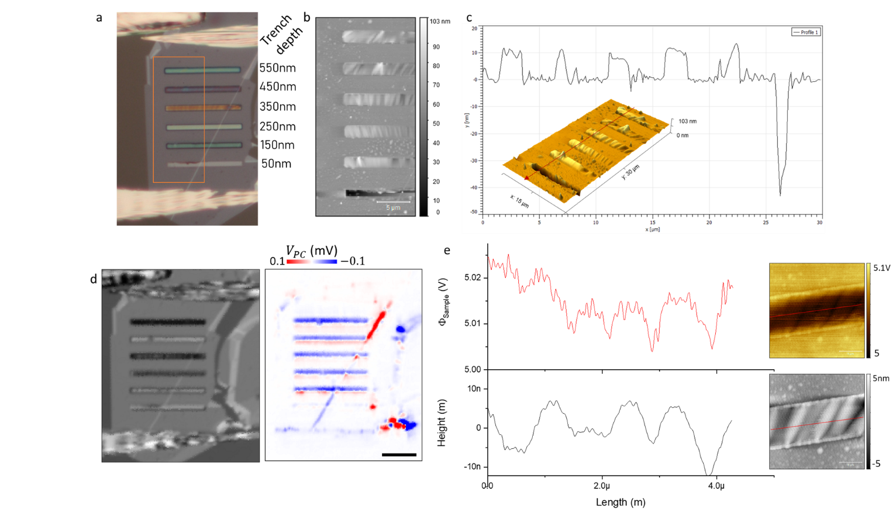
Figure S2 a. Optical microscope image of the device with trench depths labelled next to it. b. AFM height trace map and c. line trace taken along the height trace. The bulge of the crystal over the trenches is clear. d. Reflection and photovoltage maps obtained by operating the scanning microscope in photovoltage mode. Scale bar is 5 µm. e. Left panel shows the workfunction and height taken over the red lines marked on the maps given in the right panel. The variation of the workfunction along the trench is very small and correlated with the wrinkles of the crystal.
- SPCM maps taken at different laser wavelengths and incidence polarization
We used three different wavelengths, 406, 532 and 633 nm, in our experiments all of them which are at an energy larger than the band gap of MoS₂. Figure S3 shows the SPCM results collected with different laser wavelengths. Also, polarization dependence of the photocurrent measured at each end of the trench as well as a point over the contact is given in Figure S3f. There is no polarization dependence of the photocurrent. This shows that The effect is not due to built in polarization fields.
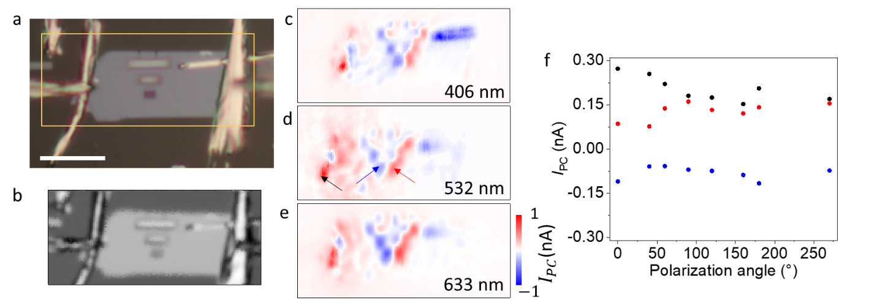
Figure S3 a. Optical microscope image of a two-terminal substrate-engineered MoS₂ device with different trench widths. Scale bar is 10 µm. b. SPCM reflection map of the region marked with yellow rectangle in a. c, d and e show photocurrent map taken at different wavelengths. At each run laser power is set to ~40 µW. The measured signal in all three measurements are very close and the overall photocurrent features are the same. f. Incident polarization of the 633 nm laser is rotated and $I_{PC}$ is measured at three different points marked by colored arrows on d, black dots- near contact, red dots- at the positive side and blue dots- at the negative side of the trench. There is no polarization dependence of the measured photocurrent at the three points where photocurrent is measured.
- Finite element simulation of a substrate modified thermoelectric junction
To understand how a substrate modified thermoelectric junction would behave depending on how the contacts are configured, we performed finite element analysis simulations using COMSOL Multiphysics. An irregularly shaped crystal is modelled over a substrate with a hole and voltage at a floating terminal is measured with respect to different laser positions. The observed pattern agrees with our measurements. Figure S4 shows the thermoelectric emf generated and temperature distribution maps.
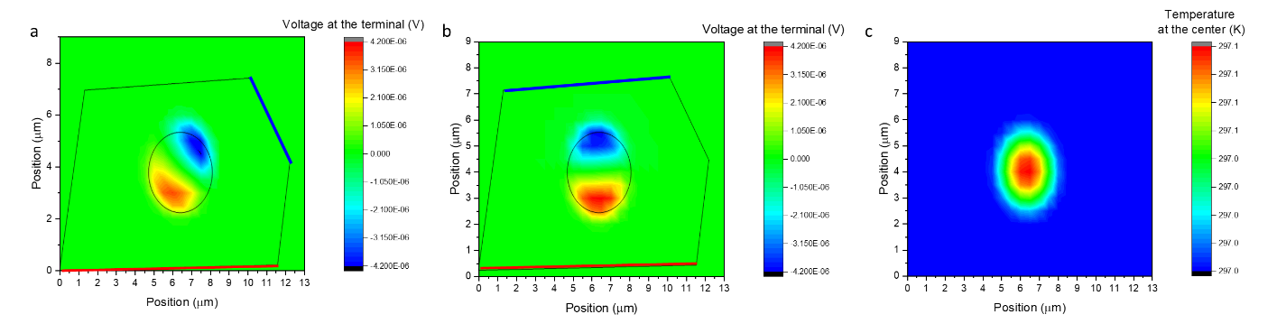
Figure S4 a. An arbitrary crystal is modelled over a SiO₂ substrate with a hole. The outline drawn over the voltage distribution map shows the outline of the crystal and the outline of the hole. The red line indicates the ground terminal and the blue line indicates the floating voltage terminal where the photothermoelectric emf is measured from like in the experiments. b. For comparison, another terminal is simulated as the floating terminal. c. Temperature distribution vs. laser position is shown. As clear, the maximum temperature rise is achieved at the center of the hole.
- KPFM on h-BN supported and suspended MoS₂
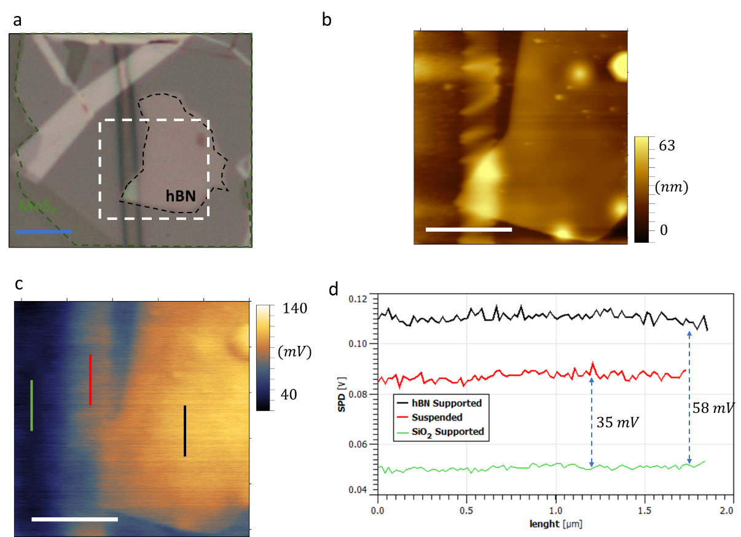
Figure S5 a. Optical micrograph of an MoS₂ crystal partially suspended over a trench and partially supported on h-BN (outlined by blacked dashed lines). White dashed square shows the AFM region. b. AFM height trace map and c. corresponding SPD map is given. d. SPD line traces from the colored lines in c are plotted. The difference between the SPD in h-BN supported, suspended and SiO₂ supported parts are evident. Scale bars are 2 µm.
- Gate dependent measurements
We performed gate dependent SPCM measurements both on suspended and h-BN supported MoS₂ devices. In both cases, we used 1 µm SiO₂ coated Si wafers. Si is used as the back gate in both device configurations. We reported the h-BN supported junctions in the main text as devices over holes showed significant change upon application of negative gate bias. Figure S5 shows the degradation of the suspended device. After application of a few volts the device irreversibly shows a contrast change starting from the edges of the hole. We fabricated a long trench with open ends to see if the trapped air within the hole is causing the observed contrast change. However, same contrast change is observed after applying negative gate voltages. We observe that the contrast change starts from near the hole and expands from there. At the moment we are not fully aware of the reasons leading this contrast change. We consider that the release of the adsorbed molecules on the surface of the substrate under large negative gate voltages lead to such degradation.
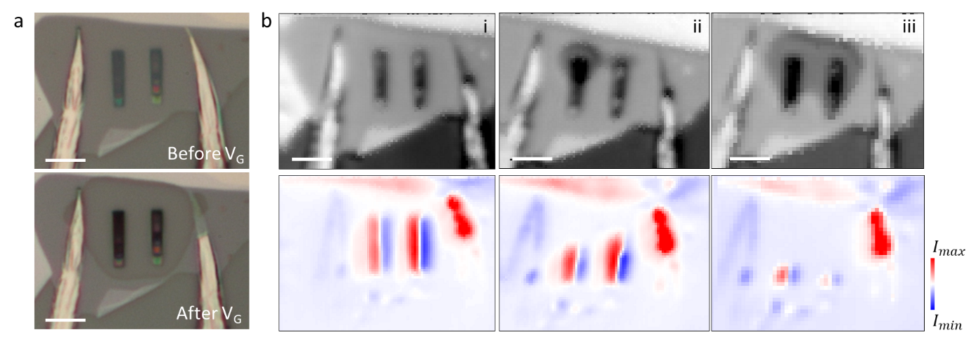
Figure S6 a. Optical microscope micrograph of indium contacted MoS₂ on SiO₂/Si with stair-like holes before and after application of gate voltages down to $V_{G}=-20 V$. Lower panel shows a clear contrast change around the holes extending to the indium contacts. b. SPCM maps taken at $V_{G}=0 V$ with 532 nm of 86 µW on sample: (i) before gating, (ii) after $V_{G}=-15 V$ scan and (iii) after the scan in (iii). $I_{max}=6.5$ nA and $I_{min}=-6.5$ nA. Scan starts from top left corner to the bottom left corner with progressing to the right in raster scan pattern. Scale bars are 5 µm.
To prevent the sample degradation problem under large negative gate voltages, we coated the substrate surface with 5 nm thick Al₂O₃ using atomic layer deposition (ALD) method after milling the holes with FIB. Then, the device is fabricated over the ALD coated surface. The device didn’t show any sign of degradation and produced pronounced photoresponse. Measurements from the device is given in Figure S6. Although the device exhibits the expected gate dependent response, as discussed in the main text, there is no carrier inversion induced reduction in the photovoltage due to the Fermi level pinning.
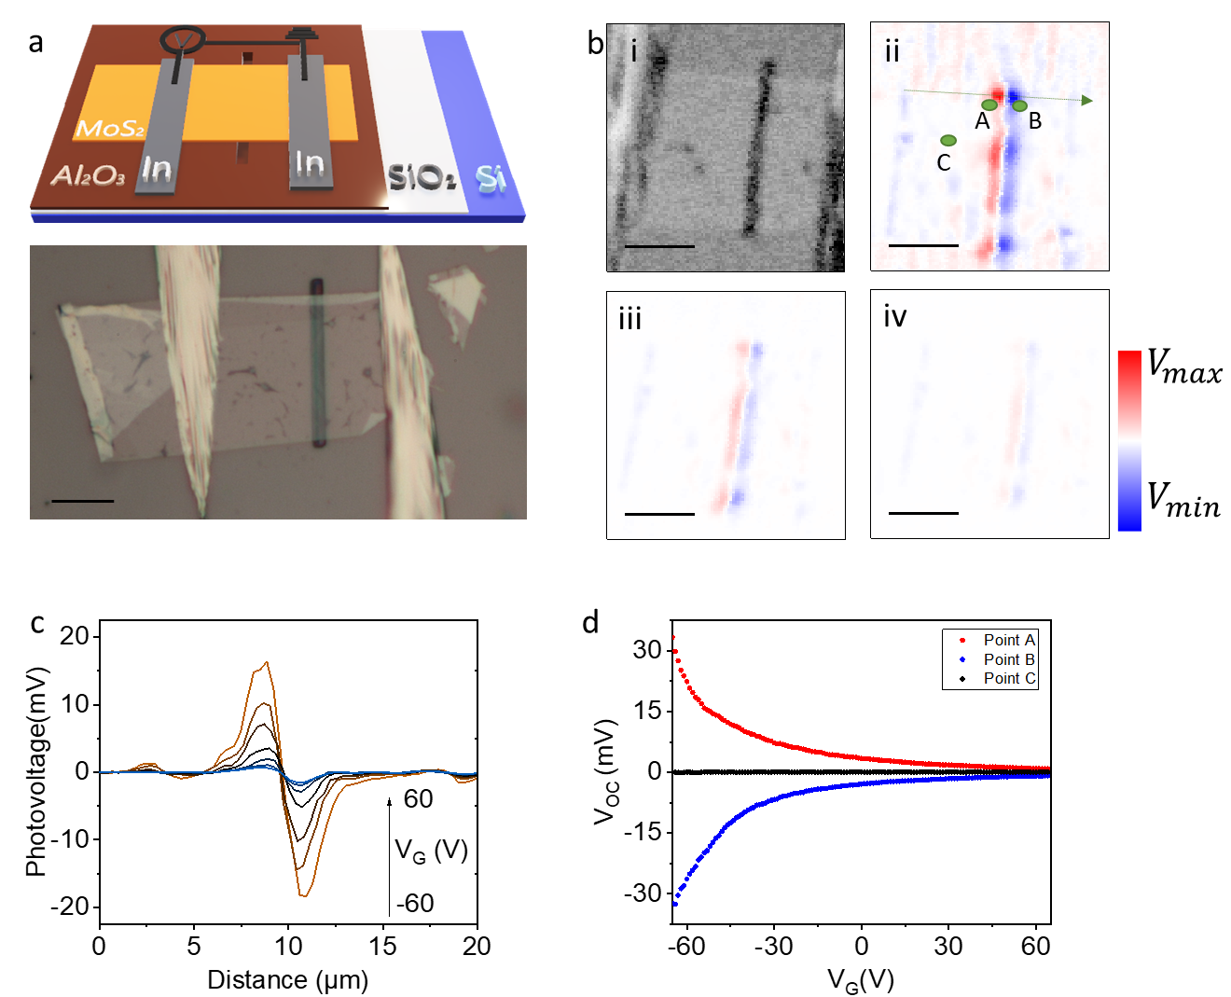
Figure S7 a. Schematic of the device along with the optical image is shown. The sample is coated with 30 nm thick Al₂O₃ to passivate the SiO₂ surface and to minimize the pinholes. Scale bar is 10 µm. b. Photovoltage map collected in DC mode without the Lock-in amplifier and chopper. i is the reflection map, and photovoltage maps at ii is the $V_{G}=$-60 V, iii $V_{G}=$ 0 V, iv $V_{G}=$60 V. Here, $V_{max}=2$0 mV and $V_{min}=$ -20 mV. c. Photovoltage line trace taken along the dashed arrow given in b-ii. Large signal corresponds to the more negative gate voltages. d. Photovoltage data collected from points indicated on b-ii. This sample showed no Seebeck coefficient inversion due to possible Fermi level pinning induced by the substrate as discussed in the main text.
H-BN supported devices performed better and showed no sign of such a contrast change. Figure S7 shows the reflection and the photocurrent maps reported in the main text and the photocurrent from point 2 and 3 subtracted from point 4, marked on the photocurrent map. Both junctions of the h-BN show almost identical response under gate voltage (point 3 data is multiplied by -1 for viewing convenience).

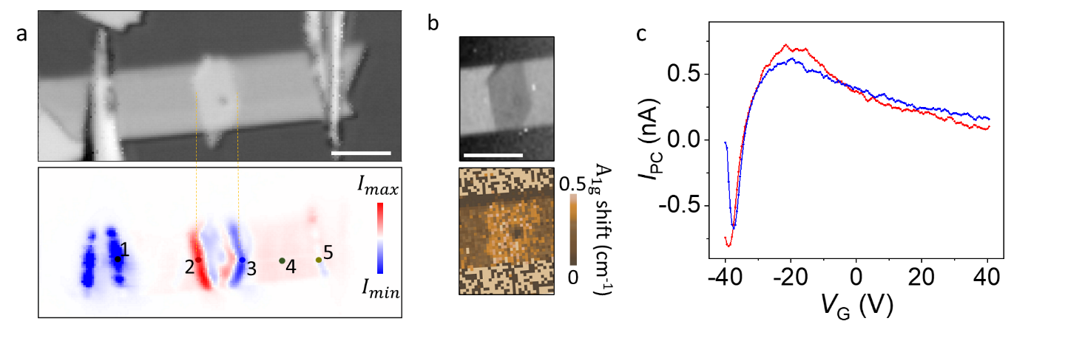
Figure S8 a. Same figure from the main text is copied here for convenience. b. Raman intensity map and the $A_{1g}$ peak shift map is given. c. Gate dependent signal from point 4 is subtracted from the gate dependent data from point 2 (red curve) and point 3 (blue curve). Blue curve is multiplied by -1 for viewing convenience.

- Scanning Thermal Microscope Calibration and Seebeck variation estimation
The Scanning Thermal Microscope (SThM) measurements were performed on a commercial Bruker Icon instrument with a VITA-GLA-DM-1 probe. The probe, consisting of the silicon nitride lever with a Pd heater/thermometer has been calibrated on a hot plate to relate the temperature to its electrical resistance. The calibration curves are shown on figure S9.
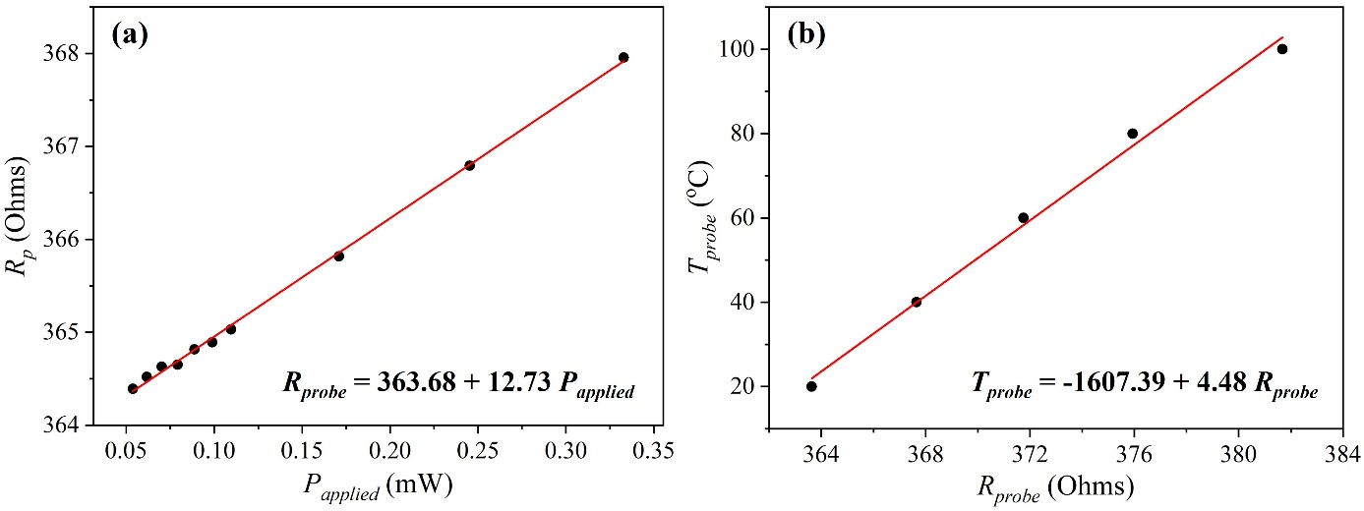
Figure S9 a. SThM probe calibration of the electrical resistance with the supplied power. b. Temperature as a function of electrical resistance
As described elsewhere^{4,5}, the probe is part of a modified Wheatstone bridge which is balanced at low voltage. During the measurements, we applied a combined AC (91 kHz) and DC bias on the bridge which heats the probe and creates a bridge offset that directly measures the probe heater temperature. For most experiments, we applied 1mW on the probe creating a $ΔT$ of 50 ± 2 K, when the probe was far away from the sample.
When the SThM tip is brought into contact with the devices, it locally heats the materials below its apex. While the probe scans the surface, the device open circuit voltage is recorded and amplified via a SR830 voltage preamplifier. This voltage is referred to as the thermovoltage. We excluded any shortcut between the probe and the device as no leakage current could be measured between the probe and both contacts.
The thermovoltage can be written analytically as^{6,7},
$$V_{th}(x)= -\int_{A}^{B}{S\left(x\right)\frac{∂T}{∂x}\left(x\right)dx }$$
where $S\left(x\right)$ is the position dependent Seebeck coefficient and $\frac{∂T}{∂x}\left(x\right)$ is the position dependent temperature gradient. Both are integrated over the whole device length from A to B.
As shown elsewhere^{6,7}, it is possible to deconvolute the Seebeck coefficient from the temperature gradient. This however requires a precise estimation of the temperature gradient and thus the sample temperature rise under the tip, $ΔT_{sample}$.
As we know the probe temperature far away from the sample (50 ± 2 K) and we monitor its temperature via the Wheatstone bridge, we know that the probe temperature in contact with the sample is 43.8 ± 4 K. The probe cooling occurs because of several heat transfer mechanisms^{4,5} (solid-solid conduction, air conduction, water meniscus, …).
For those probes, the Pd heater is however distributed over the whole triangular shaped silicon nitride tip^{4,5}. This implies that the tip temperature and probe temperature are different. We turned to finite element modelling (COMSOL Multiphysics) to estimate the tip temperature over the MoS₂ suspended and supported sample. Figure S10 shows the overall simulated probe and sample.
We used reported values for the in-plane and out-of-plane MoS₂ thermal conductivity as well as for the MoS₂-glass interface conductance. Reported values vary greatly in literature^{8–16}. However, to the best of our knowledge, for a thick sample (>10 layers), the values are on the order of 30 Wm⁻¹K⁻¹ for the supported in-plane, 60 Wm⁻¹K⁻¹ for the suspended in-plane and 3 Wm⁻¹K⁻¹ for the cross-plane conductivities. For the substrate interface conductance, we used 1 MWm⁻²K⁻¹.

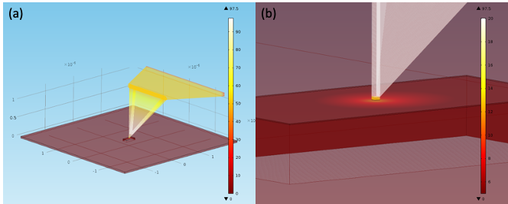
Figure S10 a. Finite element model for the SThM probe on a MoS₂ suspended sample. b. Zoomed-in view of the model where the temperature gradient is visible on the sample surface.
Using those material parameters, we estimated a ratio between the probe temperature and the tip apex temperature of 4.9. The model also accounts for the tip-sample thermal resistance. This method and model were experimentally confirmed elsewhere^{4,5,17}. Taking these into consideration, we obtain a sample temperature rise $ΔT_{sample}$ of 7.4 ± 0.7 K. This gives a Seebeck variation of 72±10 µVK⁻¹.

References
(1) Ng, H. K.; Chi, D.; Hippalgaonkar, K. Effect of Dimensionality on Thermoelectric Powerfactor of Molybdenum Disulfide. J Appl Phys 2017, 121 (20), 204303. https://doi.org/10.1063/1.4984138.
(2) Wu, J.; Liu, Y.; Liu, Y.; Liu, Y.; Cai, Y.; Zhao, Y.; Ng, H. K.; Watanabe, K.; Taniguchi, T.; Zhang, G.; Qiu, C. W.; Chi, D.; Neto, A. H. C.; Thong, J. T. L.; Loh, K. P.; Hippalgaonkar, K. Large Enhancement of Thermoelectric Performance in MoS2/h-BN Heterostructure Due to Vacancy-Induced Band Hybridization. Proc Natl Acad Sci U S A 2020, 117 (25), 13929–13936. https://doi.org/10.1073/pnas.2007495117.
(3) Cui, X.; Lee, G. H.; Kim, Y. D.; Arefe, G.; Huang, P. Y.; Lee, C. H.; Chenet, D. A.; Zhang, X.; Wang, L.; Ye, F.; Pizzocchero, F.; Jessen, B. S.; Watanabe, K.; Taniguchi, T.; Muller, D. A.; Low, T.; Kim, P.; Hone, J. Multi-Terminal Transport Measurements of MoS2 Using a van Der Waals Heterostructure Device Platform. Nature Nanotechnology 2015 10:6 2015, 10 (6), 534–540. https://doi.org/10.1038/nnano.2015.70.
(4) Tovee, P.; Pumarol, M.; Zeze, D.; Kjoller, K.; Kolosov, O. Nanoscale Spatial Resolution Probes for Scanning Thermal Microscopy of Solid State Materials. J Appl Phys 2012, 112 (11). https://doi.org/10.1063/1.4767923.
(5) Spiece, J.; Evangeli, C.; Lulla, K.; Robson, A.; Robinson, B.; Kolosov, O. Improving Accuracy of Nanothermal Measurements via Spatially Distributed Scanning Thermal Microscope Probes. J Appl Phys 2018, 124 (1), 015101. https://doi.org/10.1063/1.5031085.
(6) Harzheim, A.; Spiece, J.; Evangeli, C.; McCann, E.; Falko, V.; Sheng, Y.; Warner, J. H.; Briggs, G. A. D.; Mol, J. A.; Gehring, P.; Kolosov, O. v. Geometrically Enhanced Thermoelectric Effects in Graphene Nanoconstrictions. Nano Lett 2018, 18 (12), 7719–7725. https://doi.org/10.1021/ACS.NANOLETT.8B03406/ASSET/IMAGES/MEDIUM/NL-2018-03406E_M006.GIF.
(7) Harzheim, A.; Evangeli, C.; Kolosov, O. v.; Gehring, P. Direct Mapping of Local Seebeck Coefficient in 2D Material Nanostructures via Scanning Thermal Gate Microscopy. 2d Mater 2020, 7 (4), 041004. https://doi.org/10.1088/2053-1583/ABA333.
(8) Frausto-Avila, C. M.; Arellano-Arreola, V. M.; Yañez Limon, J. M.; de Luna-Bugallo, A.; Gomès, S.; Chapuis, P. O. Thermal Boundary Conductance of CVD-Grown MoS2 Monolayer-on-Silica Substrate Determined by Scanning Thermal Microscopy. Appl Phys Lett 2022, 120 (26), 262202. https://doi.org/10.1063/5.0092553.
(9) Taube, A.; Judek, J.; Łapińska, A.; Zdrojek, M. Temperature-Dependent Thermal Properties of Supported MoS2 Monolayers. ACS Appl Mater Interfaces 2015, 7 (9), 5061–5065. https://doi.org/10.1021/ACSAMI.5B00690/SUPPL_FILE/AM5B00690_SI_001.PDF.
(10) Yue, X. F.; Wang, Y. Y.; Zhao, Y.; Jiang, J.; Yu, K.; Liang, Y.; Zhong, B.; Ren, S. T.; Gao, R. X.; Zou, M. Q. Measurement of Interfacial Thermal Conductance of Few-Layer MoS2 Supported on Different Substrates Using Raman Spectroscopy. J Appl Phys 2020, 127 (10), 104301. https://doi.org/10.1063/1.5128613.
(11) Gabourie, A. J.; Suryavanshi, S. v.; Farimani, A. B.; Pop, E. Reduced Thermal Conductivity of Supported and Encased Monolayer and Bilayer MoS2. 2d Mater 2020, 8 (1), 011001. https://doi.org/10.1088/2053-1583/ABA4ED.
(12) Zhang, X.; Sun, D.; Li, Y.; Lee, G. H.; Cui, X.; Chenet, D.; You, Y.; Heinz, T. F.; Hone, J. C. Measurement of Lateral and Interfacial Thermal Conductivity of Single- and Bilayer MoS2 and MoSe2 Using Refined Optothermal Raman Technique. ACS Appl Mater Interfaces 2015, 7 (46), 25923–25929. https://doi.org/10.1021/ACSAMI.5B08580/ASSET/IMAGES/LARGE/AM-2015-085805_0003.JPEG.
(13) Jo, I.; Pettes, M. T.; Ou, E.; Wu, W.; Shi, L. Basal-Plane Thermal Conductivity of Few-Layer Molybdenum Disulfide. Appl Phys Lett 2014, 104 (20), 201902. https://doi.org/10.1063/1.4876965.
(14) Yuan, P.; Wang, R.; Wang, T.; Wang, X.; Chemistry, Y. X.-P.; 2018, undefined. Nonmonotonic Thickness-Dependence of in-Plane Thermal Conductivity of Few-Layered MoS 2: 2.4 to 37.8 Nm. pubs.rsc.org.
(15) Bae, J. J.; Jeong, H. Y.; Han, G. H.; Kim, J.; Kim, H.; Kim, M. S.; Moon, B. H.; Lim, S. C.; Lee, Y. H. Thickness-Dependent in-Plane Thermal Conductivity of Suspended MoS2 Grown by Chemical Vapor Deposition. Nanoscale 2017, 9 (7), 2541–2547. https://doi.org/10.1039/C6NR09484H.
(16) Meng, X.; Pandey, T.; Jeong, J.; Fu, S.; Yang, J.; Chen, K.; Singh, A.; He, F.; Xu, X.; Zhou, J.; Hsieh, W. P.; Singh, A. K.; Lin, J. F.; Wang, Y. Thermal Conductivity Enhancement in MoS2 under Extreme Strain. Phys Rev Lett 2019, 122 (15), 155901. https://doi.org/10.1103/PHYSREVLETT.122.155901/FIGURES/3/MEDIUM.
(17) Gehring, P.; Harzheim, A.; Spièce, J.; Sheng, Y.; Rogers, G.; Evangeli, C.; Mishra, A.; Robinson, B. J.; Porfyrakis, K.; Warner, J. H.; Kolosov, O. v.; Briggs, G. A. D.; Mol, J. A. Field-Effect Control of Graphene-Fullerene Thermoelectric Nanodevices. Nano Lett 2017, 17 (11), 7055–7061. https://doi.org/10.1021/ACS.NANOLETT.7B03736/ASSET/IMAGES/NL-2017-03736Q_M017.GIF.

