Appendix - Supplementary Materials
Supplementary information 1: InVEST model and parameterization
InVEST model was developed by the Natural Capital Project, which provides a suite of software tools to map and value ES(Posner et al. 2016 R. Sharp 2015). In this study, we used the habitat quality model (for HQ), the carbon storage model (for CR), the water yield model (for WY), and the sediment delivery ratio model (for SR) to evaluate the corresponding ESs (Supplementary Table.1). The critical parameters settings and the biophysical data required by models are shown in Supplementary Table.2.
Supplementary Table.1. Evaluation models and descriptions of four ESs.
ES | Caculation Formula | Method and Formula Description
Habitat Quality (HQ) | $$Q_{xj}=H_{i}×（1−（D_{xj}^{z}/（D_{xj}^{z}+k^{z}）））$$  $$D_{xj}=\sum_{r=1}^{R}{\sum_{y=1}^{Y_{r}}{（W_{r}/\sum_{r=1}^{R}{W_{r}}）r_{y}i_{rxy}b_{x}S_{jr}}}$$  $$i_{rxy}=1−（\frac{d_{xy}}{d_{rmax}}）$$ | HQ model of InVEST combines the information of land use type, habitat suitability, habit threat factors, and the sensitivity of habitats to estimate the extent of habitat and their state of degradation*.  In this formula, where $Q_{xj}$ is the HQ of land use type j at pixel x, $H_{j}$ denotes the habitat suitability of land use type j, $D_{xj}$ is the habitat threat level at pixel x with land use type j, k is the half-saturation constant (the value is equal to half of the pixel’s resolution); $i_{rxy}$ is the threat factor r（$r_{y}$） at pixel y acts on habitat threat at pixel x; $d_{xy}$ is the linear distance between pixel x and y; $d_{rmax}$ is the maximum effective threat distance for the threat factor; $W_{r}$ is the weight of the threat factor; $b_{x}$ is the reachability level of pixel x; $S_{jr}$ is the sensitivity of land use type j to threat factors.
Soil Retention (SR) | $${SC}_{i}=R_{i}×K_{i}×{LS}_{i}×\left(1−C_{i}P_{i}\right)$$  $$D_{SR,i}=R_{i}×K_{i}×{LS}_{i}×C_{i}P_{i}$$ | SC is caculated by the Sediment Delivery Ratio (SDR) model of InVEST. SDR model caculates the difference between potential and actua loverland soil erosion base on Revised Universal Soil Loss Equation (RUSLE).  In this formula, where ${SC}_{x}$ is the amount of soil retention at pixel x; ${RKLX}_{x}$is the potential soil loss at pixel x; ${USLE}_{x}$is the actual soil loss at pixel x; $R_{x}$ is rainfall erosivity factor of pixel x; $K_{x}$ is soil erodibility factor of pixel x; ${LS}_{x}$ is slope length and steepness factor of pixel x; $C_{x}$ is the crop-management factor of pixel x; and $P_{x}$ is the support practice factor of pixel x*.
Water Yield (WY) | $$Y_{jx}=（1−\frac{{AET}_{jx}}{P_{x}}）×P_{x}$$ | WY is caculated by the water yield (WY) model of InVEST. Based on the principle of water balance, WY model estimates the annual average quantity of water yield produced by landscape.  In this formula, Where $Y_{jx}$ and ${AET}_{jx}$are the WY (m³·hm⁻²) and actual annual evapotranspiration (m³·hm⁻²) of land use type j at pixel x, $P_{x}$ is the annual precipitation at pixel x.
Climate Regulation (CR) | $${CS}_{total}={CS}_{above}+{CS}_{below}+{CS}_{soil}+{CS}_{dead}$$ | Terrestrial-based carbon storage is vital to regulating the carbon dioxide-driven climate change. Therefore, CR is caculated by the Carbon Storage (CS) model of InVEST.  In this formula, where ${CS}_{total}$ is the total CS(t·hm⁻²), ${CS}_{above}$ is the carbon stored in aboveground biomass, ${CS}_{below}$ is the carbon stored in belowground biomass, ${CS}_{soil}$ is the carbon stored in the soil, ${CS}_{dead}$ is the carbon stored in dead matter (ignored due to data limitations)*.
Note: The details of the habitat suitability and the sensitivity of habitats are described in Table. S2.1; threat factors, the maximum effective threat distance of the threat factors, and the weights of threat factors are described in Table. S2.2; the crop-management factor $C_{x }$, the support practice factor $P_{x}$, and carbon density values of different land use types are described in Table. S2.3.

Supplementary Table.2.1. The habitat suitability, and the sensitivity of habitats.
Land use type |  | Habitat Suitability | Relative sensitivity to threat factors
 |  | Habitat Suitability | Paddy field | Dry field | Urban | Rural settlement | Industrial and traffic land | Sand land | Bare ground
Cultivated land | Paddy field | 0.5 | 0.2 | 0.3 | 0.5 | 0.4 | 0.5 | 0.4 | 0.4
Cultivated land | Dry field | 0.4 | 0.2 | 0.3 | 0.5 | 0.4 | 0.5 | 0.4 | 0.4
Forest | Forest land | 1 | 0.6 | 0.6 | 0.8 | 0.7 | 0.9 | 0.4 | 0.3
Forest | Shrub land | 1 | 0.6 | 0.6 | 0.8 | 0.7 | 0.8 | 0.2 | 0.2
Forest | Open forest land | 0.9 | 0.5 | 0.6 | 0.8 | 0.7 | 0.8 | 0.1 | 0.1
Forest | Other forest land | 0.8 | 0.4 | 0.5 | 0.7 | 0.6 | 0.7 | 0.1 | 0.1
Grassland | High-coverage grassland | 0.7 | 0.3 | 0.4 | 0.9 | 0.8 | 0.9 | 0.3 | 0.3
Grassland | Medium-coverage grassland | 0.7 | 0.3 | 0.4 | 0.9 | 0.8 | 0.9 | 0.3 | 0.3
Grassland | Low-coverage grassland | 0.6 | 0.5 | 0.6 | 0.9 | 0.8 | 0.9 | 0.4 | 0.4
Water body | River | 0.8 | 0.4 | 0.5 | 0.7 | 0.6 | 0.7 | 0.5 | 0.5
Water body | Lake | 0.9 | 0.5 | 0.5 | 0.7 | 0.6 | 0.7 | 0.5 | 0.5
Water body | Reservoir or pond | 0.8 | 0.5 | 0.5 | 0.7 | 0.6 | 0.7 | 0.2 | 0.2
Water body | Mudflat | 0.9 | 0.1 | 0.1 | 0.2 | 0.2 | 0.2 | 0.2 | 0.2
Water body | Beachland | 0.6 | 0.2 | 0.2 | 0.3 | 0.3 | 0.3 | 0.3 | 0.3
Bare land | Sand land | 0.1 | 0.3 | 0.3 | 0.5 | 0.4 | 0.6 | 0 | 0
Bare land | Swamp | 0.9 | 0.7 | 0.6 | 0.4 | 0.4 | 0.3 | 0.1 | 0.1
Bare land | Bare ground | 0.1 | 0.3 | 0.3 | 0.5 | 0.4 | 0.6 | 0 | 0

Supplementary Table.2.2. Threat factors, the maximum effective threat distance of the threat factors, and the weights of threat factors.
Threat factors | The maximum effective threat distance | Weights | Recession Type
Paddy field | 8 | 0.6 | Linear
Dry field | 8 | 0.6 | Linear
Urban | 10 | 0.9 | Exponential
Rural settlement | 8 | 0.8 | Exponential
Industrial and traffic land | 10 | 1 | Exponential
Sand land | 6 | 0.3 | Exponential
Bare ground | 5 | 0.2 | Linear

Supplementary Table.2.3. the crop-management factor , the support practice factor , and carbon density values of different land use types.
Land use type |  | crop-management factor $C_{x }$ | support practice factor $P_{x}$ | carbon density values (t/hm²)
 |  | crop-management factor $C_{x }$ | support practice factor $P_{x}$ | c_above | c_below | c_soil
Cultivated land | Paddy field | 0.3 | 0.5 | 16.61 | 4.15 | 10.84
Cultivated land | Dry field | 0.23 | 0.5 | 16.27 | 4.07 | 10.84
Forest | Forest land | 0.004 | 0.2 | 21.1 | 5.28 | 22.57
Forest | Shrub land | 0.02 | 0.2 | 20.74 | 5.19 | 9.4
Forest | Open forest land | 0.08 | 0.2 | 21.16 | 5.29 | 22.57
Forest | Other forest land | 0.06 | 0.2 | 16.98 | 4.25 | 22.57
Grassland | High-coverage grassland | 0.05 | 0.2 | 2.15 | 9.68 | 9.99
Grassland | Medium-coverage grassland | 0.15 | 0.2 | 2.1 | 9.43 | 9.99
Grassland | Low-coverage grassland | 0.4 | 0.2 | 0.72 | 3.22 | 9.99
Water body | River | 1 | 0 | 0 | 0 | 0
Water body | Lake | 1 | 0 | 0 | 0 | 0
Water body | Reservoir or pond | 1 | 0 | 0 | 0 | 0
Water body | Mudflat | 0.4 | 0.01 | 0 | 0 | 0
Water body | Beachland | 0.4 | 0.01 | 0 | 0 | 0
Bare land | Sand land | 0.45 | 0.5 | 18.32 | 1.83 | 0.84
Bare land | Swamp | 0.05 | 0.2 | 5.7 | 0.57 | 23.12
Bare land | Bare ground | 0.5 | 0.5 | 18.32 | 1.83 | 0.84
Artifical surface | Urban | 0.8 | 0.001 | 0.92 | 0.09 | 15.88
Artifical surface | Rural settlement | 0.8 | 0.001 | 1.35 | 0.13 | 22.15
Artifical surface | Industrial and traffic land | 0.9 | 0.4 | 1.17 | 0.12 | 15.88

Supplementary information 2: InVEST validation
To validate ES evaluation reliability, we compared our simulated results with data from other studies in the same area. The habitat quality of GBA was reported to be in the range of 0.60-0.74(Wu, Sun and Fan 2021 Hanyi et al. 2021), and our result (0.63) is within this range. The reported average soil conservation amount was 631.41 t/hm², and our result (796.52 t/hm²) is close to this figure. The total amount of carbon storage in GBA was reported to be 23019.65 (×10⁴ t）(Zhang et al. 2021), and our result was 19985.86 (×10⁴ t）, which are similar. Our modeled water yield amount per unit area was 809.7m³/ha, similar to the monitored amount per unit area of 916.0m³/ha in the same period reported by the Guangdong province Authority(TBA 2020).

Supplementary information 3: Iteration experiment of GeoSOS area optimization
The iterative experiment shows how GeoSOS delineates ecological source sites (Supplementary Fig.1). In the initial stage, artificial ants are randomly distributed in the study area. As the ants continue to explore the study area and try to find the best location through cooperation and interaction, the resulting ecological source will become more and more compact as the iterations continue.
The change of the goal utility value (i.e., contiguity) of the iterative process (Supplementary Fig.2) shows that the compactness of the spatial distribution of ecological sources increases significantly in the initial stage (the number of iterations is less than 500). And the change of compactness will level off after the number of iterations is greater than 1000. The result becomes stable when the number of iterations is greater than 1500, i.e., the contiguity is close to the maximum. Therefore, we finally set the number of surface optimization iterations as 2500.
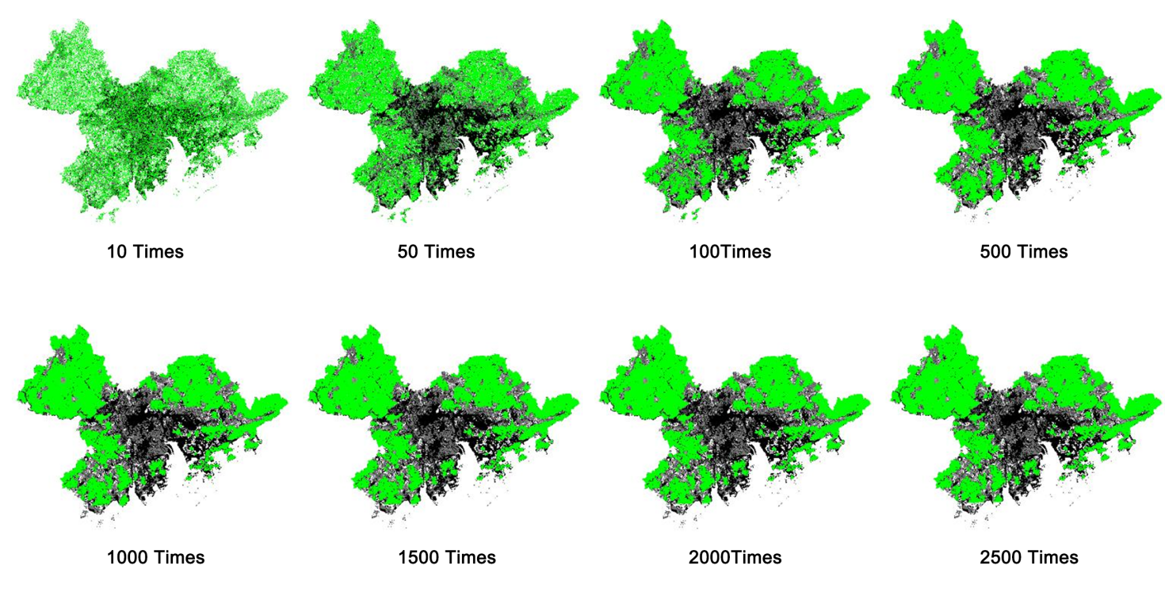
Supplementary Figure.1. The iteration process of GeoSOS area optimization (A1 scenario).

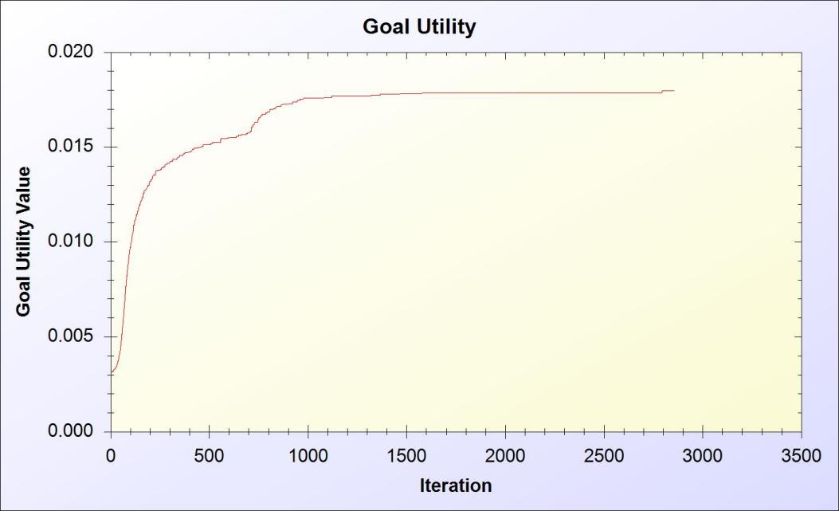
Supplementary Figure.2. The change of goal utility value for iteration process (A1 scenario).
Supplementary information 4: Basic resistance surface parameterization
The Linkage Mapper user guide recommends inputting the minimum raster resistance value as 1, which can be expected to calculate fully connected landscapes by moving through ideal habitats equal to Euclidean distances when performing cost-weighted distance calculations, and it also recommends a maximum resistance of at least 100(McRae and Kavanagh 2021). Therefore, this study set the minimum basic resistance value as 1 to represent unimpeded species migration, and the maximum basic resistance value is 100, which means species migration is almost impossible (Supplementary Table. 3).
Supplementary Table 3. Basic resistance values of different land use types.
Land use type |  | Resistance value | Source
Cultivated land |  | 20 | (Peng and Yang et al. 2018 Peng and Pan et al. 2018 Yingxuan et al. 2016)
Forest |  | 1
Grassland |  | 10
Water body | Area ＜10km² | 15 | (Huang et al. 2021)
Water body | Area≥10km² | 70 | (Huang et al. 2021)
Wetland |  | 1 | (Peng and Yang et al. 2018 Peng and Pan et al. 2018 Yingxuan et al. 2016)
Bare land |  | 50
Urban |  | 100
Rural settlement |  | 70

Supplementary information 5: Ecological source and nature protected area’s landscape characteristic metric caculation
In this study, Ecological sources and nature protected area at 1km resolution in ESRI tif. format were input separately for calculating landscape characteristic metrics in Fragstats software (version 4.2) (McGarigal, Cushman and Ene 2012). By comparing the result, we can assess the improvement in the aggregation of ecological sources. The detailed descriptions of each landscape characteristic metric are listed in Supplementary Table. 4.
Supplementary Table 4. Detailed descriptions of each landscape characteristic metric.
Acronyms | Metric (units) | Notes | Rang
PD | Patch density | It indicates spatial heterogeneity. Number of patches per 100 hectares. | PD > 0, constrained by cell size.
CLUMPY | Clumpiness Index (%) | It is a measure of aggregation. It equals the proportional deviation of the proportion of like adjacencies involving the corresponding class from that expected under a spatially random distribution. | -1 ≤CLUMPY ≤ 1  CLUMPY equals -1 for maximally disaggregated, 0 for randomly distributed and 1 for maximally aggregated classes.
MESH | Effective Mesh Size (ha) | It indicates fragmentation. It provides a relative measure of patch structure. | cell size / total area ≤ MESH ≤ total area  Equals cellsize/total area if class covers only one cell and equals total area if only one patch is present.
AI | Aggregation index (%) | Measures the frequency that patch pairs of different class types are next to each other. | 0 ≤AI≤100  Given any Pi , AI equals 0 when the focal patch type is maximally disaggregated; AI increases as the focal patch type is increasingly aggregated and equals 100 when the patch type is maximally aggregated into a single, compact patch.

References:
Hanyi, LIU, LIN Meizhen, ZHOU Rubo, and ZHONG Liang. 2021. "Spatial and temporal evolution of habitat quality in Guangdong-Hong Kong Macao Greater Bay Area based on InVEST model (in Chinese)
." Ecological Science 03 (40). 10.14108/j.cnki.1008-8873.2021.03.011
Huang, L. Y., J. Wang, Y. Fang, T. L. Zhai, and H. Cheng. 2021. "An integrated approach towards spatial identification of restored and conserved priority areas of ecological network for implementation planning in metropolitan region." SUSTAINABLE CITIES AND SOCIETY 69.10.1016/j.scs.2021.102865
FRAGSTATS v4: Spatial Pattern Analysis Program for Categorical and Continuous Map. the University of Massachusetts, Amherst.http://www.umass.edu/landeco/research/fragstats/fragstats.html
McRae, Brad, and Darren Kavanagh.2021.Linkage Mapper Toolbox: Linkage Pathways Tool User Guide.In
Peng, Jian, Yajing Pan, Yanxu Liu, Huijuan Zhao, and Yanglin Wang. 2018. "Linking ecological degradation risk to identify ecological security patterns in a rapidly urbanizing landscape." Habitat International 71:110-124.https://doi.org/10.1016/j.habitatint.2017.11.010
Peng, Jian, Yang Yang, Yanxu Liu, Yi'na Hu, Yueyue Du, Jeroen Meersmans, and Sijing Qiu. 2018. "Linking ecosystem services and circuit theory to identify ecological security patterns." Science of The Total Environment 644:781-790.10.1016/j.scitotenv.2018.06.292
Posner, Stephen, Gregory Verutes, Insu Koh, Doug Denu, and Taylor Ricketts. 2016. "Global use of ecosystem service models." Ecosystem Services 17:131-141.https://doi.org/10.1016/j.ecoser.2015.12.003
R. Sharp, H. T. Tallis T.2015.InVEST Version 3.2.0 User's Guide. The Natural Capital Project.In: The Nature Conservancy, and World Wildlife Fund, Stanford University, University of Minnesota
TBA, Guangdong province Authority of.2020.Guangdong province Water Resouces Bulletin.In: Guangdong province Authority of Ministry of Water Resources
Wu, Linlin, Caige Sun, and Fenglei Fan.2021.Estimating the Characteristic Spatiotemporal Variation in Habitat Quality Using the InVEST Model—A Case Study from Guangdong–Hong Kong–Macao Greater Bay Area.In Remote Sensing,‘edited by’.10.3390/rs13051008ER -
Yingxuan, Cheng, Wang Hongmei, Liu Guangsheng, Zheng Biao, Wang Haiyun, and Liu Cuixia. 2016. "Spatial layout optimization for ecological land based on minimum cumulative resistance model (in Chinese)." Transactions of the Chinese Society of Agricultural Engineering (16):248-257+315
Zhang, Q. R., X. C. Sun, K. B. Zhang, Z. N. Liao, and S. J. Xu. 2021. "Trade-Offs and Synergies of Ecosystem Services in the Pearl River Delta Urban Agglomeration." SUSTAINABILITY 13 (16).10.3390/su13169155

