Supplement 1: Changes of Climate connectivity (HFP<10, SSP245)
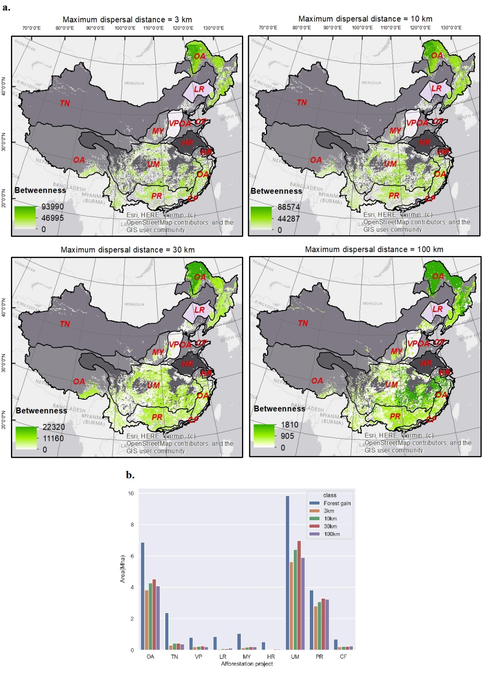
Supplementary Figure 1: Betweenness values of climate-partitioned forest patches as stepping stones for species with different dispersal capacities (3km, 10km, 30km, and 100km) in 2019. a. Betweenness values of stepping stones in 2019. b. Forest gain (Mha) between 2015-2019 as stepping stones. Eight forest shelterbelt projects: TN—the Three-North Forest Shelterbelt Project, VP—the Virescence Project of Taihang Mountain, LR—the Liao River Basin Forest Shelterbelt Project, MY—the Middle Yellow River Forest Shelterbelt Project, HR—the Huai River-Taihu Lake Basin Forest Shelterbelt Project, UM—the Upper-Middle Yangtze River Forest Shelterbelt Project, PR—the Pearl River Basin Forest Shelterbelt Project, CF—the Coastal Forest Shelterbelt Project, OA: Other Areas.

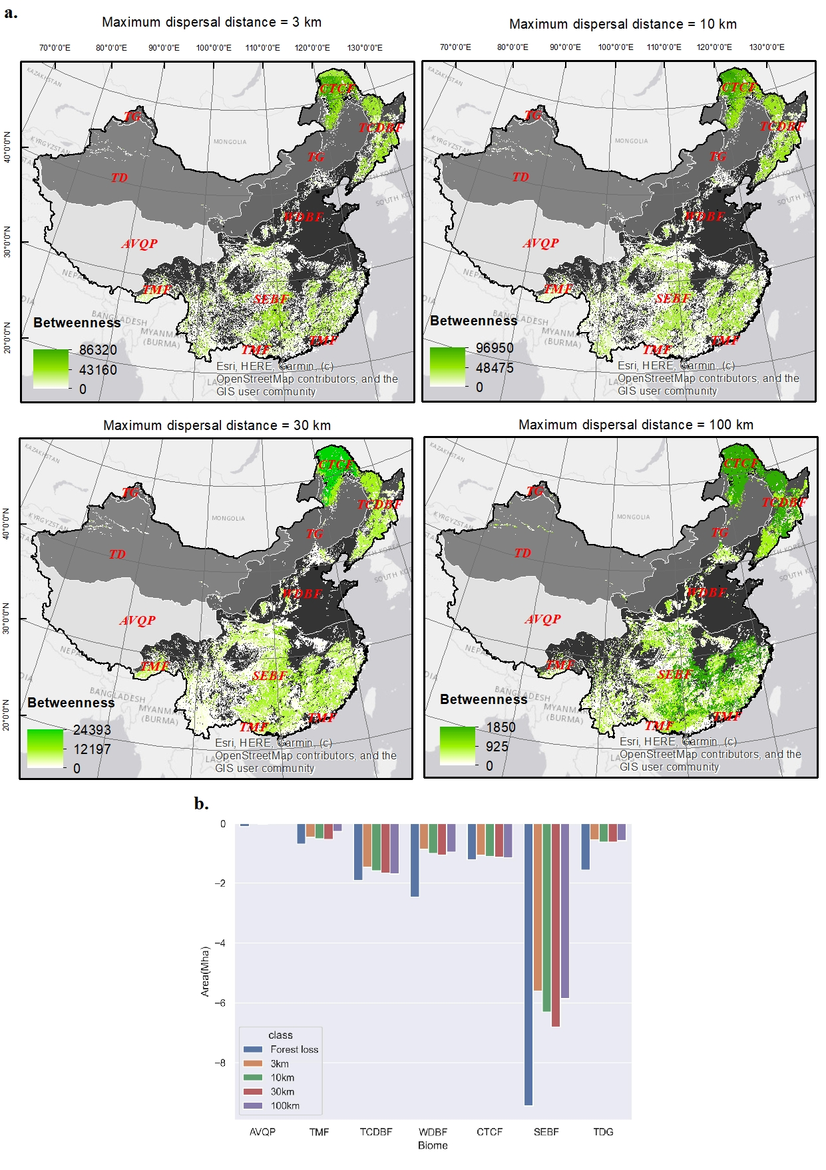
Supplementary Figure 2: Betweenness values of climate-partitioned forest patches as stepping stones for species with different dispersal capacities (3km, 10km, 30km, and 100km) in 2015. a. Betweenness values of stepping stones in 2019. b. Forest losses (Mha) between 2015-2019 as stepping stones. Biomes: AVQP—Alpine vegetation on Qinghai-Tibet Plateau, TMF—tropical monsoon forest, TCDBF—temperate coniferous & deciduous broadleaf forest, WDBF—warm-temperate deciduous broadleaf forest, CTCF—cold-temperate coniferous forest, SEBF—subtropical evergreen broadleaf forest, TDG—temperate desert and grassland.

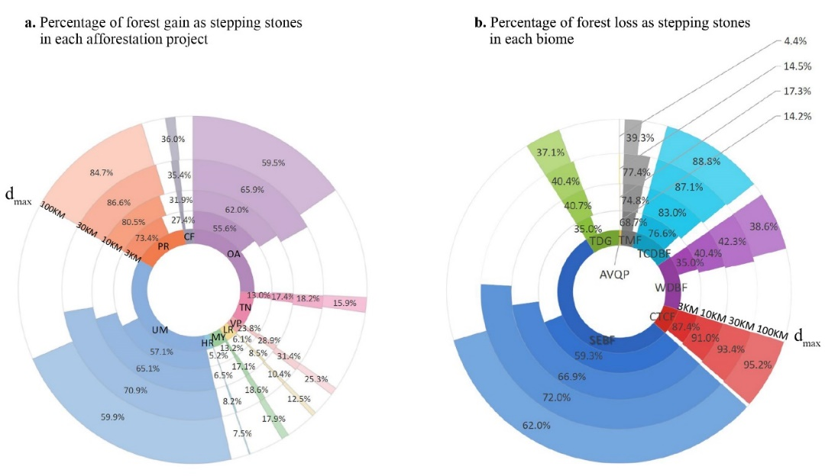
Supplementary Figure 3: Percentage of forest gain and loss between 2015-2019 as stepping stones for species with different dispersal capacities (maximum dispersal distance: d_{max}).
a. Percentage of forest gain as stepping stones in each afforestation project between 2015-2019. Eight forest shelterbelt projects: TN—the Three-North Forest Shelterbelt Project, VP—the Virescence Project of Taihang Mountain, LR—the Liao River Basin Forest Shelterbelt Project, MY—the Middle Yellow River Forest Shelterbelt Project, HR—the Huai River-Taihu Lake Basin Forest Shelterbelt Project, UM—the Upper- Middle Yangtze River Forest Shelterbelt Project, PR—the Pearl River Basin Forest Shelterbelt Project, CF—the Coastal Forest Shelterbelt Project, OA: Other Areas.
b. Percentage of forest loss as stepping stones in each biome between 2015-2019. Biomes: AVQP—Alpine vegetation on Qinghai-Tibet Plateau, TMF—tropical monsoon forest, TCDBF—temperate coniferous & deciduous broadleaf forest, WDBF—warm-temperate deciduous broadleaf forest, CTCF—cold-temperate coniferous forest, SEBF—subtropical evergreen broadleaf forest, TDG—temperate desert and grassland.

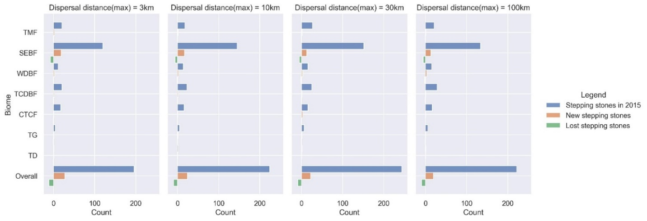
Supplementary Figure 4: Gain and loss of stepping-stone patches (weighted by patch areas) between 2015 and 2019. Biomes: TMF—tropical monsoon forest, TCDBF—temperate coniferous & deciduous broadleaf forest, WDBF—warm-temperate deciduous broadleaf forest, CTCF—cold-temperate coniferous forest, SEBF—subtropical evergreen broadleaf forest, TD—temperate desert, TG—temperate grassland.

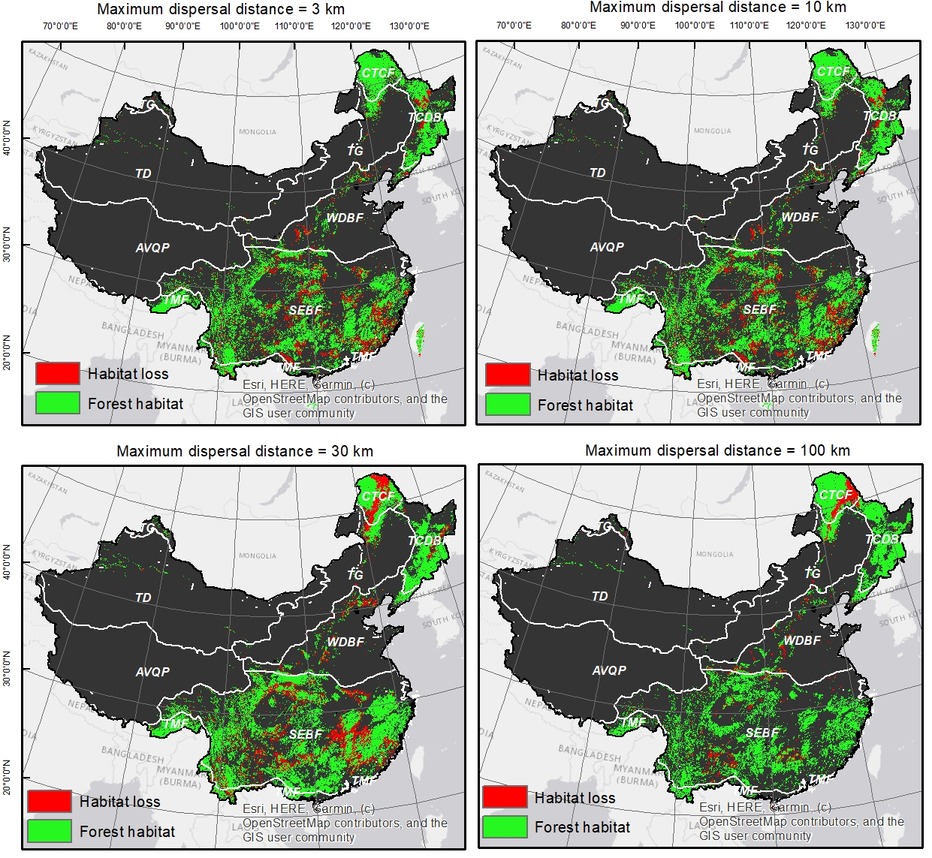
Supplementary Figure 5: Loss of habitat patches between 2015 and 2019 across biomes. Biomes: TMF—tropical monsoon forest, TCDBF—temperate coniferous & deciduous broadleaf forest, WDBF—warm-temperate deciduous broadleaf forest, CTCF—cold-temperate coniferous forest, SEBF—subtropical evergreen broadleaf forest, TD—temperate desert, TG—temperate grassland.

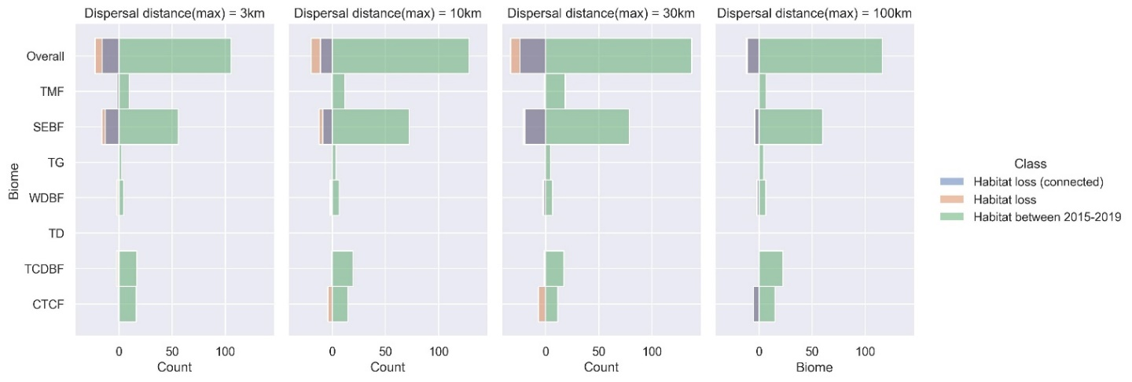
Supplementary Figure 6: Loss of forest habitat patches (weighted by patch areas) between 2015-2019 across biomes. Including the loss of habitat areas that were climatically connected in 2015 (blue) and those unsuccessfully connected (orange). Biomes: TMF—tropical monsoon forest, TCDBF—temperate coniferous & deciduous broadleaf forest, WDBF—warm-temperate deciduous broadleaf forest, CTCF—cold-temperate coniferous forest, SEBF—subtropical evergreen broadleaf forest, TD—temperate desert, TG—temperate grassland.

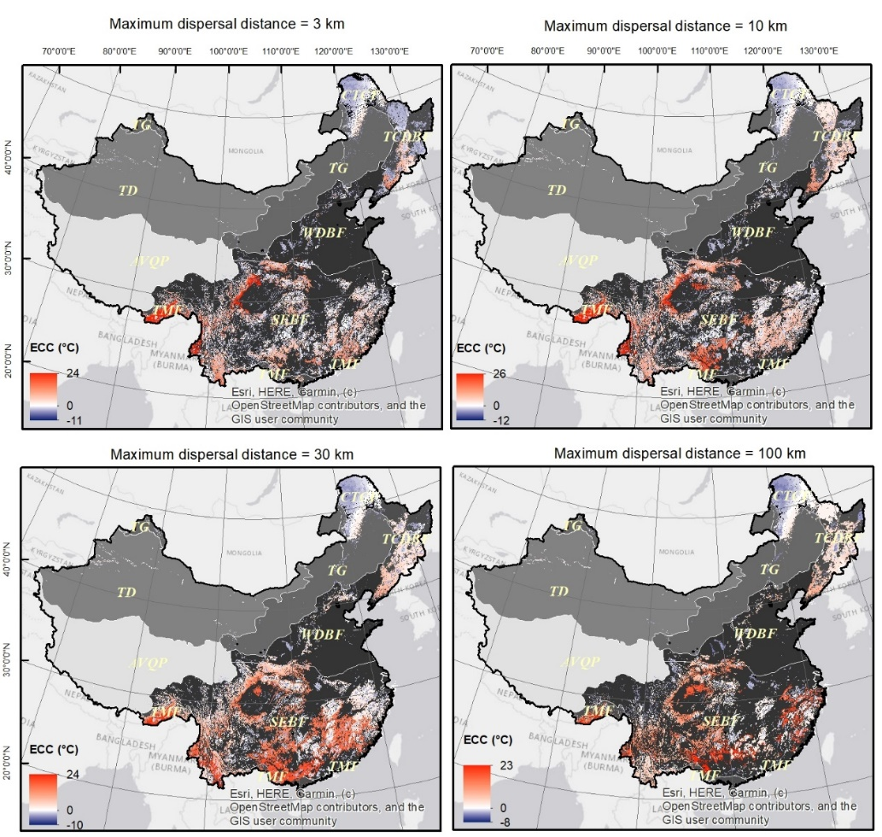
Supplementary Figure 7: ECC of the habitat patches in 2015. Biomes: TMF—tropical monsoon forest, TCDBF—temperate coniferous & deciduous broadleaf forest, WDBF—warm-temperate deciduous broadleaf forest, CTCF—cold-temperate coniferous forest, SEBF—subtropical evergreen broadleaf forest, TD—temperate desert, TG—temperate grassland.
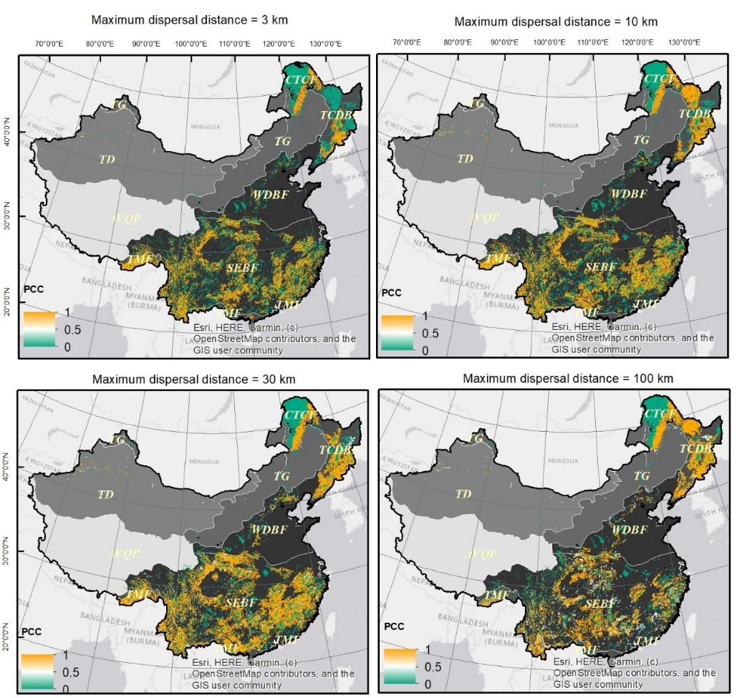
Supplementary Figure 8: PCC of the habitat patches in 2015. Biomes: TMF—tropical monsoon forest, TCDBF—temperate coniferous & deciduous broadleaf forest, WDBF—warm-temperate deciduous broadleaf forest, CTCF—cold-temperate coniferous forest, SEBF—subtropical evergreen broadleaf forest, TD—temperate desert, TG—temperate grassland.

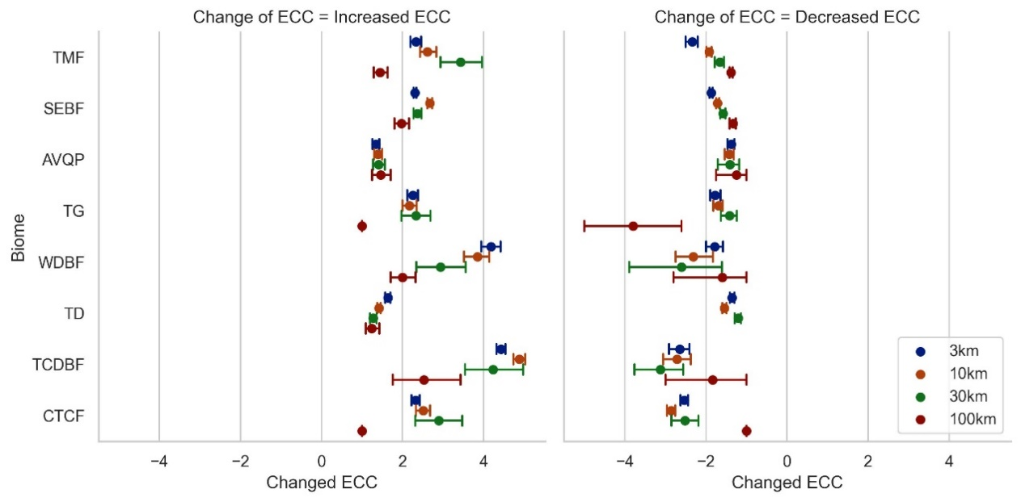
Supplementary Figure 9: Mean values of a. increased and b. decreased ECC between 2015 and 2019 across biomes. Biomes: TMF—tropical monsoon forest, TCDBF—temperate coniferous & deciduous broadleaf forest, WDBF—warm-temperate deciduous broadleaf forest, CTCF—cold-temperate coniferous forest, SEBF—subtropical evergreen broadleaf forest, TD—temperate desert, TG—temperate grassland.

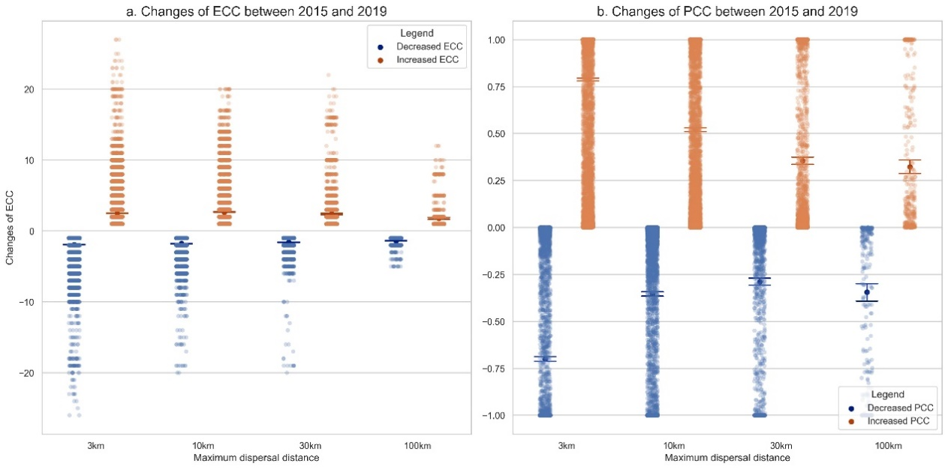
Supplementary Figure 10: Mean values of changed a. ECC and b. PCC between 2015 and 2019.

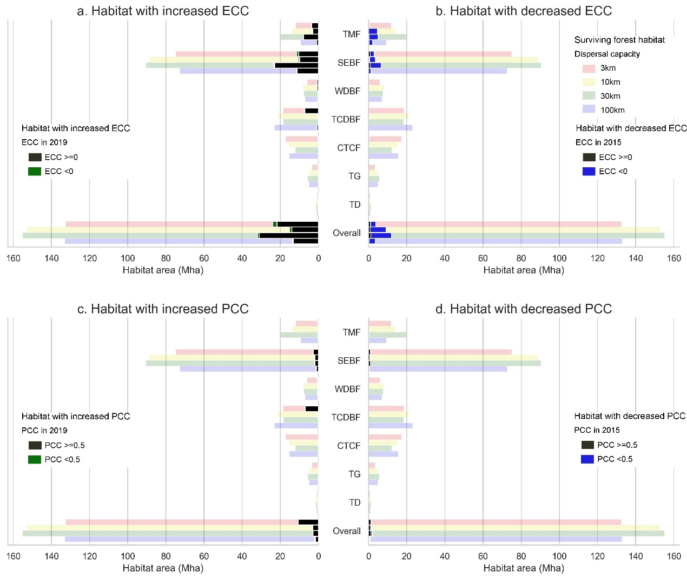
Supplementary Figure 11: Areas of forest habitat experienced changes in ECC and PCC in each biome between 2015 and 2019, including a. Habitat experiencing increases in ECC, b. Habitat experiencing decreases in ECC, c. Habitat experiencing increases in PCC, d. Habitat experiencing decreases in PCC. Biomes: TMF—tropical monsoon forest, TCDBF—temperate coniferous & deciduous broadleaf forest, WDBF—warm-temperate deciduous broadleaf forest, CTCF—cold-temperate coniferous forest, SEBF—subtropical evergreen broadleaf forest, TD—temperate desert, TG—temperate grassland.

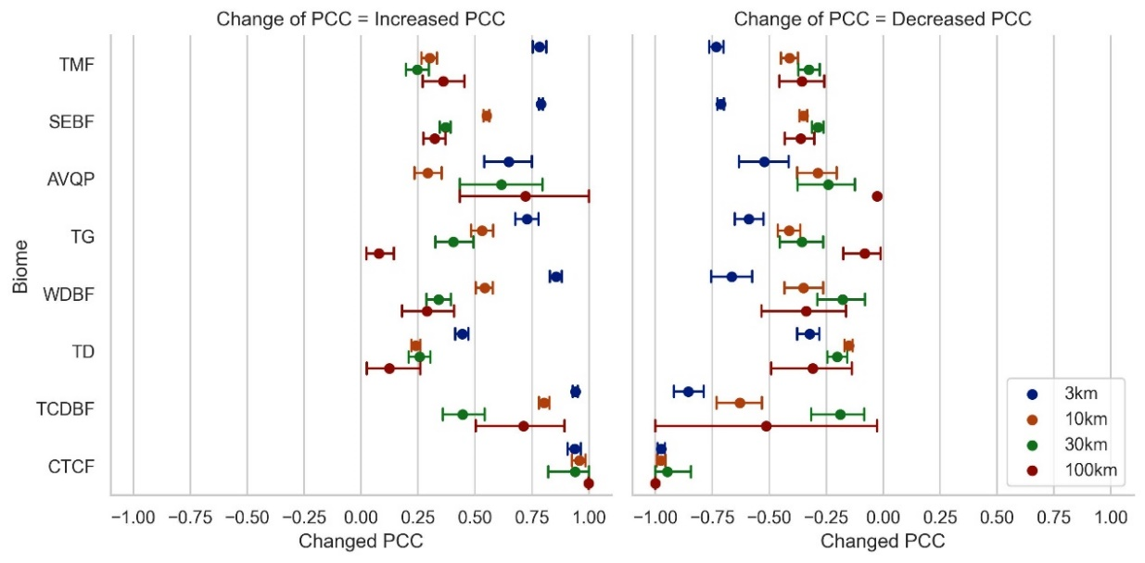
Supplementary Figure 12: Mean values of a. increased and b. decreased PCC between 2015 and 2019 in each biome. Biomes: TMF—tropical monsoon forest, TCDBF—temperate coniferous & deciduous broadleaf forest, WDBF—warm-temperate deciduous broadleaf forest, CTCF—cold-temperate coniferous forest, SEBF—subtropical evergreen broadleaf forest, TD—temperate desert, TG—temperate grassland.

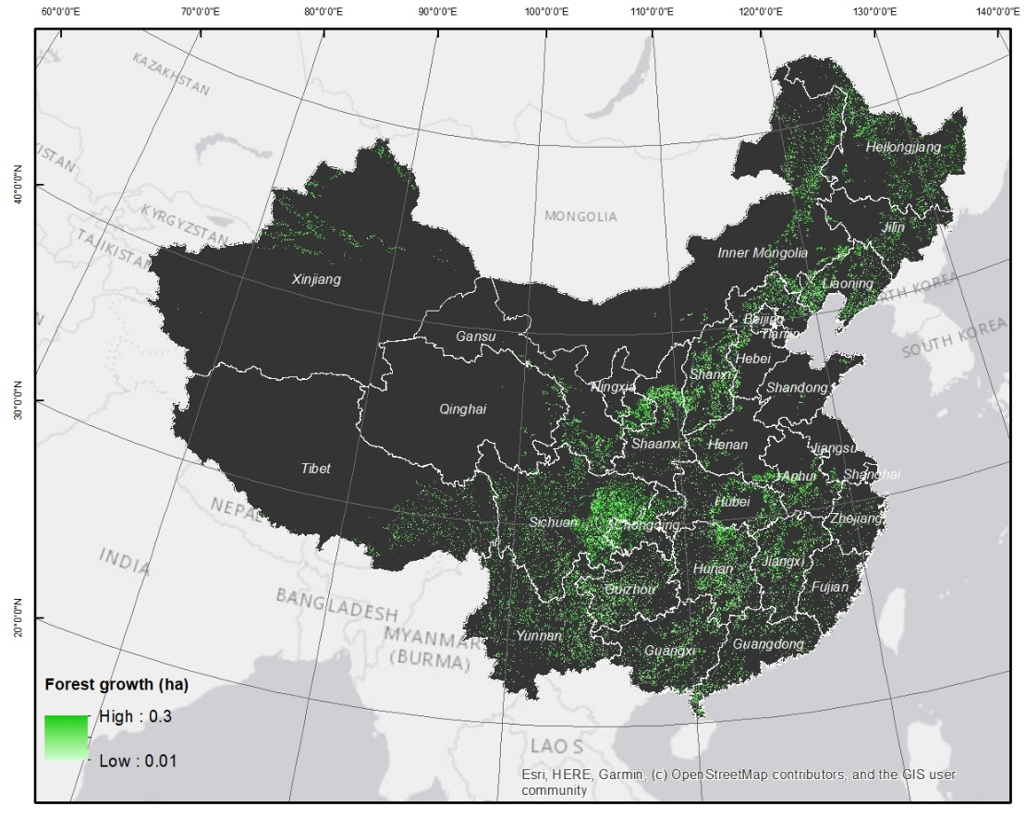
Supplementary Figure 13: Proposed afforestation (forest growth) to improve climate connectivity across Mainland China (excluding islands).

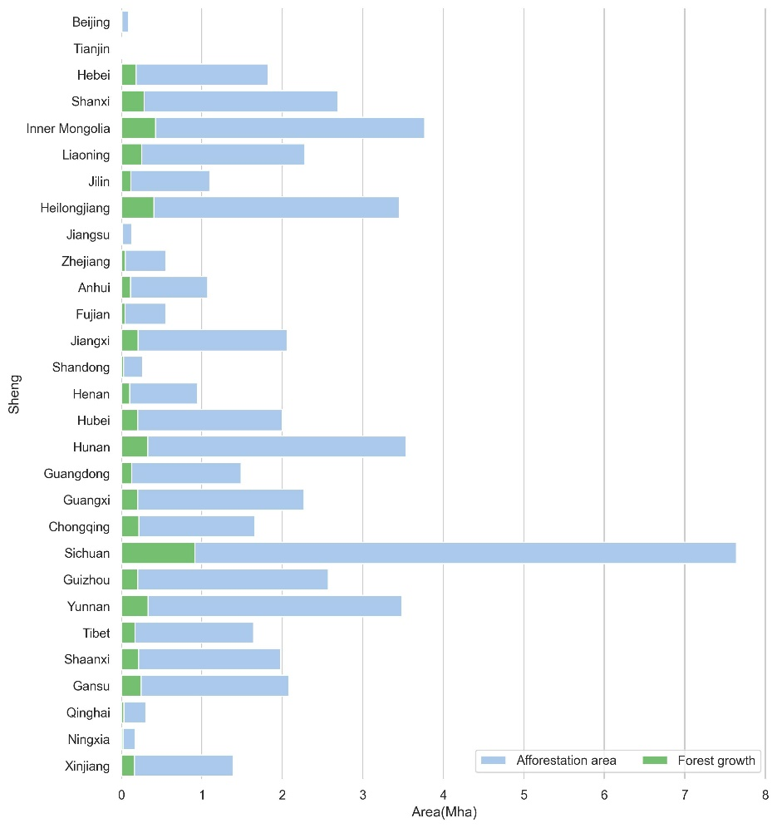
Supplementary Figure 14: Proposed afforestation area and forest growth in each province to improve climate connectivity.
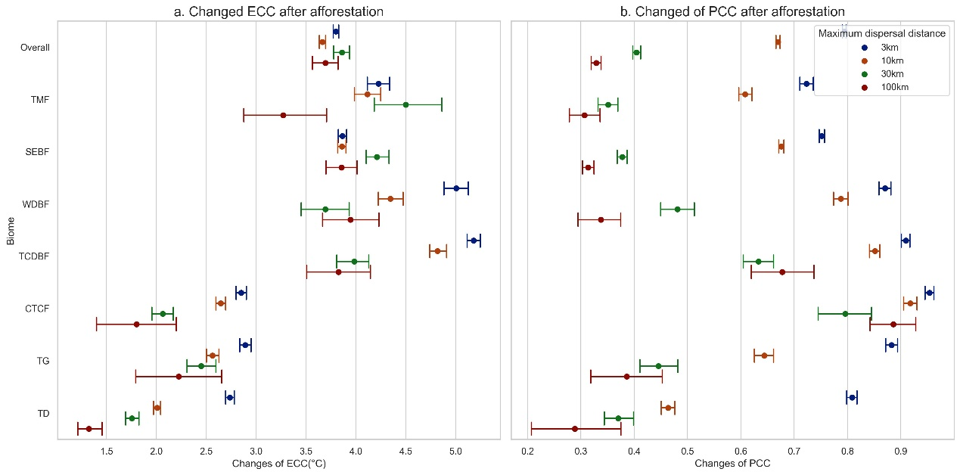
Supplementary Figure 15: Mean values of increased a. ECC and b. PCC across biomes after the proposed afforestation. Biomes: TMF—tropical monsoon forest, TCDBF—temperate coniferous & deciduous broadleaf forest, WDBF—warm-temperate deciduous broadleaf forest, CTCF—cold-temperate coniferous forest, SEBF—subtropical evergreen broadleaf forest, TD—temperate desert, TG—temperate grassland.
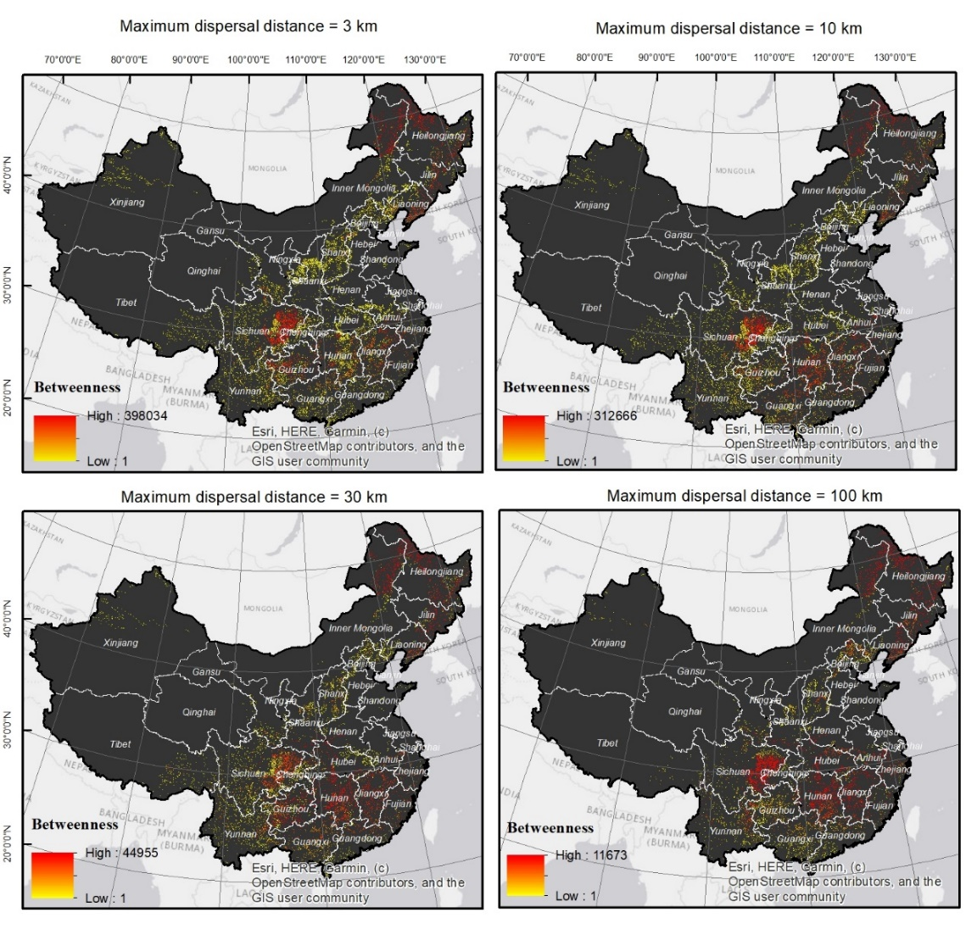
Supplementary Figure 16: Priorities of candidate sites for afforestation in each province across Mainland China (excluding islands). High betweenness values indicate high priorities for afforestation to improve climate connectivity.

Supplementary Table 1. Proposed area and forest growth for future afforestation and the mean betweenness value of new forests in each province.
Province | Forest growth (Mha) | Afforestation area (Mha) | Mean betweenness value
Beijing | 0.01 | 0.09 | 0.23
Tianjin | 0.00 | 0.01 | 0.04
Hebei | 0.18 | 1.82 | 0.44
Shanxi | 0.29 | 2.69 | 0.36
Inner Mongolia | 0.43 | 3.77 | 97.35
Liaoning | 0.25 | 2.28 | 2.30
Jilin | 0.12 | 1.10 | 12.18
Heilongjiang | 0.40 | 3.45 | 73.06
Jiangsu | 0.01 | 0.13 | 1.64
Zhejiang | 0.05 | 0.56 | 4.23
Anhui | 0.12 | 1.07 | 2.92
Fujian | 0.05 | 0.55 | 4.20
Jiangxi | 0.21 | 2.06 | 7.04
Shandong | 0.03 | 0.27 | 0.11
Henan | 0.10 | 0.95 | 3.16
Hubei | 0.20 | 2.00 | 4.65
Hunan | 0.33 | 3.54 | 7.55
Guangdong | 0.13 | 1.49 | 0.70
Guangxi | 0.21 | 2.27 | 1.25
Chongqing | 0.22 | 1.66 | 5.32
Sichuan | 0.92 | 7.64 | 5.22
Guizhou | 0.21 | 2.57 | 2.60
Yunnan | 0.33 | 3.49 | 0.71
Tibet | 0.17 | 1.64 | 0.39
Shaanxi | 0.22 | 1.98 | 2.26
Gansu | 0.25 | 2.08 | 1.10
Qinghai | 0.03 | 0.30 | 0.09
Ningxia | 0.02 | 0.17 | 0.39
Xinjiang | 0.16 | 1.39 | 0.15

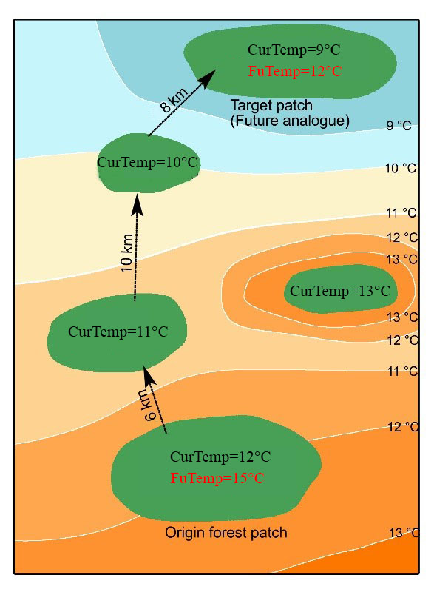
Supplementary Figure 17: Illustration of current and future climate analogues and the path length between them. The target patch has the same temperature in the future (FuTemp) as the current temperature (CurTemp) of the origin patch. The dispersal distance between the current and future climate analogues is 24km.

Supplement 2 Changes of Climate connectivity (HFP<10, SSP585)
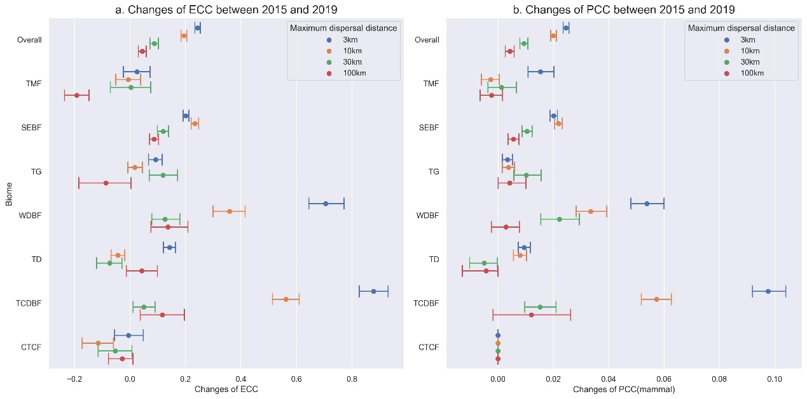
Supplementary Figure 18: Changes of climate connectivity (under SSP585) for habitat patches (HFP≤9) between 2015 and 2019. a. Changes of ECC; b. Changes of PCC for mammals. Biomes: TMF—tropical monsoon forest, TCDBF—temperate coniferous & deciduous broadleaf forest, WDBF—warm-temperate deciduous broadleaf forest, CTCF—cold-temperate coniferous forest, SEBF—subtropical evergreen broadleaf forest, TD—temperate desert, TG—temperate grassland.

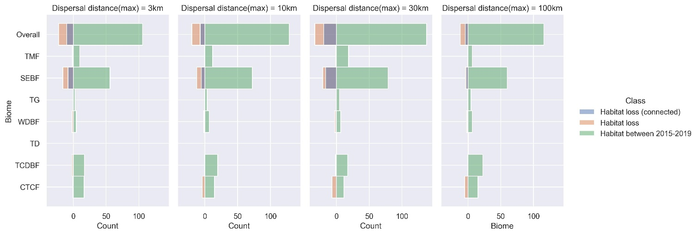
Supplementary Figure 19: Loss of forest habitat patches (HFP≤9) connected or not connected to future analogues between 2015-2019 across biomes, weighted by patch areas. Biomes: TMF—tropical monsoon forest, TCDBF—temperate coniferous & deciduous broadleaf forest, WDBF—warm-temperate deciduous broadleaf forest, CTCF—cold-temperate coniferous forest, SEBF—subtropical evergreen broadleaf forest, TD—temperate desert, TG—temperate grassland.

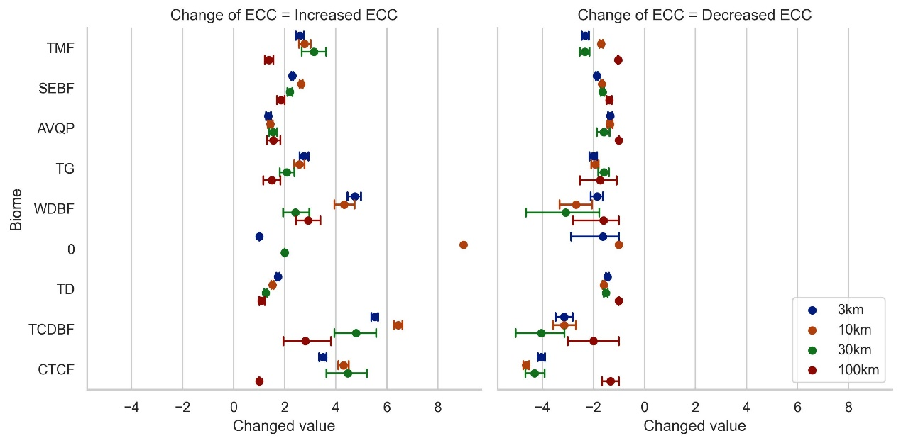
Supplementary Figure 20: Mean values of a. increased and b. decreased ECC (under SSP585) for habitat patches (HFP≤9) between 2015 and 2019 across biomes. Biomes: TMF—tropical monsoon forest, TCDBF—temperate coniferous & deciduous broadleaf forest, WDBF—warm-temperate deciduous broadleaf forest, CTCF—cold-temperate coniferous forest, SEBF—subtropical evergreen broadleaf forest, TD—temperate desert, TG—temperate grassland.

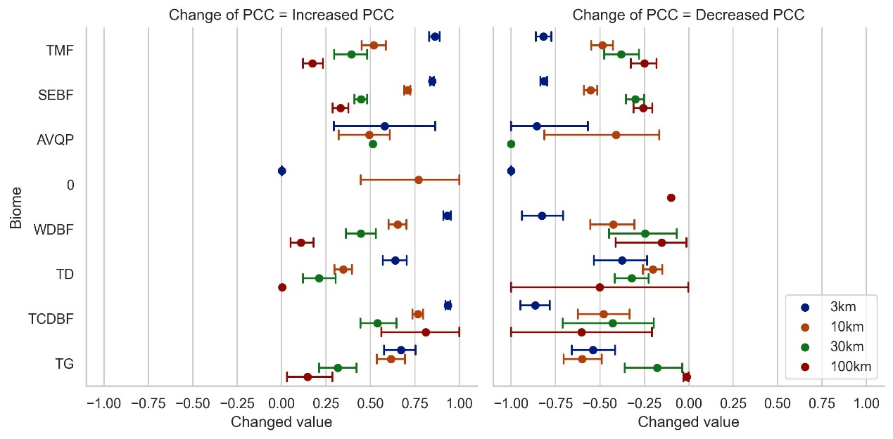
Supplementary Figure 21: Mean values of a. increased and b. decreased PCC (under SSP585) for habitat patches (HFP≤9) between 2015 and 2019 across biomes. Biomes: TMF—tropical monsoon forest, TCDBF—temperate coniferous & deciduous broadleaf forest, WDBF—warm-temperate deciduous broadleaf forest, CTCF—cold-temperate coniferous forest, SEBF—subtropical evergreen broadleaf forest, TD—temperate desert, TG—temperate grassland.

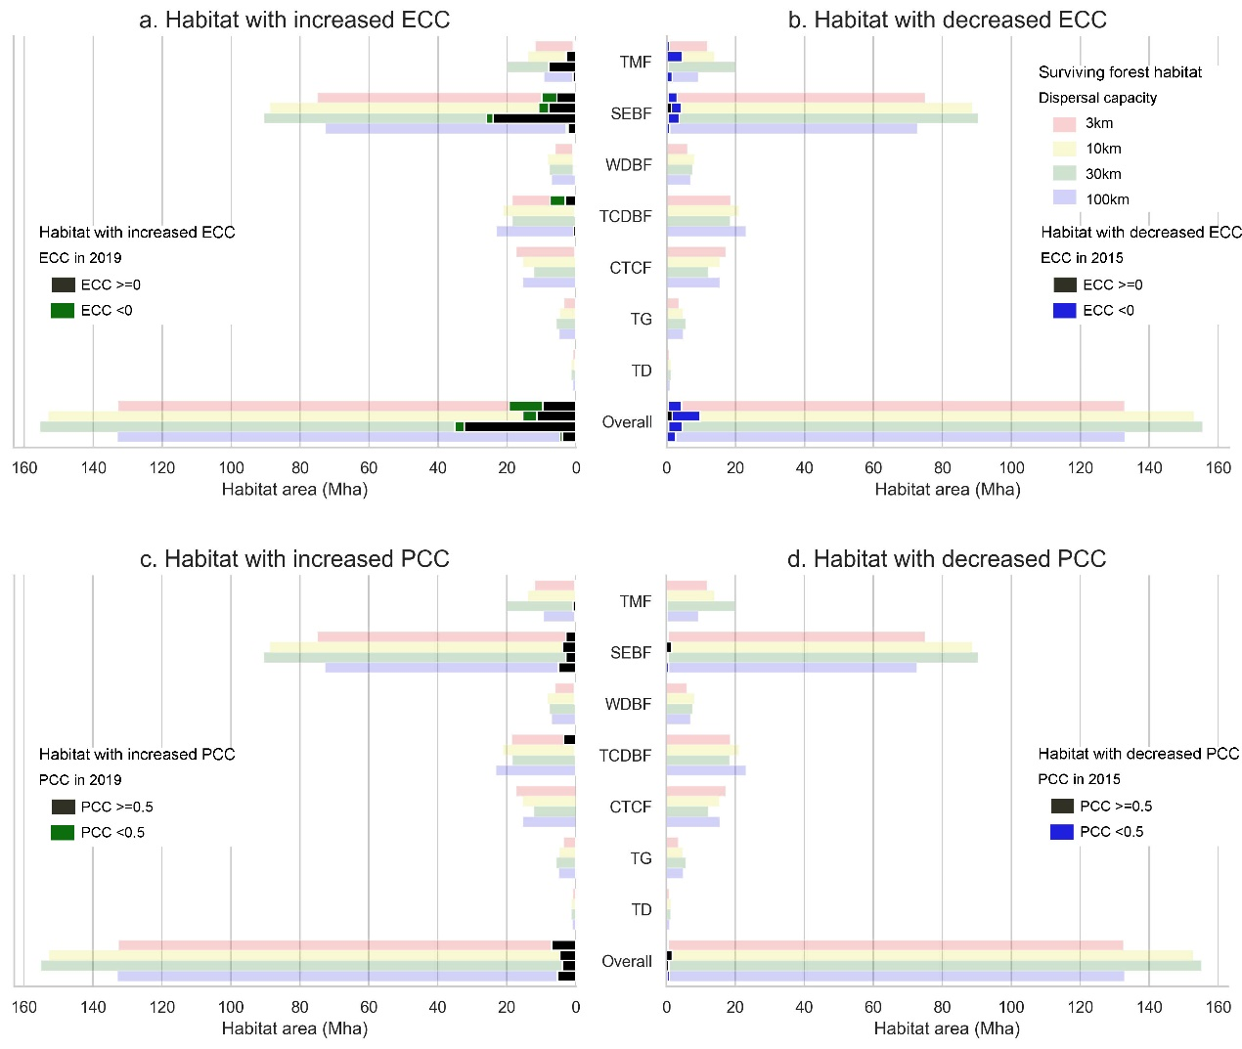
Supplementary Figure 22: Areas of forest habitat (HFP≤9) experienced changes in ECC and PCC (under SSP585), including a. Habitat experiencing increases in ECC, b. Habitat experiencing decreases in ECC, c. Habitat experiencing increases in PCC, d. Habitat experiencing decreases in PCC. Biomes: TMF—tropical monsoon forest, TCDBF—temperate coniferous & deciduous broadleaf forest, WDBF—warm-temperate deciduous broadleaf forest, CTCF—cold-temperate coniferous forest, SEBF—subtropical evergreen broadleaf forest, TD—temperate desert, TG—temperate grassland.

Supplement 3 Changes of Climate connectivity (HFP<8, SSP245)
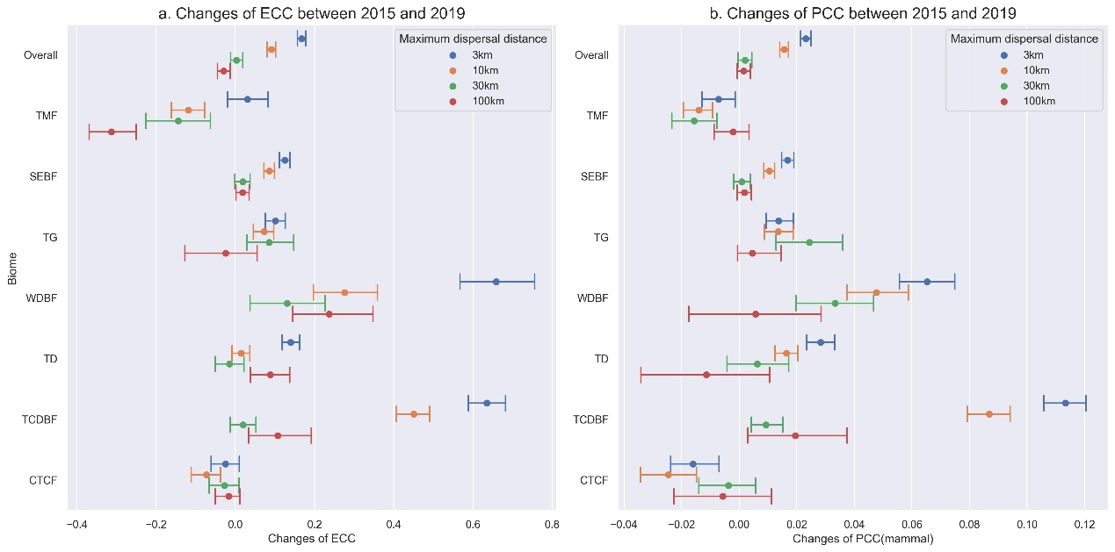
Supplementary Figure 23: Changes of climate connectivity for habitat patches (HFP≤7) between 2015 and 2019. a. Changes of ECC; b. Changes of PCC for mammals. Biomes: TMF—tropical monsoon forest, TCDBF—temperate coniferous & deciduous broadleaf forest, WDBF—warm-temperate deciduous broadleaf forest, CTCF—cold-temperate coniferous forest, SEBF—subtropical evergreen broadleaf forest, TD—temperate desert, TG—temperate grassland.

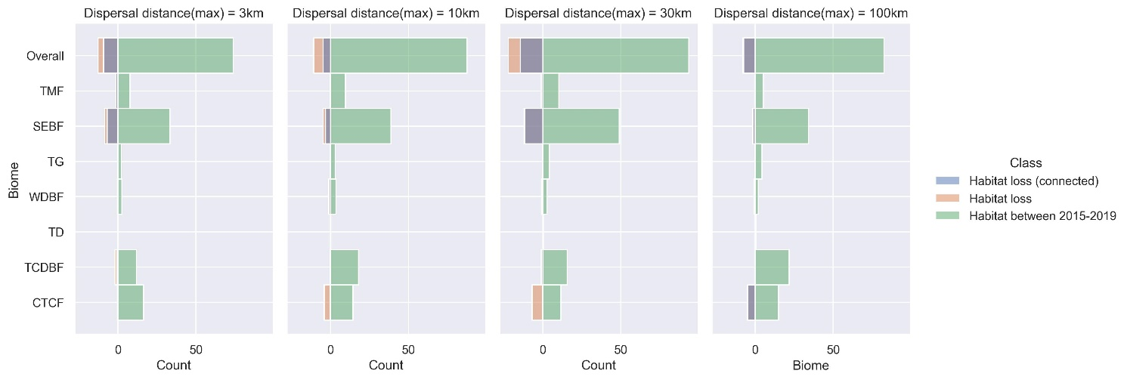
Supplementary Figure 24: Loss of forest habitat patches (HFP≤7) connected or not connected to future analogues between 2015-2019 across biomes, weighted by patch areas. Biomes: TMF—tropical monsoon forest, TCDBF—temperate coniferous & deciduous broadleaf forest, WDBF—warm-temperate deciduous broadleaf forest, CTCF—cold-temperate coniferous forest, SEBF—subtropical evergreen broadleaf forest, TD—temperate desert, TG—temperate grassland.

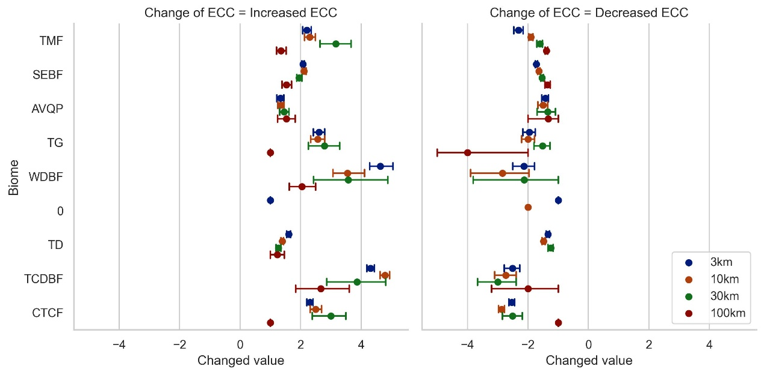
Supplementary Figure 25: Mean values of a. increased and b. decreased ECC for habitat patches (HFP≤7) between 2015 and 2019 across biomes. Biomes: TMF—tropical monsoon forest, TCDBF—temperate coniferous & deciduous broadleaf forest, WDBF—warm-temperate deciduous broadleaf forest, CTCF—cold-temperate coniferous forest, SEBF—subtropical evergreen broadleaf forest, TD—temperate desert, TG—temperate grassland.

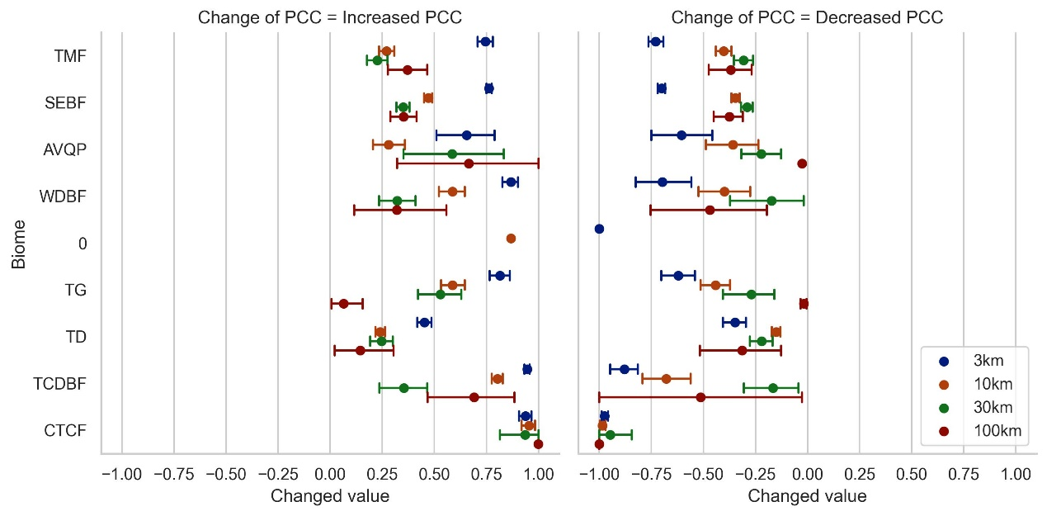
Supplementary Figure 26: Mean values of a. increased and b. decreased PCC for habitat patches (HFP≤7) between 2015 and 2019 across biomes. Biomes: TMF—tropical monsoon forest, TCDBF—temperate coniferous & deciduous broadleaf forest, WDBF—warm-temperate deciduous broadleaf forest, CTCF—cold-temperate coniferous forest, SEBF—subtropical evergreen broadleaf forest, TD—temperate desert, TG—temperate grassland.

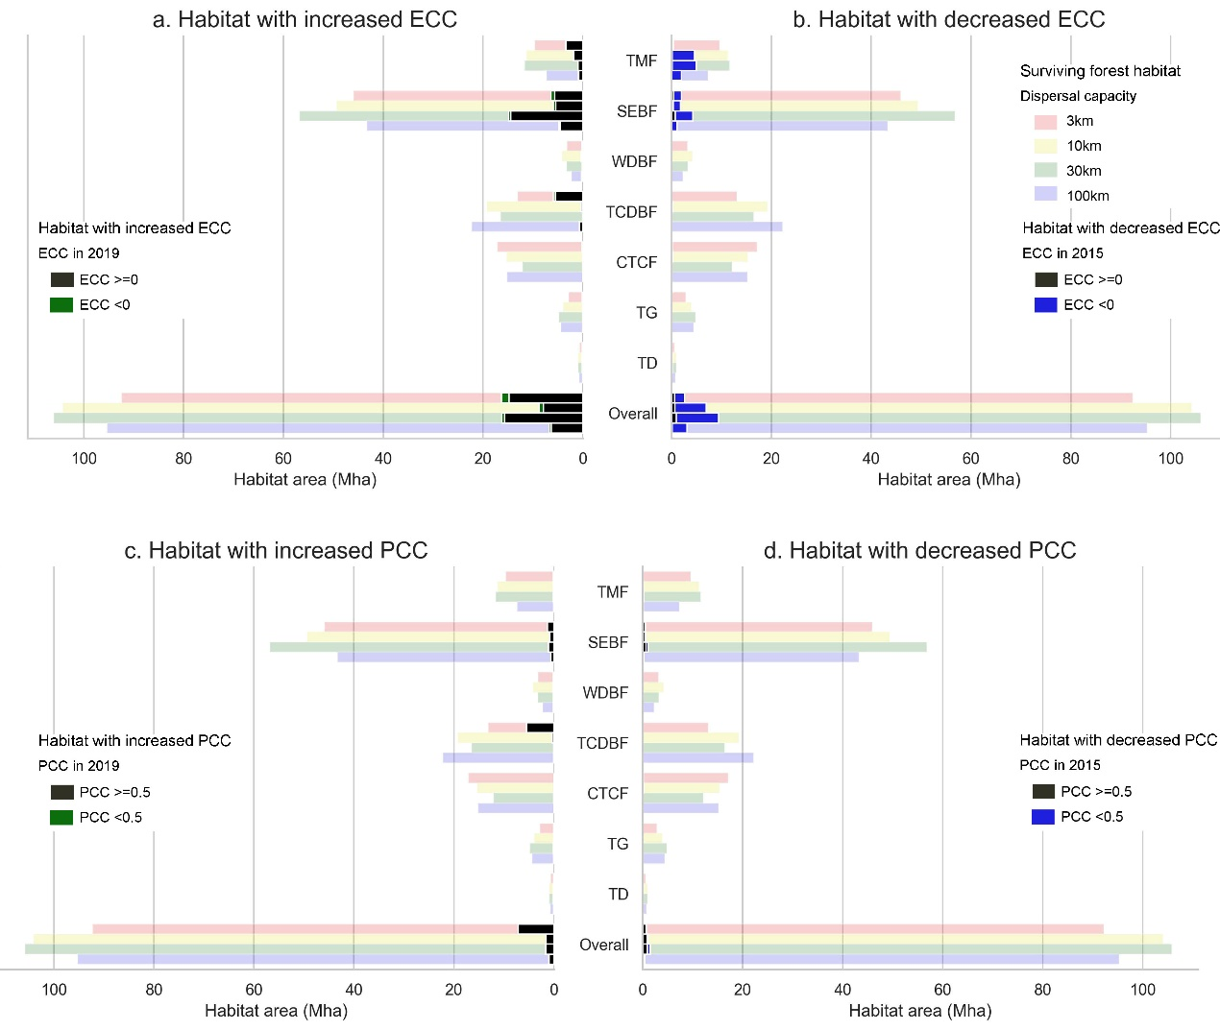
Supplementary Figure 27: Areas of forest habitat (HFP≤7) experienced changes in ECC and PCC, including a. Habitat experiencing increases in ECC, b. Habitat experiencing decreases in ECC, c. Habitat experiencing increases in PCC, d. Habitat experiencing decreases in PCC. Biomes: TMF—tropical monsoon forest, TCDBF—temperate coniferous & deciduous broadleaf forest, WDBF—warm-temperate deciduous broadleaf forest, CTCF—cold-temperate coniferous forest, SEBF—subtropical evergreen broadleaf forest, TD—temperate desert, TG—temperate grassland.

Supplement 4 Changes of Climate connectivity (HFP<6, SSP245)
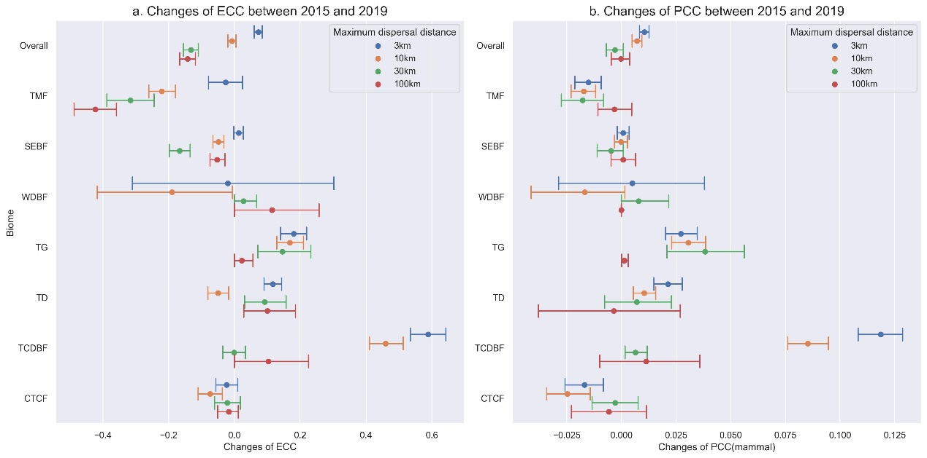
Supplementary Figure 28: Changes of climate connectivity for habitat patches (HFP≤5) between 2015 and 2019. a. Changes of ECC; b. Changes of PCC for mammals. Biomes: TMF—tropical monsoon forest, TCDBF—temperate coniferous & deciduous broadleaf forest, WDBF—warm-temperate deciduous broadleaf forest, CTCF—cold-temperate coniferous forest, SEBF—subtropical evergreen broadleaf forest, TDG—temperate desert and grassland.

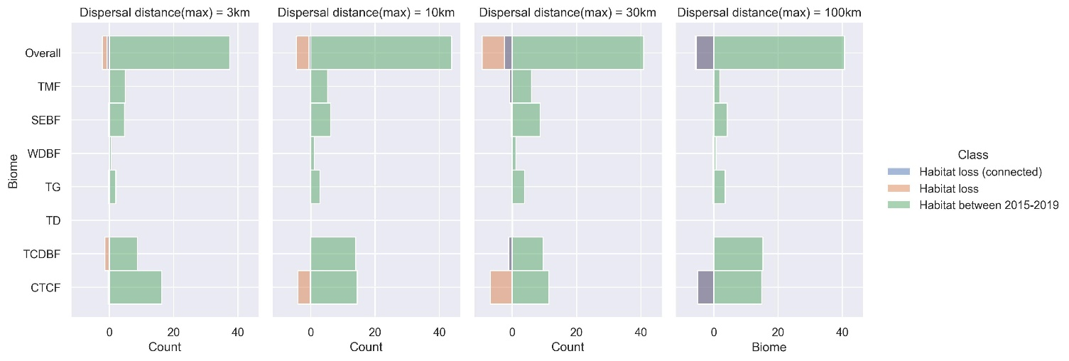
Supplementary Figure 29: Loss of forest habitat patches (HFP≤5) connected or not connected to future analogues between 2015-2019 across biomes, weighted by patch areas. Biomes: TMF—tropical monsoon forest, TCDBF—temperate coniferous & deciduous broadleaf forest, WDBF—warm-temperate deciduous broadleaf forest, CTCF—cold-temperate coniferous forest, SEBF—subtropical evergreen broadleaf forest, TDG—temperate desert and grassland.

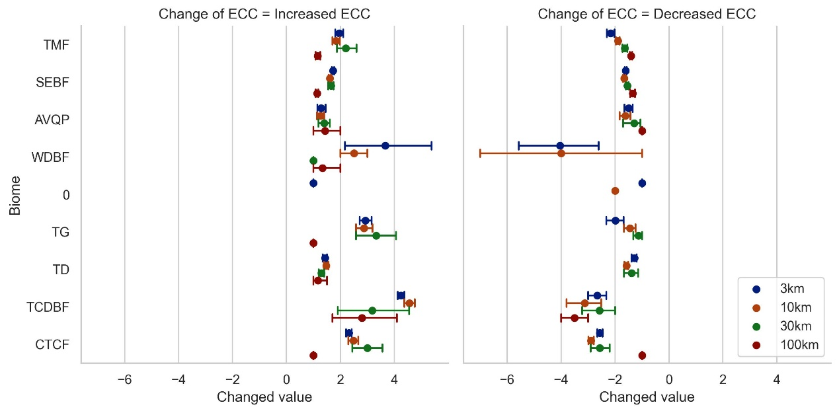
Supplementary Figure 30: Mean values of a. increased and b. decreased ECC for habitat patches (HFP≤5) between 2015 and 2019 across biomes. Biomes: TMF—tropical monsoon forest, TCDBF—temperate coniferous & deciduous broadleaf forest, WDBF—warm-temperate deciduous broadleaf forest, CTCF—cold-temperate coniferous forest, SEBF—subtropical evergreen broadleaf forest, TD—temperate desert, TG—temperate grassland.

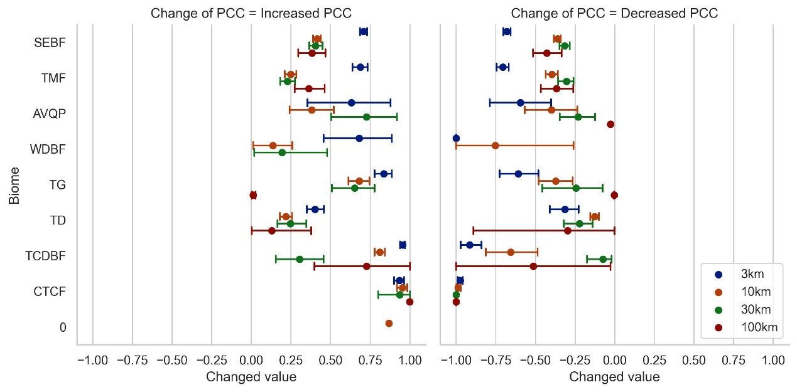
Supplementary Figure 31: Mean values of a. increased and b. decreased PCC for habitat patches (HFP≤5) between 2015 and 2019 across biomes. Biomes: TMF—tropical monsoon forest, TCDBF—temperate coniferous & deciduous broadleaf forest, WDBF—warm-temperate deciduous broadleaf forest, CTCF—cold-temperate coniferous forest, SEBF—subtropical evergreen broadleaf forest, TD—temperate desert, TG—temperate grassland.

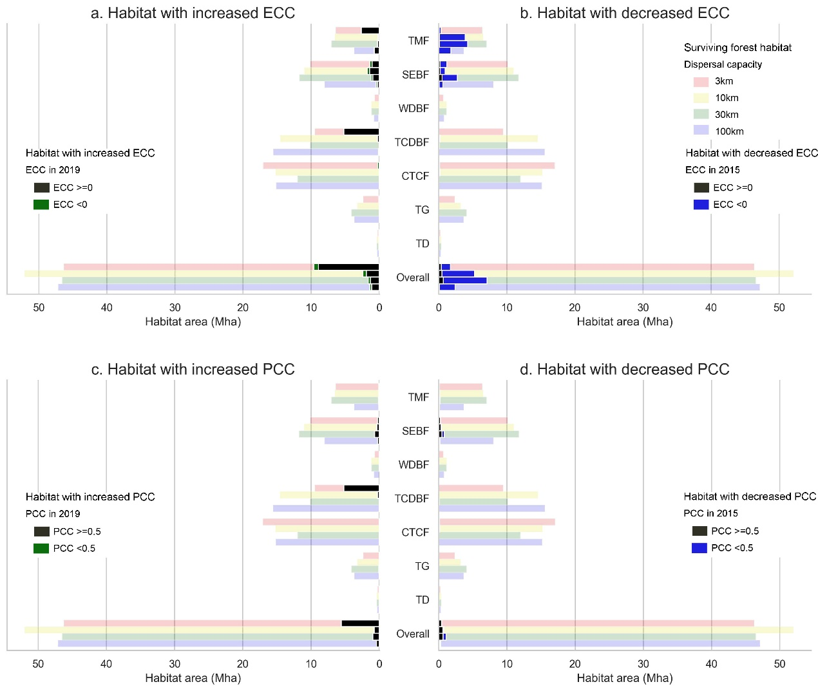
Supplementary Figure 32: Areas of forest habitat (HFP≤5) experienced changes in ECC and PCC, including a. Habitat experiencing increases in ECC, b. Habitat experiencing decreases in ECC, c. Habitat experiencing increases in PCC, d. Habitat experiencing decreases in PCC. Biomes: TMF—tropical monsoon forest, TCDBF—temperate coniferous & deciduous broadleaf forest, WDBF—warm-temperate deciduous broadleaf forest, CTCF—cold-temperate coniferous forest, SEBF—subtropical evergreen broadleaf forest, TD—temperate desert, TG—temperate grassland.

