Table of Contents
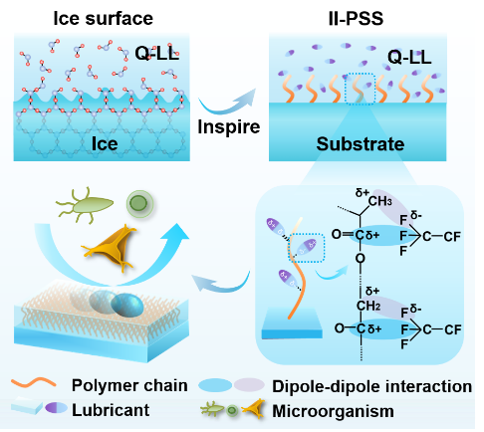
We prepared an ice-inspired polymeric slippery surface (II-PSS) with excellent smoothness, stability and antifouling properties, which are constructed by a densely surface-grafted polymer matrix and a self-lubricating liquid layer via dynamic dipole-dipole interactions.

