Supplementary Information
Ice-Inspired Polymeric Slippery Surface with Excellent Smoothness, Stability and Antifouling Properties
Runxiang Tan^{1,2#}, Peng Hao^{3#}, Daheng Wu¹*, Haoyong Yang^{1,4}, Yifu Xia¹, Shengfei Li¹, Jianing Wang¹, Lisha Liang², Jin Zhou²*, Tao Zhang¹*

¹Key Laboratory of Marine Materials and Related Technologies, Zhejiang Key Laboratory of Marine Materials and Protective Technologies, Ningbo Institute of Materials Technology and Engineering, Chinese Academy of Sciences, Ningbo 315201, China
²Key Laboratory of Leather Chemistry and Engineering of the Education Ministry, Sichuan University, Chengdu 610065, China
³College of Energy and Mining Engineering, Shandong University of Science and Technology, Qingdao 266590, China
⁴University of Chinese Academy of Sciences, Beijing 100049, China
#These authors contributed equally.
*Correspondence to: wudaheng@nimte.ac.cn, zj_scu@scu.edu.cn, tzhang@nimte.ac.cn

Supplementary Figures
Supplementary Figure 1 | Micro-FTIR spectrum of PGMA. The appearance of the C=O stretching band and the O-C-O stretching band are at 1727.91 cm⁻¹ and 1149.37 cm⁻¹, respectively, which confirmed the successful preparation of PGMA.

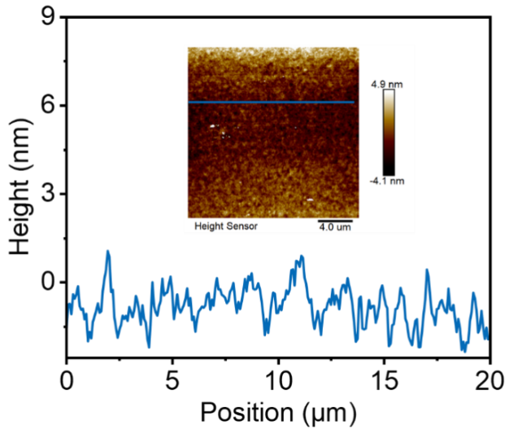
Supplementary Figure 2 | Scanning probe microscope (SPM) topographic scans of PGMA matrix. The PGMA matrix with a low roughness of 0.6 nm (Ra) over an area of 20 ×20 μm². Scale bar: 4.0 μm. Reaction time: 1 h. The vertical profile of the PGMA along the labelled blue line indicates a homogeneous PGMA layer on substrate.

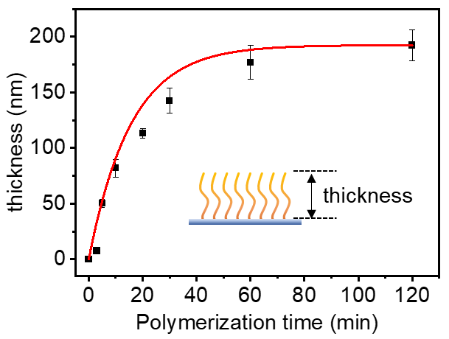
Supplementary Figure 3 | Thickness evolution of the PGMA matrix versus grafting time. The polymerization time is significantly important to PGMA growth thickness. The growth thickness of PGMA increased from 8 nm to 192 nm with the polymerization time increased from 3 min to 2 h.

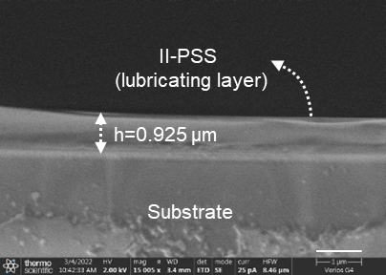
Supplementary Figure 4 | The cross-sectional scanning electron microscopy (SEM) images of II-PSS. The height of II-PSS is about 0.925 μm, scale bar: 1 μm.

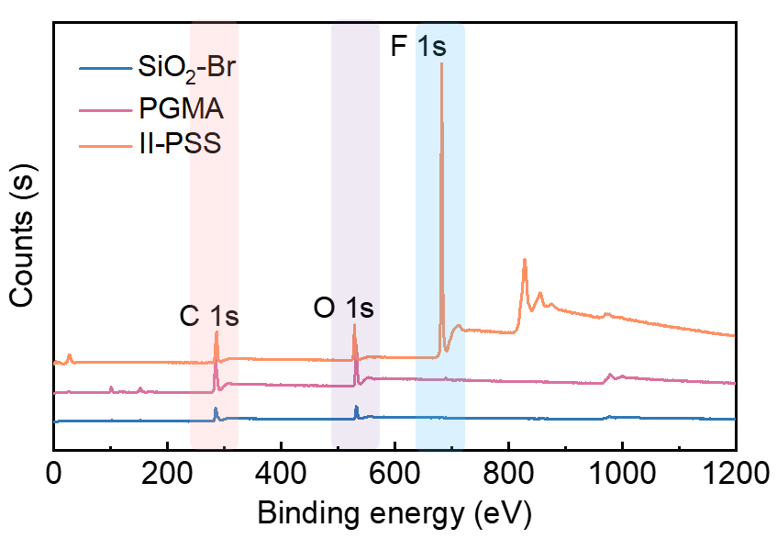
Supplementary Figure 5 | Full survey spectrum of X-ray photoelectron spectroscopy analysis of initiator functionalized substrate (SiO₂-Br), PGMA and II-PSS. The appearance stretching peaks were corresponded to C 1s (284.8 eV), O 1s (527.7 eV), F 1s (681.0 eV), respectively.

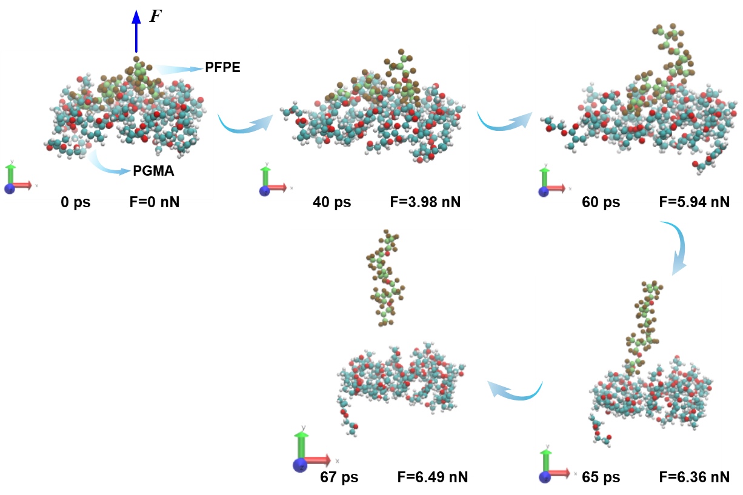
Supplementary Figure 6 | Dynamic process of peeling PFPE from PGMA matrix. The PFPE was gradually separated from the PGMA with the increasing peeling force and completely separated when the peeling force reached 6.49 N.

Supplementary Figure 7 | The variation of van der waals (Vdwl) energy respect to the timestep between -CH₃, C-O-C, O-C=O groups of PGMA matrix and -CF₃ of PFPE, respectively.

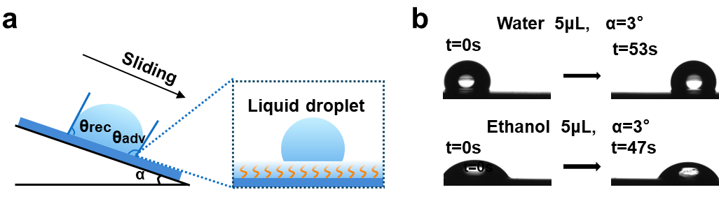
Supplementary Figure 8 | The sliding behavior tests of water and ethanol on the II-PSS. (a) Schematic diagram of sliding test. (b) The time-lapse images of water and ethanol sliding off the II-PSS with a tilting angle of 3°.

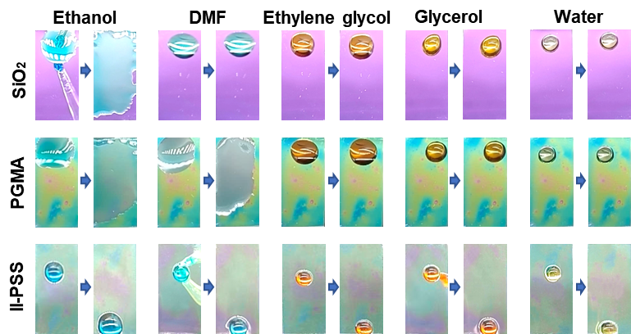
Supplementary Figure 9 | The sliding behavior tests of different surface tension liquids on the blank SiO₂ surface, PGMA and II-PSS. The testing liquids are ethanol (22.3 mN m⁻¹), dimethyl formamide (DMF, 37.1 mN m⁻¹), ethylene glycol (46.7 mN m⁻¹), glycerol (61.9 mN m⁻¹), and water (72.8 mN m⁻¹) (marked with different colors, droplet 10 μL, tilted angle 10°).

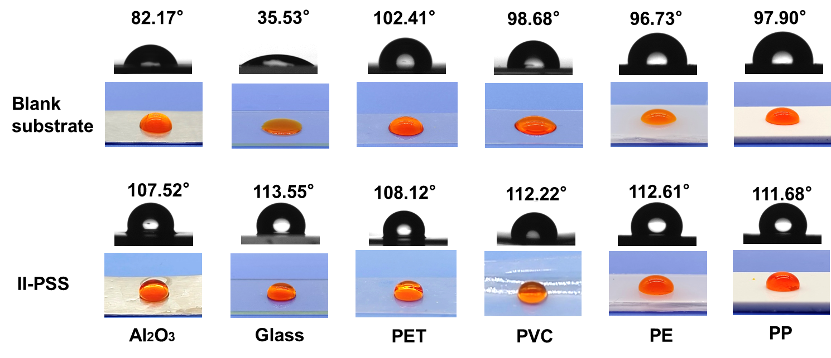
Supplementary Figure 10 | Changes in the water contact angles of the blank substrates and II-PSS coated substrates.

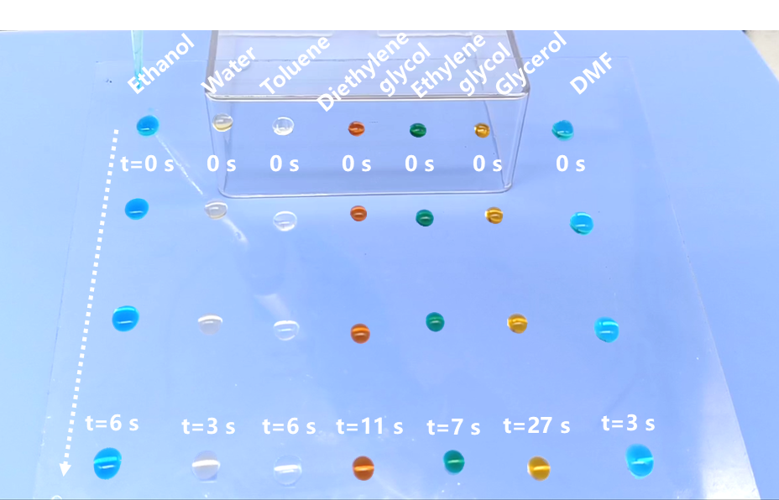
Supplementary Figure 11 | Sliding behavior of the various labeled droplets on the large-scale II-PSS coated glass (15 cm × 13 cm). The sliding times of the liquids are provided in the image (droplet 30 μL, tilt angle 20°).

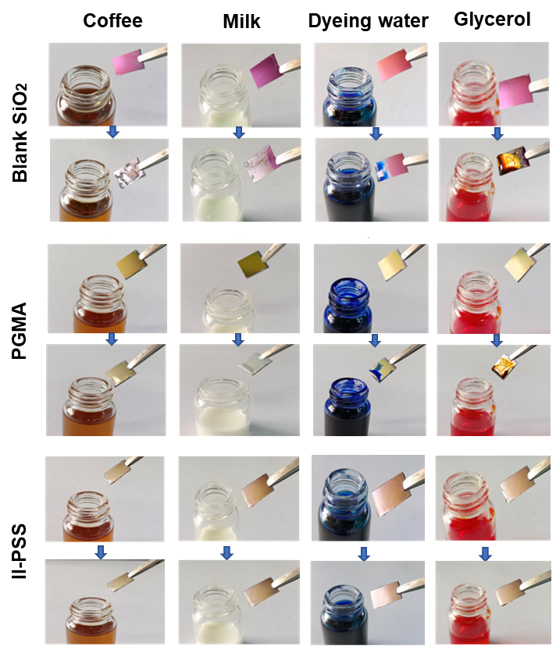
Supplementary Figure 12 | Self-cleaning property of blank SiO₂, PGMA surface and II-PSS. The blank substrate, PGMA matrix and II-PSS were immersed in coffee, milk, dyeing water and glycerol, and the II-PSS remained free of contaminating liquid adhesion after taken out.

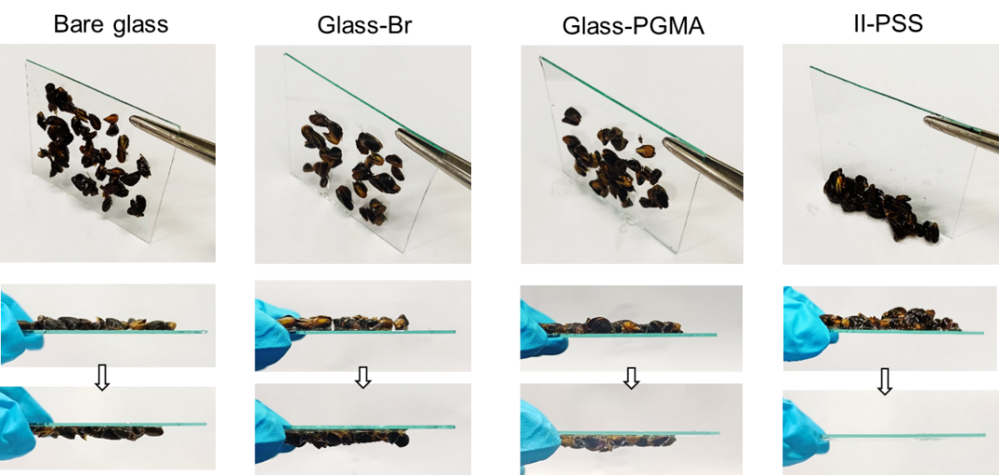
Supplementary Figure 13 | The anti-mussel adhesion test of bare glass, initiator functionalized glass (Glass-Br), PGMA surface and II-PSS.

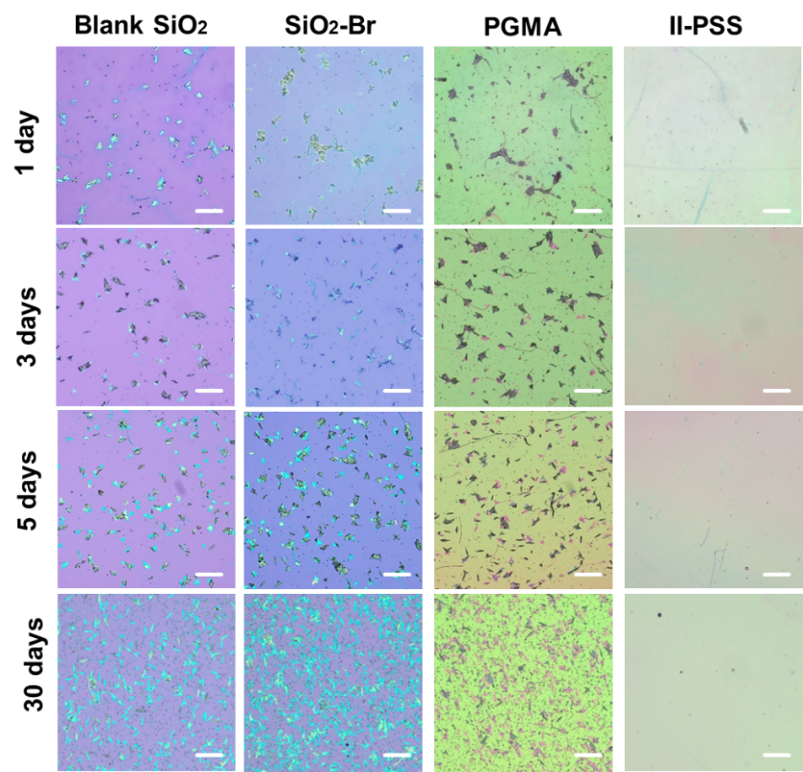
Supplementary Figure 14 | Optical microscopy images of phaeodactylum tricornutum adhesion on blank SiO₂ surface, initiator functionalized substrate (SiO₂-Br), PGMA surface and II-PSS, scale bar: 50 μm.

