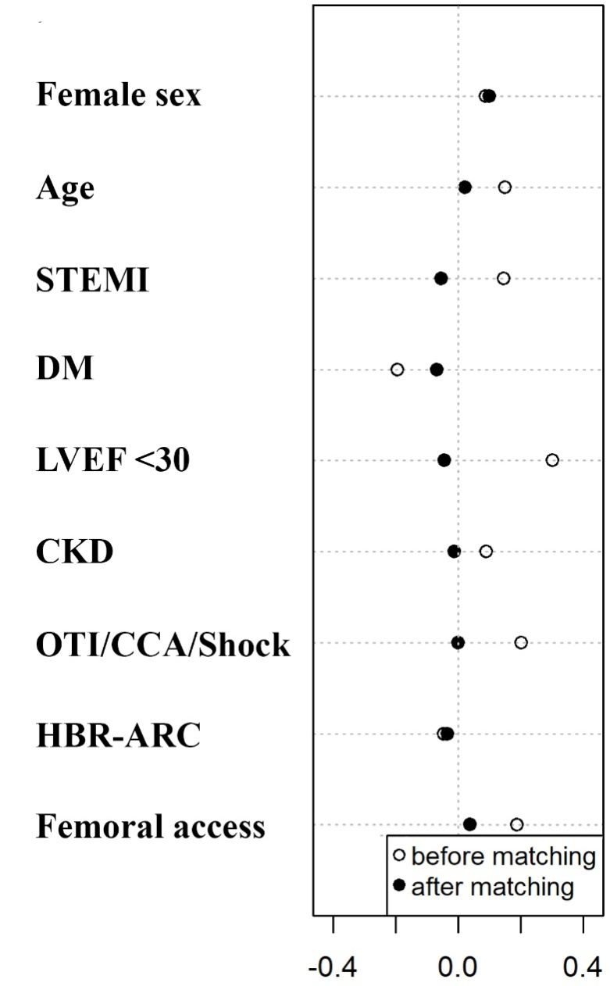
Supplementary Figure 1. Covariate balance plot before and after propensity matching, standardized for comparability.

STEMI, ST-elevation myocardial infarction; DM, diabetes mellitus; LVEF, left ventricle ejection fraction; CKD, chronic kidney disease; OTI, orotracheal intubation; CA, cardiociculatory arrest; HBR-ARC, High Bleeding Risk profile as defined by Academic Research Consortium.

