A Transfer Learning approach to develop natural molecules with specific flavor requirements

Luana P. Queiroz ^{1,2}, Carine M. Rebello³, Erbet A. Costa³, Vinícius V. Santana^{1,2}, Bruno C. L. Rodrigues^{1,2}, Alírio E. Rodrigues^{1,2}, Ana M. Ribeiro^{1,2} and Idelfonso B. R. Nogueira^{4,}*

1 LSRE-LCM - Laboratory of Separation and Reaction Engineering – Laboratory of Catalysis and Materials, Faculty of Engineering, University of Porto, Rua Dr. Roberto Frias, 4200-465 Porto, Portugal;

2 ALiCE - Associate Laboratory in Chemical Engineering, Faculty of Engineering, University of Porto, Rua Dr. Roberto Frias, 4200-465 Porto, Portugal;

3 Departamento de Engenharia Química, Escola Politécnica (Polytechnic Institute), Universidade Federal da Bahia, Salvador 40210-630, Brazil;

4 Chemical Engineering Department, Norwegian University of Science and Technology, Sem Sælandsvei 4, Kjemiblokk 5, Trondheim, Norway;

* To whom correspondence should be addressed: idelfonso.b.d.r.nogueira@ntnu.no

Supporting information

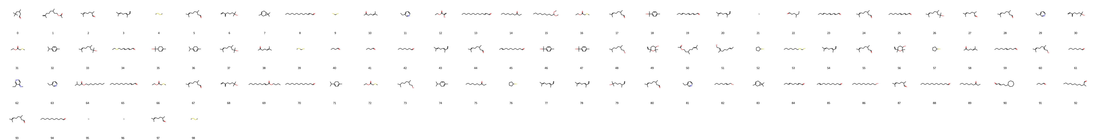
Figure S1 Citrus' new designed molecules from deep transfer learning part 1.
Figure S2 Citrus' new designed molecules from deep transfer learning part 2.
Figure S3 Citrus' new designed molecules from deep transfer learning part 3.
Figure S4 Citrus' new designed molecules from deep transfer learning part 4.
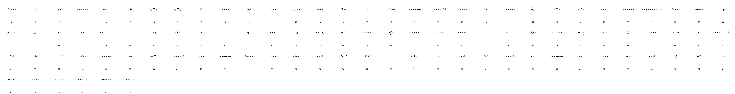
Figure S5 Fatty's new designed molecules from deep transfer learning part 1.
Figure S6 Fatty's new designed molecules from deep transfer learning part 2.
Figure S7 Fatty's new designed molecules from deep transfer learning part 3.
Figure S8 Fatty's new designed molecules from deep transfer learning part 4.
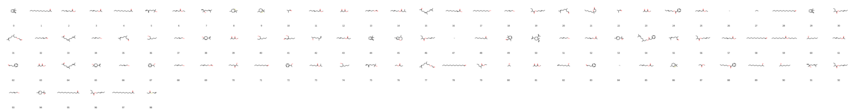
Figure S9 Fresh's new designed molecules from deep transfer learning part 1.
Figure S10 Fresh's new designed molecules from deep transfer learning part 2.
Figure S11 Fresh's new designed molecules from deep transfer learning part 3.
Figure S12 Fresh's new designed molecules from deep transfer learning part 4.
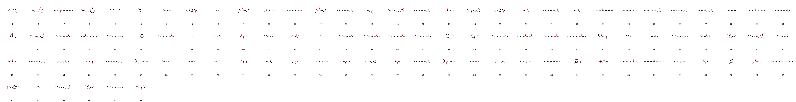
Figure S13 Fruity's new designed molecules from deep transfer learning part 1.
Figure S14 Fruity's new designed molecules from deep transfer learning part 2.
Figure S15 Fruity's new designed molecules from deep transfer learning part 3.
Figure S16 Fruity's new designed molecules from deep transfer learning part 4.
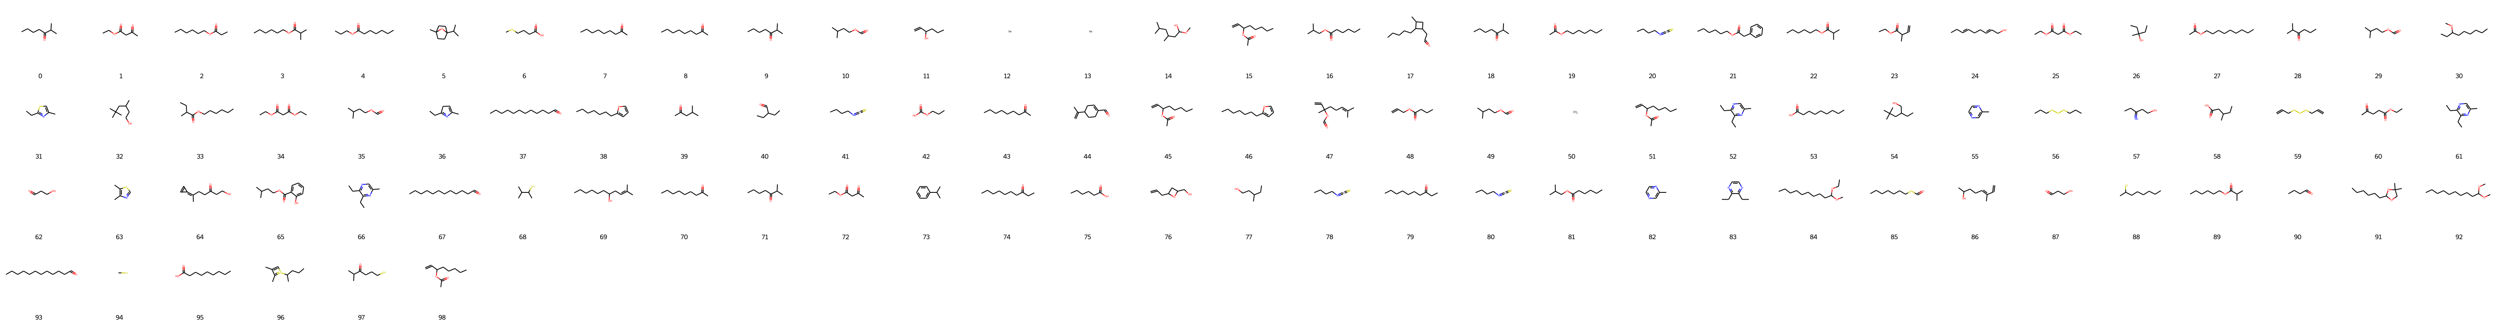
Figure S17 Green's new designed molecules from deep transfer learning part 1.
Figure S18 Green's new designed molecules from deep transfer learning part 2.
Figure S19 Green's new designed molecules from deep transfer learning part 3.
Figure S20 Green's new designed molecules from deep transfer learning part 4.
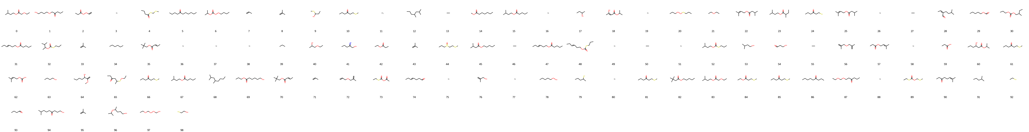
Figure S21 Ripe's new designed molecules from deep transfer learning part 1.
Figure S22 Ripe's new designed molecules from deep transfer learning part 2.
Figure S23 Ripe's new designed molecules from deep transfer learning part 3.
Figure S24 Ripe's new designed molecules from deep transfer learning part 4.
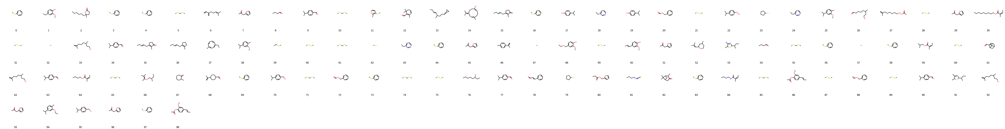
Figure S25 Spicy's new designed molecules from deep transfer learning part 1.
Figure S26 Spicy's new designed molecules from deep transfer learning part 2.
Figure S27 Spicy's new designed molecules from deep transfer learning part 3.
Figure S28 Spicy's new designed molecules from deep transfer learning part 4.
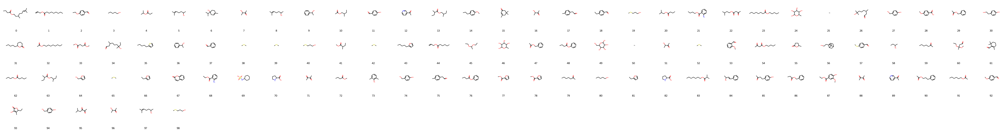
Figure S29 Sweet's new designed molecules from deep transfer learning part 1.
Figure S30 Sweet's new designed molecules from deep transfer learning part 2.
Figure S31 Sweet's new designed molecules from deep transfer learning part 3.
Figure S32 Sweet's new designed molecules from deep transfer learning part 4.
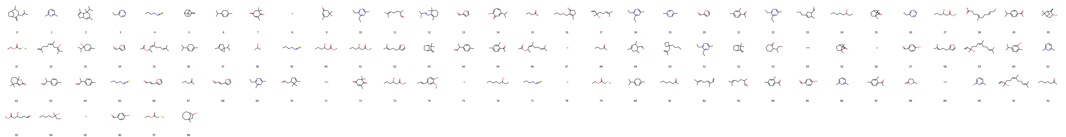
Figure S33 Woody's new designed molecules from deep transfer learning part 1.
Figure S34 Woody's new designed molecules from deep transfer learning part 2.
Figure S35 Woody's new designed molecules from deep transfer learning part 3.
Figure S36 Woody's new designed molecules from deep transfer learning part 4.

