Supplementary data

Questionnaire | Test | Global  QLQ | Physical | Role | Cognitive | Emotional | Social | Symptoms | Fatigue | Nausea | Pain | Dyspnea | Insomnia | Appetite Loss | Constipation | Diarrhea | Financial issues
First post-treatment evaluation | ANOVA | p-value = 0.0023  statistics value = 4.3862  df = 2  **
First post-treatment evaluation | Post hoc tests | p-value= 0.01198  effect size = 0.320s  * | p-value= 0.2731  effect size = 0.139 | p-value= 0.008633  effect size = 0.332  ** | p-value= 0.002765  effect size = 0.381  ** | p-value= 0.0136  effect size = 0.314  * | p-value= 0.3099  effect size = 0.130 | p-value= 0.006804  effect size = 0.342  ** | p-value= 0.1263  effect size = 0.194 | p-value= 0.3584  effect size = 0.117 | p-value= 0.0534  effect size = 0.244  (.) | p-value= 0.03973  effect size =  0.260  * | p-value= 0.8851  effect size = 0.0191 | p-value= 0.1946  effect size = 0.165 | p-value= 0.2218  effect size = 0.156 | p-value= 0.6014  effect size = 0.0676 | p-value= 0.3597  effect size = 0.118
Final post-treatment evaluation | ANOVA | p-value = 0.0012  statistics value = 6.4769  df = 2  **
Final post-treatment evaluation | Post hoc tests | p-value= 0.01414  effect size = 0.330  * | p-value= 0.02294  effect size = 0.289  * | p-value= 0.006906  effect size = 0.344  ** | p-value= 0.04366  effect size = 0.277  * | p-value= 0.0259  effect size = 0.266  * | p-value= 0.3801  effect size = 0.110 | p-value= 0.01212  effect size = 0.309  * | p-value= 0.0257  effect size = 0.266  * | p-value= 0.009145  effect size = 0.335  ** | p-value= 0.2942  effect size = 0.158 | p-value= 0.009792  effect size = 0.305  ** | p-value= 0.1209  effect size =0.155 | p-value= 0.9926  effect size = 0.0381 | p-value= 0.2829  effect size = 0.139 | p-value= 0.7873  effect size = 0.00128 | p-value= 0.1587  effect size = 0.183
Supplementary Table 1: Statistical tests performed after baseline correction to compare the hippotherapy and control groups in order to assess the difference in score evolution for all the QLQ-C30 items, at first post-treatment evaluation and final post-treatment evaluation. First a robust between-within participants ANOVA was performed to evaluate if the two therapies were following a different behavior with respect to the QoL items, for each questionnaire (Q2 and Q3). If significant, post hoc tests (two-sided Wilcoxon) were performed for each item to determine statistical differences between the two groups.

Questionnaire | Test | Body image | Sexual Functioning | Sexual Enjoyment | Future Perspectives | Side effects | Breast Symptoms | Arm Symptoms
First post-treatment evaluation | ANOVA | p-value = 0.0184  statistics value = 4.1610  df = 2  *
First post-treatment evaluation | Post hoc tests | p-value= 0.3642  effect size = 0.114 | p-value= 0.2385  effect size = 0.148 | p-value= 0.9708  effect size = 0.0136 | p-value= 0.05385  effect size = 0.242  (.) | p-value= 0.8489  effect size = 0.0247 | p-value= 0.07437  effect size = 0.226  (.) | p-value= 0.753  effect size = 0.0405
Final post-treatment evaluation | ANOVA | p-value = 0.023  statistics value =3.2578  df = 2  *
Final post-treatment evaluation | Post hoc tests | p-value= 0.01201 effect size = 0.323  * | p-value= 0.8962  effect size = 0.0512 | p-value= 0.7359  effect size = 0.0693 | p-value= 0.06796  effect size = 0.218  (.) | p-value= 0.7963  effect size = 0.0262 | p-value= 0.6398  effect size = 0.608 | p-value= 0.4898  effect size = 0.104
Supplementary Table 2: Statistical tests performed after baseline correction to compare the hippotherapy and control groups in order to assess the difference in score evolution for all the QLQ-BR23 items, at first post-treatment evaluation and final post-treatment evaluation. First a robust between-within participants ANOVA was performed to evaluate if the two therapies were following a different behavior with respect to the QoL items, for each questionnaire (Q2 and Q3). If significant, post hoc tests (two-sided Wilcoxon) were performed for each item to determine statistical differences between the two groups.

 | Questionnaire | Perceived cognitive abilities | Perceived cognitive impairments | Impact on quality of life | Comments from others
First post-treatment evaluation | ANOVA | p-value = 0.0019  statistics value = 12.219  df = 2
First post-treatment evaluation | Post hoc tests | p-value = 0.07068  effect size = 0.196  (.) | p-value = 0.00145  effect size = 0.396  ** | p-value = 0.02203  effect size = 0.268  * | p-value = 0.02248  effect size = 0.2  *
Final post-treatment evaluation | ANOVA | p-value = 0.0150  statistics value = 6.6277  df = 2
Final post-treatment evaluation | Post hoc tests | p-value = 0.06037  effect size = 0.198  (.) | p-value = 0.01185  effect size = 0.328  ** | p-value = 0.04445  effect size = 0.233  * | p-value = 0.1307  effect size = 0.153
Supplementary Table 3: Statistical tests performed after baseline correction to compare the hippotherapy and control groups in order to assess the difference in score evolution for all the FACT-Cog items, at first post-treatment evaluation and final post-treatment evaluation. A robust between-within participants ANOVA was performed to evaluate whether the two therapies followed a different behavior with respect to the FACT-Cog items, for each questionnaire (Q2 and Q3). If significant, post hoc tests (two-sided Wilcoxon) were performed for each item to determine statistical differences between the two groups.

Questionnaire | Test | General Fatigue | Physical fatigue | Mental fatigue | Activity reduction | Motivation
First post-treatment evaluation | ANOVA | p-value = 0.0124  statistics value = 6.8586  df = 2  *
First post-treatment evaluation | Post hoc tests | p-value = 0.01711  effect size = 0.301  * | p-value = 0.2017  effect size =0.162 | p-value = 0.007088  effect size = 0.340  ** | p-value = 0.9557  effect size = 0.00788 | p-value = 0.07136  effect size = 0.228  (.)
Final post-treatment evaluation | ANOVA | p-value = 0.0164  statistics value = 6.2769  df = 2  *
Final post-treatment evaluation | Post hoc tests | p-value = 0.004449  effect size = 0.334  ** | p-value = 0.0246  effect size = 0.289  * | p-value = 0.03953  effect size = 0.235  * | p-value = 0.3907  effect size = 0.109 | p-value = 0.01256  effect size = 0.296  *
Supplementary Table 4: Statistical tests performed after baseline correction to compare the hippotherapy and control groups in order to assess the difference in score evolution for all the MFI-20 items, at first post-treatment evaluation and final post-treatment evaluation. A robust between-within participants ANOVA was performed to evaluate whether the two therapies followed a different behavior with respect to the MFI-20 items, for each questionnaire (Q2 and Q3). If significant, post hoc tests (two-sided Wilcoxon) were performed for each item to determine statistical differences between the two groups.

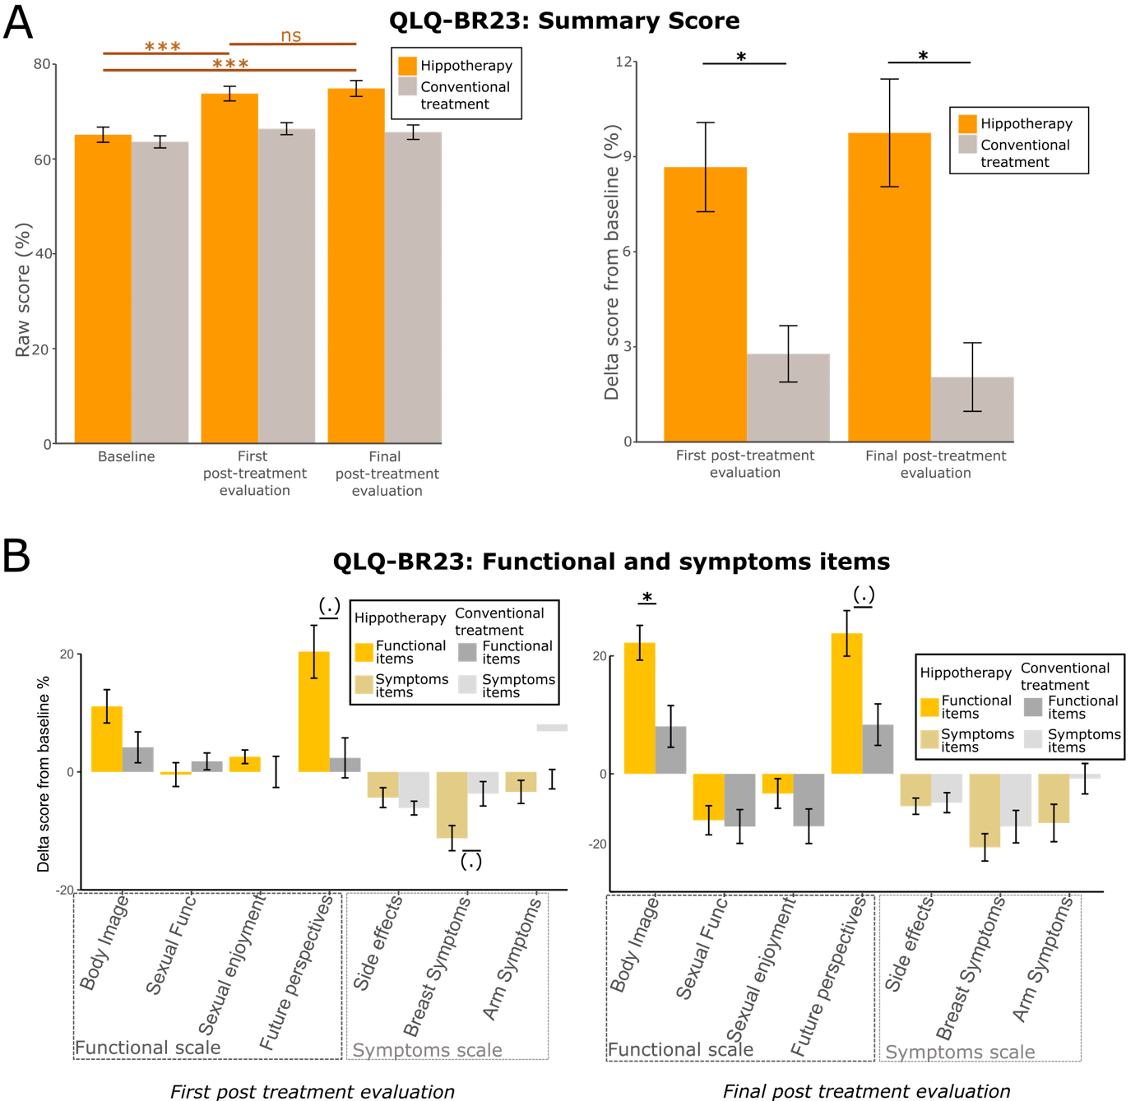
Extended Data Fig. 1: Effects of hippotherapy treatment compared to conventional treatment on QoL estimated by the EORTC-QLQ-BR23 questionnaire. A) Left: Bar chart represents means (M) and standard errors of means (SEM) of the evolution of QLQ-BR23 scores across time as a function of treatment’s type. Values (M±SD) are as follows: Baseline =65.1±12.8, First post-treatment evaluation = 73.8±12.4, Final post-treatment evaluation = 74.9±13.3 for the hippotherapy group; Baseline = 63.6±10.2, First post-treatment evaluation = 66.4±10.2, Final post-treatment evaluation = 65.7±12.2 for the control group. Right: Change of score compared to baseline QLQ-BR23 score (M±SEM), as a function of time and treatment. Values (M±SD) are as follows: First post-treatment evaluation = 8.67±11.2, Final post-treatment evaluation = 9.99±13.7 for the hippotherapy group; First post-treatment evaluation = 2.78±7.11, Final post-treatment evaluation = 2.26±8.74 for the control group. B) Comparison of scores changes for the QLQ-BR23 subsets between the two groups. Top: first post-treatment evaluation; Bottom: final post-treatment evaluation.

