Contents
Appendix Part 1 (results): Benefits, harms and cost-effectiveness of cervical screening and treatment in 78 low-income and lower-middle income countries for women in the general population: modelling to support updated WHO cervical screening and treatment guidelines to prevent cervical cancer 2
Results - Benefits 2
Results - Benefits and harms 9
Results - Resource utilisation and costs: 12
Results - Cost-effectiveness analysis 15
Appendix Part 2 (Technical information): combined technical information for manuscripts Benefits, harms and cost-effectiveness of cervical screening and treatment in 78 low-income and lower-middle income countries for women in the general population: modelling to support updated WHO cervical screening and treatment guidelines to prevent cervical cancer and Evaluation of the benefits and harms of alternative strategies for cervical screening and treatment in women living with HIV: modelling to support WHO 2021 cervical screening and treatment guidelines to prevent cervical cancer 23
Background 23
Technical information - Methods 26
Policy1-Cervix platform 26
Policy1-Cervix-HIV platform 28
Screening strategies 30
Screening test characteristics 32
Populations assessed 39
Screening algorithms (flow charts) 40
Discount rates 51
World Standard Population 51
Health economic conventions 51
Costs 51
Model of obstetric complications 52
Calculating normative costs, HALYs and cost-effectiveness across 78 LMICs 52
Country list 55
HPV-FRAME reporting standard checklist for the general population of women 59

Appendix Part 1 (results): Benefits, harms and cost-effectiveness of cervical screening and treatment in 78 low-income and lower-middle income countries for women in the general population: modelling to support updated WHO cervical screening and treatment guidelines to prevent cervical cancer

Appendix Part 1 contains results for the supplementary analysis, in which we considered different management options for two groups of women: women who test primary HPV-positive and triage-negative, and management for women who are treated for precancer (without histologically-confirmed CIN3 detected). The detailed scenarios considered are described in the methods section of the main paper.
This section also describes additional sensitivity analyses including: lower performance for VIA triage test performance, assumptions around cancer treatment access rates and lower screening adherence assuming 50% for routine attendance (with 30% of women never attending) and 75% for adherence with treatment or follow-up visits (100% for same-day eligibility) was explored for all scenarios. A range of health economic parameters were explored for one-way sensitivity analysis, including discounting 3% for both costs and effects, and considering life-years instead of HALYs.

Results - Benefits

Supplementary analysis
When assuming women who are primary HPV test positive and triage negative are followed-up in 24m instead of 12m but that loss-to-follow-up remained at 10%, there was less than 1% difference in ASR incidence, but a 5-22% decrease in pre-cancer treatments and 5-23% reduction in NNT versus the base-case (ranges represent variations across different screening frequencies and triage strategies). However, if we assume a 30% loss-to-follow-up at the 24m visit, there was a 1-9% increase in ASR incidence versus base-case, with the greatest increase observed when VIA was used as the triage test. Conversely, when assuming women required a HPV test at 12 and 24m before discharge from follow-up, there was a 1-4% decrease in ASR incidence, and a 2-6% increase in pre-cancer treatments and 2-3% increase in NNT versus the base-case assumption of one visit at 12m only (Appendix Figure 1). When considering a single visit at 24m (with 30% loss-to-follow-up) instead of 12m for this group, there was a 1-2% increase in ASR incidence, a 1-2% decrease in pre-cancer treatments and 0-3% reduction in NNT versus base-case. When considering a single visit at 12m with co-testing instead of HPV testing alone, a 1-2% decrease in ASR incidence, a 1-9% increase in pre-cancer treatments and a 2-5% increase in NNT (Appendix Figure 2).

Appendix Figure 1: Predicted cervical cancer (a) incidence and (b) mortality ASR % reductions under under different management of HPV positive women who have a negative triage, namely follow-up after 2 years assuming 10% (closed black diamonds) or 30% loss to this followup (open black diamonds); follow-ups after both 1 and 2 years (black crosses); and base-case, i.e. follow-up after 1 year (blue bars and circles).
(a) Cervical cancer incidence ASR % reductions under different post-negative triage management assumptions for HPV positive women
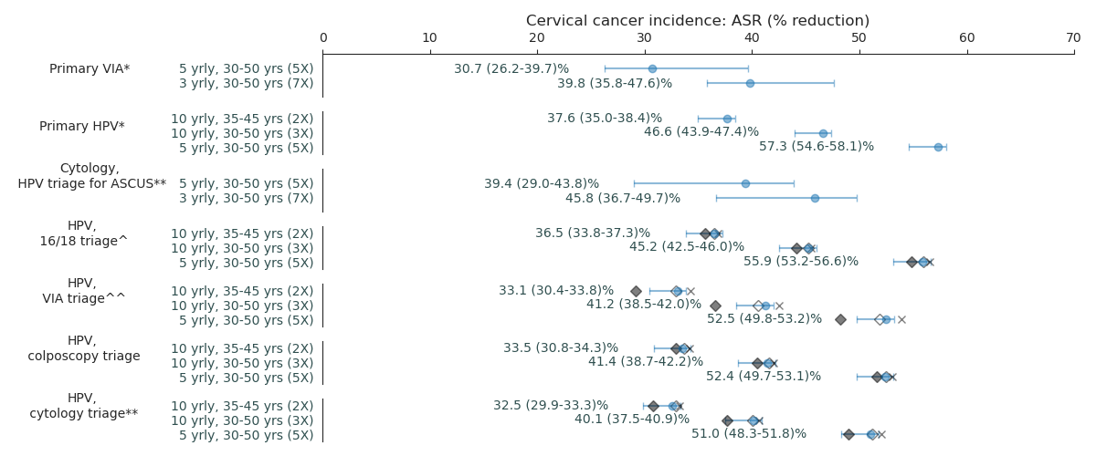

(b) Cervical cancer mortality ASR % reductions under different post-negative triage management assumptions for HPV positive women
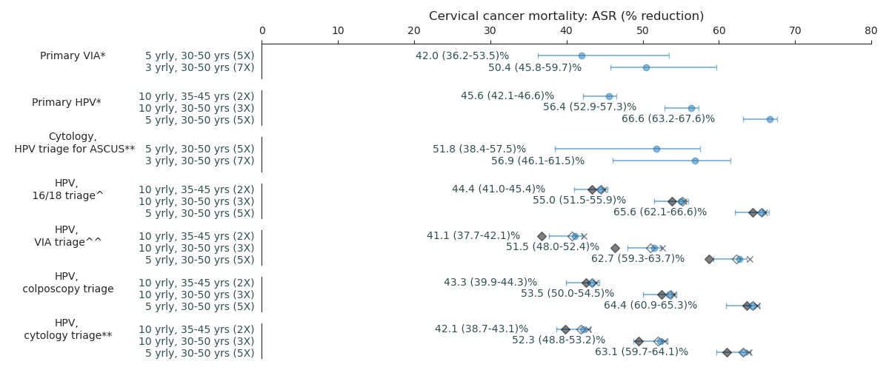

* All positive women treated after assessment of eligibility for ablative treatment ** triage positive referred to colposcopy ^^ VIA triage positive women treated after assessment of eligibility for ablative treatment. ^HPV16/18 positive women treated after assessment of eligibility for ablative treatment; Women positive for HPV types other than HPV 16/18 (‘OHR’) are triaged with VIA.
Appendix Figure 2: Predicted cervical cancer (a) incidence and (b) mortality ASR % reductions under under different management after pre-cancer treatment for women not known to have CIN3+, namely follow-up after 2 years assuming 30% loss-to-followup (open black diamonds), follow-up using cotesting after 1 year (black crosses).
(a) Cervical cancer incidence ASR % reductions under different management assumptions for women who received a pre-cancer treatment and are not known to have CIN3+.
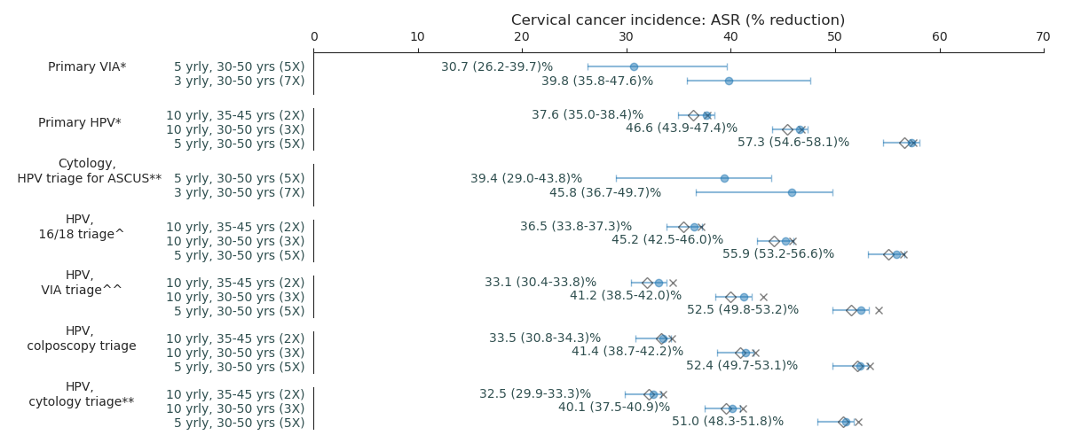

(b) Cervical cancer mortality ASR % reductions under different management assumptions for women who received a pre-cancer treatment and are not known to have CIN3+.
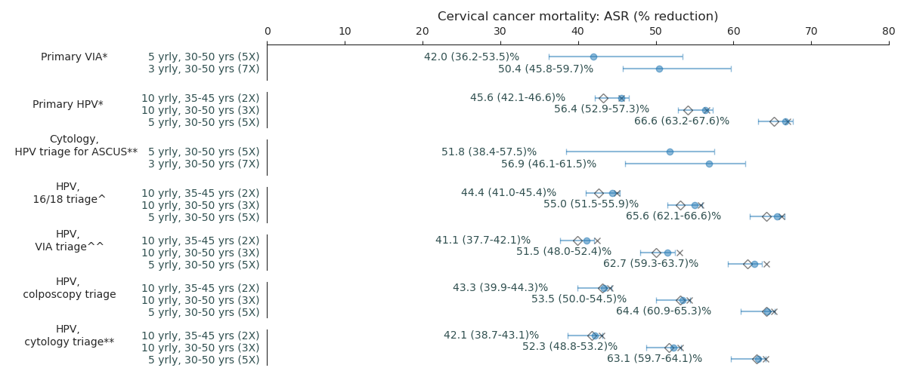
* All positive women treated after assessment of eligibility for ablative treatment ** triage positive referred to colposcopy ^^ VIA triage positive women treated after assessment of eligibility for ablative treatment. ^HPV16/18 positive women treated after assessment of eligibility for ablative treatment; Women positive for HPV types other than HPV 16/18 (‘OHR’) are triaged with VIA.

The impact of uncertainties in primary and triage test performance is shown in Appendix Figure 1. Predicted reductions in cervical cancer incidence and mortality rates vary substantially for VIA and cytology tests due to the wide range of performance reported for these testing technologies. Primary HPV testing every 5 years (regardless of triaging strategy) still resulted in larger reductions in cervical cancer incidence and mortality than Primary VIA every 3 years when simultaneously making favourable assumptions for VIA test performance and unfavourable assumptions for primary HPV.

Appendix Figure 3: Predicted cervical cancer (a) incidence and (b) mortality ASR % reductions under ranges for primary test performance (end bars) and upper VIA triage test performance (black x’s)
(a) Cervical cancer incidence ASR % reductions under ranges for test performance

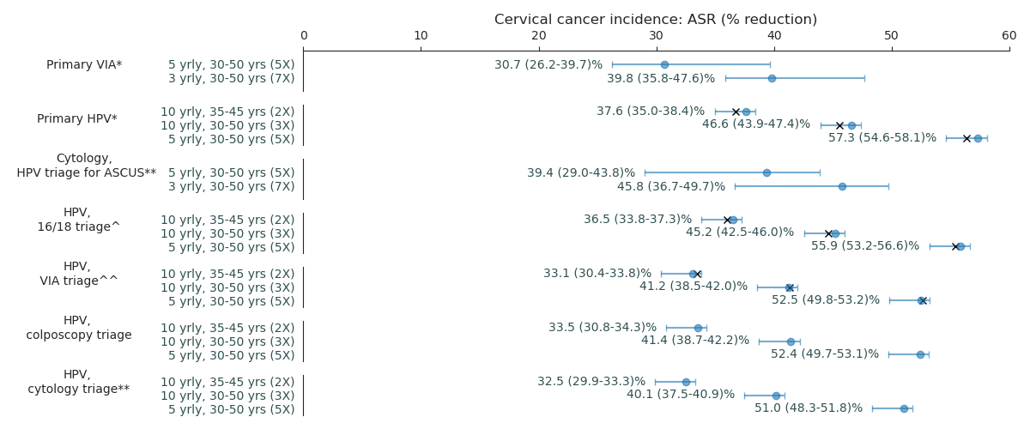
(b) Cervical cancer mortality ASR % reductions under ranges for test performance
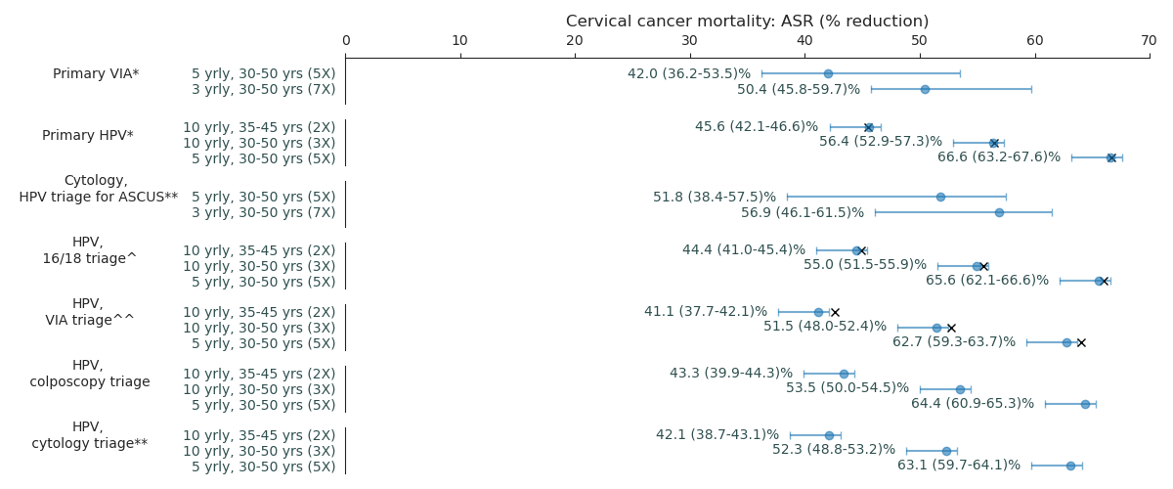
* All positive women treated after assessment of eligibility for ablative treatment ** triage positive referred to colposcopy ^^ VIA triage positive women treated after assessment of eligibility for ablative treatment. ^HPV16/18 positive women treated after assessment of eligibility for ablative treatment; Women positive for HPV types other than HPV 16/18 (‘OHR’) are triaged with VIA.

The impact of lower screening adherence is shown in Appendix Figure 4. Absolute reductions in cervical cancer incidence and mortality are lowered by at least 18% across all strategies. However, primary HPV testing approaches remain the most effective across all technologies.
Appendix Figure 4: Cervical cancer incidence and mortality ASR % reductions under lower adherence. Ranges represent uncertainty in primary test performance.
(a) Cervical cancer incidence ASR % reductions under ranges under lower adherence
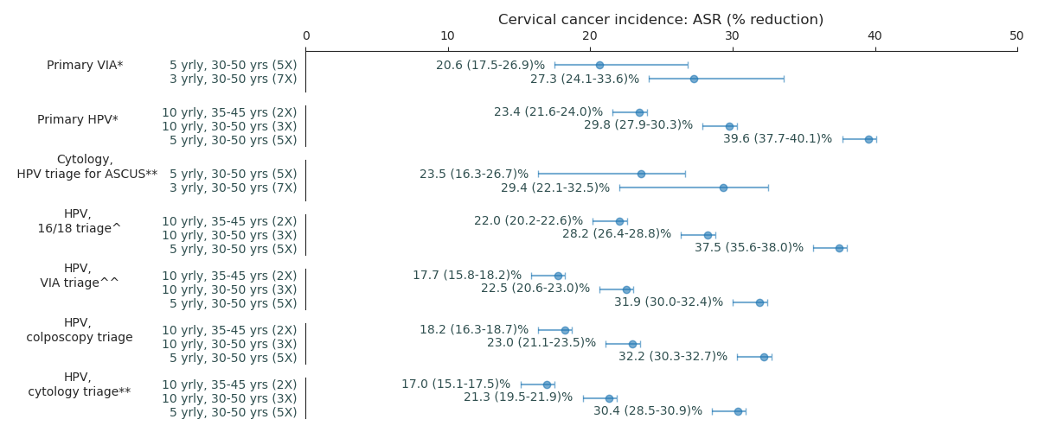

(b) Cervical cancer mortality ASR % reductions under ranges under lower adherence
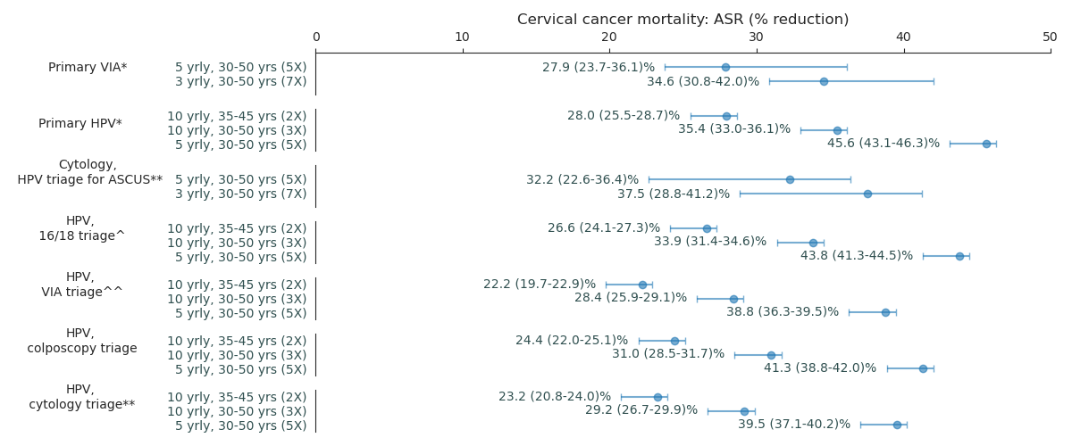
* All positive women treated after assessment of eligibility for ablative treatment ** triage positive referred to colposcopy ^^ VIA triage positive women treated after assessment of eligibility for ablative treatment. ^HPV16/18 positive women treated after assessment of eligibility for ablative treatment; Women positive for HPV types other than HPV 16/18 (‘OHR’) are triaged with VIA.
The impact of assuming screen-detected cancers don’t receive 90% cancer treatment access is shown in Appendix Figures 5. The impact of assuming symptomatically detected cancers receive 90% access to treatment (in addition to the screen-detected cancers) is shown in Appendix Figures 6.

Appendix Figure 5: Cervical cancer mortality ASR % reductions if women screen-detected for cancer don’t receive 90% cancer treatment access. Ranges represent uncertainty in primary test performance.
Cervical cancer ASR mortality % reduction for no additional treatment for screen-detected cases
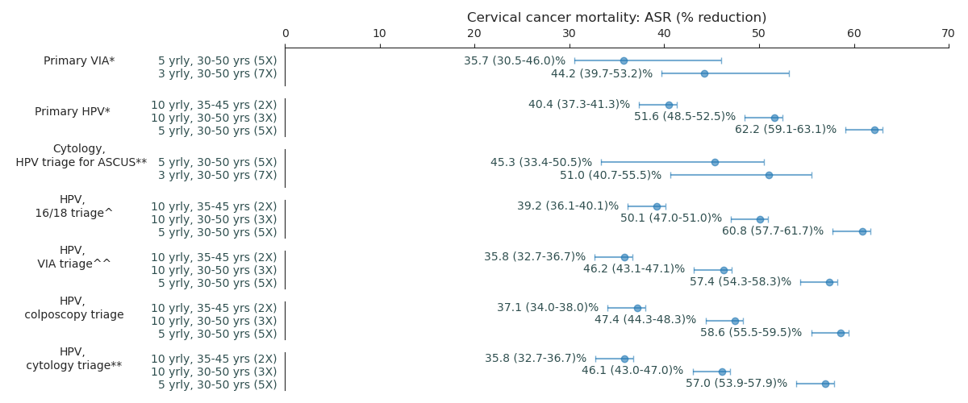

Appendix Figure 6: Cervical cancer mortality ASR % reductions if symptomatically detected women for cancer also receive 90% access to treatment. Ranges represent uncertainty in primary test performance.
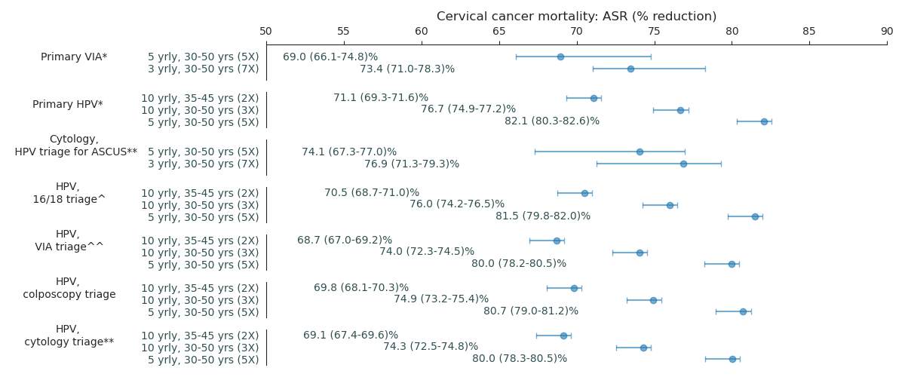

Results - Benefits and harms

Appendix Figure 7: Cervical cancer mortality ASR % reduction versus (a) lifetime number of precancer treatment events and (b) lifetime number of additional preterm delivery events due to precancer treatments for each strategy.
(a) Cervical cancer mortality ASR % reduction versus lifetime number of precancer treatment events
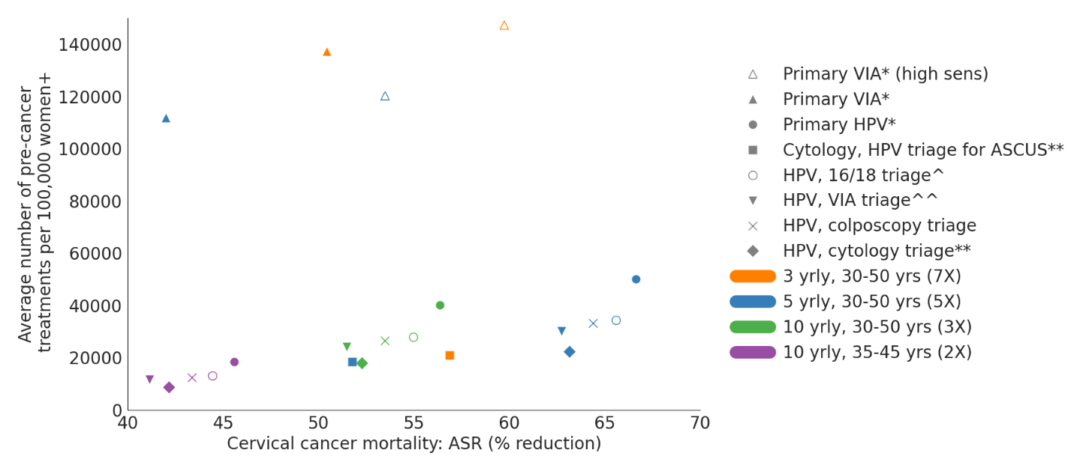

(b) Cervical cancer ASR % reduction versus lifetime number of additional preterm delivery events due to precancer treatments for each strategy
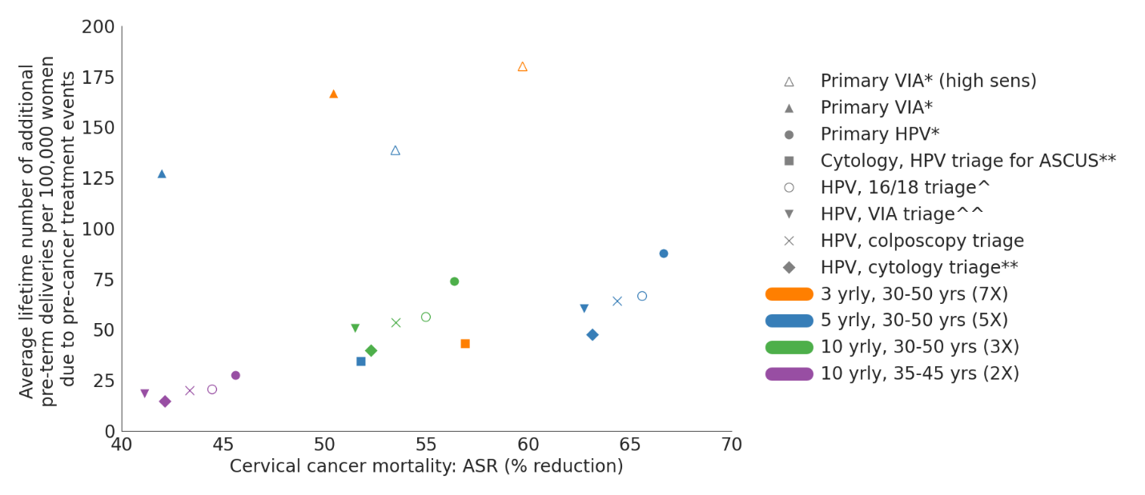

* All positive women treated after assessment of eligibility for ablative treatment ** triage positive referred to colposcopy ^^ VIA triage positive women treated after assessment of eligibility for ablative treatment. ^HPV16/18 positive women treated after assessment of eligibility for ablative treatment; Women positive for HPV types other than HPV 16/18 (‘OHR’) are triaged with VIA.

Appendix Figure 8: Lifetime number of precancer treatment events for each strategy, including different management of HPV positive women who have a negative triage, versus (a) Cervical cancer incidence ASR % reduction and (b) Cervical cancer mortality ASR % reduction.
(a) Cervical cancer incidence ASR % reduction versus lifetime number of precancer treatment events
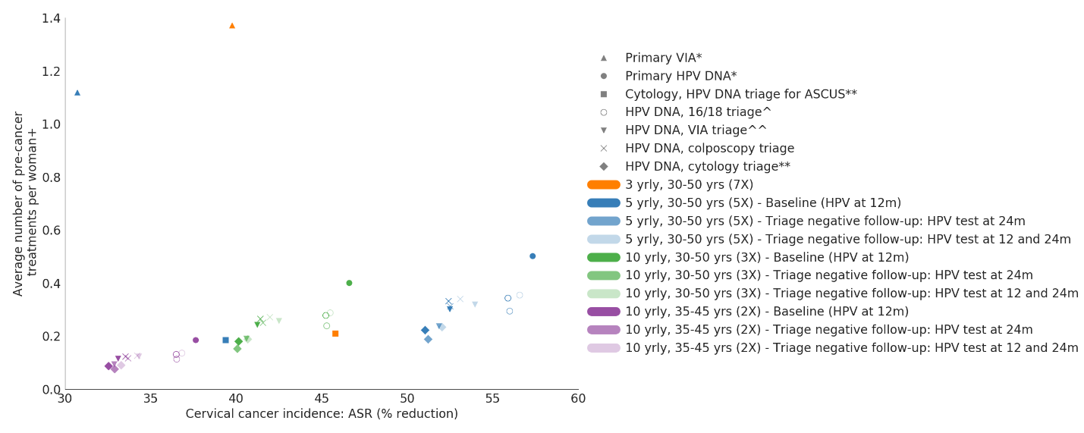
(b) Cervical cancer mortality ASR % reduction versus lifetime number of precancer treatment events
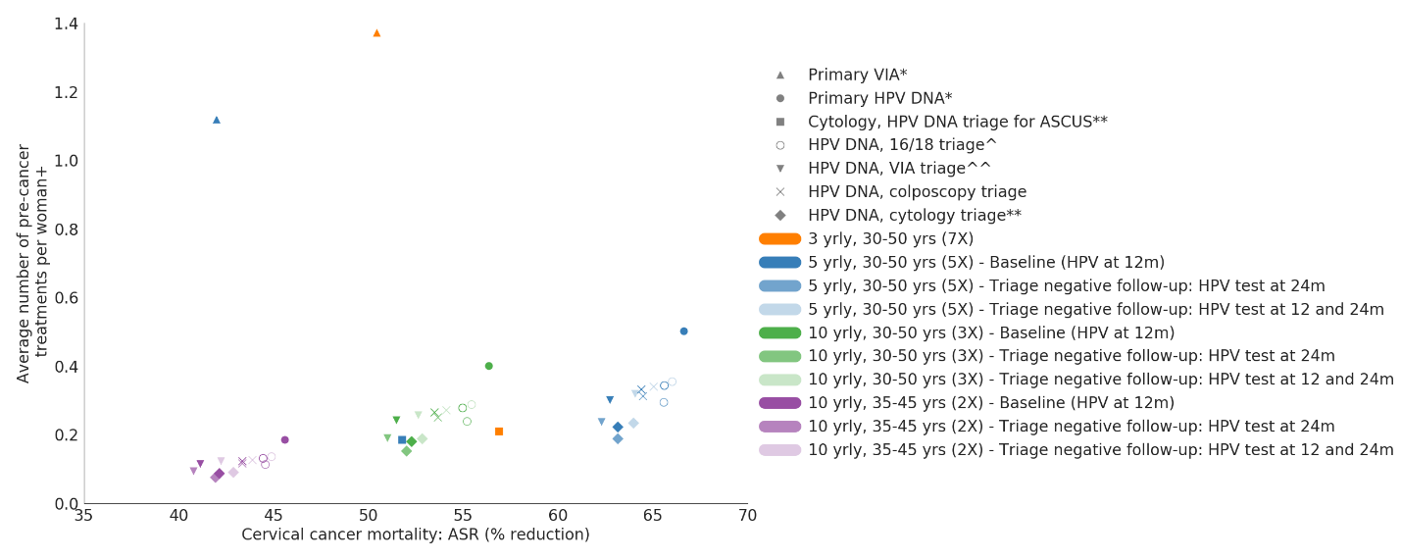
* All positive women treated after assessment of eligibility for ablative treatment ** triage positive referred to colposcopy ^^ VIA triage positive women treated after assessment of eligibility for ablative treatment. ^HPV16/18 positive women treated after assessment of eligibility for ablative treatment; Women positive for HPV types other than HPV 16/18 (‘OHR’) are triaged with VIA.

Appendix Figure 9: Lifetime number of precancer treatment events for each strategy, including variations in management of women who received pre-cancer treatment and are not known to have CIN3+, versus (a) Cervical cancer mortality ASR % reduction and (b) Cervical cancer mortality ASR % reduction.
(a) Cervical cancer incidence ASR % reduction versus lifetime number of precancer treatment events
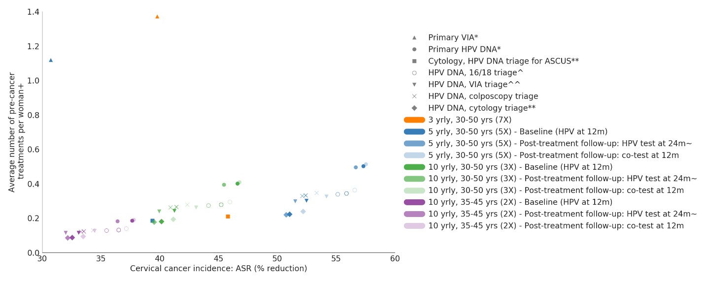
(b) Cervical cancer mortality ASR % reduction versus lifetime number of precancer treatment events
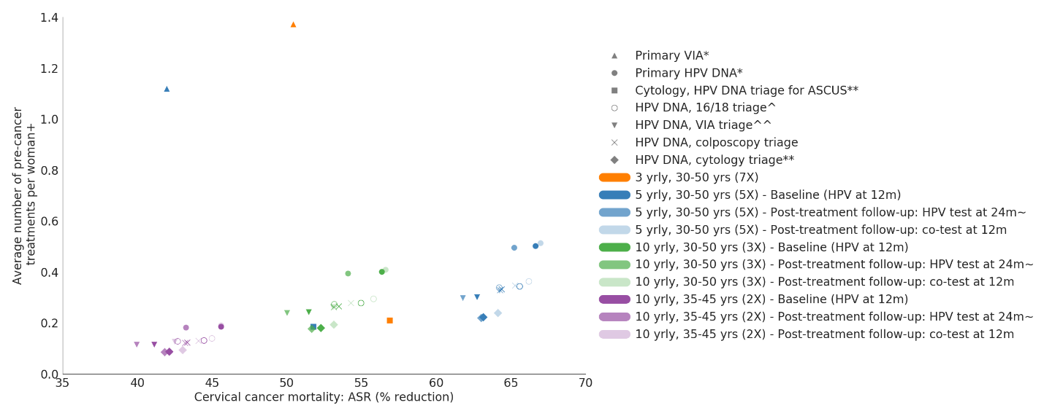
* All positive women treated after assessment of eligibility for ablative treatment ** triage positive referred to colposcopy ^^ VIA triage positive women treated after assessment of eligibility for ablative treatment. ^HPV16/18 positive women treated after assessment of eligibility for ablative treatment; Women positive for HPV types other than HPV 16/18 (‘OHR’) are triaged with VIA.

Results - Resource utilisation and costs:
At the average level across the cohort, women are expected to receive 4.2-5.9 VIA screening events over their lifetime under primary VIA screening strategies (blue); 3.7-5.1 cytology tests under primary cytology strategies and 1.5-3.8 HPV tests under primary HPV screening strategies (Appendix Figure 10). At the average level across the lifetime of the cohort, women are expected to experience 1.1-1.5 precancer treatment events (ablation or excision) in their lifetime under primary VIA scenarios. Primary HPV or Primary cytology scenarios are predicted to result in 0.1-0.5 precancer treatment events over the lifetime of the cohort (varies by screening frequency and triage options). Women are expected to experience 0.16-0.23 colposcopy and 0.06-0.08 biopsy events if primary VIA strategies are implemented, 0.28-0.32 colposcopy and 0.21-0.23 biopsy events if primary cytology strategies are implemented, 0.13-0.33 colposcopy and 0.10-0.25 biopsy events when primary HPV with cytology triage strategies are implemented, and 0.21-0.56 colposcopy and 0.13-0.36 biopsy events when primary HPV with colposcopy triage strategies are implemented.

Discounted costs
Discounted costs over the lifetime of cohorts (* All positive women treated after assessment of eligibility for ablative treatment ** triage positive referred to colposcopy ^^ VIA triage positive women treated after assessment of eligibility for ablative treatment. ^HPV16/18 positive women treated after assessment of eligibility for ablative treatment; Women positive for HPV types other than HPV 16/18 (‘OHR’) are triaged with VIA.
Appendix Figure 11) ranges from $3 for no screening, $40-$55 for primary VIA screening, $60-$82 for primary cytology-based screening and $21-$61 for primary HPV screening. For Primary VIA screening scenarios, 43-49% of the total costs arise from the primary VIA test test and 37-40% arise from precancer treatments. For Primary HPV and Primary cytology screening strategies, over 50% of the cost components come from the primary test.
Appendix Figure 10: Resource utilisation breakdowns for each strategy
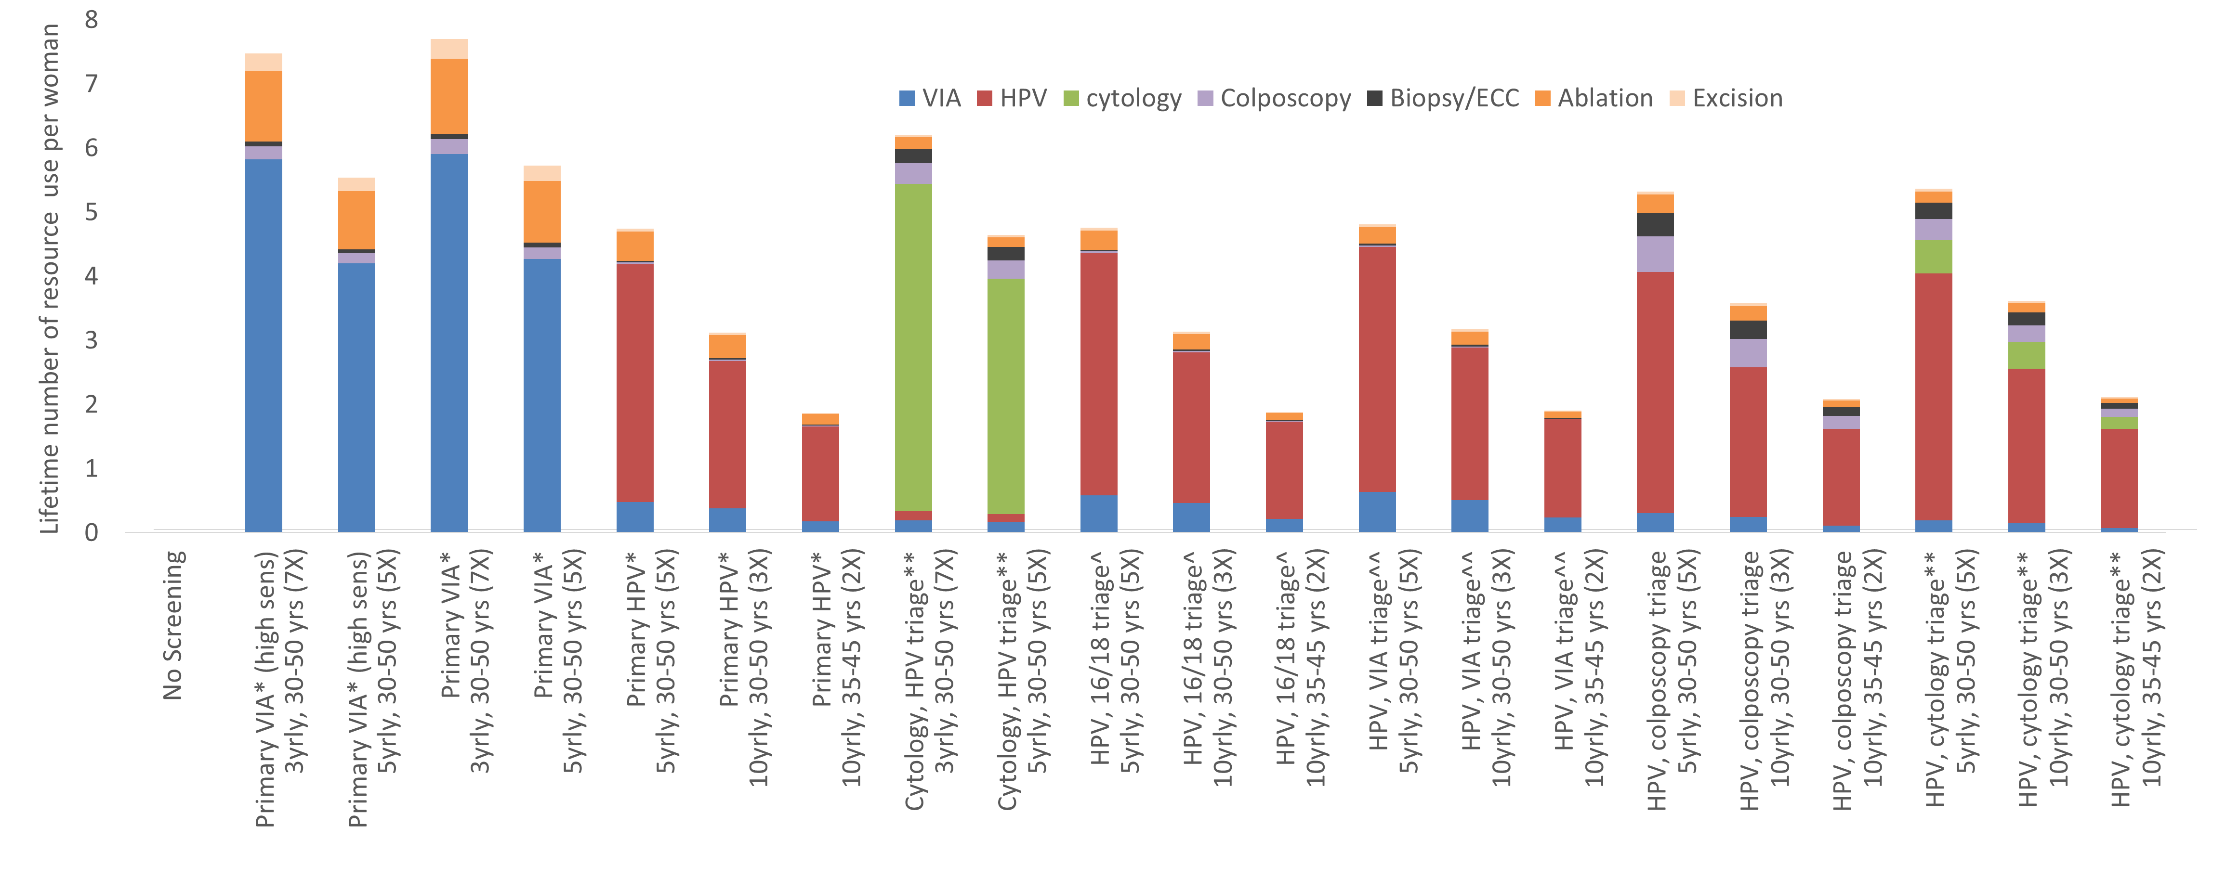
* All positive women treated after assessment of eligibility for ablative treatment ** triage positive referred to colposcopy ^^ VIA triage positive women treated after assessment of eligibility for ablative treatment. ^HPV16/18 positive women treated after assessment of eligibility for ablative treatment; Women positive for HPV types other than HPV 16/18 (‘OHR’) are triaged with VIA.
Appendix Figure 11: Average discounted cost per woman in the population, over the lifetime of the cohort, broken down by component
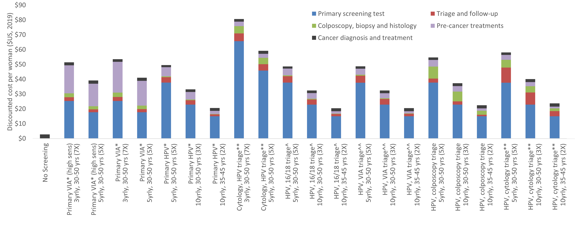
@ 3% discount rate for cost. * All positive women treated after assessment of eligibility for ablative treatment ** triage positive referred to colposcopy ^^ VIA triage positive women treated after assessment of eligibility for ablative treatment. ^HPV16/18 positive women treated after assessment of eligibility for ablative treatment; Women positive for HPV types other than HPV 16/18 (‘OHR’) are triaged with VIA.

Results - Cost-effectiveness analysis

We explored the impact of varying the discount rate, using life-years instead of HALYs and assuming a high VIA triage sensitivity on the cost-effectiveness frontiers (Appendix Figure 12). In all variations, HPV-based strategies remained the most cost-effective. When considering a discount rate of 3% for both costs and effects, the same strategies appear on the frontier, but the ICER values almost tripled for each of the screening age-range and interval combinations, with primary HPV screening every 5 years from ages 30-50 having an ICER of US$1,516/HALY saved. Using life-years instead of HALYs the ICER values varied slightly, with primary HPV screening every 5 years from ages 30-50 having an ICER of US$561/LYS saved. Assuming lower adherence rates for all scenarios decreased the ICER of all strategies, with primary HPV screening every 5 years from ages 30-50 having an ICER of US$389/HALY saved. Assuming higher VIA sensitivity when used as a triage or to determine eligibility for ablation resulted in lower ICERs across the board, primary HPV screening every 5 years from ages 30-50 having an ICER of US$531/HALY saved.
We also explored a number of different cost assumptions, including upper and lower bounds for all costs and for HPV testing specifically; and upper bounds for cancer diagnosis, staging and treatment (Appendix Figure 13). All cost variations resulted in the same strategies on the frontier (namely Primary HPV every 10-years for ages 35-45, Primary HPV every 10-years ages 30-50, and Primary HPV every 5 years for ages 30-50). ICERs ranged from $95-$176 for 10-yearly Primary HPV at ages 35-45, with a lower ICER when HPV test cost takes its lower value and higher ICER when the HPV test cost is at the upper range. For 10-yearly Primary HPV at ages 30-50, the ICERs ranged from $293-$533; and for 5-yearly Primary HPV at ages 30-50, the ICERs ranged from $371-$688.

Finally, we explored a number of different downstream management assumptions, namely: 2-year or both 1- and 2-year followup of HPV positive women with negative triage; and 2-year followup or 1-year followup with cytology and HPV DNA cotesting of women who receive pre-cancer treatment and are not known to have CIN3+ (Appendix Figure 14). All these variations resulted in the same strategies on the frontier (namely Primary HPV every 10-years for ages 35-45, Primary HPV every 10-years ages 30-50, and Primary HPV every 5 years for ages 30-50 with base-case downstream management assumptions), except that there was an additional strategy on the frontier, namely Primary HPV every 5 years for ages 30-50 with women who receive pre-cancer treatment and are not known to have CIN3+ being cotested with cytology and HPV DNA. However, this had an ICER of $5722, above the GDP per capita of any of the 78 LMICs.
Appendix Figure 12: Cost-effectiveness outcomes assuming (a) 3% discount for both costs and effects; (b) using life-years instead of HALYs; (c) assuming low screening adherence; and (d) assuming high VIA sensitivity
(a) 3% discount for both costs and effects
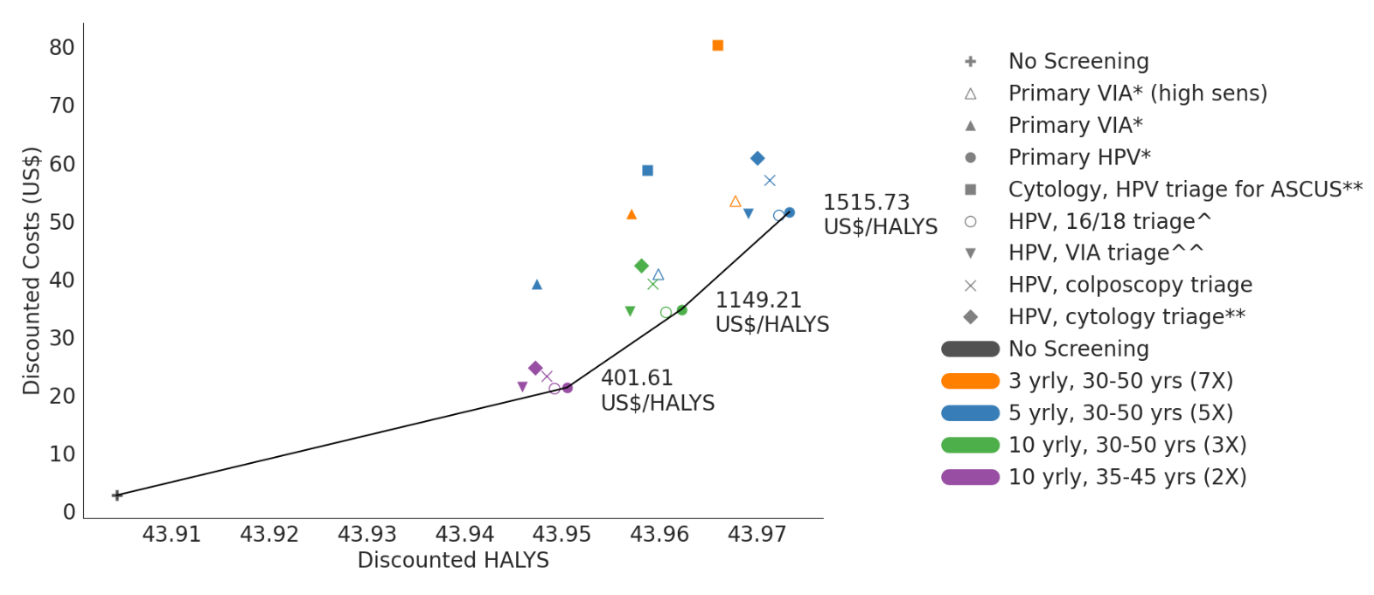

(b) Using life-years instead of HALYs
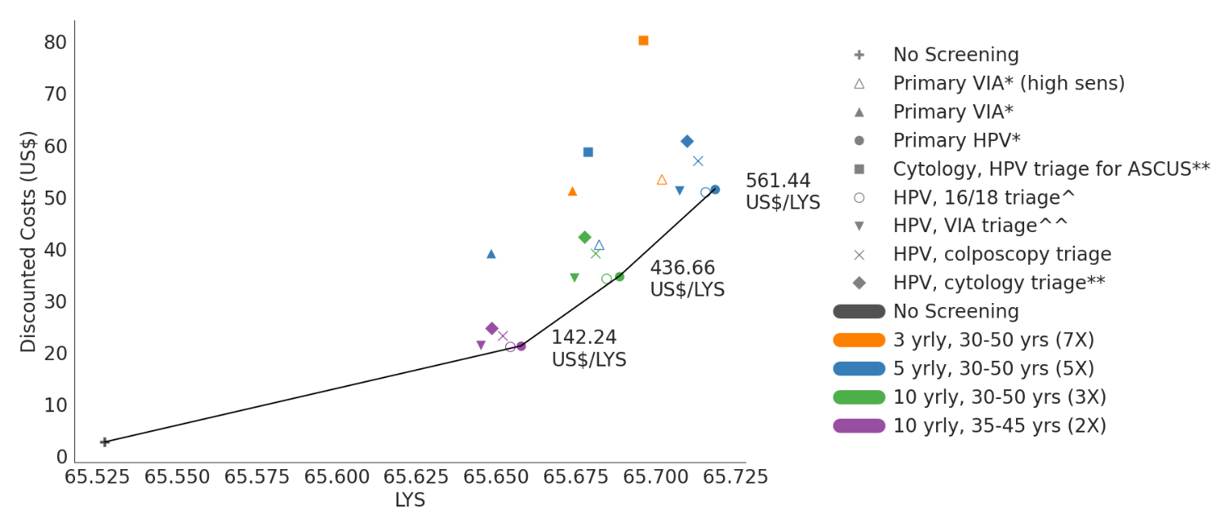

(c) Assuming lower adherence for all scenarios
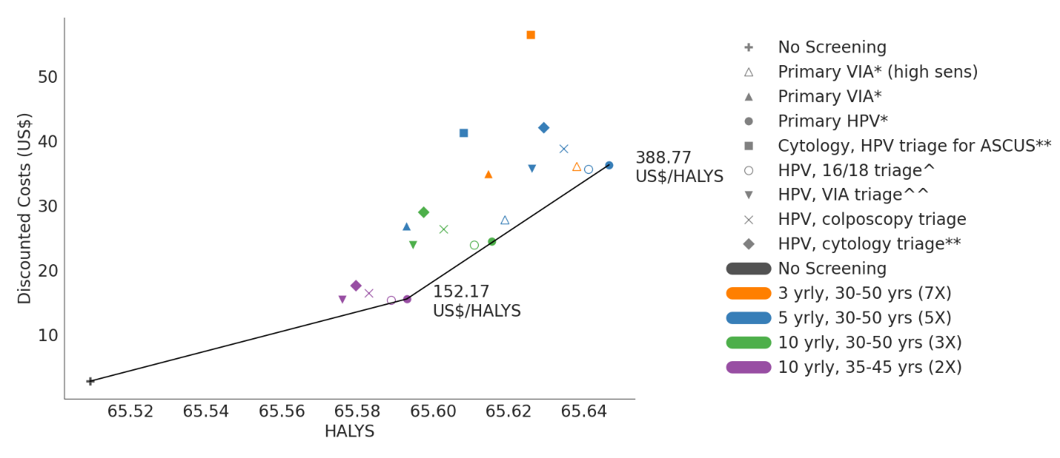

(d) Assuming high sensitivity for all VIA tests (primary and triage)
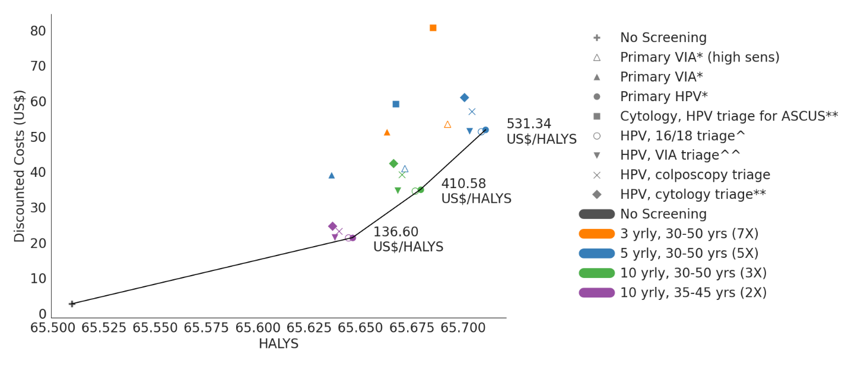
* All positive women treated after assessment of eligibility for ablative treatment ** triage positive referred to colposcopy ^^ VIA triage positive women treated after assessment of eligibility for ablative treatment. ^HPV16/18 positive women treated after assessment of eligibility for ablative treatment; Women positive for HPV types other than HPV 16/18 (‘OHR’) are triaged with VIA.

Appendix Figure 13: Cost-effectiveness under different cost assumptions
(a) Lower bound assumptions for all costs
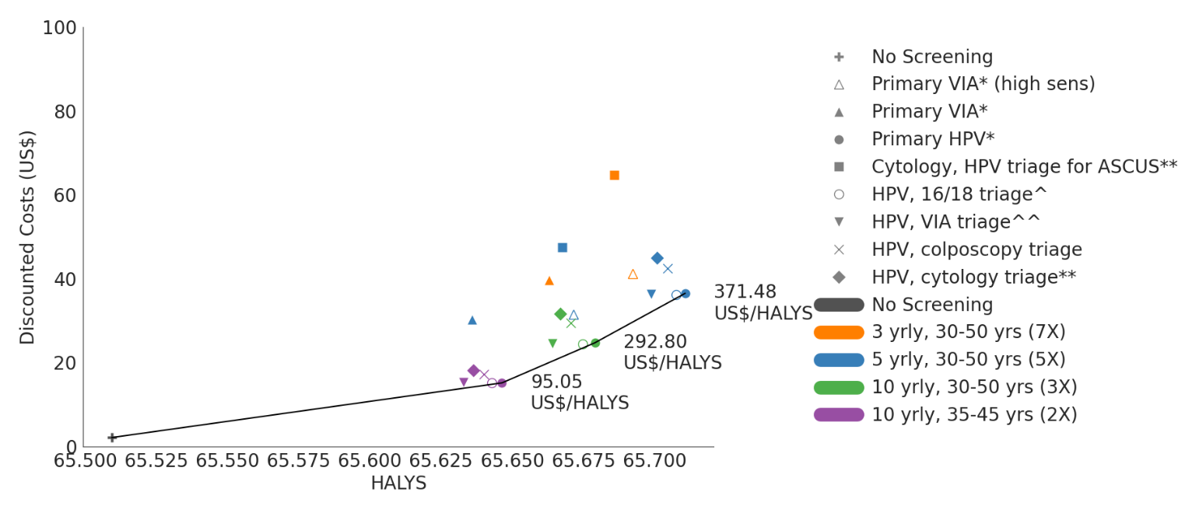

(b) Upper bound assumptions for all costs
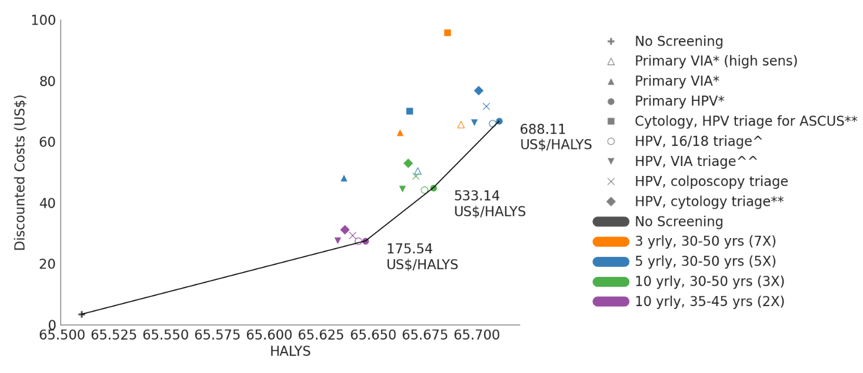

(c) Lower bound assumptions for HPV test costs (all other costs at base-case)
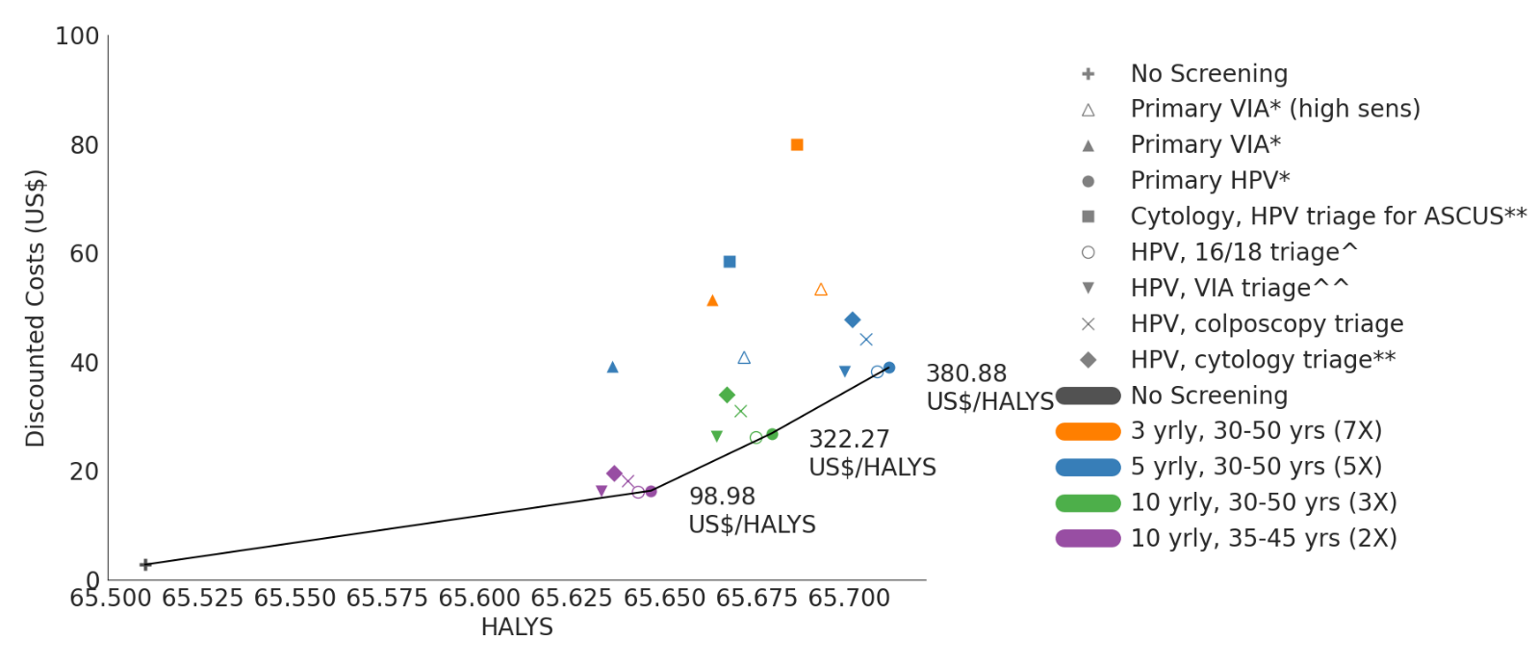

(d) Upper bound assumptions for HPV test costs (all other costs at base-case)
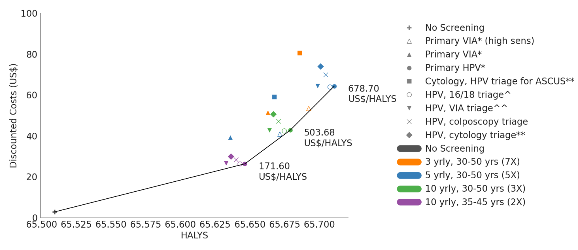

(e) Upper bound assumptions for Cancer treatment costs (all other costs at base-case)
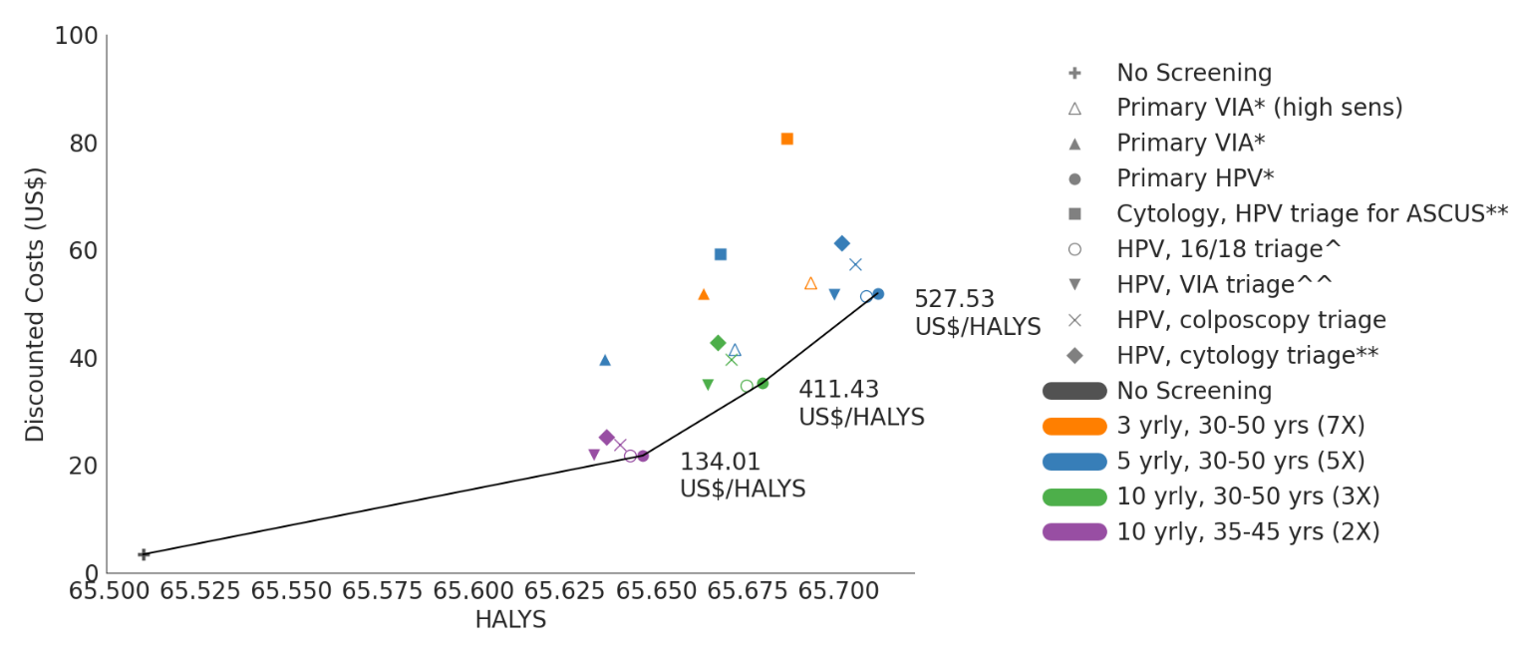
* All positive women treated after assessment of eligibility for ablative treatment ** triage positive referred to colposcopy ^^ VIA triage positive women treated after assessment of eligibility for ablative treatment. ^HPV16/18 positive women treated after assessment of eligibility for ablative treatment; Women positive for HPV types other than HPV 16/18 (‘OHR’) are triaged with VIA.
0% discount rate for effect, 3% discount rate for cost HALY: health-adjusted life-years

Appendix Figure 14: Cost-effectiveness (a) under different management assumptions for primary HPV positive women who have a negative triage; (b) under different management of women who have received pre-cancer treatment and are not known to have CIN3+.
(a) Different management assumptions for primary HPV positive women who have a negative triage
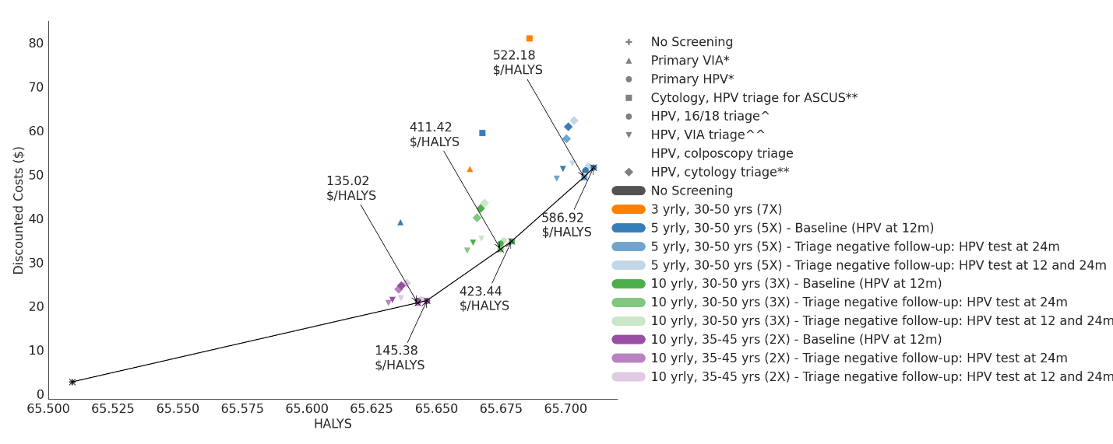

(b) Different management assumptions for women who have received pre-cancer treatment and are not known to have CIN3+
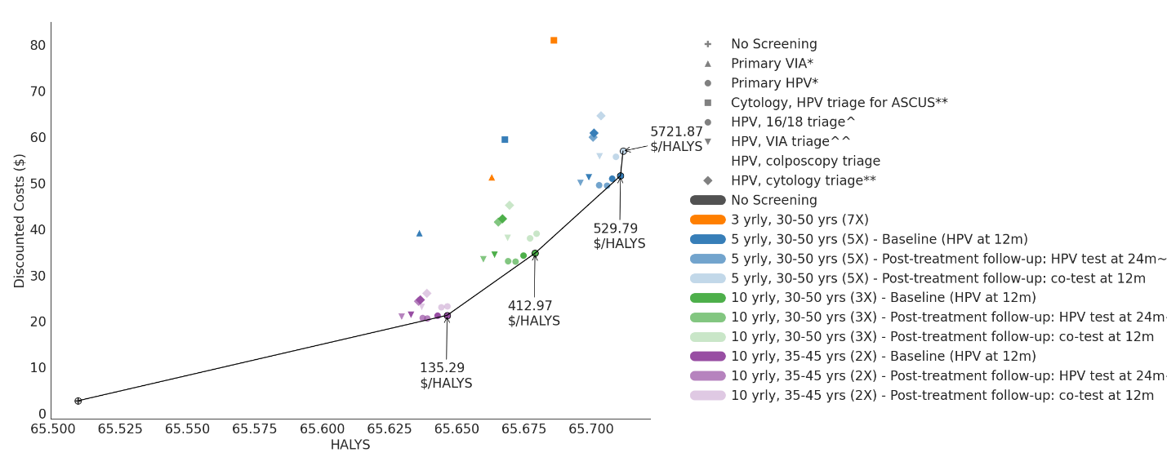
* All positive women treated after assessment of eligibility for ablative treatment ** triage positive referred to colposcopy ^^ VIA triage positive women treated after assessment of eligibility for ablative treatment. ^HPV16/18 positive women treated after assessment of eligibility for ablative treatment; Women positive for HPV types other than HPV 16/18 (‘OHR’) are triaged with VIA.
0% discount rate for effect, 3% discount rate for cost HALY: health-adjusted life-years. ~30% loss-to-followup assumed.

Appendix Part 2 (Technical information): combined technical information for manuscripts Benefits, harms and cost-effectiveness of cervical screening and treatment in 78 low-income and lower-middle income countries for women in the general population: modelling to support updated WHO cervical screening and treatment guidelines to prevent cervical cancer and Evaluation of the benefits and harms of alternative strategies for cervical screening and treatment in women living with HIV: modelling to support WHO 2021 cervical screening and treatment guidelines to prevent cervical cancer

Background
In 2013, WHO published the Comprehensive Cervical Cancer Control manual, which provided cervical screening and treatment guidelines for women with or without HIV.¹ For women aged 30-49 with negative or unknown HIV status, these guidelines recommended the use of primary HPV at intervals of at least as frequent as every 5 years in settings with adequate resources to implement the tests, followed with either VIA triage or treatment after VIA to determine eligibility for same-day treatment. In settings without adequate resources to provide the HPV test, primary VIA at 3-5 yearly intervals could be used. Treatment of precancerous lesions could us either cryotherapy, or LEEP if the woman is ineligible for cryotherapy. In settings which have an existing screening program and high-quality assurance measures in place to provide adequate coverage, follow-up and training, the 2014 guidelines note that either primary cytology or primary HPV followed by colposcopy can be used. For women of HIV+ status or unknown status in areas with high endemic HIV infection, the same recommendations apply, however screening intervals should be no longer than 3 years. Since the publication of the 2013 WHO cervical screening guidelines, new testing and treatment technologies as well as updated evidence on test performance have become available. A large community-based randomized-control trial in India following a total of 70,000 women after VIA screening over 12 years² indicated that there was no significant reduction in cervical cancer incidence in women who were screened with VIA compared to unscreened women, and a mortality reduction of 31 % (RR=0.69; [95% CI:0.54- 0.88]),² implying low sensitivity to high-grade lesions that could cause cancer. This was consistent with an earlier study that found no significant reduction in incidence and mortality after one round of VIA screening in 30,000 women.³ The American Society of Clinical Oncology (ASCO) released guidelines for cervical screening in 2016 recommending primary HPV testing be used for all settings.

Since the launch of the 2013 cervical screening guidelines, a global strategy for the elimination of cervical cancer has been launched by WHO,⁴ HPV screening tests have been pre-qualified by WHO,⁵ and thermal ablation has been added as a recommended ablative therapy method.⁶ Furthermore, new testing technologies, as well as updated evidence on test performance, have become available. To facilitate the efforts to achieve elimination and incorporate the latest evidence, WHO has launched updated cervical screening guidelines, based on a range of evidence sources including an updated systematic review on screening test performance and treatment efficacy and a modelled evaluation. To inform this update, the WHO secretariat formed the Guidelines Development Group (GDG) and consulted with methodologists and technical groups to determine PICO questions, timelines and methodology.
The PICOs address optimal primary and triage test technologies (PICOs 1 and 2), optimal screening frequency and intervals (PICO3), optimal management of women under surveillance after testing triage-negative at the primary visit (PICO 4), and optimal management of women after treatment for precancer (PICOs 5-7). The modelling evaluation for both general population of women and women living with HIV assess a range of primary and triage test technologies (PICOs 1 and 2) and a range of screening ages and frequencies (PICO 3), incorporating data on updated systematic review evidence, costing data and screening algorithms. The updated cervical screening guidelines were launched by the WHO on July 6th 2021.⁷
The GDG identified seven priority algorithms that would be potentially suitable for LMICs: Primary VIA, Primary cytology with HPV triage (ASC-US referral), Primary HPV without triage (All positive women treated after using assessment of eligibility for ablative treatment), Primary HPV 16/18 triage, Primary HPV VIA triage, Primary HPV cytology triage, and Primary HPV colposcopy triage screening strategies (see Table 1 in the main manuscript). To ensure adequate communication between the different expert groups involved in informing the update of cervical screening guidelines, weekly meetings were held between the modelling team, representatives from the WHO secretariat and representatives from the systematic review and costing teams. Regular meetings were also held between GDG members and the systematic review, modelling and costing teams to discuss the priority management algorithms. The modelled evaluation was performed over a three-stage process (Appendix Figure 15). In the first stage, we evaluated the benefits and harms (using precancer treatments as a proxy for harms) of the seven priority algorithms, considering various screening ages and frequencies. These results were presented to the GDG in July of 2020. In the second stage, we included results on additional adverse obstetric outcomes as a result of precancer treatments as a measure of the harms associated with screening, as well as cost-effectiveness outcomes. Modelled evaluations of these algorithms were presented to the GDG in September 2020. The third stage involved a detailed exploration of the optimal management of women after negative triage test and the optimal management of women after treatment for precancer. Modelled evaluations of these alternative management options was presented to the GDG in November 2020.

Appendix Figure 15: Schematic showing how the systematic review data, cost data and screening algorithms interfact with the Policy1-Cervix platform (a). Three stage process for the modelled evaluation to inform the updated WHO cervical screening guidelines (b)
(a)
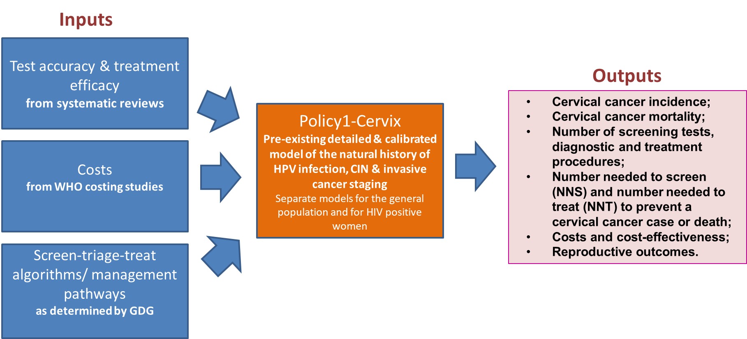

(b)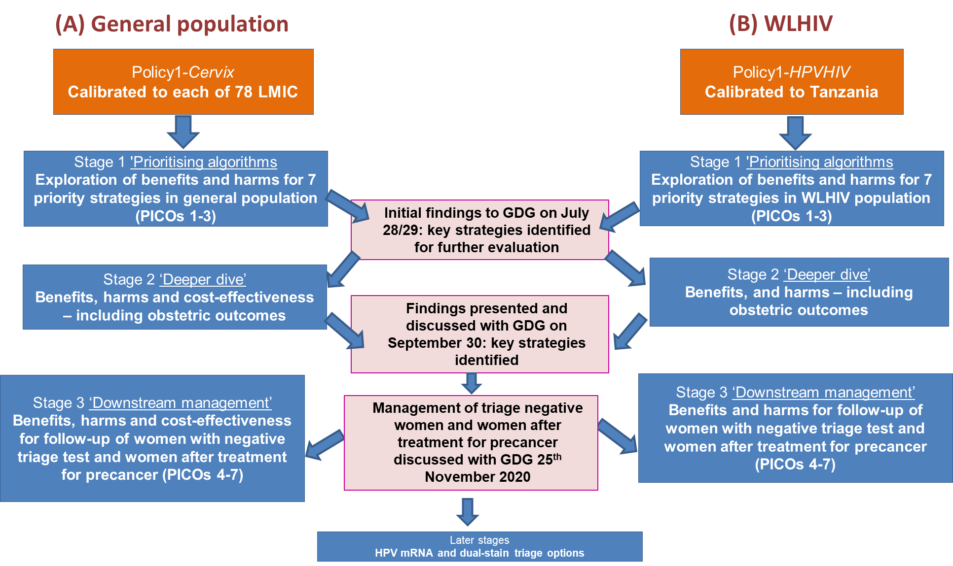

Technical information - Methods

Policy1-Cervix platform
A validated dynamic model platform ‘Policy1-Cervix’ of sexual behaviour, HPV transmission, HPV type-specific natural history, cervical screening and vaccination was used for this evaluation. This platform models HPV transmission, type-specific natural history, cervical screening, diagnosis and treatment, and has been extensively validated against data from a range of countries (Appendix Figure 16). It has been used to evaluate the impact of elimination targets on cervical cancer incidence and mortality for all 78 LMIC in the Cervical Cancer Elimination Modelling Consortium (CCEMC),^{8,9} predicting the timeline to elimination of cervical cancer for 181 countries,¹⁰ for USA,¹¹ and Australia.¹² It has been used for a range of government-commissioned studies on behalf of national cervical screening programs in Australia, New Zealand and England. Some specific examples of this include: the effectiveness modelling and economic evaluation of cervical screening for both unvaccinated cohorts and cohorts offered vaccination, as part of the Renewal of the cervical screening program in Australia¹³, as well as similar screening policy evaluations for New-Zealand¹⁴ and England.¹⁵ It has also been used to provide estimates of resource utilization and disease impacts during the transition from cytology to HPV screening in Australia and New Zealand,¹⁶⁻¹⁸ to inform clinical management guidelines in Australia¹⁹ and evaluate the impact of adopting self-collected HPV testing in Australia.²⁰ It has previously been extensively validated and used to evaluate changes to the screening interval in Australia and the United Kingdom,^{21,22} the role of alternative technologies for screening in Australia, New Zealand and England,^{21,23-25} the role of HPV testing for the follow-up management of women treated for cervical abnormalities²⁶, the cost-effectiveness of alternative screening strategies and combined screening and vaccination approaches in China,²⁷⁻²⁹ the impact of HPV vaccine hesitancy in Japan³⁰ and the cost-effectiveness of primary HPV testing and the potential for elimination in Malaysia. The model has also been used to evaluate the impact of HPV vaccination²⁹ and the incremental impact of vaccinating males in Australia,³¹ the impact of the nonavalent HPV vaccine in four developed countries³² and to assess the cost-effectiveness of the nonavalent HPV vaccine in Australia.³³ Predictions from the dynamic HPV transmission and vaccination model have also been validated against observed declines in HPV prevalence in women aged 18-24 years after the introduction of the quadrivalent vaccine.³⁴ Model predictions of age-specific cervical cancer incidence and mortality, the rate of histologically confirmed high-grade lesions per 1,000 women screened and overall screening participation rates have been previously validated against national data from Australia, England and New Zealand^{14,15,35} after taking into account local age-specific screening behaviour obtained via analysis of screening registry data. Policy1-Cervix has also been used in conjunction with a model of fertility to estimate the impact of vaccination and screening changes on adverse pregnancy outcomes³⁶ and ethnicity-specific models have been developed for New Zealand.³⁷ More details on the model structure, previous applications and calibration documentations for selected countries can be found on our Policy1 website.³⁸
Policy1-Cervix was one of three models used in the Cervical Cancer Elimination Modelling Consortium (CCEMC).^{8,9} The model was calibrated to GLOBOCAN2018 incidence and mortality of 78 LMICs and incorporated data on cervical cancer stage-distribution, treatment access and 5-year and 10-year survival rates by region (and proportion treated versus untreated) for each country, as described in detail previously.^{8,9}
The obstetric complications module incorporates country-specific and age-specific fertility rates, as well as precancer treatment outcomes by mode of treatment. This module estimates additional preterm delivery events due to precancer treatment, capturing differential risk for women treated with ablation versus excision. This model component has been used to evaluate the impact of the transitioning from cytology-based to an HPV-based screening program on adverse obstetric outcomes in Australia.³⁶
Appendix Figure 16: Policy1-Cervix model platform
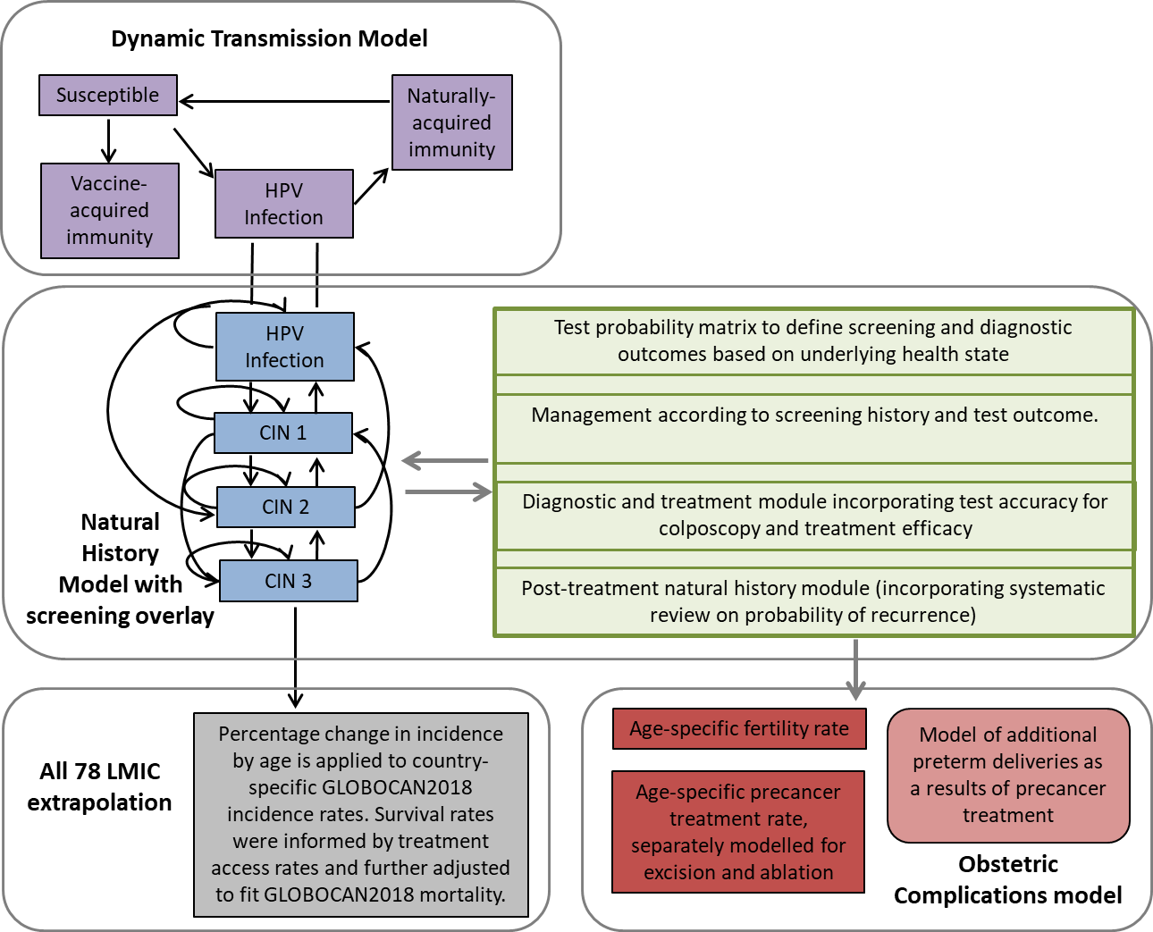

Policy1-Cervix-HIV platform
The Policy1-Cervix-HIV model is a deterministic transmission-dynamic compartment model of sexual behaviour, HIV and HPV infection and natural history (Appendix Figure 17).³⁹ The platform models the transmission and natural history of HIV, HPV 16/18, HPV 31/33/45/52/58 and other high-risk HPV types. The platform captures simultaneous HIV and HPV infections, including multiple HPV types, and incorporates comprehensive demographic, sexual behaviour and natural history assumptions, and accounts for voluntary medical male circumcision (VMMC) and anti-retroviral therapy (ART). The simulated population includes males, females and a separate subgroup of female commercial sex-workers (which females may be hired into or retire from), ages 5 to 79 years, stratified by sex, five-year age group, sexual activity level, HIV and HPV infection, and treatment status. The model incorporates historical and predicted future rates of HIV, HIV treatment, and has been extensively calibrated to HIV prevalence, HPV prevalence, and cervical cancer incidence and mortality observed in Tanzania, as described in detail in a previous publication.³⁹
Appendix Figure 17: Policy1-Cervix-HIV model platform
The Policy1-Cervix-HIV model has been extensively parameterized and validated to the United Republic of Tanzania, a setting with endemic HIV and a high burden of cervical cancer among all women (regardless of HIV status). The model is transmission dynamic, and simulates underlying demographic processes and sexual behaviour, and resultant HIV and HPV transmission and natural history, accounting for prevention and treatment strategies. For the cohort analysis presented in this study, outcomes in the cohort of women born in 2005 and who acquire HIV on or before their 25th birthday were extracted from longitudinal population-level simulations.

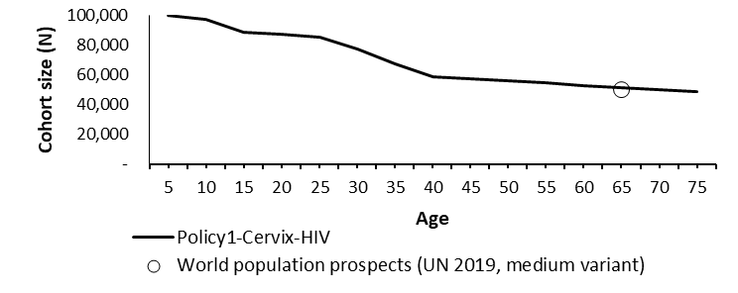
Appendix Figure 19: Simulated cohort size of 100,000 Tanzanian women (reglardless of HIV status) born in 2000, versus estimated life-expectancy (UN population projections 2019, medium variant).
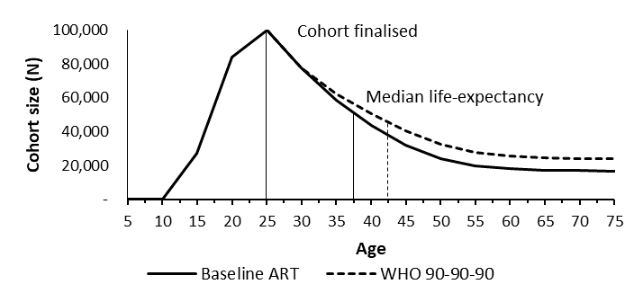
Appendix Figure 10: Simulated cohort size of 100,000 Tanzanian women born in 2000 which acquire HIV on or before their 25th birthday for base-case ART assumptions compared to target (WHO 90-90-90) ART assumptions.

Screening strategies
We consider the benefits, harms and cost-effectiveness of seven priority algorithms for a range of screening ages and intervals (see Table 1 of main manuscript and Appendix Table 1): Primary VIA, Primary cytology with HPV triage (ASC-US referral), Primary HPV without triage (All positive women treated after using assessment of eligibility for ablative treatment), Primary HPV 16/18 triage, Primary HPV VIA triage, Primary HPV cytology triage, and Primary HPV colposcopy triage screening strategies. Detailed management for each of these screening scenarios, including downstream management for women in follow-up, at colposcopy and after precancer treatment are described in Appendix Figure 21.
The screening ages and intervals are slightly different between general population and women living with HIV (WLHIV). For the general population, we assumed screening could start from age 30 years and would end by age 50 years. We considered 3-yearly and 5-yearly screening intervals for both primary VIA and cytology-based screening and 5-yearly and 10-yearly screening intervals for HPV-based screening. For WLHIV population, we assumed screening could start from age 25 years and would end by age 50 years. We considered 3-yearly, 5-yearly, and 10-yearly screening intervals for HPV-based screening and 3-yearly and 5-yearly screening intervals for primary VIA and primary cytology-based screening. Based on the GDG recommendations, we still consider the WHO CCEMC elimination strategy for both populations (HPV-based screening at ages 35 and 45 years).

Appendix Table 1: Screening scenarios considered
Screening algorithms | Screening frequency and age-range (number of lifetime routine screening tests)
General population
Primary VIA (Appendix Fig. 5a) | - 3 yearly, 30-50 years (7X)  5 yearly, 30-50 years (5X)
Cytology (ASCUS), HPV triage (Appendix Fig. 5c) | - 3 yearly, 30-50 years (7X)  5 yearly, 30-50 years (5X)
Primary HPV (Appendix Fig. 5b) | - 5 yearly, 30-50 years (5X)  - 10 yearly, 30-50 years (3X)  - 10 yearly, 35-45 years (2X) ‘Elimination strategy’
HPV, HPV16/18 triage (Appendix Fig. 5d)
HPV, VIA triage (Appendix Fig. 5e)
HPV, colposcopy triage (Appendix Fig. 5f)
HPV, cytology triage (Appendix Fig. 5g)
Total | 19 scenarios
WLHIV
Primary VIA  Cytology (ASCUS) - HPV triage | - 3 yearly, 25-50 years (9X)
Primary HPV | - 3 yearly, 25-50 years (9X)  - 5 yearly, 25-50 years (6X)  - 10 yearly, 25-50 years (3X) [additional]  - 10 yearly, 30-50 years (3X)  - 10 yearly, 35-45 years (2X)* [additional]  *[For HPV screening strategies only, to compare to CCEMC results]
HPV - HPV16/18 triage
HPV – VIA triage
HPV – colposcopy triage
HPV – cytology triage
Total | 27 scenarios

Screening test characteristics
An updated systematic review was conducted to inform the GDG on cross-sectional sensitivity and specificity of a range of screening and triage tests for both general women and WLHIV; the updated review did not include primary HPV (without triage) or primary cytology performance, and so published systematic review evidence was used for these tests. The sensitivity and specificity reported from these reviews is shown for the test and triage combinations in Appendix Table 2. Result from the systematic reviews indicate a sensitivity to CIN2+ of 92.6% for primary HPV testing, and based on uncertainty ranges reported we consider a range of 88-99.7% sensitivity to CIN2+ in sensitivity analysis. Result from the systematic reviews indicate a sensitivity to CIN2+ of 70.3% for primary cytology testing (LSIL threshold, assuming LBC testing) and based on uncertainty ranges across both conventional and LBC, we consider a range of 46.8-80% sensitivity to CIN2+ in sensitivity analysis. For VIA, test performance was based on a combination of evidence from cross-sectional studies and larger scale population-level longitudinal studies. The latest systematic reviews for general women indicated that VIA had a sensitivity to CIN2+ upwards of 60%. For WLHIV, after pooling studies involving a total of more than 7,000 women, sensitivity to CIN2+ ranged from 43.8% to 86.6%.⁴⁰ These reviews indicated that there was substantial heterogeneity in the performance of VIA, in part due to differences in the design of the studies and the amount of training of the test operators. Furthermore, many cross-sectional studies which informed the systematic reviews on test performance were short term pilot studies with intensive training of staff, and the smaller scale and short duration of the studies means that favourable results may not be translatable for longer-term population-wide settings.
Longitudinal studies of large population-based implementation of VIA have been performed in India. In 2014, results from a large community-based randomized-control trial in India (1998-2011) reported cervical cancer incidence and mortality after four VIA screening rounds over 12 years.² This study included 70,000 women participating in each of two screening arms – no screening and Primary VIA testing, resulting in a total study size of more than 140,000 women followed up over 12 years. Results indicated that there was no significant reduction in cervical cancer incidence in the VIA arm, and a mortality reduction of 31 % (RR = 0.69; 95% CI = 0.54 to 0.88),² implying low sensitivity to high-grade lesions that could cause cancer. In 2009, another randomized controlled trial assessed the impact of a single round of HPV, VIA, and cytologic testing on cervical cancer incidence and mortality in Osmanabad district, India. It included over 30,000 women in the VIA screening arm and found that women offered VIA testing had no significant reduction in incidence or mortality after one round of screening (four years of follow-up after the screening event).³
Although these studies could not be used to obtain sensitivity and specificity of the VIA test, they are of substantial size, conducted over longer periods of time and are critical studies to consider when deciding on the population-level performance of VIA testing. We performed a modelled simulation of both trials to identify what test performance assumptions of VIA would generate the reductions in incidence and mortality observed and found that sensitivity rates of 40% or lower produced the most accurate predictions. Based on the complete availability of evidence from cross-sectional studies and larger scale population-level longitudinal studies, the GDG agreed that for VIA we would consider lower test performance of 41% sensitivity to CIN2+ for the base-case analysis; for sensitivity analysis, we would consider 60% sensitivity to CIN2+ as an upper favourable bound.

The sensitivity and specificity was used to generate detailed test probability matrices for the base-case analysis, which represent the probability of certain test results given a womans true underlying health state for the three tests considered: VIA, cytology and HPV (Appendix Table 3). These test matrices, when evaluated for screening programs, produce a range of potential sensitivity and specificity values which are dependent on the underlying disease of the population. Therefore, we present a range of model-predicted sensitivity and specificity considering variation in disease rates across six geographical regions (East Asia and Pacific, Europe and central Asia, Latin America and Caribbean, north Africa and the Middle East, South Asia, and sub-Saharan Africa) and across different age-groups within each region. Specifically, we used disease state outputs from the models for each of the six geographical regions and across three age-groups per region: 25-34, 35-44, 45-54. The calculated sensitivity and specificity is presented as the range across the 6*3 = 18 combinations of regions and age-groups for each test. For cytology and HPV-based screening, the model ranges for sensitivity and specificity compare well with the systematic review data used to inform the inputs.
For sensitivity analysis, we considered the impact of the upper and lower sensitivity performance for each of the primary screening tests (VIA, cytology, HPV) on incidence and mortality outcomes. When modelling the upper and lower ranges for test performance, we do not explicitly generate updated TPM’s for these test performance assumptions. Rather, we scale the predicted reduction in incidence and mortality based on the relative difference in sensitivity of each range compared to base-case.

Appendix Table 2: Cross-sectional sensitivity and specificity inputs used for (a) primary test technologies and (b) combined primary and triage test outputs. We also present assumptions for test performance considered in sensitivity analysis for primary test technologies (c)

(a)
Primary test | Sensitivity CIN2+ targets | Specificity CIN2+ targets | Model calculated sensitivity to CIN2+@ | Model calculated specificity to CIN2+@ | Data sources
Primary VIA | 41% CIN2+ as a realistic sensitivity.  Additionally present a high sensitivity scenario (60% CIN2+) for all outputs. | 78% | 39.1-42.8% | 78.0-80.8% | Combined evidence from systematic reviews⁴⁰ and population longitudinal data.^{2,3}
Primary cytology (LSIL cut-off) | LBC: 70.3% (59.7-79.1%)  Conv: 62.8% (46.8-76.5%) | LBC: 96.2% (94.6-97.4%)  Conv: 97.7% (96.1-98.7%) | 67-71.3% | 94.1-97.8% | Published systematic review⁴¹
Primary HPV | 92.60% (89.25-95.30%) | 89.30% (87.03%-91.20%) | 96.6-98.1% | 73.0-97.0% | Published systematic review⁴¹

(b)
Primary/triage test combinations | Sensitivity CIN2+ targets | Specificity CIN2+ targets as | Model calculated sensitivity to CIN2+@ | Model calculated specificity to CIN2+@ | Data sources
HPV positive, HPV 16/18 triage* | 52.9% (95% CI 50.2-55.7%) | 74.5% (95% CI 70.3-79.0%) | 46.3-75.9% | 67.2-86.3% | Unpublished systematic review to inform the guidelines⁴²
HPV positive, Cytology triage (ASCUS)* | 71.5% (95%CI: 65.2-77.1%) | 74.7% (95% CI 69.2-79.5%) | 70.1-74.7% | 68.1-85.2% | Unpublished systematic review to inform the guidelines⁴²
HPV positive, VIA triage * | Range: 45.2% to 84.2% | Range: 44.8% to 94.5% | 39.2-42.99% | 73.3-76.9% | Unpublished systematic review to inform the guidelines for WLHIV⁴⁰ and population longitudinal data.^{2,3}
Primary cytology (LSIL cut-off) | LBC: 70.3% (59.7-79.1%)  Conv: 62.8% (46.8-76.5%) | LBC: 96.2% (94.6-97.4%)  Conv: 97.7% (96.1-98.7%) | 67-71.3%  Sensitivity analysis**: 46.8% (lower bound) – 80% (upper bound) | 94.1-97.8% | Published systematic review⁴¹
Primary HPV | 92.60% (89.25-95.30%) | 89.30% (87.03%-91.20%) | 96.6-98.1%  Sensitivity analysis**: 88% (lower bound) – 95.7% (upper bound) | 73.0-97.0% | Published systematic review⁴¹
Cytology ASCUS, HPV triage | 96.2% (95% CI : 91.7–98.3%) | 54.9% (95% CI:43.5–65.9%) | 96.9-98.2% | 39.2-88.1% | Published systematic review⁴³
Primary VIA | 41%  Range: 30-60% | 78% | Lower bound: 39.1-42.8%  Upper bound: 60-64% | Lower bound: 78.0-80.8%  Upper bound: 78.6-79.4% | Combined evidence from systematic reviews⁴⁰ and population longitudinal data.^{2,3}
*Data available for women aged 35-60. ^Liquid-based cytology assumed, and HPV test using ATIMA.**Sensitivity analysis on the sensitivity of primary HPV, primary cytology and primary VIA are performed on predictions of incidence and mortality reductions. @Range of sensitivity and specificity here. We assume a fixed test performance for each test across all scenarios. As disease burden varies substantially across all-78 LMIC, equivalent test performance may result in different sensitivity and specificity at a population-level; for instance, tests used in settings with high rates of CIN2/3 will generate different sensitivity calculation compared with settings with very low rates of disease.
(c)
Primary test | Sensitivity CIN2+ data
Primary VIA | Based on combined evidence from systematic reviews⁴⁰ and population longitudinal data^{2,3} we consider range of 30-60^%
Primary cytology (LSIL cut-off) | Based on performance across conventional and LBC shown in Appendix Table 2 (a), we consider range of 46.8%-80%
Primary HPV | Based on performance shown in Appendix Table 2 (a), we consider range of 88%-96%
^60% sensitivity values are presented explicitly for all scenarios.
For both the base-case and favourable VIA tests, we assume that the probability that a woman is eligible for same-day ablation is dependent on the underlying disease state. For women with <CIN2, 98% of are eligible for same-day ablation and for women with CIN2+, 85% would be considered eligible for same-day ablation (Appendix Table 3(b)).

Appendix Table 3: Probability of receiving a specific test result by underlying health state for (a) VIA, (b) VIA (high sensitivity), (c) VAT, (d) cytology, (e) HPV. The same test probability matrix is used when the test is used as a primary or triage test.
- VIA
Health state | Negative | Positive (eligible for ablation) | Positive (ineligible for ablation) | Suspicious for cancer
Well | 81.0% | 18.05% | 0.95% | 0%
HPV (no CIN) | 75.0% | 23.75% | 1.25% | 0%
CIN1 | 70.0% | 27.0% | 3.0% | 0%
CIN2 | 65.0% | 24.5% | 10.5% | 0%
CIN3 | 59.0% | 20.5% | 16.4% | 0%
Cervical cancer | 40.0% | 0% | 0% | 60.0%
- VIA (high sensitivity)
Health state | Negative | Positive (eligible for ablation) | Positive (ineligible for ablation) | Suspicious for cancer
Well | 80.0% | 19.0% | 1.0% | 0%
HPV (no CIN) | 74.0% | 24.7% | 1.3% | 0%
CIN1 | 69.0% | 27.9% | 3.1% | 0%
CIN2 | 50.0% | 35.0% | 15.0% | 0%
CIN3 | 37.0% | 31.5% | 25.2% | 6.3%
Cervical cancer | 12.0% | 0% | 0% | 88.0%

- VIA used as a visual assessment for treatment
Health state | Eligible for ablation | Ineligible for ablation
Well | 99.05% | 0.95%
HPV (no CIN) | 98.75% | 1.25%
CIN1 | 97.0% | 3.0%
CIN2 | 89.50% | 10.5%
CIN3 | 79.5% | 16.4%
Cervical cancer | 40.0% | 60.0%

(d) Cytology
Health state | Negative | ASC-US | LSIL | ASC-H+
Well | 96.72% | 1.35% | 1.33% | 0.6%
HPV (no CIN) | 89.3% | 4.8% | 4.8% | 1.1%
CIN1 | 45.95% | 24.69% | 20.58% | 8.78%
CIN2 | 41.59% | 1.71% | 24.3% | 32.4%
CIN3 | 24.49% | 3.51% | 25.2% | 46.8%

(e) HPV
Health state | Negative | Positive
Well | 98.6% | 1.4%
HPV (no CIN) | 44.0% | 56.0%
CIN1 | 15.85% | 84.15%
CIN2 | 7.0% | 93.0%
CIN3+ | 1.6% | 98.40%

For the population subgroup of WLHIV, we assumed that health-state specific test positivity rates for primary VIA, HPV and cytology testing as for women in the general population (Appendix Table 2). For WLHIV, these test positivity rates translate to slightly difference sensitivity and specificity due to differences in the underlying health state distribution for WLHIV. In particular, model calculated sensitivity and specificity at a CIN2+ threshold for the simulated cohort of WLHIV is 96-98% sensitivity and 54-97% specificity for primary HPV, 38-46% sensitivity and 69-71% specificity for primaty VIA, and 71-83% sensitivity and 67-75% specificity (or 57-72% sensitivity and 97% specificity at an LSIL threshold) for primary cytology. These assumptions are broadly consistent with the findings of an updated systematic review and meta-analysis of screening test performance in WLHIV.⁴⁰ This review reported a high degree of heterogeneity among studies estimating primary test characteristics, where across all included studies, primary HPV had a sensitivity of 85.7-100.0% and a specificity of 41.3-77.4%, primary VIA had a sensitivity of 43.8-86.6% and a specificity of 47.3%-96.7%, and primary cytology had a sensitivity of 20.0-78.4%.
Without modifying the health-state specific test positivity rates for WLHIV compared to women in the general population, we achieve similar trends in relative test characteristics as observed in the updated systematic review and meta-analsyis.⁴⁰ Overall, Kelly et al report that compared to women in the general population, HPV test specificity for WLHIV was substantially (~33%) lower, however, this effect was reduced for women with well controlled HIV (ART adherent for > 2 years). Furthermore, while evidence for relative test performance of primary VIA for WLHIV compared to women in the general population was weak, the review additionally notes that a lower sensitivity at CIN2+ was observed for in the general population, and, that primary cytology test characteristics were largely similar, which is consistent with modelled test characteristics. In this way, we validate our existing input assumptions for primary test positivity for WLHIV via comparison to this updated systematic review.⁴⁰Diagnostic, precancer treatment and cancer treatment assumptions
All screening scenarios assume 90% of women referred for diagnostic and treatment will attend the visit; women who are treated with ablation at point-of-care will have 100% adherence with ablation. For successfully delivered ablative precancer treatment, we assumed 81% of CIN2/3 will be successfully treated (i.e lesion is completely removed), based on an updated literature review provided through WHO.⁴⁴ For excisional treatment, we assumed 93.6% treatment success for excisional treatment for CIN2/3, based on international literature reviews.⁴⁵⁻⁴⁸ For both ablation and excisional treatments, we assume that of the women who are successfully treated, 85% of women will also clear the underlying infection whilst 15% remain HPV-infected.⁴⁹
At colposcopy, we assume women receive an abnormal colposcopy result at a rate of 50% if she has <CIN1, 77% if she has CIN1, and 88% if she has CIN2+. This was informed from a large colposcopy dataset (over 21,000 colposcopies) supplied by the Royal Women’s Hospital in Victoria, Australia.^{22,25} We assume biopsy and ECC are 100% accurate at identifying underlying disease. We assume women will receive a result of Type 3 TZ at colposcopy based on their age, with women aged <25 having 2.01% chance of Type 3 Tz; women aged 25-29 having 2.78% chance; women aged 30-34 having 6.03% chance; women aged 35-39 having 7.5% chance; women aged 40-44 having 12.56% chance; women aged 45-49 having 19.48% chance; women aged 50-54 having 30.98% chance; and women aged >=55 having 45.66%. The rationale for this has been described previously.¹³

For invasive cancers, all scenarios will assume invasive cervical cancer clinical staging according to the FIGO system. In the comparator (‘no screening’), a proportion of clinically/symptomatically detected cervical cancers are assumed to be actively treated, with proportions varying by country (averaging up to 33% of symptomatic detected cases in LMICs receiving cancer treatment) as described in our earlier evaluation.⁸ Stage distribution at detection was provided by WHO for the earlier elimination analysis performed as part of the CCEMC.⁸
All screening scenarios assumed that 90% of screen-detected cancers would receive adequate treatment and care, and therefore we assumed improved survival for screen-detected cancers. The relative survival for screen-detected cervical cancer compared to symptomatically-detected cervical cancer is additionally assumed to be scaled up by 1.15 for localised disease and 1.17 for regional/distant disease, regardless of whether the woman received adequate treatment and care,⁵⁰⁻⁵² as described previously.⁸

Populations assessed
We considered the seven priority algorithms over the lifetime of a cohort of 100,000 general women who would turn 30 in 2030, the first cohort to experience screening across their whole screening lifetime if screening started in 2030, across 78 low-and lower-middle income countries (LMICs). The 78 LMICs considered were located in six regions according to World Bank definitions: East Asia and Pacific, Europe and central Asia, Latin America and Caribbean, north Africa and the Middle East, South Asia, and sub-Saharan Africa. Each country included is listed in Appendix Table 5. All results are presented at a population-weighted average (using population estimates for 2015 from the United Nations⁵³) across all 78 LMICs.
For WLHIV, we considered outcomes over the lifetime of a cohort of 100,000 women in Tanzania who have been diagnosed with HIV by age 25, and who would turn 25 in 2030, the first cohort to experience screening across their whole screening lifetime if screening started in 2030.
We consider outcomes in unvaccinated women for both general women and WLHIV. Although vaccination programs may be implemented by this time in many LMICs, females who would be targeted by vaccination programs between 2020-2029 won’t be screen-age-eligible until ~2040, and even after this time most women within the screening age-ranges (30-49) will be unvaccinated for at least a few more decades.
The comparator scenario assumes no screening, no vaccination and no scale-up of cervical cancer treatment access.

Screening algorithms (flow charts)

Appendix Figure 21 – Priority screening algorithms modelled
(a) Primary VIA
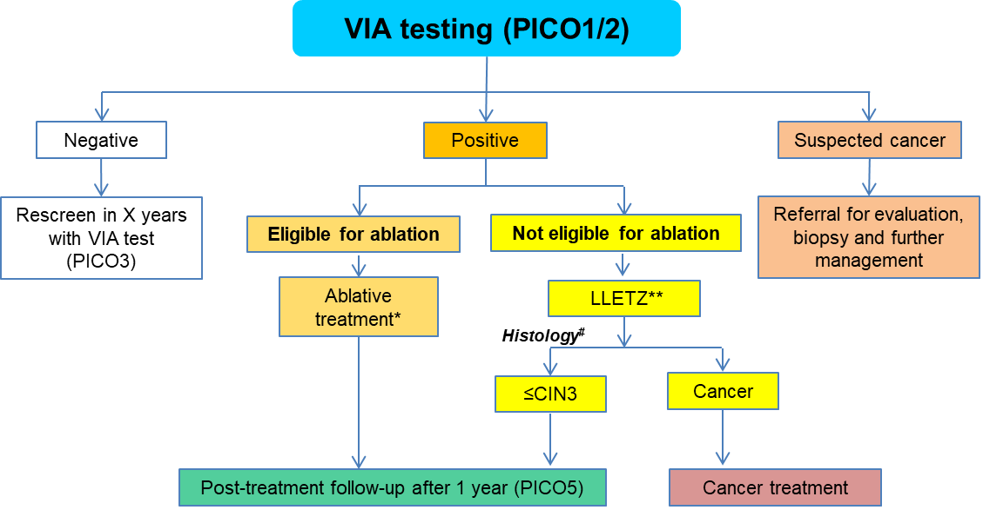
(b) Primary HPV (without triage)
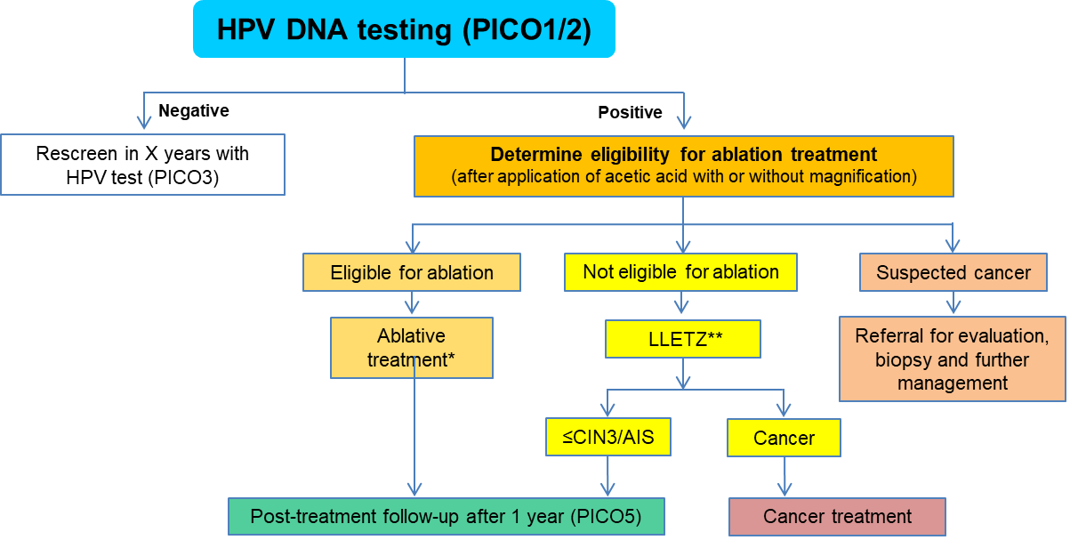
(c) Primary cytology (HPV triage for ASC-US)
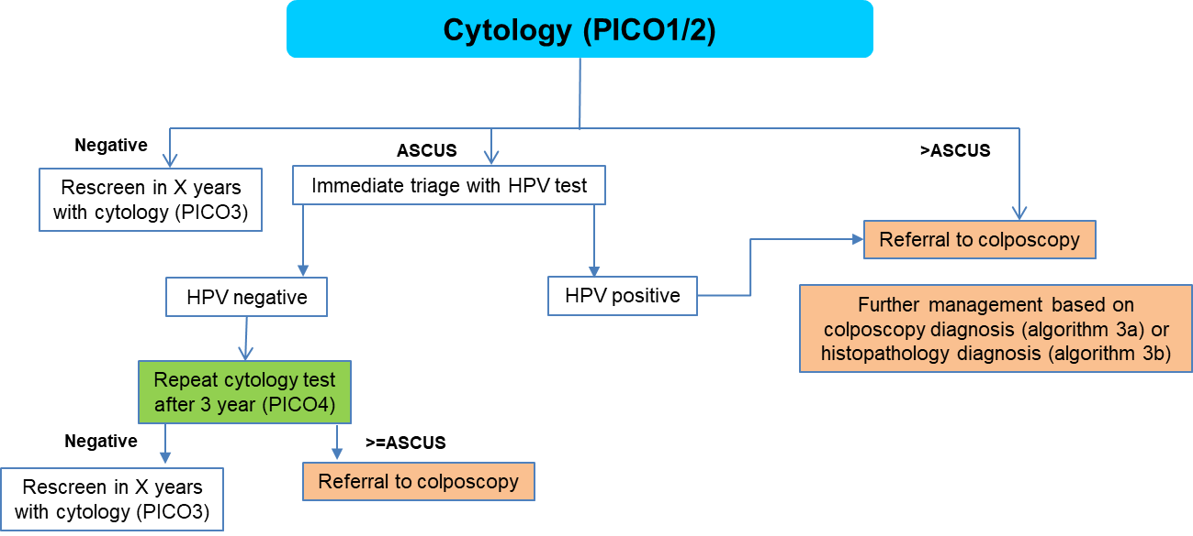

(d) Primary HPV (16/18 triage)
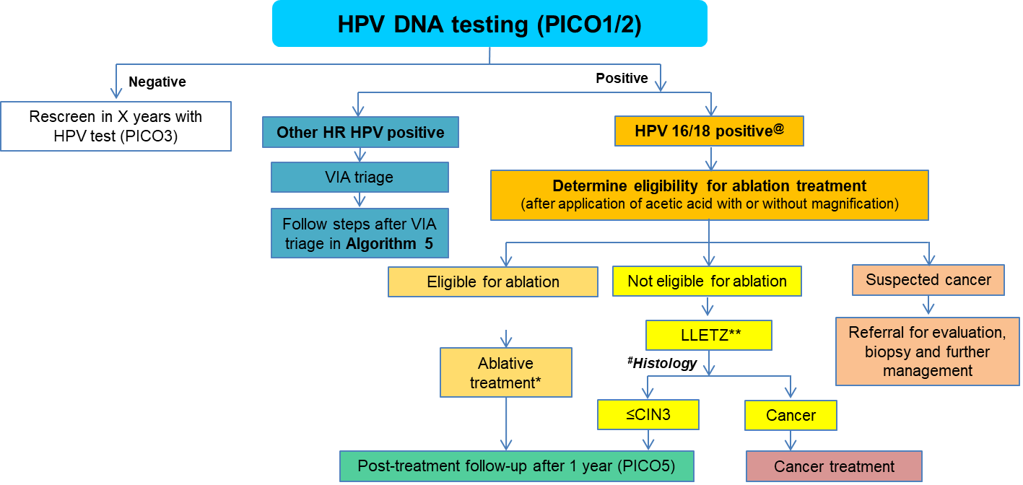

(e) Primary HPV (VIA triage)
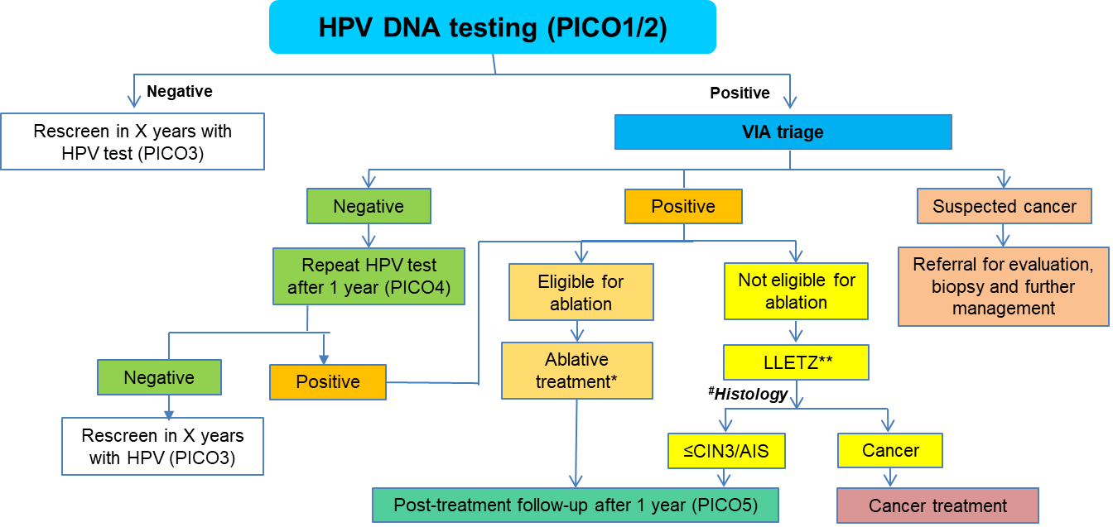
(f) Primary HPV (colposcopy triage)^
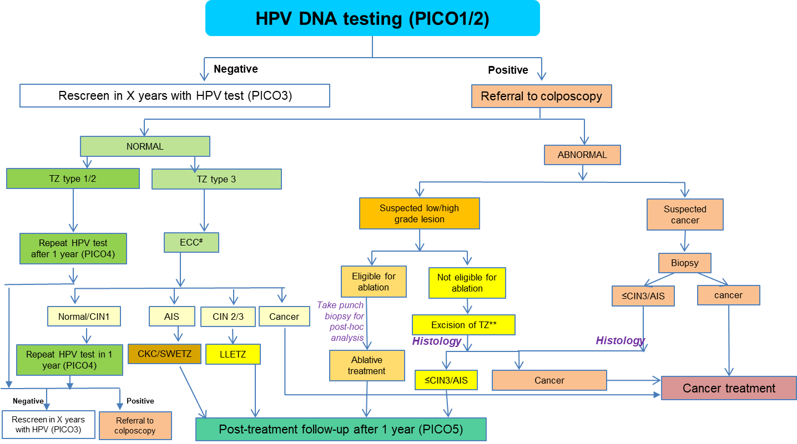
^ Women referred with cytology LSIL or worse at colposcopy will receive biopsy even if theiy have a type 1 or type 2 transformation zone at colpscopy (see Chart G).

(g) Primary HPV (cytology triage)^

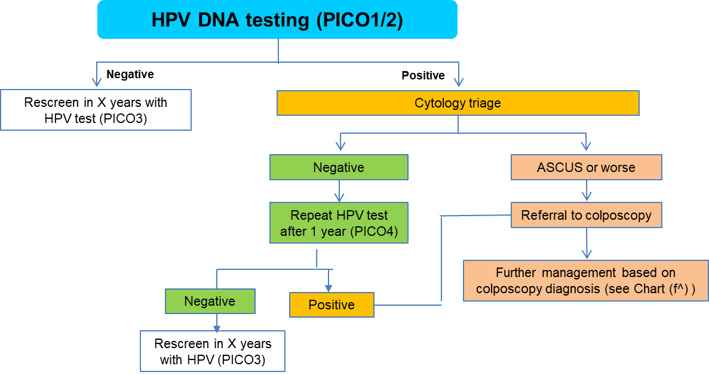^ Women referred with cytology LSIL or worse at colposcopy will receive biopsy even if theiy have a type 1 or type 2 transformation zone at colpscopy.
Appendix Table 4: Model assumptions table
Model inputs | Base case | Source | Lower value explored in sensitivity analysis | Upper value explored in sensitivity analysis | Sources for sensitivity analysis
Birth cohort | Women aged 30 in 2030 (born in 2000) for general women  Women aged 25 in 2030 (born in 2010) for WLHIV  We assume no vaccine impact and no scale-up of cervical cancer treatment for symptomatically-detected cancers. | These birth cohorts were chosen as they represent women who screened for their whole lifetime from 2030 onwards
Screening coverage | 70% | Assumption based on GDG discussions and WHO targets for screening coverage. | 50% |  | Assumption based on GDG discussions
Follow-up adherence | 90% for separate day follow-up (100% for women who attend for ablative treatment or follow-up on the same-day; we assume half of HPV positive cases will have point-of-care HPV testing and the other half require a separate day for follow-up and treatment). | Assumption based on GDG discussions and WHO targets for screening coverage. | 75% for separate day follow-up (we assume 100% follow-up for same day visits). |  | Assumption based on GDG discussions
Ablative treatment success rate | 80% chance of successful treatment for CIN2/3  We assume 15.8% of successfully treated women will retain the infection after treatment. | Based on updated literature review from WHO
Excisional treatment success rate | 93.6% chance of successful treatment for CIN2/3  We assume 15.8% of successfully treated women will retain the infection after treatment. | Based on updated literature review from WHO and prior literature review
Costs (US$), year 2019
Primary VIA | 7.12 | Generated by WHO-CHOICE team | 5.70 | 8.54 | +/-20% (capture uncertainties in costs associated with repeat training)
Primary HPV (+/- 16/18) | 15.09 | Estimated based on CHAI-UNITAID projects and generated by WHO-CHOICE team | 10.56 | 19.62 | +/-30% (encompasses high/low end for HPV test, as well as other uncertainties e.g POC implementation)
Primary cytology | 18.02 | Generated by WHO-CHOICE team | 14.42 | 21.62 | +/-20% (capture uncertainties in costs associated with repeat training)
VIA triage | 2.95 | Generated by WHO-CHOICE team | 2.36 | 3.54 | +/-20% (capture uncertainties in costs associated with repeat training)
Cytology triage | 15.62 | Generated by WHO-CHOICE team | 12.50 | 18.74 | +/-20% (capture uncertainties in costs associated with repeat training)
HPV triage | 8.15 | Generated by WHO-CHOICE team | 5.00 | 10.06 | Predictions based on current highend (upper) and anticipated lower end with higher volumes
Colposcopy | 9.96 | Generated by WHO-CHOICE team | - | -
Ablative treatment | 11.76 | Generated by WHO-CHOICE team | 8.23 | 15.29 | +/- 30%
Excisional treatment | 41.67 | Generated by WHO-CHOICE team | 29.17 | 54.17 | +/- 30%
Histology | 17.96 | Generated by WHO-CHOICE team | - | -
Punch biopsy/Biopsy | 11.61 | Generated by WHO-CHOICE team |  | -
Diag & Tx Stage I | 261.43 | Generated by WHO-CHOICE team | PSA: 209.14  (no lower bound for one-way sensitivity analysis, lower bound considered for PSA only) | one-way: 366.00:  PSA upper bound: 313.72^ | +40% considered for one-way sensitivity analysis.  ^-/+20% variation for probabilistic sensitivity analysis.
Diag & Tx Stage II | 540.23 | Generated by WHO-CHOICE team | PSA: 432.18 (no lower bound for one-way sensitivity analysis, lower bound considered for PSA only) | one-way: 756.32:  PSA upper bound: 648.28^
Diag & Tx Stage III | 673.93 | Generated by WHO-CHOICE team | PSA: 539.14 (no lower bound for one-way sensitivity analysis, lower bound considered for PSA only) | one-way: 943.50:  PSA upper bound: 808.72^
Diag & Tx Stage IV | 307.95 | Generated by WHO-CHOICE team | PSA: 246.36 (no lower bound for one-way sensitivity analysis, lower bound considered for PSA only) | one-way: 431.13:  PSA upper bound: 369.54^
Palliative care | 115.13 | Generated by WHO-CHOICE team
Yearly surveillance | 57.66 | Generated by WHO-CHOICE team | - | -
HALY assumptions: disutilities applied to cancer
Disutility applied for diagnosis of FIGO Stage 1-3 | 0.288 for 12 months | Global Burden of Disease study 2010⁵⁴ | Life-years only | -
Disutility applied for surveillance: | 0.049 from 12m after diagnosis (for a maximum of 5 years after diagnosis) | Global Burden of Disease study 2010⁵⁴ | Life-years only | -
Disutility applied for diagnosis of FIGO Stage 4: | 0.451 from diagnosis to 3 months before death (for a maximum of 5 years after diagnosis) | Global Burden of Disease study 2010⁵⁴ | Life-years only | -
Disutility applied for Palliative care | 0.54 (last three months of life) |  | Life-years only | -
Discount rates (for effects and costs) | 0% effect ; 3% cost | WHO guide for standardization of economic evaluations of immunization programmes⁵⁵ | - | 3% effect ; 3% cost | WHO guide for standardization of economic evaluations of immunization programmes⁵⁵
^ In one-way sensitivity analysis for costs associated with cancer treatment, we considered an upper bound of +40% for each of the four cancer stages to explore the impact of much higher cancer treatment costs; but for probabilistic sensitivity analysis, we considered +/-20% variation in costs.

Discount rates
The 0% discount rate for effect and 3% discount for costs was applied in the base case and a 3% discount rate for both costs and effects was applied in sensitivity analysis, as recommended by WHO for health economic evaluation of vaccination programs.⁵⁵ Although these guidelines were developed for vaccine evaluations, we used them here for this screening evaluation based on expert advice from WHO.

World Standard Population
As done in previous evaluations,^{8,9,56,57} we used the World Standard Population (WSP) 2015 for ages 0-99 years to calculate ASR for cervical cancer incidence and mortality (see Table 5, Technical Appendix). When estimating the effects across a group of countries, the UN 2015 population estimates are used as the relative weighting for each country.

Health economic conventions
Cost-effectiveness analysis was conducted for the general women population at all-78 LMIC level using 2015 population structure for population-weighted contribution of each country. Findings were presented as cost per health adjusted life-years saved (HALYS). Life-years saved and (LYS) and $/LYS were explored in sensitivity analysis.
There is no defined willingness-to-pay (WTP) when presenting cost-effectiveness at this multi-country average. As a reference point for a potential WTP threshold in this population, the population-weighted average GDP per capita (pc) for 2019 across the 78 LMIC is US$2,099. Furthermore, 71 of 78 LMICs (91%) have a GDP pc equal to or above US$518, 52 of 78 LMICs (67%) have GDP pc equal to or above US$1000, and 29 out of 78 LMICs (37%) have GDP pc equal to or above US$2000, according to the 2019 World Bank database.⁵⁸ (see Appendix Table 5 for a country-level list of GDP per-capita). The use of these macroeconomic thresholds will allow reasonable comparison across countries with very different economic profiles (although it is acknowledged that such thresholds are of limited utility for within-country CEA).^{59,60} We identify strategies that appear on, or near, the cost-effectiveness frontier as being the strategies with the best balance of costs and effects.

Costs
A health services/provider perspective was adopted for this analysis, with costs provided by WHO-CHOICE. They were provided separately for each of the 78 LMICs and we present the population-weighted aggregate cost (across ages 30-49) of each event across the 78 LMICs (‘normative’ approach). Only direct medical costs were included, namely: labour costs, consumable/supplies/equipment costs. Where applicable, some administrative and overhead costs were included (e.g. HPV test costs). Out-of-pocket and lost productively costs were not included. We considered the variation of costs in probabilistic sensitivity analysis. All costs are in US$2019 price, and are shown in Table 2 of the main manuscript.

Invasive cancer treatment was costed by stage (FIGO staging). Costs for treatment were applied to the first year and included one episode of surgery plus hospitalization and multiple episodes of radiotherapy and chemotherapy. Costs for surveillance were applied from 12 months after diagnosis until death, or a maximum of 5 years after diagnosis. Costs are calculated in terms of a wrapped up cost by stage at diagnosis that includes costs for the average surveillance time based on survival times for that stage with weights to indicate how many women would access this (treatment access proportion). Costs for palliative care are applied in the year that cervical cancer death occurs (or no costs applied if the woman dies from other causes).

Model of obstetric complications
To evaluate adverse obstetric outcomes due to precancer treatment, we developed a Monte Carlo individual-based simulation model which incorporates country-specific and age-specific fertility rates, as well as precancer treatment outcomes by mode of treatment, and explicitly model additional preterm delivery events as a result of precancer treatments. We obtained national age-specific fertility rates for each of the 78 LMICs from the United Nations (2019),⁶¹ and performed a population-weighted average to generate fertility rates for all-78 LMIC. Predictions from Policy1-Cervix on age-specific treatment rates were an input to the obstetric outcomes model. Systematic reviews indicate that the risk of preterm delivery after excision is higher than the risk after ablation (excision versus no treatment: 11.2% versus 5.5%, RR 1.87, 95% CI 1.64 to 2.12; ablation versus no treatment: 7.7% versus 4.6%, RR 1.35, 95% CI 1.20 to 1.52).⁶² Combining systematic review evidence on the risk of preterm delivery with a detailed model of cervical screening and precancer treatment for Australia,³⁶ and Australian fertility data, we estimated that women with a history of excisional treatment have an excess probability of preterm delivery of 4.8% for each subsequent pregnancy. Considering the systematic review data on the increased risk of preterm delivery after ablation versus excision,⁶² we estimate the additional probability of preterm delivery per pregnancy in women with a history of ablation without excision is (1.35-1)/(1.87-1)*4.8%=1.9%. We assumed that multiple treatments of the same type do not generate any additional risk of adverse pregnancy outcomes. We also considered a scenario in which ablative treatments did not increase the probability of preterm deliveries for subsequent pregnancies.

Calculating normative costs, HALYs and cost-effectiveness across 78 LMICs

Costs
Let $m_{r}$ be the average unit cost of resource r across the 78 countries (either as given in WHO data or population-weighted over countries) and let $u_{a,r}^{i,c}$ be the probability of using that resource r at age a in country c for scenario i. The 78-country aggregated average probability of resource r being used at age a in scenario i is:
$U_{a,r}^{i}$ = $(\sum_{c}{u_{a,r}^{i,c} n_{a}^{c})/N_{a}}$
The total costs of all resources at each age in scenario i is:
$$M_{a}^{i}= L_{a}^{i}\sum_{r}{m_{r}}U_{a,r}^{i}$$
i.e. the sum of the cost-weighted rates of each resource at that age multiplied by the alive population at that age.
We can then divide by $L_{10}$ and sum to obtain the discounted costs as usual:
$$M_{i}=(\frac{1}{L_{10}})\sum_{a}{M_{a}^{i}}{\left(1-δ\right)}^{-(a-10)}$$
where δ is the discount rate.

HALYs
To measure the effects of screening, Health adjusted Life-Years (HALY) were used in base case and life-years were explored in sensitivity analysis.

To calculate the life years, we use the country-level incidence and mortality rates combined with the all-cause mortality rates from the UN Population Division webpage.⁵³

Let $p_{a}^{c}$ be the probability of dying from all causes at age a in country c and let $γ_{a}^{i,c}$ be the probability of dying from cervical cancer at age a in scenario i in country c. We define the probability of dying from causes other than cervical cancer at age a in country c to be:
$$q_{a}^{c}=p_{a}^{c}- γ_{a}^{0,c}$$
We use United Nations population estimates and projections of each country for 2015, defined as $n_{a}^{c}$ for age a in country c. The age-specific population over all countries is then $N_{a}= \sum_{c}{n_{a}^{c}}$
Then we obtain the average 78 countries probability of dying of cervical cancer by taking the population-weighted average: $Γ_{a}^{i}=(\sum_{c}{n_{a}^{c}γ_{a}^{i,c})/N_{a}}$
Similarly, we obtain the 78-countries average of other-cause mortality: $Q_{a}=(\sum_{c}{n_{a}^{c}q_{a}^{c}})/N_{a}$
We assume the population alive at age 10 across the 78 countries is $L_{10}= N_{10}$
From this we can incrementally calculate the number alive at subsequent ages in a hypothetical global cohort: $L_{a+1}^{i}=L_{a}^{i}(1-Q_{a}- Γ_{a}^{i})$
We can then divide each of the number alive by $L_{10}$ and sum to obtain the discounted life-years as usual:
$$L_{i}=\left(\frac{1}{L_{10}}\right)\sum_{a}{L_{a}^{i}}{\left(1-δ\right)}^{-(a-10)}$$
where δ is the discount rate.

To calculate HALYs, we used the disability weights shown in Appendix Table 4. Let $A_{s}^{c}$ be the wrapped-up disutility of being diagnosed (i.e. the cervical cancer incidence) and ongoing surveillance with FIGO stage s in country c.
Let B be the disutility of palliative care (cervical cancer mortality), which is the same for all countries and stages.
Let $θ_{a,s}^{i,c}$ be the probability of being diagnosed with FIGO stage s cervical cancer at age a in country c for scenario i.
Then $Θ_{a,s}^{i}= \sum_{c}{{{A_{s}^{c}n}_{a}^{c}θ}_{a,s}^{i,c}}$ is the average disutility of diagnoses and ongoing treatments of each stage s of 78 countries for age a and scenario i.
We then estimate each HALY as: $H_{a}^{i}=L_{a}^{i}(1- \sum_{s=1}^{4}{Θ_{a,s}^{i}-BΓ_{a}^{i}}$)
We can then divide by $L_{10}$ and sum to obtain the discounted HALYS as usual:
$$H_{i}=(\frac{1}{L_{10}})\sum_{a}{H_{a}^{i}}{\left(1-δ\right)}^{-(a-10)}$$
where δ is the discount rate.

Calculating incremental cost-effectiveness ratios
Putting these all the above together, the incremental cost-effectiveness ratio (ICER) between two scenarios i and j at the 78 aggregated countries is then calculated the usual way:
$$ICER_{ij}= \frac{M_{i}- M_{j}}{H_{i}- H_{j}}$$

Country list
Appendix Table 5: List of included LMIC in the analysis
Country | WHO Region | Female population, 2020 (30-49 years) ('000)⁶³ | GDP pc (World Bank 2019⁵⁸ unless noted otherwise)
Afghanistan | South Asia | 3586 | 507
Angola | Sub-Saharan Africa | 3138 | 2791
Bangladesh | South Asia | 23841 | 1856
Benin | Sub-Saharan Africa | 1222 | 1219
Bhutan | South Asia | 103 | 3316
Bolivia | Latin America & Caribbean | 1437 | 3552
Burkina Faso | Sub-Saharan Africa | 2029 | 787
Burundi | Sub-Saharan Africa | 1572 | 261
Cape Verde | Sub-Saharan Africa | 77 | 3604
Cambodia | East Asia & Pacific | 2246 | 1643
Cameroon | Sub-Saharan Africa | 2770 | 1507
Central African Republic | Sub-Saharan Africa | 423 | 468
Chad | Sub-Saharan Africa | 1424 | 710
Comoros | Sub-Saharan Africa | 96 | 1370
Congo Dem. Rep. | Sub-Saharan Africa | 8248 | 581
Congo | Sub-Saharan Africa | 608 | 2280
Cote d'Ivoire | Sub-Saharan Africa | 2625 | 2276
Djibouti | Middle East & North Africa | 135 | 3415
Egypt | Middle East & North Africa | 12972 | 3019
El Salvador | Latin America & Caribbean | 903 | 4187
Eritrea | Sub-Saharan Africa | 374 | 567*
Ethiopia | Sub-Saharan Africa | 11462 | 856
The Gambia | Sub-Saharan Africa | 237 | 778
Georgia | Europe & Central Asia | 553 | 4698
Ghana | Sub-Saharan Africa | 3555 | 2202
Guinea | Sub-Saharan Africa | 1298 | 963
Guinea-Bissau | Sub-Saharan Africa | 215 | 697
Haiti | Latin America & Caribbean | 1460 | 1272
Honduras | Latin America & Caribbean | 1270 | 2575
India | South Asia | 185040 | 2100
Indonesia | East Asia & Pacific | 39405 | 4136
Kenya | Sub-Saharan Africa | 6259 | 1817
Korea Dem. Rep. | East Asia & Pacific | 3644 | 640*
Kyrgyz Republic | Europe & Central Asia | 858 | 1309
Lao PDR | East Asia & Pacific | 927 | 2535
Lesotho | Sub-Saharan Africa | 258 | 1118
Liberia | Sub-Saharan Africa | 535 | 622
Madagascar | Sub-Saharan Africa | 2889 | 523
Malawi | Sub-Saharan Africa | 1912 | 412
Mali | Sub-Saharan Africa | 1839 | 879
Mauritania | Sub-Saharan Africa | 517 | 1679
Moldova | Europe & Central Asia | 668 | 4504
Mongolia | East Asia & Pacific | 497 | 4340
Morocco | Middle East & North Africa | 5232 | 3204
Mozambique | Sub-Saharan Africa | 3094 | 504
Myanmar | East Asia & Pacific | 7926 | 1408
Nepal | South Asia | 4230 | 1071
Nicaragua | Latin America & Caribbean | 942 | 1913
Niger | Sub-Saharan Africa | 1978 | 554
Nigeria | Sub-Saharan Africa | 20453 | 2230
Pakistan | South Asia | 25495 | 1285
Papua New Guinea | East Asia & Pacific | 1058 | 2829
Philippines | East Asia & Pacific | 13821 | 3485
Rwanda | Sub-Saharan Africa | 1498 | 820
Sao Tome and Principe | Sub-Saharan Africa | 23 | 1947
Senegal | Sub-Saharan Africa | 1819 | 1447
Sierra Leone | Sub-Saharan Africa | 832 | 528
Solomon Islands | East Asia & Pacific | 77 | 2374
Somalia | Sub-Saharan Africa | 1321 | 105*
South Sudan | Sub-Saharan Africa | 1119 | 1120 (2015)
Sri Lanka | South Asia | 3006 | 3853
Sudan | Sub-Saharan Africa | 4560 | 442
Swaziland | Sub-Saharan Africa | 174 | 3895
Syrian Arab Republic | Middle East & North Africa | 2440 | 1194*
Tajikistan | Europe & Central Asia | 1144 | 871
Tanzania | Sub-Saharan Africa | 6009 | 1122
Timor-Leste | East Asia & Pacific | 129 | 1561
Togo | Sub-Saharan Africa | 911 | 679
Tunisia | Middle East & North Africa | 1792 | 3317
Uganda | Sub-Saharan Africa | 4283 | 794
Ukraine | Europe & Central Asia | 6861 | 3659
Uzbekistan | Europe & Central Asia | 4791 | 1725
Vanuatu | East Asia & Pacific | 36 | 3115
Viet Nam | East Asia & Pacific | 14787 | 2715
Palestine | Middle East & North Africa | 548 | 3562 (2018)
Yemen | Middle East & North Africa | 3217 | 774
Zambia | Sub-Saharan Africa | 1838 | 1305
Zimbabwe | Sub-Saharan Africa | 1727 | 1464
* Sourced from UN Data. 2019. (Accessed February 10, 2021 at https://data.un.org/).

HPV-FRAME reporting standard checklist for the general population of women
The checklist below includes core reporting standard, reporting standard for model of HPV vaccination, model of integrated HPV vaccination and cervical screening, and model for LMICs, according to Canfell et al, 2019.⁶⁴

Appendix Table 6: HPV-FRAME reporting standard checklist for the modelling in the general population of women
- Inputs | Reported?  (Y/N) | Reported by age? (Y/N) | Report by sex (F-only, M-only or both)? | Comments
Core reporting standard
Target population for intervention | Y | Y | F | Cohort of women who would turn 30 in 2030 for the general population.  Screening algorithms target between ages 30-50.
Sexual behaviour | N | N | N | Implicitly accounted for in calibration. Data not directly used since vaccination is not modelled here and therefore a dynamic transmission model is not required.
Cohort examined for evaluation/ time horizon | Y | Y | F-only | The lifetime of a single cohort of women turning 30 in 2030. For CEA, discounting is applied from age 30 onwards.
Quality of life assumptions | Y | Y | F-only | Listed in Technical Appendix Table 3 (based on Global Burden of Disease study 2010⁵⁴).
Calibration | Y | Y | F-only | Reproduces GLOBOCAN 2018 incidence at a country level. The models were then calibrated to final mortality outcomes to country- and age-specific rates from GLOBOCAN 2018 by incorporating a ‘quality factor’ into the final estimated country- and stage-specific survival assumptions. Details on this calibration in previous CCEMC work.^{2,3}
Validation (where possible) | Y | Y  (implicitly) | F-only | The models has previously been used to evaluate various HPV vaccination and cervical screening strategies for many countries, including high- resource countries, low-resource settings and globally (see Technical Appendix, page 5).
Costs | Y | Y (implicitly) | F-only | Same unit costs are assumed regardless of age and are listed in Table 2 and Technical Appendix, Table 3.
Reporting standard for model of cervical screening
Routine screening behaviour (routine and follow-up and test of cure) | Y | Y | F-only | We assumed 70% of women attend a given routine screen with 90% adherence except for some circumstances such as where HPV point-of-care is possible. This is listed in the main text methods and Technical Appendix, Table 3.
Screening test (s) and colposcopy accuracies | Y | Y (implicitly) | F-only | Sensitivity and specificity of tests for CIN2+ are listed in Technical Appendix Table 3.
Abnormal test management (primary and triage) | Y | Y | F-only | Flowcharts are detailed in Technical Appendix Figure 5 and the algorithms (age eligibility, routine screening frequency) are detailed in Table 1 and Technical Appendix, Table 1.
Diagnostic follow-up of abnormal tests | Y | Y | F-only | Flowcharts are detailed in Technical Appendix Figure 5 and the algorithms (age eligibility, routine screening frequency) are detailed in Table 1 and Technical Appendix, Table 1.
Management by disease grade (confirmed disease) | Y | Y | F-only | Flowcharts are detailed in Technical Appendix Figure 5 and the algorithms (age eligibility, routine screening frequency) are detailed in Table 1 and Technical Appendix, Table 1.
Sources of information for screening structure and parameterization | Y | Y | F-only | Specified in main text as being part of the GDG development process.
Reporting standard for models of HPV prevention in LMIC
HIV prevalence rates, if endemic in country | N | N | N | We did not explicitly take into account HIV prevalence in this study. This is addressed in a companion study.
Description of any opportunistic or pilot/demonstration screening project ongoing | N | N | N | As this study models the impact of HPV vaccination and cervical screening strategies in 78 LMICs, this is not relevant.

- Outputs | Reported?  (Y/N) | Reported by age? (Y/N) | Report by sex (F-only, M-only or both)? | Report as calibration or validation target? (Y/N)
Core reporting standard
Cancer incidence, mortality, life years, QALYs/DALYs (as appropriate) | Y | Y (implicitly) | F-only | Age-standardized and age-specific incidence and mortality rates were reported along with cases and deaths per 100,000 women. HALYS (Health-adjusted life years saved) were reported for the main results and life years were reported as part of the sensitivity analysis. Age-specific results not directly reported but are critical to calculation of HALYS and ASRs.
HPV prevalence, pre-intervention | N | N | N | This level of detail is not reported. Herd immunity effects could be a factor for vaccination but vaccination is not modelled in this paper.
CIN2 detected | N | N | N | This level of detail is not reported.
Sensitivity analysis on key inputs | Y | Y (implicitly) | F-only | One-way sensitivity analysis were performed for adherence rates and primary test performance. Life years were assessed along with equal discounting for both HALYs and costs. Probabilistic sensitivity analysis was performed for costs.  (see Figure 6 and Results Appendix)
Incremental cost-effectiveness ratios and costs saved | Y | N | F-only | ICERs along the cost-effectiveness frontiers are displayed (Figure 3 and Results Appendix Figure 6).
QALYs: quality-adjusted life-years

References

1. World Health Orgaization. WHO guidelines for screening and treatment of precancerous lesions for cervical cancer prevention. 2013; https://apps.who.int/iris/bitstream/handle/10665/94830/9789241548694_eng.pdf?sequence=1. Accessed 12/01/2020.
2. Shastri SS, Mittra I, Mishra GA, et al. Effect of VIA screening by primary health workers: randomized controlled study in Mumbai, India. J Natl Cancer Inst. 2014;106(3):dju009.
3. Sankaranarayanan R, Nene BM, Shastri SS, et al. HPV screening for cervical cancer in rural India. N Engl J Med. 2009;360(14):1385-1394.
4. World Health Organisation. Global strategy to accelerate the elimination of cervical cancer as a public health problem. 2020; https://www.who.int/publications/i/item/9789240014107. Accessed 12/01/2021.
5. World Health Organisation. WHO list of prequalified in vitro diagnostic products. 2020; https://www.who.int/diagnostics_laboratory/evaluations/201013_prequalified_product_list.pdf?ua=1. Accessed 19/01/2021.
6. World Health Organisation. WHO guidelines for the use of thermal ablation for cervical pre-cancer lesions. Geneva,2019. Licence: CC BY-NC-SA 3.0 IGO.
7. World Health Organisation. WHO guideline for screening and treatment of cervical pre-cancer lesions for cervical cancer prevention, second edition 2021.
8. Canfell K, Kim JJ, Brisson M, et al. Mortality impact of achieving WHO cervical cancer elimination targets: a comparative modelling analysis in 78 low-income and lower-middle-income countries. Lancet (London, England). 2020;395(10224):591-603.
9. Brisson M, Kim JJ, Canfell K, et al. Impact of HPV vaccination and cervical screening on cervical cancer elimination: a comparative modelling analysis in 78 low-income and lower-middle-income countries. Lancet (London, England). 2020;395(10224):575-590.
10. Simms KT, Steinberg J, Caruana M, et al. Impact of scaled up human papillomavirus vaccination and cervical screening and the potential for global elimination of cervical cancer in 181 countries, 2020-99: a modelling study. Lancet Oncol. 2019;20(3):394-407.
11. Burger EA, Smith MA, Killen J, et al. Projected time to elimination of cervical cancer in the USA: a comparative modelling study. The Lancet Public Health. 2020.
12. Hall MT, Simms KT, Lew JB, et al. The projected timeframe until cervical cancer elimination in Australia: a modelling study. Lancet Public Health. 2019;4(1):e19-e27.
13. Lew JB, Simms KT, Smith MA, et al. Primary HPV testing versus cytology-based cervical screening in women in Australia vaccinated for HPV and unvaccinated: effectiveness and economic assessment for the National Cervical Screening Program. Lancet Public Health. 2017;2(2):e96-e107.
14. Lew J-B, Simms K, Smith M, Lewis H, Neal H, Canfell K. Effectiveness Modelling and Economic Evaluation of Primary HPV Screening for Cervical Cancer Prevention in New Zealand. PLoS ONE. 2016;11(5):e0151619.
15. Kitchener HC, Canfell K, Gilham C, et al. The clinical effectiveness and cost-effectiveness of primary human papillomavirus cervical screening in England: extended follow-up of the ARTISTIC randomised trial cohort through three screening rounds. Health Technol Assess. 2014;18(23):1-196.
16. Smith MA, Gertig D, Hall M, et al. Transitioning from cytology-based screening to HPV-based screening at longer intervals: implications for resource use. BMC Health Services Research. 2016;16(1):1.
17. Hall MT, Smith MA, Lew J-B, et al. The combined impact of implementing HPV immunisation and primary HPV screening in New Zealand: Transitional and long-term benefits, costs and resource utilisation implications. Gynecologic Oncology. 2019;152(3):472-479.
18. Hall MT, Simms KT, Lew J-B, Smith MA, Saville M, Canfell K. Projected future impact of HPV vaccination and primary HPV screening on cervical cancer rates from 2017-2035: Example from Australia. PLoS One. 2018;13(2):e0185332.
19. Simms KT, Hall M, Smith MA, et al. Optimal Management Strategies for Primary HPV Testing for Cervical Screening: Cost-Effectiveness Evaluation for the National Cervical Screening Program in Australia. PLoS One. 2017;12(1):e0163509.
20. Smith MA, Hall MT, Saville M, et al. Could HPV testing on self-collected samples be routinely used in an organised cervical screening program? A modelled analysis. Cancer epidemiology, biomarkers & prevention : a publication of the American Association for Cancer Research, cosponsored by the American Society of Preventive Oncology. 2021;30(2):268-277.
21. Canfell K, Clements M, Harris J. Cost-effectiveness of proposed changes to the national cervical screening program. 2008.
22. Medical Services Advisory Committee. Human Papillomavirus Triage Test For Women With Possible or Definite Low-Grade Squamous Intraepithelial Lesions. MSAC reference 39, Assessment report. Canberra: Australian Government Department of Health;2009.
23. Canfell K, Barnabas R, Patnick J, Beral V. The predicted effect of changes in cervical screening practice in the UK: results from a modelling study. British journal of cancer. 2004;91(3):530-536.
24. Canfell K, Lew JB, Smith M, Walker R. Cost-effectiveness modelling beyond MAVARIC study end-points. In: Kitchener HC, Blanks R, Cubie H, et al., eds. MAVARIC - a comparison of automation-assisted and manual cervical screening: a randomised controlled trial. Health Technology Assessment ; Vol. 15: No. 3.2011.
25. Medical Services Advisory Committee. Automation Assisted and Liquid Based Cytology for Cervical Cancer Screening. MSAC reference 1122, Assessment report. Canberra: Australian Government Department of Health;2009.
26. Legood R, Smith M, Lew J-B, et al. Cost effectiveness of human papillomavirus test of cure after treatment for cervical intraepithelial neoplasia in England: economic analysis from NHS Sentinel Sites Study. BMJ. 2012;345:e7086.
27. Canfell K, Shi JF, Lew JB, et al. Prevention of cervical cancer in rural China: evaluation of HPV vaccination and primary HPV screening strategies. Vaccine. 2011;29(13):2487-2494.
28. Shi JF, Canfell K, Lew JB, et al. Evaluation of primary HPV-DNA testing in relation to visual inspection methods for cervical cancer screening in rural China: an epidemiologic and cost-effectiveness modelling study. BMC Cancer. 2011;11(1):239.
29. Smith MA, Canfell K, Brotherton JM, Lew JB, Barnabas RV. The predicted impact of vaccination on human papillomavirus infections in Australia. International journal of cancer Journal international du cancer. 2008;123(8):1854-1863.
30. Simms KT, Hanley SJB, Smith MA, Keane A, Canfell K. Impact of HPV vaccine hesitancy on cervical cancer in Japan: a modelling study. Lancet Public Health. 2020;5(4):e223-e234.
31. Simms KT, Smith MA, Lew JB, Kitchener HC, Castle PE, Canfell K. Will cervical screening remain cost-effective in women offered the next generation nonavalent HPV vaccine? Results for four developed countries. Int J Cancer. 2016;139(12):2771-2780.
32. Smith MA, Lew JB, Walker RJ, Brotherton JM, Nickson C, Canfell K. The predicted impact of HPV vaccination on male infections and male HPV-related cancers in Australia. Vaccine. 2011;29(48):9112-9122.
33. Simms KT, Laprise J-F, Smith MA, et al. Cost-effectiveness of the next generation nonavalent human papillomavirus vaccine in the context of primary human papillomavirus screening in Australia: a comparative modelling analysis. The Lancet Public Health. 2017;1(2):e66-e75.
34. Smith MA, Canfell K. Testing previous model predictions against new data on human papillomavirus vaccination program outcomes. BMC Res Notes. 2014;7(1):109.
35. Lew JB, Simms K, Smith MA, et al. National Cervical Screening Program Renewal: Effectiveness modelling and economic evaluation in the Australian setting (Assessment Report). MSAC application number 1276. Canberra: Department of Health 2014.
36. Velentzis LS, Caruana M, Simms KT, et al. How will transitioning from cytology to HPV testing change the balance between the benefits and harms of cervical cancer screening? Estimates of the impact on cervical cancer, treatment rates and adverse obstetric outcomes in Australia, a high vaccination coverage country. International Journal of Cancer. 2017;141(12):2410-2422.
37. Smith MA, Hall M, Lew JB, Canfell K. Potential for HPV vaccination and primary HPV screening to reduce cervical cancer disparities: Example from New Zealand. Vaccine. 2018;36(42):6314-6324.
38. Cancer Council NSW. Policy1-Cervix Documentation. 2019; https://www.policy1.org/models/cervix/documentation/policy1-cervix-v1_0.pdf. Accessed 14th February 2020.
39. Hall MT, Smith MA, Simms KT, Barnabas R, Canfell K, Murray JM. The past, present and future impact of HIV prevention and control on HPV and cervical disease in Tanzania: a modelling study. PLoS One 2019 (submitted).
40. Kelly HJ, I; Arbyn, A; Sanjose, S. Diagnostic accuracy of cervical cancer screening strategies for high-grade cervical intraepithelial neoplasia among women living with HIV: a systematic review and meta-analysis. unpublished.
41. Koliopoulos G, Nyaga VN, Santesso N, et al. Cytology versus HPV testing for cervical cancer screening in the general population. Cochrane Database of Systematic Reviews. 2017(8).
42. Arbyn M, Rezhake R, Yuill S, Canfell K. Triage of women with a positive HPV test at screening. Unpublished.
43. Arbyn M, Roelens J, Cuschieri K, et al. The APTIMA HPV assay versus the Hybrid Capture 2 test in triage of women with ASC-US or LSIL cervical cytology: a meta-analysis of the diagnostic accuracy. International journal of cancer Journal international du cancer. 2013;132(1):101-108.
44. Sauvaget C, et.al. Ablative and excisional treatment success: Systematic review. Unpublished.
45. Bigrigg A, Haffenden DK, Sheehan AL, Codling BW, Read MD. Efficacy and safety of large-loop excision of the transformation zone. Lancet. 1994;343(8888):32-34.
46. Cecchini S, Visioli CB, Zappa M, Ciatto S. Recurrence after treatment by loop electrosurgical excision procedure (LEEP) of high-grade cervical intraepithelial neoplasia. Tumori. 2002;88(6):478-480.
47. Paraskevaidis E, Lolis ED, Koliopoulos G, Alamanos Y, Fotiou S, Kitchener HC. Cervical intraepithelial neoplasia outcomes after large loop excision with clear margins. Obstet Gynecol. 2000;95(6 Pt 1):828-831.
48. Powell B. The use of large loop excision of the transformation zone (LLETZ) in an outpatient setting. The Australian & New Zealand journal of obstetrics & gynaecology. 1996;36(3):338-346.
49. Ryu A, Nam K, Kwak J, Kim J, Jeon S. Early human papillomavirus testing predicts residual/recurrent disease after LEEP. J Gynecol Oncol. 2012;23(4):217-225.
50. van der Aa MA, Schutter EM, Looijen-Salamon M, Martens JE, Siesling S. Differences in screening history, tumour characteristics and survival between women with screen-detected versus not screen-detected cervical cancer in the east of The Netherlands, 1992-2001. European journal of obstetrics, gynecology, and reproductive biology. 2008;139(2):204-209.
51. Zucchetto A, Ronco G, Giorgi Rossi P, et al. Screening patterns within organized programs and survival of Italian women with invasive cervical cancer. Preventive medicine. 2013;57(3):220-226.
52. Andrae B, Andersson TM, Lambert PC, et al. Screening and cervical cancer cure: population based cohort study. Bmj. 2012;344:e900.
53. United Nations. World Population Prospects: The 2015 Revision. 2015; https://esa.un.org/unpd/wpp/.
54. Salomon JA, Vos T, Hogan DR, et al. Common values in assessing health outcomes from disease and injury: disability weights measurement study for the Global Burden of Disease Study 2010. Lancet (London, England). 2012;380(9859):2129-2143.
55. World Health Orgaization. WHO guide for standardization of economic evaluations of immunization programmes, 2nd edition. 2019. Licence: CC BY-NC-SA 3.0 IGO; https://apps.who.int/iris/rest/bitstreams/1257211/retrieve. Accessed 20/01/2021.
56. Simms KT, Steinberg J, Caruana M, et al. Impact of scaled up human papillomavirus vaccination and cervical screening and the potential for global elimination of cervical cancer in 181 countries, 2020-99: a modelling study. The lancet oncology. 2019.
57. Hall MT, Simms KT, Lew JB, et al. The projected timeframe until cervical cancer elimination in Australia: a modelling study. The Lancet Public health. 2018.
58. World Bank. GDP per capita (current US$). [Internet]. 2019; https://data.worldbank.org/indicator/NY.GDP.MKTP.CD. Accessed August 9, 2019.
59. Bertram MY, Lauer JA, De Joncheere K, et al. Cost-effectiveness thresholds: pros and cons. Bulletin of the World Health Organization. 2016;94(12):925-930.
60. Newall AT, Jit M, Hutubessy R. Are current cost-effectiveness thresholds for low- and middle-income countries useful? Examples from the world of vaccines. Pharmacoeconomics. 2014;32(6):525-531.
61. Nations U. Department of Economic and Social Affairs Population: Fertility. 2019; Age-specific fertility. Available at: https://population.un.org/wpp/Download/Standard/Fertility/. Accessed 13/10/2020.
62. Kyrgiou M, Athanasiou A, Kalliala IEJ, et al. Obstetric outcomes after conservative treatment for cervical intraepithelial lesions and early invasive disease. Cochrane Database of Systematic Reviews. 2017(11).
63. United Nations, Department of Economic and Social Affairs, Population Division (2019). World Population Prospects: The 2019 Revision. [Internet]. 2019; https://population.un.org/wpp/Download/Standard/Population/. Accessed November 13, 2020.
64. Canfell K, Kim JJ, Kulasingam S, et al. HPV-FRAME: A consensus statement and quality framework for modelled evaluations of HPV-related cancer control. Papillomavirus Res. 2019;8:100184.

