Characterization of functional amyloid curli in biofilm formation of Enterobacter cloacae SBP-8

Tripti Misra, Meghna Taare, Prabhat Nath Jha
Department of Biological Sciences,
Birla Institute of Technology and Science, Pilani-333031, Rajasthan, India
SUPPLEMENTARY DATA:
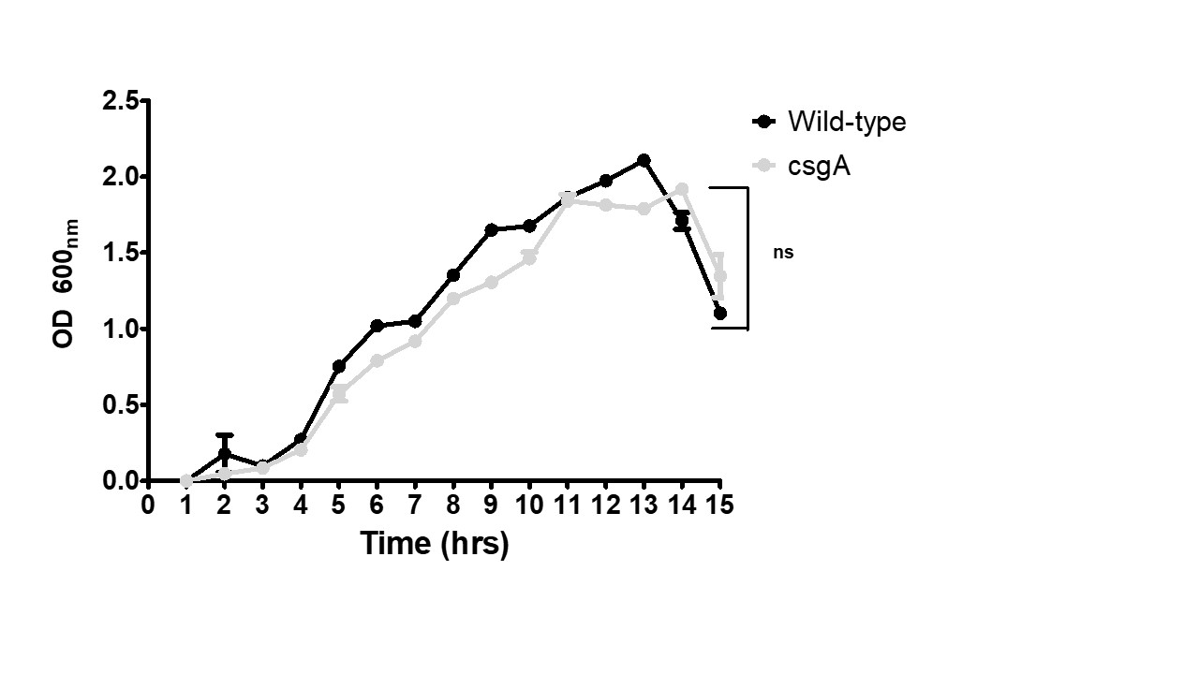
Figure S1 : Growth curve depicting the bacterial growth of Enterobacter cloacae SBP-8 wild-type strain and its corresponding mutant (Δ csgA). Bacterial strains were grown in YESCA broth, and optical density was recorded at (OD₆₀₀) every 1 hour .

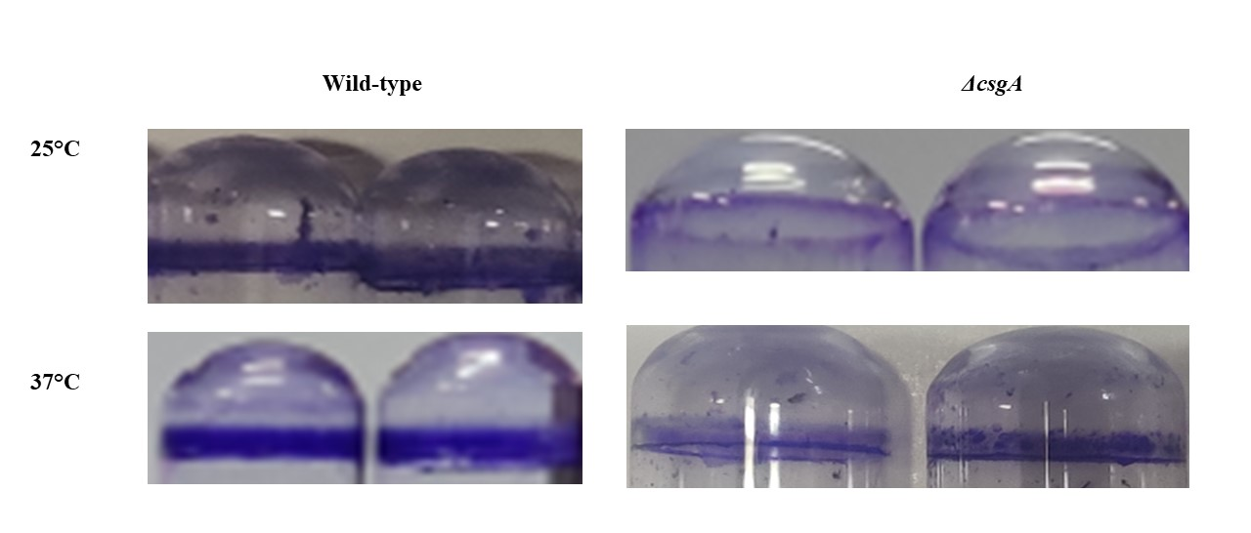Figure S2: Crystal violet assay showing adherence to the tubes at 25 and 37°C.The wild-type strain showed more adhesion at both the temperature as compared to the mutant strain.

Primer | Sequence | PCR conditions
csgA K/O Forward | GCAGCAATCGTCGTTTCTGGTAGTGCTGTGTAGGCTGGAGCTGCTTCG | Initial denaturation:  94°C for 5 min  Denaturation:  94°C for 45 sec  Annealing:  54°C for 30 sec  Extension:  72°C for 1min 50 sec  Final extension:  72°C for 10 min  No of cycles: 25
csgA K/O Reverse | GAAAGCGCGGCAAGGAGAATTAAGGTATTCCATATGAATATCCTCCTTA
Confirmatory | CCTCCTTAGTTAGTTCCTATTC
16s  Forward | CCTGGACAAAGACTGACGCT | Initial denaturation:  95°C for 3 min  Denaturation:  95°C for 30 sec  Annealing:  58°C for 30 sec  Extension:  72°C for 30 sec  Final extension:  72°C for 5 min  No of cycles: 25
16s  Reverse | TACGGCTACCTTGTTACGAC
csgA  Forward | CATTGATCAAGGTGGCTGGG | Initial denaturation:  95°C for 3 min  Denaturation:  95°C for 30 sec  Annealing:  53°C for 30 sec  Extension:  72°C for 45 sec  Final extension:  72°C for 5 min  No of cycles: 25
csgA  Reverse | TGTCGTCAGAACCTTGTCCA
Supplementary Table 1:

