Supplementary Information
Supplemental Figures 1–26
Supplementary Fig. 1 Summary of the multi-omics data and initial characteristics of 3D nuclear organization in the diploid pig genome.
Supplementary Fig. 2 Summary of whole-genome sequencing, in situ Hi-C, rRNA-depleted RNA-seq and ChIP-seq data.
Supplementary Fig. 3 Construction of chromosome-span haplotypes for hybrid pigs using genome-wide heterozygous single nucleotide variants (SNVs).
Supplementary Fig. 4 Construction of haplotype-resolved Hi-C maps for hybrid pigs using SNV phasing and a local imputation method.
Supplementary Fig. 5 Summary of phased Hi-C and RNA-seq data.
Supplementary Fig. 6 Genomic features of compartments and TADs in the haplotype-resolved pig genome.
Supplementary Fig. 7 Compartmental rearrangement among haplotypes.
Supplementary Fig. 8 Allelically compartment rearrangement and shifted TAD boundaries.
Supplementary Fig. 9 Chromosomal organization of 126 known imprinted genes retrieved from the genomic imprinting website (https://geneimprint.com/site/home, last access in Dec 2021) with homologs on the autosomes of the pig reference genome.
Supplementary Fig. 10 Allelically shifted TAD boundaries.
Supplementary Fig. 11 Haplotype-resolved interrogation of PEIs in gene expression control.
Supplementary Fig. 12 Reorganized PEIs between tissues.
Supplementary Fig. 13 Representative examples of tissue-specific PEIs for ABCG5 (a) and FMO1 (b) in the liver, MYL1 (c) and MYOT (d) in the muscle, and NRGN (e) and TBR1 (f) in the brain.
Supplementary Fig. 14 Representative examples of specific PEIs for germ layer markers in the tissues originated from their respective germ layers.
Supplementary Fig. 15 Imprinting-specific PEI organizations.
Supplementary Fig. 16 Characteristics of allelic structural variants (SVs).
Supplementary Fig. 17 Effects of sequence variation and histone modification on allelic PEI rewiring in F1 hybrids.
Supplementary Fig. 18 Breed-specific mutations induced allele-specific abolition of CTCF-mediated loops.
Supplementary Fig. 19 Significantly enriched GO-BP terms or KEGG pathways (performed using Metascape) for genes showing differential RPS between Berkshire and Tibetan haplotypes in the liver (left), muscle (middle) and brain (right).
Supplementary Fig. 20 Representative examples of genes showing differential RPS between Berkshire and Tibetan alleles across the different tissues.
Supplementary Fig. 21 Succinate dehydrogenase (SDH) histochemistry and spatial transcriptomic features of the LDM of a Berkshire pig.
Supplementary Fig. 22 Characteristics of homolog pairing in the pig genome.
Supplementary Fig. 23 Characteristics of homolog pairing in the pig genome at 100-kb resolution, which recapitulates the findings obtained at 20-kb resolution.
Supplementary Fig. 24 The unbalanced inter-homolog interactions of B4GALNT2 in tightly-paired genomic regions.
Supplementary Fig. 25 The unbalanced inter-homolog interactions of GNGT2 in tightly-paired genomic regions.
Supplementary Fig. 26 DNA sequence variants (homologous to human noncoding SNPs) associated with specific traits or diseases were enriched in enhancers in the pig genome.

Supplemental Data 1–9
Supplemental Data 1 Characteristics of switched compartments between tissues.
Supplemental Data 2 Characteristics of A/B switched and A/B variable regions between parent-of-origin in the three tissues.
Supplemental Data 3 Characteristics of A/B switched and A/B variable regions between parental breeds in the three tissues.
Supplemental Data 4 Characteristics of shifted TAD boundaries between tissues.
Supplemental Data 5 Shifted TAD boundaries between parent-of-origin in the three tissues.
Supplemental Data 6 Basic characteristics of genomic regions with differential LBS values between breeds in the three tissues.
Supplemental Data 7 Allelic PEIs, histone modifications, and expression levels of genes with differential RPS between tissues.
Supplemental Data 8 Allelic PEIs and expression levels of the 126 known imprinted genes in the three tissues.
Supplemental Data 9 Allelic PEIs, histone modifications, and expression levels of genes with differential RPS between parental breeds in the three tissues.

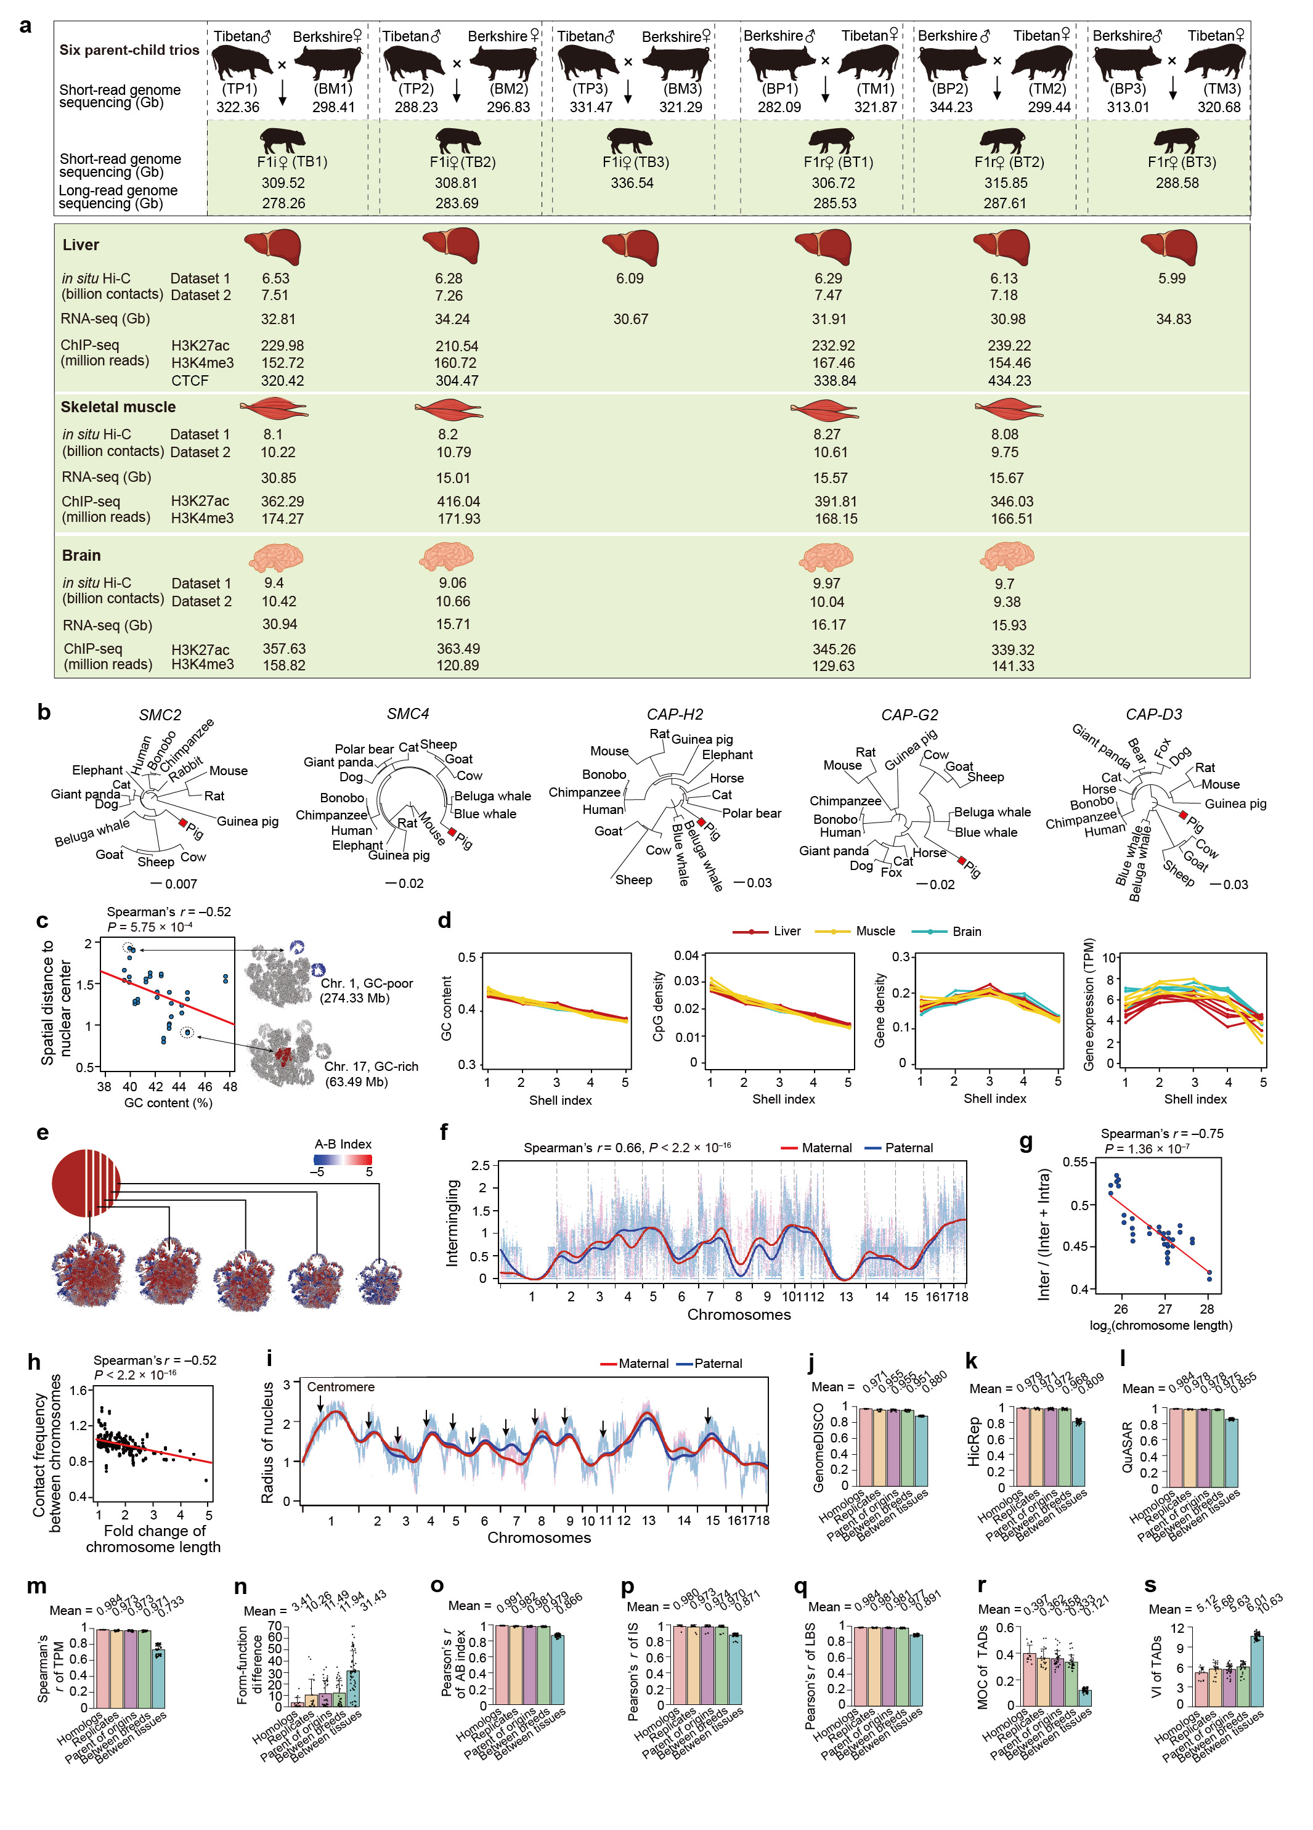
Supplementary Fig. 1 Summary of the multi-omics data and initial characteristics of 3D nuclear organization in the diploid pig genome.
a, Schematic representation of the hybrid pig model and multi-omics data generated in this study.
b, The pig genome contains full sets of functional condensin II subunits, including SMC2 (ENSSSCG00000005403), SMC4 (ENSSSCG00000011731), CAP-H2 (ENSSSCG0000 0000965), CAP-G2 (ENSSSCG00000028169), and CAP-D3 (ENSSSCG00000022192). The topological relationships of each of the five condensin II subunits (SMC2, SMC4, CAP-H2, CAP-G2, and CAP-D3)¹ across mammals were constructed based on protein sequences using the multiple sequence alignment program Clustal Omega tool (v.1.2.1). This software uses seeded guide trees and HMM profile-profile techniques to generate the alignments². The phylogenetic relationships across species of emphasized condensin II subunits follow the evolutionary distance to the pig lineage (red).
c, The radial distances of chromosomes to the nuclear center (calculated as the median radial distance of all bins in a chromosome) negatively correlates with their GC content (mean Spearman’s r = –0.52 for 14 diploid genomes, P < 0.01; left). Examples of preferential localization in the nucleus for two chromosomes (right). GC-rich chromosome 17 (GC content = 44.56%) preferentially localized to the nuclear interior, whereas GC-poor chromosome 1 (GC content = 40.20%) was consistently observed on the nuclear periphery. The 3D genome structure of the representative liver sample is shown.
d, Sequence-dependent spatial organization of the chromatin. The nucleus is divided into five shells with equal nucleotides from the center to the periphery (indexed as 1 to 5), respectively. Generally, GC-rich, gene rich, transcript-abundant chromatins were more likely to inhabit the interior of the nucleus, whereas GC-poor, transcript-sparse chromatins, were preferentially located in the nuclear periphery.
e, Compartments A/B were aggregated in the 3D space of the pig genome of the representative liver. The plot was visualized in quintuplicate, with five intersecting sections plotted from the interior regions of the nucleus (left) to the periphery (right) based on the distance (schematically depicted in the upper-left inset). Color bars indicate the value of the A-B index.
f, Highly similar multi-chromosome intermingling (mean Spearman’s r = 0.66 for 14 diploid genomes, P < 2.2×10^{–16}) between maternal (red) and paternal (blue) alleles at 20-kb resolution.
g, Ratio of inter-chromosomal contacts are negatively correlated with chromosome length (mean Spearman’s r = –0.67 for 14 diploid genomes, P < 0.004).
h, Inter-chromosomal contacts are negatively correlated with the differences in chromosome length (mean Spearman’s r = –0.52 for 14 diploid genomes, P < 2.2 × 10^{–16}). For g and h, the Hi-C data of a liver sample (TB1) was used for illustration.
i, Most chromosomes pointed their centromeres (black arrows) toward the nuclear periphery and the telomeres toward the nuclear center.
j–s, Haplotype-resolved interrogation of similarities in chromatin architecture, gene expression and histone modifications among 14 diploid genomes. The correlations of chromatin architecture were separately determined using GenomeDISCO (j), HiCRep (k), and QuASAR (l) for the Hi-C maps; A-B index (o); insulation score (IS) (p), local boundary score (LBS) (q); the measurement of TAD concordance, i.e., MoC (assessing the overlap between each pair of TADs by measured in number of base pairs and considering the overall size of both TADs)³ (r) and VI (measure the similarity of all subsets of the two TAD structures using a dynamic programming algorithm to compute the VI metrics)⁴ (s). The correlations of gene expression (m) and the combined differences in chromatin architecture (i.e., form) and gene expression (i.e., function) (n) among haplotypes are also shown. These correlation rates were grouped into the following five categories: between homologs, among biological replicates, between parent-of-origins, between parental breeds, among tissues. Data are shown as mean ± SD.
For the Hi-C maps, a 20-kb resolution was used in (c–f) and (i), and a 1-Mb resolution was used in panel (h).
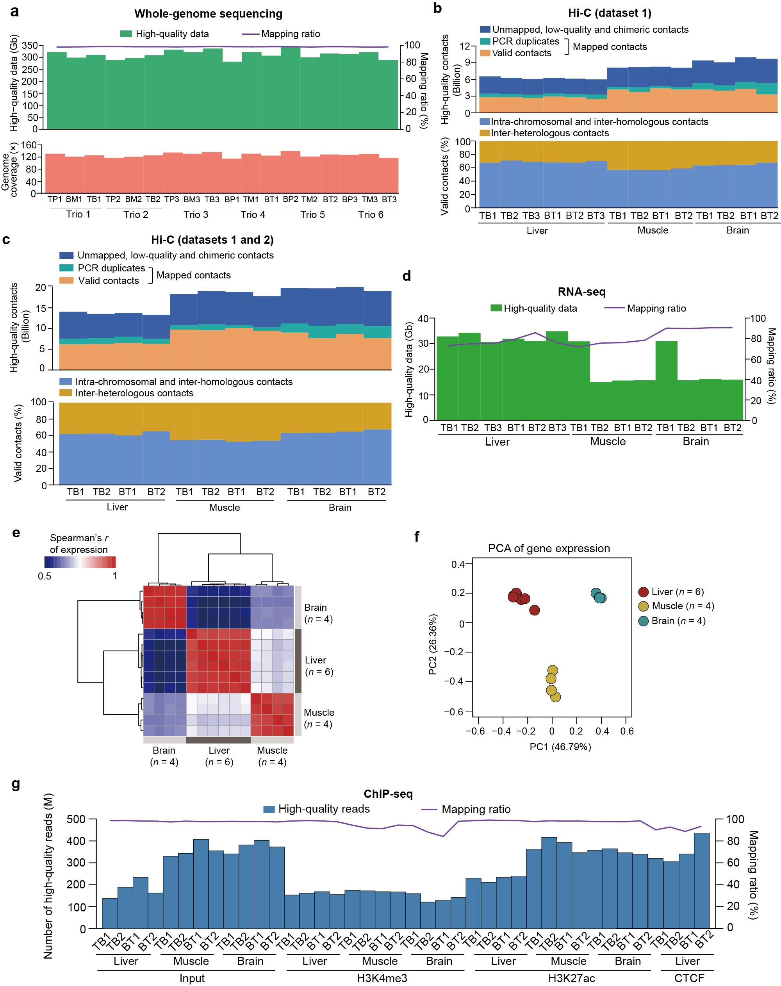
Supplementary Fig. 2 Summary of whole-genome sequencing, in situ Hi-C, rRNA-depleted RNA-seq and ChIP-seq data.
a Summary of the whole-genome resequencing data for six parent-child trios. The high-quality data (upper, green bars), mapping ratio (purple lines) and coverage depth (~122 x of the reference genome for each of the 18 individuals) (lower, pink bars) are shown.
b Composition of high-quality reads and valid contacts obtained for the in situ Hi-C dataset 1. The calculated average proportion of unphased intra-chromosomal (i.e., occurring within chromosomes and between homologs) and inter-chromosomal (i.e., between heterologs) contacts were 64.54% and 35.46% for the fourteen samples, respectively.
c Summary of the combined in situ Hi-C data (datasets 1 and 2) of twelve tissue samples. These data are described in detail in Supplementary Fig. S1a and used for PEI identification. Valid contacts and proportions of unphased intra- and inter-chromosomal contacts are shown for each sample.
d High-quality reads and mapping ratios of the RNA-seq data.
e, f Similarity of transcriptional profiles between samples from hybrid pigs using Spearman’s r correlation, showing a tissue-dominant pattern.
g Mapping ratios of high-quality ChIP-seq data for H3K27ac, H3K4me3, and CTCF.

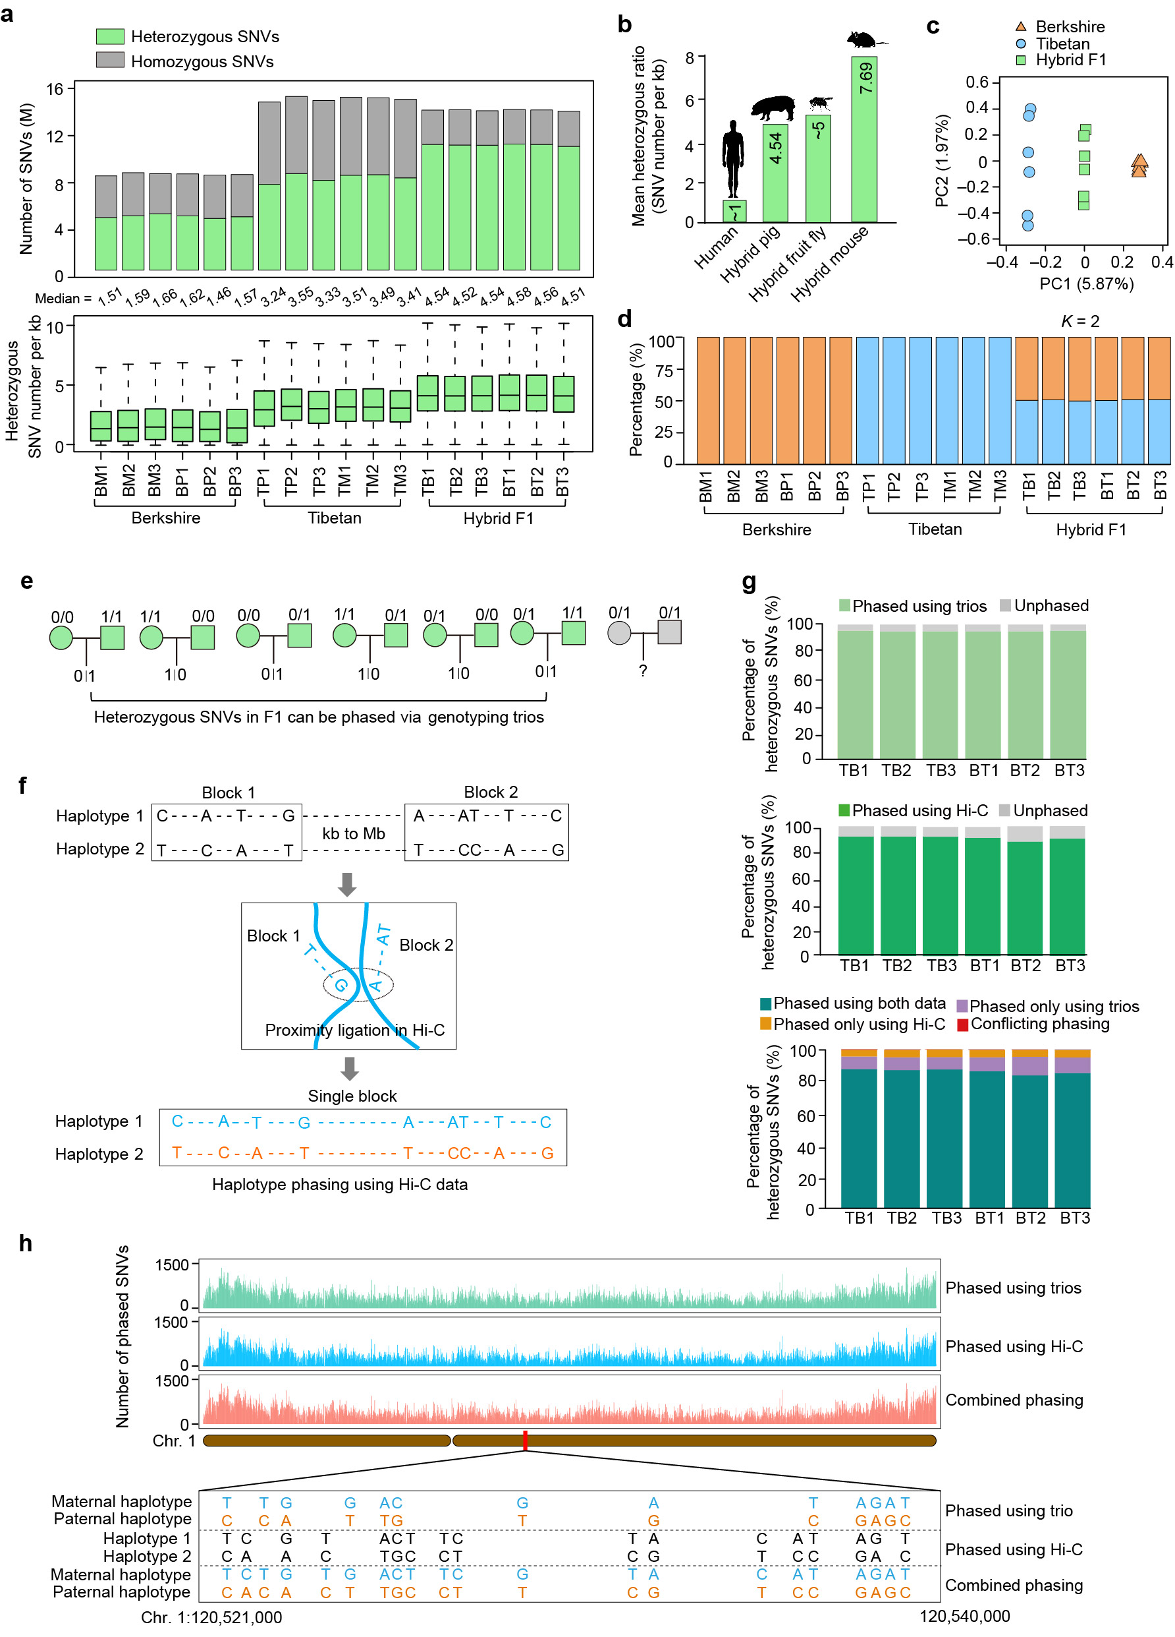
Supplementary Fig. 3 Construction of chromosome-span haplotypes for hybrid pigs using genome-wide heterozygous single nucleotide variants (SNVs).
a Summary of SNVs called based on whole-genome resequencing data. The higher number of SNVs identified in Asian Tibetan pigs compared to European Berkshire pigs after mapping to the reference European Duroc pig genome (heterozygous SNVs: 8.12 M versus 4.72 M, P = 0.002; homozygous SNVs: 6.92 M versus 3.69 M, P = 0.002; heterozygous SNV ratio: 3.42 versus 1.57, P = 0.002; Mann-Whitney U test), reveals the extensive genomic divergence between Eurasian pig breeds.
b In our study, the heterozygous SNV ratio calculated in hybrid pigs (4.54 per kb) was lower than that of hybrid mice (7.70 per kb)⁵, comparable to the values obtained in hybrid fruit flies (~5 per kb)⁶, and significantly higher than humans (~1 per kb)⁵. The diploid 3D genome of these three species was successfully reconstructed.
c Principal component analysis (PCA) of the six parent-child trios constructed using genomic SNVs.
d Genetic structure of six parent-child trios using genome-wide SNVs. The length of the colored segments represents the proportion of the genome of each individual that originates from two ‘ancestral populations’ (K = 2, two parental breeds of F1 hybrid pigs, i.e., Berkshire and Tibetan).
e Schematic representation of heterozygous SNV phasing based on the genotypes of trios. Heterozygous SNVs in F1 hybrids can be phased when at least one of the parents is homozygote.
f Schematic representation of haplotype construction based on Hi-C contacts using the HapCUT2 algorithm⁷.
g Comparisons between the phased heterozygous SNVs for F1 hybrid pigs using three approaches: 1) genome sequencing data of parent-child trios alone (top), 2) Hi-C data of F1 hybrids (middle), and 3) the combination data of both (bottom).
h Illustration of SNV phasing in chromosome 1 using the three different approaches described in (g). Top: tracks showing the number of phased heterozygous SNVs per 100-kb genomic bin. Bottom: zoom-in of the constructed haplotypes. Parental origin can only be determined via genotyping of parent-child trios. Seed haplotypes rebuilt with the Hi-C data of F1 hybrids were arbitrarily designated as ‘1’ and ‘2’, and contained genetic variants that were absent in the trio-phased haplotypes. The integration of these data can generate high-quality haplotypes spanning the entire chromosome, whereby employing a combination of genome sequencing data of parent-child trios and Hi-C data of F1 hybrids improves the efficiency of chromosome-span haplotype reconstruction.
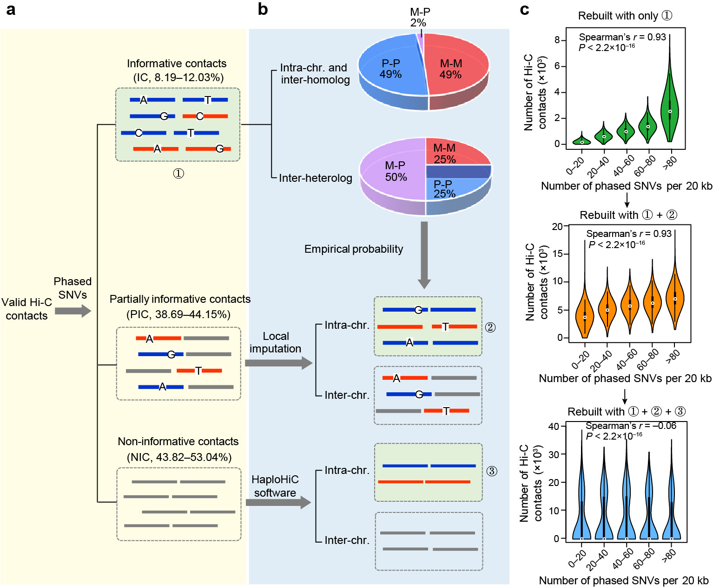
Supplementary Fig. 4 Construction of haplotype-resolved Hi-C maps for hybrid pigs using SNV phasing and a local imputation method.
a Phasing of Hi-C contacts. Paired-end Hi-C reads can be classified into three categories based on haplotype-resolved SNVs: informative contacts (IC, reads containing phased SNVs at both ends, top), partially informative contacts (PIC, reads containing phased SNVs at one end, middle), and non-informative contacts (NIC, reads containing no phased SNVs, bottom).
b According to the proportion of contacts occurring within maternal (intra-maternal, ‘M-M’) or paternal (intra-paternal, ‘P-P’) alleles, and between maternal and parental alleles (inter-parental, ‘M-P’) (top), we assigned unphased intra-chromosomal PIC and NIC to their parental origins using a local imputation strategy and the HaploHiC software⁸, respectively (bottom).
c Violin plots showing the correlation between the number of phased SNVs and the phased contact counts for phased IC (denoted as ①), IC+PIC (①+②), and IC+PIC+NIC ①+②+③), respectively, which indicates that allele assignment of all categories of Hi-C contacts can efficiently eliminate the negative effects caused by differences in SNV density across the genome.
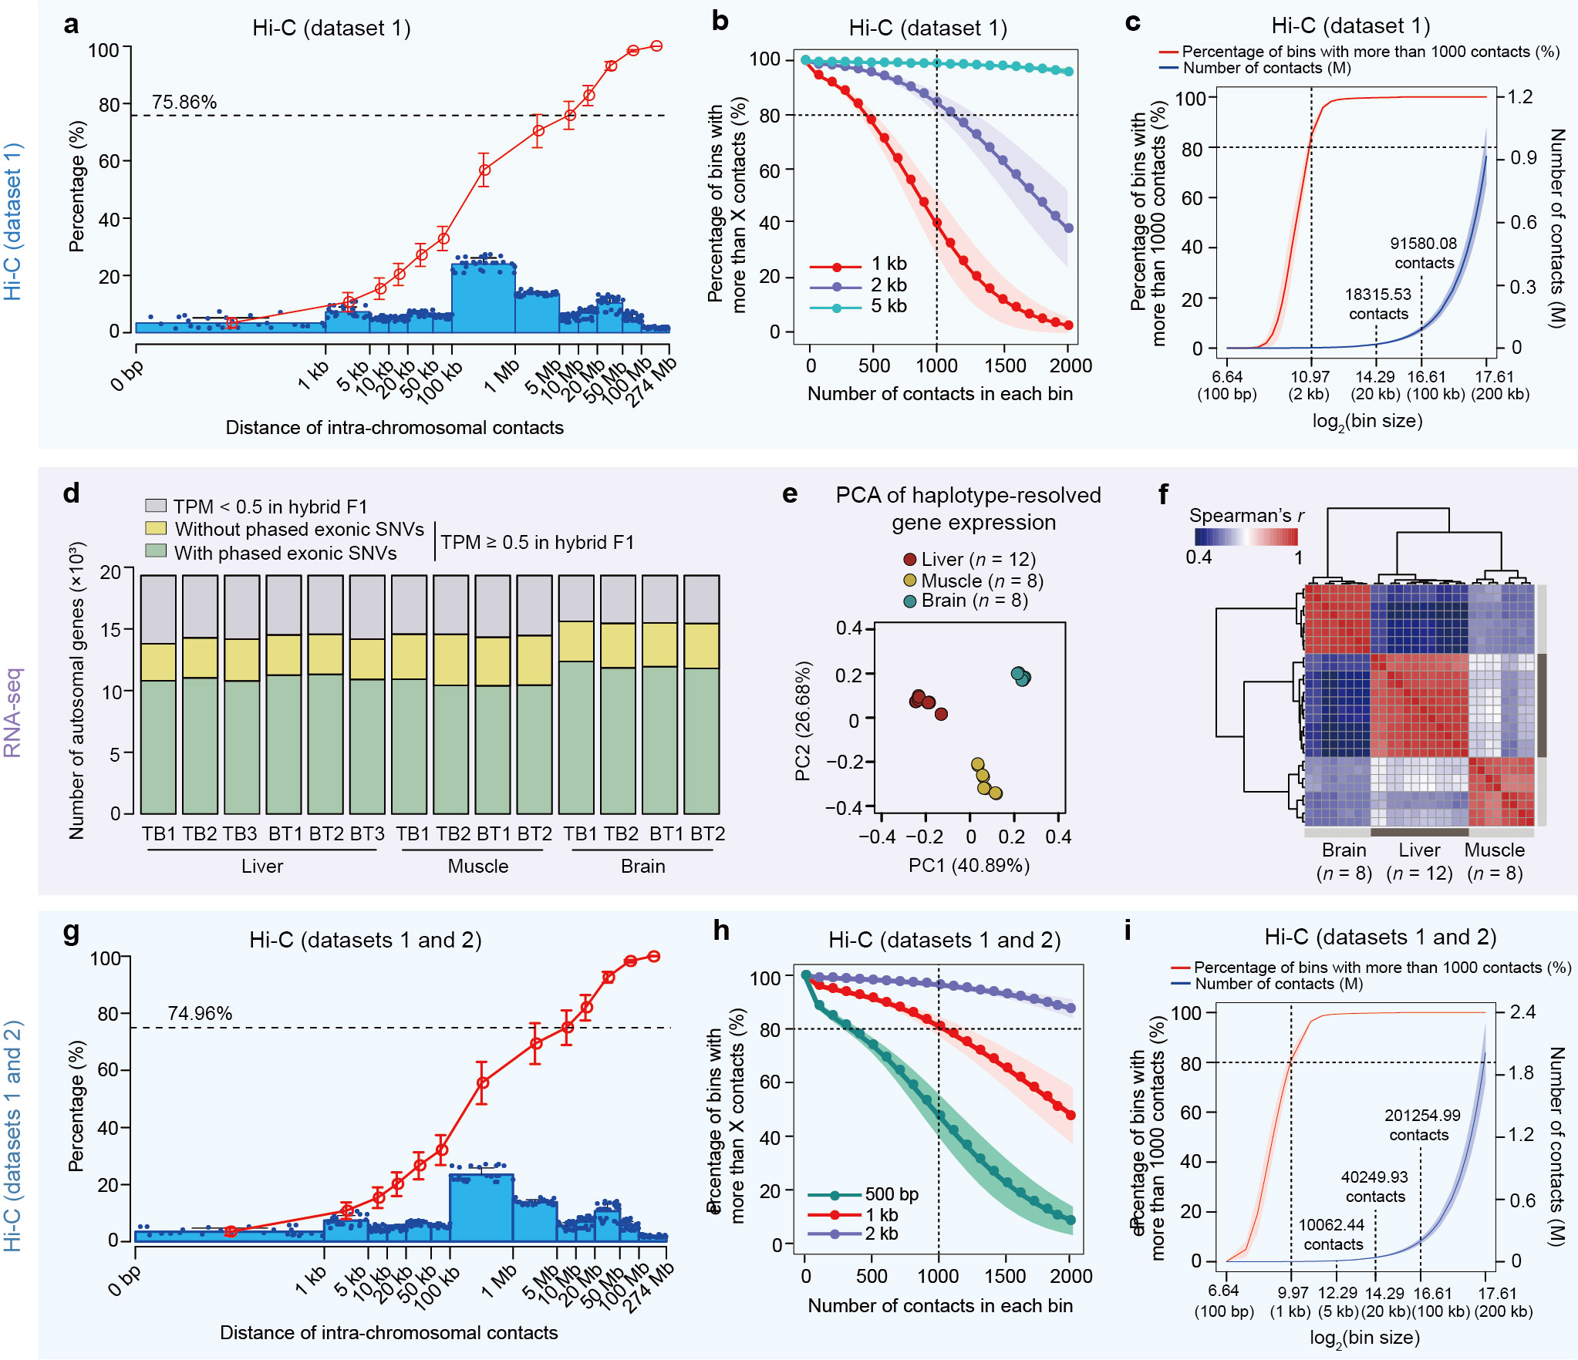
Supplementary Fig. 5 Summary of phased Hi-C and RNA-seq data.
a Insert size distribution of haplotype-resolved intra-chromosomal Hi-C contacts for dataset 1. The column represents the proportion of contacts within each distance interval. The circle on the column indicates the proportion of each sample. The red curve shows the cumulative percentage. Data are represented as mean ± SD (n = 28). The intra-chromosomal contacts (average 75.85%, dashed lines) mainly occurred within 10 Mb.
b, c Resolution of haplotype-resolved intra-chromosomal Hi-C maps at different bin sizes. The Hi-C map resolution was defined as the smallest bin size where 80% of bins have at least 1000 reads to allow for reliable discerning of local features⁹. Data are shown as mean ± SD (n = 28). The mean number of contacts at resolution of 20 kb and 100 kb are shown in (c).
d The number of autosomal genes with phased transcription in haplotypes (n = 28).
e PCA of allelic transcription for haplotypes (n = 28), showing a tissue dominant pattern.
f Similarity of allelic transcriptional profiles between haplotypes (n = 28) from hybrid pigs using Spearman’s r correlation, showing a tissue-dominant pattern.
g–i Insert size distribution (g) and resolution estimation (h and i) of phased intra-chromosomal Hi-C contacts for datasets 1 and 2. Data are shown as mean ± SD (n = 24). The mean number of contacts at resolution of 5 kb, 20 kb and 100 kb are shown in (i).

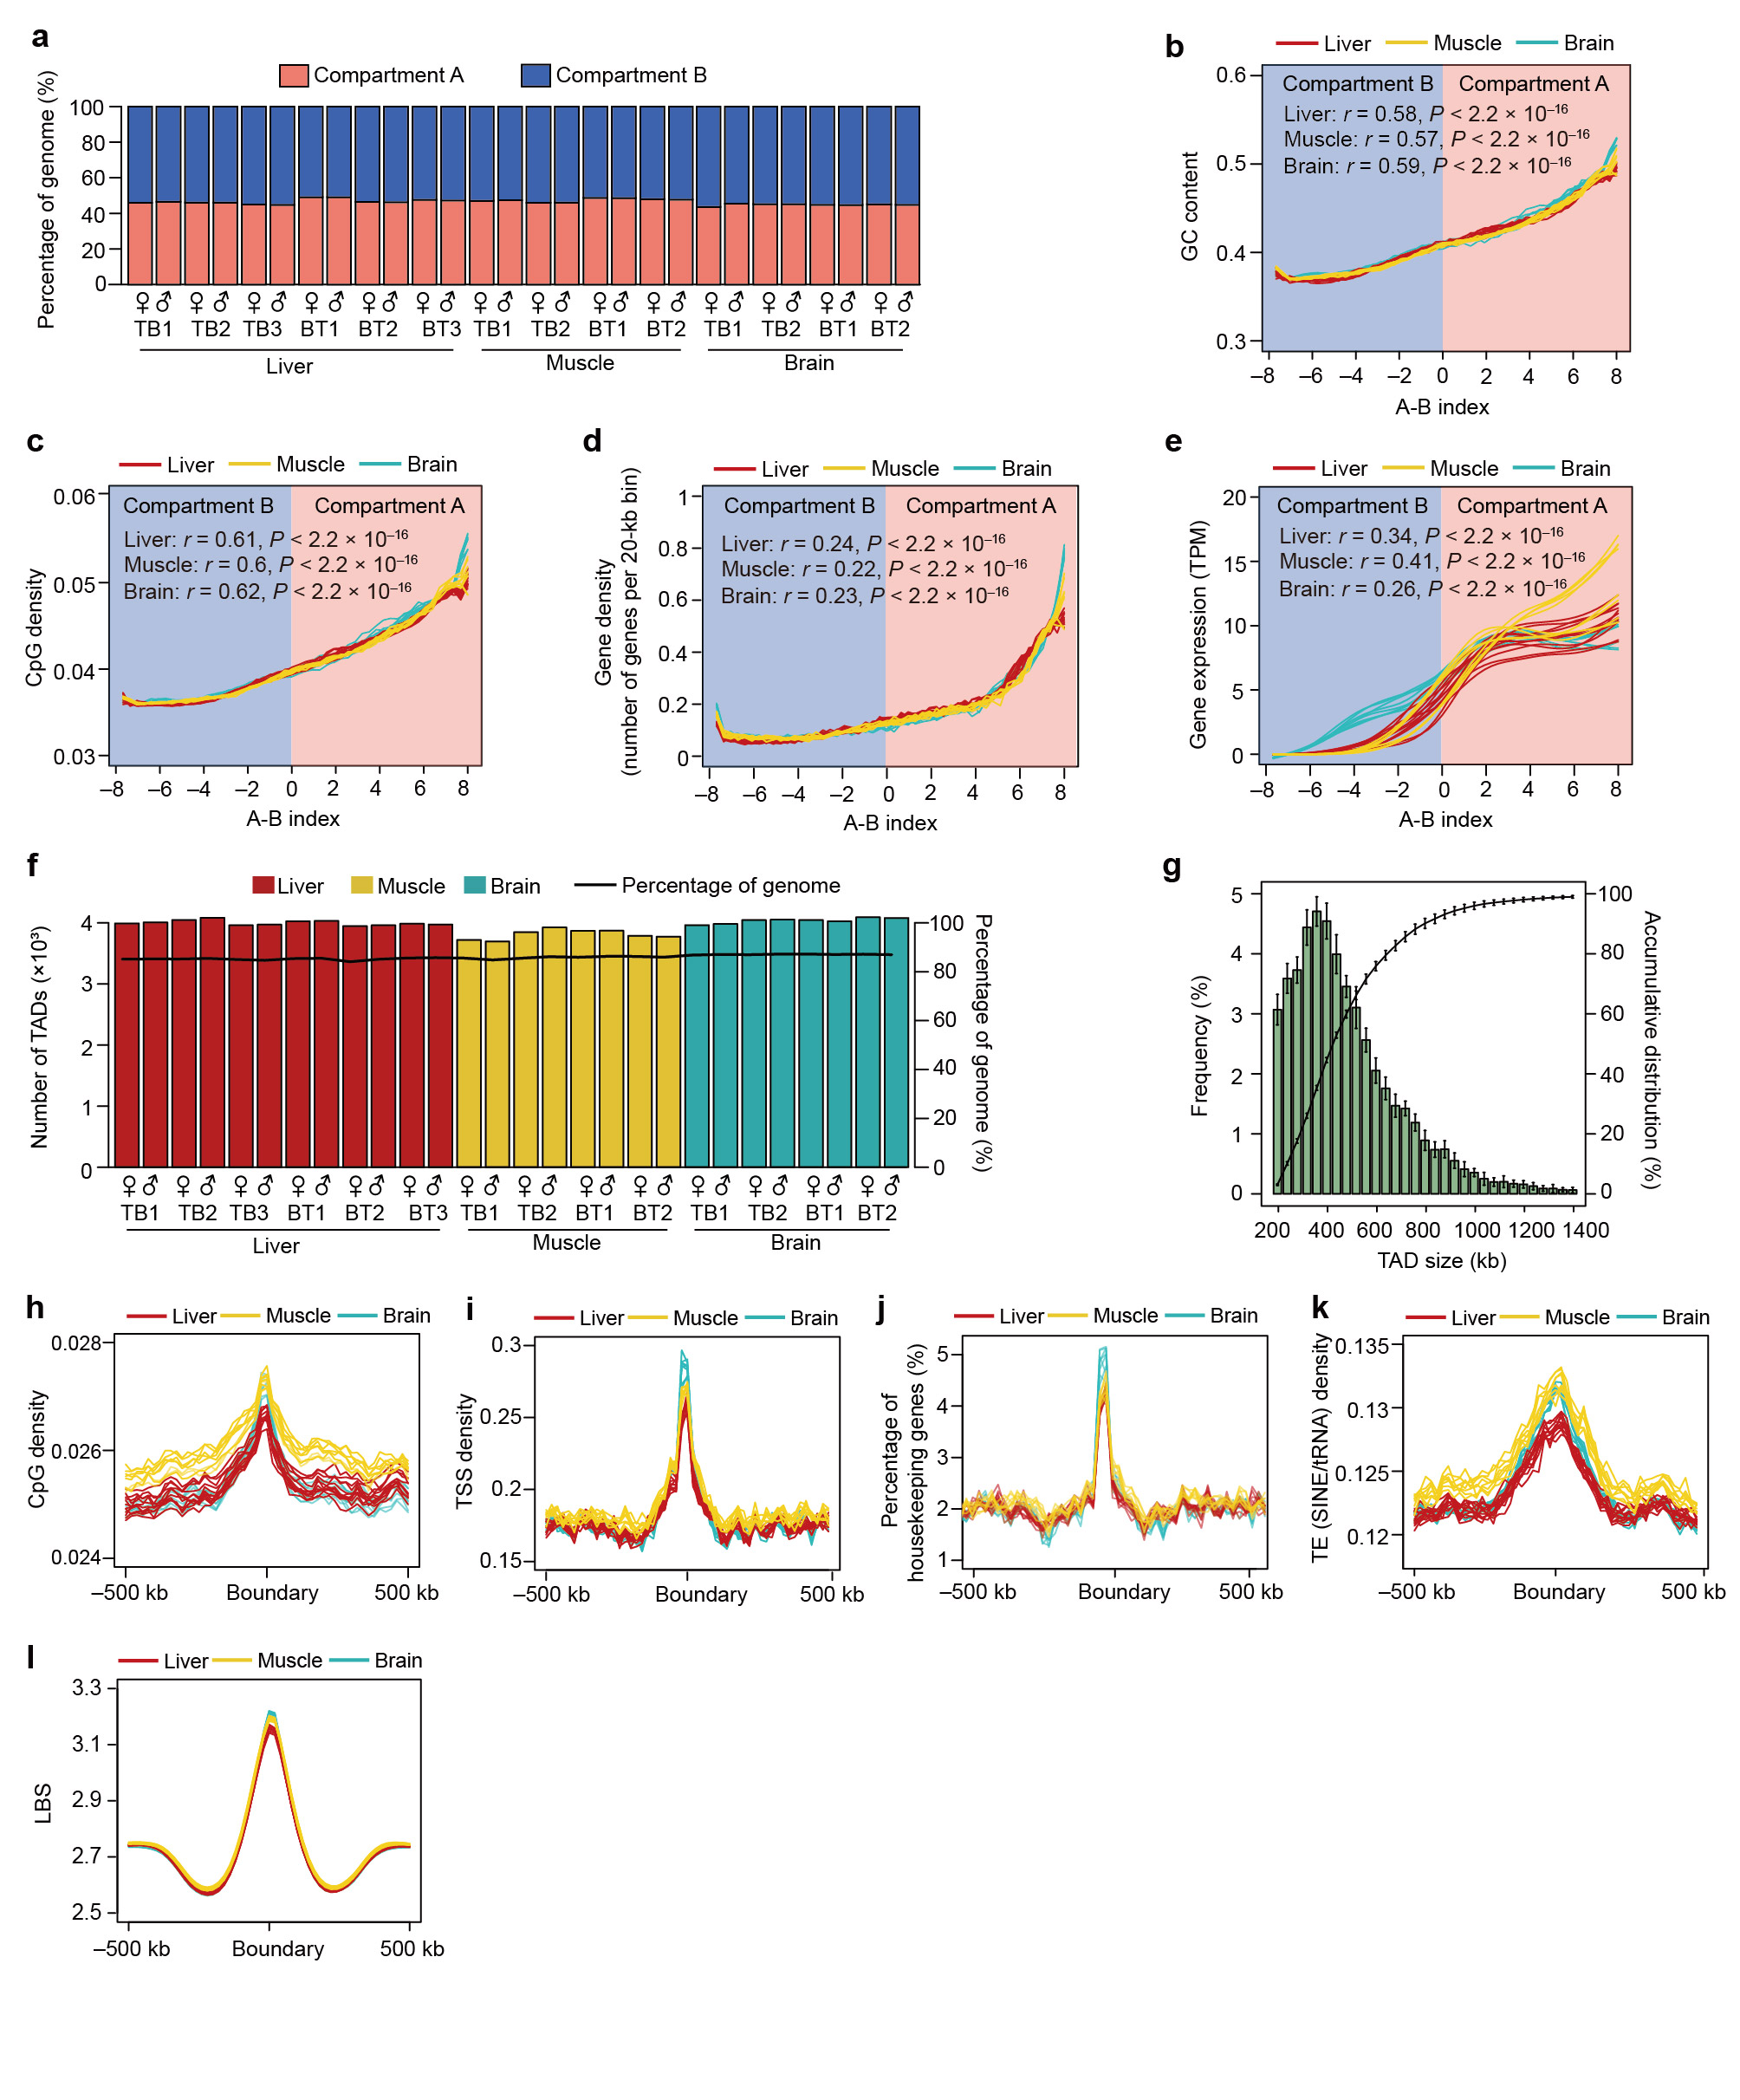
Supplementary Fig. 6 Genomic features of compartments and TADs in the haplotype-resolved pig genome.
a Length proportions of A/B compartments among 28 haploid genomes. On average, 45.71% of the genome (~1035.7 Mb) could be recognized as accessible A compartments, while the remaining of the genome was categorized as less accessible B compartments (52.59% of the genome or ~1191.56 Mb).
b–e GC content (b), CpG density (c), gene density (d), and gene expression (e) of A/B compartments with different activities. According to the A-B index, A and B compartments were separately divided into 50 equal parts across each of the three tissues (x-axis). Compared to compartment B, compartment A regions contain a higher GC content (45.19% vs. 39.08%), are more gene-rich (13.62 vs. 4.38 genes per Mb), and have relatively higher transcriptional activity (median TPM 8.18 vs. 0.20). Spearman’s correlation between A-B index and the genomic features in each tissue are shown.
f Numbers and genome coverage of TADs across 28 haploid genomes. TADs occupy ~85.91% of the genome.
g, Size distribution of TADs. TAD median size was estimated at ~440 kb.
h–l Genomic features around TAD boundaries (1 Mb centered on the TAD). Compared to other regions, TAD boundaries exhibited relatively higher densities of CpG (h) and transcription start site (TSS) (i), an increased ratio of house-keeping genes (j), larger proportion of short interspersed element-transposable RNA (SINE/tRNA) (k), and higher local boundary scores (LBS; low LBS means high density of local interactions) (l). These features were consistent with previous reports in mammals¹⁰, confirming the robustness of the TADs in the pig genome.

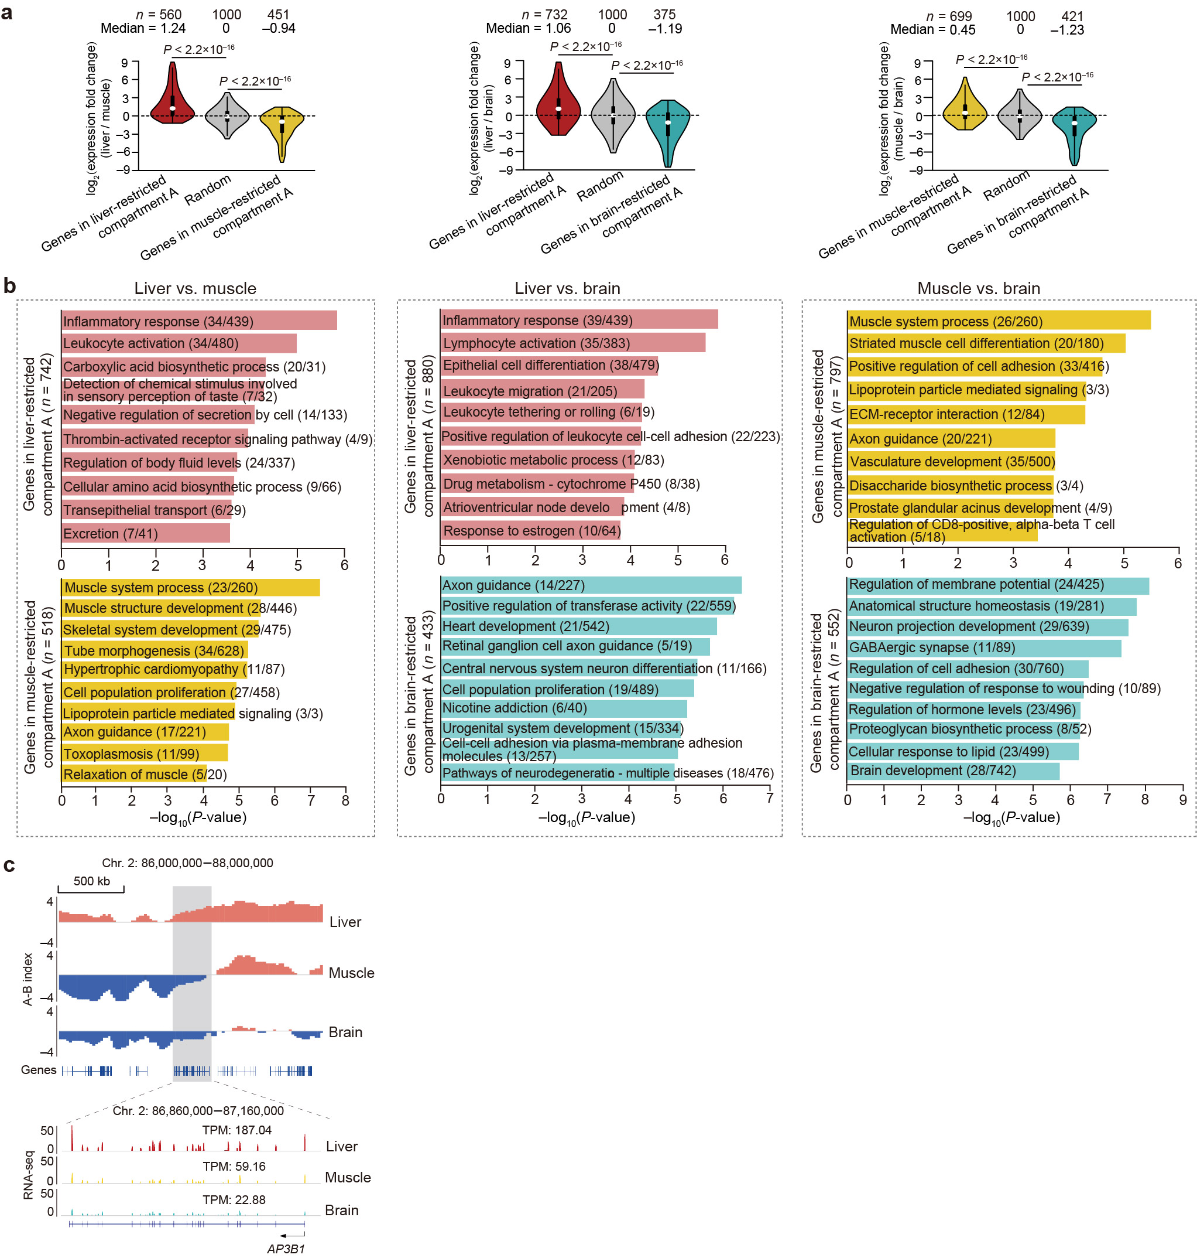
Supplementary Fig. 7 Compartmental rearrangement among haplotypes.
a Expression changes in genes that were located in compartment-switching regions between tissues. Compared to randomly selected genes, the genes located in tissue-specific A compartments showed significantly increased expression. The P-values shown are from the Wilcoxon rank-sum test.
b Top ten significantly enriched GO-BP terms or KEGG pathways for genes located in tissue-restricted compartment A regions from pairwise comparisons of the three tissues. Gene enrichment analysis was performed using the software Metascape¹¹.
c A typical example of A/B switches between tissues containing AP3B1, a functional gene participating in inflammatory response.

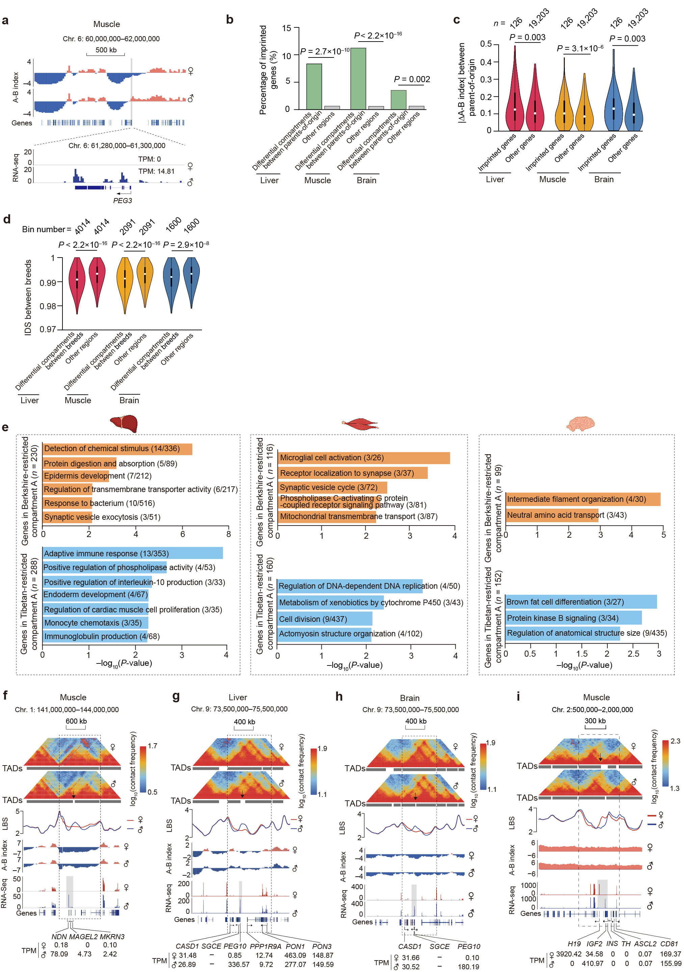
Supplementary Fig. 8 Allelically compartment rearrangement and shifted TAD boundaries.
a, An example of A/B switches between parent-of-origins containing a paternally imprinted gene PEG3.
b, Known imprinted genes were statistically enriched in regions that show allelically differential compartmentalization (including A/B switch and A/B variable) between parent-of-origins across the three tissues. The P values were calculated using a χ² test.
c, Regions with known imprinted genes have more variable compartment scores between alleles. Median |∆A-B index| = 0.13, P < 0.003, Wilcoxon rank-sum test.
d, Regions showing allelically differential compartmentalization (including A/B switch and A/B variable) exhibited the lowest pairwise haplotype similarities between the two parental breeds measured using the identity score (IDS; see Methods). The P values were calculated using a Wilcoxon rank sum test.
e, Significantly enriched GO-BP terms or KEGG pathways (performed using Metascape¹²) for genes located in regions with differential compartmentalization (i.e., A/B switches and A/B variables) between the two parental alleles across the three tissues.
f–i, Parental-restricted TAD boundaries are adjacent to imprinted genes. A paternal-specific boundary in the muscle (f) influencing three imprinted genes (NDN, MAGEL2 and MKRN3); a paternal-specific boundary in the liver (g) and brain (h) influencing two imprinted genes (CASD1 and SGCE); a maternal-specific boundary in the muscle (i) influencing seven imprinted genes (H19, IGF2, INS, TH, ASCL2, CD81 and TSSC4).
For the Hi-C maps, a 20-kb resolution was used in (a) and (f–i).

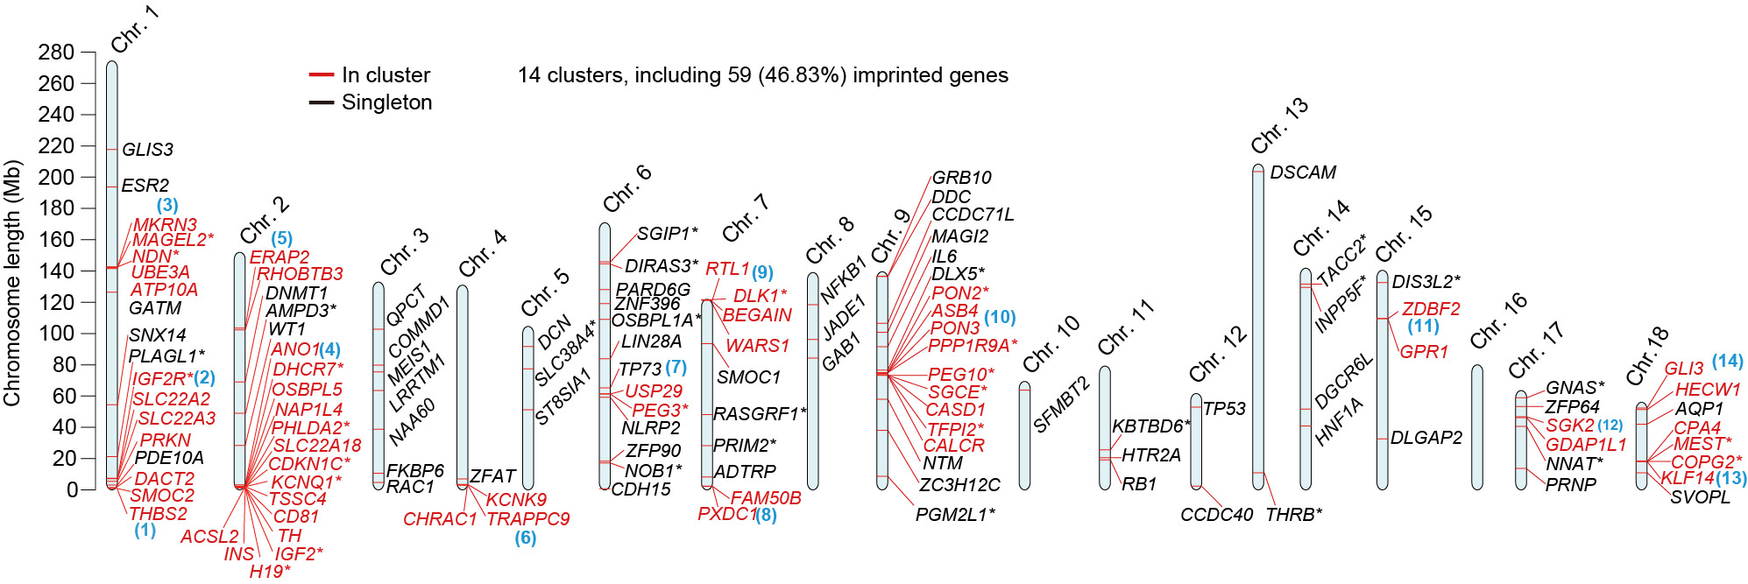
Supplementary Fig. 9 Chromosomal organization of 126 known imprinted genes retrieved from the genomic imprinting website (https://geneimprint.com/site/home, last access in Dec 2021) with homologs on the autosomes of the pig reference genome.
A total of 36 of these genes were previously identified in pigs (labeled with ‘*’), and 90 (including a lncRNA gene - H19) were reported in 12 other mammal species (i.e., cow, dog, human, lab opossum, mouse, opossum, platypus, rabbit, rat, rhesus macaque, sheep, and wallaby). Supporting the notion that mammalian imprinted genes often located adjacently to each other¹³, and thus found in conserved clusters in the genome, we uncovered approximately half imprinted genes (59 of 126, or 46.83%; labelled in red) in the pig genome that we grouped into 14 clusters (with at least two genes in a cluster) based on linear distances lower than 1 Mb.
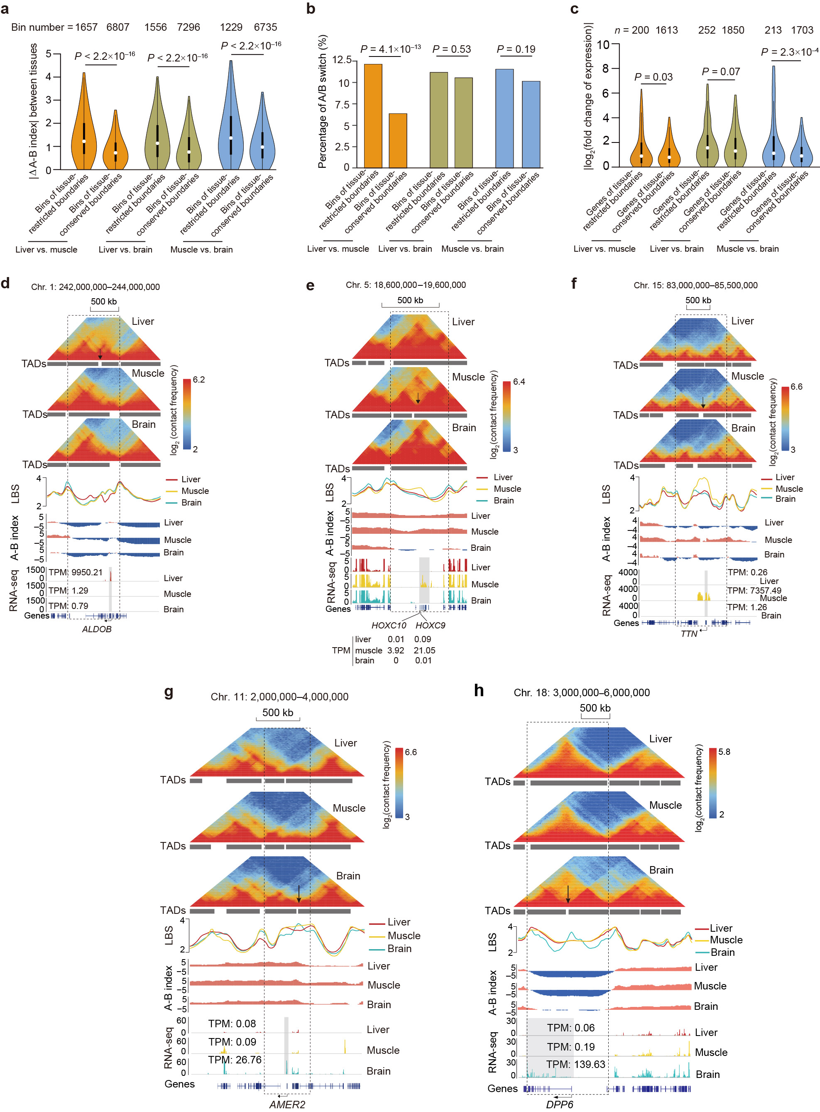
Supplementary Fig. 10 Allelically shifted TAD boundaries.
a Tissue-restricted TAD boundaries have significantly higher differences in compartmentalization compared to tissue-shared TAD boundaries. P values were calculated using a Wilcoxon rank-sum test.
b Tissue-restricted TAD boundaries are enriched in A/B switched regions compared to tissue-shared TAD boundaries. P values were calculated using a χ² test.
c Compared to genes located close to tissue-shared TAD bounaries (± 60 kb from the anchor bin of TAD boundary), genes nearby tissue-restricted TAD boundaries exhibit a subtle but statistically significant increase in expression. P values were calculated using a Wilcoxon rank-sum test.
d–h Examples of tissue-restricted TAD boundaries being adjacent to typical marker genes of relative tissues, including ALDOB (d) in liver, HOXC9 (e), -10 (e) and TTN (f) in muscle, and AMER2 (g) and DPP6 (h) in brain tissues. From top to bottom are shown the Hi-C maps, TAD boundaries, local boundary scores (LBS), the A-B index, structures, and expression (TPM) of the different genes. Black dashed boxes indicate the shifted TAD boundaries.
For the Hi-C maps, we used a resolution of 20-kb in panels d–h.

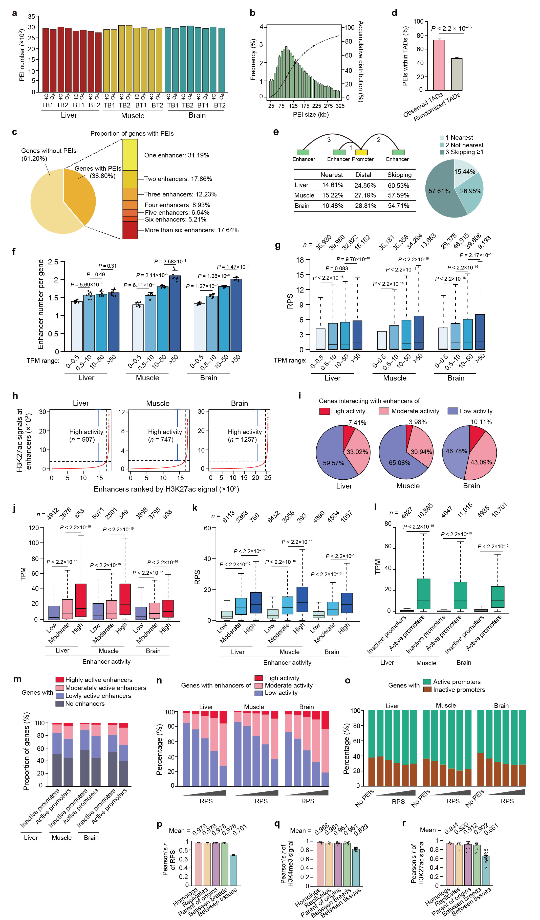
Supplementary Fig. 11 Haplotype-resolved interrogation of PEIs in gene expression control.
a, b, Number (a) and bridging size distribution (b) of PEIs in 24 haploid genomes.
c, Summary of genes (n = 19,328 in autosomes) interacting with different numbers of enhancers.
d, Proportion of PEIs within or across TADs. Expected frequencies were calculated using shuffling TAD linear positions for 1,000 times. Data are presented as mean ± SD. The P values were calculated using a paired Student’s t-test.
e, Proportion of promoters interacting with the nearest enhancer or skipping at least one enhancer (scenarios are illustrated in the upper left).
f, Genes with higher expression generally contact with more enhancers. The dots on the bar represent the mean number of enhancers of a given gene across eight haplotypes for each of the three tissues. The P values were obtained using a paired Student’s t-test.
g, Genes with higher expression generally had larger RPS. The P values were calculated using the Wilcoxon rank-sum test.
h, Saturation curves of H3K27ac density (see Methods). The number of ranked moderately active enhancers and super enhancers of high activity by H3K27ac density (x-axis) and their respective densities (y-axis) are plotted. Horizontal dotted lines represent density cutoffs used for the classification of super enhancers and vertical dotted lines demarcate super enhancers from moderately active enhancers.
i, The proportion of genes interacting with enhancers have high activity (i.e., super-enhancer), moderate activity, and lesser activity.
j, k, Expression (j) and RPS (k) values of genes interacting with enhancers have different activities. The P values were calculated using the Wilcoxon rank-sum test.
l, Expression of genes with active (enriched by H3K4me3 peaks) or inactive (depleted in H3K4me3 peaks) promoters. The P values were calculated using the Wilcoxon rank-sum test.
m, Active promoters containing a higher proportion of genes interacted with more active enhancers.
n, o, Genes with an active promoter interacted more often with enhancers with increased activity. Genes with higher RPS tended to interact with enhancers (n) and promoters (o) and have increased activities.
p–r, Haplotype-resolved interrogation of similarities in the regulatory potential score (RPS) for genes (p), and genome-wide distribution of ChIP-seq signals of H3K27ac (q) and H3K4me3 (r). The correlation rates were grouped into the following five categories: between homologs, among biological replicates, between parent-of-origins, between parental breeds, among tissues. Data are shown as mean ± SD.
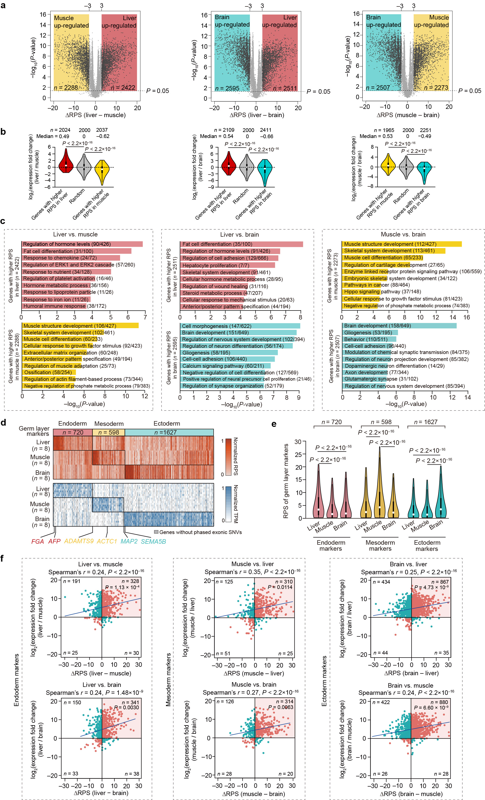
Supplementary Fig. 12 Reorganized PEIs between tissues.
a Volcano plots of genes that showed statistically different RPS (|ΔRPS| > 3 and P < 0.05, paired Student’s t-test) between liver and brain (left), liver and muscle (middle), and muscle and brain (right).
b Co-variation between RPS and gene expression. Genes having higher RPS values (|ΔRPS| > 3 and P < 0.05, paired Student’s t-test) between tissues are generally up-regulated compared to randomly selected genes. P-values were calculated using the Wilcoxon rank-sum test.
c Top ten significantly enriched GO-BP terms and KEGG pathways (performed using the software Metascape) for genes with increased RPS in pairwise tissue comparisons.
d Heatmaps showing RPS (top) and expression (bottom) of marker genes for the definitive germ layers. Out of 4428 germ layer markers in the pig genome¹⁴, 2945 marker genes (720 for endoderm, 598 for mesoderm, and 1627 for ectoderm) are in contact with enhancers and thus have RPS values in at least one tissue. Each gene’s RPS values and their respective expression levels are standardized in order to range between 0 and 1. Typical genes are indicated below.
e Comparison between RPS values of germ layer markers across tissues. P values were calculated using a Wilcoxon rank-sum test.
f A scatter plot and trend line (Pearson’s r) showed correlation between changes in RPS and gene expression for germ layer makers of endoderm (512 and 574 markers with RPS and evident expression, i.e., TPM > 0.5, in at least one tissue for liver vs. muscle and liver vs. brain, respectively; left), mesoderm (511 and 488 markers with RPS and evident expression in at least one tissue for muscle vs. liver and muscle vs. brain, respectively; middle), and ectoderm (1380 and 1356 markers with RPS and evident expression in at least one tissue for brain vs. liver and brain vs. muscle, respectively; right) across the three tissues. The blue line represents the linear regression. Red and teal dots represent genes with coordinate and incoordinate changes in RPS and expression, respectively. The number of genes in each quadrant showing a specific relationship between RPS and expression differences is provided (upper left: genes with lower PRS that are upregulated; bottom left: genes with lower RPS that are downregulated; upper right: genes with higher RPS that are upregulated; bottom right: genes with higher RPS that are downregulated). As expected, the makers of the three germ layers generally exhibited higher RPS and upregulated expression in the tissue that originates from the respective germ layer (the endoderm-derived liver, mesoderm-derived muscle, and ectoderm-derived brain), as indicated by the significant enrichment (P < 0.05, χ² test) of genes in the upper right quadrant (in colored shadow) of the scatter plots.
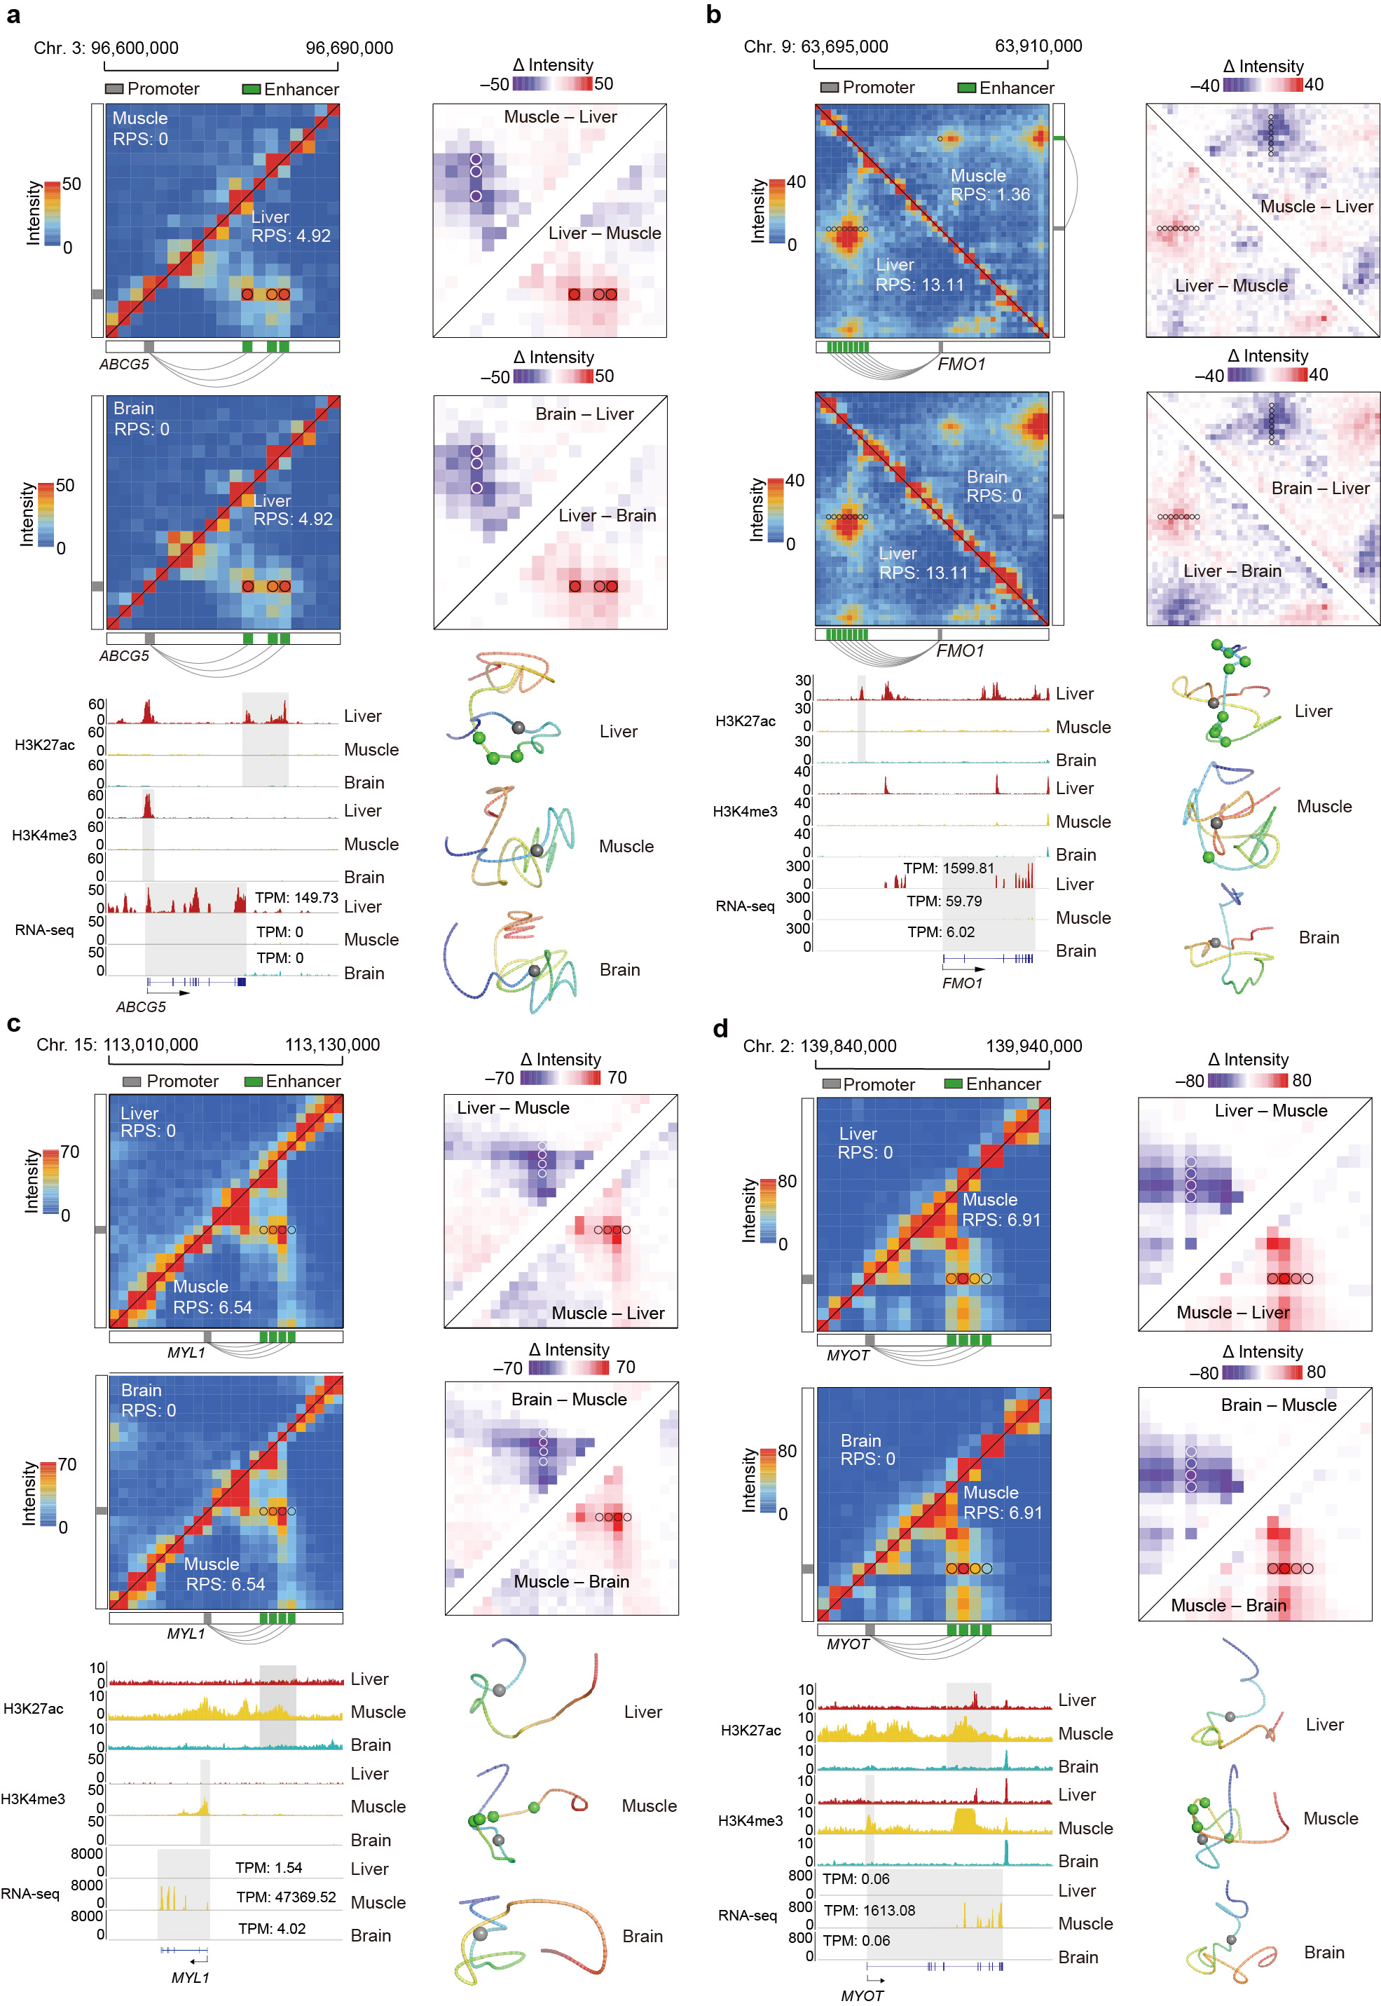
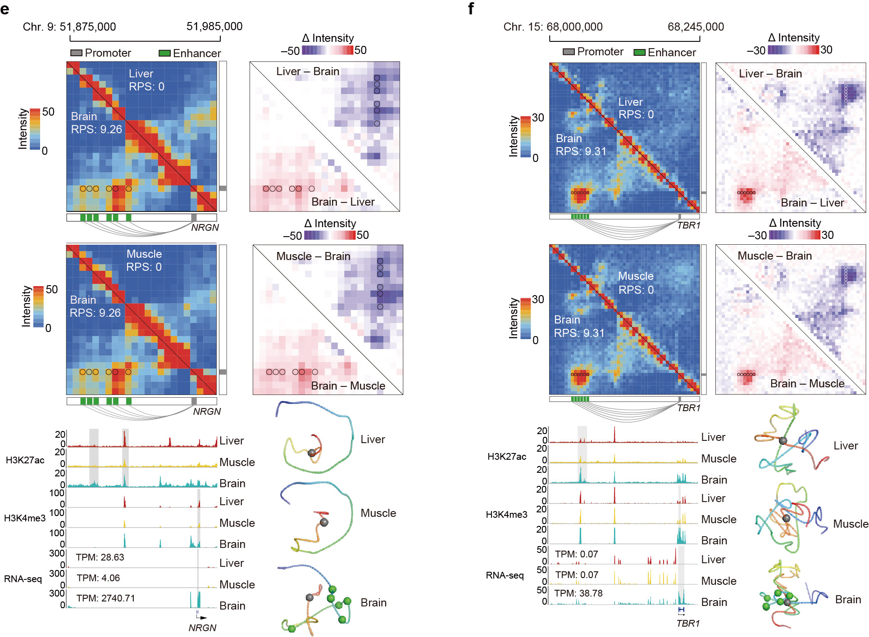
Supplementary Fig. 13 Representative examples of tissue-specific PEIs for ABCG5 (a) and FMO1 (b) in the liver, MYL1 (c) and MYOT (d) in the muscle, and NRGN (e) and TBR1 (f) in the brain.
Top to bottom: Hi-C maps (upper left) and their allelic differences (upper right), ChIP-seq signals of H3K27ac and H3K4me3, and gene expression levels (lower left) and 3D structural models (lower right) of the corresponding genomic regions. Promoter (grey square), enhancers (green squares), and PEIs (connecting lines) are displayed beside the Hi-C maps.
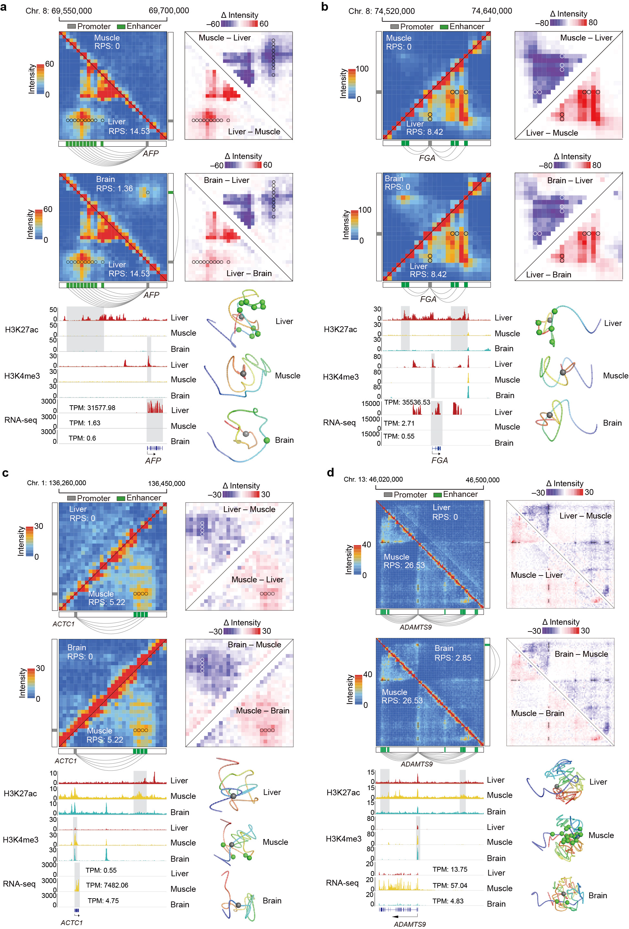
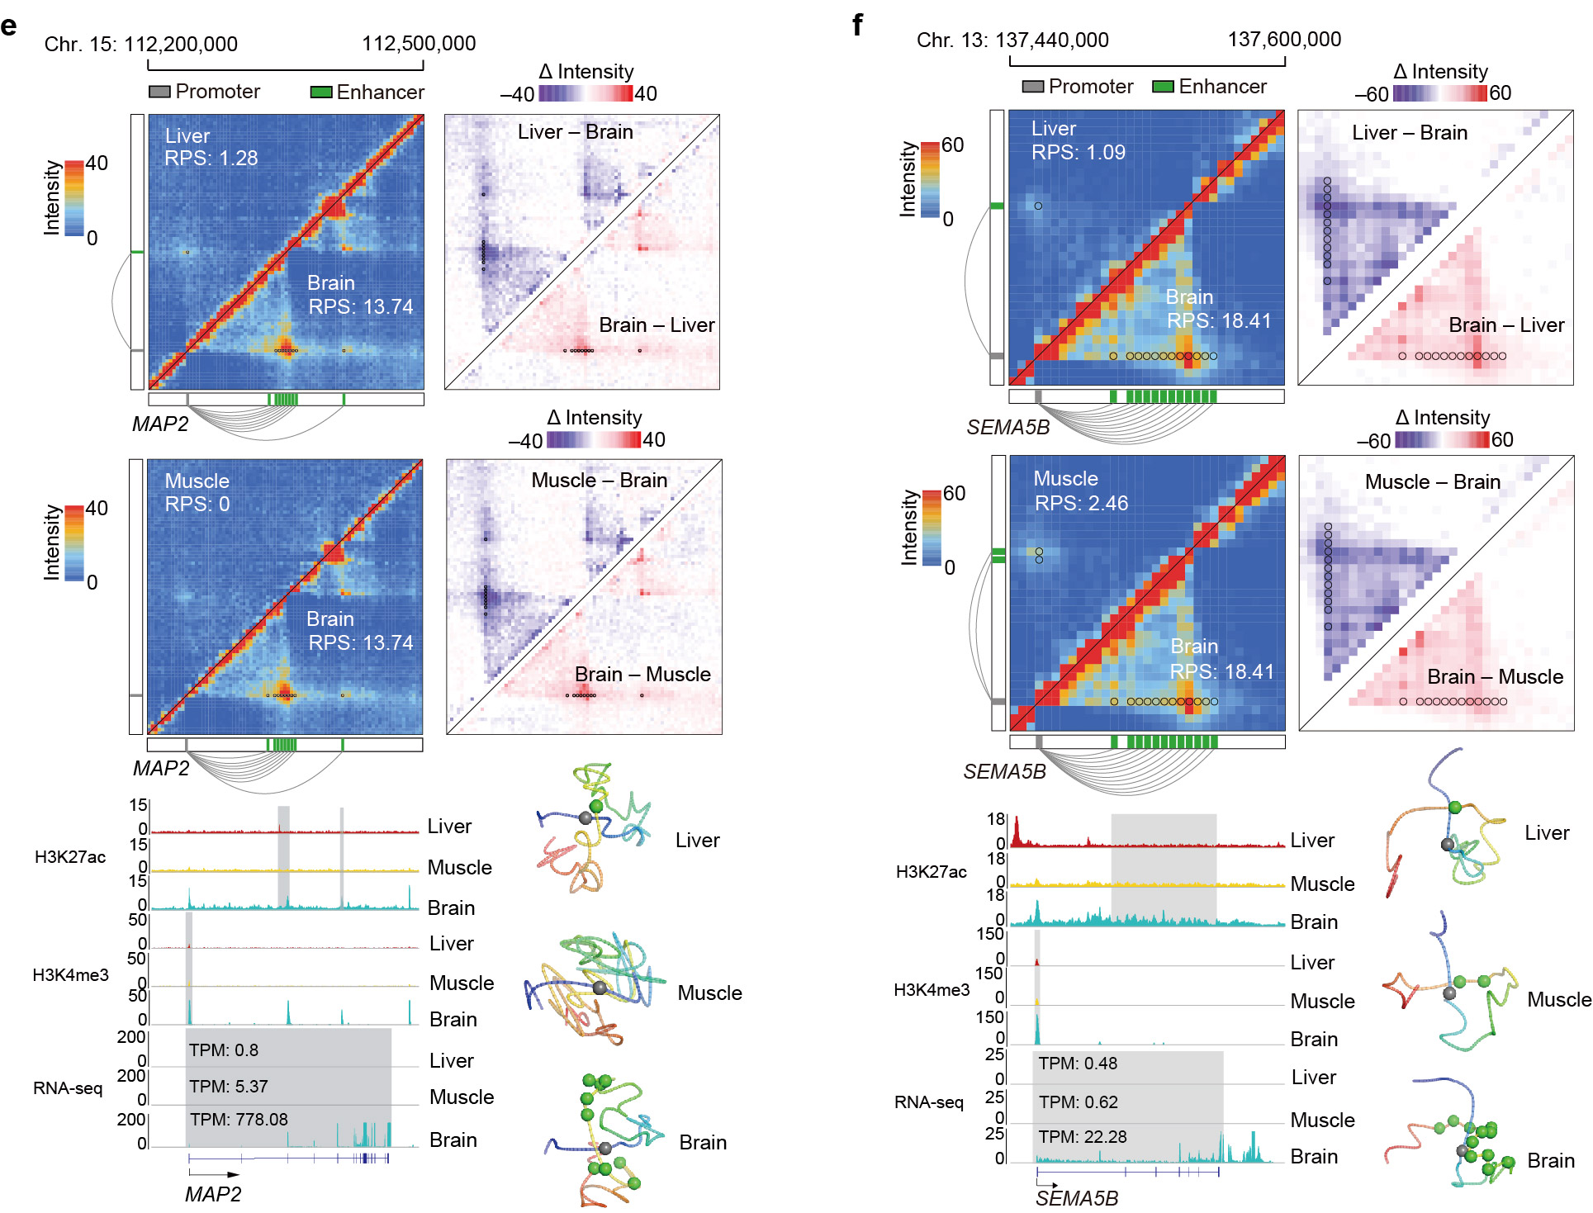
Supplementary Fig. 14 Representative examples of specific PEIs for germ layer markers in the tissues originated from their respective germ layers.
Specifiers of (a and b) endoderm (AFP and FGA) in endoderm-derived liver; (c and d) mesoderm (ACTC1 and ADAMTS9) in mesoderm-derived muscle; and (e and f) ectoderm (MAP2 and SEMA5B) in ectoderm-derived brain. The schematics are similar to those shown in Supplementary Fig. 13.
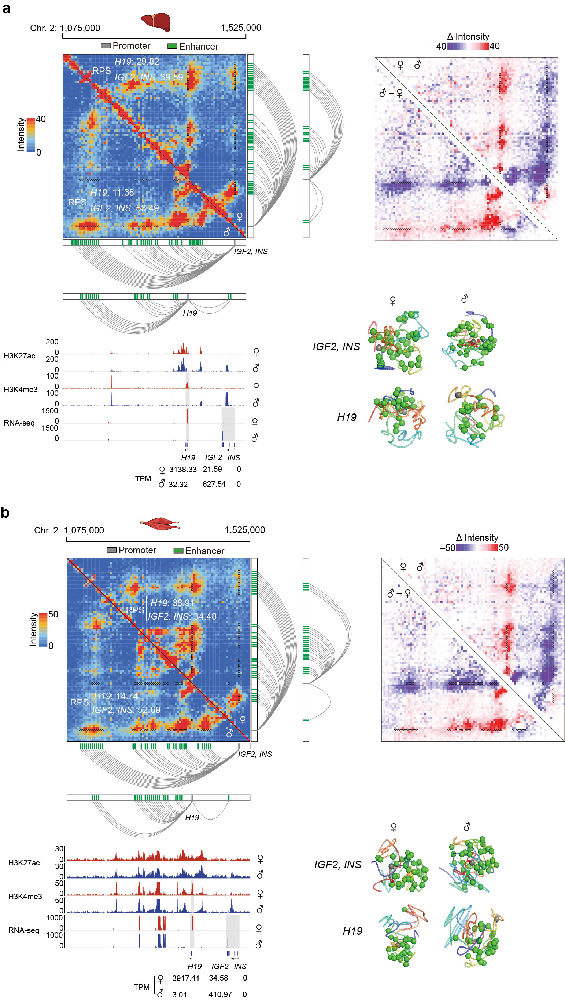
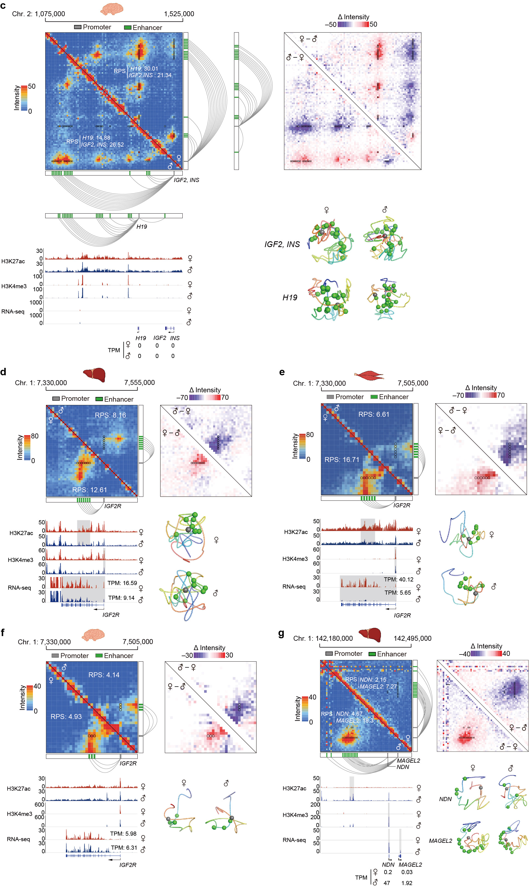
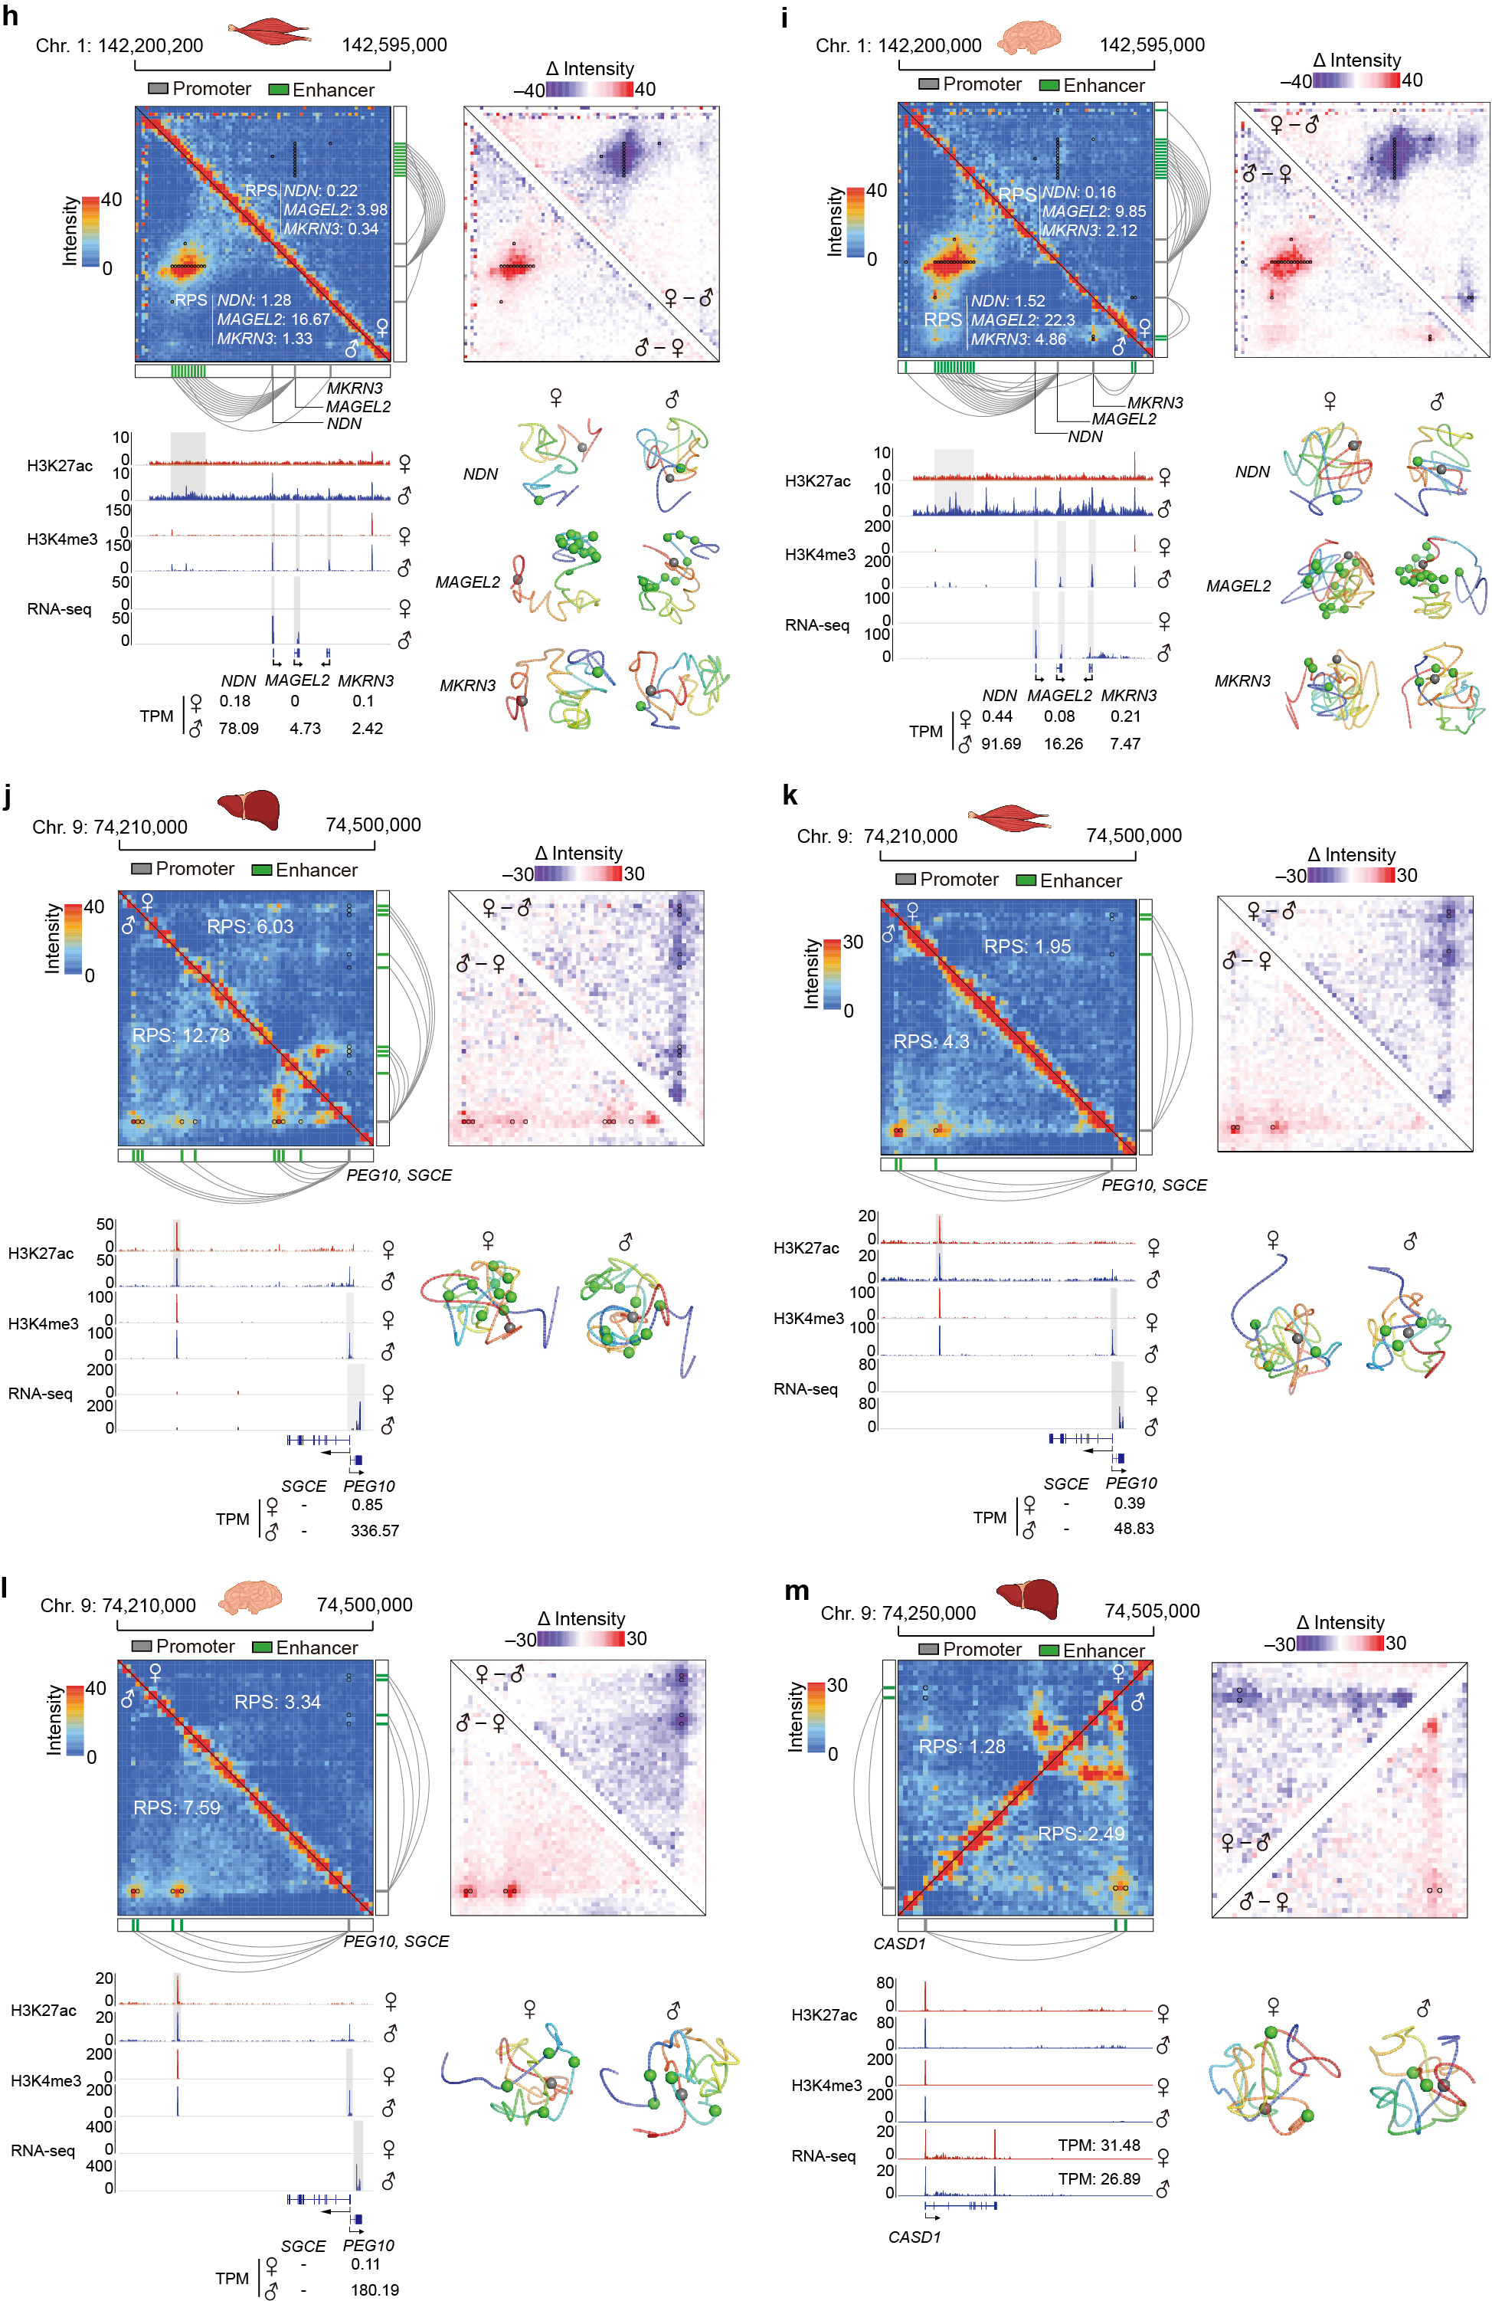
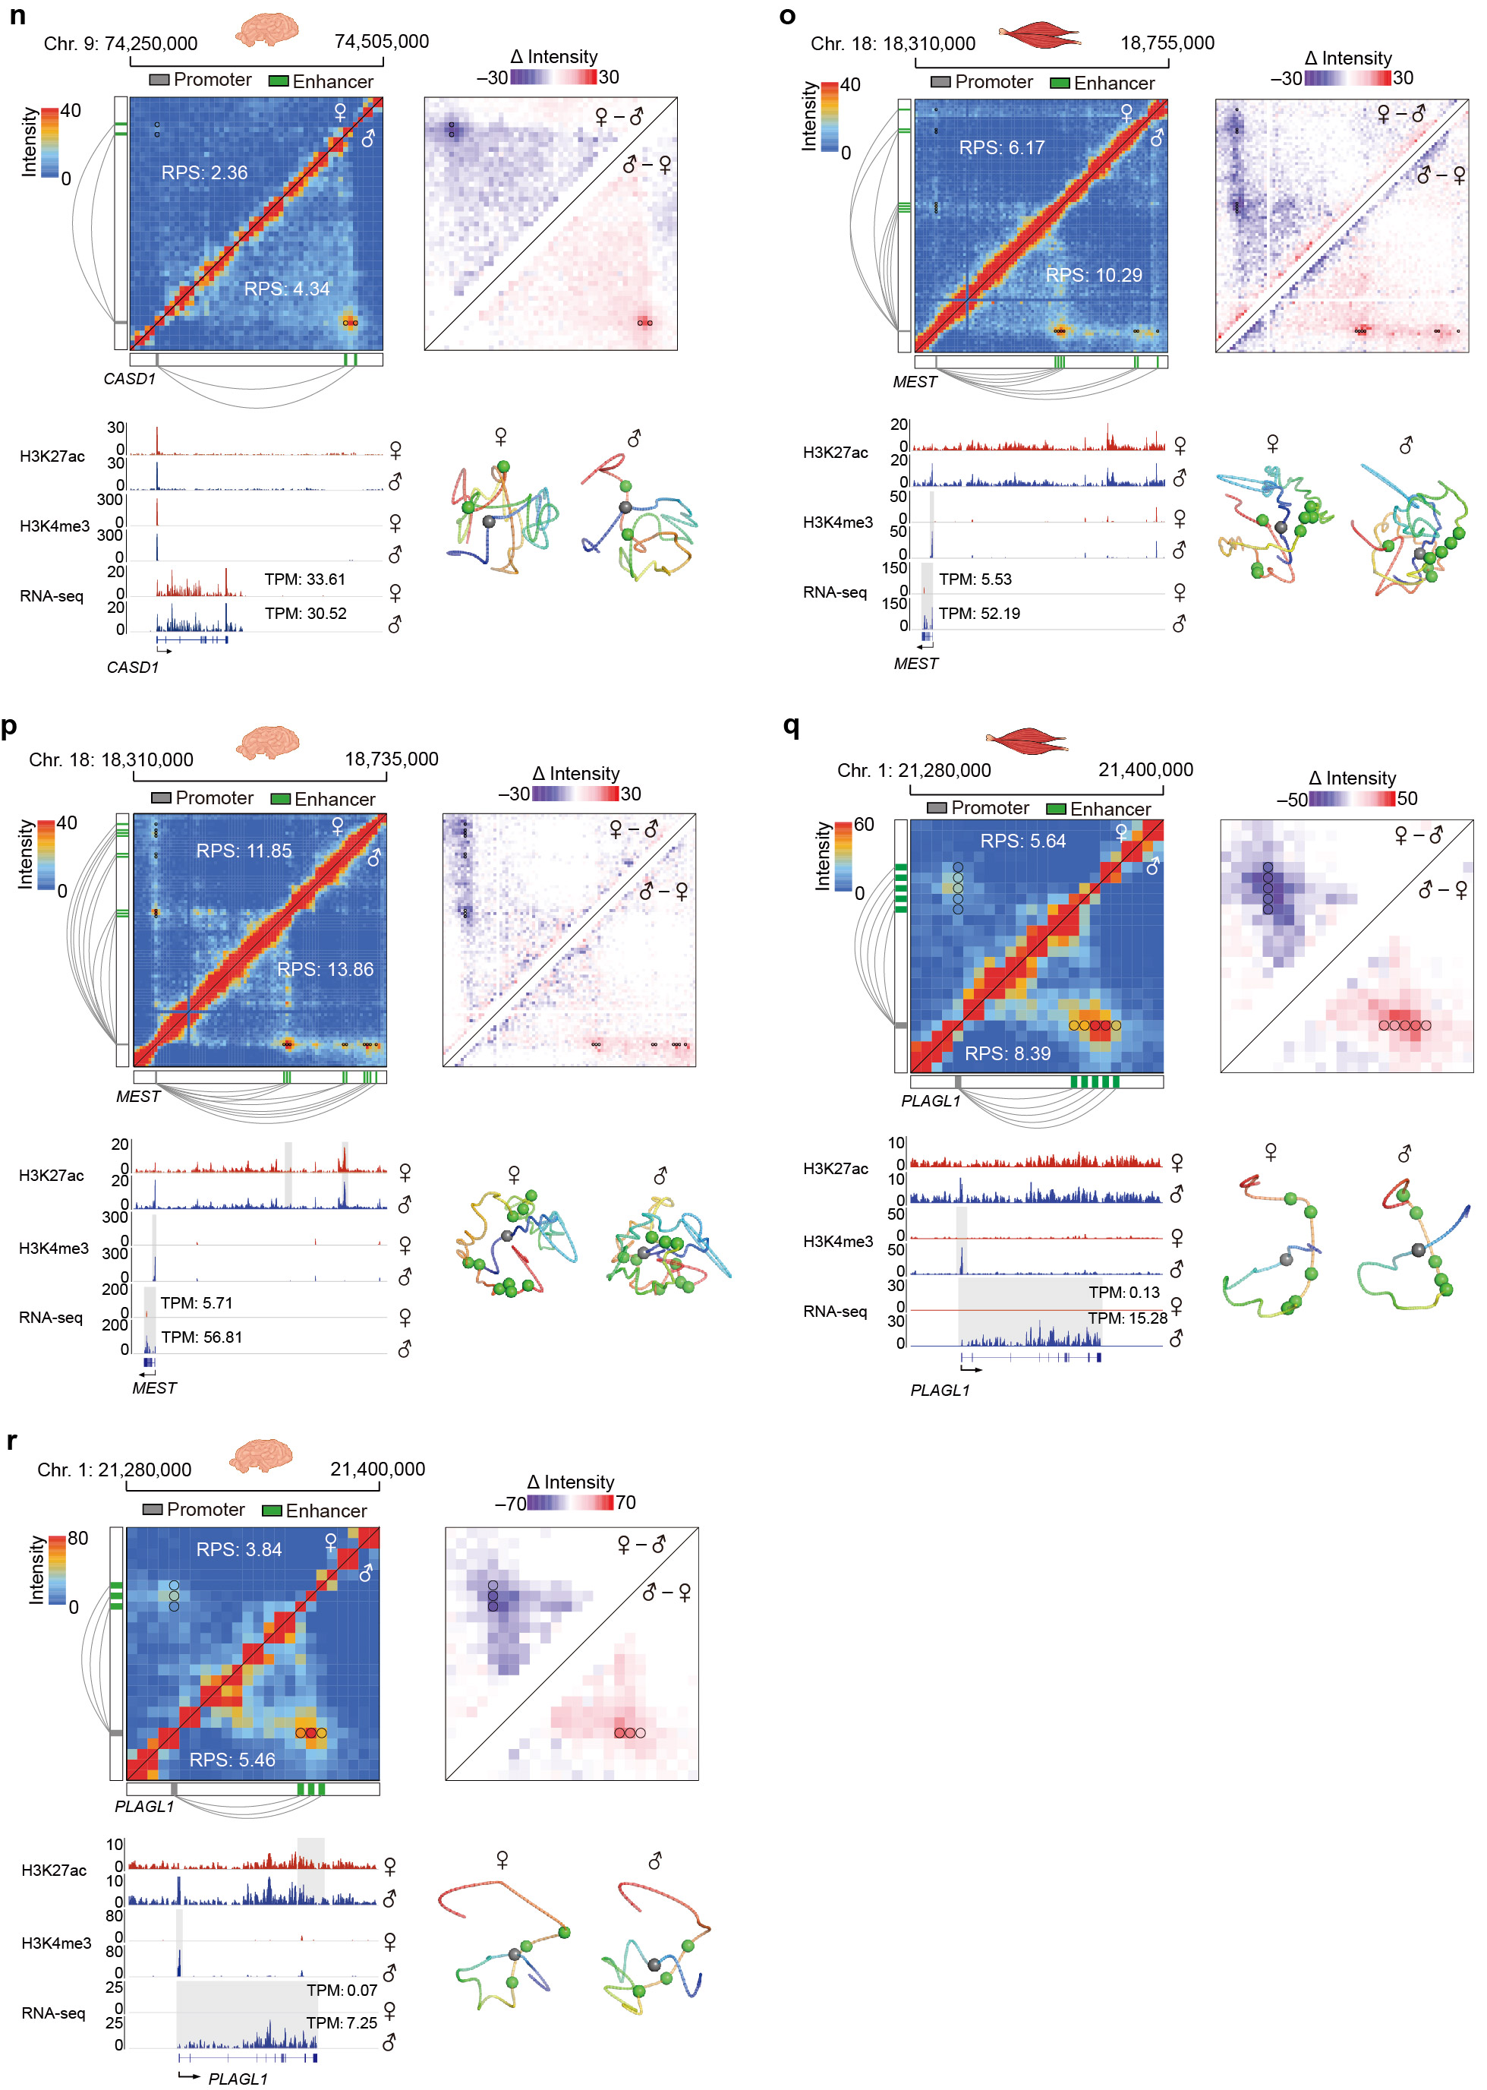
Supplementary Fig. 15 Imprinting-specific PEI organizations.
A total of 12 allelic-expression testable imprinted genes (with informative SNVs and interacting with enhancers in at least one tissue) that exhibited strong evidence of parent-of-origin-specific PEI organization in at least two of the three tissues are shown. Paternally imprinted IGF2/INS and maternally imprinted H19 in the liver (a), muscle (b), and brain (c); maternally imprinted IGF2R in the liver (d), muscle (e), and brain (f); paternally imprinted NDN, MAGEL2 and MKRN3 in the liver (g), muscle (h), and brain (i); paternally imprinted PEG10 and SGCE in the liver (j), muscle (k), and brain (l); paternally imprinted gene CASD1 in the liver (m) and brain (n); paternally imprinted MEST in the muscle (o) and the brain (p); and paternally imprinted PLAGL1 in the muscle (q) and brain (r). The schematics are similar to those shown in Supplementary Fig. 13.

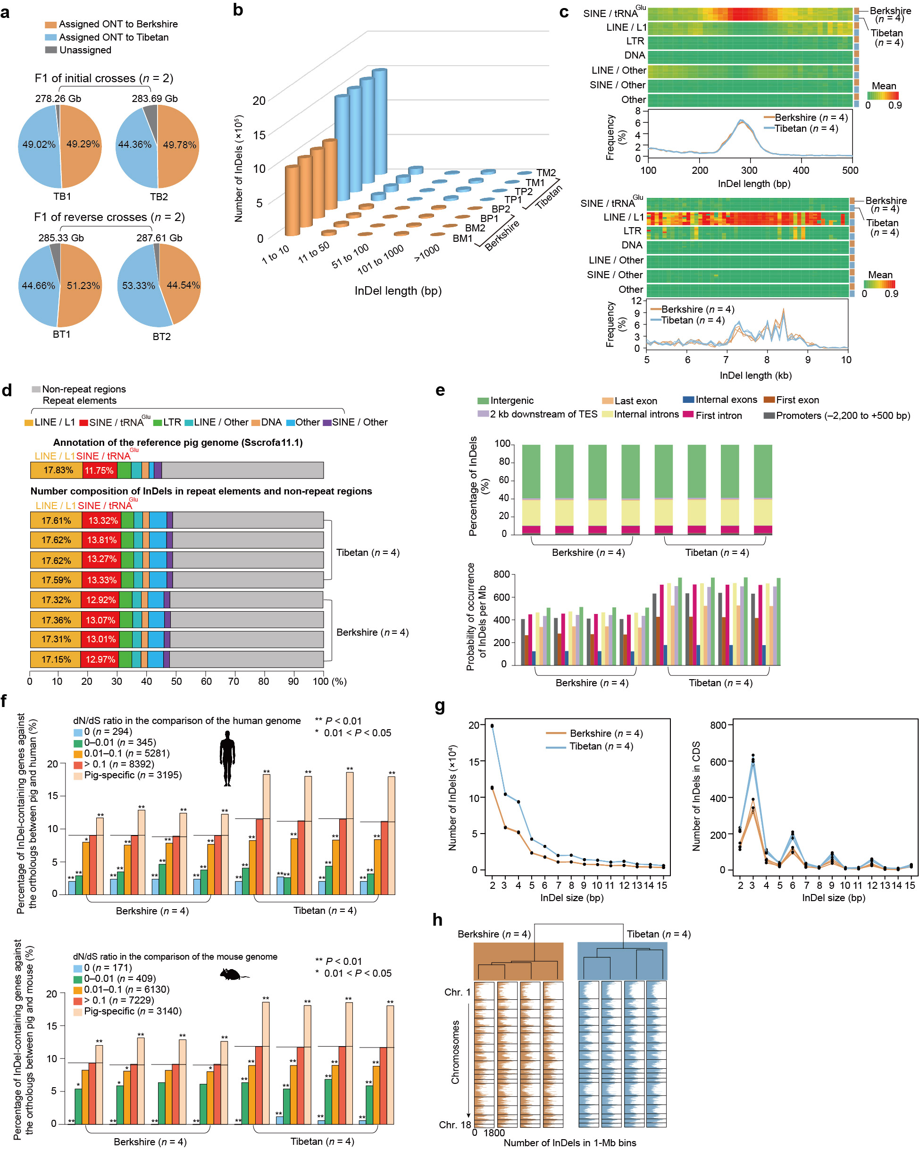
Supplementary Fig. 16 Characteristics of allelic structural variants (SVs).
a Allele assignment of high-quality ONT reads of four F1 hybrids (see Methods).
b Length distribution of the InDels identified in F1 hybrids. We detected ~734.78 k (~8.42 Mb in length) insertions and ~340.13 k (~9.44 Mb in length) deletions in Berkshire haplotypes mapped against the pig reference genome, and ~1.009 M (~12.51 Mb in length) insertions and ~633.92 k (~15.15 Mb in length) deletions in Tibetan haplotypes mapped against the pig reference genome. More than 91% of the InDels spanned 1–10 bp in length.
c Distribution of InDels between 100 bp and 500 bp, and 5 kb and 10 kb in length. The peaks at ~300bp and ~8kb in length (top) are probably associated with the enrichment of InDels of tRNA^{Glu}-derived short interspersed elements (SINE/tRNA^{Glu}) and LINE/L1-derived long interspersed elements, respectively (bottom).
d InDels overlapping with repeat elements in pig genomes. Length composition of repeat elements in the pig reference genome is displayed (top). Number composition of InDels across 8 haploid genomes in repeat elements and non-repeat regions are shown (bottom). Repetitive elements constitute ~46.21% of the genome, of which ~48.08% were InDels, which suggests they are an important source of SVs in the pig genome. Moreover, the SINE/ tRNA^{Glu} (294.47 Mb containing ~13.15% of all InDels) showed a higher incidence of InDels than the predominant long interspersed elements (LINE/L1) (446.51 Mb containing ~17.45% of all InDels).
e Percent distribution (measured by length of InDels, top) and probability of occurrence (measured by number of InDels, bottom) of InDels across different genomic elements. The InDels appear to be constrained by selection: more than 50% of InDels (~58.95% in length) were located in intergenic regions, and the InDel ratio was lower in the coding sequences than in introns.
f Conservation levels of InDel-containing genes, which were categorized following dN/dS ratios compared to gene sets of human (top) and mouse (bottom) genomes (downloaded from Ensembl using the biomart online tool). The black horizontal lines represent the overall percentage of InDel-containing genes against all the orthologs between the pig and human/mouse genomes for 8 haplotypes. By counting the number of orthologs and InDel-containing genes against the genome-wide background, we determined the statistical significance of enrichment of InDel-containing genes for each group that was categorized by the dN/dS ratio using a χ² test (*0.01 < P < 0.05; **0.001 < P < 0.01). This analysis showed that more conserved genes contained fewer InDels.
g Length distribution of short InDels (1–15 bp in length) in the whole genome (left) and coding sequence (CDS) regions (right). We observed an enrichment of short InDels (1–15 bp in length) in coding sequences (~28.97%) that were multiples of 3 bp, which is expected to preserve the reading frame.
h Analysis of the phylogenetic relationship among 8 haplotypes using InDel numbers in 1 Mb non-overlapping genomic bins. Hierarchical clustering based on Pearson’s r of InDel occurrence was used as distance metrics. As in the case of SNVs (Supplementary Fig. 2c), the distribution of short InDels across the genome also reflected a deep phylogenetic split between European (i.e., Berkshire) and Asian pigs (Tibetan).
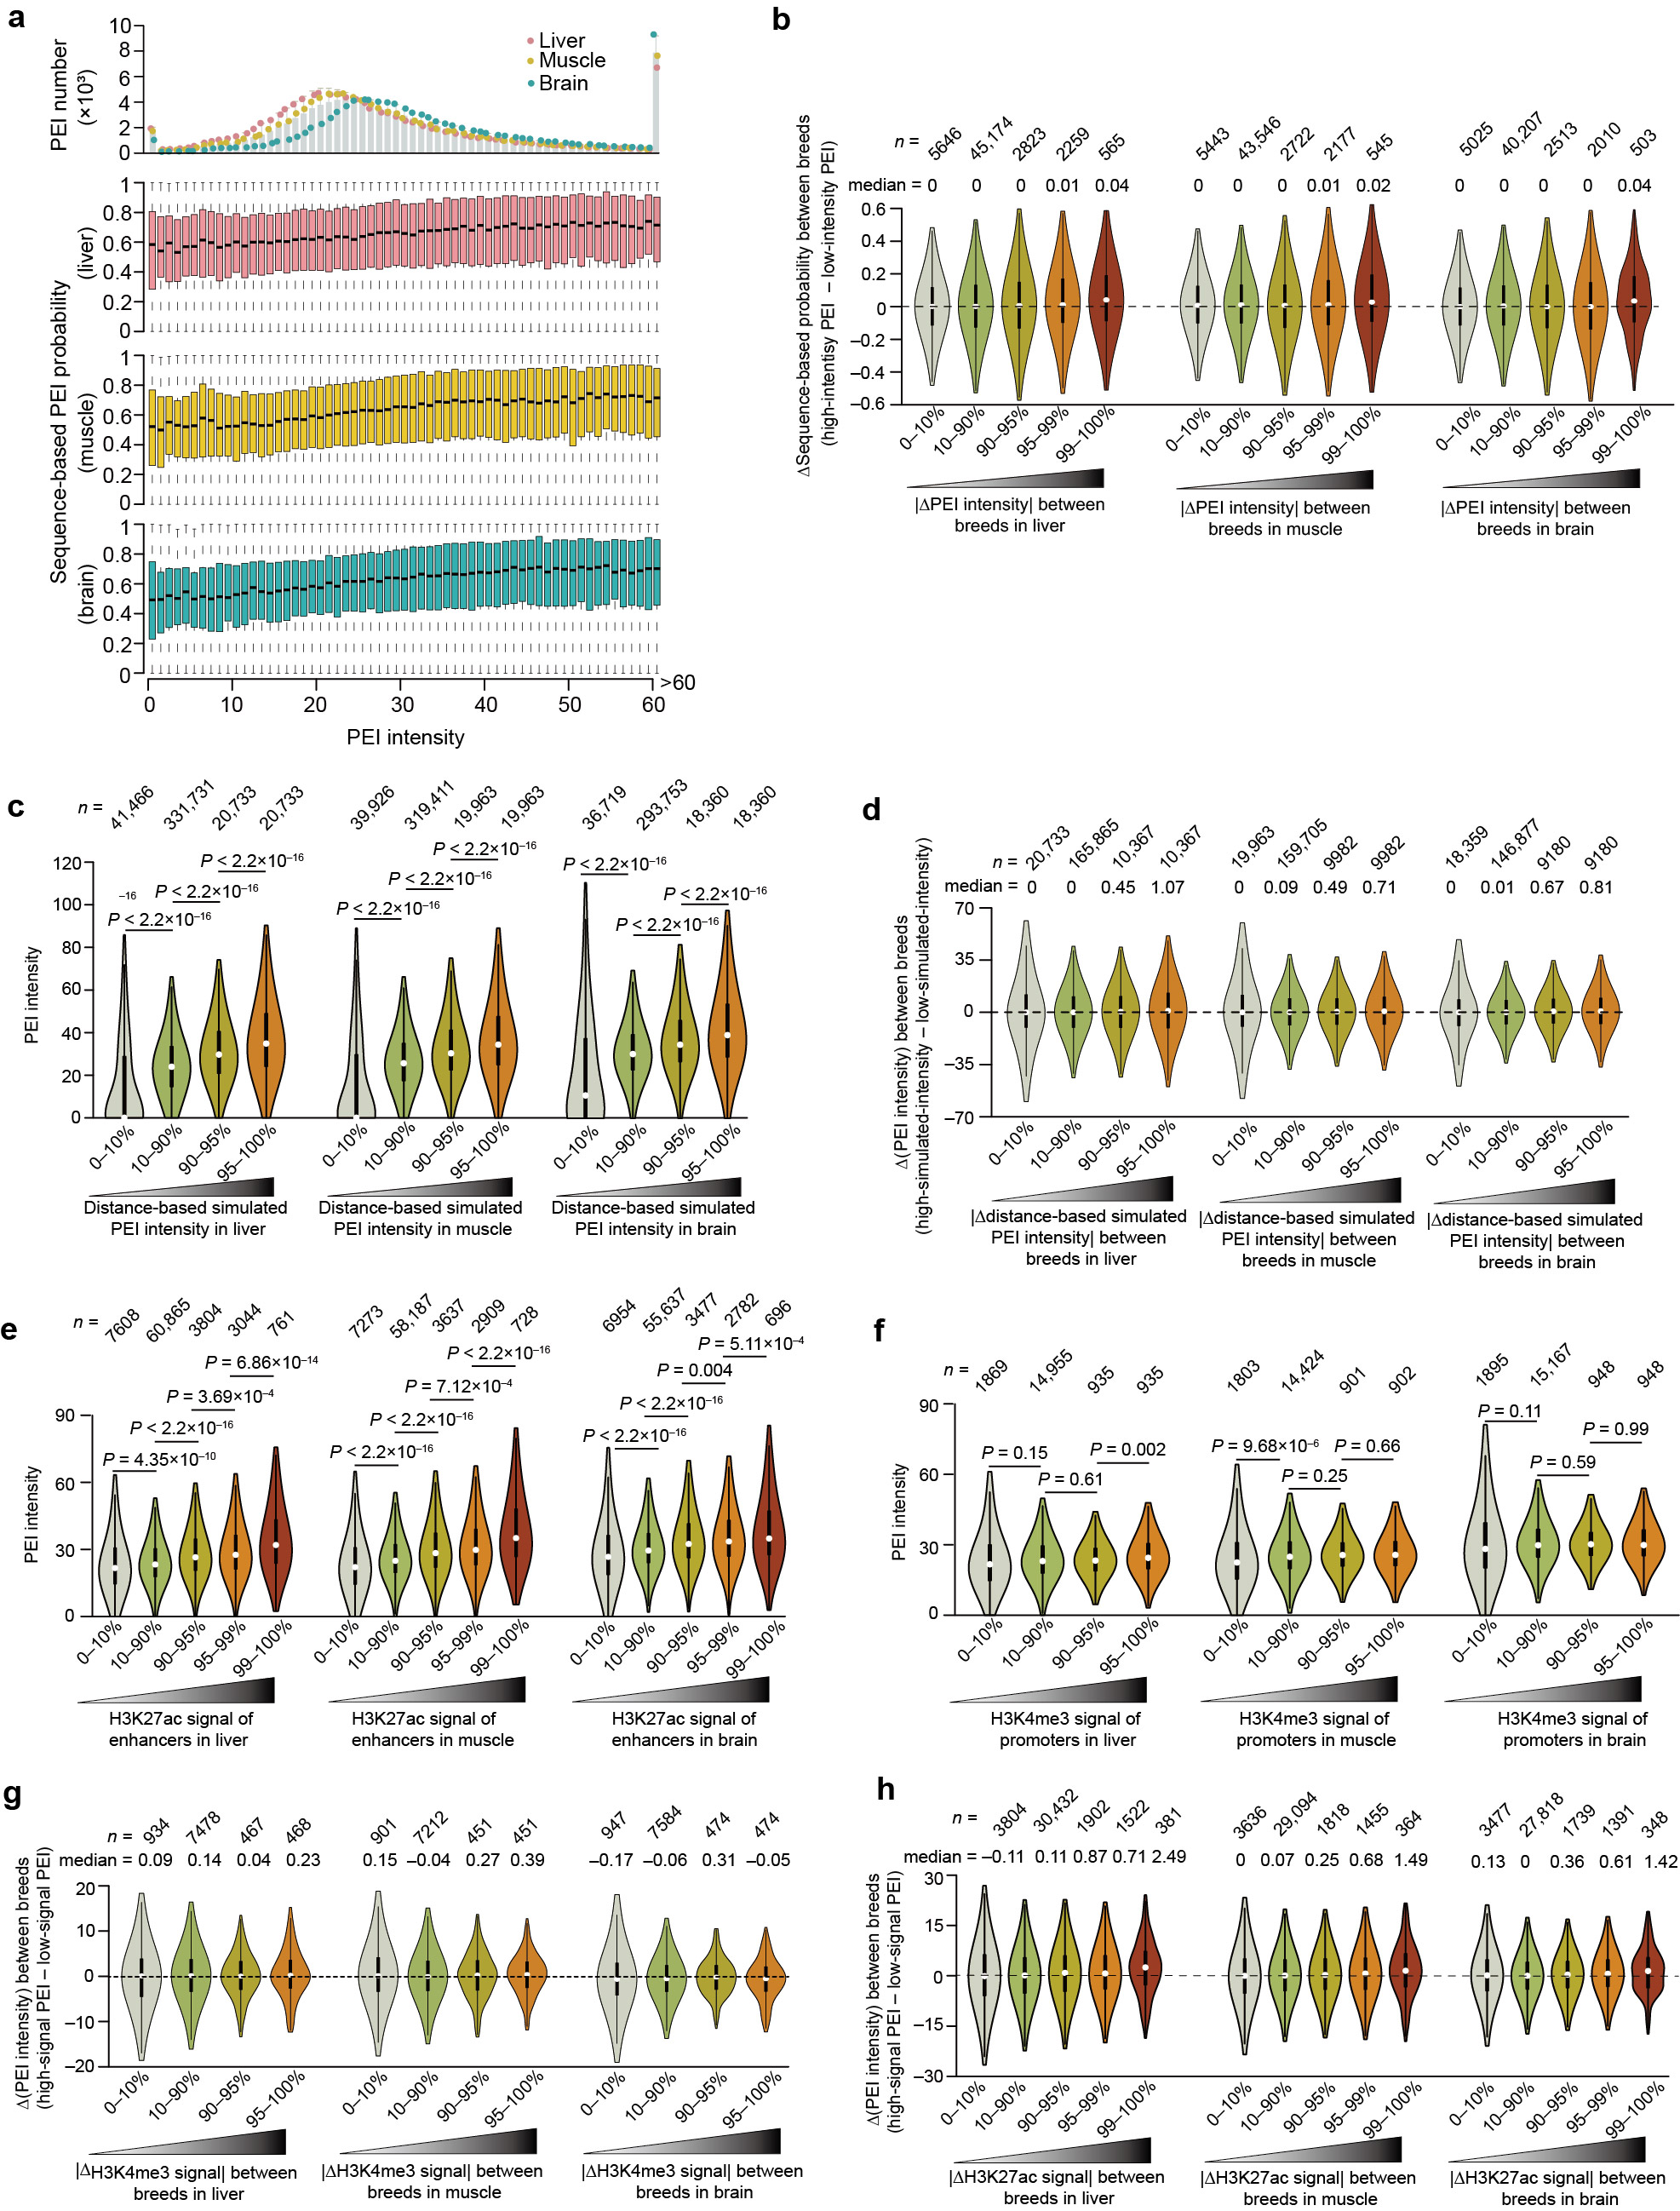
Supplementary Fig. 17 Effects of sequence variation and histone modification on allelic PEI rewiring in F1 hybrids.
a, Among distinct PEIs within each of the 24 haploid genomes, we found that those with increased intensity (x-axis) generally have elevated interaction probabilities (y-axis). Data are shown as mean ± SD (eight haploid genomes for each of the three tissues). The probability of long-range interactions for each allelic PEI were estimated by considering their variation using the PEP algorithm that only employs sequence-based features¹⁵ (see Methods). The intensity distribution of PEIs in each tissue are also shown in the top.
b, For the comparison of particular PEIs between two parental alleles in F1 hybrids in a specific tissue, those with more dramatic changes in intensity (especially those in the highest top 1% allelic intensity changes; see Methods) generally have elevated allelic differences of estimated interaction probabilities. The P-values were calculated using the Wilcoxon rank-sum test.
c, d, Among the distinct PEIs within each haploid genome (c), or for a given PEI between two parental alleles (d), the simulated PEI intensities based on the variable bridging distances of the PEI using Huynh’s algorithm (see Methods) suggest that promoter and enhancers neighbor each other in the linear genome, and generally have an elevated interaction intensity. The P-values were calculated using the Wilcoxon rank-sum test.
e–h, Among the distinct PEIs within each haploid genome (e and g), or for a given PEI between two parental alleles (f and h), the increased activities for H3K4me3-marker promoters (e and f) and H3K27ac-marked enhancers (g and h) generally have an elevated PEI intensity. The P-values were calculated using the Wilcoxon rank-sum test.

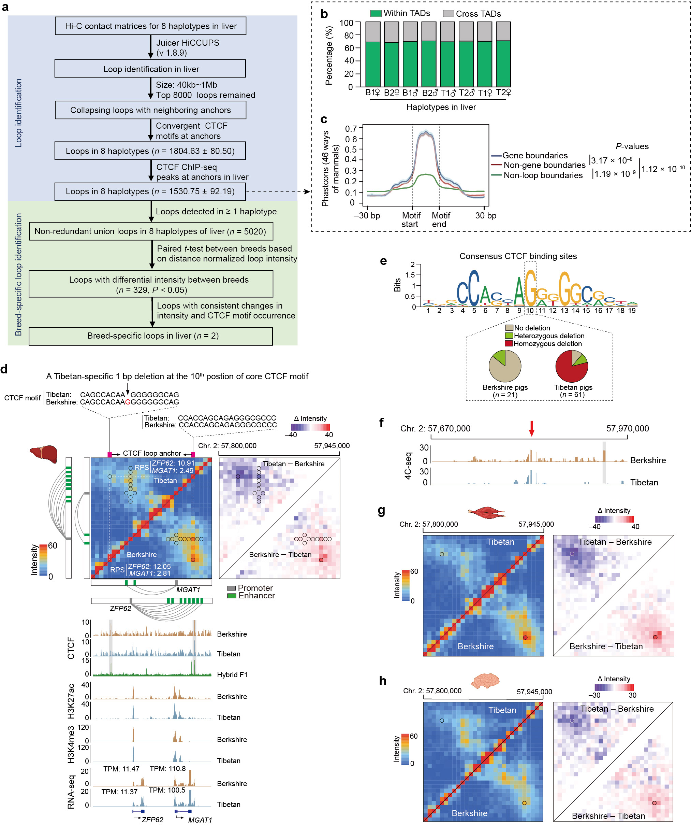
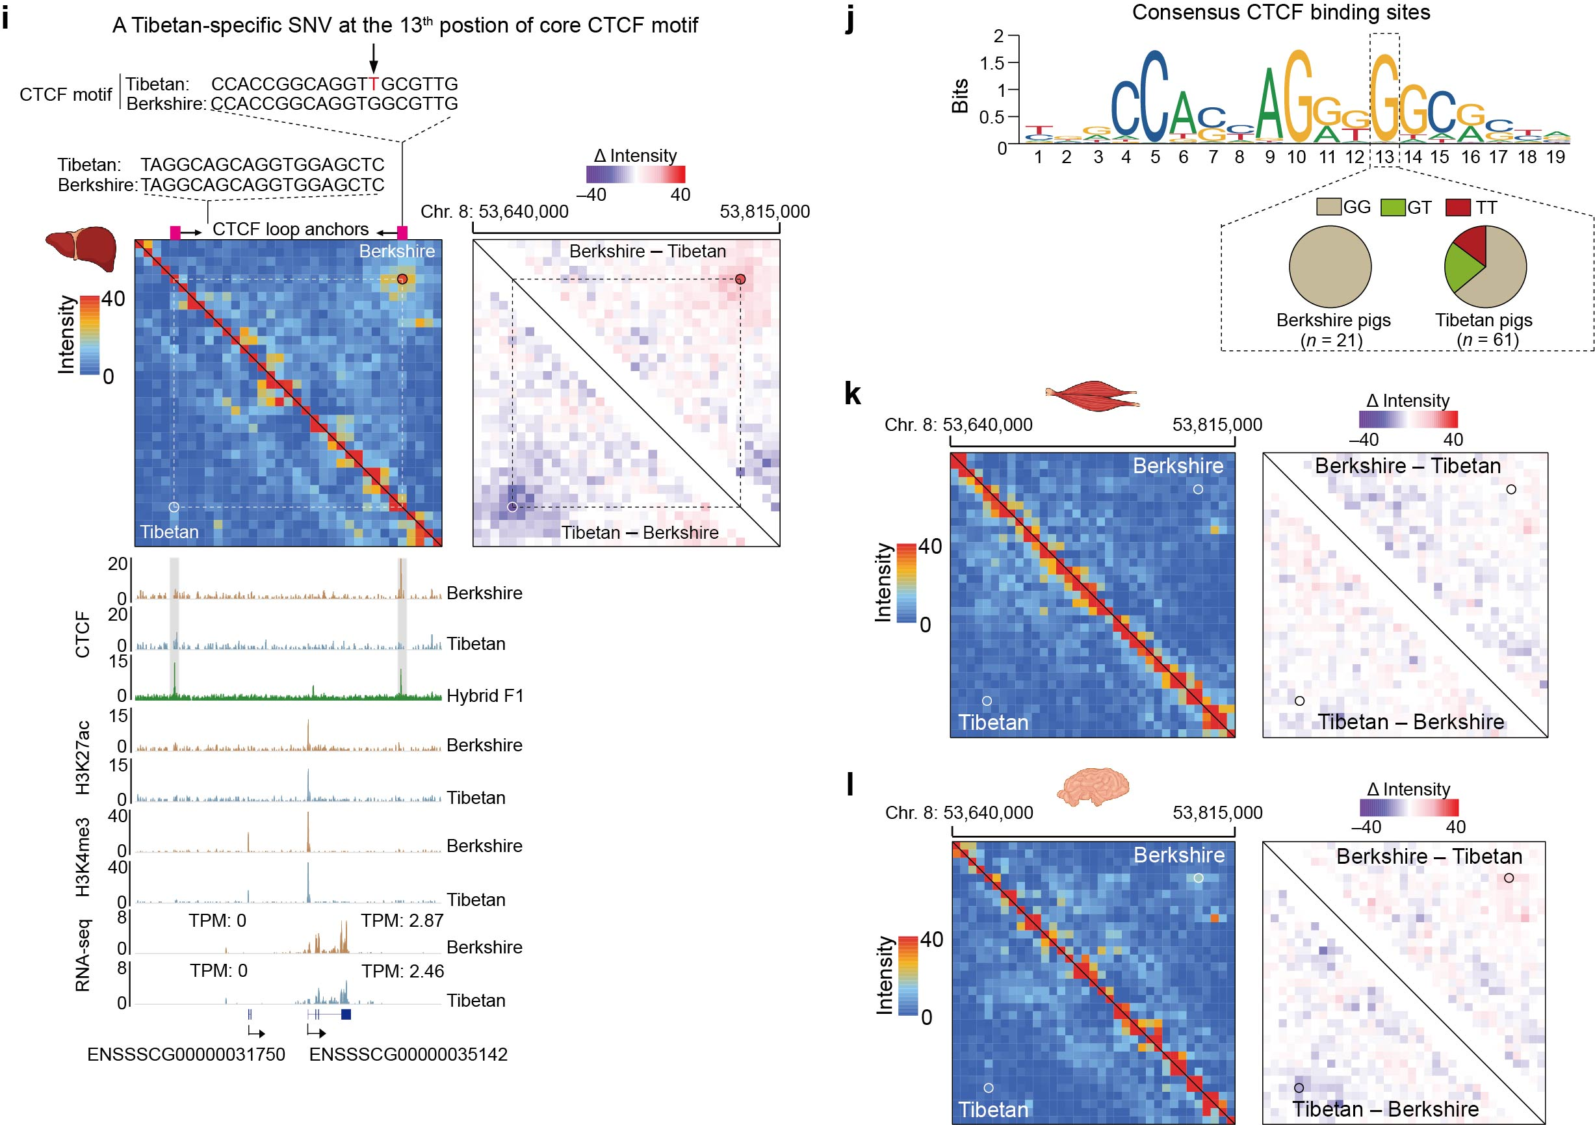
Supplementary Fig. 18 Breed-specific mutations induced allele-specific abolition of CTCF-mediated loops.
a Identification of breed-specific CTCF loops in the liver. Briefly, we applied Juicer HiCCUPS to identify loops in 8 haplotypes using their Hi-C contact matrices. Only loops with anchor distances between 40-kb and 1-Mb were kept and then ranked by detection significance, with the top 8000 loops retained. Loops with neighboring anchors were collapsed into a non-redundant set, and those without convergent CTCF motifs or CTCF ChIP-seq peaks at both anchors were removed. Loops detected in at least one of the 8 haplotypes were combined into a single non-redundant union set. For each loop set, the distance-normalized interaction intensity was retrieved from the Hi-C contact matrices for the 8 haplotypes. We identified loops with differential intensity between Berkshire and Tibetan haplotypes (P < 0.05, paired Student’s t-test), and those with consistent intensity change and CTCF motif occurrence were considered as breed-specific CTCF loops.
b Proportion of CTCF loops within and across TADs.
c Evolutionary conservation (inferred by Phastcons) of consensus CTCF motifs at CTCF loop boundaries with or without genes, and non-boundary regions. The motif region (19 bp in length) is indicated by the dashed box. Data are presented as mean ± SD. The shaded area indicates the standard deviation. P-values were calculated using a paired Student’s t-test.
d–h A 1-bp deletion (‘G’, chromosome 2: 57822013; the 10th position of the core CTCF binding motif at the 5’ loop anchor) in Tibetan alleles most likely resulted in allele-specific abolition of the CTCF loop.
d Hi-C maps and their allelic differences. Linear positions of the CTCF loop anchors (magenta squares) and sequences of the core CTCF binding site of Tibetan and Berkshire alleles are shown (top). ChIP-seq signals of CTCF, H3K27ac and H3K4me3, and expression of two genes located within loop are also exhibited (bottom).
e Sequence logos of the consensus CTCF binding motif (downloaded from https://jaspar.genereg.net/) indicate that the 10th position is highly conserved in vertebrates (top). The frequency of a 1-bp deletion (‘G’, chromosome 2: 57822013) in populations of Berkshire (n = 21) and Tibetan pigs (n = 61) (bottom). Of the 82 pigs, six Berkshire and six Tibetan pigs were from six parent-child trios used in our study. The publicly available InDels of other 60 pigs (including 15 Berkshire and 55 Tibetan pigs) were retrieved from the ISwine database (Fu et al., 2020).
f 4C-seq signals confirmed the CTCF loop existing in Berkshire pigs were not present in Tibetan pigs. Histogram showing the genomic interactions across the 150 kb up- and down-stream the CTCF loop anchor. Red vertical arrows indicate the viewpoint. The grey shadow shows the differential interaction intensity between Tibetan and Berkshire pigs at the genomic loci where Berkshire had enriched chromatin interactions due to a breed-specific CTCF loop.
g, h Hi-C maps around the Tibetan-specific 1-bp deletion (‘G’, chromosome 2: 57822013) and their allelic differences in the muscle (g) and brain (h). Hi-C maps showing substantial differences in loop intensity between the two parental alleles (similar as shown in e).
i–l A SNV (‘G’ > ’T’, chromosome 8: 53792054; the 13th position of the core CTCF binding motif of the 3’ loop anchor) in Tibetan alleles mostly like resulted in allele-specific abolition of the CTCF loop. The schematics of i–l are similar to those shown in panels d–g.
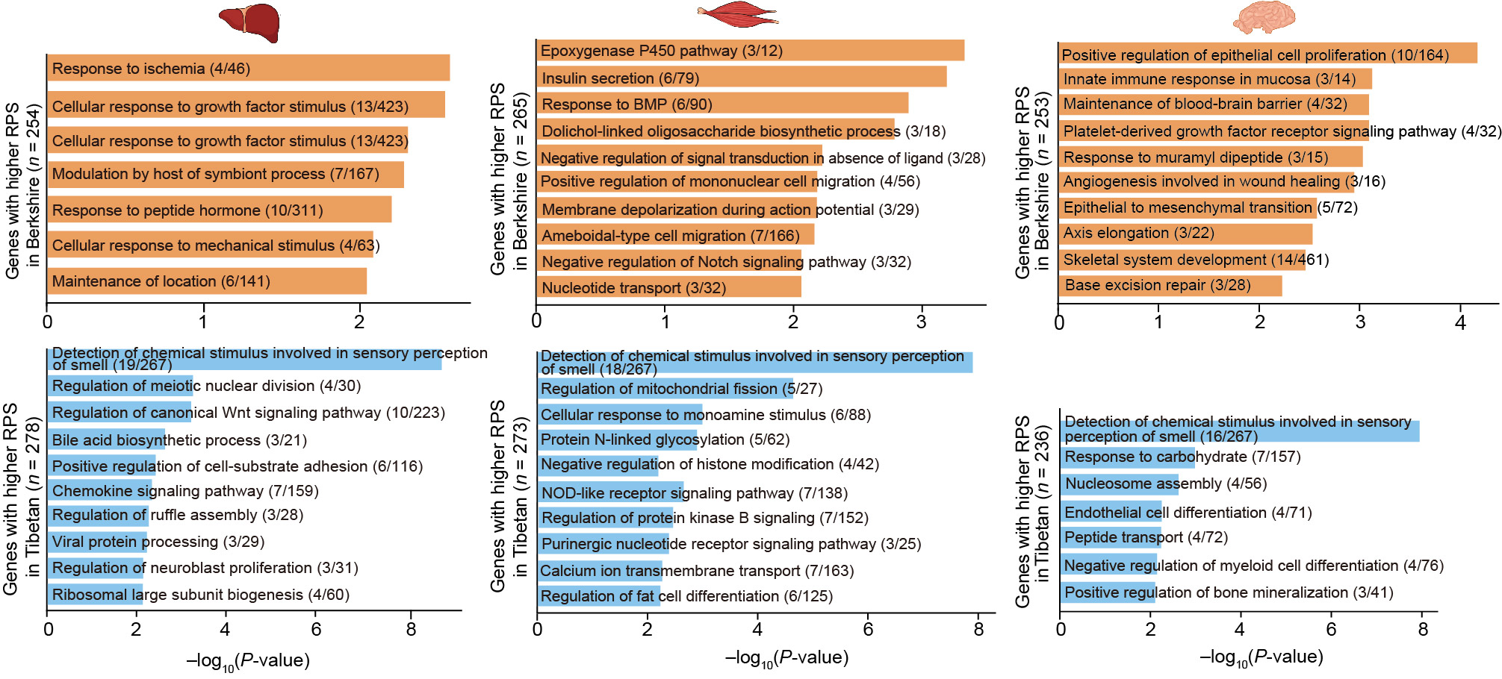
Supplementary Fig. 19 Significantly enriched GO-BP terms or KEGG pathways (performed using Metascape) for genes showing differential RPS between Berkshire and Tibetan haplotypes in the liver (left), muscle (middle) and brain (right).

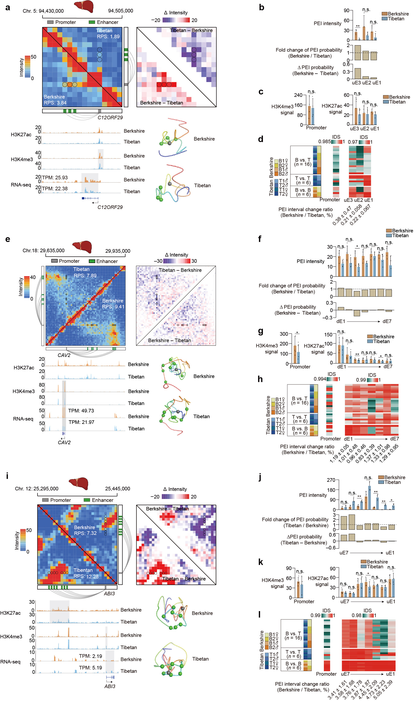
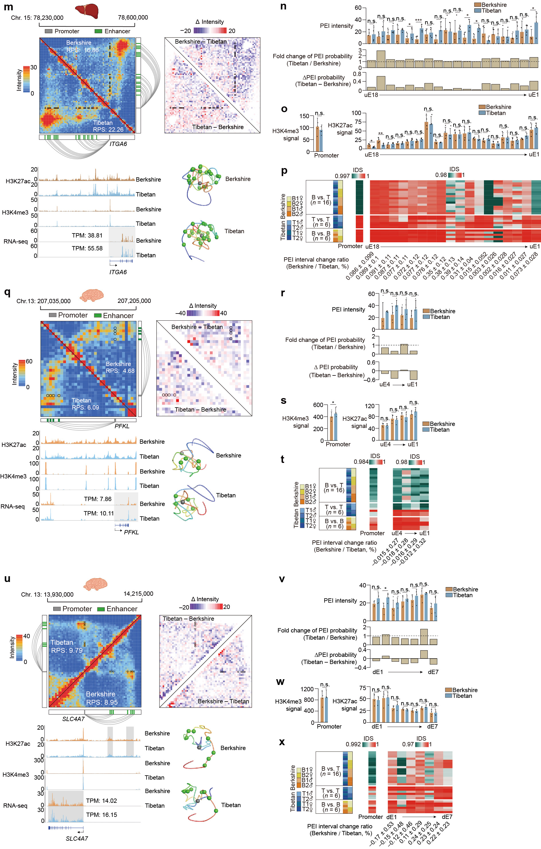
Supplementary Fig. 20 Representative examples of genes showing differential RPS between Berkshire and Tibetan alleles across the different tissues.
a–d Allelically differential RPS of C12ORF29 in the liver.
a Hi-C maps (upper left) and their allelic differences (upper right). ChIP-seq signals of H3K27ac and H3K4me3, gene expression (lower left), and 3D structural models (lower right). Promoter (grey square), enhancers (green squares), and PEIs (connecting lines) are displayed.
b Allelic differences of PEI intensity (mean ± SD, n = 4, top) and sequence-based PEI probability (middle and bottom). n.s., P ≥ 0.05; *P < 0.05; **P < 0.01.
c Allelic differences of histone modification (H3K27ac in enhancers and H3K4me3 in promoter). Mean ± SD (n = 4). n.s., P ≥ 0.05; *P < 0.05; **P < 0.01.
d Degree of haplotype similarities (measured by IDS) of promoter and enhancer in pairwise comparisons among 8 haplotypes. The allelic changes in the PEI interval length are also provided.
Allelically differential RPS of CAV2 (e–h), ABI3 (i–l), and ITGA6 (m–p) in the liver, and PFKL (q–t) and SLC4A7 (u–x) in the brain are similar to those shown in (a–d).
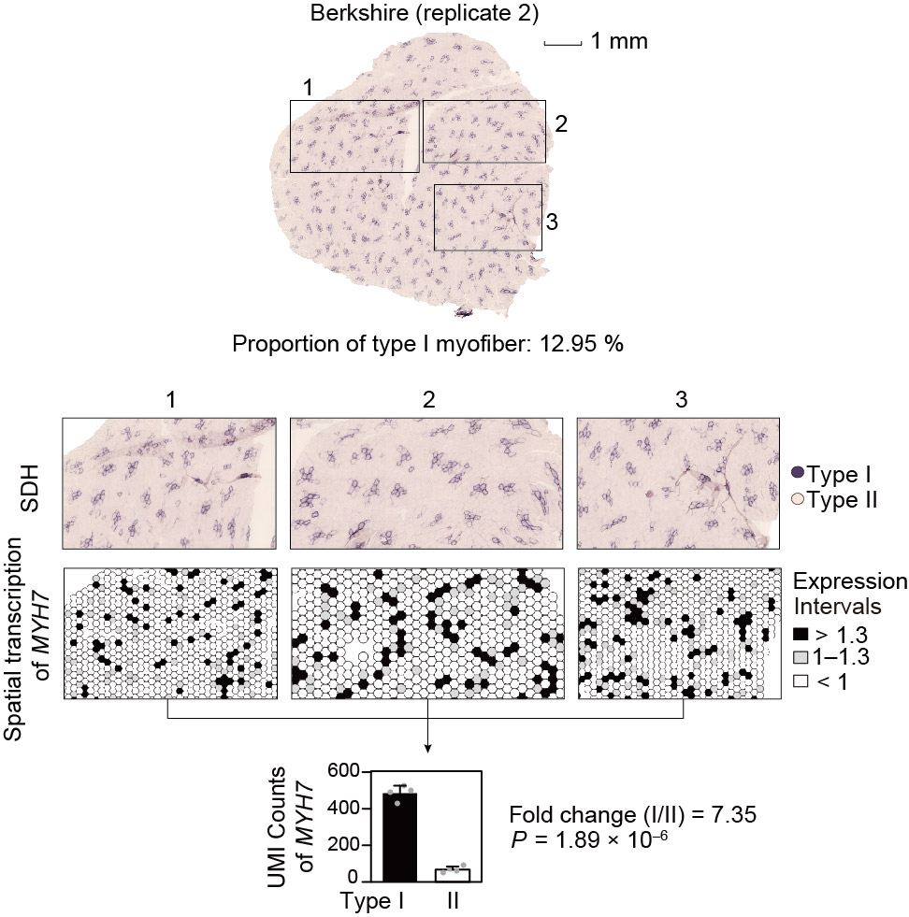
Supplementary Fig. 21 Succinate dehydrogenase (SDH) histochemistry and spatial transcriptomic features of the LDM of a Berkshire pig.
Top: SDH against slow-twitch type I (dark color) and fast-twitch type II (light color) myofiber for LDM between the two pig breeds. The proportion of type I myofiber measured as the area ratio of type I myofibers from three randomly selected fields is shown below the plots.
Middle: Three typical regions/images (top) from SDH-stained histological sections (denoted with numbers) magnified for comparison matching results. Spatial transcriptional profiles of myofiber marker genes (bottom), i.e., MYH7 (type I), and MYH4 (type II), are also shown. The color of the spot indicates the transcription level.
Bottom: Boxplot showing the expression differences of MYH7 and MYH4 between type I and type II myofibers, which was quantified using pseudo-bulk data from corresponding types of spots (masked from SDH sections) simulating four times. The data are presented as mean ± SD (n = 4).
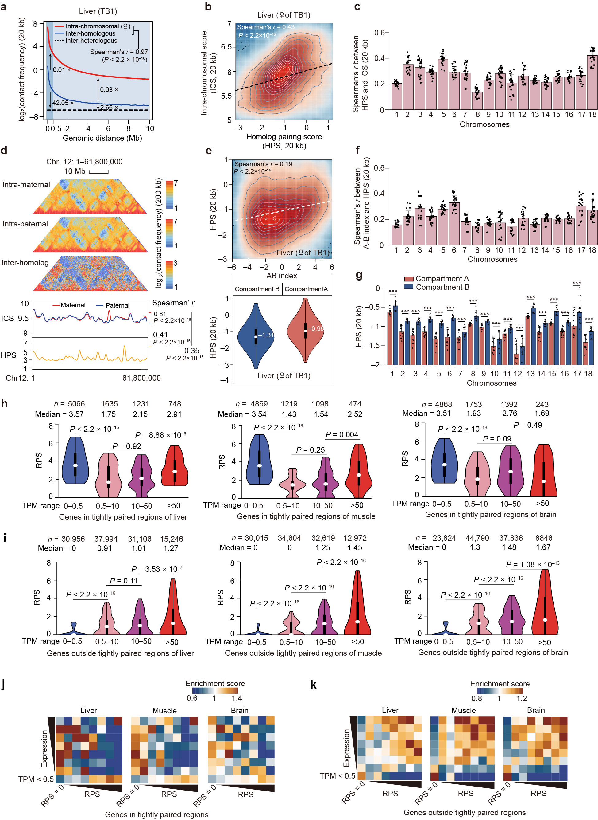
Supplementary Fig. 22 Characteristics of homolog pairing in the pig genome.
a, Similar distance-dependent decay of intra-chromosomal (red) and inter-homologous (blue) contacts (Spearman’s r = 0.97, P < 2.2 × 10^{–16}). The interactions between homologs are statistically weaker than within chromosomes (inter-homolog vs. intra-chromosome: average 0.01-fold between 20-kb to 500-kb, P < 0.01; and 0.036-fold between 500-kb to 10-Mb, P < 2.2 × 10^{–16}), but statistically stronger than between heterologs (dashed line) (inter-homolog vs. inter-heterolog: average 35.31-fold between 20-kb to 500-kb, P < 9.73 × 10^{–16}; and 2.41-fold between 500-kb to 10-Mb, P < 2.2 × 10^{–16}) in 12 samples. The P values were obtained using a paired Student’s t-test. Data of a representative liver sample is shown.
b, Homolog pairing score (HPS) is positively correlated with the intra-chromosomal score (ICS; Spearman’s r = 0.43, P < 2.2 × 10^{–16}). Data of a representative liver sample is shown.
c, Correlation between HPS and ICS for each of the 18 autosomes.
d, Homology pairing is correlated with compartmentalization. Top: HPS values are positively correlated with compartment scores (A-B index; Spearman’s r = 0.19, P < 2.2 × 10^{–16}). A representative liver sample is shown. Bottom: in comparison to compartment B regions, compartment A regions exhibited enhanced allelic pairing (reflected by statistically increased HPS values), which supports findings uncovered in flies^{16–18}.
e, Correlation between HPS and compartment scores (A-B index) for each of the 18 autosomes.
f, Comparison of HPS between compartment A and B regions for each of the 18 autosomes.
g, Hi-C maps of chromosome 12 in the pig genome (61.80 Mb in length) (top). The intra-chromosomal contacts (measured by ICS) of two parental alleles, and inter-homolog contacts (measured by HPS) are also shown (bottom).
In c, e, and f, the data are presented as mean ± SD (n = 12), and the dots represent the Spearman’s correlation coefficients for each sample. The P values were calculated using a Wilcoxon rank-sum test. *P < 0.05; **P < 0.01; *** P < 0.001.
h, i, Compared to other genes (h), those located in tightly paired regions (i) exhibited strikingly decreased covariations between allelic expression and RPS. Genes present in eight haplotypes within each tissue were classified into four classes based on their respective expression levels. This suggests a complicated transcriptional regulation program besides the intra-chromosomal PEI exists.
j, k, Enrichment of RPS (x-axis) from gene expression (y-axis) indicates the increased covariations between allelic expression and intra-chromosomal-based RPS (i.e., genes with larger RPS had higher expression) for genes outside the tightly-paired regions (j) compared to genes located in tightly-paired regions (k).
For Hi-C maps, a 20-kb resolution was used in (a–c) and (e–g), and a 200-kb resolution was used in panel (d).

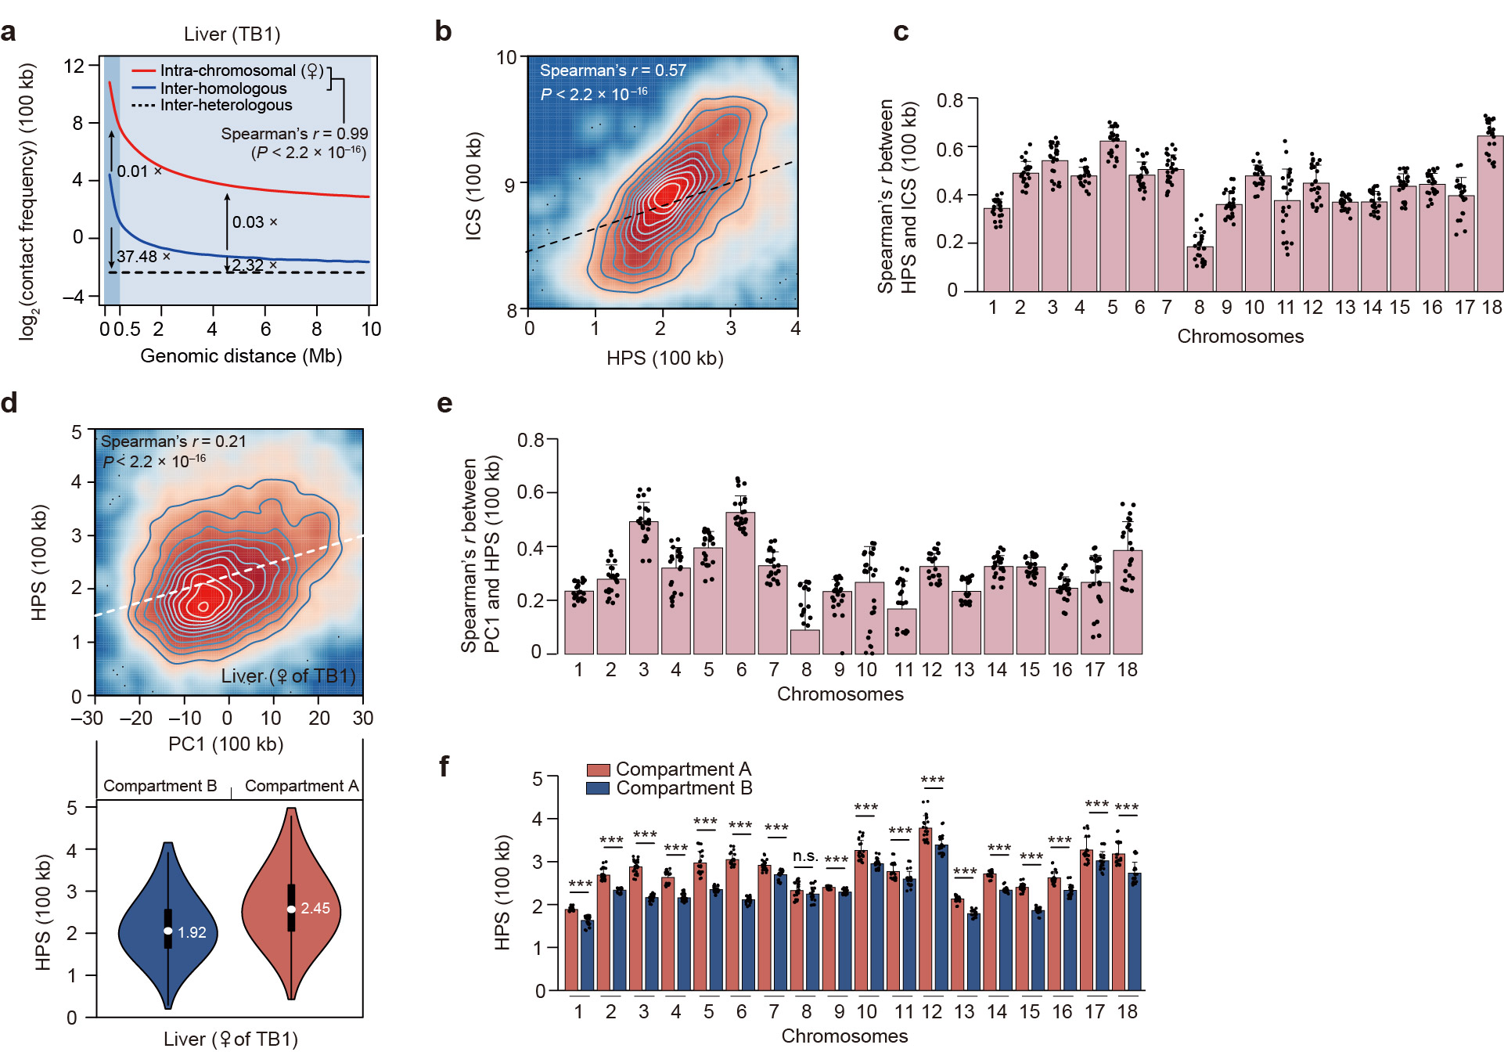
Supplementary Fig. 23 Characteristics of homolog pairing in the pig genome at 100-kb resolution, which recapitulates the findings obtained at 20-kb resolution.
a Similar distance-dependent decay of intra-chromosomal (red) and inter-homologous (blue) contacts (mean Spearman’s r = 0.99, P < 2.2 × 10^{–16}). Although the interactions between homologs are statistically weaker than within chromosomes (inter-homolog versus intra-chromosome: average 0.01-fold between 20-kb to 500-kb, P < 0.12; and 0.028-fold between 500-kb to 10-Mb, P < 1.06 × 10^{–8}), they are still statistically stronger than between heterologs (dashed line) (inter-homolog versus inter-heterolog: average 37.48-fold between 20-kb to 500-kb, P < 0.007; and 2.32-fold between 500-kb to 10-Mb, P < 2.2 × 10^{–16}). P values were calculated using a paired Student’s t-test. Data of a representative liver sample is shown.
b Homolog pairing score (HPS) is positively correlated with the intra-chromosomal score (ICS) (Spearman’s r = 0.57, P < 2.2 × 10^{–16}). A representative liver sample is shown.
c Correlations between HPS and ICS for each of the 18 autosomes.
d Homology pairing is correlated with compartmentalization. Top: HPS values are positively correlated with A-B index (Spearman’s r = 0.28, P < 2.2 × 10^{–16}). A representative liver sample is shown. Bottom: In comparison to compartment B regions, compartment A regions exhibited enhanced allelic pairing (reflected by statistically increased HPS values).
e Correlation between HPS and compartment scores (A-B index) for each of the 18 autosomes.
f Comparison of HPS between compartments A and B regions for each of the 18 autosomes.
In c, e, and f, the data are presented as mean ± SD (n = 12), and the dots represent the Spearman’s correlation coefficients for every sample. P values were calculated using the Wilcoxon rank-sum test. *P < 0.05; **P < 0.01; *** P < 0.001.
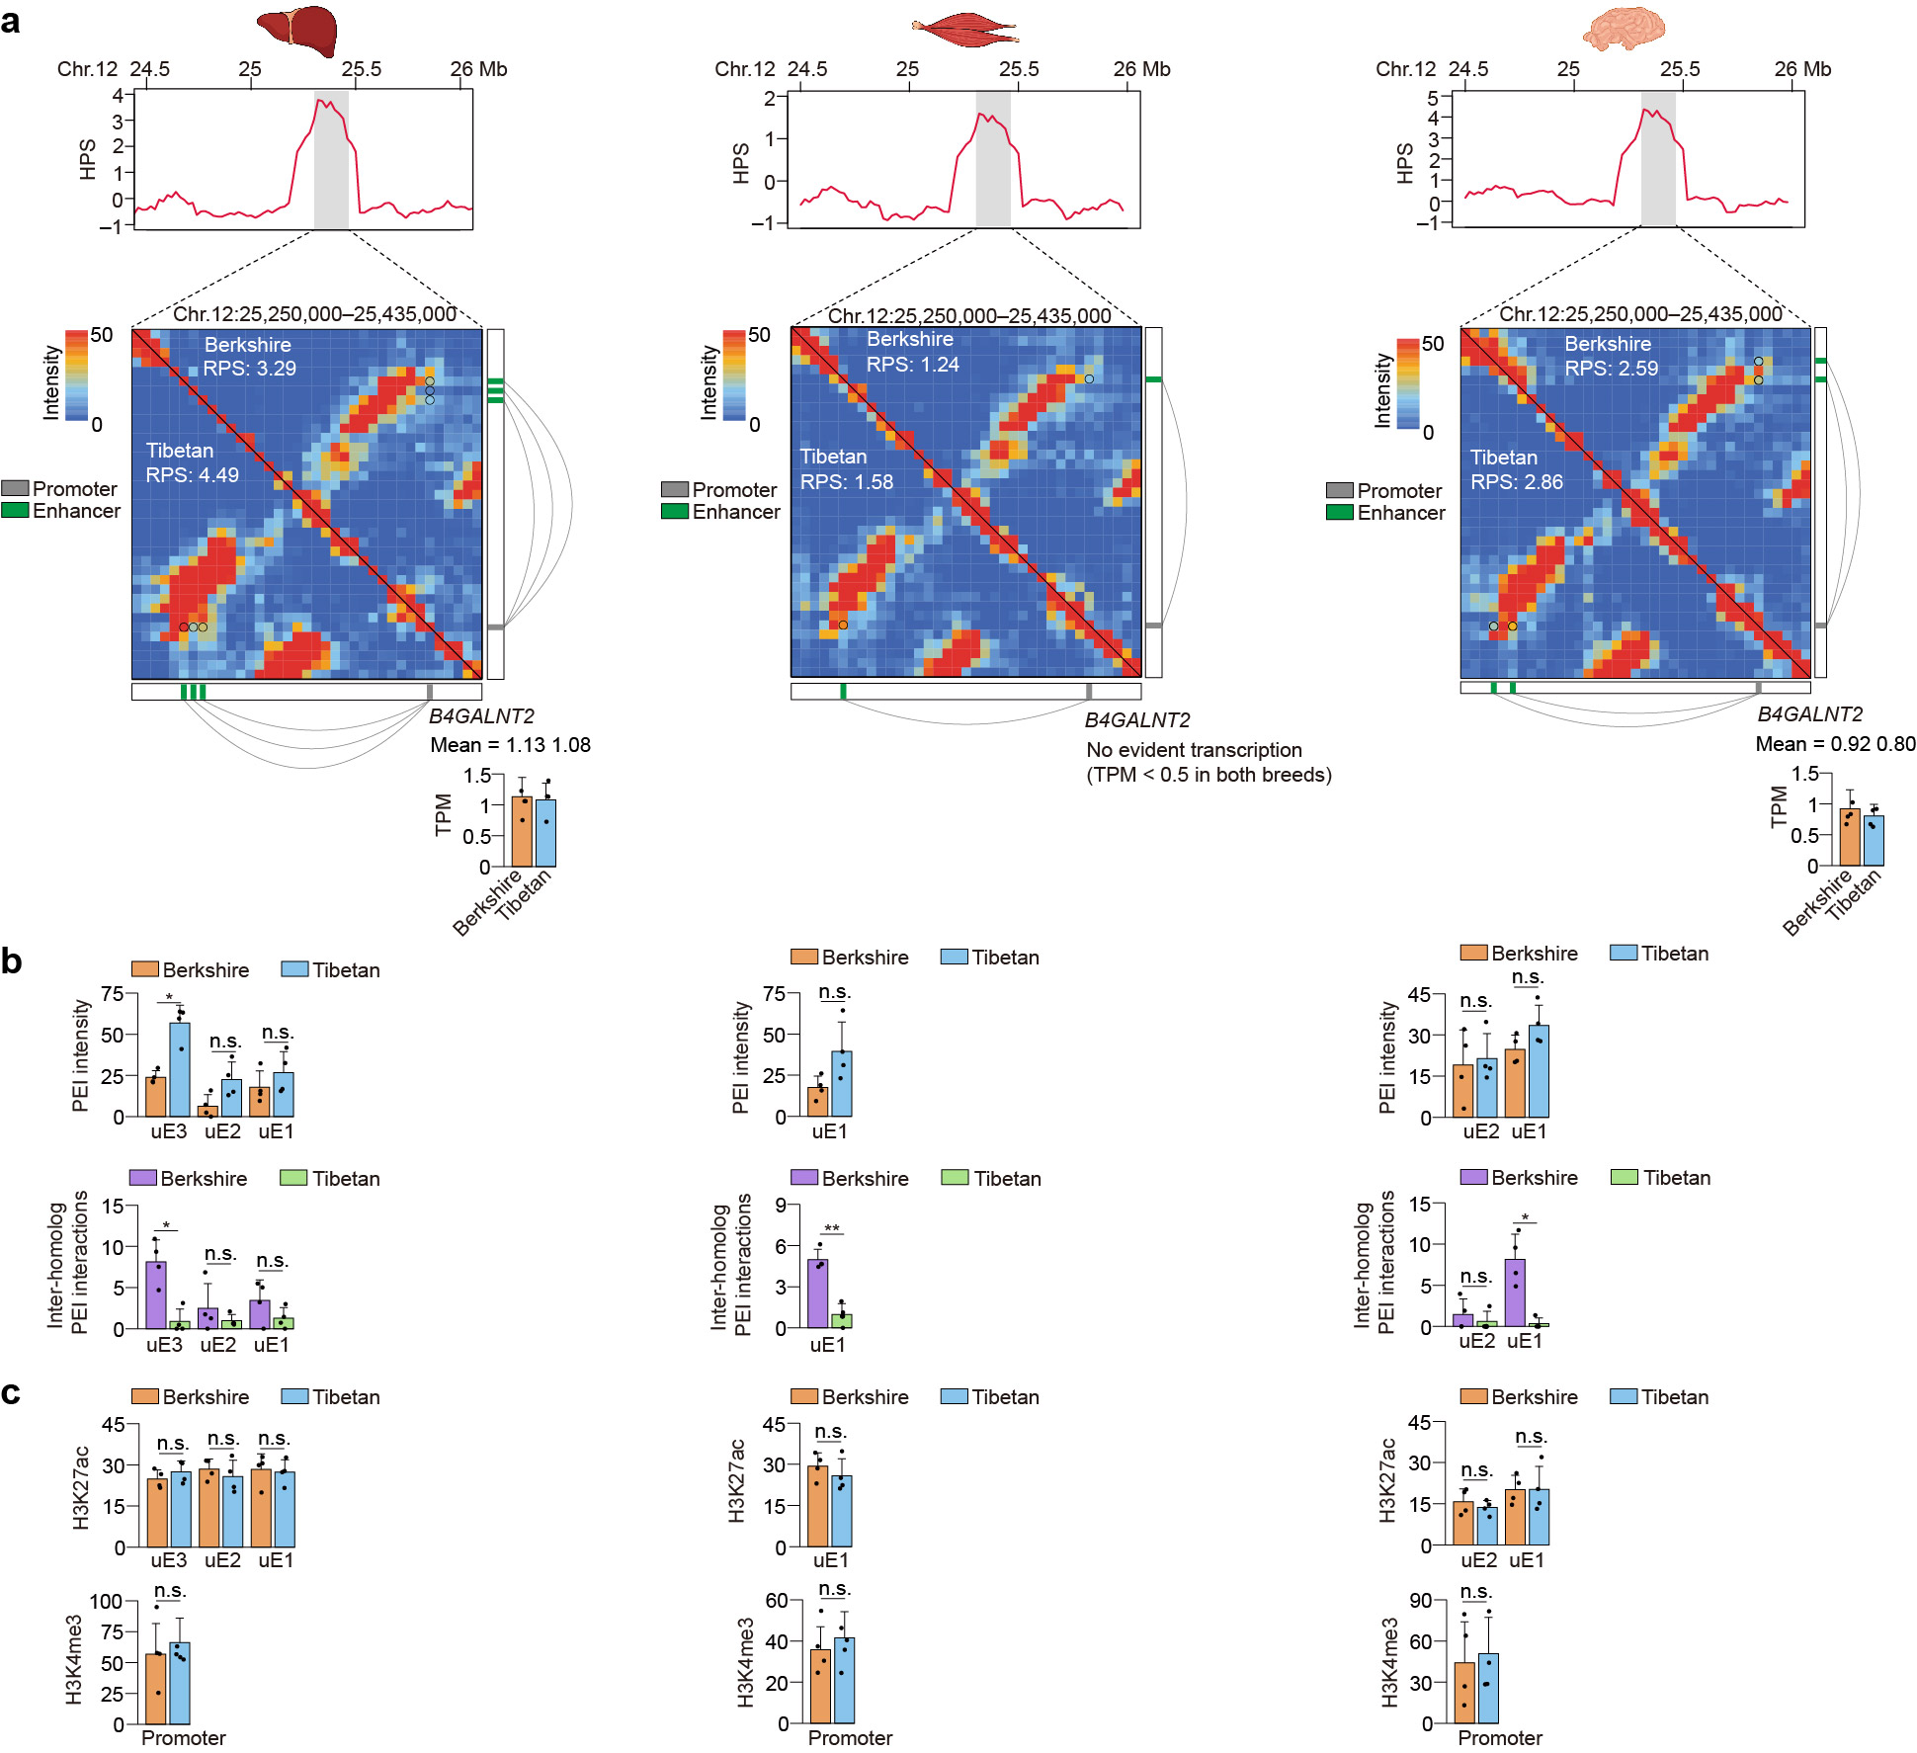
Supplementary Fig. 24 The unbalanced inter-homolog interactions of B4GALNT2 in tightly-paired genomic regions.
Top to bottom: HPS values and Hi-C maps (with schematic representation of allelic PEIs organizations) of the corresponding genomic regions. Allelic differences of gene expression, intensity of PEIs that occurred within chromosome or between homologs, ChIP-seq signals of H3K27ac for enhancers and H3K4me3 for promoters (mean ± SD, n = 4). The P-values were calculated using a paired Student’s t-test. n.s., P ≥ 0.05; *P < 0.05; **P < 0.01.
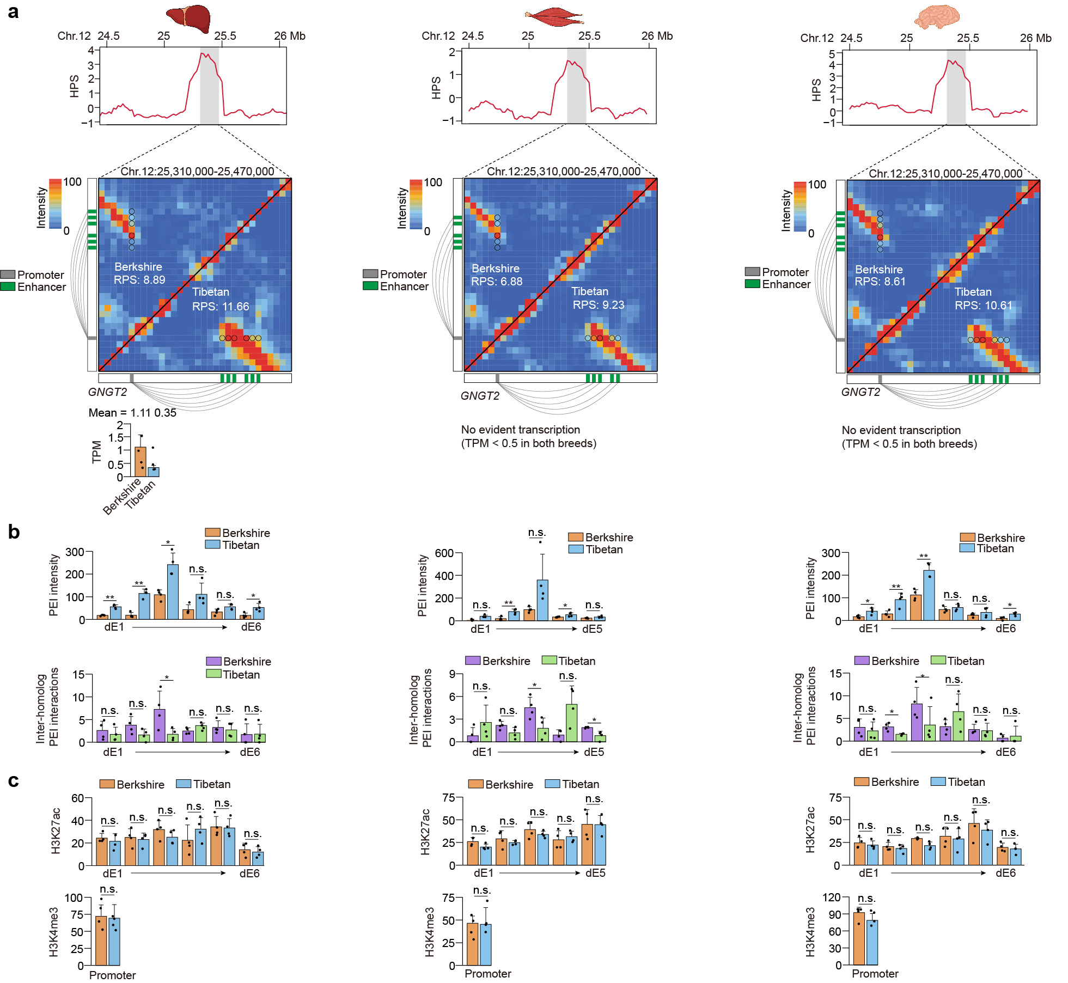
Supplementary Fig. 25 The unbalanced inter-homolog interactions of GNGT2 in tightly-paired genomic regions.
Top to bottom: HPS values and Hi-C maps (with schematic representation of allelic PEIs organizations) of the corresponding genomic regions. Allelic differences of gene expression, intensity of PEIs that occurred within chromosome or between homologs, ChIP-seq signals of H3K27ac for enhancers and H3K4me3 for promoters (mean ± SD, n = 4). The P-values were calculated using a paired Student’s t-test. n.s., P ≥ 0.05; *P < 0.05; **P < 0.01.
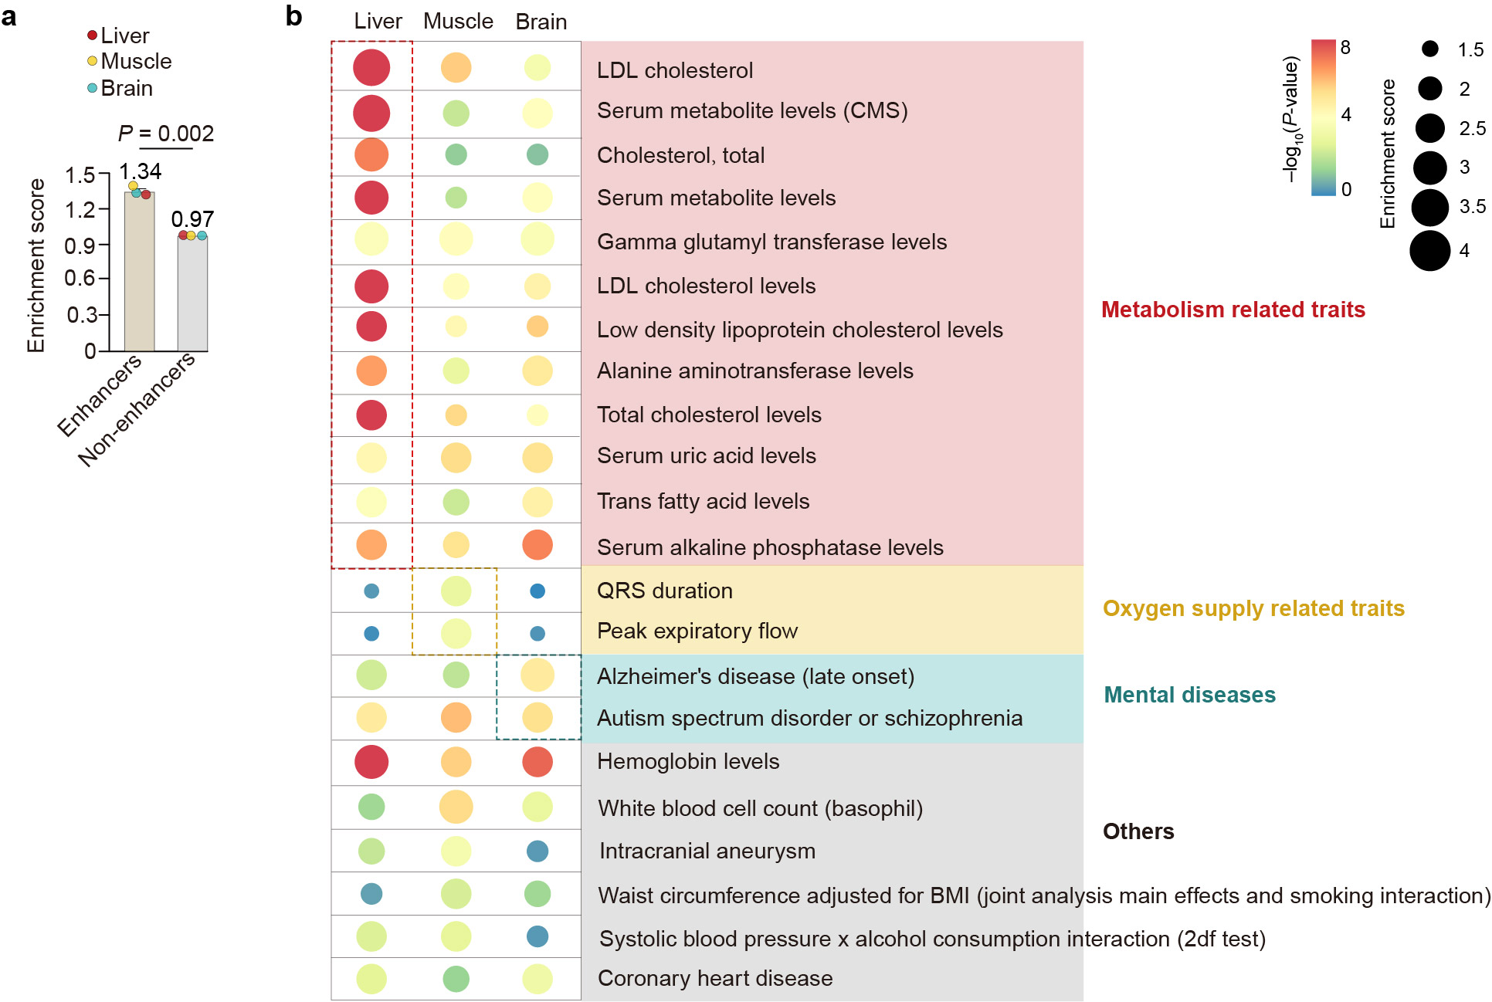
Supplementary Fig. 26 DNA sequence variants (homologous to human noncoding SNPs) associated with specific traits or diseases were enriched in enhancers in the pig genome.
a Comparison of enrichment for human trait-associated, noncoding SNPs (nucleotides that can be liftover from the human to the pig genome) in enhancers and other regions of the pig genome.
b Bubble plot showing the enrichment of noncoding SNPs in enhancers that were separately identified in the liver, muscle, and brain. The traits or diseases shown were merged from the ten terms with the highest enrichment scores in each tissue (P < 0.05, χ² test), and can be empirically classified into four categories, including metabolism, oxygen supply, mental diseases, and others.

References
- Hoencamp, C. et al. 3D genomics across the tree of life reveals condensin II as a determinant of architecture type. Science 372, 984–989 (2021).
- Sievers, F. & Higgins, D. G. The clustal omega multiple alignment package. Methods Mol. Biol. 2231, 3–16 (2021).
- Zufferey, M., Tavernari, D., Oricchio, E. & Ciriello, G. Comparison of computational methods for the identification of topologically associating domains. Genome Biol. 19, 217 (2018).
- Sauerwald, N. & Kingsford, C. Quantifying the similarity of topological domains across normal and cancer human cell types. Bioinformatics 34, i475–i483 (2018).
- de Wit, E. Capturing heterogeneity: single-cell structures of the 3D genome. Nat. Struct. Mol. Biol. 24, 437–438 (2017).
- AlHaj Abed, J. et al. Highly structured homolog pairing reflects functional organization of the Drosophila genome. Nat. Commun. 10, 4485 (2019).
- Edge, P., Bafna, V. & Bansal, V. HapCUT2: robust and accurate haplotype assembly for diverse sequencing technologies. Genome Res. 27, 801–812 (2017).
- Lindsly, S. et al. Functional organization of the maternal and paternal human 4D Nucleome. iScience 24, 103452 (2021).
- Rao, S. S. et al. A 3D map of the human genome at kilobase resolution reveals principles of chromatin looping. Cell 159, 1665–1680 (2014).
- Dixon, J. R. et al. Topological domains in mammalian genomes identified by analysis of chromatin interactions. Nature 485, 376–380 (2012).
- Zhou, Y. et al. Metascape provides a biologist-oriented resource for the analysis of systems-level datasets. Nat. Commun. 10, 1523 (2019).
- Zhou, Y. et al. Metascape provides a biologist-oriented resource for the analysis of systems-level datasets. Nat. Commun. 10, 1523 (2019).
- Santini, L. et al. Genomic imprinting in mouse blastocysts is predominantly associated with H3K27me3. Nat. Commun. 12, 1–16 (2021).
- Jin, L. et al. A pig BodyMap transcriptome reveals diverse tissue physiologies and evolutionary dynamics of transcription. Nat. Commun. 12, 3715 (2021).
- Yang, Y., Zhang, R., Singh, S. & Ma, J. Exploiting sequence-based features for predicting enhancer-promoter interactions. Bioinformatics 33, i252–i260 (2017).
- AlHaj Abed, J. et al. Highly structured homolog pairing reflects functional organization of the Drosophila genome. Nat. Commun. 10, 4485 (2019).
- Child, M. B. 6th. et al. Live imaging and biophysical modeling support a button-based mechanism of somatic homolog pairing in Drosophila. Elife 10 (2021).
- Erceg, J. et al. The genome-wide multi-layered architecture of chromosome pairing in early Drosophila embryos. Nat. Commun. 10, 4486 (2019).

