Table 1 Characteristics of the study populations (n=113)

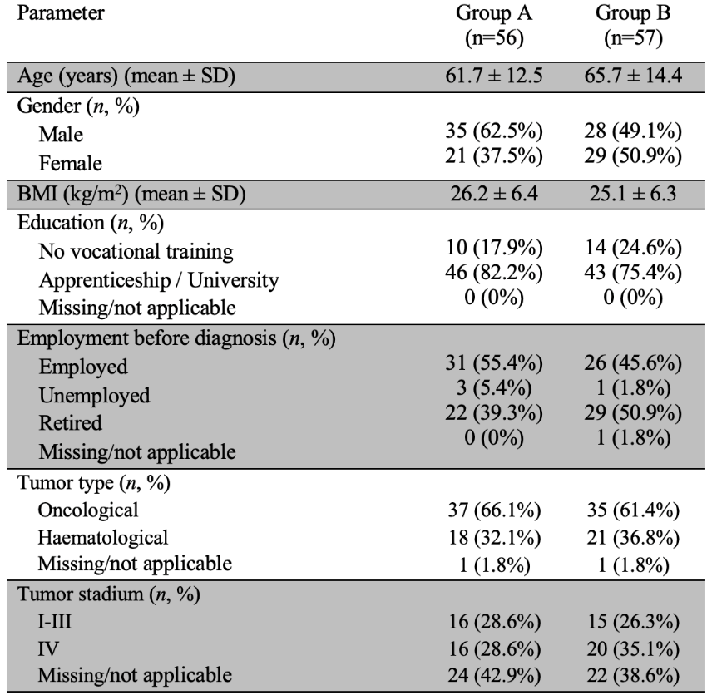

Table 2 Feasibility (n = 56)
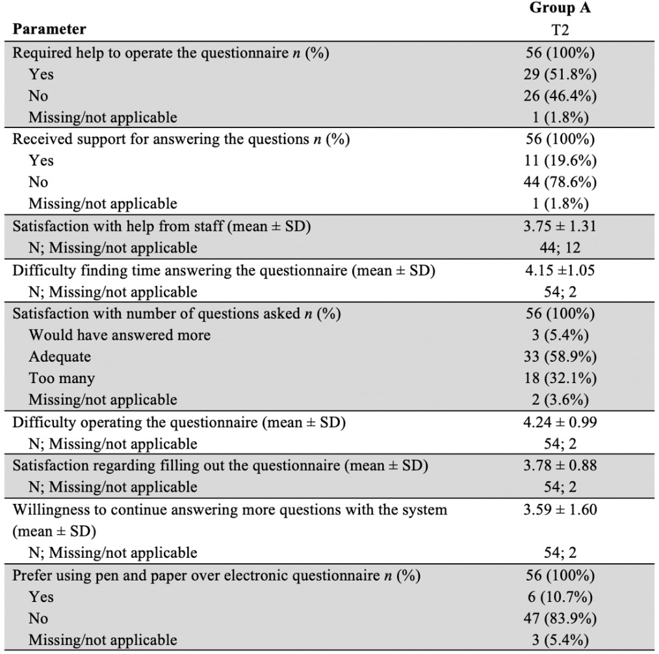

Table 3 Questionnaire Completion (100%)
Questionnaire | 100 % Completion Rates
Questionnaire | Group A (ePRO) |  | Group B (paper)
Questionnaire | T0 | T2 | T0 | T2
EORTC QLQ-C30 | 64 | 59 | 93 | 82
PRO-CTCAE | 93 | 96 | 93 | 91
SDM-Q-9 |  | 79 |  | 77
IN PATSAT32 |  | 79 |  | 79

