Supplementary information: Multiphase superconductivity at the interface between monolayer FeTe islands and Bi₂Te₃

V. Tkáč^{1,2}, S. Vorobiov², P. Baloh², M. Vondráček³, G. Springholz⁴, K. Carva¹, P. Szabó⁵, Ph. Hofmann⁶, J. Honolka*³

¹Department of Condensed Matter Physics, Faculty of Mathematics and Physics, Charles University, Ke Karlovu 5, CZ-12116 Prague 2, Czech Republic

²Institute of Physics, Faculty of Science, P. J. Šafárik University, Park Angelinum 9, 041 54, Košice, Slovakia

³Institute of Physics, Academy of Sciences of the Czech Republic, Na Slovance 2, CZ-18221 Prague 8, Czech Republic

⁴ Institute of Semiconductor and Solid State Physics, Johannes Kepler University, Altenbergerstrasse 69, 4040 Linz, Austria
⁵ Institute of Experimental Physics, Slovak Academy of Sciences, Watsonova 47, 040 01 Košice, Slovakia
⁶ Department of Physics and Astronomy, Interdisciplinary Nanoscience Center (iNANO), Aarhus University, 8000 Aarhus C, Denmark

- Growth of FeTe/Bi₂Te₃ in angle-resolved photoemission

Supplementary S1: Room temperature angle-resolved photoemission spectroscopy during growth of FeTe on Bi₂Te₃. (a) LEED patterns and Fermi surface of decapped Bi₂Te₃. (b) Shows the energy dispersion along the k-direction indicated in yellow in (a). The bottom panel shows the Bi₂Te₃ topological surface states (TSS) on a larger scale. (c) – (j) Respective data after FeTe growth on Bi₂Te₃. Energy dispersions are shown along several k-space directions defined in yellow. The angles indicate the direction with respect to the $\overline{M}$-$\overline{X}$ directions of the Brillouin zone of the FeTe domain D_{1,} sketched in white dashed lines (see domain definition in the main text). The bottom panel of (j) shows that the TSSs have disappeared after FeTe growth.

- Magnetic susceptibility measurements

As an independent confirmation of the SC phase in FeTe, we studied the temperature dependence of the magnetic susceptibility. The DC susceptibility measurement was performed on the 2 ML FeTe sample after the electrical transport measurement shown in the main text. The piece of 5 × 5 mm² was cut off from the original sample.

The results in Fig. S2 were measured in two regimes, namely zero field cooling (ZFC) and field cooling (FC) at indicated fields. Susceptibility measurements were performed in Quantum Design Magnetic Properties Measurement Systems (MPMS3). Magnetic fields were applied perpendicular to the plane. The DC magnetic susceptibility is generally dominated by the negative diamagnetic contribution from the 0.5 mm thick BaF₂ substrate and the 300 nm Bi₂Te₃ layer on top. Nevertheless, a drop in the magnetic susceptibility was observed in the smallest magnetic field of 10 mT in FC and ZFC regime at ≈ 5 K [see green lines in Fig. S2 (a)]. Due to the extremely low volume of our superconducting sample material, this drop is faint. A similar study on Bi₂Te₃(9 nm)/FeTe(140 nm) heterostructures showed changes in magnetization in the order of 10⁻⁷ emu [1]. Our experimental values are of the same order, 10⁻⁷ emu for magnetization and 10⁻⁹ emu for magnetic susceptibilities [Fig. S2 (a)]. The acquired critical field roughly agrees with values obtained from electrical transport measurement in B = 10 mT and T_{c} ≈ 5 K. Application of a higher magnetic field causes shifting of the susceptibility drop to lower temperatures as is expected for the superconducting phase diagrams shown in Fig. S2 (b).

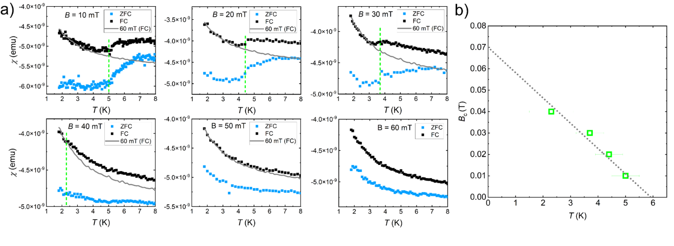
Supplementary S2: (a) Temperature dependence of the DC susceptibility of Si-capped FeTe/Bi₂Fe₃ (2 ML FeTe) in perpendicular magnetic fields of 10 mT, 20 mT, 30 mT, 40 mT, 50 mT, and 60 mT. Blue and black data correspond to zero-field cooling (ZFC) and field cooling (FC) conditions. The gray solid line represents 60 mT FC data. (b) Estimation of the critical fields from green dashed vertical lines indicating changes in the susceptibility.

We comment here that we observed that repetitive temperature cycling between 2 K and room temperature on that same sample piece caused a continuous lowering of critical fields to a tenth of militesla [see Fig. S2 (b)].
To highlight the superconducting transition in different magnetic fields with respect to the nonsuperconducting part of the sample, we added 60 mT FC data to all graphs [Fig. S2 (a)]. The lines were shifted by a constant value to fit the FC experimental data at the lowest temperatures.
DC magnetic susceptibility data in B = 10 mT are more negative due to the diamagnetic contribution from the superconducting state.

- Transport measurements on a Si-capped bulk FeTe reference sample
The measurement of the electrical resistance of the FeTe bulk sample covered by a silicon protection layer was realized in the PPMS system using the AC transport option in the temperature range between 1.8 and 300 K. Electrical contacts between the sample, and AC transport puck were created the same way as in FeTe / Bi₂Te₃ heterostructures via indium droplet using 50 μm thin silver wires (see methods section of main text). The measurements were realized during the cooling and heating of the sample (Fig. S3). The antiferromagnetic transition was detected at T_{N} = 58 K during the sample cooling and at T_{N} = 61 K during the sample heating. No phase transition is detected at the lowest temperatures (Fig. S3, inset).

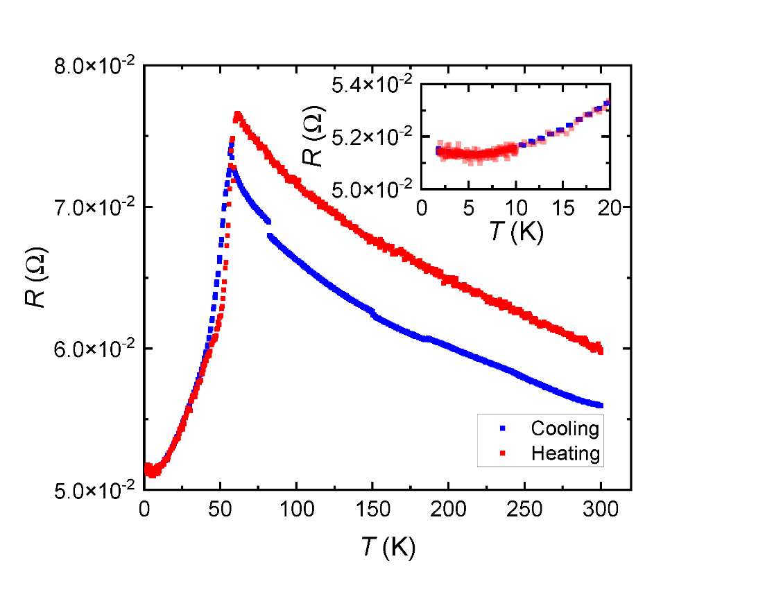
Supplementary S3: Temperature dependence of the electrical resistance of FeTe bulk sample with Si protection layer. The electrical resistance was measured during the cooling and heating of the sample. The inset shows the lowest temperature range of the data in detail.

References
[1] Q. L. He et al., Anisotropic Magnetic Responses of a 2D-Superconducting Bi ₂ Te ₃ /FeTe Heterostructure, Journal of Physics: Condensed Matter 27, 345701 (2015).

