Supplementary materials for
Higher resistance of a microcystin (MC)-producing Microcystis strain to the cocultured submerged macrophyte Myriophyllum spicatum compared to a non-MC-producing strain in association with microenvironment

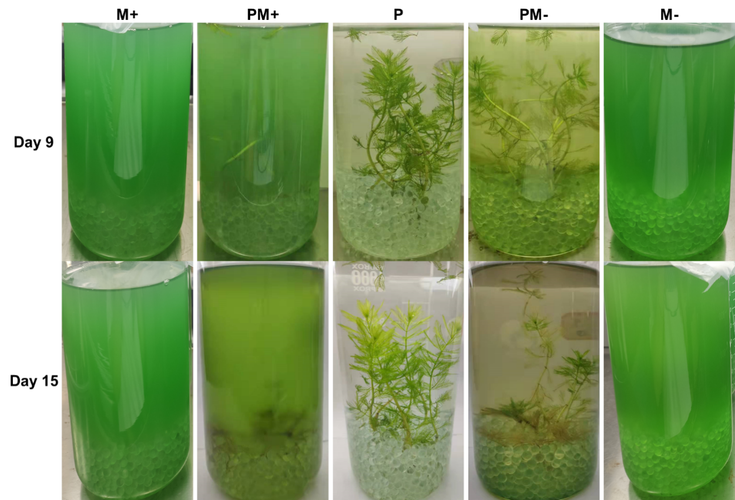
Fig. S1 Macroscopic changes in M. spicatum and Microcystis strains under coculture treatments (PM+, PM−) and monoculture treatments (P, M+, M−) on days 9 and 15.
Notes: P represents the plant control without Microcystis cells, and M+ and M− represent the monoculture control of MC-producing and non-MC-producing Microcystis strains, respectively.
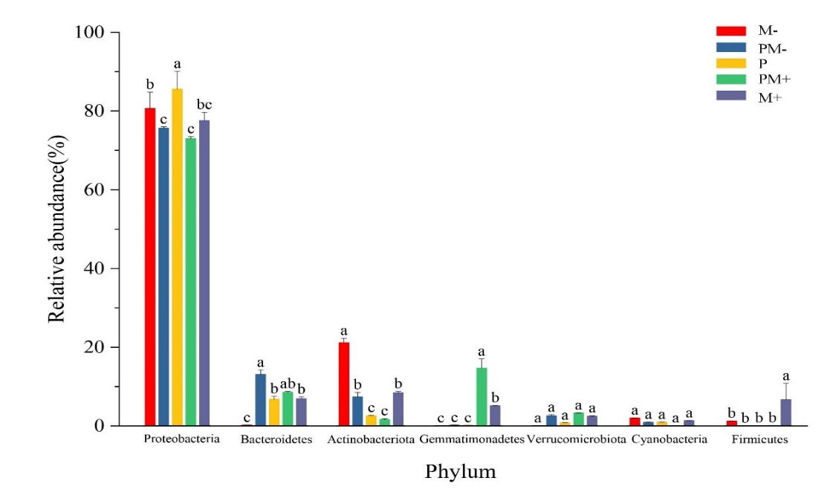
Fig. S2 Seven most dominant bacterioplankton phyla in the experimental groups. Different lowercase letters indicate significant differences amongst experimental groups (one-way ANOVA, p < 0.05).
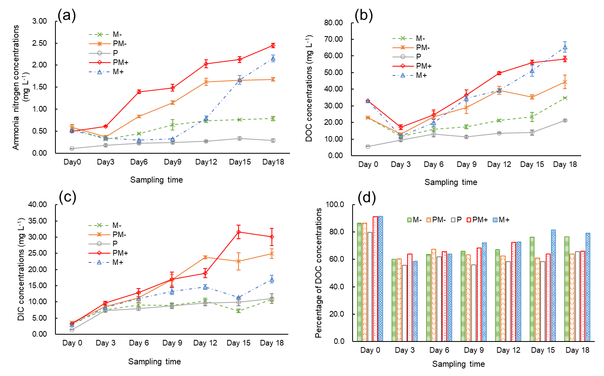
Fig. S3 Dynamic changes in NH₄-N concentrations (A), DOC (B), DIC (C) and percentage of DOC (D) in the culture medium under the treatments.

