Supplementary Information
Hypothermal opto-thermophoretic tweezers

Authors: Pavana Siddhartha Kollipara¹, Xiuying Li², Jingang Li^{3,4}, Zhihan Chen³, Hongru Ding¹, Suichu Huang⁵, Zhenpeng Qin^{2,6,7,8}, Yuebing Zheng^{1,3,*}
Affiliations:
¹Walker Department of Mechanical Engineering, The University of Texas at Austin, Austin, Texas, 78712, USA.
²Department of Mechanical Engineering, The University of Texas at Dallas, Richardson, Texas, 75080, USA
³Materials Science and Engineering Program and Texas Materials Institute, The University of Texas at Austin, Texas, 78712, USA
⁴Laser Thermal Laboratory, Department of Mechanical Engineering, University of California, Berkeley, California 94720, USA
⁵Key Laboratory of Micro-Systems and Micro-Structures Manufacturing of Ministry of Education and School of Mechatronics Engineering, Harbin Institute of Technology, Harbin 15001, China
⁶Department of Bioengineering, The University of Texas at Dallas, Richardson, Texas, 75080, USA
⁷Department of Surgery, The University of Texas Southwestern Medical Center, Dallas, Texas, 75390, USA
⁸Center for Advanced Pain Studies, The University of Texas at Dallas, Richardson, Texas, 75080, USA
*Correspondence to: zheng@austin.utexas.edu

Supplementary Figures:
Figure S1: Experimental Setup and Temperature control of sample and the trap: a) The laser is expanded using a beam expander and directed towards the sample through an objective (40X magnification). A white lamp is used to illuminate the sample. The transmitted white light and the reflected laser at the sample is directed to a charge-coupled device (CCD) camera. The source meter is used to control the Peltier thermoelectric device (thermocooler). The laser, camera, white light, objective, and sample position is controlled using a computer. b) Zoomed-in view shows the exploded view of the objective, aqueous sample over the objective, thermocooler and its heat sink. c) The sample temperature as a function of applied voltage across the thermocooler demonstrates that the device can be used for both heating and cooling. d) The maximum localized temperature increment as a function of incident laser power measured by a phase camera (introduced instead of CCD camera only for this experiment). e) The maximum temperature of the laser trap as a function of thermocooler voltage and laser power.
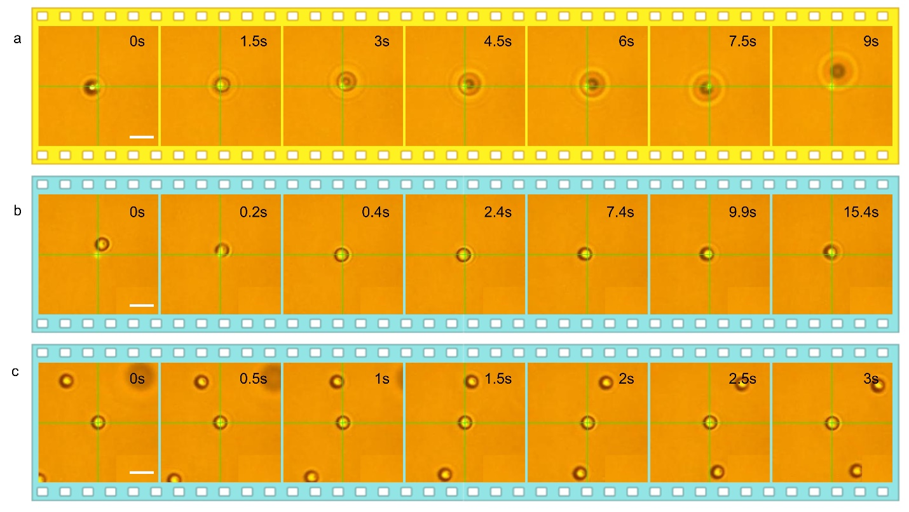
Figure S2: Trapping and Manipulation of 2.66 $μ$m COOH-functionalized PS particles: a) Repulsion of a PS-COOH 2.66 $μ$m particle under 532 nm laser excitation at ambient temperature of 27 ⁰C. Optical repulsion force dominates and moves the particles away from the laser beam. b) Attraction and trapping of the particle at sub-ambient temperature of 10 ⁰C. c) Manipulation of the particle across two particles at sub-ambient temperature of 10 ⁰C. Laser power is 0.14 mW, Scale bar: 5 $μ$m.

Figure S3: Erythrocytes in different tonicities: Bright field (a,c,e) and dark field (b,d,f) optical microscopy images at erythrocytes in hypotonic, isotonic, hypertonic PBS solutions.

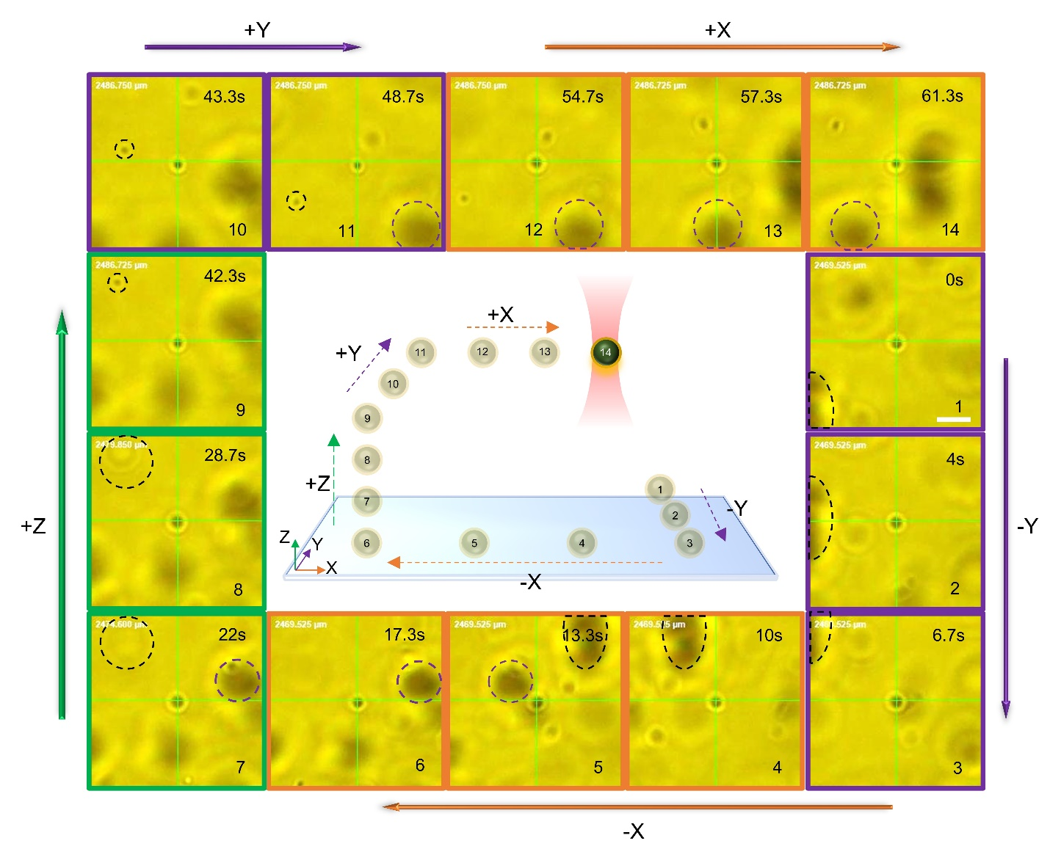
Figure S4: Three-dimensional manipulation of plasmonic vesicles: Each panel shows the trapped vesicle at the center of crosshairs. The sequence of images is shown on the right bottom corner of each panel and the dashed curves represent the reference particles/clusters. The panel is first moved along the Y direction (panels: 1-3, purple border), followed by X direction manipulation (panels: 4-6, orange border). The vesicle is then moved vertically upwards to a different plane until the defocused reference vesicle is moved onto the focus plane (panels: 7- 9). The vesicle is later moved in Y direction (panels: 10,11) and X direction (panels: 12-14) at the same Z position. Laser power: 0.67mW. Scale bar: 5 $μ$m.

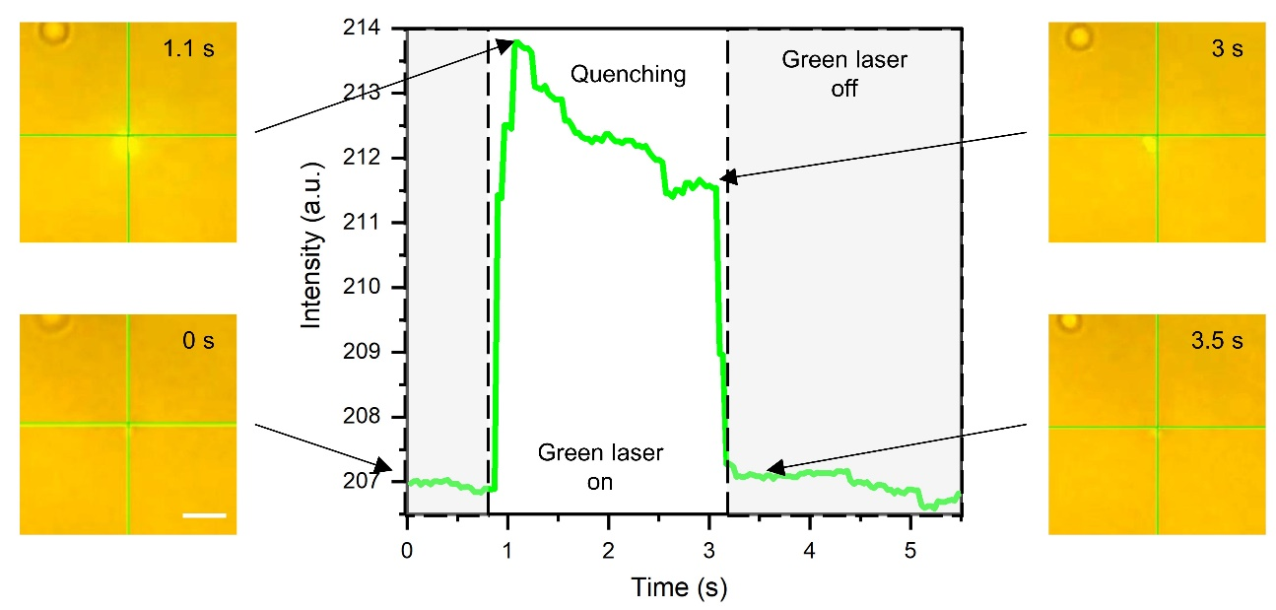
Figure S5: Fluorescent intensity of plasmonic vesicles during rupture: The vesicle is manipulated using the red laser and positioned. The green laser is then focused on the trapped vesicle at 1.1 s to rupture and release the cargo. Because of fluorescent quenching, the intensity gradually decreases. The green laser is then switched off indicated by the sudden drop in the intensity measurement.

Supplementary Note 1: Thermophoretic force on microparticles
The thermophoretic drift velocity ($u_{th}$) of the particle is directly proportional to the mean temperature gradient ($∇T$) experienced by the microparticle, and the proportional constant known as the thermo-diffusion coefficient ($D_{T}$).
 | $$u_{th}= -D_{T}∇T$$ | (S1)
$D_{T}$ intricately depends on several parameters such as temperature, colloidal concentration, electrolyte and surfactant type and concentration, polymers, and so on. $D_{T}$ is related to the Ludwig-Soret coefficient ($S_{T}$) as
 | $$D_{T}=D.S_{T}$$ | (S2)
where $D$ represents the Brownian diffusion coefficient, given in terms of
 | $$D=C(T_{sub}).\frac{k_{B}T_{avg}}{6πη\left(T_{avg}\right)r_{p}}$$ | (S3)
$k_{B}$ is the Boltzmann constant, $T_{avg}$is the average temperature of the particle, $η\left(T\right)$ is the viscosity of the solvent as a function of temperature and $r_{P}$ is the radius of the particle. The coefficient $C$ represents a correction factor that incorporates distinct phenomena such as the gap between the particle and the substrate, friction due to electrostatic attraction between the particle and substrate, and so on. Since the correction factor arises due to the interactions between the particle and substrate, it strongly depends on the local temperature ($T_{sub}$) between the particle and the substrate. The Stokes Drag force is given as
 | $$F_{drag}=\frac{k_{B}T_{avg}}{D}u$$ | (S4)

Here, $u$ is the escape velocity of the particle, i.e., the limiting velocity of the laser beam where the particle escapes the laser trap. Experimental evaluation of the thermo-diffusion coefficient and the Soret coefficient is mentioned in Supplementary Note 4.

Supplementary Note 2: Temperature controller fabrication
A Peltier thermoelectric device utilizes a voltage across two plates (that encompass a thermoelectric material) to generate a temperature difference across the plates.
 | $$T_{hot}-T_{cold}=c_{1}V$$ | (S5)

where $T_{hot, cold}$ are the temperatures of the hot and cold sides of the plate, $V$is the applied voltage across the two plates, and $c_{1}$ is the proportionality constant of the cooler. A commercial Peltier cooler (Laird systems) and a source meter are used to control the temperature difference. However, as the voltage increases, the resistive heating of the thermocooler results in the overall heating of the thermocooler. This leads to the colder side’s temperature being approximately equal to the ambient temperature, and the hot side's temperature increasing with varying voltage.
 | $$T_{cold}\sim T_{amb} (no heat sink)$$ | (S6)

To overcome this, a commercially available aluminum heat sink (www.amazon.com, Model number: a14111400ux0256) is cut according to the requirements and attached to the hot side of the Peltier device using a thermal interface material/thermal adhesive (www.amazon.com, SOBEIT, SH-thermal tape). The heat sink effectively dissipates the generated heat while maintaining the hot plate temperature closer to the ambient temperature. This is because of the increased surface area due to the heat sink.
 | $$T_{hot}\sim T_{amb} (with heat sink)$$  $$T_{cold}=T_{amb}-c_{2}V$$ | (S7)

Note that $c_{1}$ and $c_{2}$ are different proportionality constants corresponding to the Peltier device without and with the attached heat sink respectively. The resultant device is then directly placed on the coverslip which is supported over the objective by a sample holder. The holder holds the coverslip by all its edges to limit bending during temperature changes. The effective temperature of the sample in this configuration is then measured using an infrared camera as a function of the applied voltage as shown in Figure S1c.
Supplementary Note 3: Evaluation of trapping stiffness on the particle
The trapped particle is tracked using Nikon CCD using a time step of 10 ms (effective timestep while saving videos is 30 ms). The trajectory of the trapped particle is fitted to a gaussian distribution curve, and the standard deviation of the fit $σ$ is used to determine the trapping stiffness as
$$κ=\frac{k_{B}T}{σ^{2}}$$
where $κ$ is the trapping stiffness and $σ$ is the standard deviation of the Gaussian fit for the histogram of X coordinates.
Supplementary Note 4: Experimental evaluation of Correction factor, Brownian diffusion coefficient, thermo-diffusion coefficient, and Soret Coefficient as a function of temperature
Brownian diffusion coefficient and Correction factor determination
To simultaneously evaluate the thermo-diffusion coefficient (or the Soret coefficient) and the thermophoretic force on the particle, the correction factor $C\left(T\right)$ in the equation S3 needs to be evaluated experimentally. SiO₂ particles are dispersed and sonicated in DI water and introduced into the coverslip (Figure S6a). Note that SiO₂ particles are used because they can gradually get settled on the substrate due to their weight giving a consistent opportunity to evaluate the effects of the substrate. Also, SiO₂ particles can be trapped at ambient temperature, which provides a greater working range in terms of temperature study. The sample temperature is then controlled using the temperature controller. The Brownian motion of the particles is recorded using a Nikon CCD camera at a frame rate ($δt$) of 10 ms. Using image tracking, the trajectory of several particles is obtained as a function of time (Figure S6b). Please note that no laser beam is used to trap these particles. The trajectory is then used to evaluate the diffusion coefficient based on the mean displacement $<σ^{2}>$of the particle
 | $$<σ^{2}> = 4D(T)δt$$ | (S8)

The obtained Brownian diffusion coefficient $D\left(T\right)$ is plotted as a function of temperature in Figure S6c. The correction factor $C\left(T\right)$ is then evaluated using equation (S3) using $T_{sub}=T_{avg}=T_{sample}$, to obtain as a function of temperature.
Local temperature and mean temperature of the particle as a function of laser particle distance
Parallelly, temperature simulations are performed to analyze the temperature distribution of the particle situated near the laser beam. This enables us to evaluate the average viscosity of water as a function of mean temperature, and the correction factor as a function of substrate temperature simultaneously.
Thermo-diffusion coefficient and Soret Coefficient as a function of temperature:
For a given laser power and Peltier device voltage, the temperature distribution can be evaluated using a series of experiments and theoretical simulations as highlighted in the previous sections. Using the exact local temperature, and the average temperature distribution of the particle, the net (drag) force in the lateral direction (perpendicular to the laser axis) on the particle is evaluated as
 | $$F_{th}=F_{net}-F_{opt}=F_{drag}-F_{opt}$$ | (S9)
$F_{opt}$ in the lateral direction is evaluated via simulations in Supplementary Note 5. $F_{drag}$ is experimentally evaluated using Equations (S3) and (S4). The laser-particle distance is set as 0.9 $μm$ from particle manipulation experiments. Therefore, the net thermophoretic force acting on the particle can be evaluated using S9. We can associate a thermophoretic drift velocity to the net thermophoretic force like Stokes drag force as
 | $$F_{th}=\frac{k_{B}T}{D}u_{th}=-\frac{k_{b}T}{D}D_{T}∇T=-k_{B}TS_{T}∇T$$ | (S10)

The Soret coefficient can then be evaluated as a function of temperature and is displayed in Figure S6d. The variation in Soret coefficient arises from the variation in Brownian diffusion coefficient and can be limited by using an ultrafast camera and a good graphics card to record videos at a faster frame rate. The resultant Soret Coefficient follows the standard empirical relation:
 | $$S_{T}=S_{T,∞}\left(1-e^{\frac{T^{*}-T}{T_{0}}}\right)$$ | (S11)
$S_{T,∞}$, $T^{*}$ and $T_{0}$ are fitting parameters and $T^{*}$ is the transition temperature between the thermophobic and thermophilic nature of the particle. The transition temperature for SiO₂ particles is estimated around 32.5 $±$ 2.1 ⁰C .

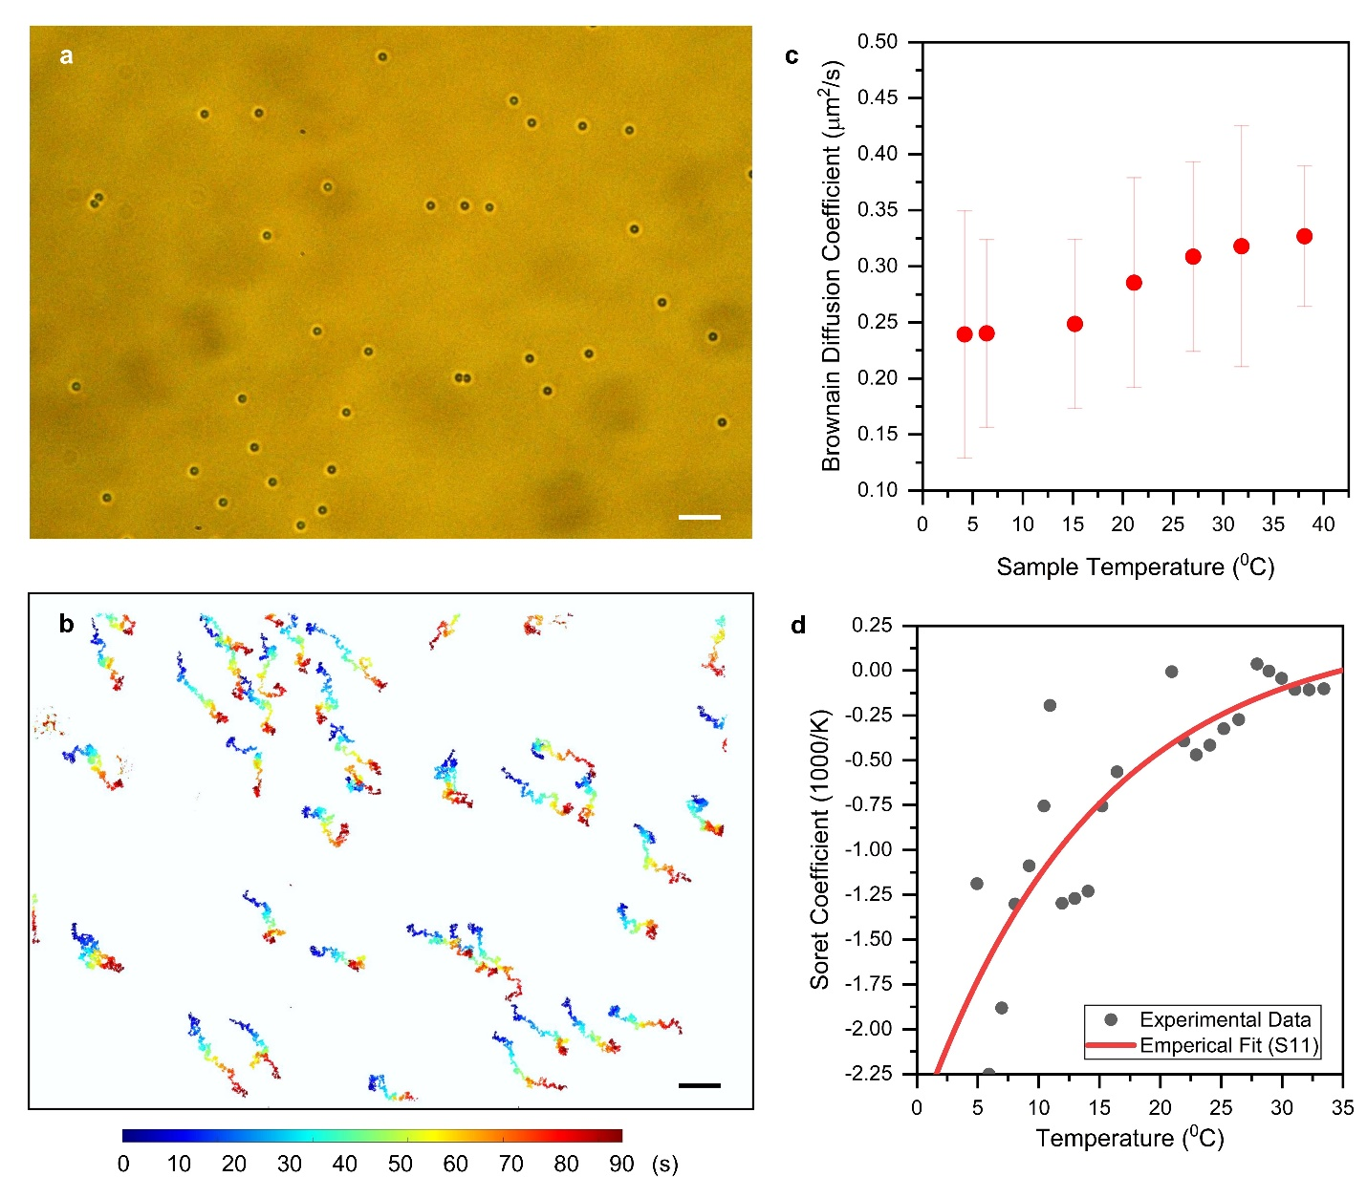
Figure S6: Experimental derivation of Soret Coefficient as a function of temperature: a) Brightfield optical microscopic image of 1.96 SiO₂ particles dispersed in DI water. b) Trajectories of particles as a function of time. c) Experimental valuation of Brownian Diffusion coefficient at varying temperatures. d) Soret Coefficient of SiO₂ particles in DI water as a function of temperature.

Supplementary Note 5: Optical force on microparticles
Optical forces on SiO₂ 1.96 $μ$m particles are evaluated using Ansys Lumerical FDTD (ver. 2021 R2.5). The refractive index of SiO₂ particles is assumed as 1.46, water as 1.33, and glass coverslip as 1.46. Optical force is evaluated at 532 nm, with a beam radius of 840 nm (measured from experiments) at the interface of glass coverslip and water. The total domain size is set to 3000 $μ$m in either direction to encompass the complete laser beam. A mesh grid of 3 nm is used for meshing the particle. The setup is run on clusters provided by the Texas Advanced Computing Center, using 5 x 32 cores. Since micrometer-sized particles were used in this study, we employed the Maxwell Stress Tensor (MST) methodology to evaluate the electric field and magnetic field around the particle using E-field monitors, using Lumerical’s script. The space between the monitor and the particle in all directions is set to three mesh cells (~9 nm). Figure S7 shows the optical forces perpendicular to and along the laser beam propagation axis respectively. Negative force indicates attraction and positive force indicates repulsion.
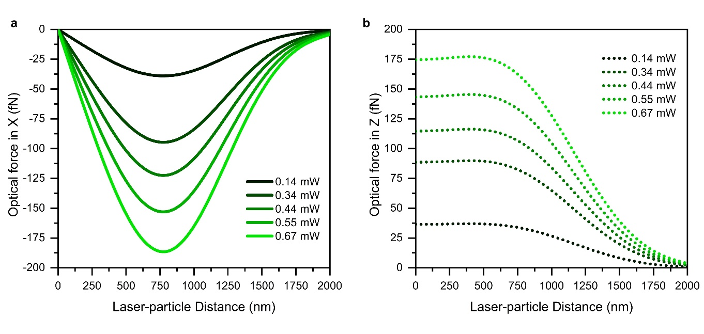
Figure S7: Optical force on SiO₂ microparticles by 532 nm laser beam at varying powers (a) perpendicular to the laser beam axis (X direction) and (b) along the laser beam axis (Z direction)

Other supplementary materials included in this manuscript:
(Convention for titles: Ambient temperature = 27 ⁰C, sub-ambient temperature = 4 ⁰C)
SI Video 1: Repulsion and trapping of 1 $μ$m PS particles in DI water at ambient and sub-ambient temperatures respectively
SI Video 2: Repulsion and trapping of 2.66 $μ$m PS-COOH particles in DI water at ambient and sub-ambient temperatures respectively
SI Video 3: Repulsion and trapping of 1.96 $μ$m SiO₂ particles in DI water at 31.6 ⁰C and sub-ambient temperatures respectively
SI Video 4: Repulsion and trapping of 1 $μ$m PS particles in 1mM NaCl_{0.2}NaOH_{0.8} solution at ambient and sub-ambient temperatures respectively
SI Video 5: Rupture and trapping of isotonic erythrocytes in PBS 0.5X at ambient and sub-ambient temperatures respectively
SI Video 6: Repulsion and trapping of hypotonic erythrocytes in PBS 0.3X at ambient and sub-ambient temperatures respectively
SI Video 7: Repulsion and trapping of hypertonic erythrocytes in PBS 0.7X at ambient and sub-ambient temperatures respectively
SI Video 8: Repulsion and trapping of plasmonic vesicles at ambient and sub-ambient temperatures respectively
SI Video 9: Three-dimensional manipulation of plasmonic vesicles at sub-ambient temperature
SI Video 10: Manipulation followed by controlled drug release of plasmonic vesicles at sub-ambient temperature
SI Video 11: Manipulation of plasmonic vesicles over random aggregates at sub-ambient temperature

