Co-immobilized Alcohol Dehydrogenase and Glucose Dehydrogenase with Resin Extraction for Continuous Chiral Diaryl Alcohol Production

Jieyu Zhou, Yanfei Wu, Qingye Zhang, Guochao Xu, Ye Ni*

Key laboratory of industrial Biotechnology, Ministry of Education, School of Biotechnology, Jiangnan University, Wuxi 214122, Jiangsu, China.

Contents
General protocol for protein expression 2
Table S1. Enzyme production of Mu-S5 and BmGDH in per liter fermentation under laboratory-scale 3
Table S2. Mu-S5 Binding capacity of Mn- and Ni- NTA Cerose 4
Figure S1. Time course of CPMK conversion catalyzed by outflows Mu-S5 5
Table S3. Activity calculation of inflows. 5
Figure S2. Time course of CPMK conversion catalyzed by outflows Mu-S5 6
Table S4. Activity calculation of outflows. 6
Figure S3. Time course of CPMK conversion catalyzed by immobilized Mu-S5 7
Table S5. Activity calculation of immobilized Mu-S5. 7
Table S6. Activity recovery of immobilized Mu-S5. 8
Table S7. Preparation of 10 mM CPMK solution using Tween 80 and Triton X-100 as co-solvents. 9
Table S8. Preparation of 10 mM CPMK solution using hydroxypropyl-beta-cyclodextrin (HP-β-CD) as a co-solvent. 10
Table S9 Comparison of enzyme activity loss of Mu-S5 using 6×His Tag and Heli-Tag 11
Table S10. Basic information of D101 and XDA-1 resins 12
Table S11. Adsorption and adsorption rate of (S)-CPMA by D101 and XDA-1 resin 13
Table S12. Desorption rate of D101 and XDA-1 resin eluted by ethanol/ethyl acetate 14
Table S13. Determination of NADP+ concentration after resin adsorption 15
Fig. S4. Standard curve of NADP⁺concertration 15
Fig. S5. Thermostability of Mu-S5 at 30℃ in 100 mM potassium phosphate buffer at pH 7.0. 16

General protocol for protein expression
Recombinant Mu-S5 and BmGDH were prepared by cultivation of E. coli BL21(DE3) harboring pET28-KpADH at 37 °C and 180 rpm in LB medium supplemented with 50 μg mL−1 kanamycin. Until the OD600 reached 0.6–0.8, 0.2 mM isopropyl-β-Dthiogalactopyraniside was added and further cultured at 25 °C. After induction for 12 h, the cells were harvested by centrifugation centrifugation (8000 × g, 10 min) and disrupted by a highpressure homogenizer (ATS BASIC-II, ATS ENGINEERING Inc., Shanghai). After centrifugation, the supernatant was used for immobilization or lyophilized under vacuum (SCIENTZ-10N, NINGBO SCIENTZ BIOTECHNOLOGY Co., Ltd., Ningbo) to prepare lyophilized enzyme, and stored at 4 °C for further use.

Table S1. Enzyme production of Mu-S5 and BmGDH in per liter fermentation under laboratory-scale
Enzyme | Amount of crude enzyme  (mg) | Specific activity of crude enzyme  (U/mg) | Specific activity of purified enzyme(U/mg) | Total activity  (U)
Mu-S5 | 2260 | 3.68 | 6.64 | 8316.8
BmGDH | 2083 | 4.80 | 7.96 | 9998.4

Table S2. Mu-S5 Binding capacity of Mn- and Ni- NTA Cerose
 | Volume of inflows (mL) | Activity of inflows (U) | Activity of outflows (U) | Total activity of immobilized enzyme (U) | Amount of immobilized enzyme (mg) | Proportion of activity loss (%)
Mn-NTA Creose | 15 | 175.7 | 10.7 | 165.0 | 24.7 | 6.10
Mn-NTA Creose | 27 | 316.2 | 32.9 | 283.3 | 42.2 | 10.4
Ni-NTA Cerose | 15 | 175.7 | 5.92 | 169.8 | 25.6 | 3.37
Ni-NTA Cerose | 27 | 315.5 | 13.98 | 301.5 | 45.4 | 4.43
Ni-NTA Cerose | 40 | 467.4 | 53.9 | 405.5 | 61.9 | 11.5
Each sample was determined in three parallel and the average value was taken.

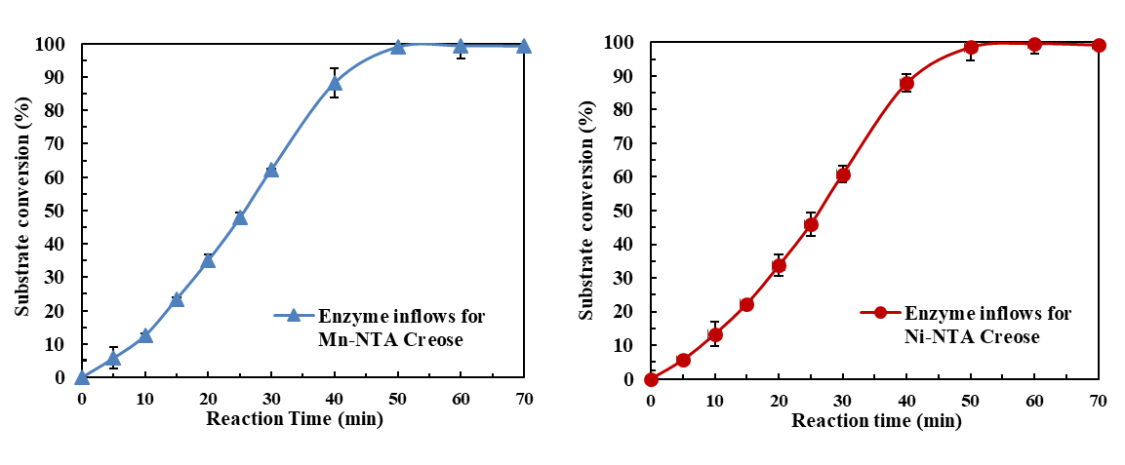

Fig. S1. Time course of CPMK conversion catalyzed by outflows Mu-S5

Table S3. Activity calculation of inflows.
 | Total volume of inflows (mL) | Volume of inflows for reaction (mL) | CPMK conversion in 10 min (%) | Total activity of inflows (U)
Mn-NTA Cerose | 40 | 0.25 | 12.55 | 401.5
Ni-NTA Cerose | 40 | 0.25 | 13.33 | 426.6

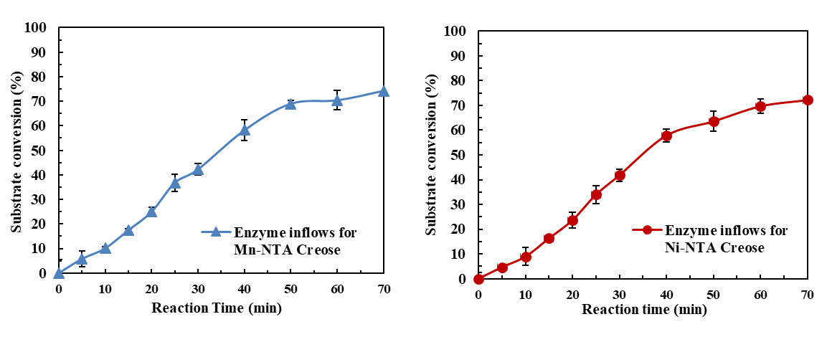

Fig. S2. Time course of CPMK conversion catalyzed by outflows Mu-S5

Table S4. Activity calculation of outflows.
 | Total volume of outflows (mL) | Volume of outflows for reaction (mL) | Substrate conversion in 10 min (%) | Total activity of inflows (U)
Mn-NTA Cerose | 40 | 1.0 | 10.01 | 80.8
Ni-NTA Cerose | 40 | 1.0 | 8.95 | 71.6

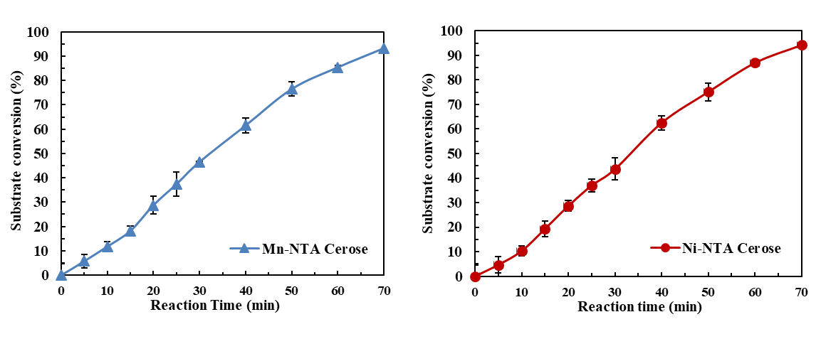

Fig. S3. Time course of CPMK conversion catalyzed by immobilized Mu-S5

Table S5. Activity calculation of immobilized Mu-S5.
Immobilization carrier | Weight of 1 mL immobilized enzyme (g) | Weight of immobilized enzyme for reaction (g) | Substrate conversion in 10 min (%) | Total activity of 1 mL immobilized enzyme (U)
Mn-NTA Cerose | 1.23 | 0.013 | 11.76 | 213.5
Ni-NTA Creose | 1.20 | 0.012 | 10.3 | 206.0

Table S6. Activity recovery of immobilized Mu-S5.
Immobilization carrier | Inflows activity (U) | Outflows activity (U) | Theoretical activity (U) | Total activity of immobilized enzyme (U) | Activity recovery (%)
Mn-NTA Cerose | 401.5 | 80.1 | 321.4 | 213.5 | 66.4
Ni-NTA Cerose | 426.6 | 71.6 | 355.0 | 206.0 | 58.0
Each sample was determined in three parallel and the average value was taken. The calculation was based on 250 μL inflows, 1 mL outflows, 0.013 g Mn-NTA Cerose and 0.012 g Ni-NTA Creose.

Table S7. Preparation of 10 mM CPMK solution using Tween 80 and Triton X-100 as co-solvents.
Addition amount (%) |  | Phenomenon
Addition amount (%) |  | Tween 80 | Triton X-100
1.0 |  | Not being fully soluble | Emulsion, precipitated after 10 min
1.5 |  | Not being fully soluble | Emulsion, precipitated after 30 min
2.0 |  | Emulsion,  precipitated after 10 min | translucent emulsion
2.5 |  | Emulsion,  precipitated after 10 min | Clear solution
3.0 |  | Emulsion,  precipitated after 10 min | -
3.5 |  | Emulsion,  precipitated after 10 min | -
4.0 |  | translucent emulsion | -
5.0 |  | Clear Solution | -

Table S8. Preparation of 10 mM CPMK solution using hydroxypropyl-beta-cyclodextrin (HP-β-CD) as a co-solvent.
Final concentration (mM) | Phenomenon
5 | Not being fully soluble
10 | Not being fully soluble
15 | Not being fully soluble
20 | Clear Solution
25 | Clear Solution

Table S9 Comparison of enzyme activity loss of Mu-S5 using 6×His Tag and Heli-Tag
Fusion protein tag | Specific activity of crude enzyme  (U/mg) | Total activity of crude enzyme  (U) | Activity loss ratio after 20 mM imidazole elution  (%) | Activity loss ratio after 50 mM imidazole elution (%)
Heli-Tag | 8.33 | 264 | 36.1 | 95.3
6×His-tag | 7.76 | 246 | 1.60 | 3.90
Each sample was determined in three parallel and the average value was taken.

Table S10. Basic information of D101 and XDA-1 resins
Type | Adsorption mechanism | Applications | Recommended elution solvent
D101 | Physisorption | To extract effective components, such as saponin, flavonoids, alkaloid etc. from traditional Chinese herbal medicines. | Aqueous ethanol solution
XDA-1 | Physisorption | To remove of aniline, benzyl chloride, benzyl alcohol, halohydrocarbon etc. in aqueous solvent, commonly used in the purification of phenol production process. | Aqueous ethanol solution

Table S11. Adsorption and adsorption rate of (S)-CPMA by D101 and XDA-1 resin
Type | Initial concentration (mg/mL) | Residual concentration (mg/mL) | Adsorption capacity (mg/g) | Static adsorption rate (%)
D101 | 21.9 | 2.60 | 38.6 | 88.1
XDA-1 | 21.9 | 1.90 | 40.0 | 91.3
Each sample was determined in three parallel and the average value was taken.

Table S12. Desorption rate of D101 and XDA-1 resin eluted by ethanol/ethyl acetate
Type | Eluent | Adsorbed (S)-CPMA(mg) | (S)-CPMA of outflow (mg) | Desorption rate  (%)
D101 | Ethanol | 18.9 | 4.62 | 24.5
XDA-1 | Ethanol | 18.9 | 3.61 | 19.1
D101 | Ethyl acetate | 18.9 | 18.2 | 96.1
XDA-1 | Ethyl acetate | 18.9 | 15.6 | 82.7
Each sample was determined in three parallel and the average value was taken.

Table S13. Determination of NADP+ concentration after resin adsorption
 | △OD₅₆₅ | Concentration of NADP⁺(μM)
Control | 0.135 | 1062.9
D101 | 0.134 | 1055.1
XDA-1 | 0.131 | 1031.5
The concentration of NADP⁺ was calculated according to formula [NADP(H)] = $\frac{△OD565}{Slope (μM-1)}$×n

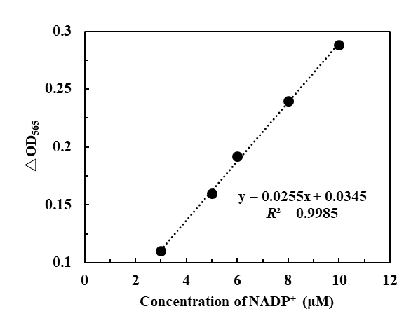

Fig. S4. Standard curve of NADP⁺concertration

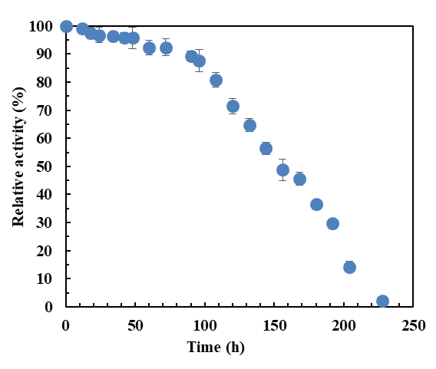

Fig. S5. Thermostability of Mu-S5 at 30℃ in 100 mM potassium phosphate buffer at pH 7.0.

