SUPPORTING MATERIALS
THE EFFECT OF SCATTERED MULTIPURPOSE TREES (Erythrina brucei SCHWEINF. AND Croton macrostachyus HOCHST. EX DELILE) ON WHEAT (Triticum aestivum L.) YIELD IN SOUTHERN ETHIOPIA

Daba Misgana^{1*}, Tesfay Hailemarium², Dereje Tsegaye³
¹Forestry Department, Agricultural Sciences College, Arba Minch University, P.O.Box 21, Arba Minch, Ethiopia; dhaabaamisgana@gmail.com
²Former Forestry Department Agricultural Sciences College, Arba Minch University, currently Aksum University, Ethiopia; tesfayhailemariam94@gmail.com
³Plant Sciences Department, Agricultural Sciences College, Arba Minch University, P.O.Box 21, Arba Minch, Ethiopia; dassdere@yahoo.com

*Corresponding author
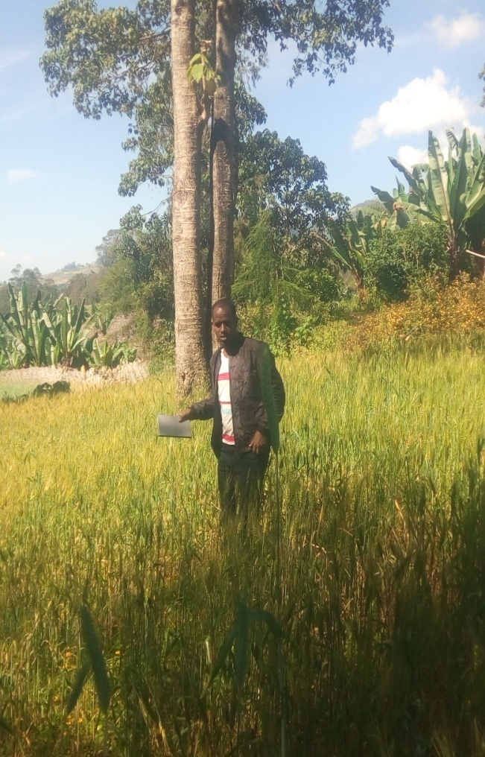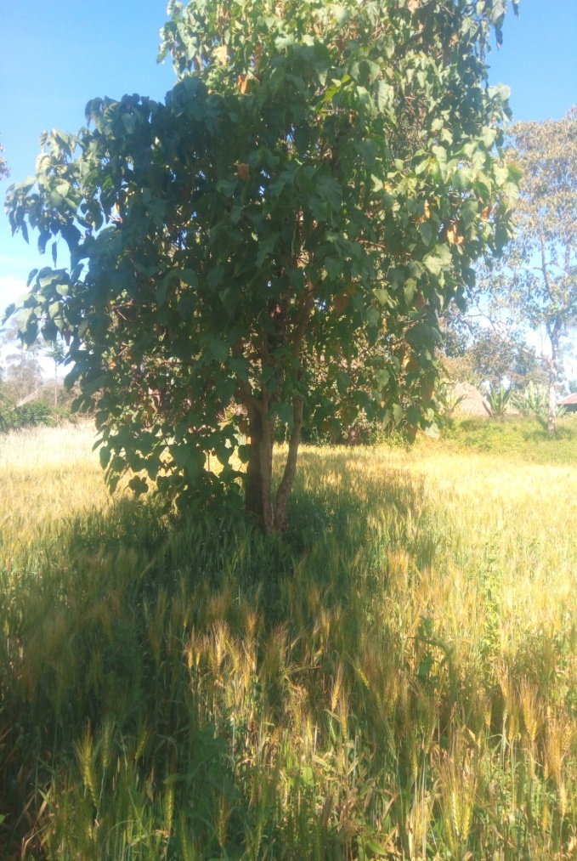
Picture A. Wheat crop under croton macrostachus trees in the study area.

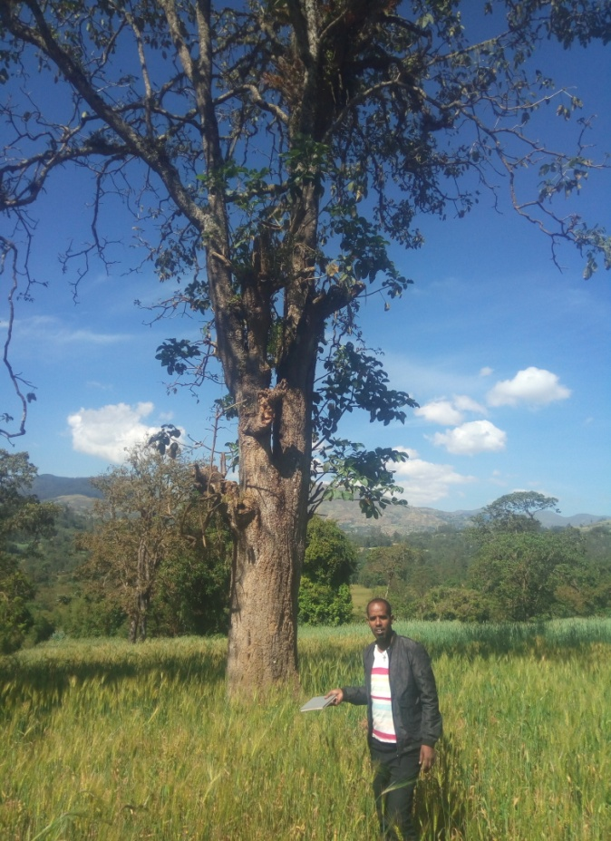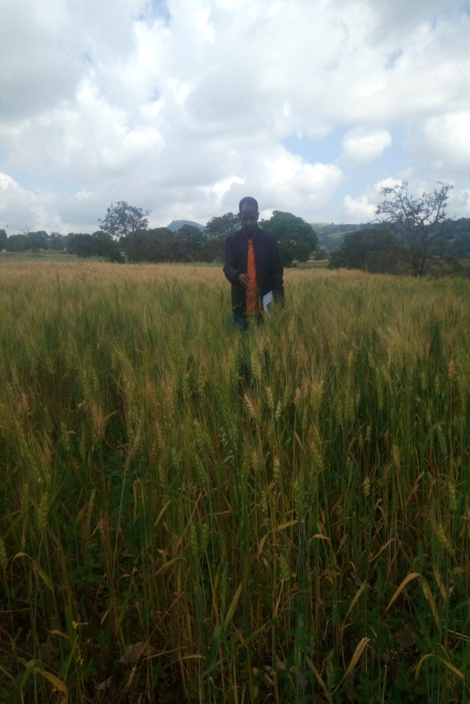
Picture B. Wheat crop under Erthyrina brucei in the study area.
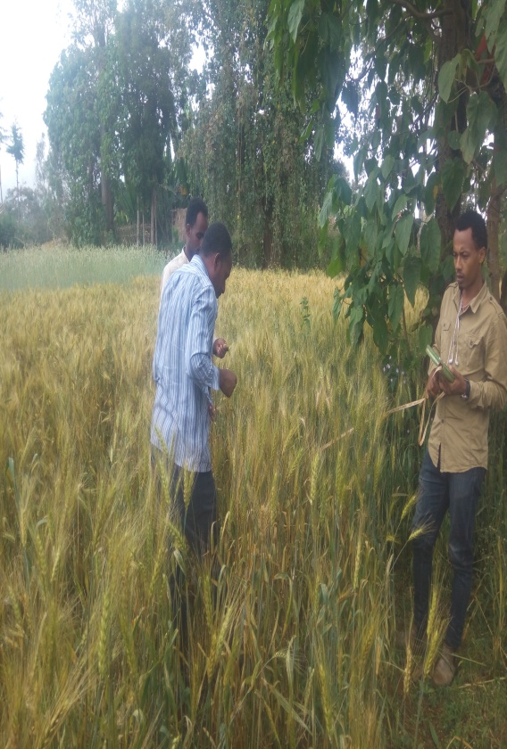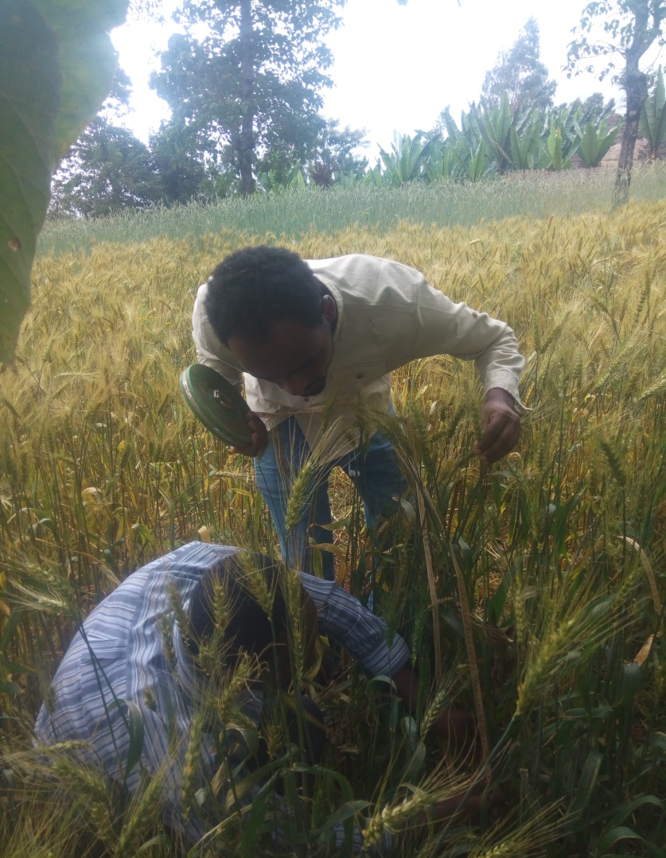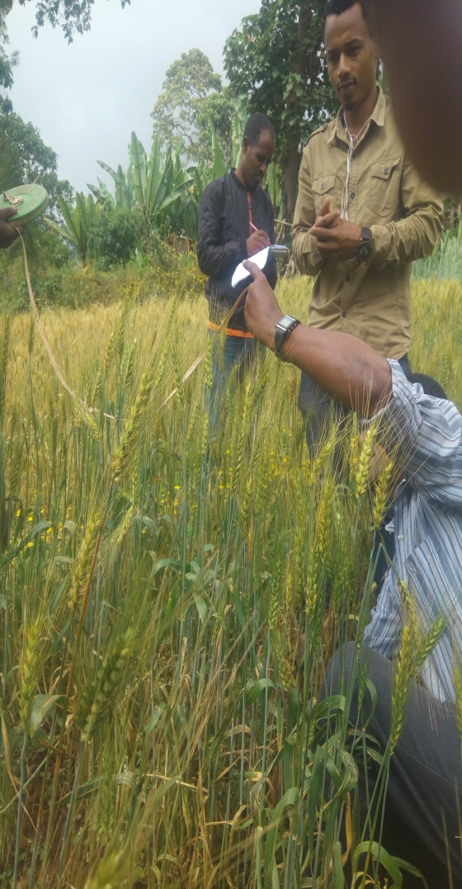
Picture C. Collecting the wheat data under the canopy of Croton macrostachyus and Erthyrina brucei trees.
Table A. Raw data of wheat crop collected under the canopy of Croton macrostachyus and Erthyrina brucei trees.
no. | Tree name | Treatment | Replication | Yield of wheat | Biomass of wheat
1 | Croton macrostachyus | treatment 1 | Control (12m) | 1090.1 | 2400.4
2 | Croton macrostachyus | treatment 1 | Control (12m) | 800 | 2600.2
3 | Croton macrostachyus | treatment 1 | Control (12m) | 900.2 | 2050
4 | Croton macrostachyus | treatment 1 | Control (12m) | 1008.4 | 2100.6
1 | Croton macrostachyus | treatment 2 | 1/3 m | 1540.4 | 2400.5
2 | Croton macrostachyus | treatment 2 | 1/3 m | 1405.4 | 2900
3 | Croton macrostachyus | treatment 2 | 1/3 m | 1300 | 2600.4
4 | Croton macrostachyus | treatment 2 | 1/3 m | 1600.5 | 3200.2
1 | Croton macrostachyus | treatment 3 | 2/3m | 1500.9 | 3984.2
2 | Croton macrostachyus | treatment 3 | 2/3m | 1350.5 | 2540.1
3 | Croton macrostachyus | treatment 3 | 2/3m | 1450.4 | 3240.5
4 | Croton macrostachyus | treatment 3 | 2/3m | 1750.5 | 3600
1 | Croton macrostachyus | treatment 4 | edge | 1400.4 | 3840.4
2 | Croton macrostachyus | treatment 4 | edge | 1450 | 2500.4
3 | Croton macrostachyus | treatment 4 | edge | 1200.6 | 2460.2
4 | Croton macrostachyus | treatment 4 | edge | 1450.4 | 3800.4
1 | Erthyrina brucei | treatment 1 | Control (12m) | 1300.5 | 920.6
2 | Erthyrina brucei | treatment 1 | Control (12m) | 1100 | 1700.4
3 | Erthyrina brucei | treatment 1 | Control (12m) | 1020 | 2600
4 | Erthyrina brucei | treatment 1 | Control (12m) | 1250 | 2400
1 | Erthyrina brucei | treatment 2 | 1/3 m | 1510.9 | 2400.4
2 | Erthyrina brucei | treatment 2 | 1/3 m | 1420.4 | 2100
3 | Erthyrina brucei | treatment 2 | 1/3 m | 1760.6 | 2920.2
4 | Erthyrina brucei | treatment 2 | 1/3 m | 1460.2 | 3360.1
1 | Erthyrina brucei | treatment 3 | 2/3m | 2100.1 | 2400.4
2 | Erthyrina brucei | treatment 3 | 2/3m | 2200.2 | 2800.4
3 | Erthyrina brucei | treatment 3 | 2/3m | 2202.4 | 3220.2
4 | Erthyrina brucei | treatment 3 | 2/3m | 2720.2 | 3480.4
1 | Erthyrina brucei | treatment 4 | edge | 1250 | 2400.4
2 | Erthyrina brucei | treatment 4 | edge | 1010.9 | 2350.2
3 | Erthyrina brucei | treatment 4 | edge | 1200.5 | 2620.4
4 | Erthyrina brucei | treatment 4 | edge | 1620 | 2510.2

