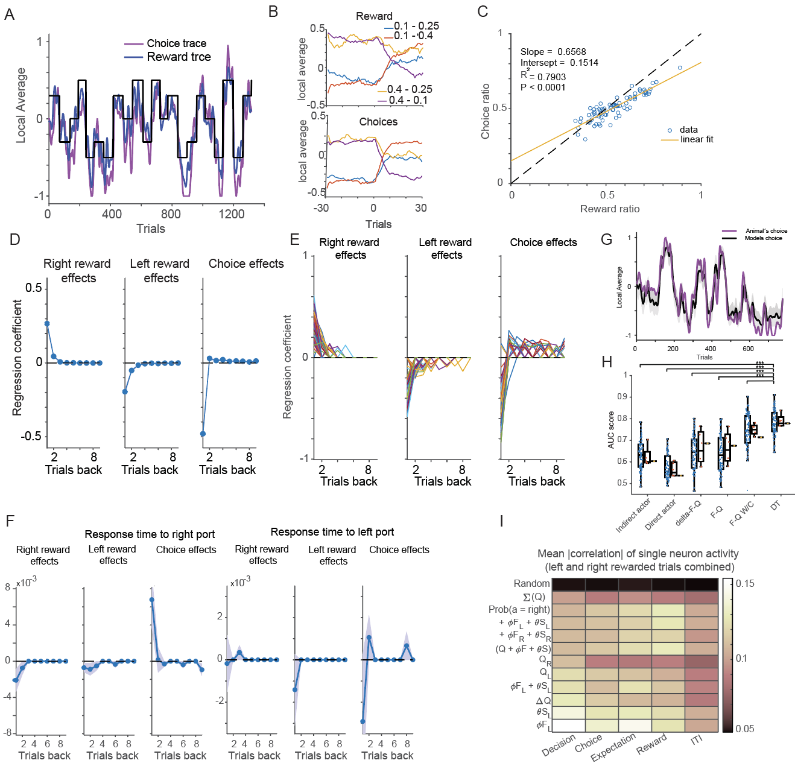
Supplementary Figure 1. A) Performance of animals (D004) in individual sessions. The block transitions are shown in black solid lines. These lines also show the difference in set reward probabilities. Magenta line shows the choices convolved with gaussian filter of length of 10 trials and s.t.d. of 5 trials. Right choices were counted as 1 and left choices as -1. Blue line shows the rewards convolved with the same filter as choices. B) Left panel shows experienced reward rates (convolved as in A) during different block transitions that correspond to different set reward probabilities (different colors of solid lines). The right panel shows the choices (convolved as in A) for the same block transitions as in the left panel. C) reward ratio vs. choice ratio in each session in all animals shown with blue circles. The solid yellow line shows a linear fit with the slope of 0.65, indicating undermatching. D) The regression coefficients of logistic regression for past right rewards, past left rewards, and past choices against current choices. The solid line shows the mean and shaded area s.e.m. for n = 82 sessions combined. E) Reward and choice history regression coefficients from individual sessions shown in different colors. F) Regression analysis of past rewards, past no rewards and past choices on response times for right and left choices. Y-axis shows logistic regression coefficients for each independent variable (x-axis). Solid lines show mean and shaded area s.e.m. of all sessions across all animals combined. G) Choices convolved with gaussian filter (window size of 20 and s.t.d. of 5 trials) of a mouse from an example session (magenta) and DT model. Both animal and DT model were tested on the same VI task. The DT model was run on the same choice and reward history data 1000 times. We show the mean (black line) and s.e.m. (shaded area) of DT model’s choices. H) Various RL model’s (see description of each model in Materials and Methods section) prediction of animal’s choices. We derived each model’s best-fit parameters from 4/5 of the data and tested it on the remaining 1/5. We used the AUC score as a metric for prediction. Blue dots indicate AUC scores from individual sessions (n = 66, in 16 sessions we could not compute AUC score), red dots indicate AUC scores from concatenated sessions for each animal (n = 5), and red dots – all concatenated sessions. Man-Whitney U nonparametric test compared the DT model with all other models. *** indicates p values < 0.001. I) Average correlation of firing rates of each recorded neuron in VI task with DT model decision variables for different behavioural epochs. This analysis was done only for rewarded trials to avoid movement-induced variability in the side port entry period. The higher correlations are shown with lighter colors. Random indicates firing rate correlations to the decision variable with the shuffled trials.

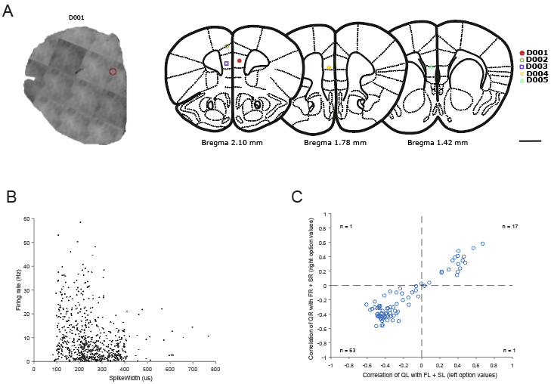
Supplementary Figure 2. A) bright field image of the lesion site (left panel) in one representative animal (D001) shown with solid red circle and lesion sites for the rest of the animals (right panel) shown in schematics (Paxinos atlas). Dashed circles show lesion sites for the rest of the animals. B) The distribution of firing rate of the recorded neurons vs. spike half-width measured in microseconds. Spike half width was calculated as the width of the spike at half-maximal amplitude. C) Scatter plot of correlations of values(Q) and policy (𝜙*F + 𝜃*S) for left (x-axis) and right (y-axis) options. The values and policy are derived from the DT model.

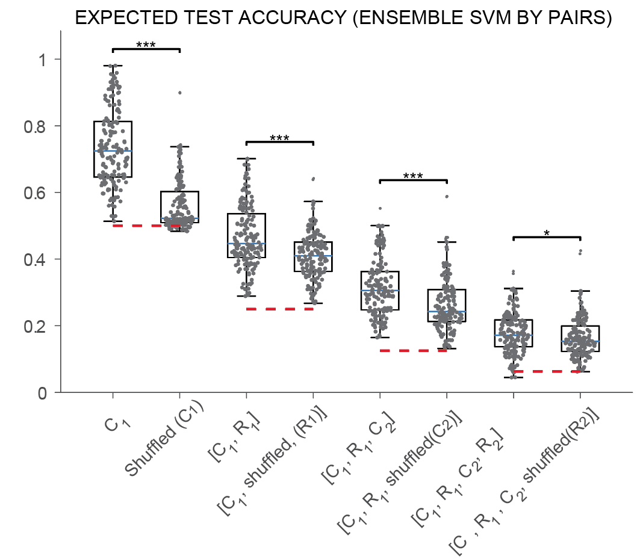
Supplementary figure 3. Performance of the linear classifier to identify unique behavioral states. The support vector machine (SVM) was trained using the trial averaged firing rate of neurons in the decision epoch to find the best linear separation on states that comprised of different binary events: rewards and no rewards for past immediate trial (R1), rewards and no rewards for two trials back (R2), current left and right choices (C1) and immediate past left and right choices C2). The SVM was trained on trials from half of the session, and the performance was tested on the other half. SVM was separately trained on each pair of states and different classifiers were combined to perform multiclass separation. The performance of the classifier was tested against the shuffled data that included all combination of pairs of class labels except the one indicated in the figure. The shuffled data was derived by assigning the firing rate to random trials 1000 times and computing the mean of the classifier performance using the AUC score. The stars indicate the Man Whitney U-test (* p < 0.05, *** p < 0.001) between the mean of the shuffled data and classifier performance on the untrained data.

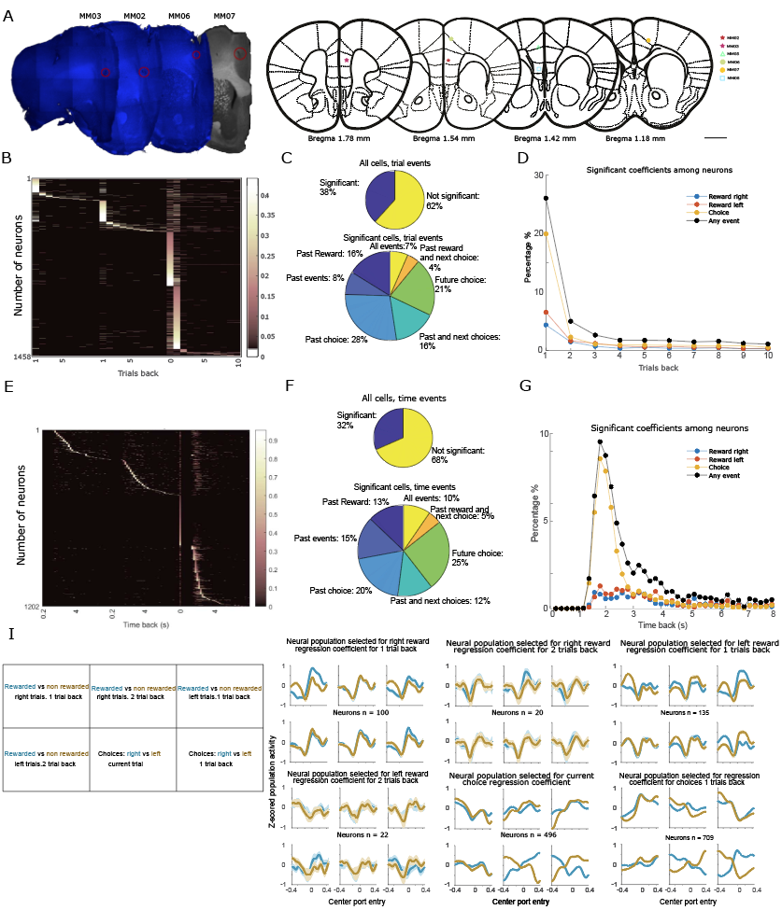
Supplementary figure 4. A) The left panel shows the lesion sites visualized using DAPI staining (four brain slices) and using brightfield microscopy (one rightmost brain slice). Right panel shows schematics of the lesions recovered either from brain images (five brain images of the left panel) or were inferred based on the implantation coordinates and movement of the electrodes (MM005). B-G are the same plots as in Fig.2C-F just performed for a different set of animals using Kilosort2 based spike sorting platform. B) The individual neuron’s coefficients for past rewards, current choice, and past choices (up to ten trials back) regressed against trial averaged firing rate in the decision epoch sorted by their highest absolute regression coefficient. C) Percentage of neurons affected by any trial events (upper panel), affected by specific past events or their combination (lower chart). D) Shows the percentage of neurons showing significant regression coefficients as described previously to any past events (black line), past rewards (blue line) and past choices (red line). In E), F), and G), we performed the same analysis as in B), C), and D) respectively, except that we used regression for time-history-specific rewards and choices. For this, we divided the time into bins of 200ms. and regressed past rewards, past choices, and current choices in each of these time bins against each neuron's trial averaged firing rate in the decision epoch. I) Left, schematics shows the two behavioral events (colors indicate the selection of behavioral events) used to plot average and normalized (zscored) PETH from selected neurons in each of the six boxes. Right panels show the selection of neurons based on highest absolute regression coefficient for six different events depicted with the titles: past rewards one and two trials back for left and right options and past and current choices. PETH’s were inverted for negative coefficients. Solid lines indicate the mean and shaded areas, s.e.m.

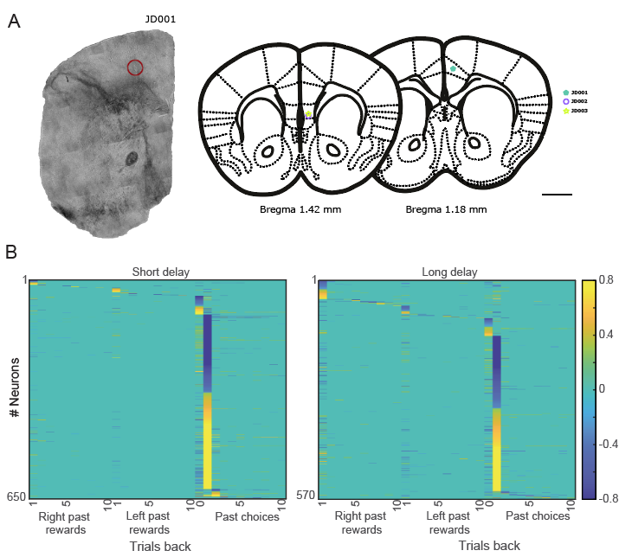
Supplementary figure 5. A) Lesion and recording sites of the 3 animals (JD002 to JD004) performing delayed choice task. For the animal JD001 we only have tetrode drive implanted coordinates which was 0.5 mm Mediolateral 1.6mm anterior to bregma and at least 500 micron depth from the brain surface. B) A heatmap of the regression coefficients. These coefficients are computed by regressing the past rewards (up to ten trials back), past (up to ten trials back) and current choices against trial-average firing rate of each neuron in the decision epoch. Only significant coefficients after cross-validation on 1/5 of the test data and false discovery rate correction are plotted. The coefficients are sorted based on their maximum absolute value and divided horizontally into four groups: those affected by past right rewards, past left rewards, current choice, and past choices.

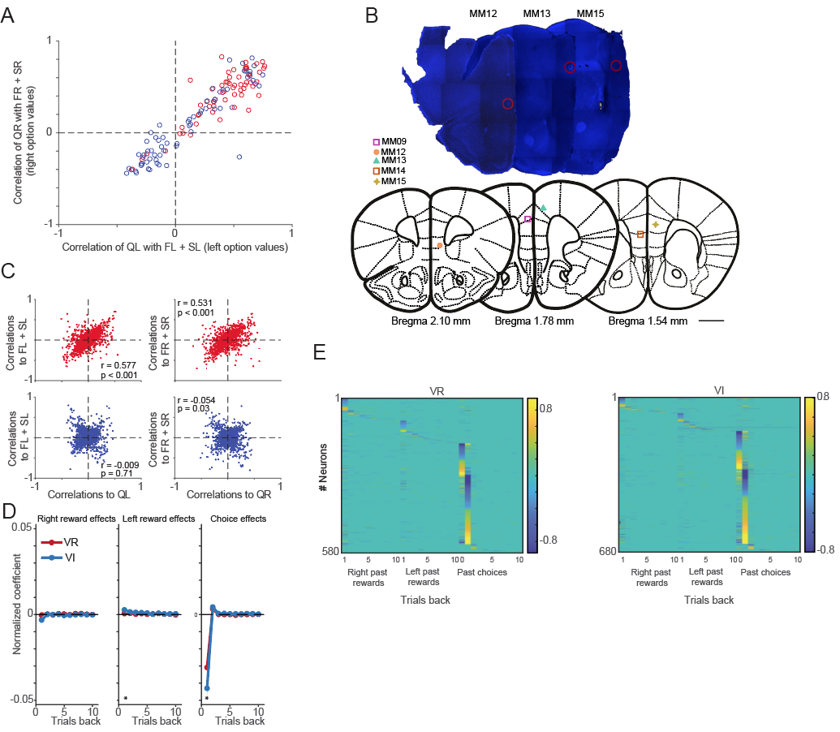
Supplementary figure 6. A) Correlation of values (Q, x-axis) and policy (𝜙*F + 𝜃*S, y-axis) for left and right options in VI (blue) and VR (red) tasks. Correlations are computed for each session. B) Lesions and recording sites from 5 animals recorded in VI and VR tasks. The upper panel shows the brain sections (three brains were recovered) with lesions (in red circle) visualized using DAPI staining. The lower panel shows the lesions on the brain schematics (Paxinos atlas) of all animals recorded in VI and VR tasks concurrently. C) Scatter plot of correlation of trial averaged firing rate of neurons in the decision epoch with values (Q, x-axis) or policy (𝜙*F + 𝜃*S, y-axis) for left and right options for VR (in red) and VI (blue) task. D) The absolute regression coefficients in VR (in red) and VI (in blue) tasks. The regression coefficients were computed by regressing past rewards and past choices for ten trials back in history and current choices against the trial-averaged firing rate of neurons in the decision epoch. Solid lines show the mean across all neurons that passed the significance test, and shaded areas show s.e.m. E) A heatmap of the regression coefficients for past rewards, past choices, and current choices (indicated as 0) as indicated on the panels (left VR and right VI task). Only significant coefficients after cross-validation on 1/5 of the test data and false discovery rate correction are plotted. The coefficients are sorted based on their maximum absolute value and divided horizontally into four groups: those affected by past right rewards, past left rewards, current choice, and past choices.

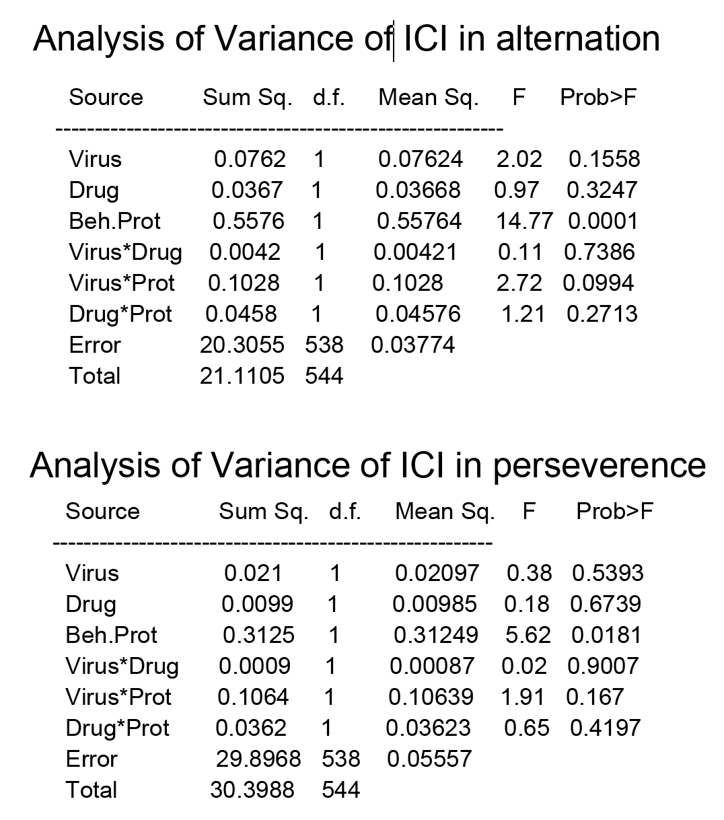

Supplementary table. Upper panel shows Analysis of variance of inter choice interval (ICI) for alternation trials. Beh.Prot. indicates VI and VR task groupings, virus - DREADD and GFP groups, drug - CNO and Saline treatment groups and others- their interactions. Lower panel shows ANOVA of ICI in perseverance trials.

