Supplementary Materials
Investigation of the inverse problem for the Arrhenius equation using the example of thermal degradation of spongin-based scaffolds
Sonia Żółtowska¹, Michał Ciałkowski², Krzysztof Alejski¹, Teofil Jesionowski^{1,*}

¹ Poznan University of Technology, Faculty of Chemical Technology, Institute of Chemical Technology and Engineering, Berdychowo 4, PL-60965 Poznan, Poland
² Poznan University of Technology, Faculty of Environmental Engineering and Energy, Institute of Thermal Engineering, Piotrowo 3, PL-60965 Poznan, Poland

Corresponding author: Teofil.jesionowski@put.poznan.pl

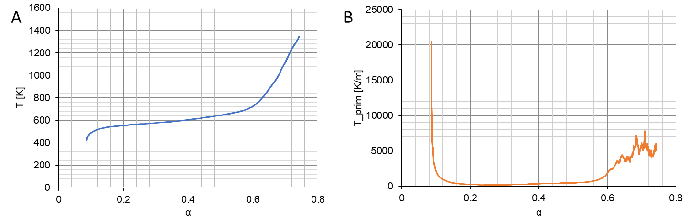
Fig. S1. Temperature curve (A) and temperature derivative (B) in the range α₀=0.0867; α_{end}=0.742 for β=2.5.

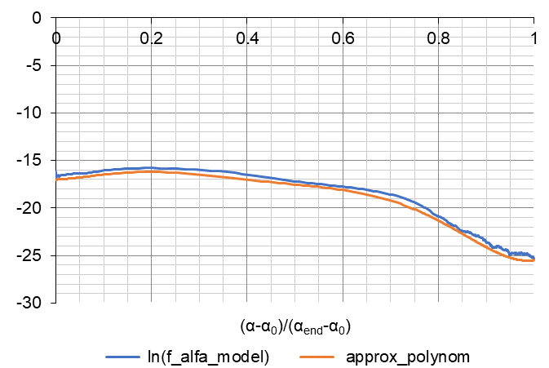
ln(α)_model
Fig. S2. Comparison of the approximation of a function (its exponent) ln(f_{model}(α)) with its polynomial approximation: N_{polynom}=6; N=371; $ln\left(f{\left(α\right)}_{model}\right)=ln⁡(\frac{β}{T_{prim}})-(\frac{E_{A}}{R})∙\left(\frac{1}{T_{S}}-+\frac{1}{T}\right),$E_{A}=51028, T_{S}=270.48, A=0.714∙10¹⁰, α₀=0.0867, α_{end}=0.742.
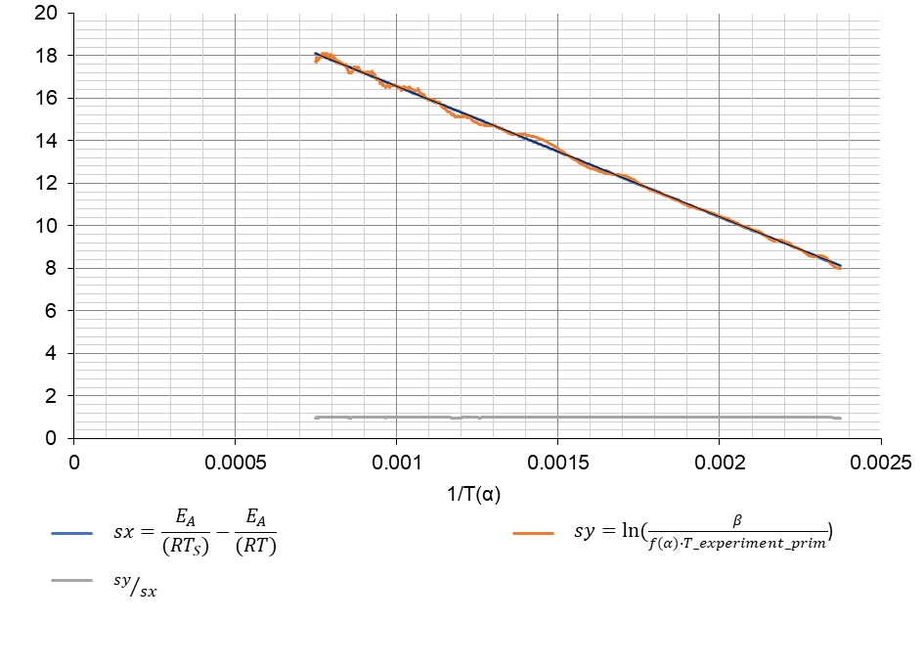
Fig. S3. Investigation of the quality of the model function f(α) satisfying the Arrhenius equation (15) for the known values of E_{A}=51028, T_{S}=270.48 and A=0.714∙1010.
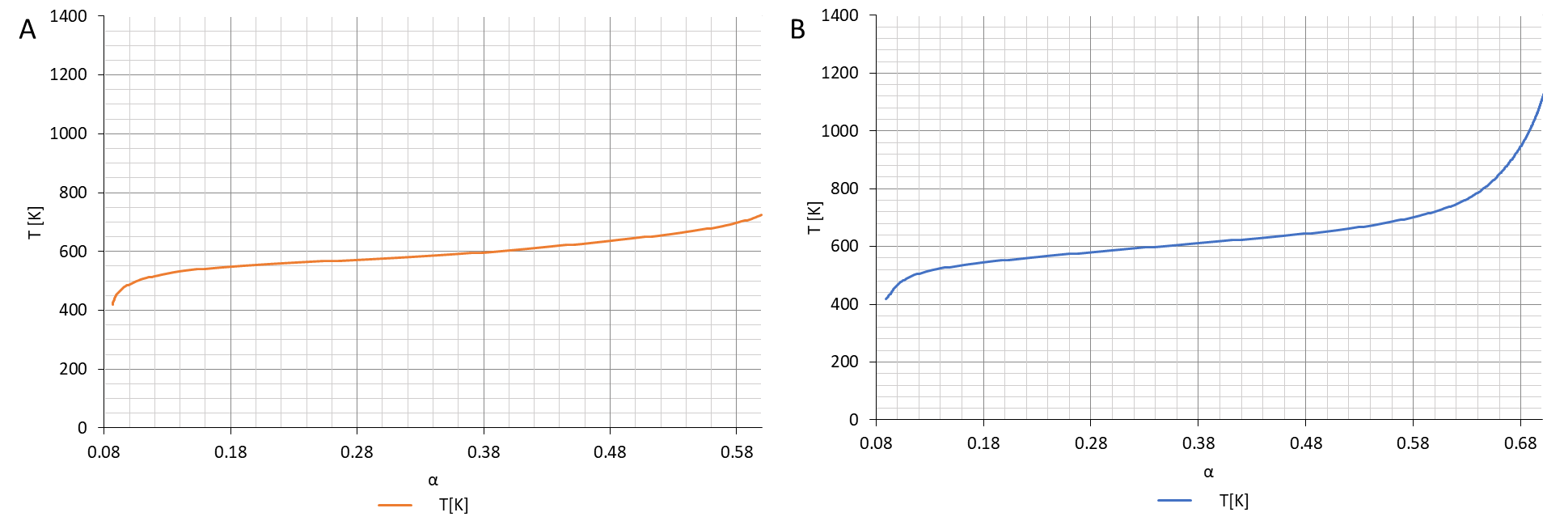
Fig. S4. Temperature plots in the range α₀=0.0867; α_{end}=0.6 for β=2.5 (A) and α₀=0.0958; α_{end}=0.699 for β=20 (B).
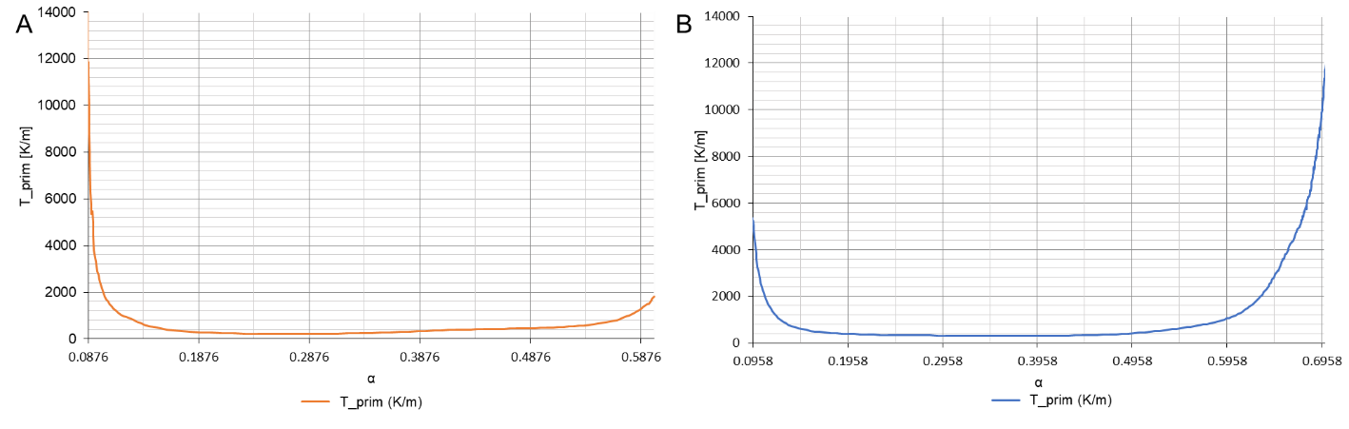
Fig. S5. Plots of the first derivative in the range α₀=0.0867; α_{end}=0.6 for β=2.5 (A) and α₀=0.0958; α_{end}=0.699 for β=20 (B).
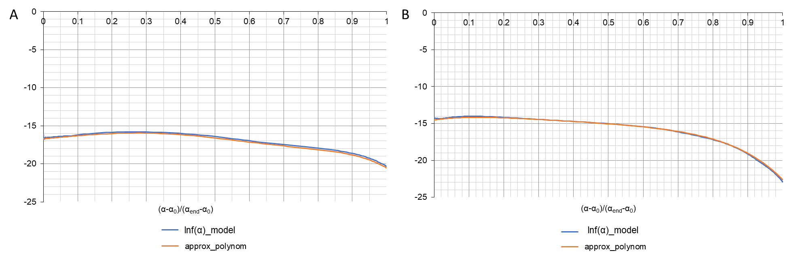
Fig. S6. Comparison of the function approximation (exponent) ln(f_{model}(α)) with its polynomial approximation: N_{polynom}=6; β=2.5 (A) and β=20 (B).
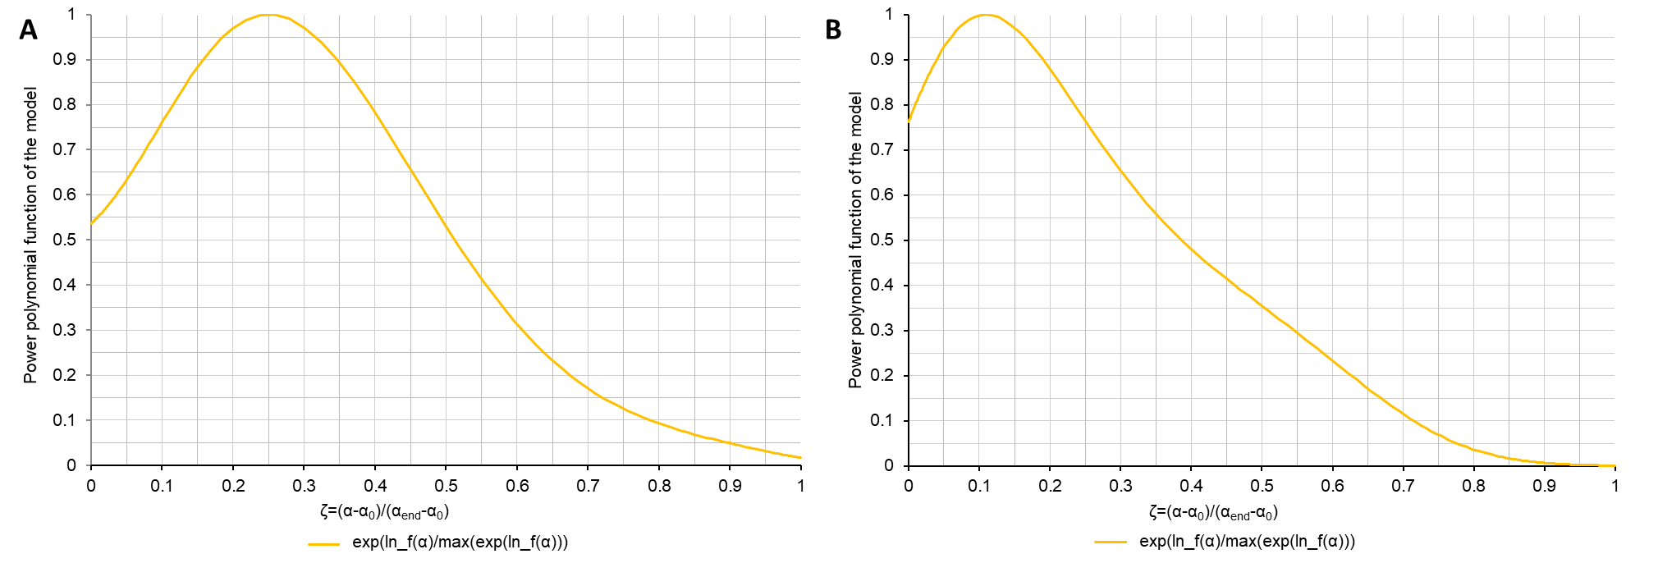
Fig. S7. Plots of the relative model function (relative to the maximum value) in the range <α₀, α_{end}> for β=2.5 (A) and β=20 (B).
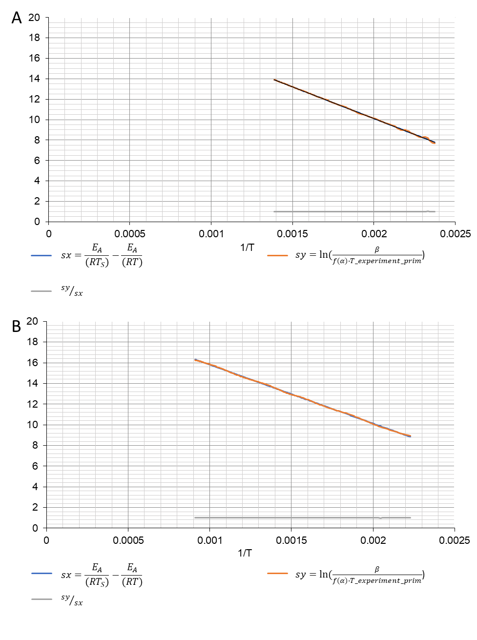
Fig. S8. Testing the quality of the model function f(α) satisfying the Arrhenius equation (15) for β=2.5 (A) and β=20 (B).

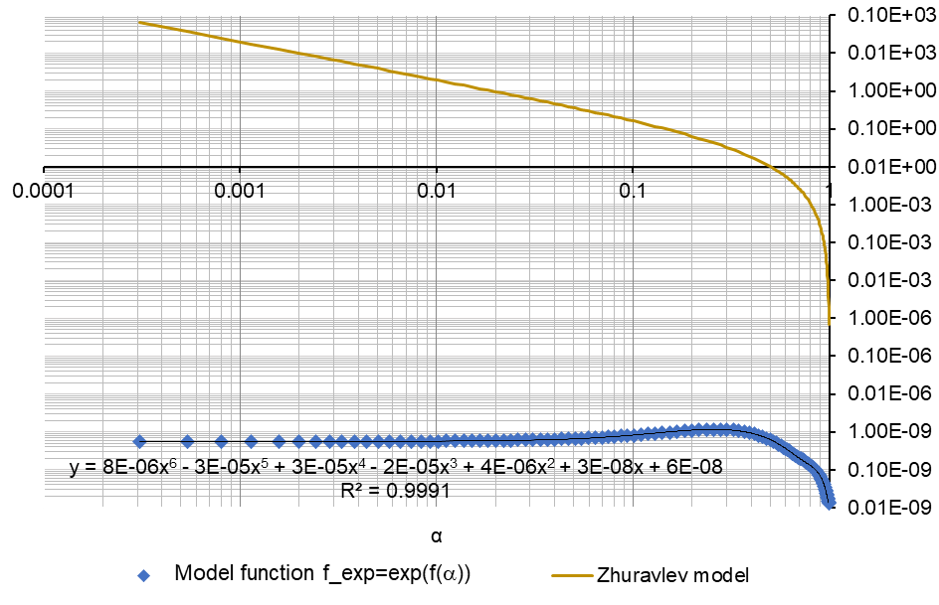
Fig. S9. Comparison of the evaluated model f_{exp}=exp(f(α)) with the Zhuravlev function for β=2.5.

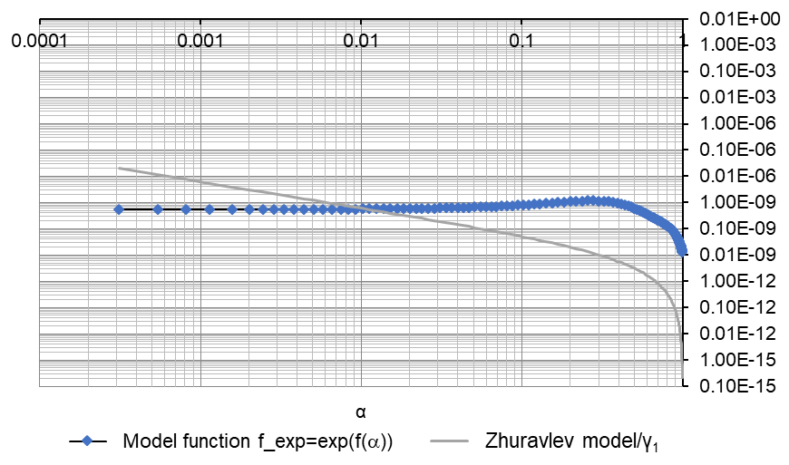
Fig. S10. Comparison of the evaluated function exp(f(α)) with the scaled Zhuravlev function with the multiplier γ₁ , so that ||γ₁$∙$f(α)-f_{model}(α)||²=min(γ₁), for β=2.5 and γ₁= 0.32135∙10¹⁰.

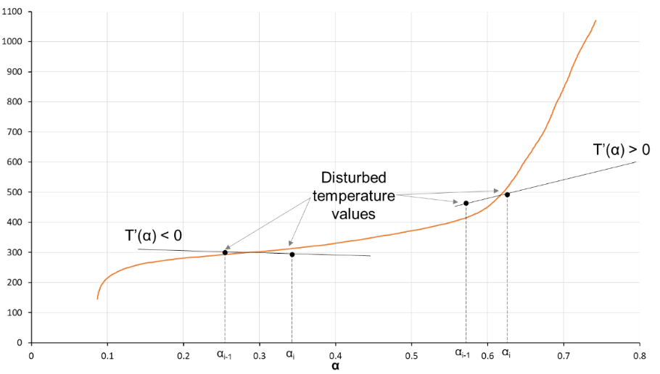
Fig. S11. Analysis of the influence of temperature disturbance on the sign of the derivative T' (α).

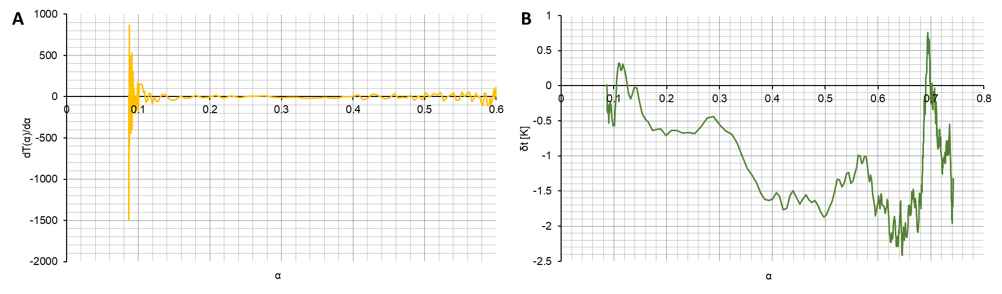
Fig. S12. Disturbance of the derivative dT(α)/dα with a random error of 10% (A); disturbance of temperature ΔT [K] determined from the disturbed derivative dT(α)/dα with a random error of 10%, for β=2.5.
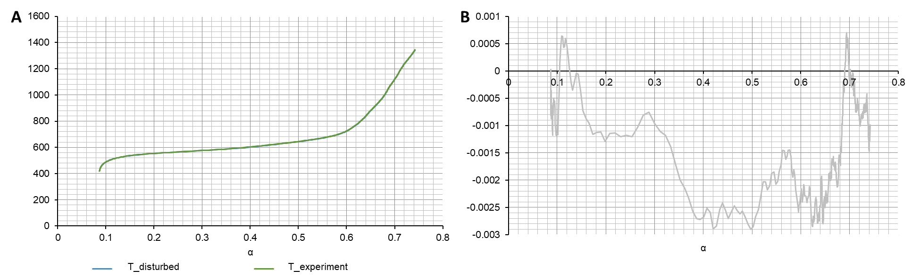
Fig. S13. Comparison of the quasi-exact temperature T_{experiment} with the temperature determined from the disturbed graph of dT(α)/dα with a random error of 10%, for β=2.5 (A); the margin of the relative error of disturbed temperature resulting from errors of disturbance of dT(α)/dα with a random error of 10%, for β=2.5.

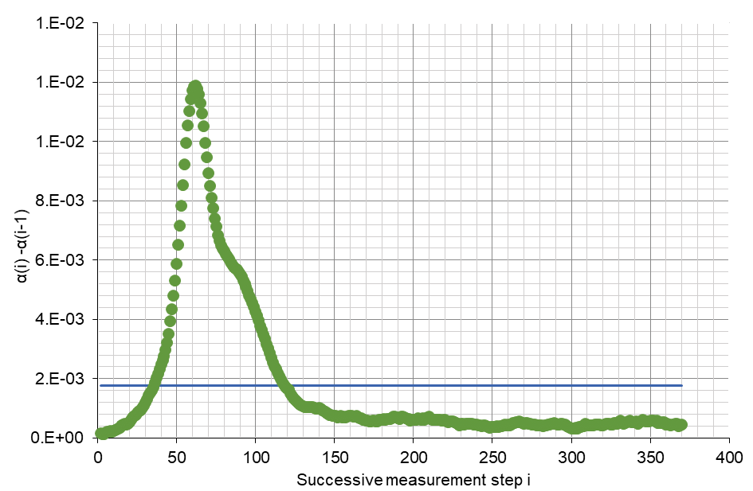
Fig. S14. The length of intervals α(i)–α(i-1) for successive measurement steps. Average step length αs=0.17751∙10-2 – blue line.

