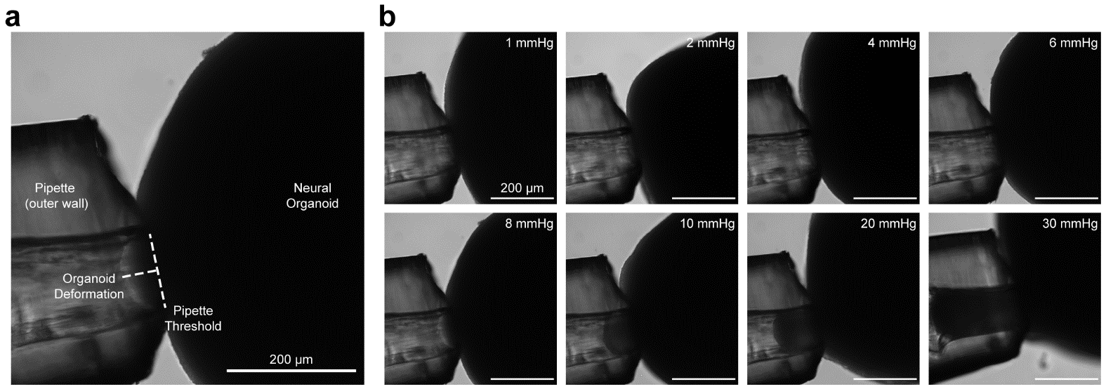

Supplementary Figure 1. Neural organoid surface tension measurements.
a. Representative BF image of a neural organoid adjacent to the vacuum aspirator used for surface tension measurements. b. Representative BF images of the same neural organoid across a range of vacuum pressures.
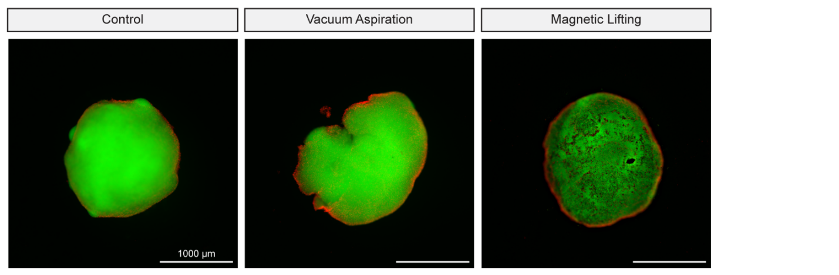

Supplementary Figure 2. Neural organoid viability following vacuum aspiration and magnetic lifting.
Representative fluorescence images of neural organoids with and without aspiration-assisted lifting and magnetic lifting with calcein-AM labeled live cells (green) and ethidium homodimer-1 labeled dead cells (red). The control organoid was not lifted. The dark dots visible on the neural organoid exposed to magnetic lifting are MNPs on the organoid surface.
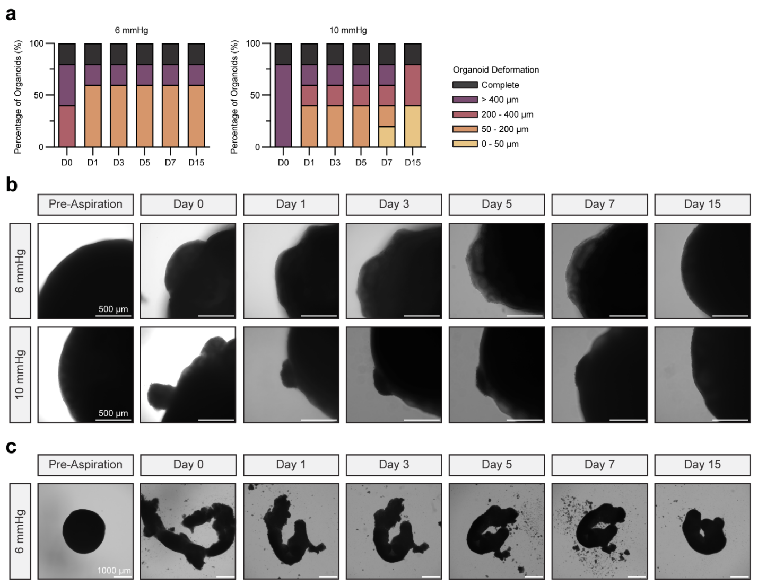

Supplementary Figure 3. Aspiration-mediated deformation over time.
a. Quantification of neural organoid deformation over time following exposure to either 6 mmHg or 10 mmHg vacuum pressure (n = 5 per vacuum pressure). b. Representative BF images of a single neural organoid exposed to either 6 mmHg or 10 mmHg over time. c. Representative BF images of a single neural organoid which, when exposed to 6 mmHg, exhibited a deformation so severe that it was no longer spherical, herein referred to as ‘Complete Deformation’.
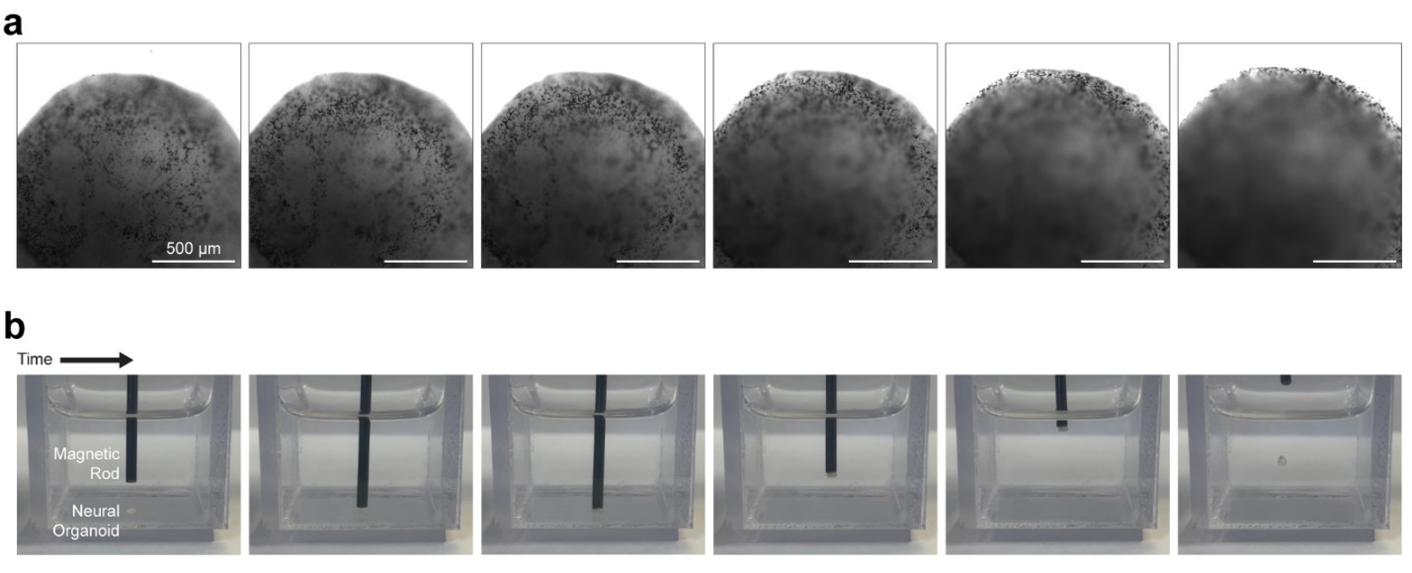

Supplementary Figure 4. CNF MNPs coat neural organoids sufficiently for lifting.
a. Representative BF images of different z-planes of a single neural organoid coated with an MNP-laden CNF ink. b. Representative images of the same neural organoid being lifted and released by an iron rod affixed to an electromagnet.
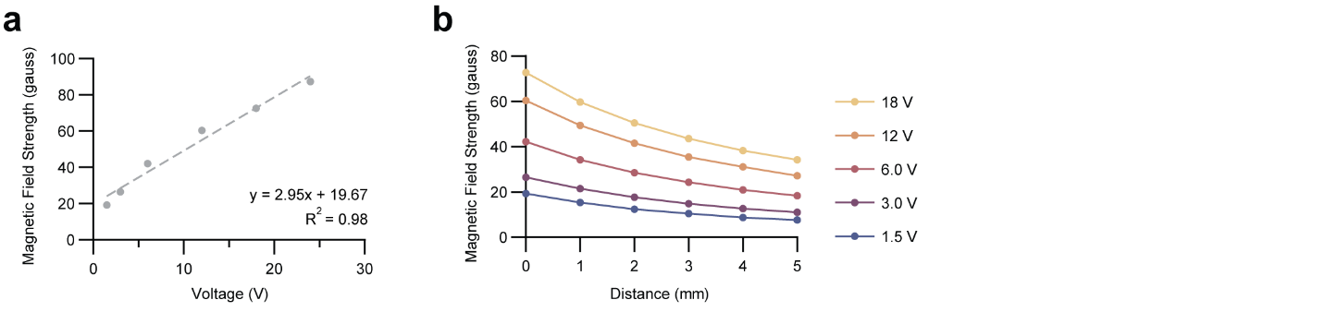

Supplementary Figure 5. Quantification of magnetic field strength.
a. Magnetic field strength over increasing voltages. b. Magnetic field strength at distinct voltages over increasing distances.
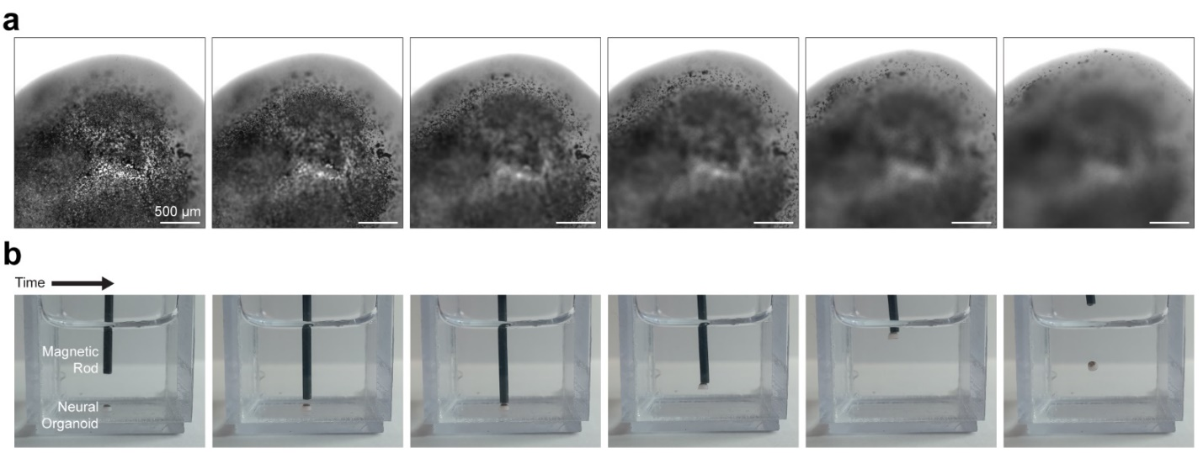

Supplementary Figure 6. Orbital shakers coat neural organoids sufficiently for lifting.
a. Representative BF images of different z-planes of a single neural organoid incubated in an orbital shaker with MNPs in DPBS. b. Representative images of the same neural organoid being lifted and released by an iron rod affixed to an electromagnet.
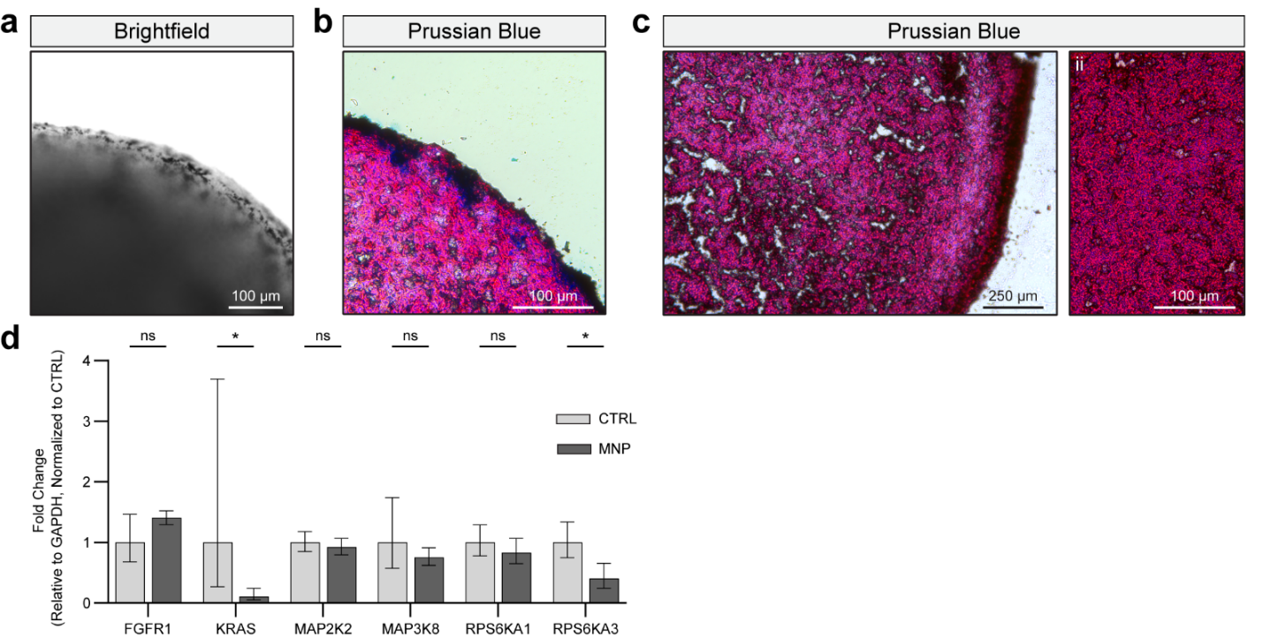

Supplementary Figure 7. The effect of MNPs on neural organoids is limited.
a. Representative BF images of a single z-plane of a neural organoid coated with MNPs. b. Representative Prussian blue staining of an MNP-coated neural organoid wherein blue denotes iron. c. Representative Prussian blue staining of a neural organoid that has never come in contact with MNPs. d. mRNA expression of MAPK genes previously identified to have been affected by iron oxide nanoparticles (n = 4). CTRL represent non-coated organoids while MNP represent MNP-coated organoids.

Statistical analyses performed separately for each marker with unpaired t tests with Welch's correction. Data plotted as mean ± SD where * p<0.05, **p<0.01, ***p<0.001, ****p<0.0001, and ns = not significant.
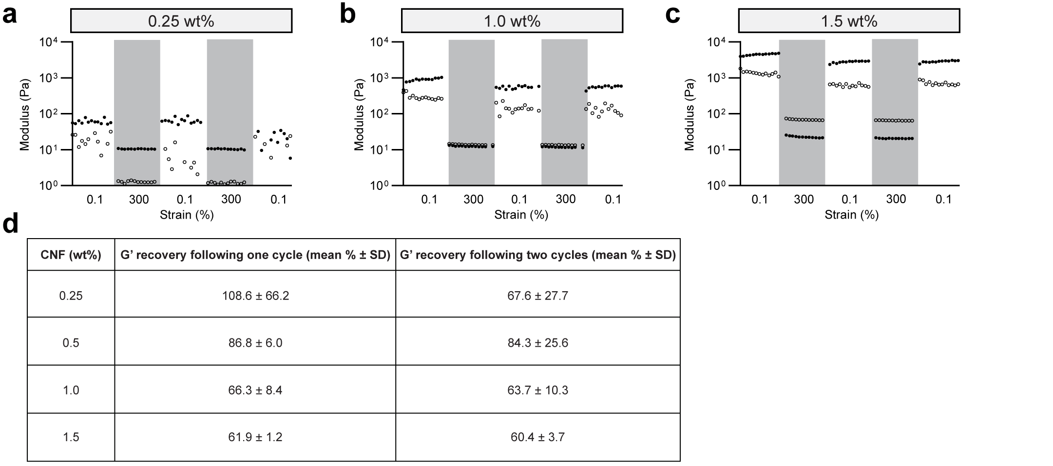

Supplementary Figure 8. Modulus recovery following high strain for CNF support scaffolds.
a. Representative storage modulus (filled circles) and loss modulus (open circles) of 0.25 wt% CNF support scaffold exposed to cyclical periods of low (0.1 %) and high (300 %) strain to evaluate the ability of the material to shear thin and self-heal. b. Representative storage modulus and loss modulus of 1.0 wt% CNF support scaffold exposed to cyclical periods of low and high strain. c. Representative storage modulus and loss modulus of 1.5 wt% CNF support scaffold exposed to cyclical periods of low and high strain. d. Summary of storage modulus recovery as a percentage of the initial modulus (n = 4).

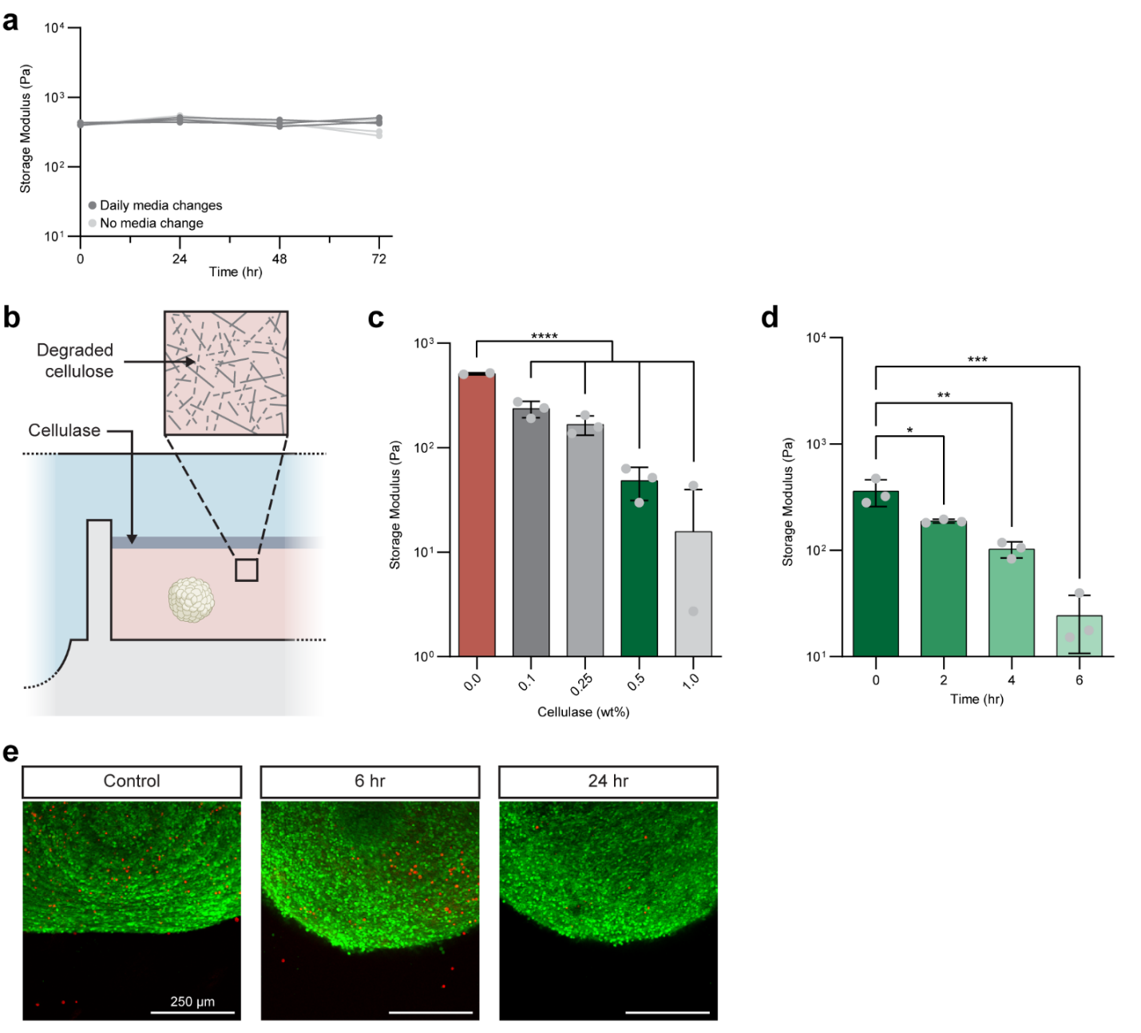

Supplementary Figure 9. Cellulase degrades CNF in a bioorthogonal manner.
a. Storage modulus of 0.5 wt% CNF support scaffold over time with or without daily media changes. b. Schematic of the use of cellulase to degrade CNF. c. Storage modulus of 0.5 wt% CNF exposed to various wt% of cellulase (n = 3). d. Storage modulus of 0.5 wt% CNF exposed to 0.5 wt% cellulase over time (n = 3). e. Representative fluorescence images of neural organoids following 0.5 wt% cellulase treatment over time with calcein-AM labeled live cells (green) and ethidium homodimer-1-labeled dead cells (red).

Statistical analyses performed as one-way ANOVA with Tukey multiple comparisons test. Data plotted as mean ± SD where * p<0.05, **p<0.01, ***p<0.001, ****p<0.0001, and ns = not significant.
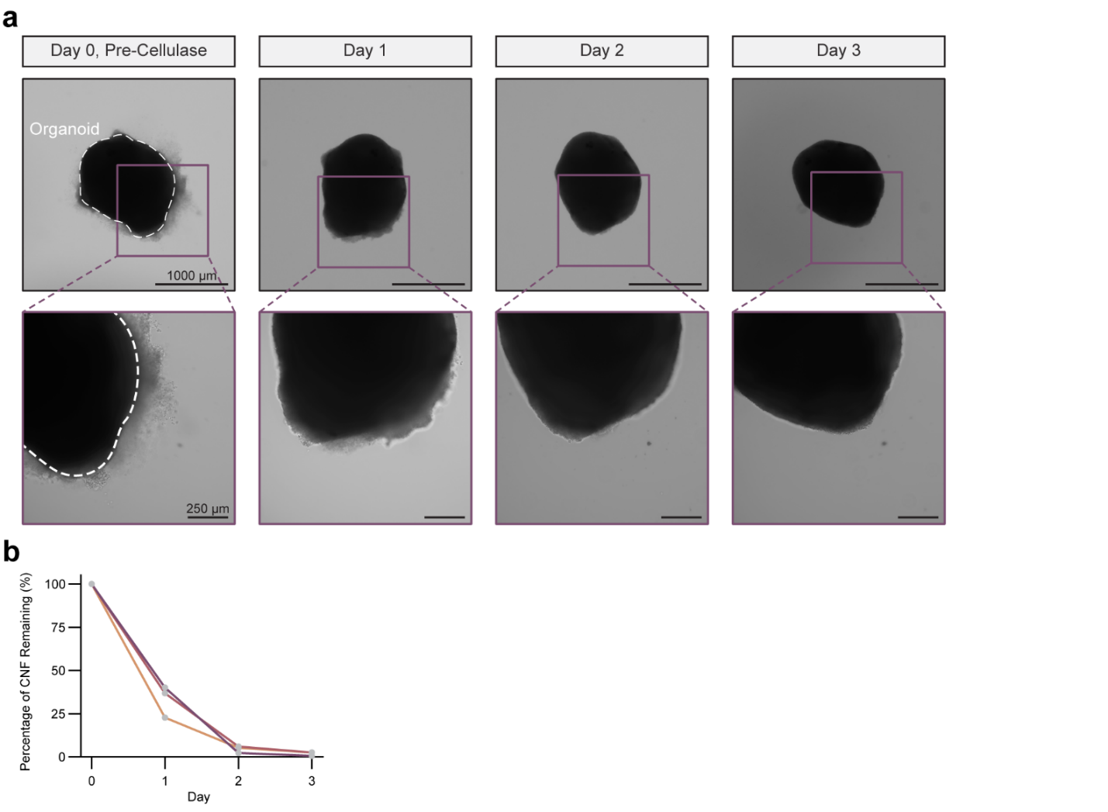

Supplementary Figure 10. Cellulase-mediated removal of residual CNF.
a. Representative BF images of a neural organoid following STAMP and removal from the CNF support scaffold. The organoid was treated with 0.5 wt% cellulase over 3 days to remove residual CNF on the organoid’s surface. b. Quantification of CNF removal with 0.5 wt% cellulase. Each set of data points connected with a line represents a single replicate.
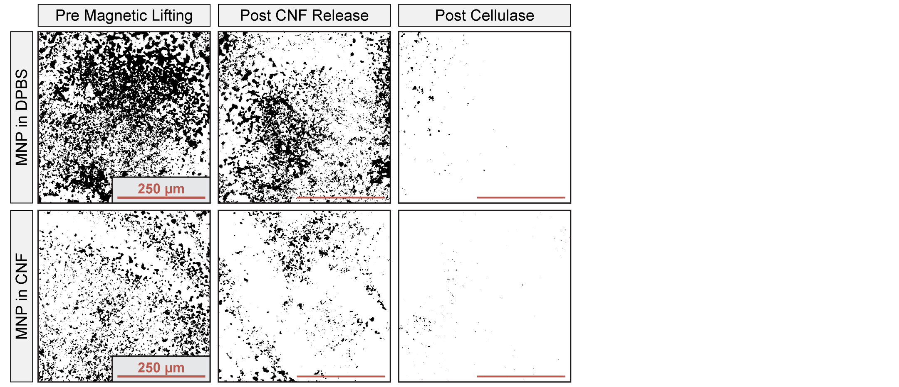

Supplementary Figure 11. MNP surface coverage throughout STAMP.
Representative maximum projection, false colored BF images of neural organoid surfaces following STAMP wherein one organoid was coated with MNPs suspended in DPBS and the other with an MNP-laden 0.025 wt% CNF ink. In both cases, the initial concentration of MNPs in the coatings were 1 wt%.
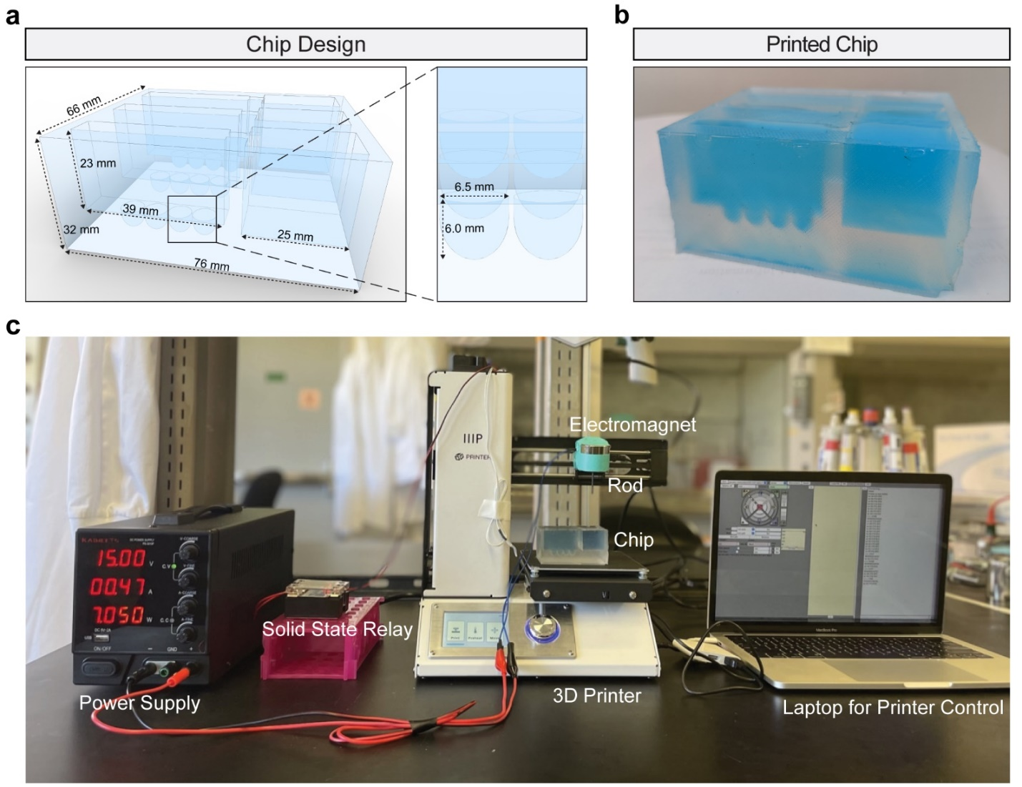

Supplementary Figure 12. STAMP chip design and fabrication.
a. 3D rendering with measurements of the chip designed to facilitate STAMP automation. b. Image of the chip after the PDMS has been cured. The reservoirs are filled with DPBS with blue food coloring to provide contrast. c. Image of the STAMP set-up.
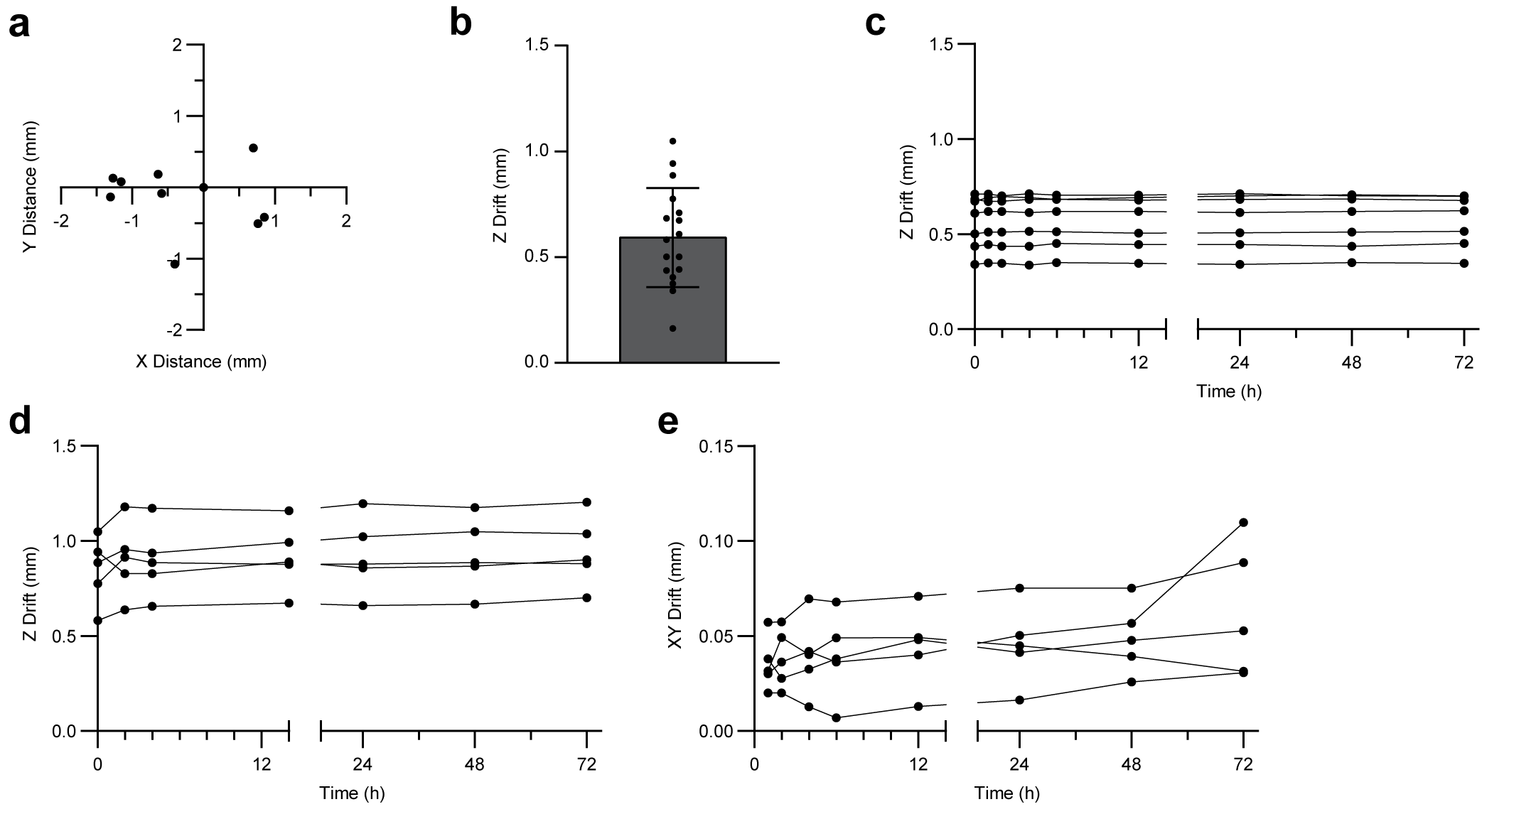

Supplementary Figure 13. XYZ localization with STAMP.
a. Precision of automated STAMP positioning in X and Y dimensions. Data points represent the observed positions where alginate microgels were deposited in a coordinate plane wherein (0,0) represents the intended position of the microgel. b. Quantification of the initial Z drift. c. Z drift of microgels with diameters greater than 1.5 mm over time. d. Z drift of microgels with diameters less than 1.5 mm over time. e. Total XY drift of microgels over time.
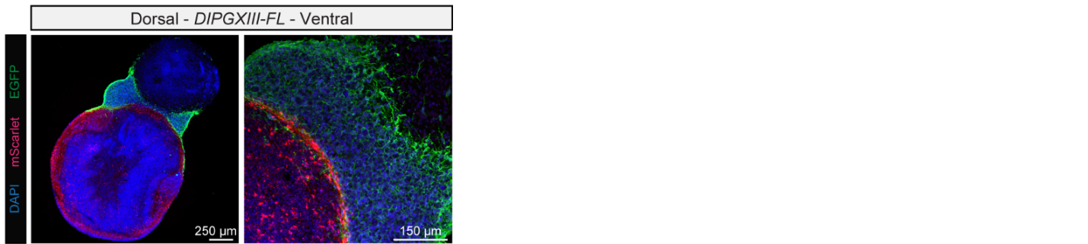

Supplementary Figure 14. Three-part fusion of two regionalized neural organoids and a DIPG organoid.
Representative IF images of an mScarlet-expressing dorsal forebrain neural organoid fused to an eGFP-expressing frontal lobe DIPG metastasis fused to a non-fluorescent ventral forebrain neural organoid.
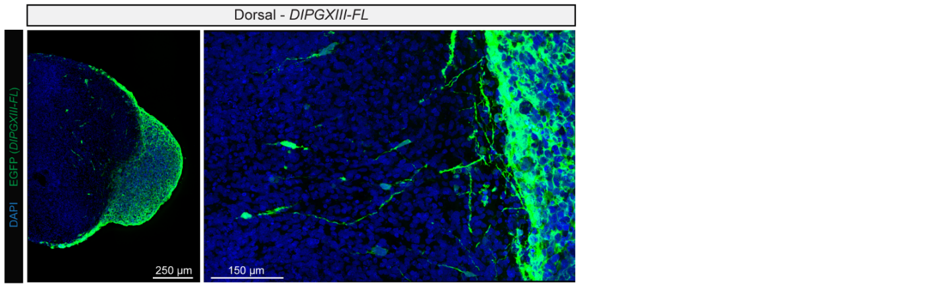

Supplementary Figure 15. Infiltration of a DIPG organoid into a neural organoid.
Representative IF images of an eGFP-expressing frontal lobe DIPG metastasis fused to a non-fluorescent dorsal forebrain neural organoid.
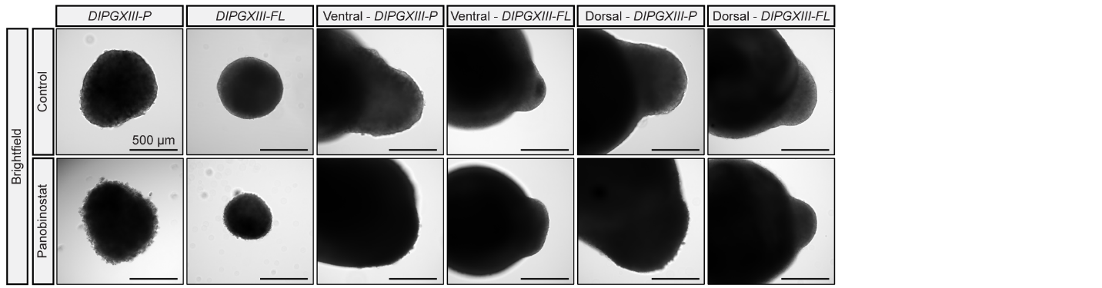

Supplementary Figure 16. DIPG organoids fused to an array of neural organoids.
Representative BF images of DIPG organoids, from the pons and frontal lobe, fused to ventral and dorsal neural organoids with and without 200 nM panobinostat.
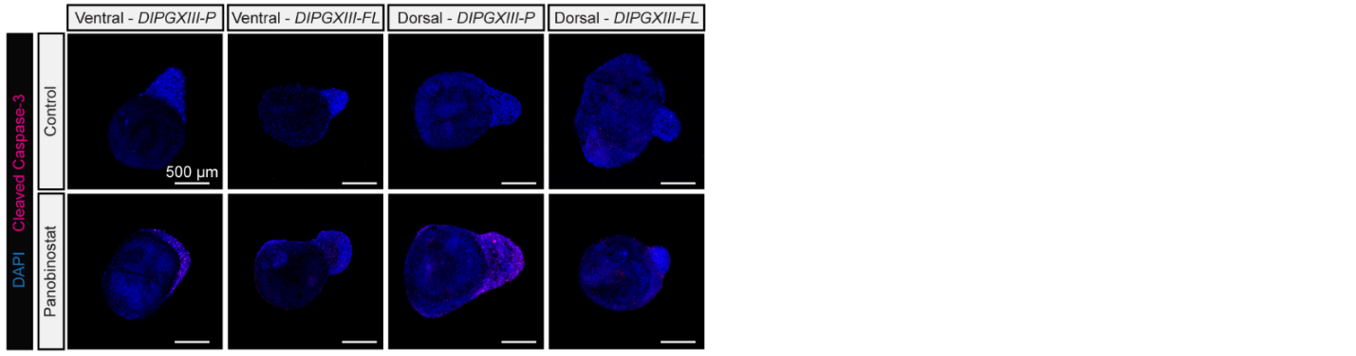

Supplementary Figure 17. Panobinostat does not induce substantial apoptosis in neural organoids.
Representative IF images stained with the apoptosis marker cleaved caspase-3 of DIPG organoids, from the pons and frontal lobe, fused to ventral and dorsal neural organoids with and without 200 nM panobinostat.

5. Supplementary Videos
Supplementary Video 1. Ventral interneuron migration into the dorsal forebrain organoid.
Representative IF of a section of a hiPSC-derived forebrain assembloid, constructed with STAMP, comprised of eGFP-expressing ventral and mScarlet-expressing dorsal neural organoids. DAPI (blue), mScarlet (magenta), eGFP (white).
Supplementary Video 2. Interneurons exbibit highly branched morphologies within the dorsal forebrain organoid.
Representative IF of a section of a hiPSC-derived forebrain assembloid, constructed with STAMP, comprised of eGFP-expressing ventral and mScarlet-expressing dorsal neural organoids. DAPI (blue), mScarlet (magenta), eGFP (white).
Supplementary Video 3. Interneurons span Z-depths within the dorsal forebrain organoid.
Representative IF with false-coloring to denote depth in the Z dimension of a section of a hiPSC-derived forebrain assembloid, constructed with STAMP, comprised of eGFP-expressing ventral and dorsal neural organoids. DAPI (blue), eGFP (white).

6. Supplementary Tables
Supplementary Table 1. Previous demonstrations of AAB.
Cell Type | Spheroid Size  (μm) | Vacuum Pressure  (mmHg) | Nozzle Diameter  (μm) | Support Type | Dimensionality | Reference
MSC, HUVEC, 3T3, 4T1, HDF | 200-600 | 20-60 | 250 | Agarose | 2D | Ayan, Ozbolat et al.  Sci. Adv. 2020.
MSC | 150-400 | 20-300 | 150 | Carbopol | 3D | Ayan, Ozbolat et al.  Commun. Phys. 2020.
MSC | 250-600 | 70 | 200 | Alginate | 3D | Kim, Ozbolat et al.  Biofabrication. 2022.
MSC, hiPSC-CM | 200-400 | Not described | 100 | Hyaluronan | 3D | Daly, Burdick et al.  Nat. Commun. 2021.

Abbreviations:
Aspiration-assisted bioprinting (AAB)
Mesenchymal stromal cells (MSC),
Human umbilical vein endothelial cells (HUVEC),
NIH/3T3 murine embryonic fibroblasts (3T3),
Murine breast cancer cell line derived from mammary gland (4T1),
Human dermal fibroblasts (HDF),
Human induced pluripotent stem cell-derived cardiomyocytes (hiPSC-CM)

Supplementary Table 2. Characterization of MNPs.
 | Homemade (mean ± SD) | Commercial (mean ± SD)
Zeta Potential (mV) | -22.26 ± 1.342 | 49.50 ± 5.920 *
Aggregate Diameter (nm) | 2864 ± 4438 | 2545 ± 1926
Hydrodynamic Diameter (nm) | 1003 ± 49.3 | 669.8 ± 41.0

Magnetic nanoparticles (MNPs)
* These values provided by Alpha Nanotech

Supplementary Table 3. Fluorescence recovery after photobleaching of 0.5 wt% CNF across MWs.
Diffusant MW (Da) | Hydrodynamic Radius (nm) | Diffusivity (um^2 s^-1)
10,000 | 2.3 | 130 ± 9
20,000 | 3.3 | 105 ± 2
40,000 | 4.5 | 82 ± 2
70,000 | 6.0 | 85 ± 3
150,000 | 8.5 | 82 ± 2
250,000 | 10.6 | 63 ± 2
500,000 | 14.7 | 39 ± 1

Abbreviations:
Percent by weight (wt%)
Cellulose nanofiber (CNF)
Molecular weight (MW)
Supplementary Table 4. Primer sequences.
Target | Forward Primer  (5’ to 3’) | Reverse Primer  (5’ to 3’)
FGFR1 | CGTGGCCTTGACCTCCAACC | GTCCGCCATTGGCAAGCTGG
GAPDH | CATGAGAAGTATGACAACAGCCT | AGTCCTTCCACGATACCAAAGT
KRAS | GTCATGAACTGTACTACTCC | GGATACTTCTAACAAGCTGC
MAP2K2 | GTCACGGGATGGATAGCCGG | CTCGGACCGCTTGATGAAGG
MAP3K8 | CCTCACGACCACCTCATGAG | CACATGGTCATTAGACTGGG
RPS6KA1 | CCACCAGGACCTACAGCTTG | CCTGTGGCCCGAATGCCCTG
RPS6KA3 | CTTCAAGGTATTGCCATTCC | CCCCATTCCCACCCATGACC

Supplementary Table 5. Statistical details.
Full statistical details for each figure panel.

