Choice of Number of White Matter Independent Components for this study:
The components generated by ICA from fMRI data generally denotes a functional network which is spatially independent from other networks. Choosing the right number of components has always been debated in ICA literature. If more components are chosen, single networks may divide into weaker subnetworks, each of which is represented by an independent component^{1,2}. But larger numbers of components also are needed to identify finer scale networks. In one such study Tien et al has shown that a single motor network is divided into 4 subnetworks when more than an optimal number of components is chosen¹.
We used a combination of guidelines which included previous literature and empirical evidence from our study to decide the number of components to use. From literature, we know that the major spinal cord WM tracts include Dorsal Column tracts, bilateral Spino-Cerebellar tracts, bilateral Cortico-Spinal tracts, bilateral Spino-Thalamic Tracts, bilateral Anterio-Cortico-Spinal Tracts and bilateral Extrapyramidal tracts³. We did an empirical study on the resting state functional MRI (rsfMRI) data and noted the different regions that show highly localized BOLD fluctuations. We saw components at each of the above-mentioned WM tracts (from at least one slice of spinal cord) except the extrapyramidal tracts, when we experimented with different number of components (10 & 20 respectively). The extrapyramidal tracts were not distinctly observed probably because of its proximity to the larger Anterio-Cortico-Spinal Tracts and the lack of fMRI resolution to pick them up separately. Hence, we went ahead in our study with 9 independent components (excluding the Extrapyramidal tracts) from each of the 5 slices which resulted into 9*5=45 components assuming all the slices will ideally show all the WM tract Components.
After performing ICA with 45 components, we found components at the dorsal column (DC) tracts from all 5 slices, Right and Left Cortico-Spinal (CS) tracts from all 5 slices, Right Spino-Cerebellar (SC) tract from all 5 slices, Left Spino-Cerebellar (SC) tract from 4 slices (absent in slice 5), Right and Left Spino-Thalamic (ST) tract from 4 slices (absent in slice 4). The Anterio Cortico-Spinal (ACS) Component was split into bilateral halves in 3 of the slices whereas it appeared as merged in 2 of the slices. For simplicity of analysis, we combined the bilateral Anterio Cortico-Spinal components into one component so that we have equal components from all the slices. Some of the WM tracts (Dorsal, Left and Right Cortico-Spinal and Left Spino-Cerebllar) were also subdivided into more than component in one of the slices, in which case we merged them together to keep the number of components equal from each slice.

Functional connectivity analysis WM and GM hubs within and between segments in resting state (supplementary to main text)
Functional connectivity analysis was done on WM-GM correlation within slices (Supplementary Figure S9). The WM hubs were found to have the strongest correlations with the neighboring GM hubs (thicker edges) compared to those far away (thinner edges) as seen in the graphical representation of Figure S8C. This was also evident from the from the Inter-ROI connectivity boxplots in Supplementary Figure S8B viz. DC which had the highest node strength (Supplementary Figure S8D) was maximally correlated with LD and RD hubs of GM and this was significantly higher than that with the ventral horns (LV and RV). Also, the nodes with the higher node strength were found to be located at the dorsal side such as the LD, RD and DC (Supplementary Figure S9D).
Graph-Theory analysis was also performed on GM-GM correlations within and between segments, the results of which are shown in Supplementary Figure S10. Overall, there were strong correlations among the different GM hubs with significantly higher node strength for the dorsal (LD &RD) and intermediate nodes (LI & RI) than the ventral nodes (LV &RV) both within and between segments.

References
1. Tian, L. et al. Spatial vs. Temporal Features in ICA of Resting-State fMRI - A Quantitative and Qualitative Investigation in the Context of Response Inhibition. PLoS One 8, (2013).
2. Smith, S. M. et al. Correspondence of the brain’s functional architecture during activation and rest. Proc. Natl. Acad. Sci. U. S. A. 106, 13040–13045 (2009).
3. Neuroscience Online. (Department of Neurobiology and Anatomy at The University of Texas Health Science Center at Houston, McGovern Medical School.).

Figures

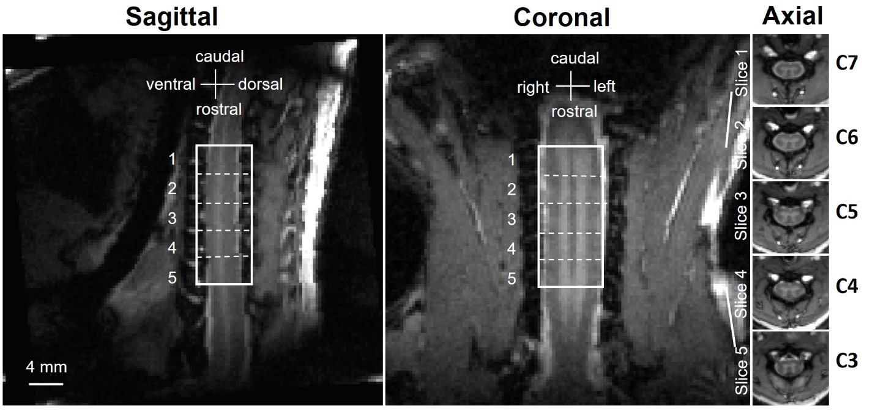
Supplementary Figure S1: The locations of five axial slices on the sagittal and coronal planes shown on anatomic Magnetization Transfer Contrast (MTC) image of the spinal-cord of one representative monkey. The five axial slices correspond to C3-C7 cervical segments.

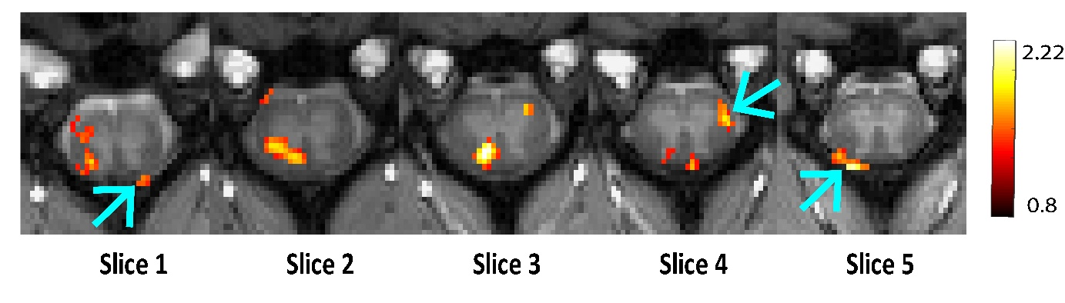
Supplementary Figure S2: Functional MRI activation map (thresholded at t = 0.8) on five axial MTC structural images of spinal cord after Innocuous tactile (8 Hz vibration) stimuli at digits D2 on left hand. The arrows show WM activated regions without any activity from neighboring GM region.

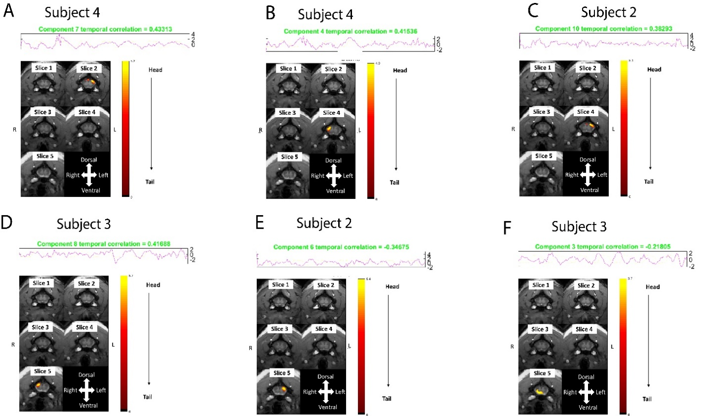
Supplementary Figure S3: ICA obtained components which showed high temporal correlation with stimulus from representative subjects(monkeys). The task involved Innocuous tactile (8 Hz vibration) stimuli at digits D2 on the left hand of squirrel monkeys. Each figure (A-F) shows the ICA time series associated with that component for a subject/monkey and its correlation with the stimulus paradigm at the top. Below is shown the fMRI activation or the spatial ICA map of that component (thresholded at Z=3) from group analysis and overlayed on anatomical images of spinal cord. Most components were positively correlated (A-D) while some components (E-F) showed negative correlation with the stimulus paradigm (baseline =30 secs followed by 7 cycles of 30 sec ‘ON’ and 30 sec “OFF’). Sometimes more than one component was found to have high correlation with the stimulus paradigm in individual monkeys e.g. A and B are both from Subject 4.

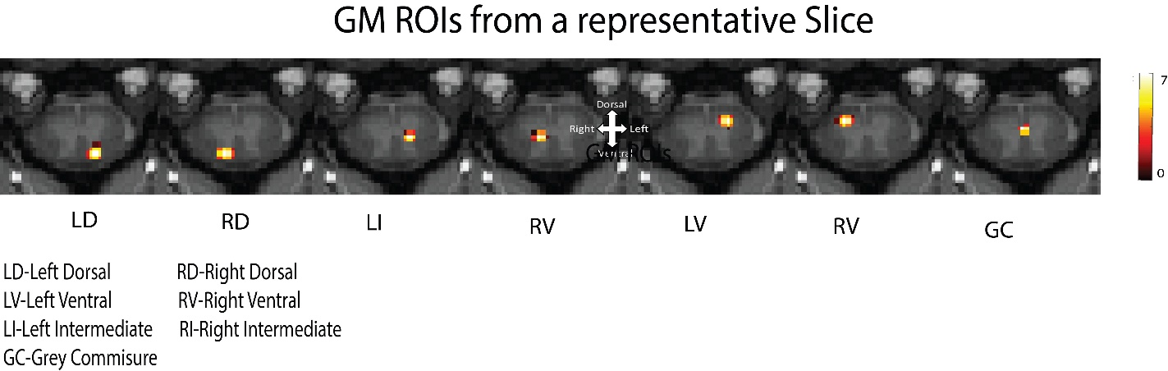
Supplementary Figure S4: Spatial representation of seven independent components of a representative slice/segment (Slice3/C5) from the GM of spinal cord of 22 monkeys (64 runs). The color bar represents Z-score which was thresholded at Z=4. Each column represents the spatial distribution of one independent component. These regions represent GM functional hubs.

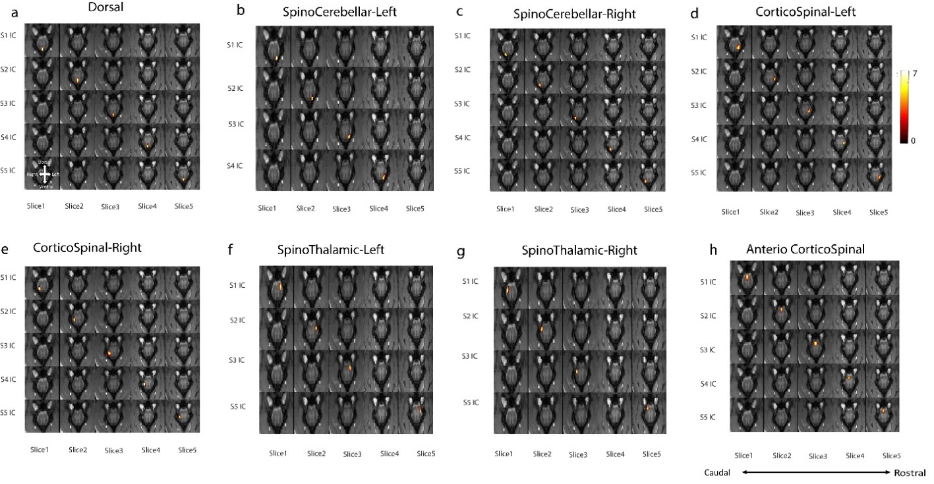
Supplementary Figure S5: Spatial maps of all the WM Independent Components from 5 slices overlayed on the anatomic (MTC) images (thresholded at Z-score > 4). The color bar represents Z-score. Note there was no component detected at Spino-Cerebellar Tract-Left in 5th slice, and Spino-Thalamic Tract left and right from 4th Slice.

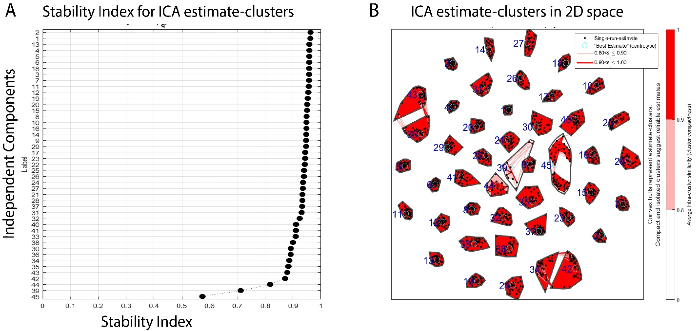
Supplementary Figure S6: Reliability results of Independent Components obtained. Fig (A) plots the stability index (0-1) of the components obtained through ICASSO method (GIFT software) using 30 iterations of running ICA. Fig (B) shows intra-cluster similarity of the estimates through projection on a 2D space. Compact and isolated clusters suggest reliable estimates. Note pair-wise similarity between estimates inside a cluster is omitted if the intra-cluster similarity is above 0.9.

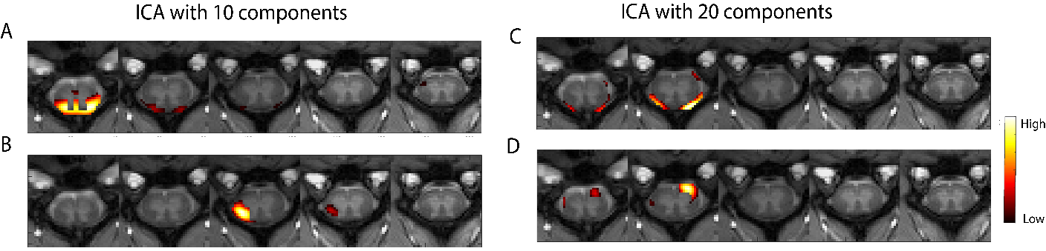
Supplementary Figure S7: Representative components from ICA decomposition with 10 (A &B) on the left and 20 (C&D) components on the right. Figure (A) and (C) is thresholded at Z= 0.5, (B) is thresholded at Z=1.5 and (D) is thresholded at Z=1.

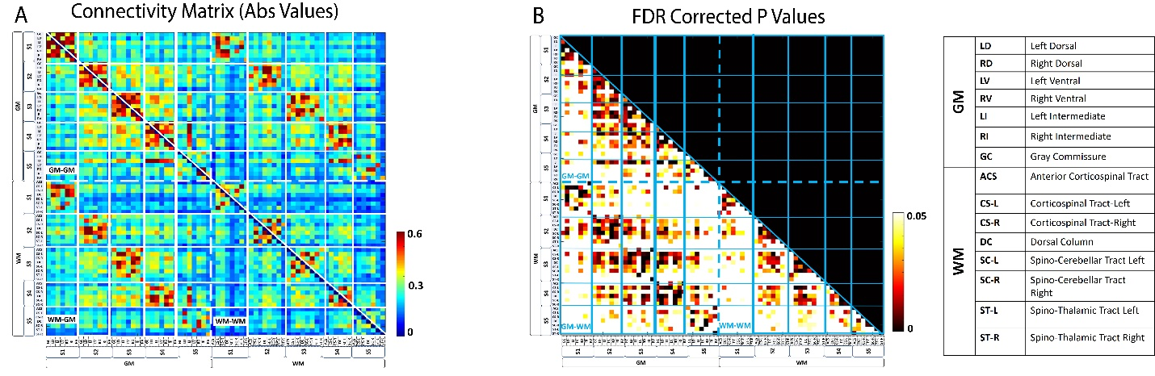
Supplementary Figure S8: Connectivity matrix between GM and WM ROIs from all slices averaged over 22 monkeys. (A) Correlation matrix (r values from Pearson correlation) obtained from the 35 GM ROIs and 37 WM ROIs covering Slice 1-Slice 5 (C3-C7 segment). The matrix is divided into four quadrants shown by dashed (--) white lines. Upper left quadrant represents GM-GM correlations, lower left represents WM-GM correlations and lower right represent WM-WM correlations. Solid white lines divide the matrix into separate slices. The diagonal lines divide the matrix into two mirror halves. The color bar represents r value. Abbreviated names of WM and GM ROIs are shown on the right (B) Significant correlations (p<0.05) after FDR correction are shown in the lower triangle of the matrix. The color bar represents p value. The matrix is divided into four quadrants shown by dashed blue lines. Upper half of the triangle represents GM-GM correlations, lower left represents WM-GM correlations and lower right represent WM-WM correlations. Solid blue lines divide the matrix into separate slices.

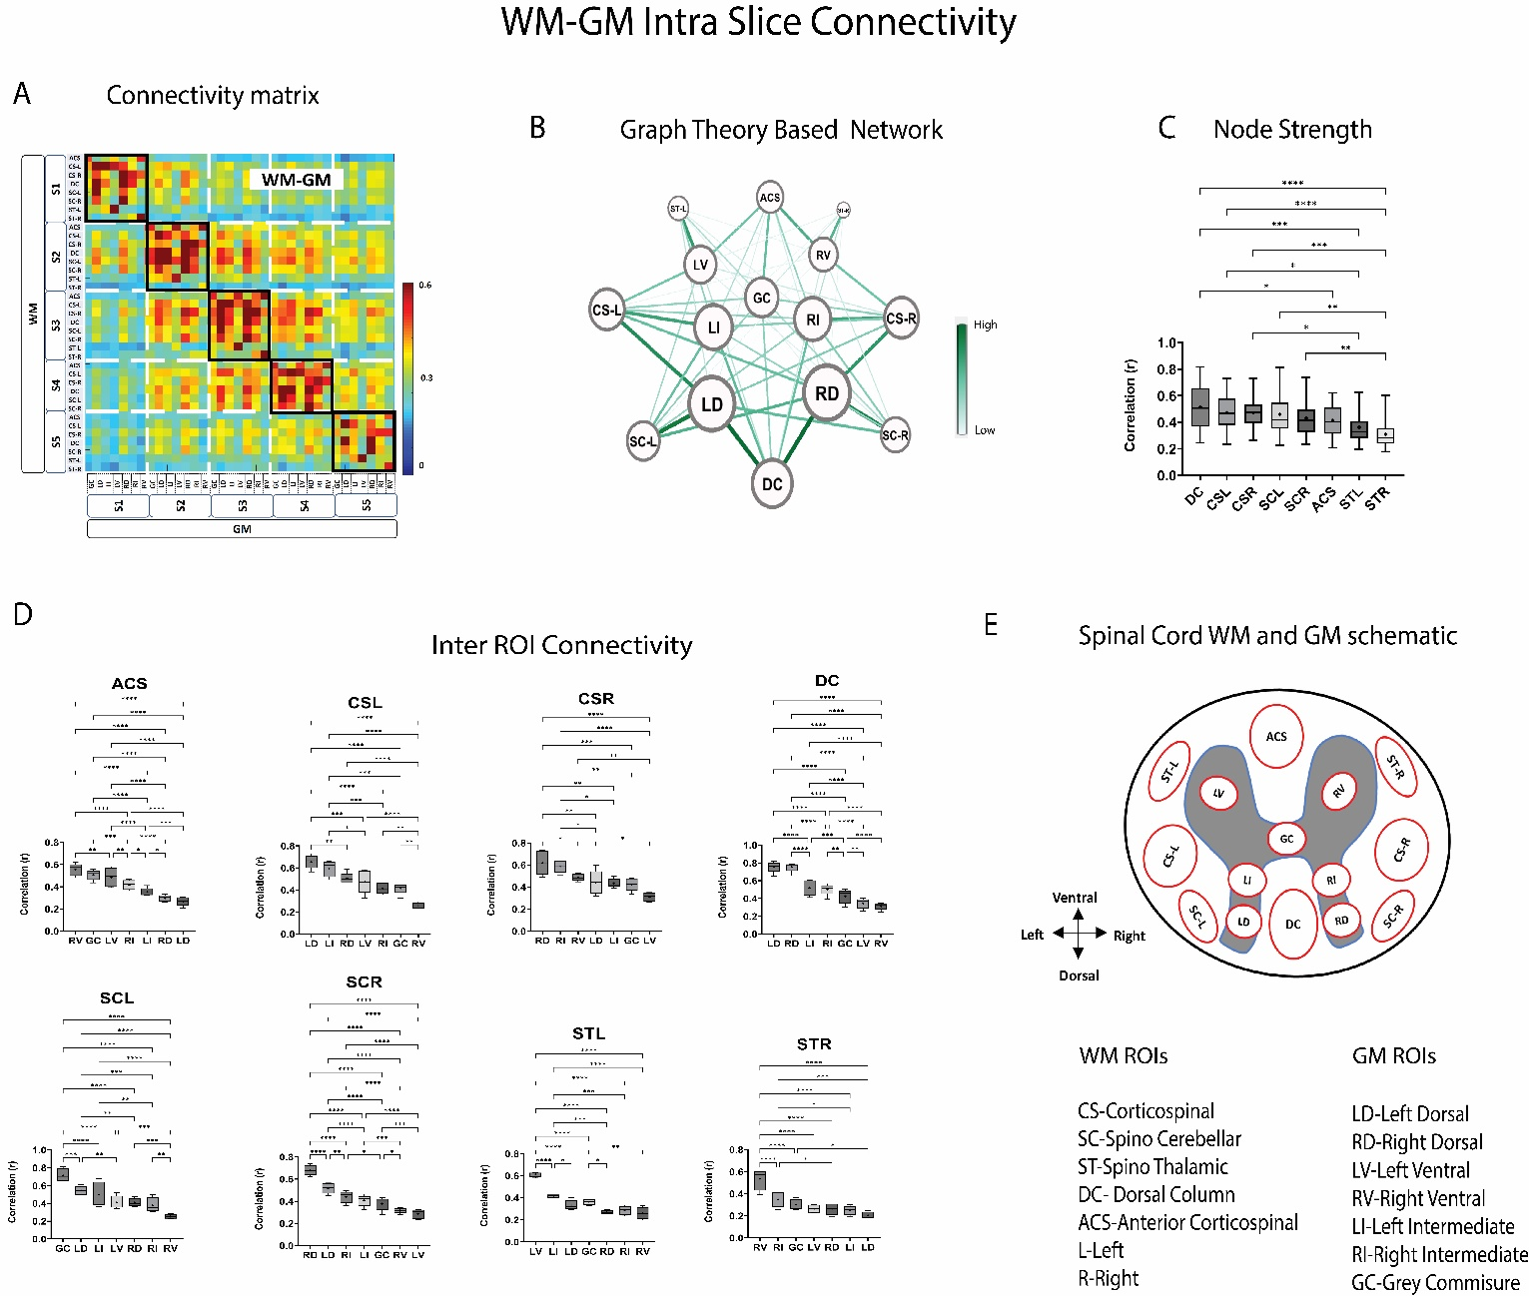
Supplementary Figure S9: Intra-slice/segment WM-GM connectivity averaged over 22 monkeys (64 runs). (A) Correlation matrix (r values from Pearson correlation) obtained from the 35 GM ROIs and 37 WM ROIs covering Slice 1-Slice5 (C3-C7 segment). Intra-slice correlations are arranged in the square boxes near the diagonal. The color bar represents r value. Abbreviated names of WM and GM ROIs are shown at the bottom right. Graphical representation of the intra-slice WM-GM correlations averaged over the 5 slices are shown in (B). Nodes represent the WM and GM ROIs while edges represent functional connectivity values between them. Nodes which have higher strength (sum of the weight of the links connected to each node) appear bigger while edges which have higher correlation (r) appear darker green. Labels of the nodes are proportional to the node strength. Boxplots depicting the weight of the links of each WM hub that make up its node strength are arranged in decreasing order and shown in (C). (D) Correlation value (r) of each WM hub with GM hubs from the 5 slices are shown using boxplots. Within box-plots, the dashed line represent median value of the distribution and the * represents mean value. Significantly different box-plots (One-Way ANOVA with Tukey’s multiple comparison test) are denoted by * (p<0.05) ,** (p<0.01) and *** (p<0.01). (E) is a spinal cord schematic showing the approximate location of the different WM and GM functional hubs. Note all the 8 WM hubs were not robustly observed from all segments.

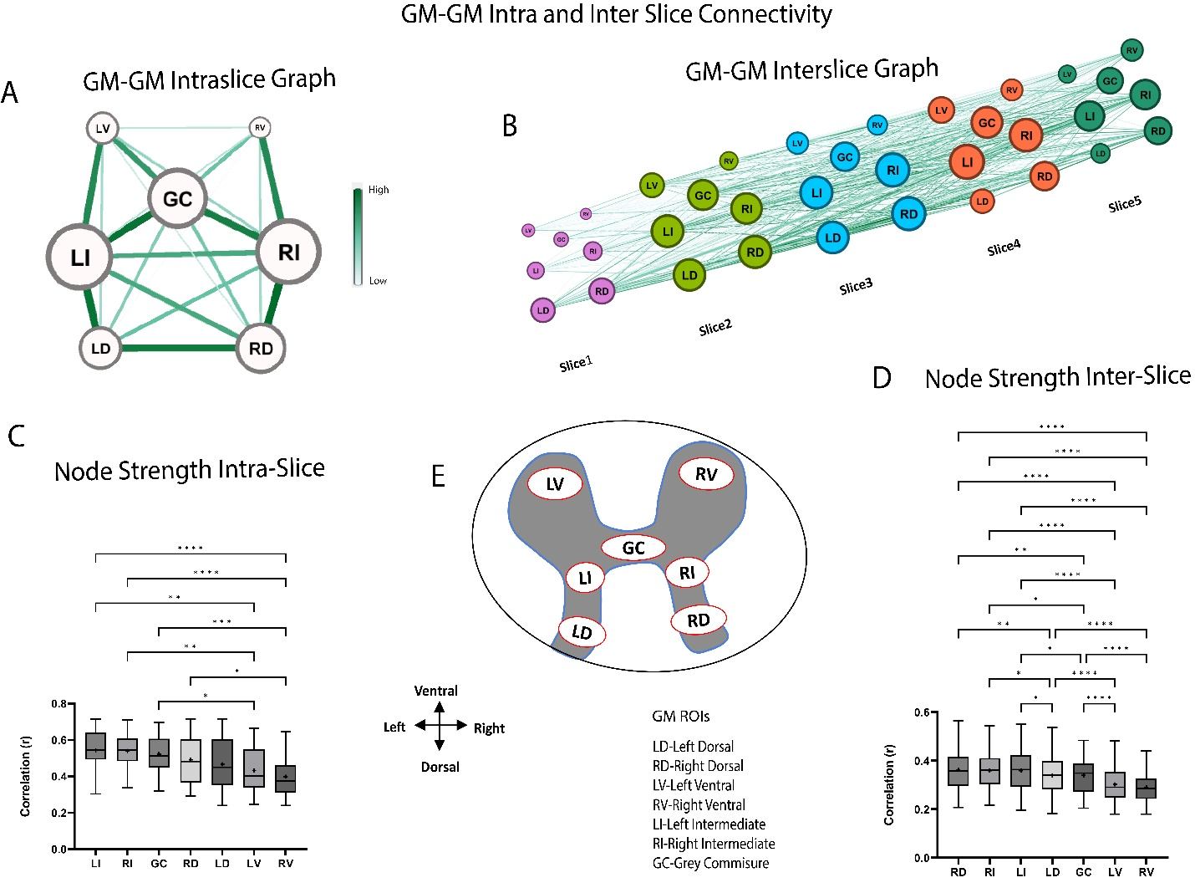
Supplementary Figure S10: Graph-Theory applications on GM-GM correlations within and between slices during resting state averaged over 22 monkeys (64 runs). Graphical representation of GM-GM correlations within a slice (A) and between slices (C) thresholded at r = 0.3 (B). Nodes represent GM ROIs while edges represent functional connectivity values between them. Nodes which have higher strength (sum of the weight of the links connected to each node) appear bigger while edges which have higher correlation (r) appear darker green. Boxplots depicting the weight of the links of each GM hub that make up its node strength (B) within a slice (averaged from all slices) and (D) between the slices are arranged in decreasing order of their strength. Within box-plots, the dashed line represent median value of the distribution and the * represents mean value. Significantly different box-plots (One-Way ANOVA with Tukey’s multiple comparison test) are denoted by * (p<0.05) ,** (p<0.01) and *** (p<0.01). (E) is a spinal cord schematic showing the approximate location of the different GM functional hubs.

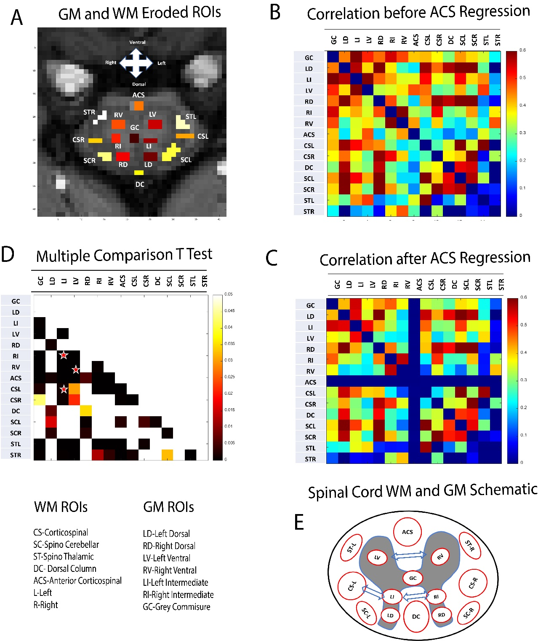
Supplementary Figure S11: Regression Analysis on WM-GM correlation of a representative slice (Slice 2) from 15 monkeys (35 runs). (A) shows the WM and GM masks used in this study obtained after erosion to avoid partial volume effects. (B) and (C) shows the correlation between WM and GM hubs before and after regression of a representative WM hub which is ACS in this case. (D) is the lower triangular matrix of significantly changed correlations (p<0.05) shown by non-white colored cells obtained by a T-Test with multiple comparison correction by Bonferroni-Dunn method. (E) is the spinal cord schematic showing the location of the WM and GM hubs. The significantly changed correlations (due to regression of fMRI time course from ACS) which have been focused on in this study are LV-RV, CSL-LI and LI-RI and they have been shown by red * in (D) and blue arrows in (E).

