Supplementary Information
Figure S1 The temperature variation (daily mean) during the experimental period (2017-2020).
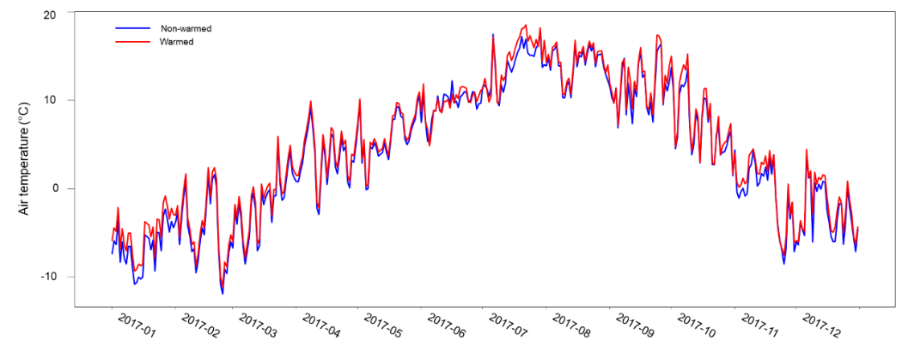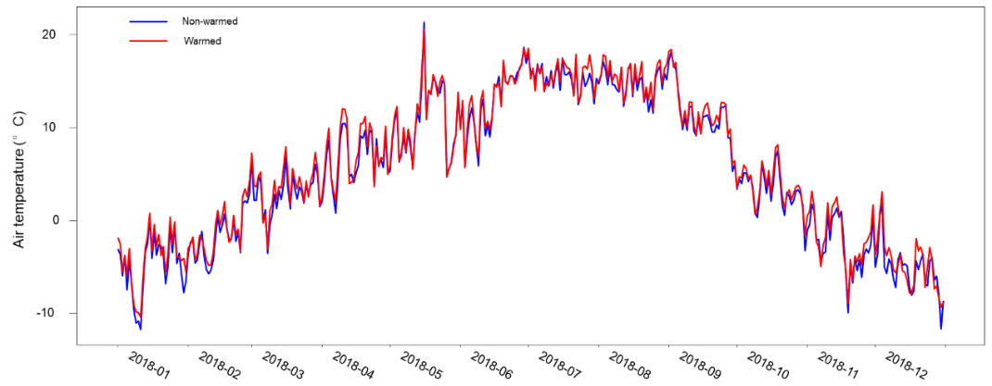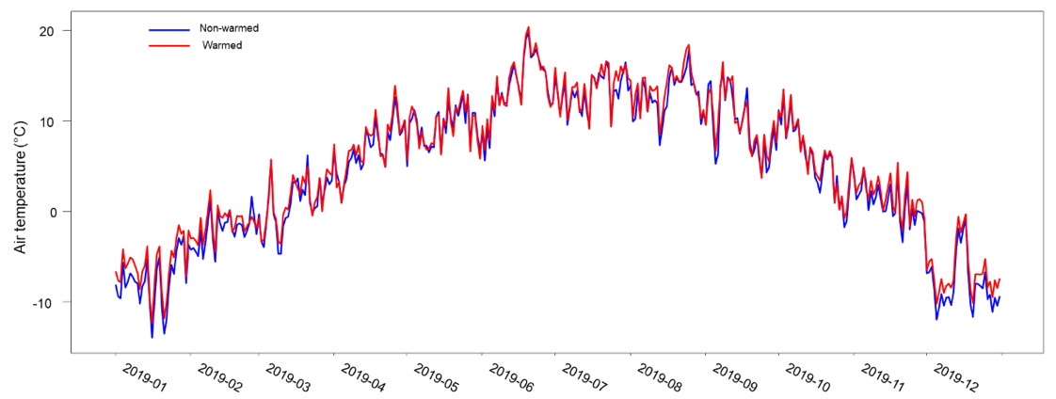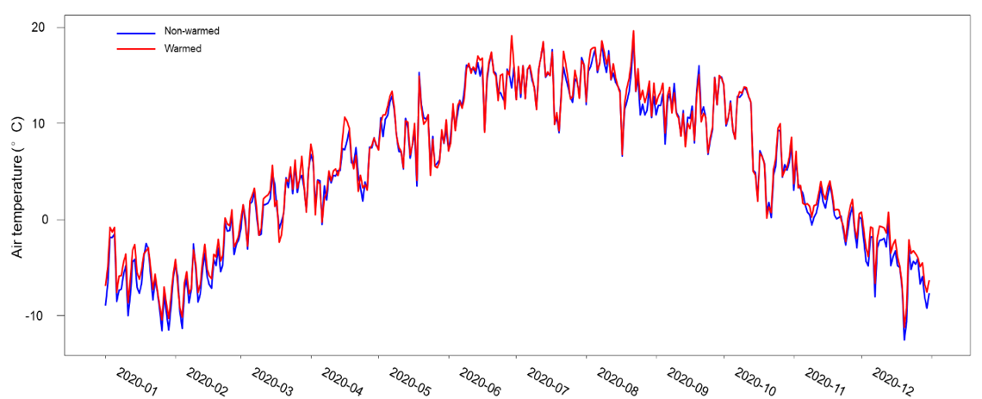

Figure S2 The soil moisture (-5 cm) in the August (the driest month each year) of 2017 to 2019 (data deficiency in 2020 because of the logger malfunctioning).
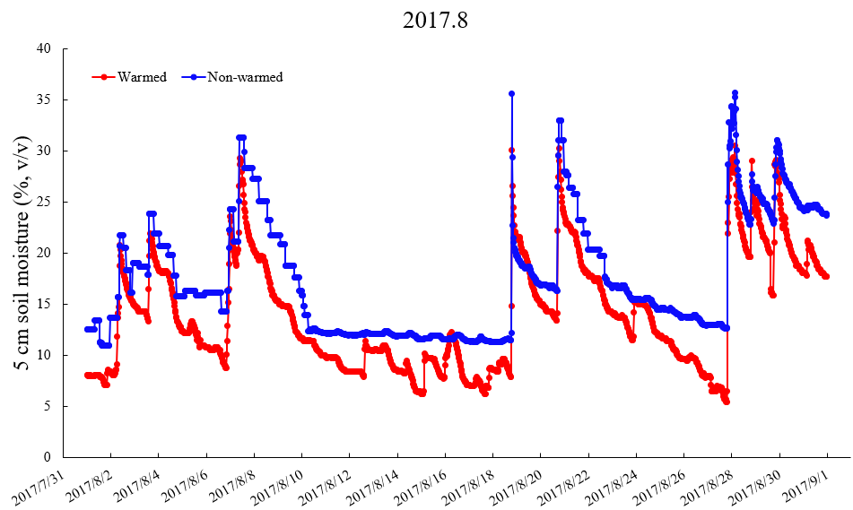
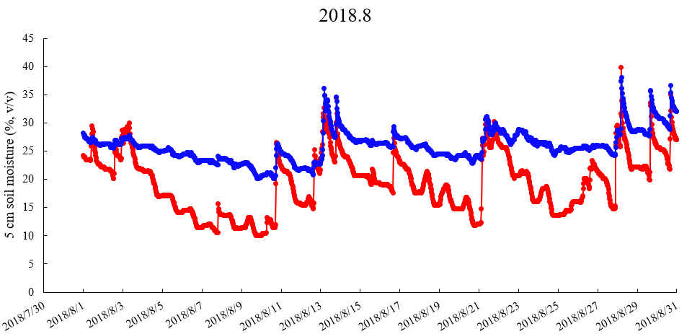
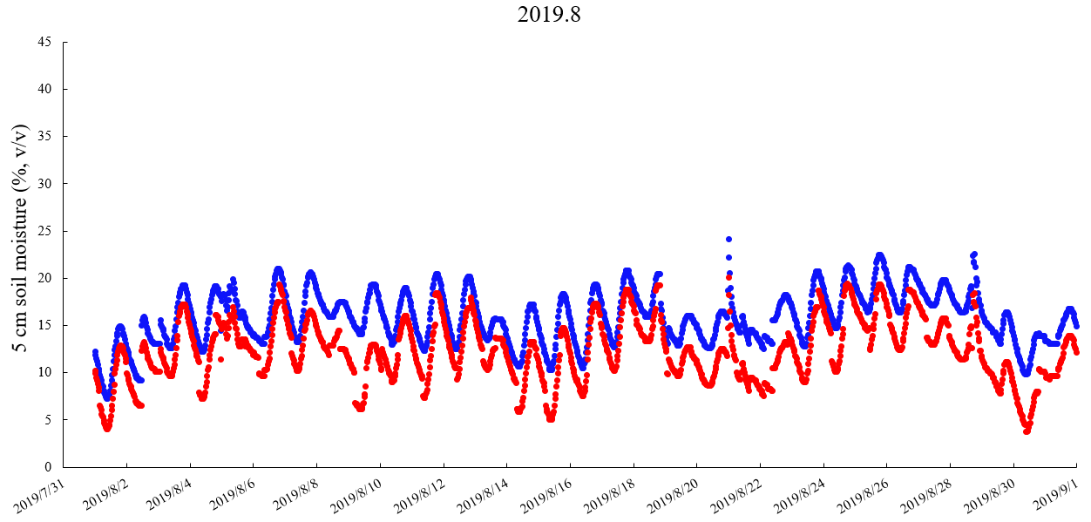

Figure S3 The relationship between the total number of observed prey items of two dominant spider species and the total number of potential prey items captured by sweep nets.
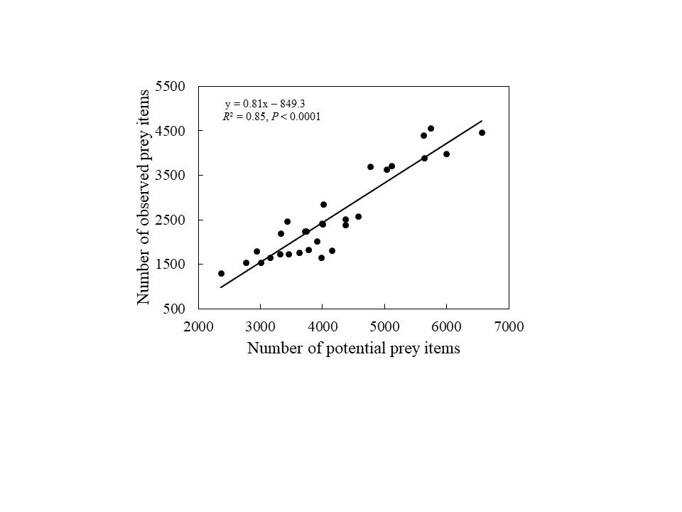

Figure S4 Schematic representation of the measurements of web diameter and mesh size of (A) Aculepeira luosangensis and (B) Microlinyphia pusilla. Web diameter is the mean length of red lines, and mesh size is the mean area of the blue polygon.
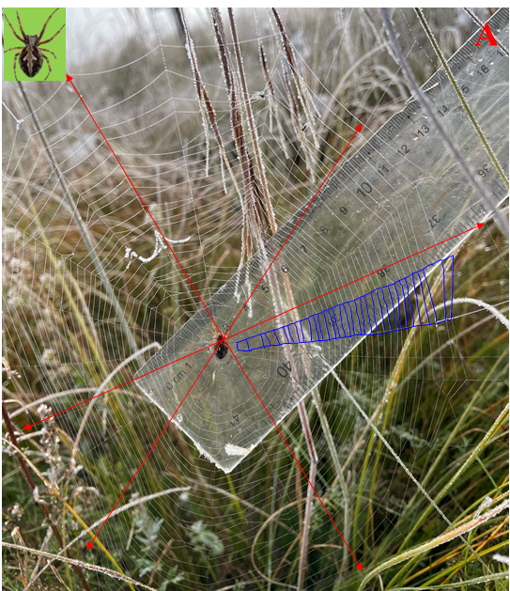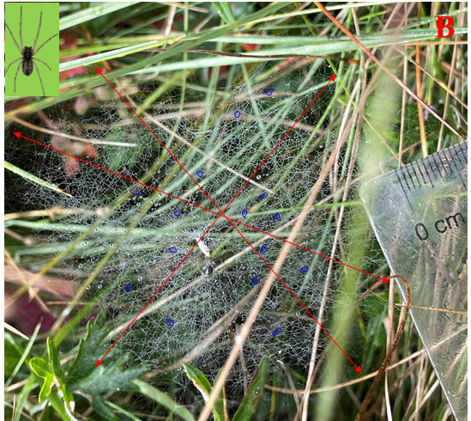

Figure S5 The potential relationships between different variables. (A) The relative biomass of grasses and the weighted average body length of prey, (B) The relative biomass of grasses and abundance of shared prey (body length ranging between 2 and 9 mm), (C) The abundance of shared prey and mesh size of large spider, (D) The abundance of shared prey and web diameter of large spider, (E) The abundance of shared prey and mesh size of small spider, (F) The abundance of shared prey and web diameter of small spider.
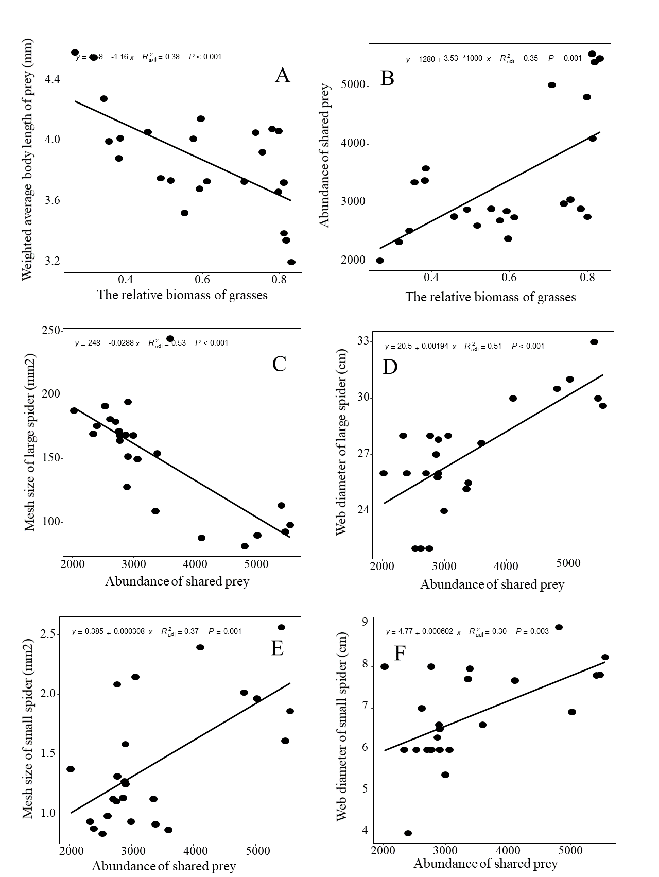

Figure S6 Aboveground biomass (A), relative biomass of Gramineae (B), forbs (C) and Cyperaceae (D) in both non-warmed and warmed chambers from 2017 to 2020. The asterisk represents significance at α = 0.05 level. The bar shows the standard error. The data from 2017 to 2018 were published in Frontier in Ecology and Evolution (Hu et al. 2021). The impact of warming on relative biomass of sedges was analyzed using simple linear model because the Linear mixed model is singular.
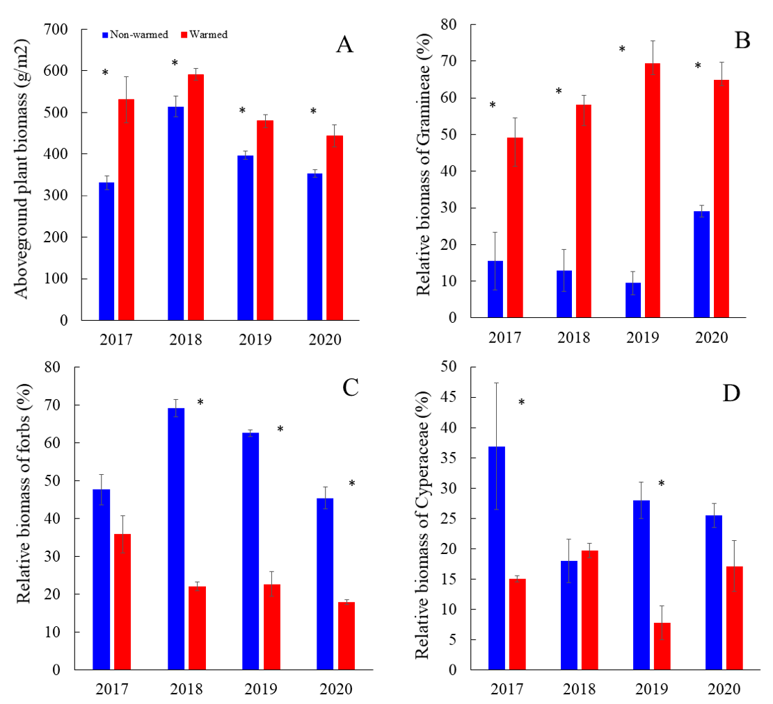
Hu X, Zhou W, Li X, Niklas KJ and Sun S (2021) Changes in Community Composition Induced by Experimental Warming in an Alpine Meadow: Beyond Plant Functional Type. Front. Ecol. Evol. 9:569422.doi: 10.3389/fevo.2021.569422

Figure S7 Prey biomass (A), abundance (B), and weighted average of prey body length (C) for two dominant spider species (large spider Aculepeira luosangensis and small spider Microlinyphia pusilla) combined in non-warmed (blue dash-line) and warmed (red solid line) open-top chambers from 2017 to 2020. The asterisks represent significance at α = 0.05 level. The bar shows the standard error.
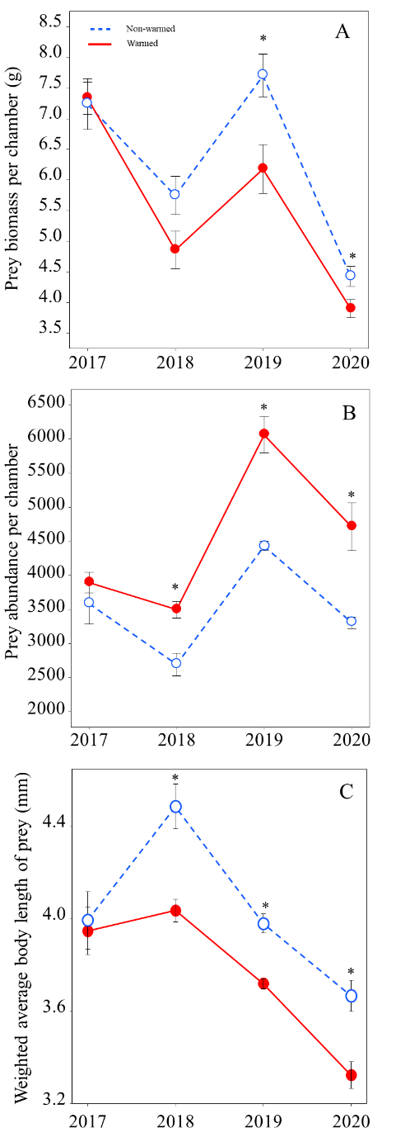

Figure S8 (A) The foraging success of the two dominant spider species large spider Aculepeira luosangensis and small spider Microlinyphia pusilla in non-warmed (blue) and warmed open-top chambers (red) in 2020. The asterisk represents significance at α = 0.05 level. The bar shows the standard error. A minimum of 20 webs (depending on their abundance) were randomly marked using stake flags for each spider species in each experimental chamber, and the foraging success was calculated as the number of webs having feeding spiders divided by the total number of webs for both spider species in each chamber to subsequently determine prey community composition. (B) The weighted body length of observed prey to two spider species (large spider Aculepeira luosangensis and small spider Microlinyphia pusilla) in non-warmed (blue) and warmed open-top chambers (red) in 2020. The asterisk represents significance at α = 0.05 level. The bar shows the standard error.
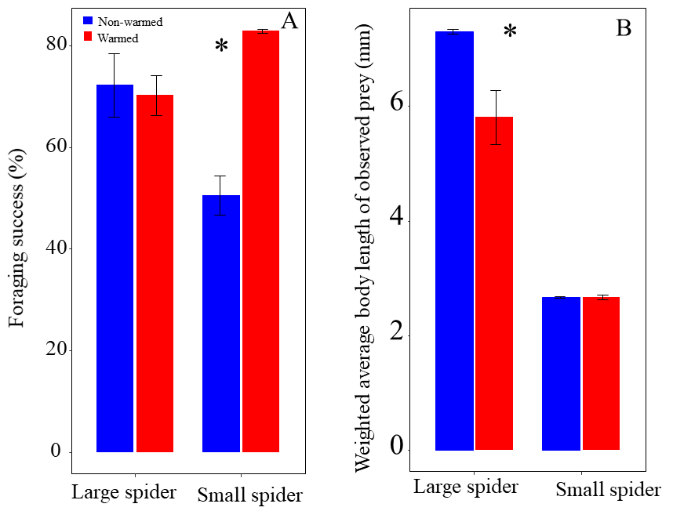

Figure S9 (A) The observed prey to spiders feeding on grasses and forbs, which is shown in descending order of body length from left to right. The herbivores species denoted by the Arabic numbers is listed in the Table S2. The average body size of grass-feeding herbivores is 5.22 mm (N=10), and the average body size of forb-feeding herbivores is 8.49 mm (N=8). The prey species denoted by the Arabic numerals are listed in the Supplementary Table S2.
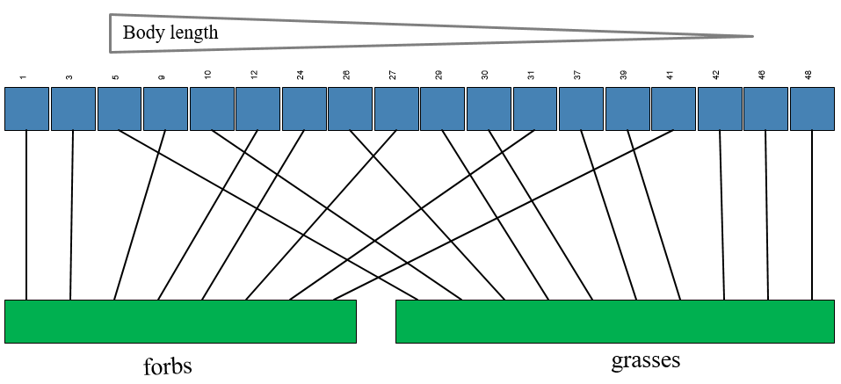

Figure S10 Linear Models were used to predict the spider abundance. The observed (white) and predicted (black) abundance of large spider Aculepeira luosangensis and small spider Microlinyphia pusilla. The bar shows the standard error. The asterisks represent significance at P = 0.1. The spider abundance was set as the dependent variable, abundance of shared prey, mesh size, web diameter, and their prey biomass were set as independent variables. The analyses were performed in R 4.1.2 (R Core Team 2021). The “predict” function was used to predict the change of spider abundance when the web properties were unchanged, and the prey body size changed as observed. The predicted formula of Aculepeira luosangensis is abundance = -0.00835* abundance of shared prey- 0.078* mesh size - 0.48* web diameter + 0.0057* prey biomass + 55.29 (R² = 0.74, P < 0.001). The predicted formula of Microlinyphia pusilla is abundance = 0.168* abundance of shared prey + 97.18* mesh size - 23.97* web diameter – 0.17* prey biomass + 401.17 (R² = 0.84, P < 0.001). The predicted population of both spider species from 2018 to 2022 is shown in Figure S7. The predicted abundance in 2020 of Aculepeira luosangensis is 8.57, 71% of the observed (12.3). The predicted abundance in 2020 of Microlinyphia pusilla is 652.35, 79% of the observed (829).
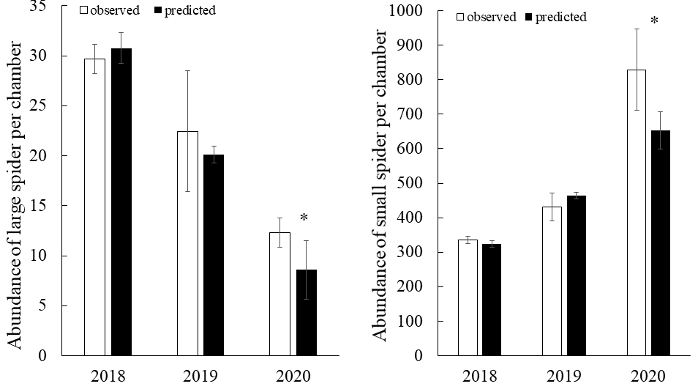

Table S1 The monthly mean, minimum and maximum air temperature both in non-warmed and warmed chambers from 2017 to 2020.
 |  | Mean air temperature |  | Minimum air temperature |  | Maximum air temperature
year | month | Non-warmed | Warmed | Non-warmed | Warmed | Non-warmed | Warmed
2017 | 1 | -6.59 | -5.13 | -10.80 | -9.34 | -2.30 | -0.84
2017 | 2 | -4.76 | -3.99 | -11.90 | -11.13 | 1.60 | 2.37
2017 | 3 | -1.87 | -1.16 | -8.50 | -7.80 | 5.20 | 5.90
2017 | 4 | 3.35 | 4.04 | -2.90 | -2.21 | 9.20 | 9.89
2017 | 5 | 5.87 | 6.31 | -0.10 | 0.34 | 10.50 | 10.94
2017 | 6 | 9.51 | 9.66 | 5.20 | 4.85 | 12.20 | 11.85
2017 | 7 | 13.91 | 14.77 | 9.39 | 9.73 | 17.79 | 18.53
2017 | 8 | 14.14 | 14.50 | 10.30 | 10.68 | 16.40 | 16.78
2017 | 9 | 11.39 | 12.12 | 6.90 | 7.17 | 16.37 | 17.37
2017 | 10 | 7.24 | 7.94 | 1.49 | 1.67 | 13.74 | 15.22
2017 | 11 | -0.54 | 0.24 | -8.50 | -7.55 | 4.38 | 4.49
2017 | 12 | -2.79 | -2.01 | -7.10 | -6.29 | 3.65 | 4.42
2018 | 1 | -4.99 | -4.13 | -11.76 | -10.45 | 0.23 | 0.76
2018 | 2 | -1.80 | -1.25 | -5.76 | -4.86 | 2.90 | 4.26
2018 | 3 | 2.87 | 3.61 | -3.55 | -3.17 | 6.79 | 7.92
2018 | 4 | 6.60 | 7.28 | 0.79 | 2.00 | 10.49 | 12.03
2018 | 5 | 10.72 | 10.92 | 4.93 | 4.67 | 21.36 | 20.66
2018 | 6 | 12.81 | 13.05 | 5.82 | 5.67 | 18.68 | 18.54
2018 | 7 | 15.37 | 15.71 | 12.49 | 12.72 | 17.87 | 18.55
2018 | 8 | 14.78 | 15.39 | 11.57 | 11.93 | 17.14 | 17.84
2018 | 9 | 11.29 | 11.77 | 5.29 | 6.09 | 18.22 | 18.42
2018 | 10 | 3.26 | 3.76 | -3.26 | -1.62 | 7.52 | 8.14
2018 | 11 | -2.44 | -1.76 | -9.94 | -8.94 | 1.73 | 3.16
2018 | 12 | -5.33 | -4.76 | -11.70 | -9.39 | 1.73 | 3.08
2019 | 1 | -7.64 | -6.14 | -13.94 | -12.38 | -2.68 | -1.52
2019 | 2 | -2.09 | -1.39 | -5.54 | -4.50 | 1.66 | 2.36
2019 | 3 | 0.86 | 1.27 | -4.66 | -3.59 | 6.22 | 5.75
2019 | 4 | 6.91 | 7.41 | 1.00 | 0.91 | 12.65 | 13.90
2019 | 5 | 9.40 | 9.45 | 5.03 | 5.69 | 13.06 | 13.64
2019 | 6 | 13.76 | 14.00 | 5.64 | 6.82 | 19.80 | 20.39
2019 | 7 | 13.27 | 13.77 | 9.35 | 9.13 | 16.65 | 16.60
2019 | 8 | 12.85 | 13.66 | 7.32 | 8.49 | 17.88 | 18.43
2019 | 9 | 9.56 | 9.91 | 3.77 | 3.70 | 15.52 | 16.53
2019 | 10 | 5.85 | 6.17 | -1.72 | -0.77 | 12.83 | 13.52
2019 | 11 | 0.98 | 1.81 | -3.39 | -2.03 | 4.85 | 5.39
2019 | 12 | -8.00 | -6.67 | -11.93 | -10.20 | -0.81 | -0.30
2020 | 1 | -6.60 | -5.59 | -11.55 | -10.40 | -1.49 | -0.78
2020 | 2 | -5.03 | -4.38 | -11.34 | -10.12 | 0.49 | 1.03
2020 | 3 | 1.93 | 2.17 | -3.06 | -2.74 | 5.71 | 6.59
2020 | 4 | 5.16 | 5.44 | -0.50 | -0.24 | 9.33 | 10.66
2020 | 5 | 8.93 | 9.08 | 3.50 | 4.09 | 15.32 | 14.90
2020 | 6 | 13.70 | 14.04 | 7.21 | 7.15 | 17.29 | 19.11
2020 | 7 | 14.26 | 14.43 | 9.06 | 9.23 | 18.35 | 18.50
2020 | 8 | 14.10 | 14.77 | 6.62 | 6.77 | 19.08 | 19.62
2020 | 9 | 11.37 | 11.38 | 6.80 | 6.96 | 16.02 | 15.08
2020 | 10 | 7.99 | 8.08 | 0.21 | 0.16 | 13.96 | 14.04
2020 | 11 | 1.10 | 1.68 | -2.94 | -2.26 | 6.19 | 7.10
2020 | 12 | -4.70 | -3.54 | -12.54 | -11.17 | 0.08 | 0.79

Table S2 The observed prey species of the two spider species.
No. | Order | Latin Names | body length (mm)
1 | Lepidoptera | Epirrhoe pupillata | 15.959
2 | Diptera | Antrops sp. | 14.615
3 | Lepidoptera | Chrysoteuchia culmella | 13.485
4 | Diptera | Eristalis tenax | 13.45
5 | Lepidoptera | Gynaephora alpherakii | 12.353
6 | Diptera | Nephrotoma ferruginea | 11.834
7 | Diptera | Phyllomya gymnops | 11.668
8 | Orthoptera | Altichorthippus fallax | 10.507
9 | Lepidoptera | Schinia cumatilis | 10.344
10 | Hemiptera | Alydus calcaratus | 9.914
11 | Diptera | Cylindromyia brassicaria | 9.813
12 | Lepidoptera | Celypha flavipalpana | 9.037
13 | Diptera | Calliphora vomitoria | 8.181
14 | Hemiptera | Tettigella viridis | 8
15 | Diptera | Blaesoxipha sp1. | 7.951
16 | Diptera | Sphaerophoria scripa | 7.81
17 | Diptera | Peteina hyperdiscalis | 7.379
18 | Hymenoptera | Ctenopelmatinae sp. | 6.543
19 | Diptera | Portevinia dispar | 6.534
20 | Diptera | Rhagionidae sp. | 6.429
21 | Diptera | Chrysotoxum biguttatum | 5.997
22 | Diptera | Heteronychia sp. | 5.973
23 | Araneae | Aculepeira luosangensis ♂ | 5.943
24 | Lepidoptera | Coleophora benestrigatella | 5.899
25 | Diptera | Scathophaga stercoraria | 5.717
26 | Hemiptera | Neophilaenus sp1. | 5.665
27 | Hemiptera | Atrachya menetriesi | 5.632
28 | Hemiptera | Nabis sp. | 5.49
29 | Hemiptera | Notostira elongata | 5.135
30 | Diptera | Meromyza brevifasciata | 5.067
31 | Lepidoptera | Ochsenheimeria urella | 4.82
32 | Hymenoptera | Ctenopelmatinae sp2. | 4.513
33 | Hemiptera | Anoscopus sp. | 4.316
34 | Coleoptera | Adalia bipunctata | 4.168
35 | Diptera | Helina latitarsis | 4.117
36 | Diptera | Botanophila sp. | 3.653
37 | Hemiptera | Neophilaenus sp. | 3.623
38 | Diptera | Toxonevra saltuum | 3.604
39 | Hemiptera | Craspedolepta sp. | 3.444
40 | Diptera | Drymeia hamata | 3.185
41 | Coleoptera | Phyllotreta striolata | 2.779
42 | Diptera | Chloropidae sp. | 2.389
43 | Diptera | Cratyna sp. | 2.378
44 | Diptera | Coenosia alpicola | 2.349
45 | Hemiptera | Miridae sp. | 2.333
46 | Hemiptera | Psyllia sp. | 2.324
47 | Diptera | Psilopa sp. | 2.317
48 | Hemiptera | Atheroides sp. | 2.255
49 | Collembola | Folsomia sp. | 2.183
50 | Diptera | Chironomus novosibiricus | 1.482

