Supplementary Material

Supplementary Figures
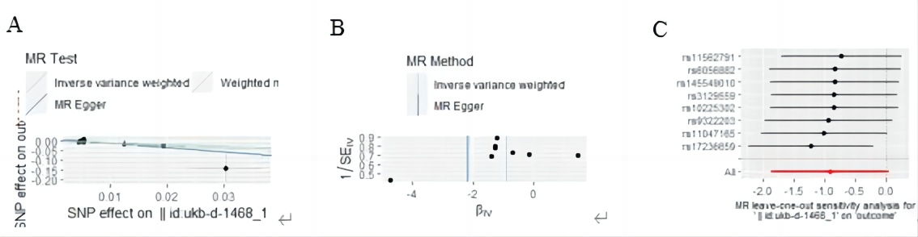
Supplementary Figure 1. Mendelian randomization study of the effects of Bran cereal on HTN. (A) scatter plot, (B) funnel plot, (C) leave-one-out sensitivity analysis.
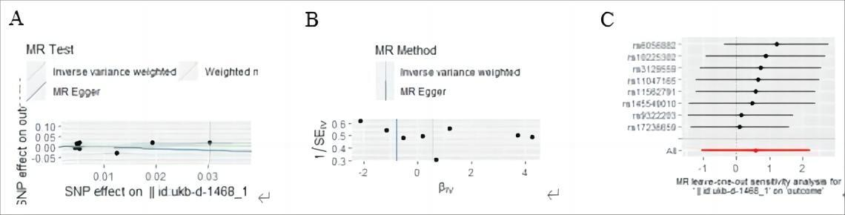
Supplementary Figure 2. Mendelian randomization study of the effects of Bran cereal on CHD. (A) scatter plot, (B) funnel plot, (C) leave-one-out sensitivity analysis.
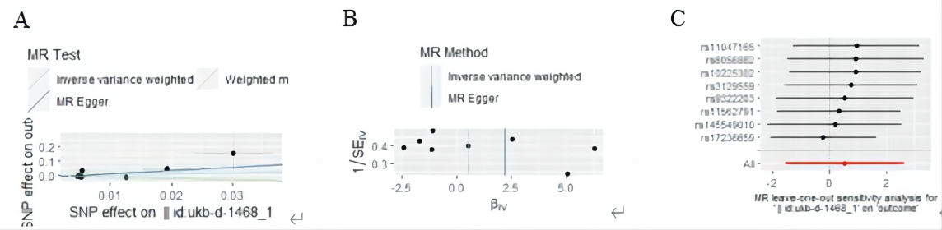
Supplementary Figure 3. Mendelian randomization study of the effects of Bran cereal on MI. (A) scatter plot, (B) funnel plot, (C) leave-one-out sensitivity analysis.

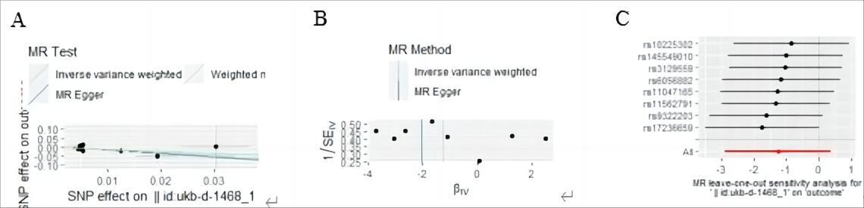
Supplementary Figure 4. Mendelian randomization study of the effects of Bran cereal on AF. (A) scatter plot, (B) funnel plot, (C) leave-one-out sensitivity analysis.
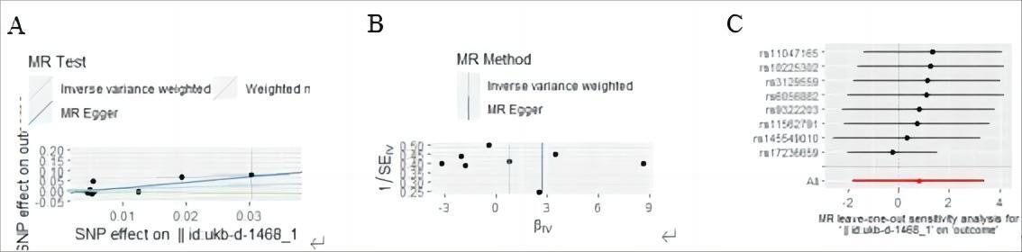
Supplementary Figure 5. Mendelian randomization study of the effects of Bran cereal on HF. (A) scatter plot, (B) funnel plot, (C) leave-one-out sensitivity analysis.
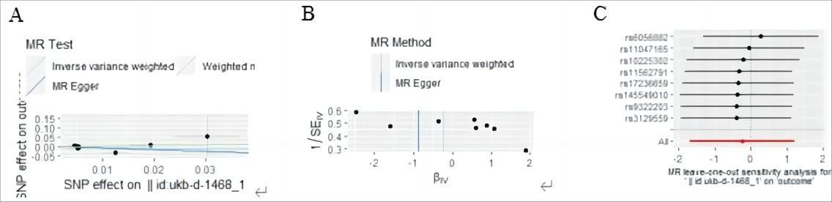
Supplementary Figure 6. Mendelian randomization study of the effects of Bran cereal on Stroke. (A) scatter plot, (B) funnel plot, (C) leave-one-out sensitivity analysis.
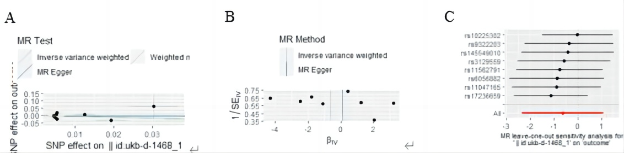
Supplementary Figure 7. Mendelian randomization study of the effects of Bran cereal on T2DM. (A) scatter plot, (B) funnel plot, (C) leave-one-out sensitivity analysis.
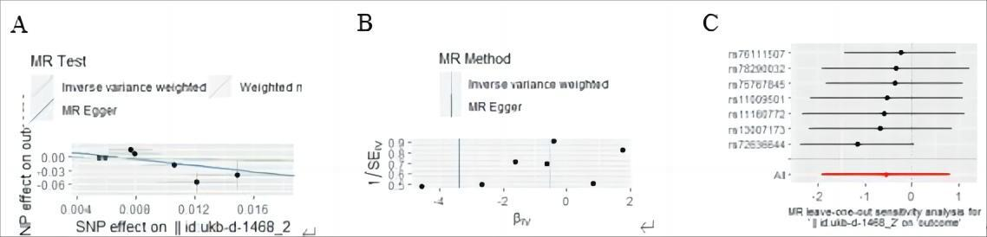
Supplementary Figure 8. Mendelian randomization study of the effects of Biscuit cereal on HTN. (A) scatter plot, (B) funnel plot, (C) leave-one-out sensitivity analysis
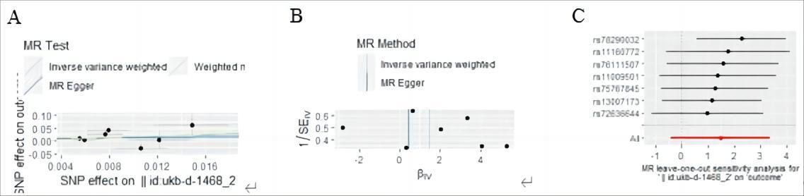
Supplementary Figure 9. Mendelian randomization study of the effects of Biscuit cereal on CHD. (A) scatter plot, (B) funnel plot, (C) leave-one-out sensitivity analysis.
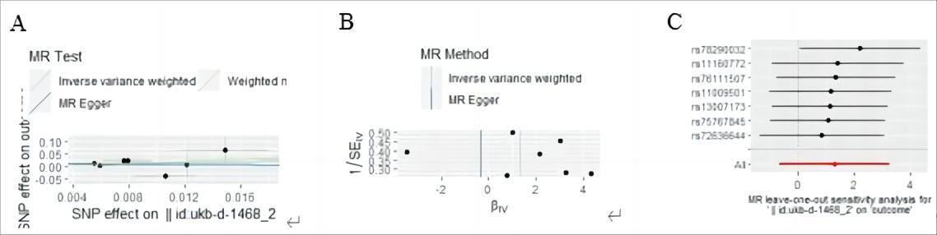
Supplementary Figure 10. Mendelian randomization study of the effects of Biscuit cereal on MI. (A) scatter plot, (B) funnel plot, (C) leave-one-out sensitivity analysis.
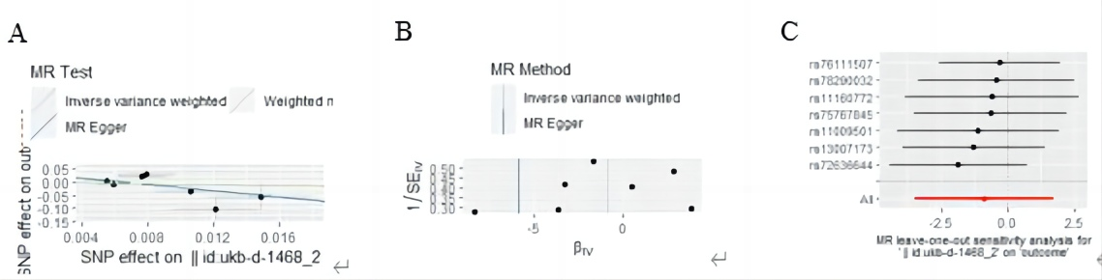
Supplementary Figure 11. Mendelian randomization study of the effects of Biscuit cereal on AF. (A) scatter plot, (B) funnel plot, (C) leave-one-out sensitivity analysis.

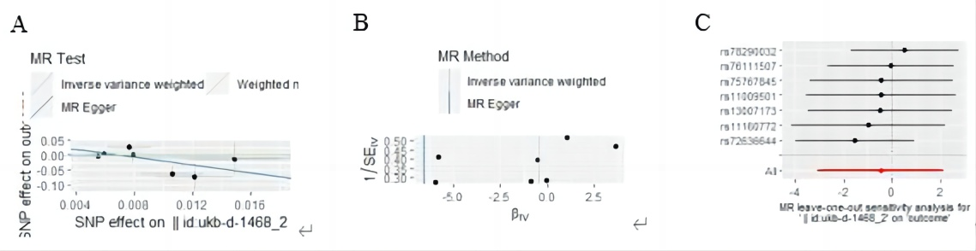
Supplementary Figure 12. Mendelian randomization study of the effects of Biscuit cereal on HF. (A) scatter plot, (B) funnel plot, (C) leave-one-out sensitivity analysis.
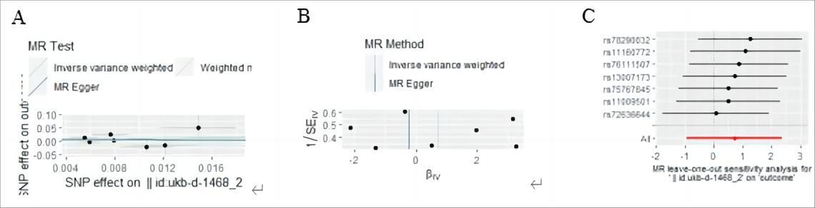
Supplementary Figure 13. Mendelian randomization study of the effects of Biscuit cereal on Stroke. (A) scatter plot, (B) funnel plot, (C) leave-one-out sensitivity analysis.
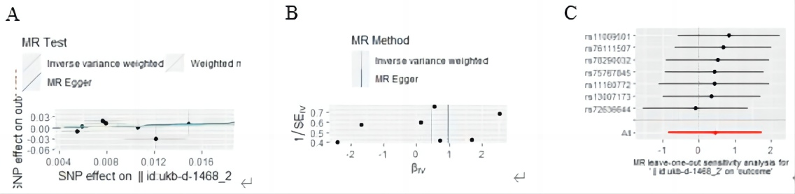
Supplementary Figure 14. Mendelian randomization study of the effects of Oat cereal on T2DM. (A) scatter plot, (B) funnel plot, (C) leave-one-out sensitivity analysis.
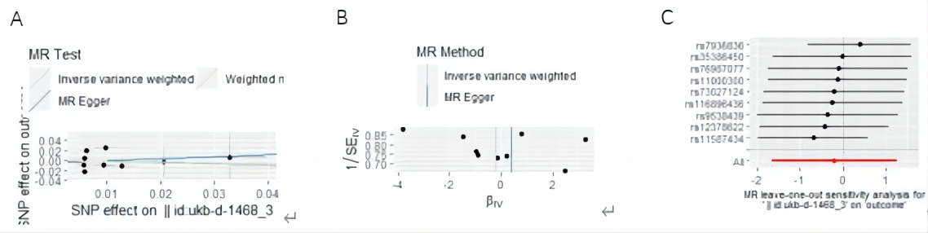
Supplementary Figure 15. Mendelian randomization study of the effects of Biscuit cereal on HTN. (A) scatter plot, (B) funnel plot, (C) leave-one-out sensitivity analysis
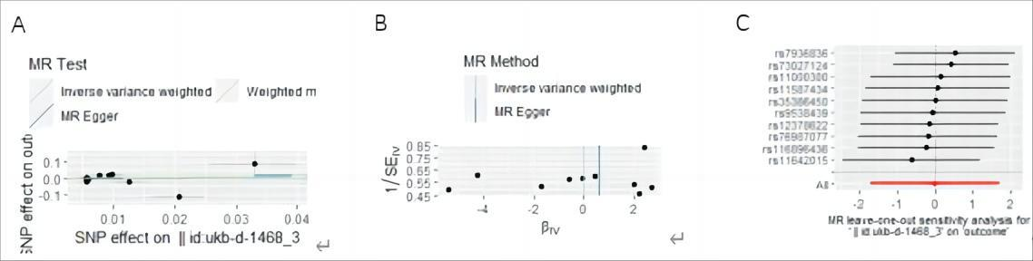
Supplementary Figure 16. Mendelian randomization study of the effects of Oat cereal on CHD. (A) scatter plot, (B) funnel plot, (C) leave-one-out sensitivity analysis
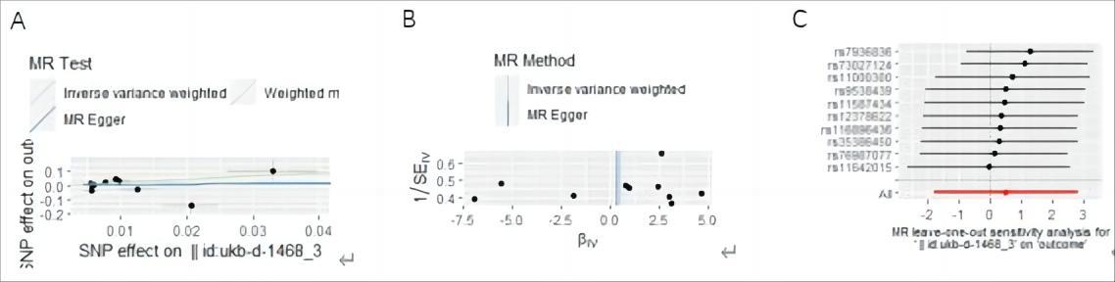
Supplementary Figure 17. Mendelian randomization study of the effects of Oat cereal on MI. (A) scatter plot, (B) funnel plot, (C) leave-one-out sensitivity analysis.
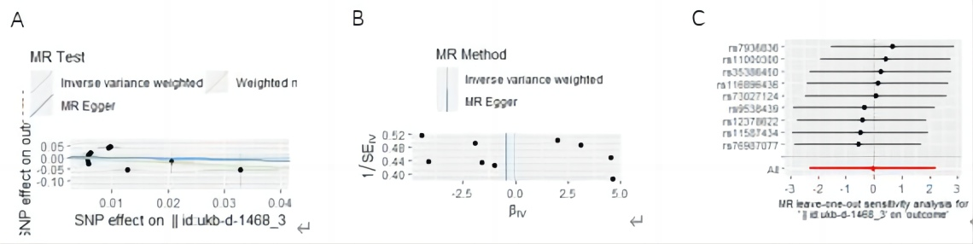
Supplementary Figure 18. Mendelian randomization study of the effects of Oat cereal on AF. (A) scatter plot, (B) funnel plot, (C) leave-one-out sensitivity analysis.
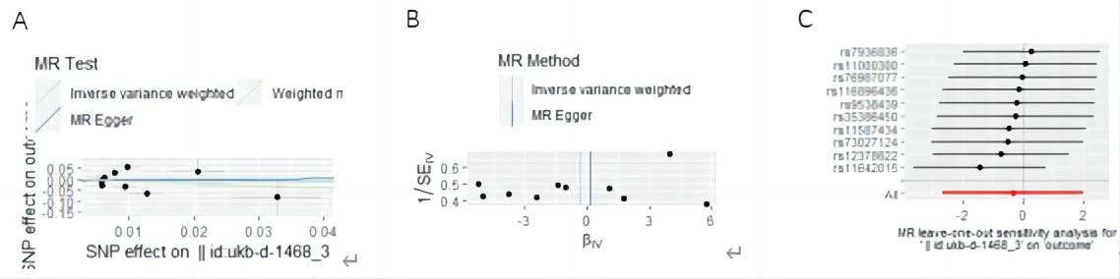
Supplementary Figure 19. Mendelian randomization study of the effects of Oat cereal on HF. (A) scatter plot, (B) funnel plot, (C) leave-one-out sensitivity analysis.

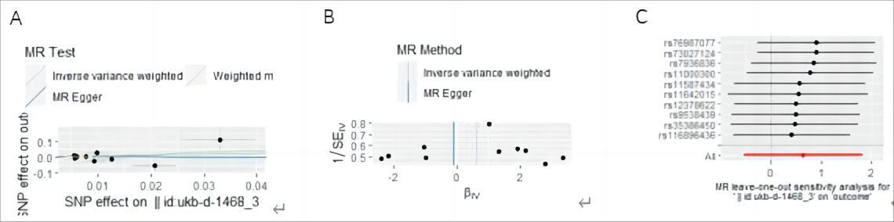
Supplementary Figure 20. Mendelian randomization study of the effects of Oat cereal on Stroke. (A) scatter plot, (B) funnel plot, (C) leave-one-out sensitivity analysis.
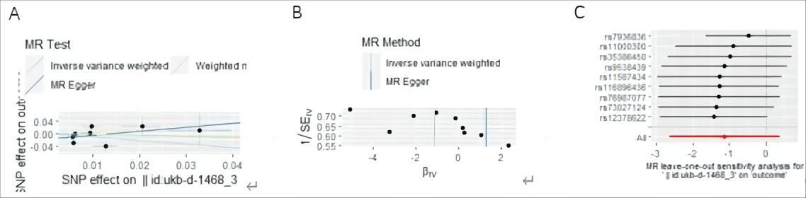
Supplementary Figure 21. Mendelian randomization study of the effects of Oat cereal on T2DM. (A) scatter plot, (B) funnel plot, (C) leave-one-out sensitivity analysis.
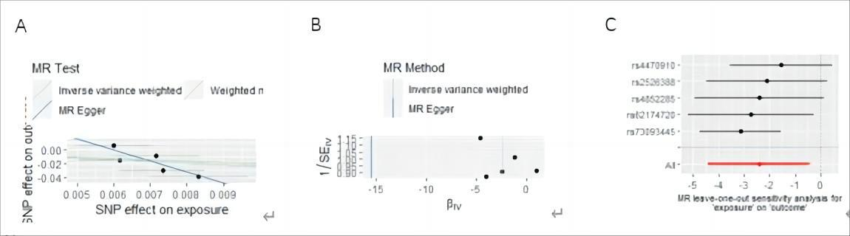
Supplementary Figure 22. Mendelian randomization study of the effects of Muesli on HTN. (A) scatter plot, (B) funnel plot, (C) leave-one-out sensitivity analysis.
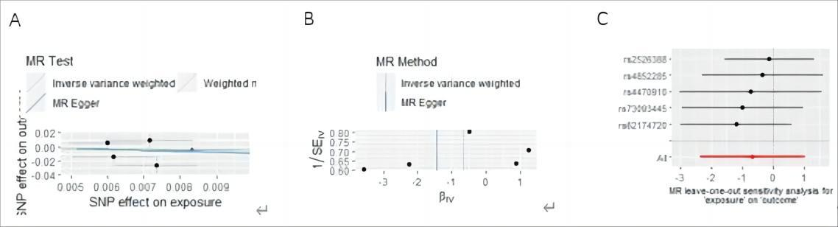
Supplementary Figure 23. Mendelian randomization study of the effects of Muesli on CHD. (A) scatter plot, (B) funnel plot, (C) leave-one-out sensitivity analysis.
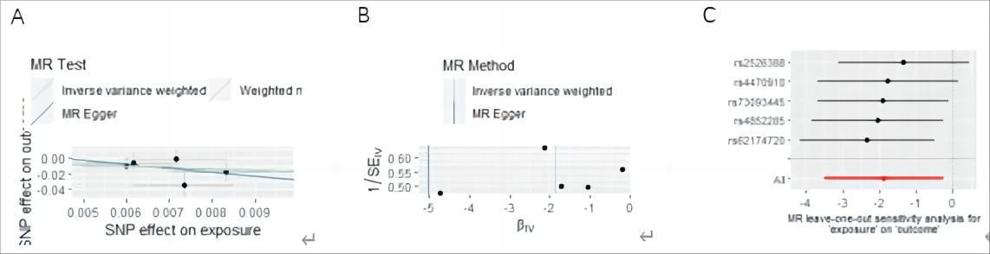
Supplementary Figure 24. Mendelian randomization study of the effects of Muesli on MI. (A) scatter plot, (B) funnel plot, (C) leave-one-out sensitivity analysis.
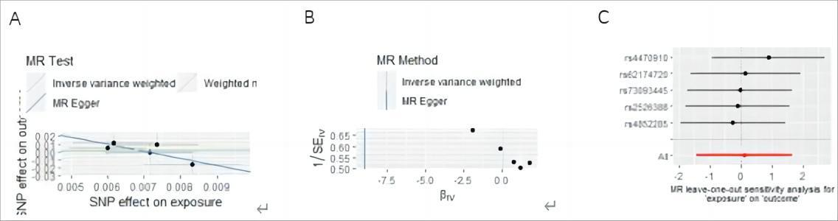
Supplementary Figure 25. Mendelian randomization study of the effects of Muesli on AF. (A) scatter plot, (B) funnel plot, (C) leave-one-out sensitivity analysis.
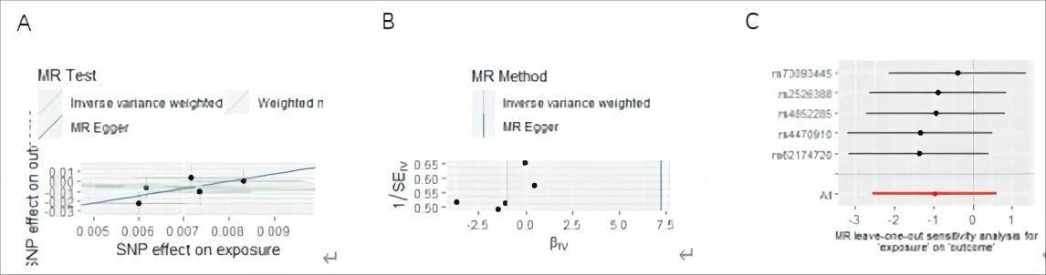
Supplementary Figure 26. Mendelian randomization study of the effects of Muesli on HF. (A) scatter plot, (B) funnel plot, (C) leave-one-out sensitivity analysis.
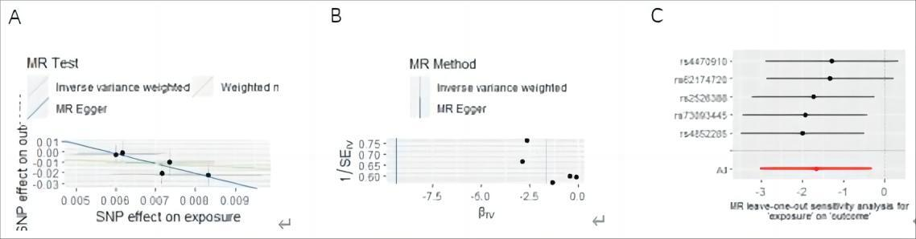
Supplementary Figure 27. Mendelian randomization study of the effects of Muesli on Stroke. (A) scatter plot, (B) funnel plot, (C) leave-one-out sensitivity analysis.

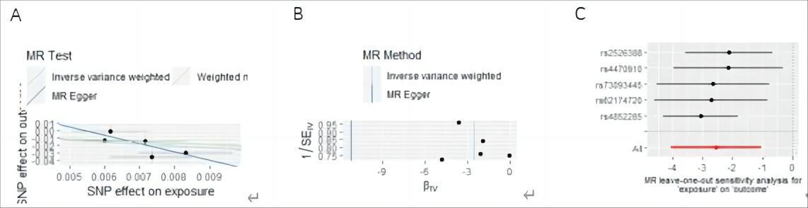
Supplementary Figure 28. Mendelian randomization study of the effects of Muesli on T2DM. (A) scatter plot, (B) funnel plot, (C) leave-one-out sensitivity analysis.
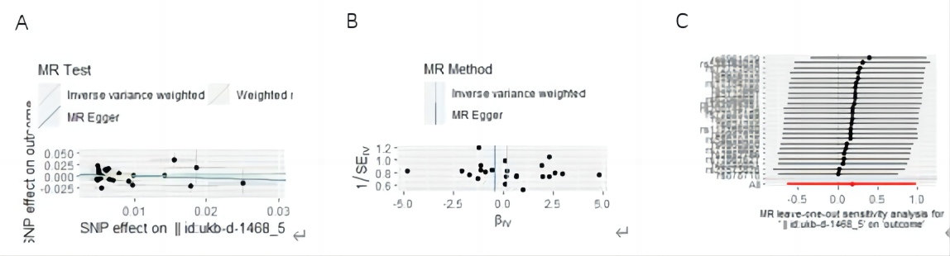
Supplementary Figure 29. Mendelian randomization study of the effects of Other cereal on HTN. (A) scatter plot, (B) funnel plot, (C) leave-one-out sensitivity analysis.
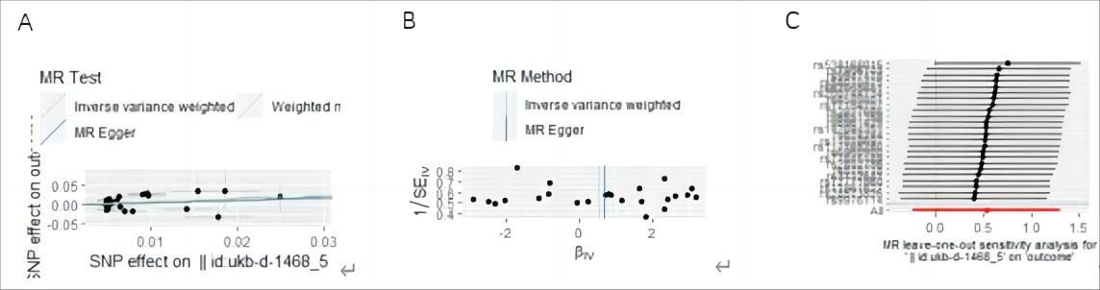
Supplementary Figure 30. Mendelian randomization study of the effects of Other cereal on CHD. (A) scatter plot, (B) funnel plot, (C) leave-one-out sensitivity analysis.
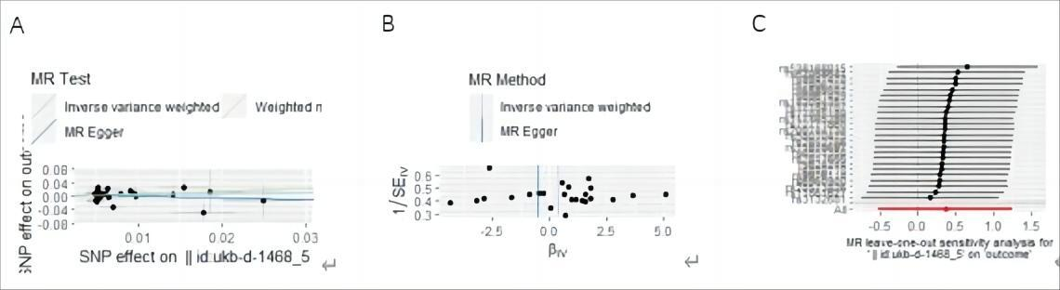
Supplementary Figure 31. Mendelian randomization study of the effects of Other cereal on MI. (A) scatter plot, (B) funnel plot, (C) leave-one-out sensitivity analysis.
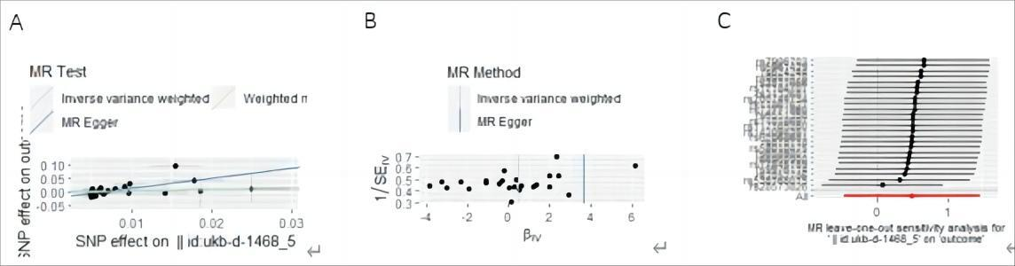
Supplementary Figure 32. Mendelian randomization study of the effects of Other cereal on AF. (A) scatter plot, (B) funnel plot, (C) leave-one-out sensitivity analysis.
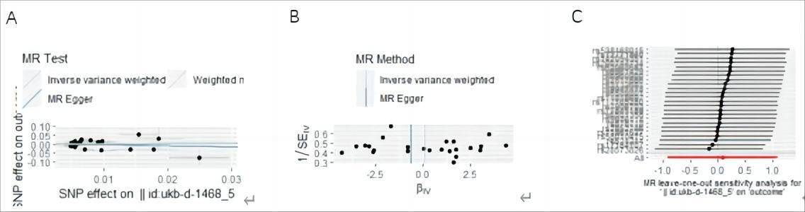
Supplementary Figure 33. Mendelian randomization study of the effects of Other cereal on HF. (A) scatter plot, (B) funnel plot, (C) leave-one-out sensitivity analysis.
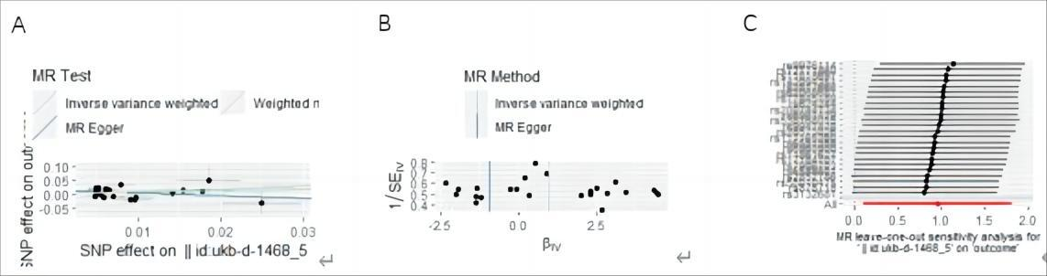
Supplementary Figure 34. Mendelian randomization study of the effects of Other cereal on Stroke. (A) scatter plot, (B) funnel plot, (C) leave-one-out sensitivity analysis.
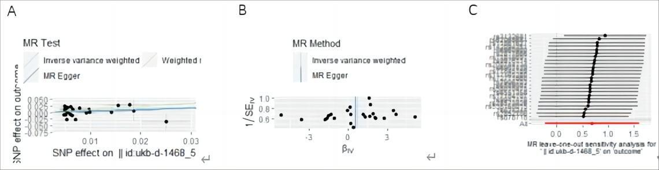
Supplementary Figure 35. Mendelian randomization study of the effects of Other cereal i on T2DM. (A) scatter plot, (B) funnel plot, (C) leave-one-out sensitivity analysis.

