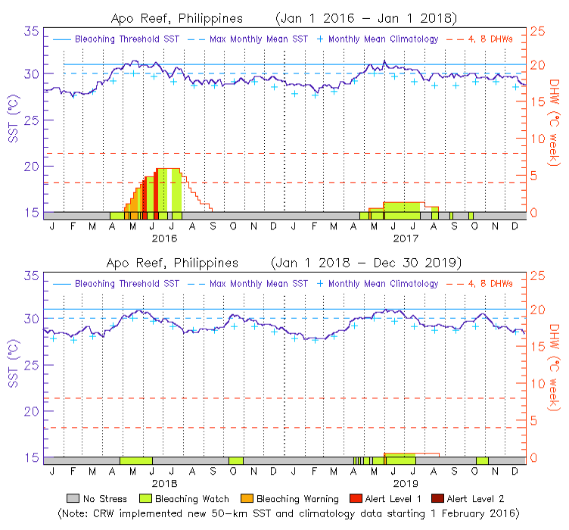
SFig. 1. NOAA temperature data at the ARNP from 2016 to 2019
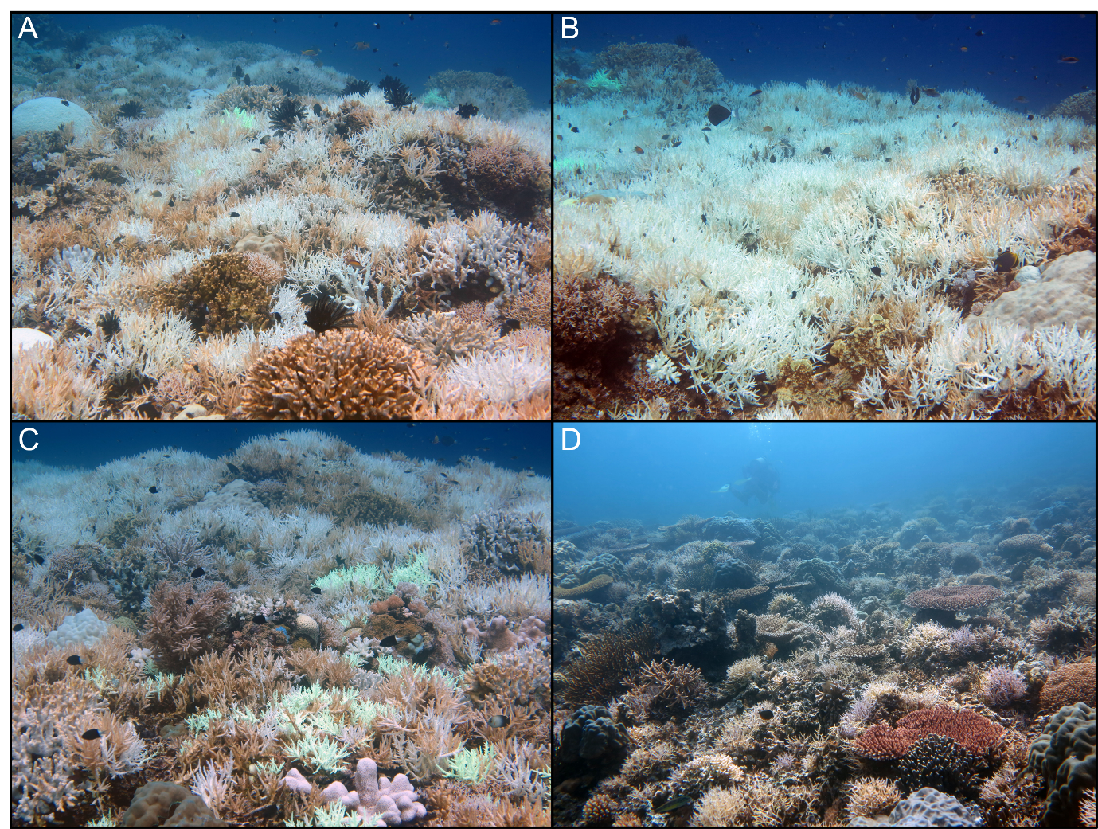
SFig. 2. Pictures of coral individuals that showed signs of bleaching at the ARNP from 2016 to 2017. A-C show corals that bleaching, while D shows minimally affected corals.

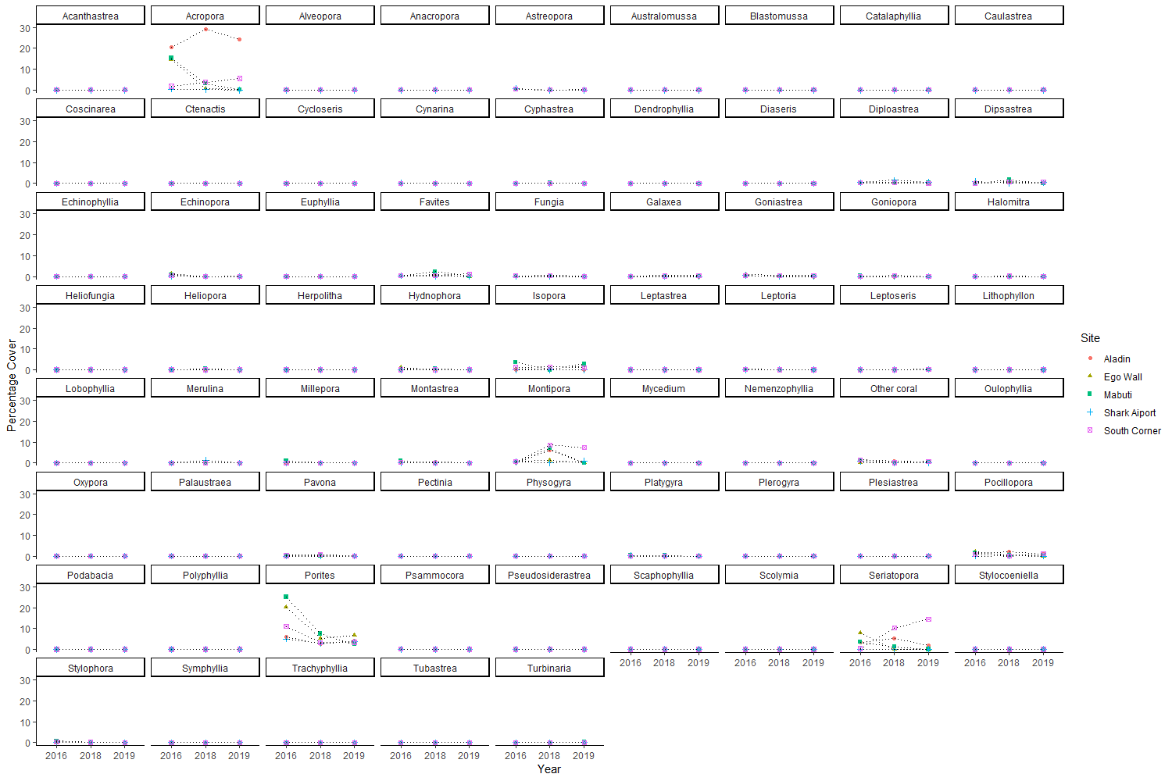
SFig. 3. Mean percentage cover of coral genera among sites and years at the ARNP.

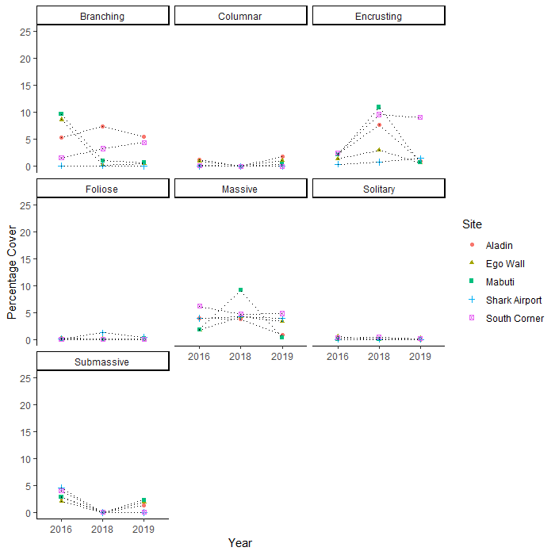
SFig. 4. Mean percentage cover of coral morphology among sites and years at the ARNP.

