Fig.1.Isolation and purification of Treg cells by flow cytometry.
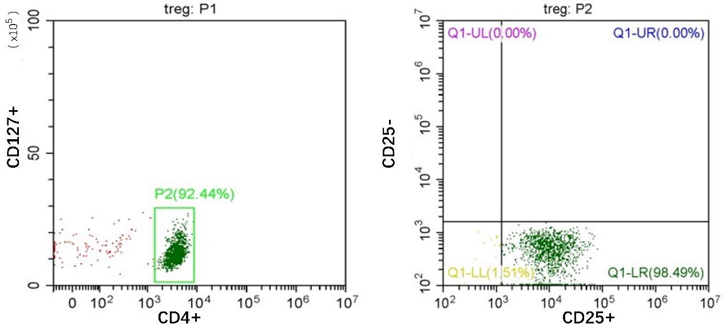
We first separated monocytes through negative selection to isolate CD4+CD127- cells. and then isolated CD4+CD25+CD127- cells by positive selection. The purity of CD4+ cells after sorting was 92.44%. The CD25+CD127- cells represented 98.49% of the total CD4+ cells. Therefore, after sorting, the purity of CD4+CD25+CD127-Treg cells was 91.04%, which was sufficient for the subsequent experiments.

