SUPPLEMENTARY MATERIALS
Supplementary figures
A
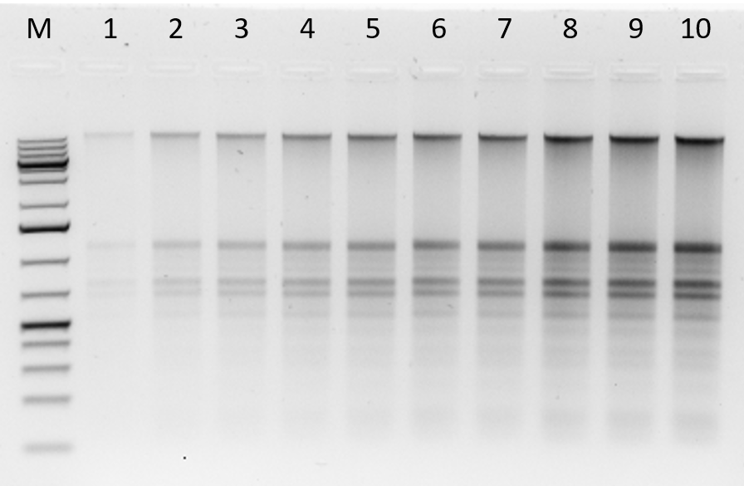
B
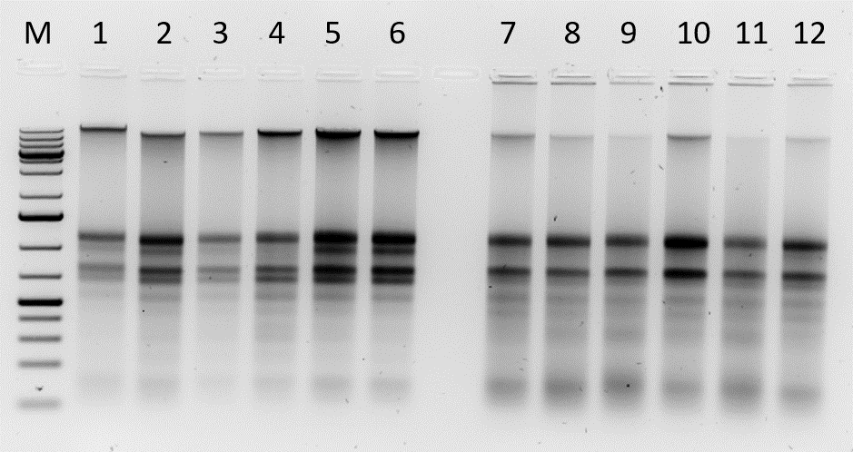
C
M 13 14 15 16 17 18 19 20 21 22 23 24

C2

M 25 26 27 28 29 30
D

D2
Figure .3. Quality of DNA and RNA isolated using optimized method 3 (M3)
- 1 to 10 are total nucleic acids extracted from a fresh cassava leaf sample using our optimized method then diluted to 200ng to 2000ng. 1 (200ng), 2 (400ng), 3 (600ng) 4 (800ng), 5 (1000ng), 6 (1200ng), 7 (1400ng), 8 (1600ng), 9 (1800ng) and 10 (2000ng). Following experiments, 1800 ng was used as the standard in subsequent gels.

- Samples 1 to 6 are genomic DNA and total RNA isolated from fresh leaf samples and 7 to 12 are herbarium 1-month old using a modified method. 800 ng of total nucleic acids were used in the agarose gel.

- Samples 13-18 and 19-24 are total nucleic acids (RNA & DNA) isolated from 8 and 26 month-old herbarium respectively using modified M3.

C2. Samples 13-18 and 19-24 are total nucleic acids (RNA & DNA) isolated from 8 and 20 months of herbarium respectively using modified M3. Pictures were taken in black and white.
- Total nucleic acids isolated from 56 month-old herbarium samples (samples 25-30) using a modified (M3) method.

D2. Total nucleic acids isolated in 56 months’ herbarium samples using a modified (M3) method. Pictures were taken in black and white.

E
M 1 2 3 4 5 6 7 8 9 10 11 12

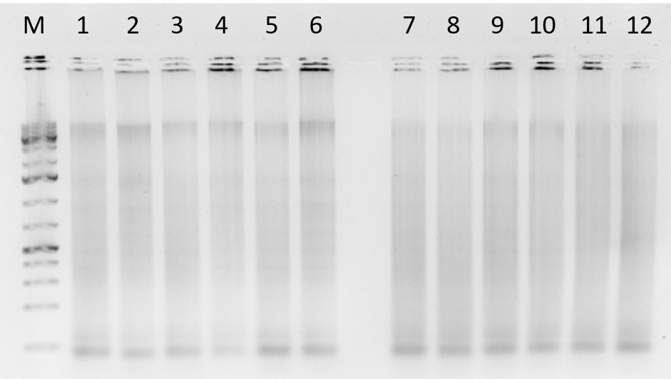
F
G
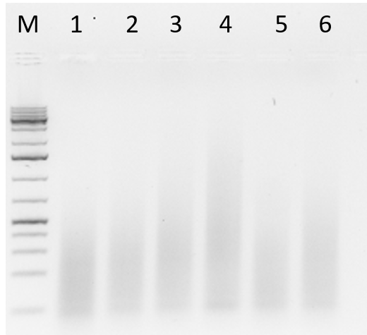

M 1 2 3 4 5 6 7 8 9 10 11 12
H

M 1 2 3 4 5 6 7 8 9 10 11 12
I

M 1 2 3 4 5 6
J

Figure .4. Total nucleic acids isolated using extraction methods 1 and 2.

- DNA and RNA isolated from fresh cassava samples 1-6, and 1-month-old herbarium samples 7-12 isolated using method 2.

- Samples 1-6 and 7-12 are nucleic acids of 8 and 26-month-old herbarium samples respectively isolated using method 2.

- 56-old samples showing degraded RNA and DNA isolated using method 2.

- DNA and RNA extracted using method 1. Samples 1-6 are fresh cassava leaf samples and 7-12 are 1 month old.

- Total nucleic acid isolated using method 1. Samples 1-6 are 8 months old while 7-12 are 26 month old samples.

- Total nucleic acids isolated from 56 months’ old herbarium cassava leaf samples (samples 1-6) using method 1.

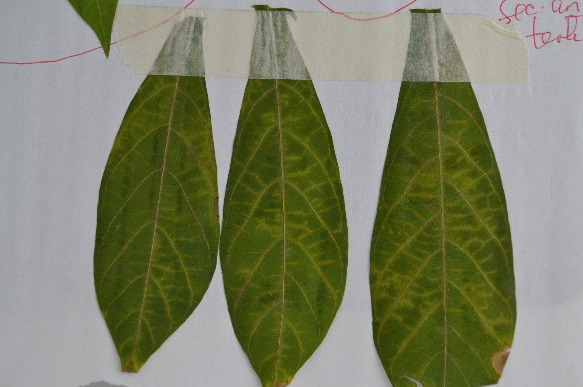
Figure .11. One-month old herbarium cassava leaf samples displaying cassava brown streak symptoms (vein clearing).

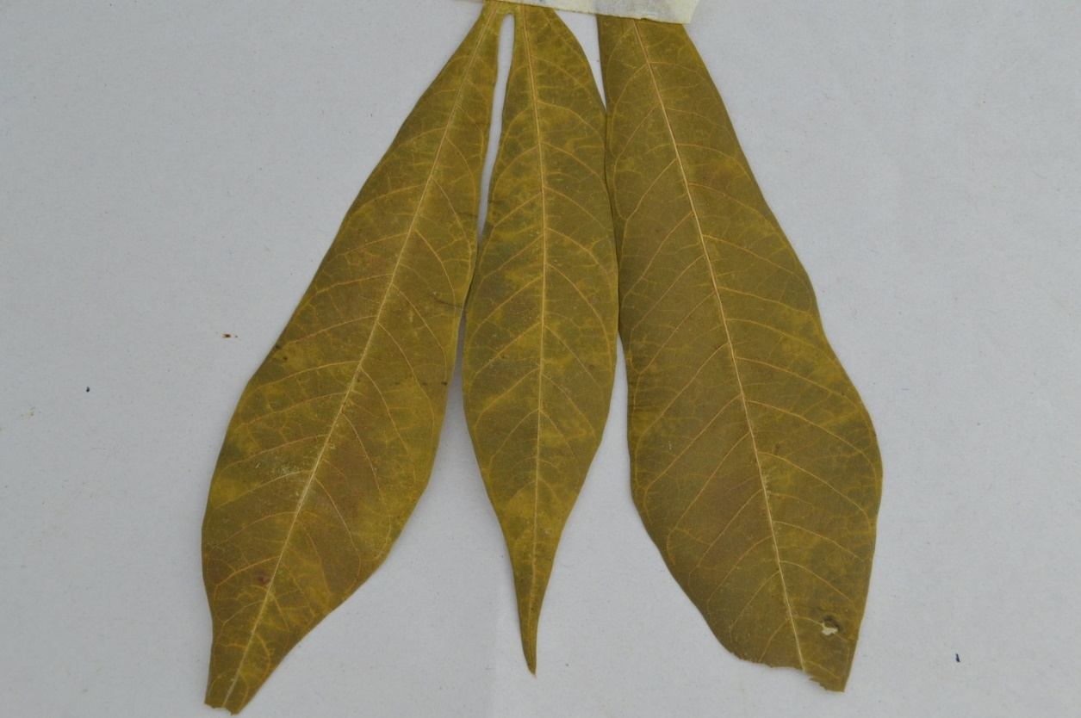
Figure .11. Eight month-old cassava leaf samples.

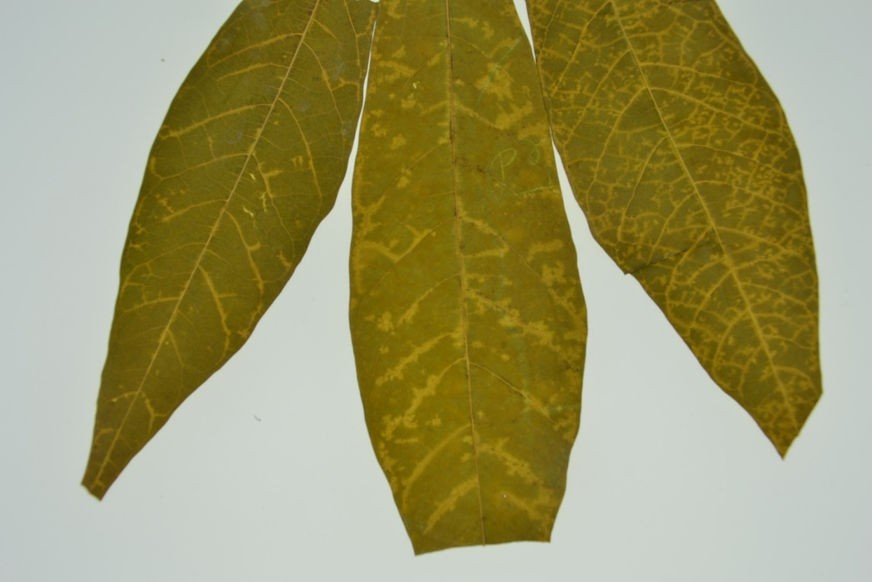
Figure .11. 26-month old herbarium cassava leaf samples.

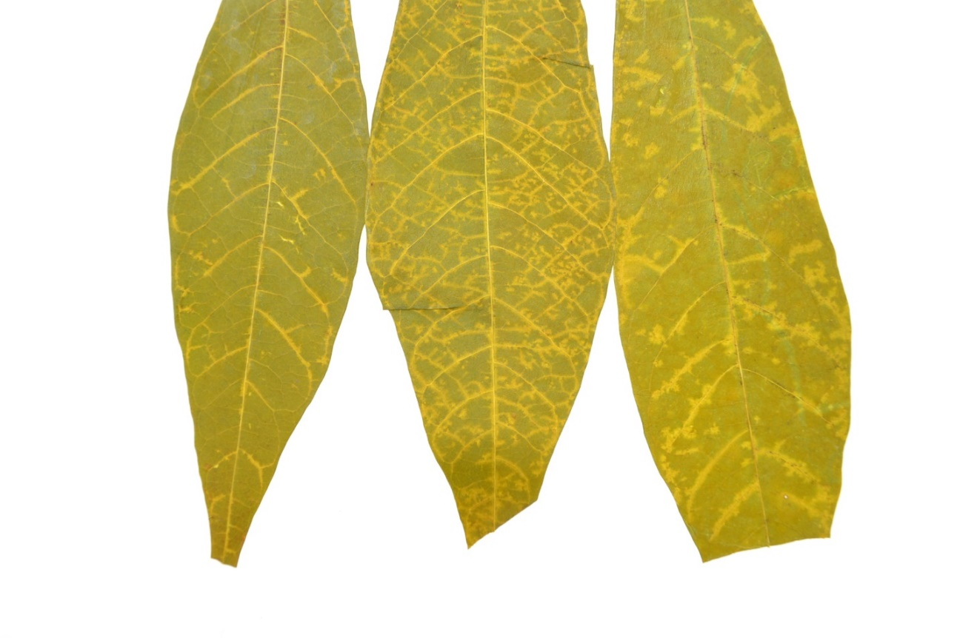
Figure .11. Additional image showing 26 month-old herbarium samples displaying cassava brown streak symptoms (secondary and tertiary vein clearing).

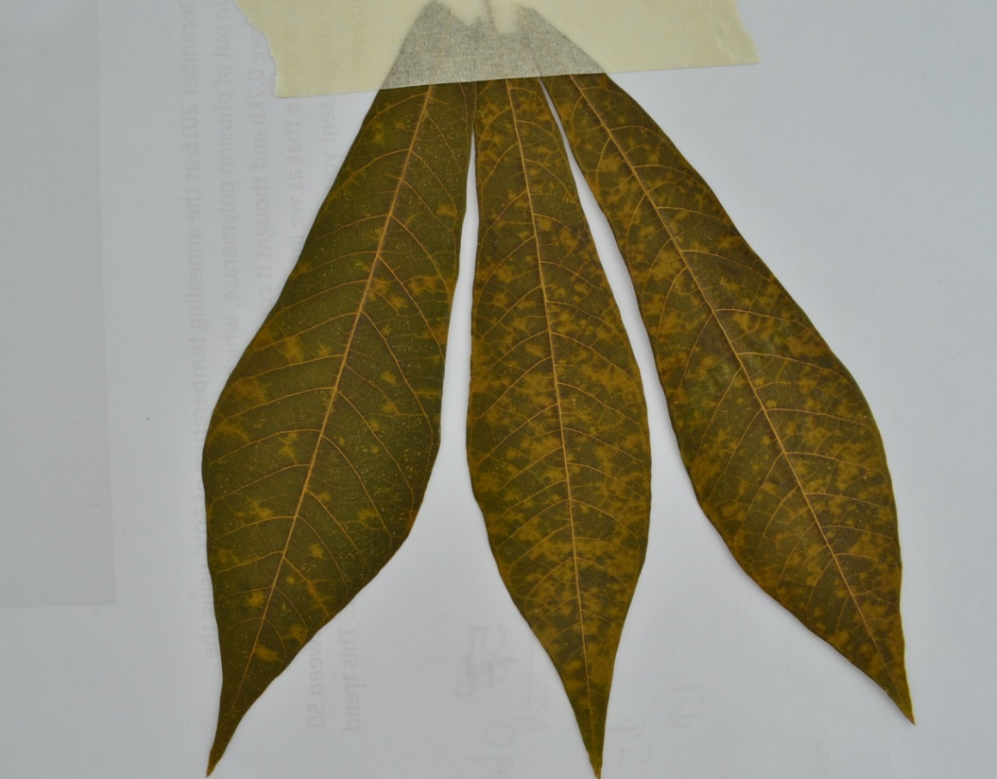
Figure .11. Additional image showing 56 month-old herbarium samples displaying cassava brown streak symptoms (chlorotic spots).
M 1 2 3 4 5 6 7 8 9 10 11 12
M 13 14 15 16 17 18 19 20 21 22 23 24 25 26 27 28 29 30

Figure .12. PCR results showing amplification of CBSV and UCBSV. Fresh samples and 1-month-old samples (1-6 and 7-12) were infected with UCBSV whereas 8 and 26-month-old (13-18 and 19-24) were infected with CBSV. The 56-month-old samples (25-30) were co-infected with both CBSV and UCBSV. M is 1kb plus DNA ladder marks 344 and 440 bp for CBSV and UCBSV respectively.

M 13 14 15 16 17 18 19 20 21 22 23 24 25 26 27 28 29 30
M 1 2 3 4 5 6 7 8 9 10 11 12
Figure .12. Additional image for PCR results showing amplification of CBSV and UCBSV. Fresh samples and 1-month-old samples (1-6 and 7-12) were infected with UCBSV whereas 8 and 26-month-old (13-18 and 19-24) were infected with CBSV. The 56-month-old samples (25-30) were co-infected with both CBSV and UCBSV. M is 1kb plus DNA ladder marks 344 and 440 bp for CBSV and UCBSV respectively.

M H 1 2 3 4 5 6 7 8 9 10 C1 C2 B

Figure.13. Amplification of chloroplast ribulose-bisphosphate carboxylase gene (rbcL) using P609 and P610 primer pairs. While M represents 1kb plus DNA ladder, B represents buffer control and F is non chloroplast sample of fish DNA. Samples 1&2, 3&4, 5&6, 7&8, and 9&10 represent fresh, 1, 8, 26, and 56-month-old samples respectively. C1 & C2 are previously amplified DNA samples from maize flour.

M H 1 2 3 4 5 6 7 8 9 10 C1 C2 B
Figure.13. Additional image showing amplification of chloroplast ribulose-bisphosphate carboxylase gene (rbcL) using P609 and P610 primer pairs. While M represents 1kb plus DNA ladder, B represents buffer control. Samples 1&2, 3&4, 5&6, 7&8, and 9&10 represent fresh, 1, 8, 26, and 56-month-old samples respectively.

Figure .14. Showing cropped images from figure 3B, 3C and 3D. Three samples were selected from fresh (sample 4, 5 & 6) 1 month (samples 7, 8 & 9) 8 month (sample 14, 15 & 16) 26 month (samples 21, 22 & 23) and 56 month-old samples (25, 26 & 27) merged together.
Figure .15. Cropped image from figure 3B (fresh samples 5 & 6 with intact DNA and RNA) and figure 3D, 56 month-old (sample 25 & 26) showing degraded DNA and RNA.

