Table S1 Characteristics of the 29 study islands in the Thousand Island Lake region, China (Zhang et al., 2021).
Island | Latitude (N) | Longitude (E) | Area (ha) | Plots (5m×5m) | Number of Species | Individuals
1 | 29°34'08.37" | 118°53'56.69" | 0.08 | 7 | 8 | 93
2 | 29°30'51.40" | 118°49'13.84" | 0.12 | 19 | 14 | 237
3 | 29°34'50.90" | 118°54'38.69" | 0.14 | 46 | 20 | 1070
4 | 29°30'52.56" | 118°49'21.63" | 0.19 | 42 | 26 | 1797
5 | 29°34'47.52" | 118°54'36.58" | 0.19 | 23 | 18 | 616
6 | 29°30'28.42" | 118°49'17.12" | 0.25 | 50 | 19 | 2654
7 | 29°32'50.81" | 118°54'41.30" | 0.25 | 52 | 25 | 894
8 | 29°30'37.33" | 118°48'56.19" | 0.29 | 74 | 27 | 2595
9 | 29°30'49.27" | 118°49'14.96" | 0.36 | 56 | 22 | 1561
10 | 29°33'04.95" | 118°54'26.95" | 0.39 | 90 | 24 | 1629
11 | 29°34'06.36" | 118°53'59.60" | 0.42 | 89 | 28 | 1655
12 | 29°31'50.74" | 118°55'27.17" | 0.46 | 68 | 29 | 2305
13 | 29°30'55.31" | 118°49'20.37" | 0.53 | 73 | 28 | 2985
14 | 29°31'49.65" | 118°55'15.80" | 0.62 | 138 | 36 | 4307
15 | 29°31'47.43" | 118°55'21.12" | 0.69 | 141 | 27 | 3716
16 | 29°30'28.83" | 118°49'22.58" | 0.79 | 205 | 38 | 8497
17 | 29°34'45.67" | 118°54'45.71" | 0.84 | 195 | 34 | 6221
18 | 29°30'15.06" | 118°49'40.26" | 0.85 | 176 | 33 | 7451
19 | 29°33'01.07" | 118°54'40.91" | 0.86 | 97 | 29 | 2279
20 | 29°32'02.01" | 118°54'23.61" | 0.99 | 278 | 43 | 9936
21 | 29°34'04.75" | 118°53'53.67" | 1.31 | 246 | 40 | 7419
22 | 29°30'51.67" | 118°49'27.67" | 1.32 | 207 | 39 | 9631
23 | 29°34'05.98" | 118°53'41.49" | 1.33 | 249 | 39 | 8100
24 | 29°30'24.09" | 118°49'38.13" | 2.56 | 260 | 46 | 10401
25 | 29°30'45.68" | 118°49'26.12" | 3.70 | 356 | 43 | 15781
26 | 29°30'53.72" | 118°49'44.24" | 9.79 | 400 | 45 | 22018
27 | 29°32'16.11" | 118°56'19.83" | 27.49 | 412 | 43 | 14942
28 | 29°31'39.72" | 118°56'14.17" | 47.98 | 435 | 47 | 13566
29 | 29°32'25.41" | 118°52'55.85" | 1153.88 | 598 | 53 | 22472

Table S2 Ten continuous plant functional traits examined in the study.
Abbreviation | Trait | Instruments | Range
Chloro | Leaf chlorophyll content per dry leaf mass | A portable chlorophyll meter (SPAD-520Plus; Konica Minolta) | 32.30 – 79.86 SPAD unit
LA | Leaf area | A flatbed scanner (LA-S, Plant Image Analyses System, Wanshen, China) | 0.266 – 351.026 cm²
LDMC | Leaf dry matter content | An electronic balance (AL104, Mettler Toledo Co., Switzerland) | 0.245 – 0.546 g·g⁻¹
LT | Leaf thickness | A micrometer | 0.121 – 1.188 mm
SLA | Specific leaf area | A flatbed scanner and an electronic balance | 4.561 – 34.945 m²·kg⁻¹
StoD | Leaf stomatal density | A light microscope (B204TR, OPTEC, China) | 52.830 – 1090.200 per cm²
C: N | Leaf carbon: nitrogen ratio | An elemental analyzer (Vario EL III, elementar, German) | 11.991 – 43.496
N: P | Leaf Nitrogen: phosphorus ratio | An elemental analyzer and a UV-Vis spectrophotometer (UV-2550, UV-Visible Spectrophotometer, Shimadzu, Japan) | 11.006 – 45.778
WD | Wood density | An electronic balance and a beaker | 0.322 – 0.693 g·cm⁻³
SM | Seed mass | An electronic balance | 0.0000248 – 1.0055 g

Table S3 Pearson Correlations between functional traits. Bold values indicate that the correlation is significant at the 0.05 level (2-tailed).
 | LT | LDMC | SLA | Chloro | StoD | C: N | N: P | WD | SM
LA | -0.178 | 0.051 | 0.121 | 0.098 | 0.198 | -0.320 | 0.128 | -0.265 | -0.022
LT | 1 | 0.031 | -0.524 | 0.552 | -0.244 | 0.394 | 0.056 | -0.158 | -0.130
LDMC |  | 1 | -0.576 | 0.095 | 0.203 | 0.189 | -0.040 | 0.485 | 0.265
SLA |  |  | 1 | -0.478 | 0.105 | -0.534 | -0.020 | -0.203 | -0.194
Chloro |  |  |  | 1 | -0.134 | 0.179 | 0.215 | -0.005 | -0.174
StoD |  |  |  |  | 1 | -0.251 | -0.113 | 0.159 | 0.374
C: N |  |  |  |  |  | 1 | 0.068 | 0.093 | 0.034
N: P |  |  |  |  |  |  | 1 | 0.030 | 0.081
WD |  |  |  |  |  |  |  | 1 | 0.223

Table S4 Phylogenetic signal of functional traits in the Thousand Island Lake. Bold values indicate a significant phylogenetic signal at the 0.05 level.
Trait | Blomberg’s K |  | Pagel’s Lambda
Trait | K | P value | Lambda | P value
LA | 0.447 | 0.013 | 0.997 | <0.001
LT | 0.454 | 0.003 | 0.808 | <0.001
LDMC | 0.112 | 0.523 | 0.333 | 0.136
SLA | 0.208 | 0.008 | 0.571 | 0.055
Chloro | 0.268 | 0.001 | 0.762 | 0.027
StoD | 0.211 | 0.083 | 0.675 | 0.002
C: N | 0.226 | 0.006 | 0.809 | <0.001
N: P | 0.237 | 0.004 | 0.418 | 0.104
WD | 0.135 | 0.244 | 0.192 | 1.000
SM | 0.184 | 0.257 | 0.630 | <0.001
Abundance | 4.326 | 0.001 | 1.009 | <0.001

Table S5 PCoA results of MFPD values between islands.
PCoA | a optimization | comdist calculation | first two axes explained | first five axes explained
MFPD.pw | nonweighted_0.8 | nonweighted | 8.60 | 20.60
MFPD.pw | nonweighted_0.8 | weighted | 19.14 | 34.32
MFPD.nn | nonweighted_0.8 | nonweighted | 70.58 | 99.11
MFPD.nn | nonweighted_0.8 | weighted | 163.11 | 213.05
MFPD.pw | weighted_0.3 | nonweighted | 8.48 | 20.21
MFPD.pw | weighted_0.3 | weighted | 17.35 | 31.22
MFPD.nn | weighted_0.3 | nonweighted | 64.82 | 95.15
MFPD.nn | weighted_0.3 | weighted | 172.08 | 222.14

Table S6 The relationship among non-weighted and abundance weighted MFPD and SES.MFPD values with log-transformed island area, using the sample linear regression.
Response variable | a optimization | SES calculation | Fixed effect | LM P value | Adjusted R²
MFPD.pw | nonweighted_0.8 | nonweighted | logarea | 0.004 | 0.242
MFPD.pw | nonweighted_0.8 | weighted | logarea | 0.070 | 0.083
SES.MFPD.pw | nonweighted_0.8 | nonweighted | logarea | 0.297 | 0.005
SES.MFPD.pw | nonweighted_0.8 | weighted | logarea | 0.002 | 0.289
MFPD.nn | nonweighted_0.8 | nonweighted | logarea | <0.001 | 0.463
MFPD.nn | nonweighted_0.8 | weighted | logarea | 0.003 | 0.265
SES.MFPD.nn | nonweighted_0.8 | nonweighted | logarea | <0.001 | 0.481
SES.MFPD.nn | nonweighted_0.8 | weighted | logarea | 0.087 | 0.071
MFPD.pw | weighted_0.3 | nonweighted | logarea | 0.003 | 0.257
MFPD.pw | weighted_0.3 | weighted | logarea | 0.192 | 0.027
SES.MFPD.pw | weighted_0.3 | nonweighted | logarea | 0.161 | 0.037
SES.MFPD.pw | weighted_0.3 | weighted | logarea | <0.001 | 0.391
MFPD.nn | weighted_0.3 | nonweighted | logarea | <0.001 | 0.461
MFPD.nn | weighted_0.3 | weighted | logarea | 0.002 | 0.273
SES.MFPD.nn | weighted_0.3 | nonweighted | logarea | 0.001 | 0.299
SES.MFPD.nn | weighted_0.3 | weighted | logarea | 0.015 | 0.171

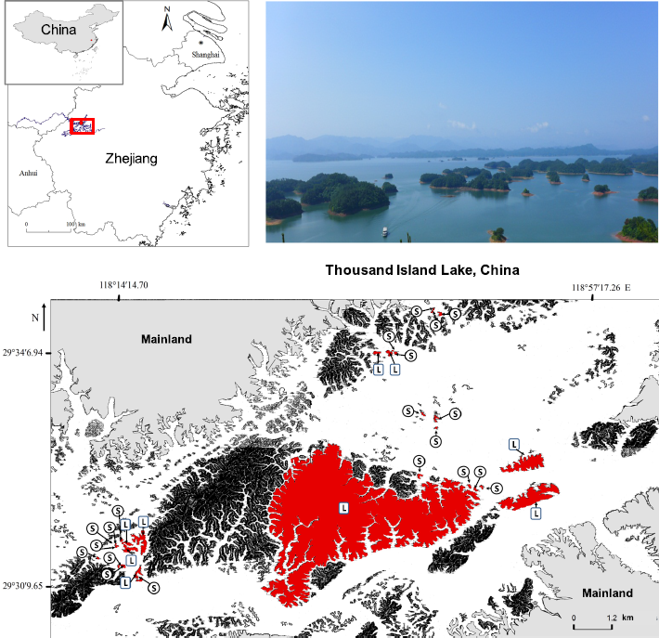
Figure S1 Map of the islands used in this study in the Thousand Island Lake (TIL). The 29 study islands are shown in red: 20 small islands (S, <1 ha) and nine large islands (L, >1 ha). Map created with ArcGis, Version 10.0, http://www.arcgis.com/. (Liu et al., 2018).

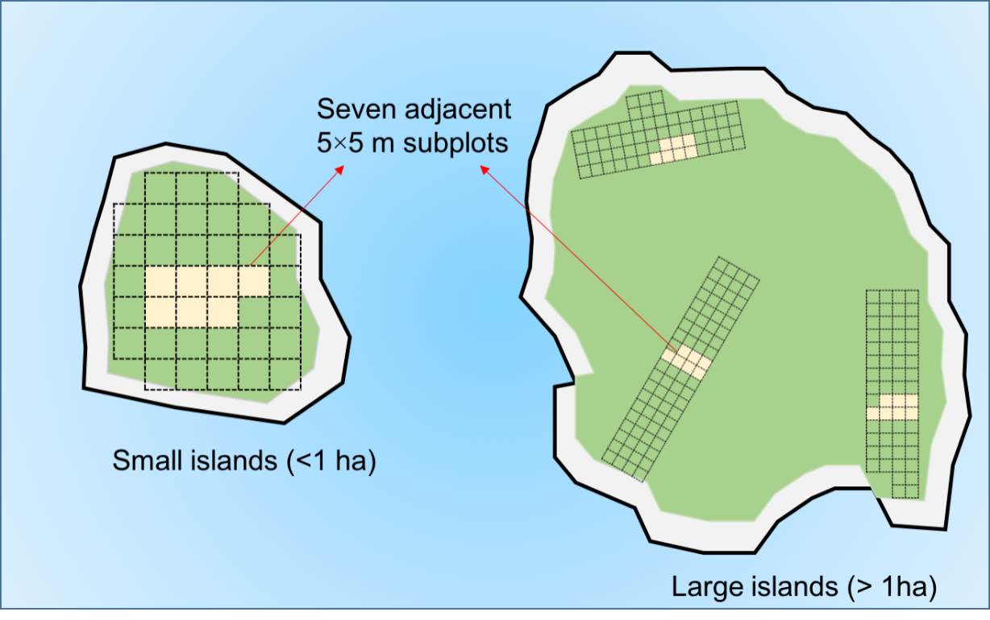
Figure S2 Sampling methods on small (< 1ha) and large (>1ha) islands, covered by adjacent 5×5 m subplots. This figure represents a schematic representation of a hypothetical small island of ~0.14 ha (left) and large island of ~1.33 ha (right) (Liu et al., 2018).

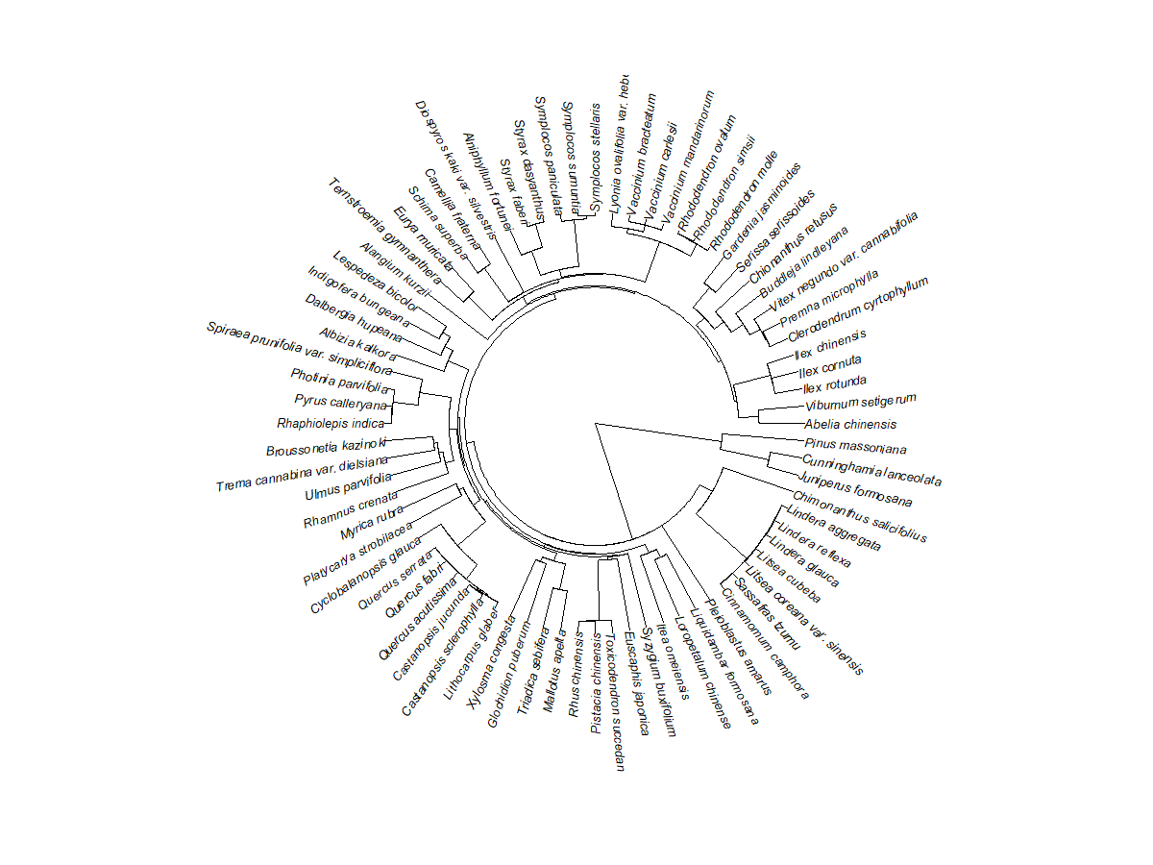
Figure S3 Phylogenetic tree of 76 woody plants on 29 islands in the Thousand Island Lake, which we used for further analyses.

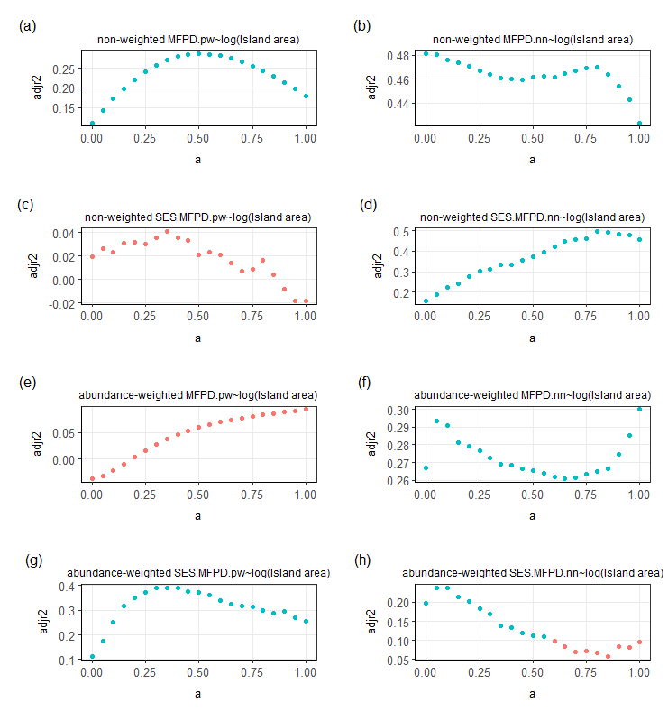
Figure S4 Adjusted R-squared values (adjr²) of the sample linear regression between the mean pairwise and nearest functional–phylogenetic distances (MFPD) and their SES values and island area across the range of a values (the weighting parameter). The red circle indicated non-significance (P>0.05), while blue circle indicated significance (P<0.05). When using abundance weighted dataset, SES.MFPD.pw and island area had a significant relationship with island area (the highest R² was reached when a=0.30), but MFPD.pw had no significant relationship with island area (Figure S4eg). Despite this, we still used a=0.30 to do the analysis (Tables S5&S6) to support the results of Figure 3.

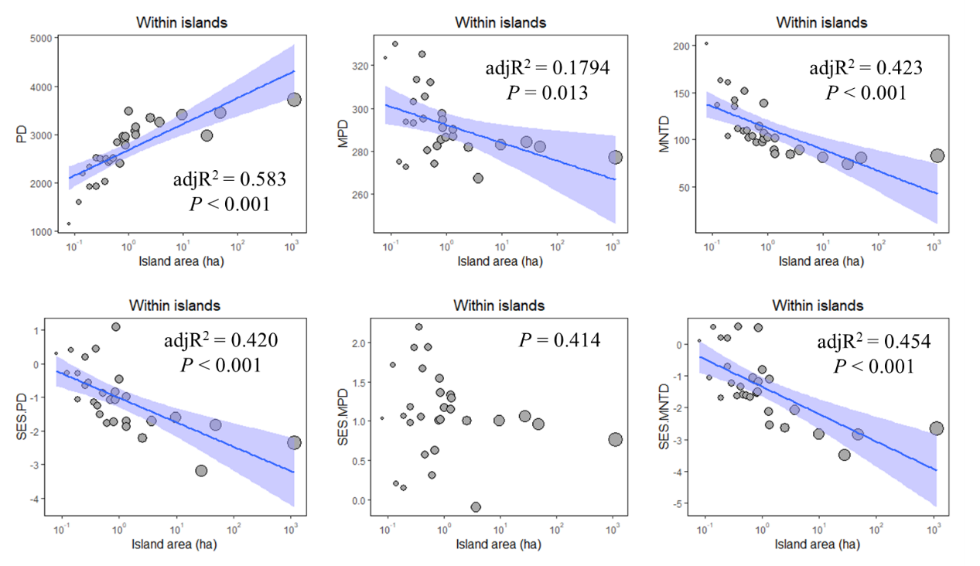
Figure S5 Phylogenetic diversity (PD), mean nearest taxon distance (MNTD), mean pairwise phylogenetic distance (MPD) and their standardized effect size values shifted along island. The calculation was taken by R package picante (Kembel et al., 2019), with using non-abundance-weighted data and “taxa.labels” null model.

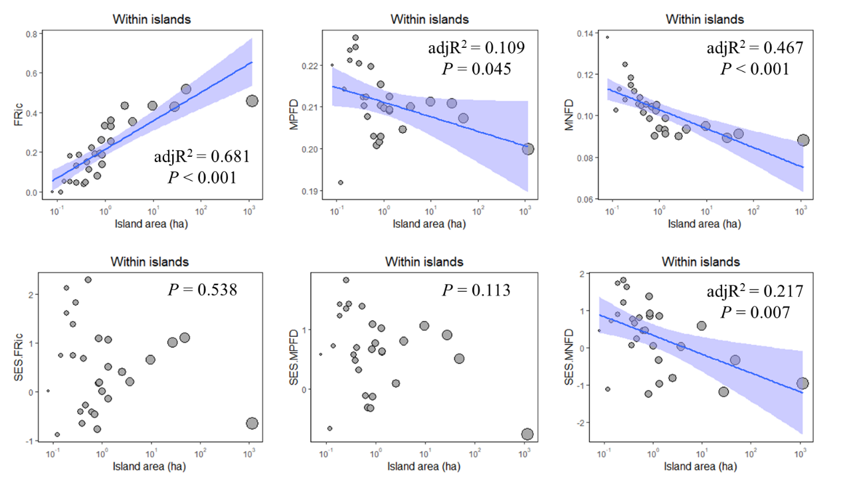
Figure S6 Functional richness (FRic), mean nearest functional distance (MNFD), mean pairwise functional distance (MPFD) and their standardized effect size values shifted along island. FRic was calculated by the R package FD (Laliberté et al. 2014). Imitating from the method of MNTD and MPD, MNFD and MPFD were calculated by R package picante (Kembel et al. 2019), with using non-abundance-weighted data and “taxa.labels” null model.

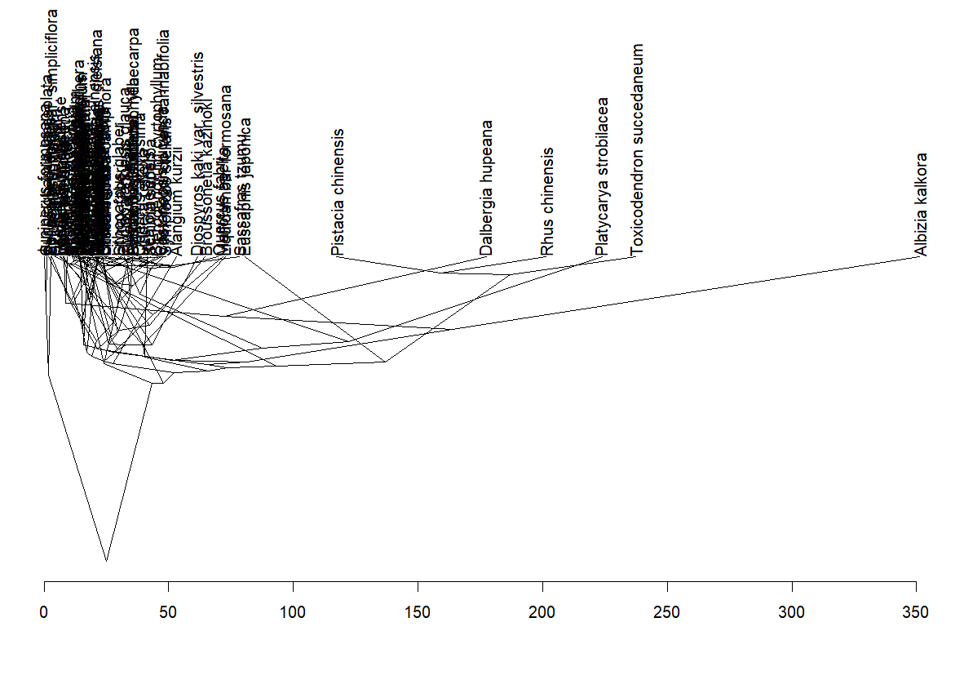
Figure S7 The traitgram plots the phylogenetic time on the y-axis and functional distance on the x-axis. This “traitgram space” showed how species traits are distributed phylogenetically and they were functionally and phylogenetically converged.

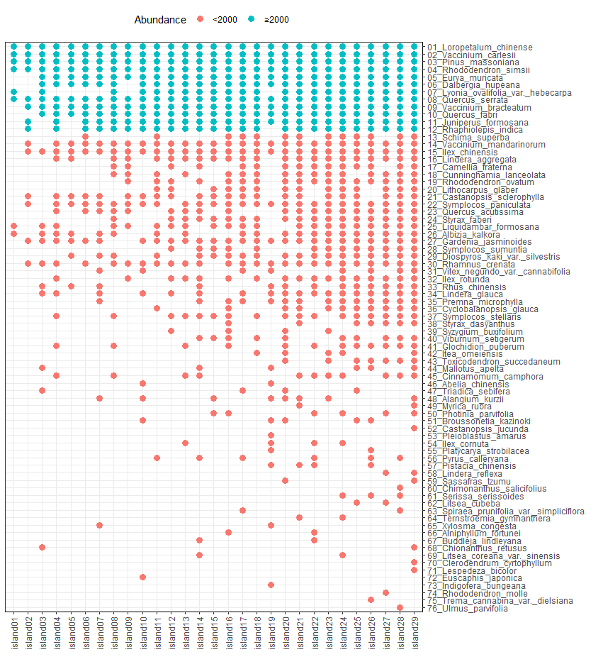
Figure S8 Occupancy of 76 species on 29 study islands. The different color of dots represents different species abundance (across all islands). Island was ranked by area (from small to large). Species was ranked by abundance from top (most abundant) to the bottom.

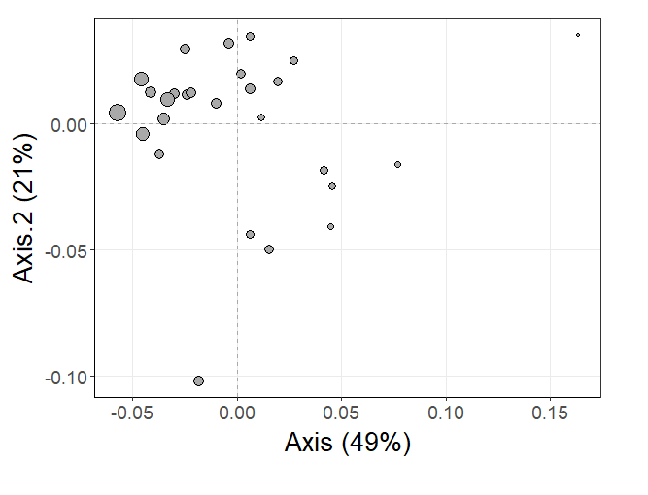
Figure S9 The relative mean nearest functional-phylogenetic distances (MFPD_{nn}, a = 0.80, non-weighted) between islands were visualized by the Principal Co-ordinates Analysis (PCoA). The larger grey dot represents larger island area.

References
Laliberté, E. et al. 2014. FD: measuring functional diversity from multiple traits, and other tools for functional ecology. R package version 1.0–12.
Liu, J., Vellend, M., Wang, Z., Yu, M. (2018). High beta diversity among small islands is due to environmental heterogeneity rather than ecological drift. J. Biogeogr. 45(10): 2252–2261.
Kembel, S. W. et al. 2019. Picante: R tools for integrating phylogenies and ecology. Bioinformatics 26: 1463–1464.
Zhang, A., Zheng, S., Didham, R.K., Holt, R.D., Yu M. (2021). Nonlinear thresholds in the effects of island area on functional diversity in woody plant communities. J. Ecol. 109: 2177–2189.

