Table 1 Physical properties of azoimino-sulfathiazole 5a-5i
Entry | Compounds | M.P.(°C) | Yield% | Color
5a |  | 227 | 78% | 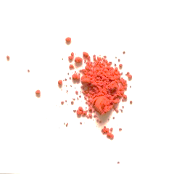
5b |  | 233 | 48% | 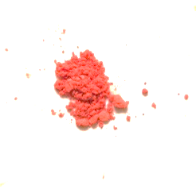
5c |  | 258 | 71% | 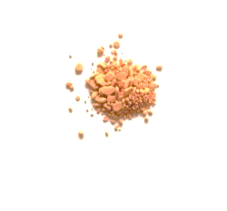
5d |  | 248 | 63% | 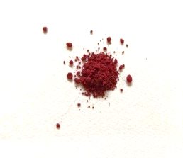
5e |  | 258 | 78% | 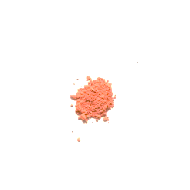
5f |  | 242 | 59% | 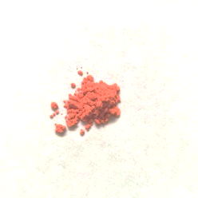
5g |  | 244 | 33% | 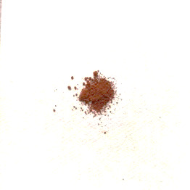
5h |  | 249 | 55.11% | 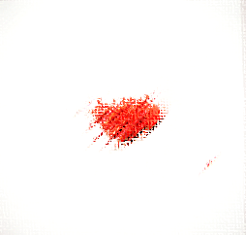
5i |  | 203 | 42.14% | 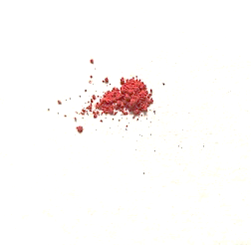

Table 2 Antimicrobial activity of compounds 5a-5i
Diameter of growth of inhibition zone (mm) |  | Compound
E. coli | S. aureus | Compound
14 | 16 | 5a
21 | 24 | 5b
24 | 29 | 5c
22 | 30 | 5d
21 | 24 | 5e
18 | 22 | 5f
27 | 31 | 5g
12 | 21 | 5h
17 | 19 | 5i
- | - | DMSO
23 | 37 | Penicillin

