Supplementary figures and table

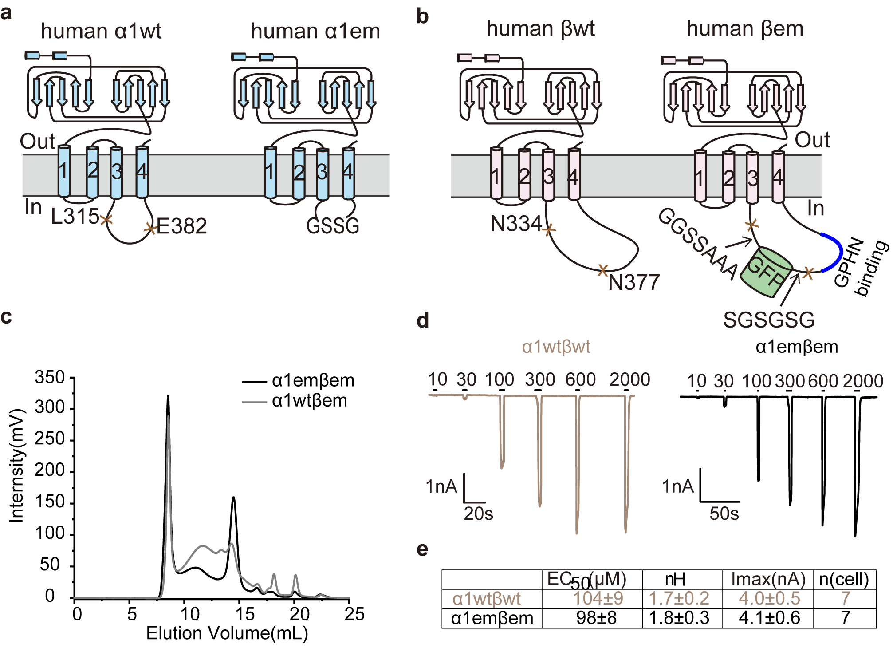
Supplementary Figure 1 | The topology of ⍺1 and β GlyRs constructs and whole cell voltage-clamp electrophysiology.
(a) The topology diagrams of human ⍺1wt and ⍺1em. (b)The topology diagrams of human βwt and βem. (c) FSEC of ⍺1wtβem and ⍺1emβem expressed at 1:3 of ⍺1:β virus ratio. The trace represented GFP fluorescence (excitation 480nm, emission 515nm) of elution from a Superose6 increase 10/300 column. (d) Representative whole cell voltage-clamp electrophysiology recordings of glycine dose response for Fig.1a. (e) EC₅₀, nH (Hill coefficient), Imax, and n (cells) are listed.
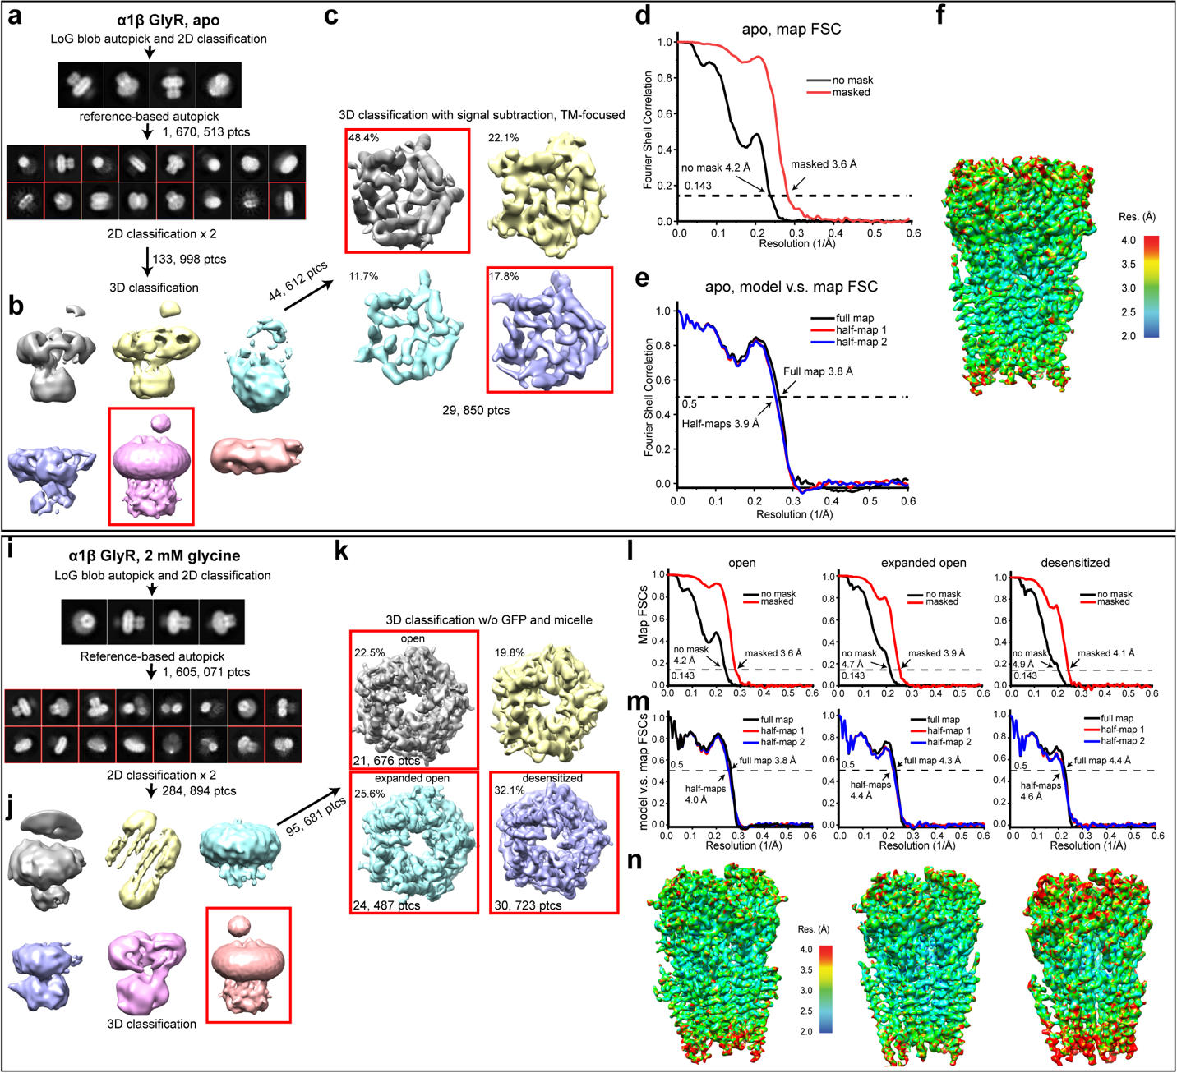

Supplementary Figure 2 | Overview cryo-EM data processing.
(a-f) The apo state of ⍺1β GlyR. (a,b) Selected (red boxes) 2D and 3D classes average for the apo state of ⍺1β GlyR. (c) 4 classes resulting from 3D classification. The percentages of particles in each class were showed. The two good classes were combined for further refined. (d) The gold standard FSC curves from the final map of the apo state. (e) FSC between the atomic model and half maps/full map. Resolution at FSC of 0.5 was indicated. (f)Local resolution maps for the apo state. (i-n) The open, expanded open and desensitized states of ⍺1β GlyR. (i, j) Selected (red boxes) 2D and 3D classes average for the glycine-bound ⍺1β GlyR. (k) 4 classes resulting from 3D classification. The percentages of particles in each class are shown. The 3 good classes in boxes were selected for further refined. (l) Gold standard FSC curves of the final maps of the open state, expanded open state, desensitized state. (m)FSC between the atomic model and half maps/full map. Resolution at FSC of 0.5 was indicated. (n) Local resolution maps for the open state, expanded open state, desensitized state. Local resolutions are calculated using ResMap.

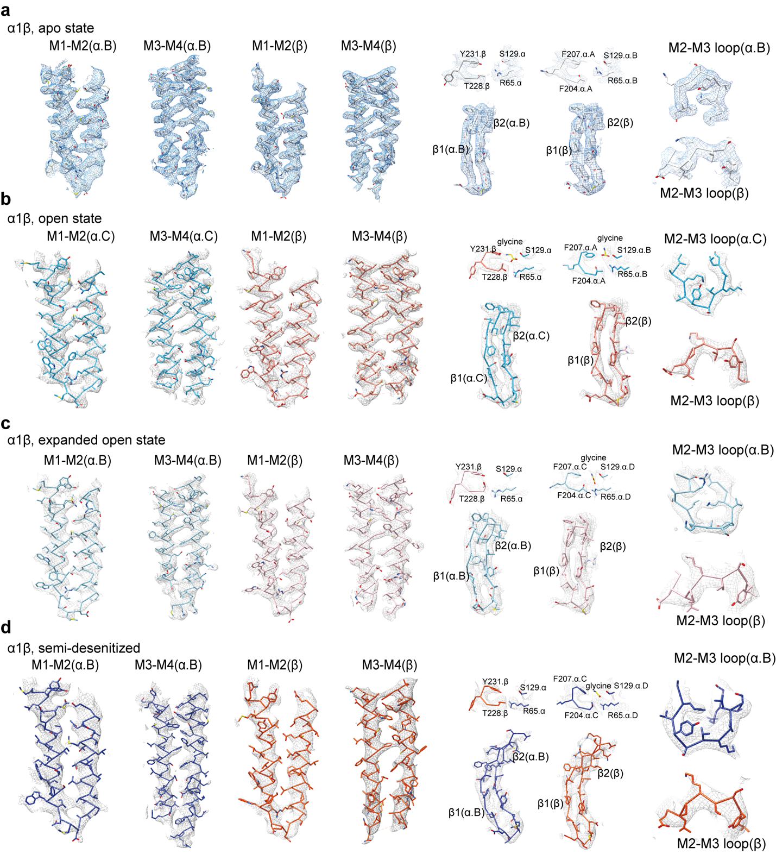
Supplementary Figure 3 | cryo-EM densities for selected regions of ⍺1β GlyR.
Left to right, M1-M4 helices of the ⍺1 subunit and β subunit, orthosteric pockets at β(+)⍺(-) and ⍺(+)⍺(-) interfaces, β1-β1 sheet, and M2-M3 loop of the ⍺1 subunit (variants of blue) and β subunit (variants of orange). (a) apo state; (b) open state; (c)expanded open state; (d) desensitized state.
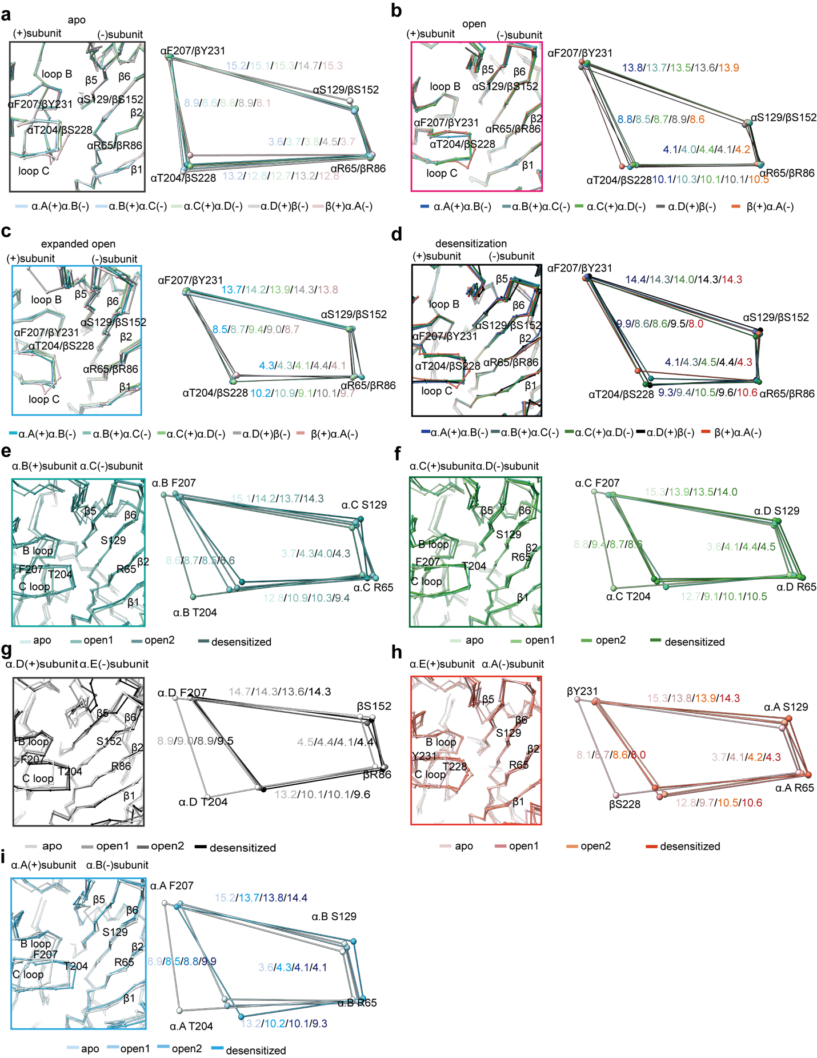
Supplementary Figure 4 | Comparison of the glycine binding pocket.
(a, b, c, d) Superposition of all 5 glycine binding pockets in each of the apo (a), open (b), expanded open (c) and desensitized (d) states, with schematic diagram illustrating the relative positions of key residues in (+) and (–) sides shown on the right. (e, f, g, h, i) Conformational changes of glycine binding pockets at ⍺.A(+)⍺.B(-) (e), ⍺.B(+)⍺.C(-) (f), ⍺.C(+)⍺.D(-) (g), ⍺.D(+)β(-) (h), β(+)⍺.A(-) (i) interfaces superimposed across the apo, open, expanded open and desensitized states (aligned using ECD). Schematic diagram illustrating the change in distance of key residues are shown on the right. All distances are given in Å.
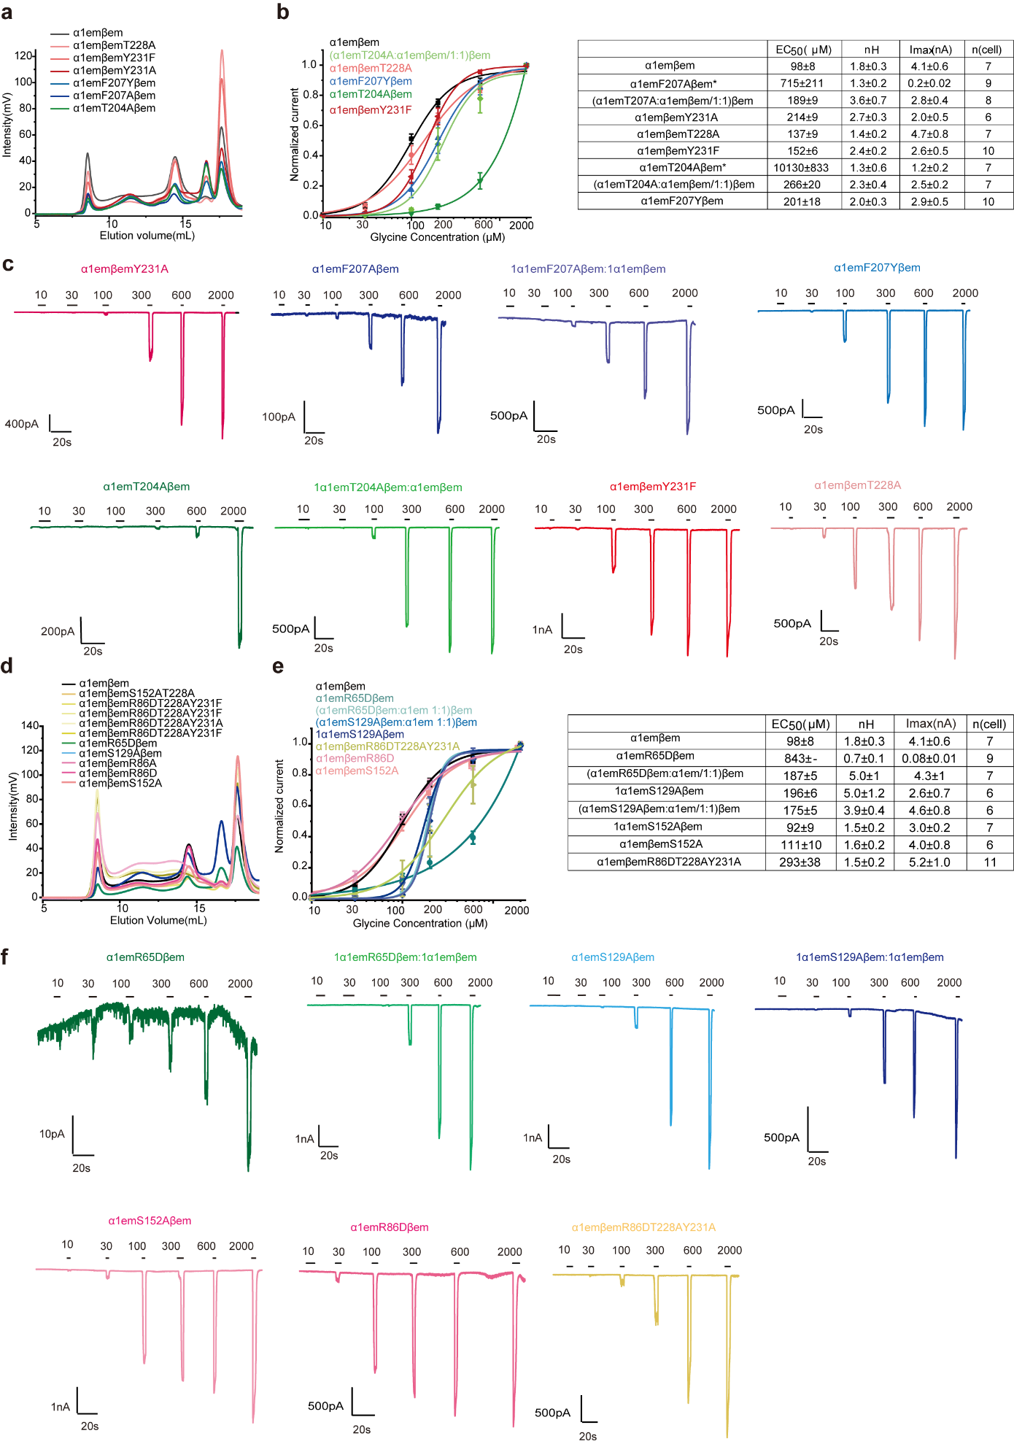

Supplementary Figure 5 | FSCE expression assay and dose response of glycine for glycine binding pocket mutants.
(a) FSEC of ⍺ (+) side and β (+) side mutants. All trace represented the GFP signal arising from fusion on the β subunit. ( b) Glycine dose response of (+) side mutants. (c) Typical complete whole cell voltage-clamp electrophysiology traces of mutants in panel b. (d) FSEC of ⍺ (-) side and β (+)/β (-) double sides mutants. (e) Glycine dose response curves of mutants in panel d. (f)Typical complete whole cell voltage-clamp electrophysiology traces of mutants in panel e. Data are represented as mean ± SEM. EC₅₀, n (Hill coefficient), Imax, and n (cells) are listed on the side.

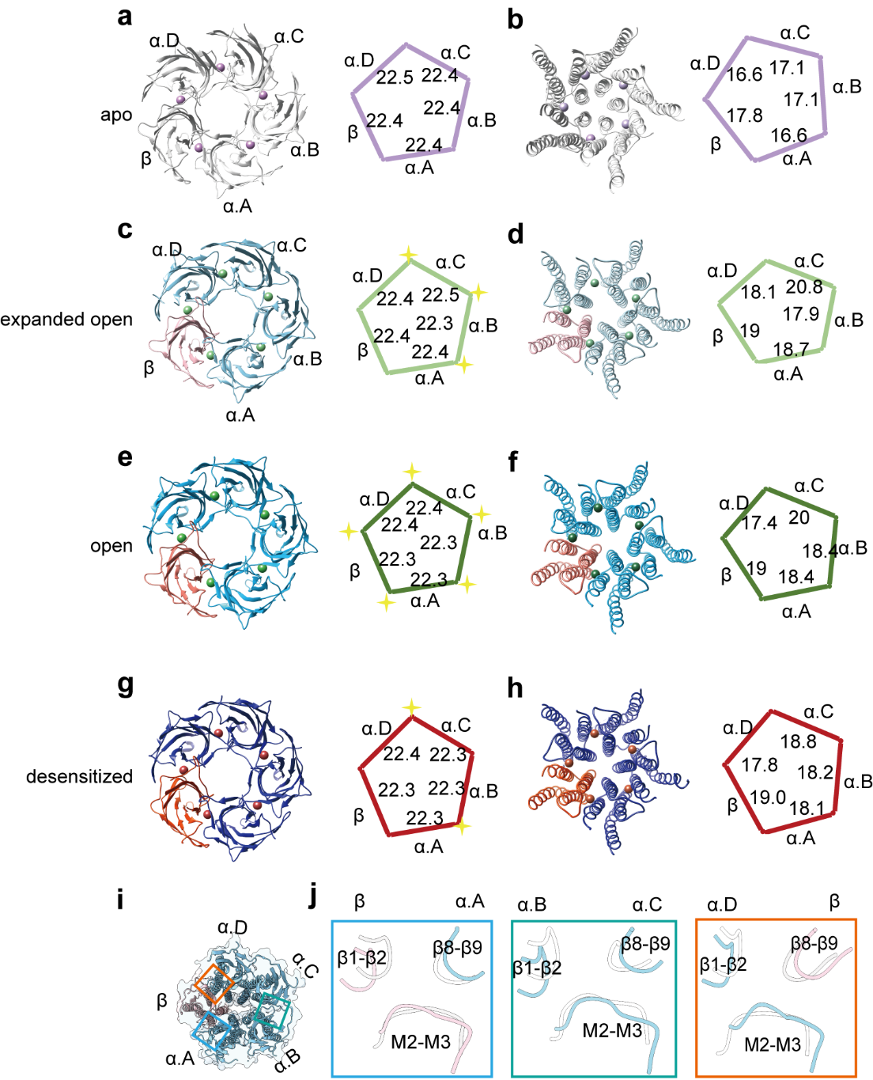
Supplementary Figure 6 | Overall geometry of ⍺1β GlyR throughout the gating cycle and conformational changes at the ECD-TMD interface.
Cartoon representation of ECD (a, c, e, g) and TMD (b, d, f, h), with diagram on the right showing distances between the centers of mass of two adjacent subunits. (a, b,) apo state. ⍺: white. β: gray. (c, d) expanded open state. ⍺: light sky blue. β: pink. (e, f) open state. ⍺: sky blue. β: salmon; (g, h) desensitized state. ⍺: blue. β: tomato. (i) Top-down view of ECD- TMD interface. (j) Overlay of ECD-TMD interface between apo and open states at β(+) ⍺.A(-) (left), ⍺.B(+)⍺.C(-) (middle) and ⍺.D(+)β(-) (right) interfaces. All the distances are given in Å.

Supplementary Table 1 Cryo-EM data collection, refinement and validation statistics

 | Apo  α1β GlyR  (EMDB-27553)  (PDB 8DN3) | Expanded open  α1β GlyR  (EMDB-27552)  (PDB 8DN2) | Open  α1β GlyR  (EMDB-27555)  (PDB 8DN5) | Desensitized  α1β GlyR  (EMDB-27554)  (PDB 8DN4)
Data collection and processing
Magnification | 105,000 | 105,000 | 105,000 | 105,000
Voltage (kV) | 300 | 300 | 300 | 300
Electron exposure (e–/Å²) | 69.6 | 69.6 | 69.6
Defocus range (μm) | -1.0 to -2.5 | -1.0 to -2.5 | -1.0 to -2.5 | -1.0 to -2.5
Pixel size (Å) | 0.83 | 0.83 | 0.83 | 0.83
Symmetry imposed | C1 | C1 | C1 | C1
Initial particles(no.) | 1,670,513 | 1,605,071 | 1,605,071 | 1,605,071
Final particles (no.) | 29,850 | 24,487 | 21,676 | 30,723
Map resolution (Å)  FSC threshold | 3.6  0.143 | 3.9  0.143 | 3.6  0.143 | 4.1  0.143
Refinement
Initial model used (PDB code) | 7MLY | 7MLY | 7MLY | 7MLY
Model resolution (Å)  FSC threshold | 3.8  0.5 | 4.3  0.5 | 3.8  0.5 | 4.4  0.5
Model composition  Non-hydrogen atoms  Protein residues  Ligands | 14319  1699  DD9:13 D10:1  NAG:5 CL:2  HEX:15 HP6:8  NBU:5 UND:12 | 14111  1697  DD9:2 D10:1  NAG:5 HEX:10  HP6:9 NBU:3  UND:3 OCT:7  GLY:3 | 14085  1689  DD9:4 D10:3  NAG:5 GLY:5  HEX:13 HP6:6  NBU:8 UND:6  OCT:2 | 13729  1684  DD9:1 NAG:5  GLY:2 LNK:1  HEX:9 HP6:1  NBU:3
B factors (Å²)  Protein  Ligand | 92.59  33.10 | 110.51  29.88 | 47.86  25.70 | 128.59  76.32
R.m.s. deviations  Bond lengths (Å)  Bond angles (°) | 0.004  0.774 | 0.003  0.773 | 0.005  1.128 | 0.003  0.743
Validation  MolProbity score  Clashscore  Rotamer outliers (%) | 2.07  11  1.97 | 2.4  15  2.76 | 2.26  14  1.72 | 2.17  18  0.07
Ramachandran plot  Favored (%)  Allowed (%)  Disallowed (%) | 96  3.87  0.12 | 94  5.8  0.1 | 94  6.25  0.2 | 94  5.9  0.2

